***Walk the Talk***

**„Access of Rural Youth to Cultural Heritage:**

**European Youth Card’s role in promoting Cultural Routes”**

23-25/26 September 2024

Visegrád, Hungary

*with the possibility of attending*

*the 13th Annual Advisory Forum Cultural Routes of the Council of Europe*

Seminar of the Partial Agreement on Youth Mobility

through the Youth Card

and the European Youth Card Association (EYCA)

CONCEPT AND DRAFT PROGRAMME

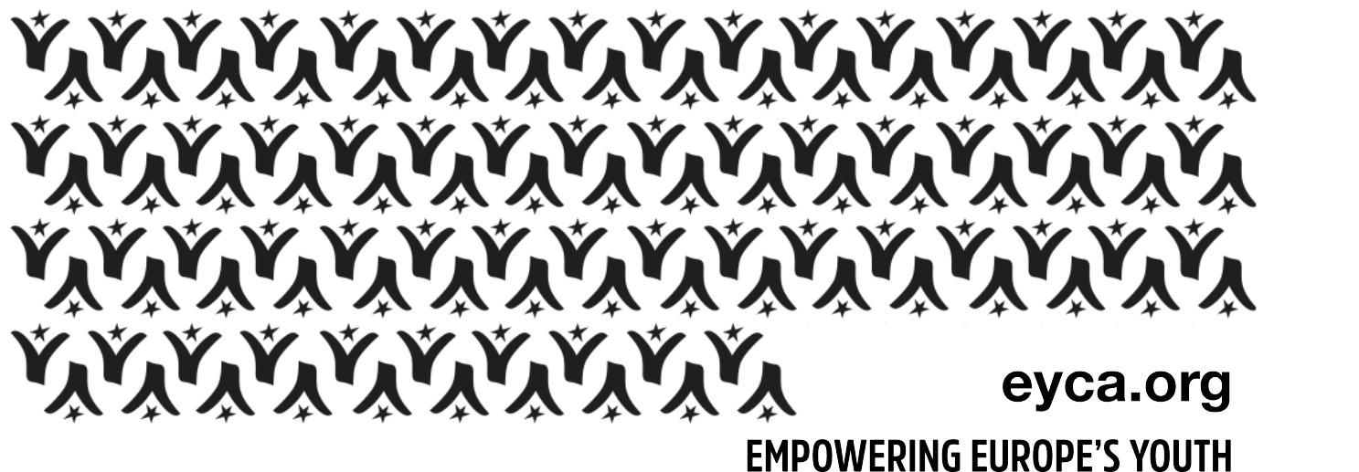

**Introduction**

The seminar is organised in the framework of the programme of activities 2024 of the Council of Europe’s Partial Agreement on Youth Mobility through the Youth Card. It will offer its participants an **innovative interactive** format ‘***Walk the Talk’***, where guests will be walking a cultural route accompanied by an expert and simultaneously **learning and exchanging about youth mobility, youth card, cultural heritage and how to put all this together**! The seminar will also place special attention on young people in rural areas and try to address the challenges they face in accessing cultural or mobility programmes. The event draws on the conclusions and recommendations of several events and processes [1]which took place both at the level of Council of Europe and EYCA over the past year.

The event is organised by the Partial Agreement on Youth Mobility through the Youth Card together with the European Youth Card Association (EYCA) in co-operation with the Youth Department of the  
Ministry of Culture and Innovation of Hungary and the Partial Agreement on Cultural Routes of the Council of Europe.

**The main objectives** **of the seminar:**

* Promote the European Youth Card as a tool for connecting young people, *in particular those from rural areas*, with the cultural offers of the Council of Europe member States, and notably Hungary;
* Open EYCA members to the cultural heritage possibilities for young people, *in particular those from rural areas*, including the European Cultural Routes of the Council of Europe, and encourage them to develop partnerships with cultural heritage actors for the benefit of young people;
* Provide networking opportunities between the civil servants of the Partial Agreements’ member States, the European Youth Card organisations and youth organisations representing rural youth. *For those who will stay on to take part in the Annual Advisory Forum on Cultural Routes of the Council of Europe, there will be opportunity to network with the Cultural Routes counterparts.*

**Profile of expected participants**:

* Representatives of member States of the Partial Agreement on Youth Mobility through the youth card;
* Representatives of EYCA member organisations, including EYCA Board and EYCA Youth Panel;
* Representatives of youth NGOs active in cultural heritage, youth mobility, rural youth issues; special attention will be offered to this target group, as *working with/for rural youth is a priority of all organising institutions;*
* Young people/card-holders from rural areas, including local participants;
* A number of representatives of cultural institutions, tourism developers and youth NGOs in relevant fields from various member states of the Council of Europe.

**About the organisers and partners**

The **Enlarged Partial Agreement on Youth Mobility through the Youth Card** exists since 1991 and is a programme of the Council of Europe[2] aimed at developing the youth card scheme, particularly at European level, in the best interests of young people with a view to facilitating their mobility as well as access to the various goods and services necessary for their personal and cultural development.

The **European Youth Card Association** (EYCA) groups 38 youth card organisations all over Europe and is the Partial Agreement’s statutory partner. EYCA’s vision is a Europe where all young people are mobile and active (socially, culturally, educationally and economically). EYCA’s mission consists in delivering quality youth card services and in contributing to a better policy on youth mobility and active citizenship. Today, over eight million youth cardholders benefit from youth card opportunities.

|  |
| --- |
| **Participants will have a unique opportunity to join the *13th Annual Advisory Forum of the Enlarged***  ***Partial Agreement on Cultural Routes of the Council of Europe.* Attending the Forum is not mandatory,**  **but participants need to decide at the moment of the application and express their interest to attend.** |

**DRAFT PROGRAMME**

|  |  |
| --- | --- |
| **DAY 0 | Monday 23rd September** | |
| Until 20.00 | Arrival of participants and Dinner |
| **DAY 1| Tuesday 24th September** | |
| 09.00 – 09.30 | **Welcome**   * Deputy State Secretary – Ministry of Culture and Innovation (TBC) * Hungarian Open Air Museum (TBC) * Natalja Turenne, Council of Europe, Partial Agreement on Youth Mobility * Manel Sanchez, EYCA Director |
| 09.30 – 10.00 | **Aim and objectives** **of this event**   * mapping the audience * expectations |
| 10.00 - 10.30 | Short Presentations of the Partial Agreement on Youth Mobility through the Youth Card and the European Youth Card  Presentation of the Partial Agreement on Cultural Routes of the Council of Europe |
| 10.30 -11.00 | Coffee break |
| 11.00 – 11.45 | Keynote speech: Barriers to access cultural heritage for young people and possible ways to overcome them” – (TBC)  Youth Panel presentation on EYCA Rural Youth project  Q&A |
| 11.45 – 12.30 | Presentation from Galicia Youth Card/Camino de Santiago  Follow up after the 2023 Walk the Talk seminar in Luxembourg  Q&A |
| 12.30 – 13.45 | Lunch break |
| 14.00–16.30 | Walking a Cultural Route and engaging in a treasure hunt – possibility for a coffee break stop and exchange of impressions |
| 16.30 – 18.00 | Return to the venue: Debrief session/working in groups |
| 19.30 – 21.30 | Dinner |
| **DAY 2 | Wednesday 25th September** | |
| Until 09.00 | Breakfast |
| 09.00 – 10.00 | Conclusions and next steps, ahead of the Annual Forum on Cultural Routes |
| 10.00 – 11.00 | Registration of participants at the 13th Forum on Cultural Routes (Thermal Hotel) |
| 11.00 – 15.30 | Cultural programme as part of the 13th Forum on Cultural Routes |
| 16.30 – 18.30 | Official opening of the 13th Annual Advisory Forum   * Welcoming remarks * Forum keynote speech * High-level Dialogue: * “Shaping tomorrow – Promoting European values among youth” * Cultural Routes of the Council of Europe renewals of certification 2024 * Presentation of the 13th Annual Advisory Forum on Cultural Routes |
| 19.00 – 21.30 | Welcoming Dinner hosted at the 13th Forum on Cultural Routes |
| *After 16.00* | *Participants who do not want to attend the 13th Forum on Cultural Routes can depart* |
| **DAY 3 | Thursday 26th of September** | |
| 9.00 - 9.15 | Introduction to the 13th Annual Advisory Forum |
| 9.15 – 10.30 | General session 1:  **“Encouraging youth engagement along the Cultural Routes of the Council of Europe”** |
| 10.30 – 11.00 | Coffee break |
| 11.00 – 13.00 | Panel Discussion:  **“Intergenerational transmission of traditional practices and know-how”** |
| 13.00 – 14.30 | Lunch break |
| 14.30 – 15.00 | Bus transportation to Hungarian Open Air Museum (Skanzen), in Szentendre |
| 15.30 – 16.30 | Thematic session:  **“Innovative approaches to youth participation in cultural heritage activities: challenges and opportunities”** |
| 17.00 – 18.30 | Workshop on good practices and cultural programme in the regions of Skanzen |
| 19.00 – 20.00 | Folklore programme |
| 20.00 – 22.00 | Dinner, Open Air Museum |
| **DAY 4 | Friday 27th of September** | |
| 9.00 | Breakfast and departures |
| 9.30 – 11.00 | *For those who leave later in the day:*  General Session 2: “**Successful initiatives related to youth along the Cultural Routes of the Council of Europe**” |

**Interested participants are invited to fill in the annexed application form and apply by sending it to** [**youthmobility@coe.int**](mailto:youthmobility@coe.int) **before 25th of August 2024.**

**Practical information**

Selected participants will be offered the possibility to join the Forum on Cultural Routes and will be provided with a separate link to register for the event.

All participants are expected to arrive before the dinner on 23rd September. For departure, participants:

* Who do not choose to attend the Forum on Cultural Routes, are expected to depart on 25th September;
* Who plan to attend the Forum on Cultural Routes, are expected to depart on 27th September.

A detailed info-pack will be sent to all accepted participants.

**Accommodation and meals**

The organisers will cover accommodation and meals for all participants in Visegrád, Hungary, for the entire duration of the event, including the Forum on Cultural Routes, starting with the night of 23rd September.

**Transport**

Participants are expected to plan their trip to Hungary using the most convenient and cost-effective means. *Organizers may ensure private shuttles from Budapest Airport to Visegrad on 23 September.*

The organisers cover up to 350 Euros/participant for international travel and fully reimburse the domestic travel (within Hungary), especially for young people.

**Visa**

Should a selected participant need a visa to attend the event, please mention so in the application form and then contact [youthmobility@coe.int](mailto:youthmobility@coe.int). You will be provided with a specific form to fill in your details and a nominative invitation letter will be issued by the Council of Europe.

**Contact**

For all practical information, please contact [corina.pirvulescu@eyca.org](mailto:corina.pirvulescu@eyca.org)

**APPENDIX I**

**Expression of interest form**

|  |  |  |  |  |  |  |
| --- | --- | --- | --- | --- | --- | --- |
| **Personal detaIls** | | | | | | |
| First name |  | | | | | |
| Last name |  | | | | | |
| Date of birth (dd/mm/yyyy) |  | Nationality |  | | Gender |  |
| Permanent address |  | | | | | |
|  | Postal code |  | | | | |
|  | Town |  | | Country |  | |
| Telephone (with a country and city codes!) |  | | | | | |
| Mobile |  | | | | | |
| Email |  | | | | | |
| Emergency contact details |  | | | | | |
| Place of work |  | | | | | |
| Address of the employer |  | | | | | |
| Professional telephone |  | | | | | |
| Professional Email |  | | | | | |
| Your roleand tasks in your organisation |  | | | | | |

|  |
| --- |
| Do you have any **special needs or requirements** that the hosting organisation should know about? (E.g. mobility, medical needs, allergies, dietary restrictions) |
| **Do you need a visa to attend the event?** |
| **Do you intend to join the Forum on Cultural Routes, if you are selected?** |

|  |
| --- |
| **DEADLINE – SUNDAY 25 AUGUST 2024**  **MIDNIGHT CET**  **All expressions of interest should be sent to**  [youthmobility@coe.int](mailto:youthmobility@coe.int) |

1. Rural Youth Report by the EYCA Youth Panel  - <https://eyca.org/news/rural-youth-report> (EYCA Youth Panel)

   100 proposals from Rural Youth - <https://eyca.org/news/rural-youth-report> 
2.