Visegrad Regional Seminar
on Global Development Education
Expert Meeting
16 March, 2021
10:00 - 13:00

MEETING AGENDA

In cooperation with:
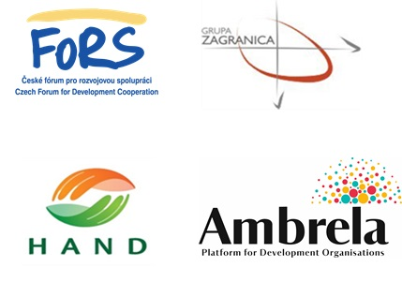

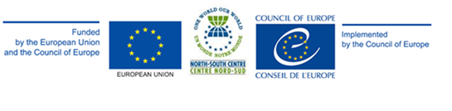

PROGRAMME

16 March

Registration

09.45-10.00 - Registration to on-line platform

Welcoming

10.00-10.15 - Welcoming words & introduction to the meeting (North-South Centre representative)

Introduction

10.15 - 11.00

- 10.15 - 10.30 In plenary: short introduction session: where are we now

- 10.30 - 10.45 Breakout sessions “State of play” - task: update/share GDE practices Professional groups - advocacy + capacity-building

- 10.45 - 11.00 Sharing in plenary

11.00 - 11.15 - offline break

Session 1

11.15-11.30 - Presentation of GENE (Global Education network Europe) advocacy support in the Visegrad region – GENE representative

11.30-11.45 - Presentation of Bridge 47 Envision 4.7 roadmap – Bridge 47 representative

11.45-12.00 - Q&A

Session 2

12:00 -12:45 - Break-out sessions: countries working group

12:45-13.00 - Presentation of working groups conclusions/recommendations

