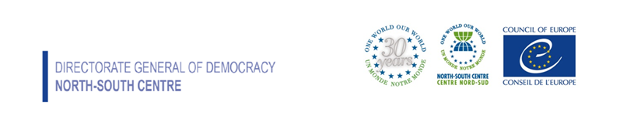
Visegrad

on-line experts meeting
on
Global Development Education

16-March 2021 – 10h00-13h00 CET
Regional State of play
Summary
In cooperation with:
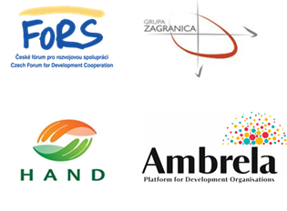

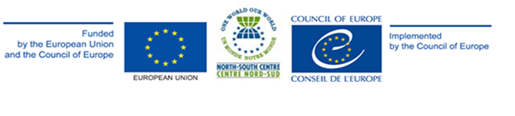
Policy Making and Curricula Development

In Czech Republic, Global Development Education (GDE) was established more than 15 years ago and is systematically developing. The ultimate follow-up Strategy for Global Development Education and Awareness of Global Topics is prepared for the period 2018–2030. The GDE strategy builds on existing national strategy papers and aligns with their objectives.
In Hungary, as the government accepted the concept of global citizenship education in 2016, its adoption and developments in advancing global education are still taking place. Meanwhile, there are excellent materials and tools to be used, there is also a dedicated website collecting these tools called www.globnev.hu, provided by many teachers and NGOs in all levels of education. Despite this rich context, initiatives mostly remain non-systemic, fragmented in scope and isolated, dependent on the dedication of individual teachers and heads of institutions. This situation has not changed significantly even with the adoption of the new national curricula in 2020.
In Poland, the institutions responsible for global education are the Ministry of Foreign Affairs and the Ministry of Education and Science. The government included a declaration on the elaboration of a comprehensive global education strategy, in the new Multiannual Plan of Development Cooperation for 2021–2030. However, since 2017 the structural and content-wise reform of the education system took place and new curricula did not cover global education and all global issues, which were included before.
In Slovakia, the Ministry of Education has begun a process of drafting the new National Global Education Strategy, which should be completed in 2021. The working group coordinated by the ministry includes the MFA, SlovakAid, GENE and NGO representatives. The whole process is supported by the strenghtened relations between GENE and Slovak MoE, which have signed a Memorandum of Understanding. Moreover, Ambrela (Slovak Platform for Development Organisations), continues to be the focal point of advocacy for NGOs working in the area of Global Education and to develop advocacy activities in the area of NDICI and future DEAR programme setup, Rights and Values instrument, Envision 4.7 Roadmap as well as National Global Education Strategy process.

Stakeholders and quality support of GDE

In Czech Republic, the Ministry of Foreign Affairs (MFA) and the Ministry of Education, Youth and Sports (MoE) have been playing a key role in the implementation of GDE. MFA is primarily a professional guarantor of global and development issues and, through the Czech Development Agency (CDA), financially supports GDE projects through grant titles and, until recently, in the form of a program to support trilateral projects. Non-government organizations also play the most important role in the implementation of the programs or projects and in the development of GDE.
In Hungary, consultations leading up to the adoption of the government GCE concept of 2016 involved various stakeholders from educational institutions, ministries, the institute for educational research and development and NGOs. Since then, this dialogue has unfortunately ceased to continue as well and therefore the field lacks the previous flow of information, exchange of ideas and cooperation among the different sectors. Besides that, a positive and promising development in this context is that Hungary in 2020 joined the GENE network of government ministries and agencies responsible for global education.

In Poland, Grupa Zagranica in cooperation with the Ministry of Foreign Affairs, the Ministry of Education and Science, the Centre for Education Development, the Ministry of Climate and Environment and several academic institutions, during a long-term process created an official definition of global education which is still a framework of most activities implemented by institutions and organisations. The process was finalized with the Memorandum of Understanding on the promotion of global education in 2011. Since then, there is a stable relation in a multi-stakeholder process, which is focused on promotion of global education such as cooperation between actors, national call for proposals. However, the implementation of European strategic documents such as the Paris declaration on promoting citizenship and the common values of freedom, tolerance, and non-discrimination through education, on national level, is not part of the multi-stakeholder consultations.
In Slovakia, the Ambrela is working in cooperation with Slovak MoE, MFA, SlovakAid on national levels as well as Bridge 47, GENE and CONCORD on European level. In 2021, SlovakAid, as the key actor in the national GE ecosystem in Slovakia, has raised its budget for Global Education projects from 100000 € to 120000€ and has, together with MFA as well as the permanent representative of Slovakia at UNESCO in Paris, raised the importance of Global Education in their public statements and meetings with Ambrela. Areas for further development of the GCE ecosystem in Slovakia are:
- National Global Education strategy
- Non-formal Education Fund
- Private–NGO-Public partnerships and hybrid models for innovating and mainstreaming Global Education
- Exploring and possibly piloting EU delegated cooperation in area of Global Education (related to the new structure and long term opportunities within GE-friendly EC programmes )

Awareness raising and pedagogical tools

Czech Republic: the NGOs associated in FoRS, have been running a website www.globalnirozvojovevzdelavani.cz, gathering various GDE materials and providing information regarding the basic principles of GDE, upcoming events, campaigns and other activities. Another web-portal, managed by the MoE, provides teachers with methodological support in teaching and implementation of the framework educational programmes, including sharing experience among teachers in GDE-related areas.
Hungary: dedicated website collecting pedagogical tools provided by many teachers and NGOs in all levels of education: www.globnev.hu,

Challenges
Challenges in the field of GDE in the Czech Republic, which the participation in the seminar can help to fulfil:
- MFA: to actively promote GDE towards other ministries and units of state administration; to ensure and develop the capacities of the staff of the Ministry of Foreign Affairs and the Czech Development Agency to manage the GDE agenda; to significantly increase funding for the GDE grant title.
- MoE: to accept the demonstrable role of the Ministry of Education, Youth and Sports as the manager of the GDE and to actively participate in inter-ministerial cooperation, especially with the Ministry of Foreign Affairs and the Ministry of the Environment.
- Faculties of Education: to include GDE in the education of future teachers, both in theoretical training and as part of pedagogical practices.
- Schools and Educators: to integrate GDE objectives into strategic documents at the regional, local, and school level, to develop and support GDE cooperation between teachers (inside and outside the school), schools, and the region.
- NGOs: to monitor trends in education and bring the experience directly from development practice from abroad, to develop professional, methodological, and teaching capacities of employees of organizations.
Challenges in the field of GDE in Hungary, which the participation in the seminar can help to fulfil:
- GE initiatives remain nonsystemic, fragmented in scope and isolated, dependent on the dedication of individual teachers and heads of institutions; multi stakeholder dialogue discontinued.

Opportunities

Czech Republic: Strategy for Global Development Education and Awareness of Global Topics.
Hungary: HAND Association research project funded by the International Visegrad Fund on questions related to teacher training and cooperation among relevant stakeholders. Hungary will organise an international sustainability expo and summit in November-December 2021.
Poland: The government included a declaration on the elaboration of a comprehensive global education strategy, in the new Multiannual Plan of Development Cooperation for 2021–2030.
Slovakia: i) new National Global Education Strategy drafting process coordinated by the MoE, including MFA, SlovakAid, GENE and number of NGO representatives; Non-formal Education Fund; ii) Private–NGO-Public sectors partnerships and hybrid models for innovating and mainstreaming Global Education; iii) Exploring and possibly piloting EU delegated cooperation in area of Global Education (related to the new structure and long term opportunities within GE-friendly EC programmes).

