Visegrad

on-line experts meeting
on
Global Development Education

16 March 2021 – 10h00-13h00 CET

Concept Note

In partnership with:

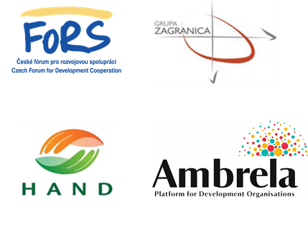

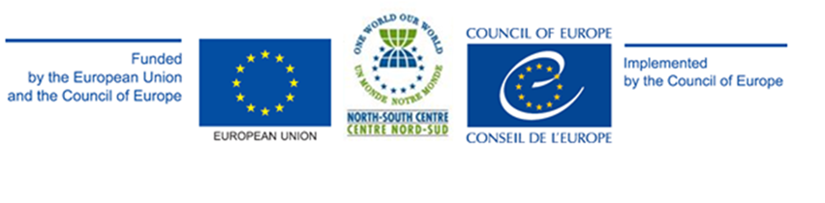

BACKGROUND

The North-South Centre of the Council of Europe (NSC) is implementing from 2019 to 2022 a cycle of regional meetings and follow-up events for the understanding of and competence development on Global Development Education in new EU member States and candidate countries. These regional meetings are developed in the framework of iLegend II, the Joint Programme between the European Union (EU) and the Council of Europe to promote Global Development Education (GDE) in the Balkan, Baltic, South-East Europe and Mediterranean, and Visegrad countries.
These meetings aim at sharing expertise and practices, identify needs and priorities to be tackled in terms of capacity-building and advocacy, and agree on a follow-up mechanism through sub-granted projects.
They target formal and non-formal education practitioners; national Civil Society Organisations platforms; youth organisations and youth multipliers; Ministries of Education, and/or Ministries of Youth, and Ministries of Foreign Affairs; representatives of national parliaments (commission for education and/or development); platforms of local and regional authorities, as well as representatives from GENE-Global Education Network Europe, CONCORD and Bridge47, with the objective of offering a space of dialogue for a shared understanding, practice and recognition of GDE and a sound development of education policies that can be carried back to the national level.
This approach follows the Council of Europe Recommendation CM/Rec (2011)4 on education for global interdependence and solidarity and is aligned with the Council of Europe Reference Framework of Competences for Democratic Culture.
It is developed in the framework of the Development Education and Awareness Raising (DEAR) programme of the European Union and responds to the 2017 European Consensus for Development and the 2014-2020 financing instrument for development cooperation.
It is also in line with United Nations (UN) 2030 Agenda, contributing to the following SDGs:
- Goal 4: Ensure inclusive and equitable quality education and promote life-long learning opportunities for all (in particular goal 4.7.);
- Goal 5: Achieve gender equality and empower all women and girls;
- Goal 16: Promote peaceful and inclusive societies for sustainable development, provide access to justice for all and build effective, accountable and inclusive institutions at all levels;
- Goal 17: Strengthen the means of implementation and revitalize the global partnership for sustainable development
The Visegrad meeting is organised and implemented by North-South Centre of the Council of Europe with the support of the European Commission and in cooperation with the Visegrad partners: the Czech Forum for Development Co-operation-FoRS; the Hungarian Association of NGOs for Development and Humanitarian Aid–HAND; Grupa Zagranica (Poland); and The Slovak NGDO Platform–AMBRELA.
As from March 2020, the regional meetings took the format of on-line experts meetings, in compliance with sanitary contingencies.
ACTIVITY DESCRIPTION

Short introduction to the activity
The Visegrad meeting on GDE, to be held in 16 March 2021, will bring together approximately 20 to 24 practitioners and decision-makers from Czech Republic, Hungary, Poland and Slovakia to jointly discuss existing perspectives and further developments on the support and practice of GDE - focusing on advocacy, competences development and pedagogical support of practitioners and decision-makers, awareness-raising and networking - taking into consideration the challenges arise in the context of to the current pandemic situation and the contribution of GDE in this context.
Each national delegation shall include five to six participants maximum representing formal/non-formal education sector; CSO platform; local authorities; Ministries of Education (MoE) and/or of Foreign Affairs (MFA); parliamentarian commissions on education, and the national coordinator of the NSC GE network.
Through plenary and/or working sessions, participants will review the state of advancement of advocacy, professional development of and pedagogical support to educators and institutional stakeholders and propose a roadmap to increase GDE advocacy and capacity-building at national and regional level.
The half-day online expert meeting shall be followed by a second half-day session for sharing its outcomes with a wider audience of GDE educators and stakeholders and allow further networking.

Targeted outputs:

Advocacy:
- regional state of play in the field of GDE capacity-building and advocacy is shared;
- policy frameworks and processes relevant for GDE development in the region are shared (GENE programmes, Envision 4.7 Roadmap, UNESCO Futures of Education);
- regional involvement in the above-mentioned policy frameworks and processes is discussed and gaps identified;
- regional needs and priorities are defined in terms of GDE of policy processes;
- GDE policy development follow up mechanisms and terms of reference are proposed for the next two years in the framework of sub-granted projects;
- prospects for longer term engagement in the form of a multistakeholder forum to advance GDE in the national context are discussed with experts, based on existing practices in Visegrad or elsewhere.

Capacity-building:
- GDE practices of V4 teacher training institutions for mainstreaming GE are shared;
- research results on mainstreaming GDE in teacher training from the V4 region are shared;
- a new V4 research initiative on mainstreaming GDE in teacher training is introduced. Connection points between the project activities and GENE’s, the NSC’s and the V4 expert’s priorities are explored;
- regional needs and priorities are defined in terms of competencies development of main stakeholders (both practitioners and institutional stakeholders);
- GDE competencies development of main stakeholders (both practitioners and institutional stakeholders) follow up mechanisms and terms of reference are proposed for the next two years in the framework of sub-granted projects;
- prospects for longer term engagement in the form of a multistakeholder forum to advance GDE in the national context are discussed with experts, based on existing practices in Visegrad or elsewhere.
Targeted outcomes:

- confidence among representatives from the quadrilogue (governments, national parliaments, local and regional authorities, and civil society) is strengthened;
- knowledge of policy makers (representatives of national governments, local/regional authorities, and national Parliaments) about policy frameworks and processes relevant for GDE development in the region - GENE programmes, Envision 4.7 Roadmap, UNESCO Futures of Education - is increased;
- relevant government representatives were engaged in the meeting in a productive manner and show commitment for cooperation for longer term engagement;
- competences of practitioners (i.e. educators, youth multipliers and NSC GE Network members) on the different dimensions of GDE and its practical implementation are strengthened, and an advocacy and capacity-building scheme is agreed, taking into consideration new challenges arose with COVID-19 pandemic;
- the NSC Global Education Network is strengthened and reinforced, with government and youth representatives.

Targeted group(s):

- Formal and non-formal educators;
- CSO platform, including youth organisations;
- Local authorities;
- Ministries (MoE / MFA) or training institutes;
- Parliamentarian commissions on education;
- National coordinator within the NSC GE network
Working language

English will be the only working language of the meeting and no interpretation to other languages is foreseen. The meeting is intended to be interactive and thus only participants with relevant level of English will be selected to participate.

DATE

16 March – 10h00-13h00 CET

BACKGROUND DOCUMENTATION
International reference documentation

- North-South Centre Global Education network annual meeting report, Lisbon, January 2020;
- North-South Centre Global Education Guidelines – a Handbook for Educators to Understand and Implement Global Education, Lisbon 2019;
- Council of Europe framework of Competences for Democratic Culture, Strasbourg 2016;
- Council of Europe Recommendation CM/Rec(2011)4 of the Committee of Ministers to member states on education for global interdependence and solidarity, Strasbourg 2011;
- Council of Europe Charter on Education for Democratic Citizenship and Human Rights Education, Strasbourg 2010;
- Council of Europe White Paper on Intercultural Dialogue: “Living Together As Equals in Dignity”, Strasbourg 2008;
- Envision 4.4 roadmap;
- GENE state of GCE in Europe;European Consensus for Development, 2017;
- 2014-2020 financing instrument for development cooperation;
- United Nations 2030 Agenda for sustainable development;
- UNESCO futures of education resources.

NSC granting mechanism for follow-up activities
In accordance with the CoE Congress of Local and Regional Authorities
When possible, in accordance with GENE-Global Education Network Europe representatives
In accordance with the CoE Council of Europe Parliamentary Assembly: Committee on Culture, Science, Education and Media

