2024 Periodic Activity Report

Intercultural Cities Network of Ukraine

April – June 2024

# Summary

During the second quarter of 2024, the Ukrainian network of ICC cities continued its efforts to address social, economic and other challenges in their communities related to the ongoing conflict. As it was decided during the first annual meeting in April, ICCUA members focused on the development and implementation of the projects designed to help cities address their immediate needs within the intercultural framework and lay the foundations for long-term recovery.

Throughout this period, the network maintained a strong commitment to intercultural values and community support. By encouraging creative expression and economic opportunities, its members continue to strengthened the resilience and solidarity of their communities and the network as a whole. The second quarter was marked by impactful actions that align with the network's objectives, ensuring that their efforts continue to support sustainable development and intercultural understanding. The city of Sumy, for example, demonstrated effective strategies for combating misinformation and hate speech, showcasing the critical role of accurate information and community support in overcoming challenges of war and underscoring the importance of an intercultural approach for community resilience in the time of crisis.

In addition to local initiatives, ICC Ukraine members actively engaged in international events. For instance, representatives from Ukrainian ICC cities participated in the No Hate Speech Week 2024 in Strasbourg, France; contributed to the 2nd Luxembourg-Ukraine Business Forum "Rapid Recovery of Ukraine," and took part in the “Local Government Approaches to Diversity” conference organized by the Agency for Home Affairs of the Government of Flanders under the Belgian EU Presidency in Mechelen, Belgium.

# Network coordination and activities

Following an effective negotiation process with the political leadership of the Intercultural (ICC) City of Stavanger, Norway, which was preceded by two working documents prepared by the ICC Ukraine coordinator and the ICC coordinator of Stavanger – covering the current situation in the country, prospects for collaboration, planning, legislative details, and technicalities among other – financial support was granted to the Ukrainian ICC Network for the year 2024. This demonstrates Stavanger's continued commitment to supporting Ukraine during these difficult times, regardless of the change in political leadership in the city.

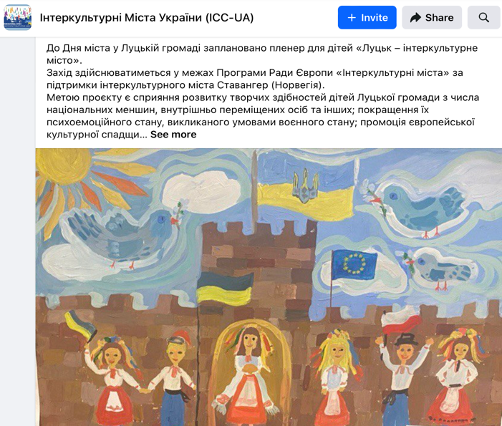A few concrete projects to be implemented with Stavanger’s support had been identified by the ICC Ukraine member cities and submitted to the ICC Ukraine national coordinator.



The city of Lutsk, for example, has designed an open air initiative for children titled “Lutsk – an Intercultural City.” This initiative aims to cultivate the creative skills of children, particularly those with national minority background and from internally displaced families. Its objectives are not only to nurture artistic talents but also to enhance the children's psychological well-being, which has been negatively affected by the war.

Scheduled to run from August to September 2024, the project will begin with a call for creatively gifted children. 30 participants will be selected to take part in a series of art-focused activities. These activities will culminate in an open air event, which is planned to coincide with the celebrations of Lutsk City Day at the beginning of September. This event will feature an enriching thematic excursion aimed at fostering intercultural understanding among the young participants. One of the key features of the project is the planned exhibition of the children's artwork in the Old Town Lutsk. It will showcase the creative art-works of the young participants and serve as a symbol of hope and pride for the entire intercultural community. The project will document its progress in a video, capturing interviews with participants and highlighting their personal experiences and emotional journeys throughout the initiative.

The local partners of the project - the "Lutsk Art School" and the Department for Culture of the Lutsk City Council - will play a key role in its organizational and informational aspects, as well as in spreading a word about the outcomes. The NGO "New Level" has been tasked with project funds management, owing to their expertise in providing technical support and navigating the financial restrictions imposed during martial law. This includes participant

recruitment, logistical support for the open air event, preparation of project materials, and handling financial transactions.

The long-term impact of this initiative is expected to be profound. By engaging children in artistic endeavors and intercultural dialogue, the project aims to ignite a sustained interest in the fine arts and foster a sense of community and belonging. In summary, the open air project “Lutsk – an Intercultural City” embodies the spirit of intercultural cooperation and resilience. It leverages art as a medium to heal, empower, and unite the community’s youngest members, providing them with an invaluable opportunity to express themselves and connect with their heritage and peers in a supportive environment.

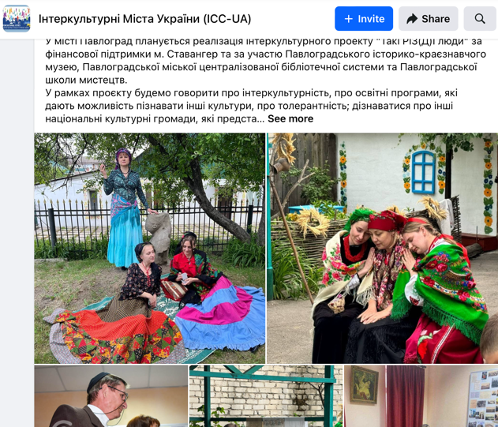In its turn, the city of Pavlohrad worked on the design of the project "So Different People," which involves the Pavlohrad Historical and Local History Museum, the Pavlohrad City Library, and the Pavlohrad School of Arts. Within the framework of the project, an educational program will be conceived to offer opportunities to:

* understand key intercultural concepts
* learn about other cultures,
* meet closer with the national cultural communities represented in Pavlohrad,
* and participate in art therapy and psycho-emotional relief activities.

As part of the initiative, several ‘ethno-evenings’ will be organized to highlight the uniqueness of different cultures.

The Intercultural Odesa is set to organize an art therapy initiative for internally displaced children. This program, conducted within the art space "I Choose Life," aims to help children alleviate psychological stress through art and intercultural interaction.

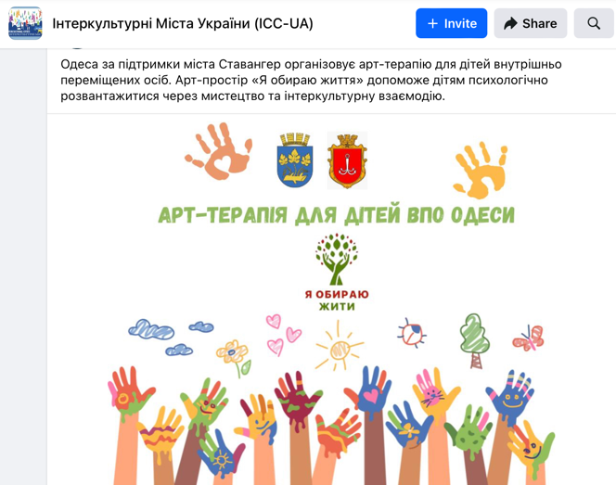The city of Sumy intends to focused on the integration of minorities, including Roma. The project includes the implementation of several measures: updating and detailing statistical information and data regarding the national minorities, ensuring social and legal protection and combating discrimination against individuals with minority background, expanding access to quality education and healthcare services, supporting the cultural and linguistic identity of minorities.

The methodological and technical aspects of these projects have been discussed and designed in close collaboration with the National ICCUA coordinator through a series of online and in-person meetings, ensuring a well-structured and effective implementation of and regarding secure environment for the participants as a priority.

## International Engagements and Intercultural Advocacy

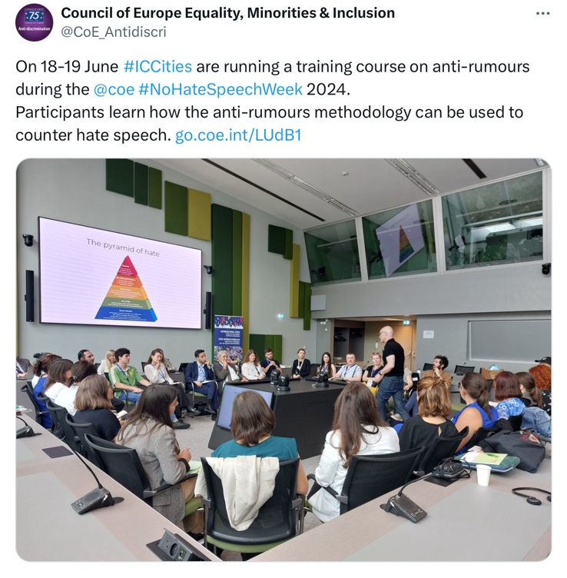ICC Ukraine network members are active contributors to the events organized by the ICC Programme and the Council of Europe in general. On June 18 and 19, 2024, the Intercultural Cities Programme hosted a delegation of its city representatives for the No Hate Speech Week 2024 at the Council of Europe in Strasbourg.This initiative promoted the exchange of experiences and involved participants in various activities such as plenary sessions to review political directions on combating hate speech, workshops, networking opportunities, and an award ceremony recognizing journalists who promoted positive images of national minorities.

During the week of events in Strasbourg, the Council of Europe’s ICC Program conducted a two half-day training course for participants from different ICC cities, including representatives from ICC Ukraine. This training focused on the anti-rumours methodology, teaching participants how to counteract hate speech effectively. The methodology emphasized the importance of understanding and addressing rumours, stereotypes, and prejudices that could lead to hate speech and hate crimes.

The No Hate Speech Week facilitated the exchange of knowledge and best practices among participants through diverse methodological approaches under the theme "Speak Human Rights, Counter Hate Speech." The events, which also marked the International Day for Countering Hate Speech, included plenary sessions, masterclasses, networking opportunities, and an award ceremony organized by the Lithuanian Directorate of the Committee of Ministers of the Council of Europe. This comprehensive approach underscored the critical need for collaborative efforts to combat hate speech at both local and international levels.

For representatives of the Ukrainian ICC Network, the No Hate Speech Week was particularly valuable. It provided a platform to learn innovative strategies to combat hate speech and fostered international cooperation. The event allowed Ukrainian cities to showcase their efforts, learn from the experiences of others, and establish connections, enhancing their capacity to address hate speech and promote intercultural dialogue within their communities.

***Effective Counteraction Against Hate Speech in Sumy: A Case Study***

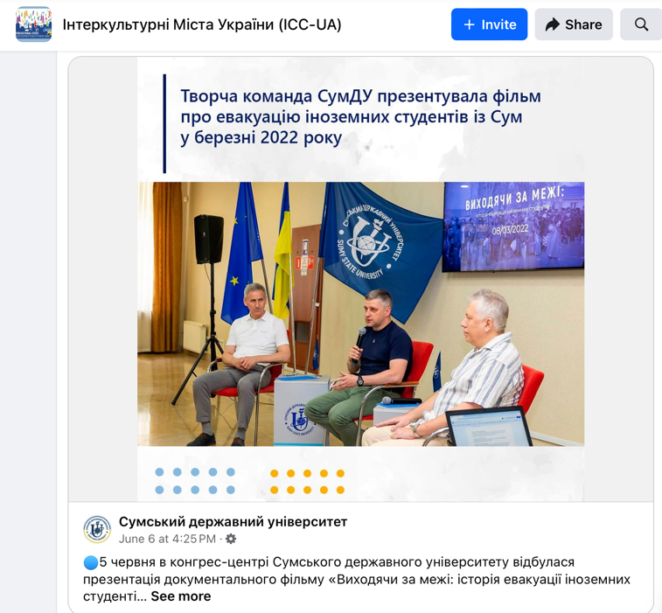Representatives from ICC Sumy, Ukraine, could not join the No Hate Speech Week in Strasbourg this year. However, they have proven their professional approach to countering hate speech and faulse information locally. On June 5, Sumy State University premiered the documentary "Beyond Borders: The Story of the Evacuation of Foreign Students from Sumy" at its congress center. The film depicted the harrowing early days of the full-scale invasion when around 2,000 international students were trapped in Sumy. Amid the crisis, misinformation and hate speech spread rapidly, falsely claiming that these students were either abandoned by the authorities or held as hostages to ensure the city's safety.

The spread of false information and hateful messages exacerbated the already tense situation, undermining trust and spreading anti-discrimination sentiments. However, thanks to the coordinated efforts of Sumy State University, government bodies, diplomatic missions, local authorities, and international humanitarian organizations, a successful evacuation was organized. This collaboration demonstrated the power of inter-sectoral collaboration and collective action in combating misinformation and hate speech.

During the film presentation, officials and students, who have returned to their university in Sumy today regardless the ongoing conflict, shared their firsthand experiences. The university’s rector praised the team that provided essential support to the students during the crisis, ensuring their safety and well-being. He emphasized that the university's commitment to openness and responsibility towards its students would likely attract more international students in the future. The event highlighted how critical support from the university, local community, and government helped maintain intercultural values and trust in Sumy, effectively countering the negative impact of fake news and hate speech.

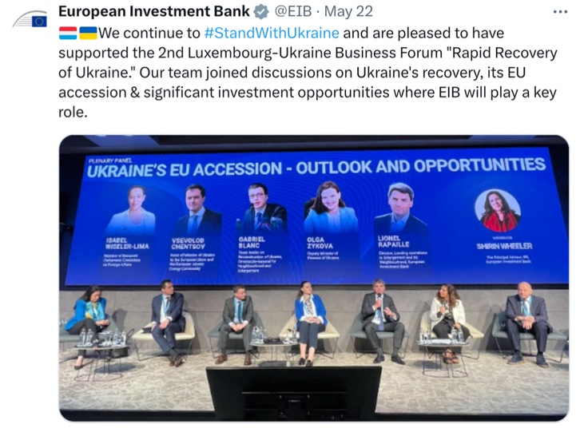Whenever possible, ICC Ukraine representatives participate in international events and forums addressing the current challenges in Ukraine and its cities. This was the case with the Second Luxembourg-Ukraine Business Forum "Rapid Recovery of Ukraine" on May 21, 2024, at the Luxembourg Chamber of Commerce, where key stakeholders convened to discuss critical strategies for Ukraine's economic recovery and post-conflict reconstruction. The forum aimed to encourage valuable discussions on rebuilding Ukraine, fostering partnerships between the business communities and governments of Luxembourg and Ukraine. Building on the inaugural forum's success in January 2023, this year's event was designed to be even more impactful, addressing essential topics for economic growth and development.

Participants delved into several pivotal issues, including Ukraine’s EU accession prospects, attracting international investment, and employing Ukrainians in Luxembourg companies. Additionally, the forum explored key sectors such as energy, industry, agriculture, and financing recovery, along with defense technology, space, cybersecurity, and the practicalities of running businesses in Ukraine. By bringing together representatives from Ukrainian and Luxembourgish authorities, European institutions, industrial and financial sectors, international financial institutions, and investors, the forum sought to accelerate Ukraine's economic recovery and foster sustainable growth.

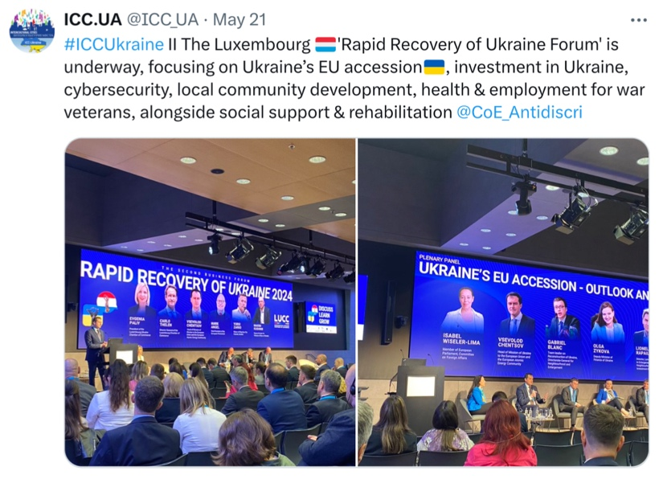A significant highlight of the forum was the introduction of the [Seeds of Bravery](https://seedsofbravery.eu/) initiative, a €20 million initiative funded by the European Innovation Council. This project aims to support Ukrainian tech startups by providing non-refundable grants of up to €60,000, access to additional financing, and entrepreneurial education. Seeds of Bravery focuses on fostering deep tech and high-growth potential startups, promoting diversity, and connecting Ukrainian innovators with European markets. The initiative is designed to nurture innovation, resilience, and economic sustainability in Ukraine during and after the reconstruction phase.

The information about the Seeds of Bravery initiative was promptly shared with the Ukrainian ICC Network by the national coordinator, who encouraged the member cities to file their applications durng the next call. The initiative offers a comprehensive support system, including mentoring, training, and networking opportunities with industry experts and investors. This initiative is crucial for empowering Ukrainian communities and entrepreneurs, enabling them to contribute significantly to the country's recovery and long-term economic stability, and ensuring Ukraine’s successful entrance to the broader European market.

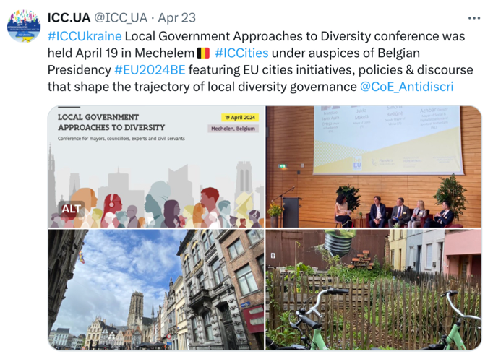Another event involving ICC Ukraine participants during this period was the High-Level Policy Forum and Ministerial Conference on ‘The Integration of Newcomers by EU Member States’ and the Conference on ‘Local Government Approaches to Diversity,’ organized by the Agency for Home Affairs of the Government of Flanders under the Belgian EU Presidency, held in Mechelen in April 2024. These events fostered professional networking and learning about diversity management and intercultural initiatives across Europe.

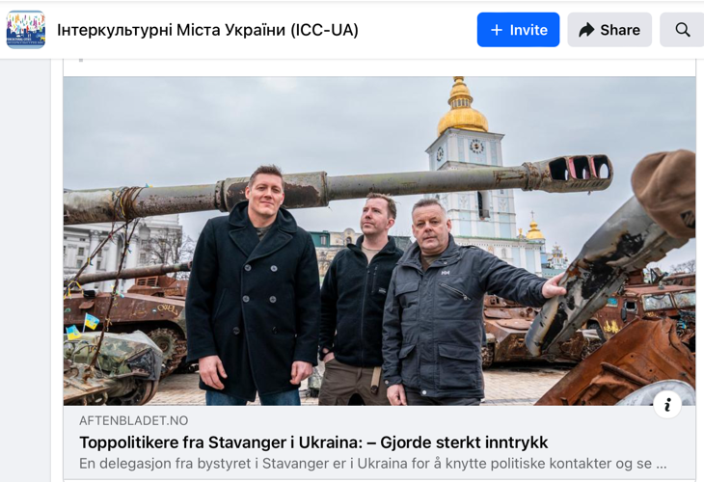In particular, the conference offered a comprehensive platform for discussing best practices, policy frameworks, and innovative approaches to managing diversity. The national ICC Ukraine coordinator had the opportunity to engage with experts and policymakers from various EU member states, sharing their experiences and best practicies in implementing successful diversity and integration programs across Europe. The sessions highlighted the importance of collaboration and the sharing of knowledge on how to address common challenges and to promote social cohesion and inclusion at both local and national levels​ [www.vlaanderen.be](http://www.vlaanderen.be),​​ [VISITFLANDERS](https://www.visitflanders.com/en).

It is worth noting that our partners from ICC Stavanger, Norway, continue to support our Network not only with financial means but also in person. Recently, representatives from Stavanger visited Ukrainian cities on a support visit, communicating during their journey: “Good morning from Ukraine. War, undoubtedly, but highly motivated people here who are fighting for what we have taken for granted for too long: freedom and democracy. Another night of targeted attacks on civilian infrastructure. Ukraine's struggle is our struggle. The country deserves all the support we can give. Contribute today at <https://u24.gov.ua/>."

# Next steps

Moving forward, the Ukrainian ICC Network will continue leveraging the support from its partners to implement key projects that address immediate needs and promote recovery of its communities. A focus will be placed on expanding potentially impactful initiatives such as the “Lutsk – an Intercultural City” project, ensuring that more participants benefit from these programs, and advocating for the Council of Europe’s principles of equal opportunity and broader participation.

The network will continue to work to enhance its international collaborations by participating in intercultural events and forums, sharing best practices, and learning innovative approaches to diversity management. Continuous engagement with the Council of Europe’s Intercultural Cities Programme will help to maintain momentum in intercultural advocacy and application of anti-rumour methodologies locally.

The network will also work on strengthening local partnerships, fostering more inclusive and resilient communities. Monitoring and evaluation mechanisms may be needed to be established to measure the impact of ongoing projects, ensuring alignment with the network's objectives and adaptability to emerging challenges. By building on these strategic actions, the Ukrainian ICC Network aims to solidify its role in promoting intercultural dialogue and sustainable development amidst the ongoing conflict.