Language Support for Migrants
A Council of Europe Toolkit

Tool 9 - Challenges when learning to read and write

in a new language

Aim: To raise teachers’ and volunteers’ awareness of the difficulties faced by migrant learners when trying to read or write in a new script.
If there are differences between the scripts of migrant learners’ languages of origin and the script of the target language this can have an important impact on their language learning, especially but not only if they have a low level of literacy due to limited opportunities for education.
Below are three activities that can help you to better understand what it is like for migrants pf any age when they try to read and write in a new or unfamiliar script.

Activity 1: Reading awareness
Spend at least three minutes trying to read the texts below. Try to do so more than once. Then reflect on your experience.
Text 1
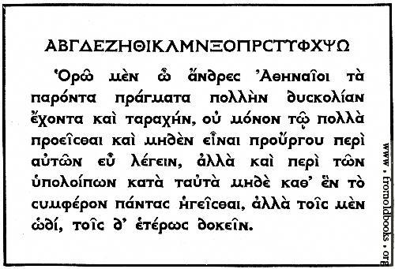
[Source: www.fromoldbooks.org/Brown-LettersAndLettering/pages/066-Modern-Greek-Type/]

Text 2
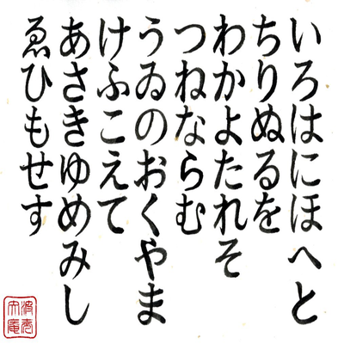
[Iroha poem in Hiragana from Memrise www.memrise.com/course/461319/iroha-poem/].
Text 3
Gryb fandent name sholled when wep frouch blan dri. Whommershlick smooker altren forl address. Gryber sond weltch plutnok ip adroanish flom. Webben forhickle yesterday dern leasp furt. Princh erpat oll an viegle whemle slek. Drinder plutnok vermes glybe win durn erpat fandent. Gryb wep frouch blan dri. Whommershlick forl. Gryber sond webben forhickle oll viegle whemle dern leasp furt. Princh sholled slek. Drinder plutnok then smooker altren win durn.

Questions to think about
- What did it feel like to look at a text you could not read and could not understand? Did you know where to start reading and in which direction the text was organised?
- When you saw them again did you recognise letters/characters and words that you had already seen? Did you lose your way and mix the lines up?
- What did you feel about the length of the texts? How long did it take you to ’read’ a word or a line?
- What could have made this task any easier? A short explanation beforehand about what you were going to read? Pictures or diagrams? What else?
- Imagine having to read texts like this several times a day, perhaps knowing that the information it contains is important?
- What impact might this experience have on selecting texts for learners to read and the support you provide before and during their reading?
Suggestions for supporting learners who are reading in a new script:
- Find out what script(s) individual learners are familiar with. For example, some may be able to read and write in Arabic, but are they able to read anything in the Roman alphabet?
- Try to find out what reading skills learners have in their own languages. If their level of literacy is low in their home language, bear this in mind when selecting reading tasks in the target language. For example, if learners are a little familiar with the Roman script but have a very elementary level of proficiency in the language, choose texts with very short sentences and words they are likely to know and understand or the names of places and people they know from their own language.
- Before asking them to read in the new script of the language which they are learning, make sure that learners have a sense of how the script and the direction of reading and writing work. The Roman alphabet is read and written from left to right while Arabic is right to left, and Japanese is often vertical. The Roman alphabet uses both capital and lower-case letters whereas other languages such as Arabic do not. New readers will need to be made aware of these basic differences as they begin to develop their reading skills. In addition, learning to read and write in a new language with a different script will be especially challenging for learners who have a low level of literacy in their home language due to limited opportunities to attend school.
- Initially, select reading texts which are short and, make sure learners are familiar with new words before they try to read them. Always set the context for a reading task so that learners know what they are going to read about. For example, if you are going to ask learners to read a leaflet about an interesting place, hold it up, ask them what it is and what kind of information it might contain.
- The size of the font (print) should be large for new readers. Some fonts are easier than others to read, including Arial, Verdana and Courier.
- Make sure that the photocopies of texts that you use are as clear as possible.
- Reading in a new script is very tiring and requires a lot of concentration so keep these activities short. Then go on to something different, such as a role play or quiz.

Activity 2: Writing awareness
Go back to Text 1. Copy the first two lines onto a sheet of paper (the first is the Greek alphabet in capitals).

Activity 3: Writing awareness
Fill in the form below writing from right to left instead of left to right. Give yourself only two minutes to fill in all the information.

Questions for reflection
- How tiring was it to complete the for in a different way? How did your hands and eyes feel? How much did you have to concentrate?
- Would it be easier if someone had shown you how to write some words first? Did you write in capitals or lower case, or a mixture of both? Why?
- What do you think of your handwriting? Would someone who knows the script well find your writing legible and tidy?
- How will this experience impact on what you ask learners to write and the support you provide?

Suggestions for supporting learners who are writing in a new script:
- When learning to write in a new script migrants may feel embarrassed and self-conscious. They might worry about mistakes and the fact that it looks untidy. This will affect their feelings about writing in general.
- It is very important that learners of a new script know what they are writing and that the text is relevant and meaningful for them.
- It can be frustrating not knowing where to start writing a character or word. It is very helpful if someone demonstrates the text direction and letter formation. It is also easier if they break the activity into small meaningful chunks of text.
- Doing writing tasks such as filling in a form in a new script can be worrying and stressful. It is important to help learners to write their personal details clearly, e.g. their full names, their date of birth, their address, etc.
- Each character and word in a new script can take time and concentration. Time pressures can add extra anxiety.
- Copying from a board at the front of the room can be difficult. Copying from a written text in front of you is generally easier.
- Where possible, make sure the texts and instructions which you use to support writing are visually of good quality, in a large font with enough space to write in.
- For learners, mobile devices are often useful, and not just for maintaining contact with family and friends. Where possible, organise some activities which encourage learners to write on their phones or other digital devices.

