 | Language Support for Migrants  A Council of Europe Toolkit | 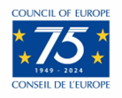

Tool 8 – Creating a plurilingual self-portrait: a reflective task for you
Aim: To help those providing language support for migrants to reflect on the languages they know, how they use them, and what they mean to them.
The concept “language repertoire“ refers to the fact that all individuals are potentially or actually plurilingual, i.e. capable of learning several languages and communicating in more than one language. A ‘language portrait’ is one way of making a person’s language repertoire visible. The woman who created the example below has used the colours red, orange, purple and blue to show the languages she is able to use.
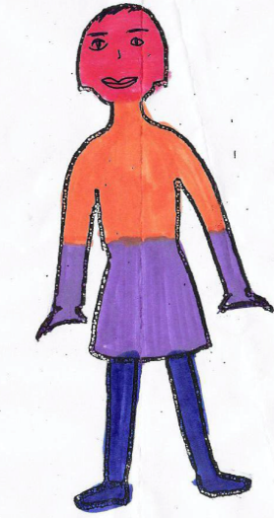 | red = Panjabi
 | orange = German
 | purple = English
 | blue = Hindi
Each time we learn a new language we have to reorganise our language repertoire, finding a place for the new language depending on the situations in which we use it and the people we use it with.

Creating your language self-portrait
Make a drawing like the one on the previous page and use colours to create your own language self-portrait, bearing the following points in mind:
- This is a spontaneous and intuitive activity, which you should finish as quickly as you can. The time for reflection is after you have created your language portrait.
- Include all language varieties: dialects are as important as standard languages.
- Competence levels are not important: if you know just one word in a language it is worth making it visible in your portrait.
- If you prefer, you can write the names of your languages on the figure instead of colouring it in.
When you have completed your self-portrait, think about the following questions, perhaps discussing them with a colleague:
- Why did you put the languages in those parts of your body?
- In which contexts do you use your different languages (in the family, with friends, at work, etc.)?
- Which of your languages are broadly respected in your community?
- Do you speak a language or dialect which doesn’t receive the same kind of respect?
- Why do you think some languages have a higher status than others?
- How is it possible that some people from African countries speak seven languages fluently but are still considered uneducated, whereas people who speak two or three European languages fluently are considered highly educated?
- Are there situations where you mix languages when you communicate with other people?
Task for migrant learners
This activity has often been used with migrants of different ages (see tool 50 -Plurilingual portrait - a reflective task for migrants). It has proved to be a good way of helping them to become aware of the “linguistic capital” they already possess, which is good for their self-esteem, especially in circumstances where they may be defined by the languages they don’t know, not the languages they do know.
When they have produced a language portrait many learners are keen to compare their repertoires and experience with those of other migrants – to talk about the languages they know, where they learnt them, and with whom they use them. Language portraits are a good way of getting migrant adults and children to talk and think about languages from the perspective of their own experience.

Source of the plurilingual portrait: H.-J. Krumm (Hgg. H.-J. Krumm/E.M. Jenkins): Kinder und ihre Sprachen – lebendige Mehrsprachigkeit. Vienna 2001

