Language Support for Migrants
A Council of Europe Toolkit

Tool 77 - Mapping journeys and the local area with migrants
Aim: To offer suggestions for running simple language activities based on mapping migrants’ journeys to their current location and for mapping the local area.
Activity 1 – mapping journeys to learners’ current location
- Find a large wall map of the world and/or make copies of a map of the world. Ask simple questions such as ‘Where is [this country] on the map?’, ‘What is this country to the west/east/north/ south of [xxx country of current location]?’, ‘Where is Turkey on the map? Can you show me?’, ‘Where is your country on the map?’ etc. If necessary, give examples: e.g. Mosul is in Iraq. Iraq is here on the map, Turkey is to the north of Syria. The distance from Munich to Berlin by road is nearly 600 km. etc.
- Give an example of the journey a learner may have taken. This can be the route taken by an imaginary learner or by someone in the group who is willing to give you information. Tell the story using simple language, for example:
“Ahmed is from Aleppo in Syria, which is here in the map. He left his home in 2016. He first went by bus to Turkey and crossed the border, here. He stayed in Turkey for 6 weeks. Then he travelled by boat to an island in Greece, here on the map…” And so on. From time to time during the story stop to ask simple questions (e.g. where is Ahmed from? When did he leave? Where did he go first, etc.). End the story of the journey with “he arrived here in June, and now he is living in….”.
- Tell (or read) the story again or tell another similar story. This time ask learners to mark the route of the journey on the map. Tell them to ask you questions if they are not sure (e.g. where did he go from Greece? Where is Lampedusa? How many weeks was he in….?).
- Now ask learners to tell some of their stories. Give them some time to prepare and offer help. If they have a smart phone, they can also check maps and information that way.
- Important note: learners must be willing to do this: if anyone is shy or unwilling to talk about their journey, do not ask any further questions (especially in case of refugees and unaccompanied minors).
If learners prefer, they can talk about a family member or someone else they know who is not in the group. While a learner is talking, others can ask questions and mark the journey on the map.

If several learners want to tell the story of their journeys, spread the activity over several sessions.

Activity 2 – Mapping the local area
- Ask the group to tell each other about the local places they know that like. Ask questions to find out more. If you are supporting new arrivals, encourage the group to use shared languages to get the information across. You could also invite people who have been living in the area for a while, for example migrants who arrived some time previously, to give information about local facilities and services and answer questions.
- Learners then work together to create one or more shared maps of the local area of places with useful or interesting facilities or services, e.g. local parks and playgrounds, children’s centres, city farms, schools, health centres, community centres, sports facilities, shops etc. This will depend on whether the learners are children or older migrants, their language levels and the local context.
- Children may like to do drawings of places. Older learners can take photos of their map on their phones or, if possible, make copies for other learners. They can also display their maps for other people who may be able to add more information.

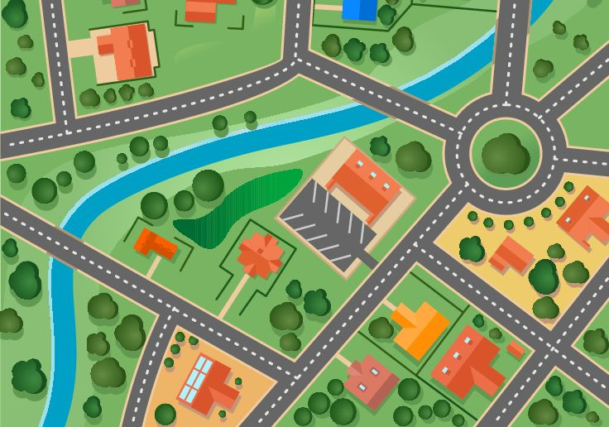

Some ideas
- For the map making, you can use large sheets of paper or wallpaper. If you are meeting online, you could use the whiteboard or sharing facility on the meeting platform.
- If there are some places of particular interest, maybe you can arrange a visit there or ask someone from that place to come and give learners more information.
- Try to collect relevant information leaflets with images and/or key information in different languages.
- If you have access to a computer the group can find out more about different places, e.g. opening times, location etc. They could also use a journey planning app to work out how to get there and Street View to have a look round and familiarise themselves with the journey and the area if it is new to them.
- Use the maps for a treasure hunt type activity, which children really enjoy. Prepare simple clues to help them find certain places or items in the area.
Activity 3
Learners can produce a short information sheet about the local area for new arrivals. This could either be in their first language only, or in their first language and the language of the country they are in.
Examples of useful language for this activity
Get information. | Where do you get free Wi-Fi access?  Where is the market?  Who can help with … (legal advice, food vouchers, information about …. etc.)?  What time does it open? | At the …  In the centre of town.  Ask for … at the …  It’s open from … to …
Ask for and give directions and tell each other where places are. | Where is the …., please? | Go straight on.  Turn right.  It’s on the left/behind the/next to …. etc.  Go straight ahead and turn left at the second traffic lights.  The …… Clinic is near here.  The Advice Centre is opposite the school.
Describe places/buildings. | The training centre is very nice. The courses are free. It’s got a cheap café and a garden.  It’s the tall building next to the bus station.
Express likes/dislikes. | I like … supermarket. It’s very cheap.  That shop is too expensive.
Make comparisons. | ... is more useful than …….  ... are cheaper than ……
Languages used in different places. | They speak Arabic in that centre.  Is there an interpreter at the clinic?
Ask for help. | We need more bins for our rubbish.  Can you give us another voucher, please?

Observation task
Ask learners to listen to people when they want information or ask for something: Can they remember any useful phrases? It will be useful to collect such phrases or to do role plays to practise using them (see also Tool 58, Scenario - Language needed to find one’s way in town).

