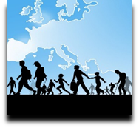 | Language Support for Migrants  A Council of Europe Toolkit | 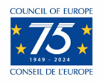

Tool 76 - Preparing language support activities in the community with migrants

Aim: To offer guidance on setting up activities which take migrants out into the community, especially if they have only recently arrived.
It is best if recently arrived migrants make visits and do activities in the community together with people who live in the area and are willing to spend some time with them acting as informal guides. In the case of younger migrants who are at school of college, it may be necessary to obtain the permission of school authorities and/or parents. You may also need to obtain permission if your learners are adult asylum seekers living in a reception centre. Check this before any activities are planned.

Deciding where to go
Look at maps, local newspapers and websites, and, with the help of local people, make a list of places which it would be interesting and helpful for the learners to visit, using pictures relevant to your environment, e.g.:
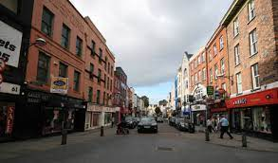 |  |  | 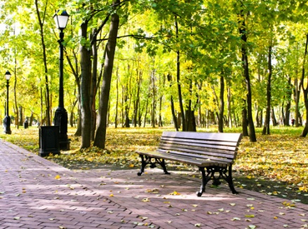
The main street | A shopping centre | A market | A park
With the help of local people and learners, you can plan a walk or look for information on the internet, local posters etc. to look for free events in the area and make a list, including times and places. For example:
 | 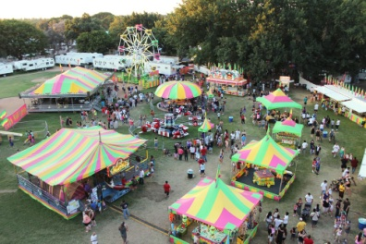 | 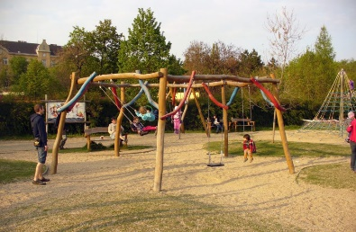 | 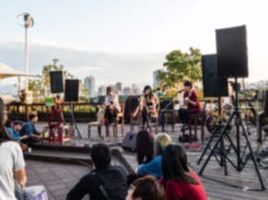
A sports club | A fair | A playground | A musical event

Organizing the trip
Discuss questions like the following with your group. If possible, the learners and local people can talk briefly in small groups.
 | 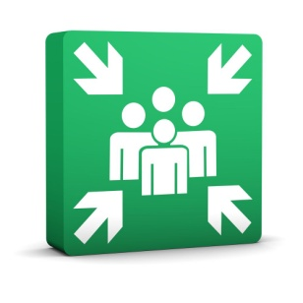
Where shall we go? | Where shall we meet? | What time shall we meet?

How will we get there?
 | 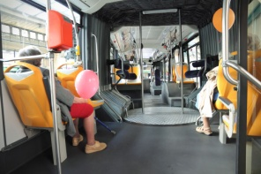
on foot | by bus, tram, metro

Useful language for planning a trip: if possible, local people can help to ‘teach’ learners expressions like the following (and ask them how to say the same thing in their languages):
- Let’s go to... Would you like to go to…?
- Good idea! / Let’s do that!
- Where is it? How far is it? It’s about one kilometre.
- Let’s walk/go by bus/... Shall we go on foot…?
- Meet me at… [place] at …. [time]
- I will bring a bottle of water/a map/ an umbrella...

Other language preparation: some useful expressions
- What is this called?
- Can I have half a …?
- How much is it?
- Have you got... / Where can I get...?
- Can I take a picture?
- Yes, please/No, thank you.
- Prices, cheap, expensive.
- Would you like to try this?

After the trip: talking and writing about the experience
The learners could, for example:
- write a text message/SMS/ post on social media about the trip in their own languages or in the target language, exchange photos or other items they have collected
- work with you on language points, such as:
  - New words they heard
  - Things they said or wanted to say
  - Describing where they went and what they did: where did you go? What did you do there? Who did you meet? what was new/different? What was familiar? etc. (photos or objects will be helpful for this)
  - Would you like to go there again? Why? Why not?
After trips and activities in the community these can become the focus of a language learning activity (e.g. a group photo album or a group diary with contributions from all participants) or for a language practice scenario.

