Language Support for Migrants
A Council of Europe Toolkit

Tool 70 - Scenario: talking about sports
Aim: To enable migrants to talk about their experience and knowledge of different sports and to share ideas about fair play in sports.

Communicative situations
- Talking about themselves and their experiences related to sports.
- Reflecting on fair play in sport.

Materials
A) Pictures of different sports.
B) Icons related to sports.
C) Images related to good behaviour in sports.

Language activities
Activity 1
- Invite learners in pairs to talk about their experiences of sports and the sporting activities they like.
- Then get feedback from them on their sport-related interests and experiences. Remember to positively acknowledge the learners’ contributions.

Activity 2
- Use materials A) to get learners talking about sports and people practising different sports. Try to elicit what they already know about sports activities and the sports that are most popular in the host country.
- Ask them to find pictures of sports venues (stadiums, swimming pools etc.) and sporting activities in their countries on their mobile phones and to describe them orally in turn.
- Invite participants to compare the most popular sports in their countries with those of the host country and to talk about similarities and differences.

Activity 3
- Use materials B) and invite participants to guess the meaning of the icons.
- Then, ask them to write down the key words in their exercise books and check their understanding by asking them to match the words to the relevant icons.

Activity 4
- Ask learners to reflect on good bevaiour, bad behaviour and fair play in sports.
- Ask learners in turn to describe the pictures at C) on the last 2 pages. Ask “participant-mediators” (learners who are more helpful and whose oral skills in the target language are more advanced), to help learners to summarise the points discussed in a mind map (see Tool 35 - Techniques to aid vocabulary learning, page 2).

Activity 5
- Invite participants to reflect on the scenario they have just worked on.
- Try to raise their awreness about what they have done and learned, for example, by using Tool 52 – Encouraging migrants to think about their learning activities and Tool 53 – Encouraging migrants to assess their own progress in language learning).

Materials
A)

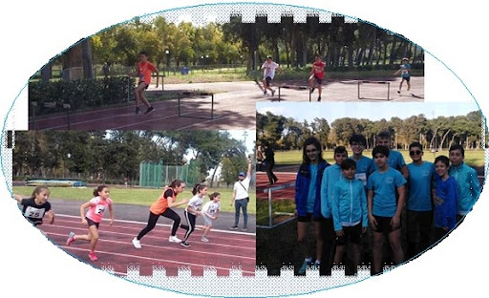

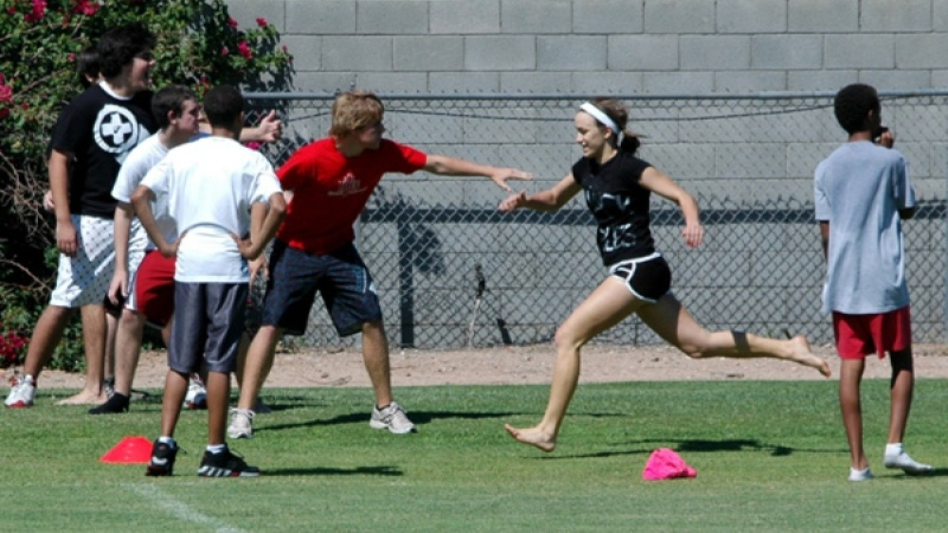

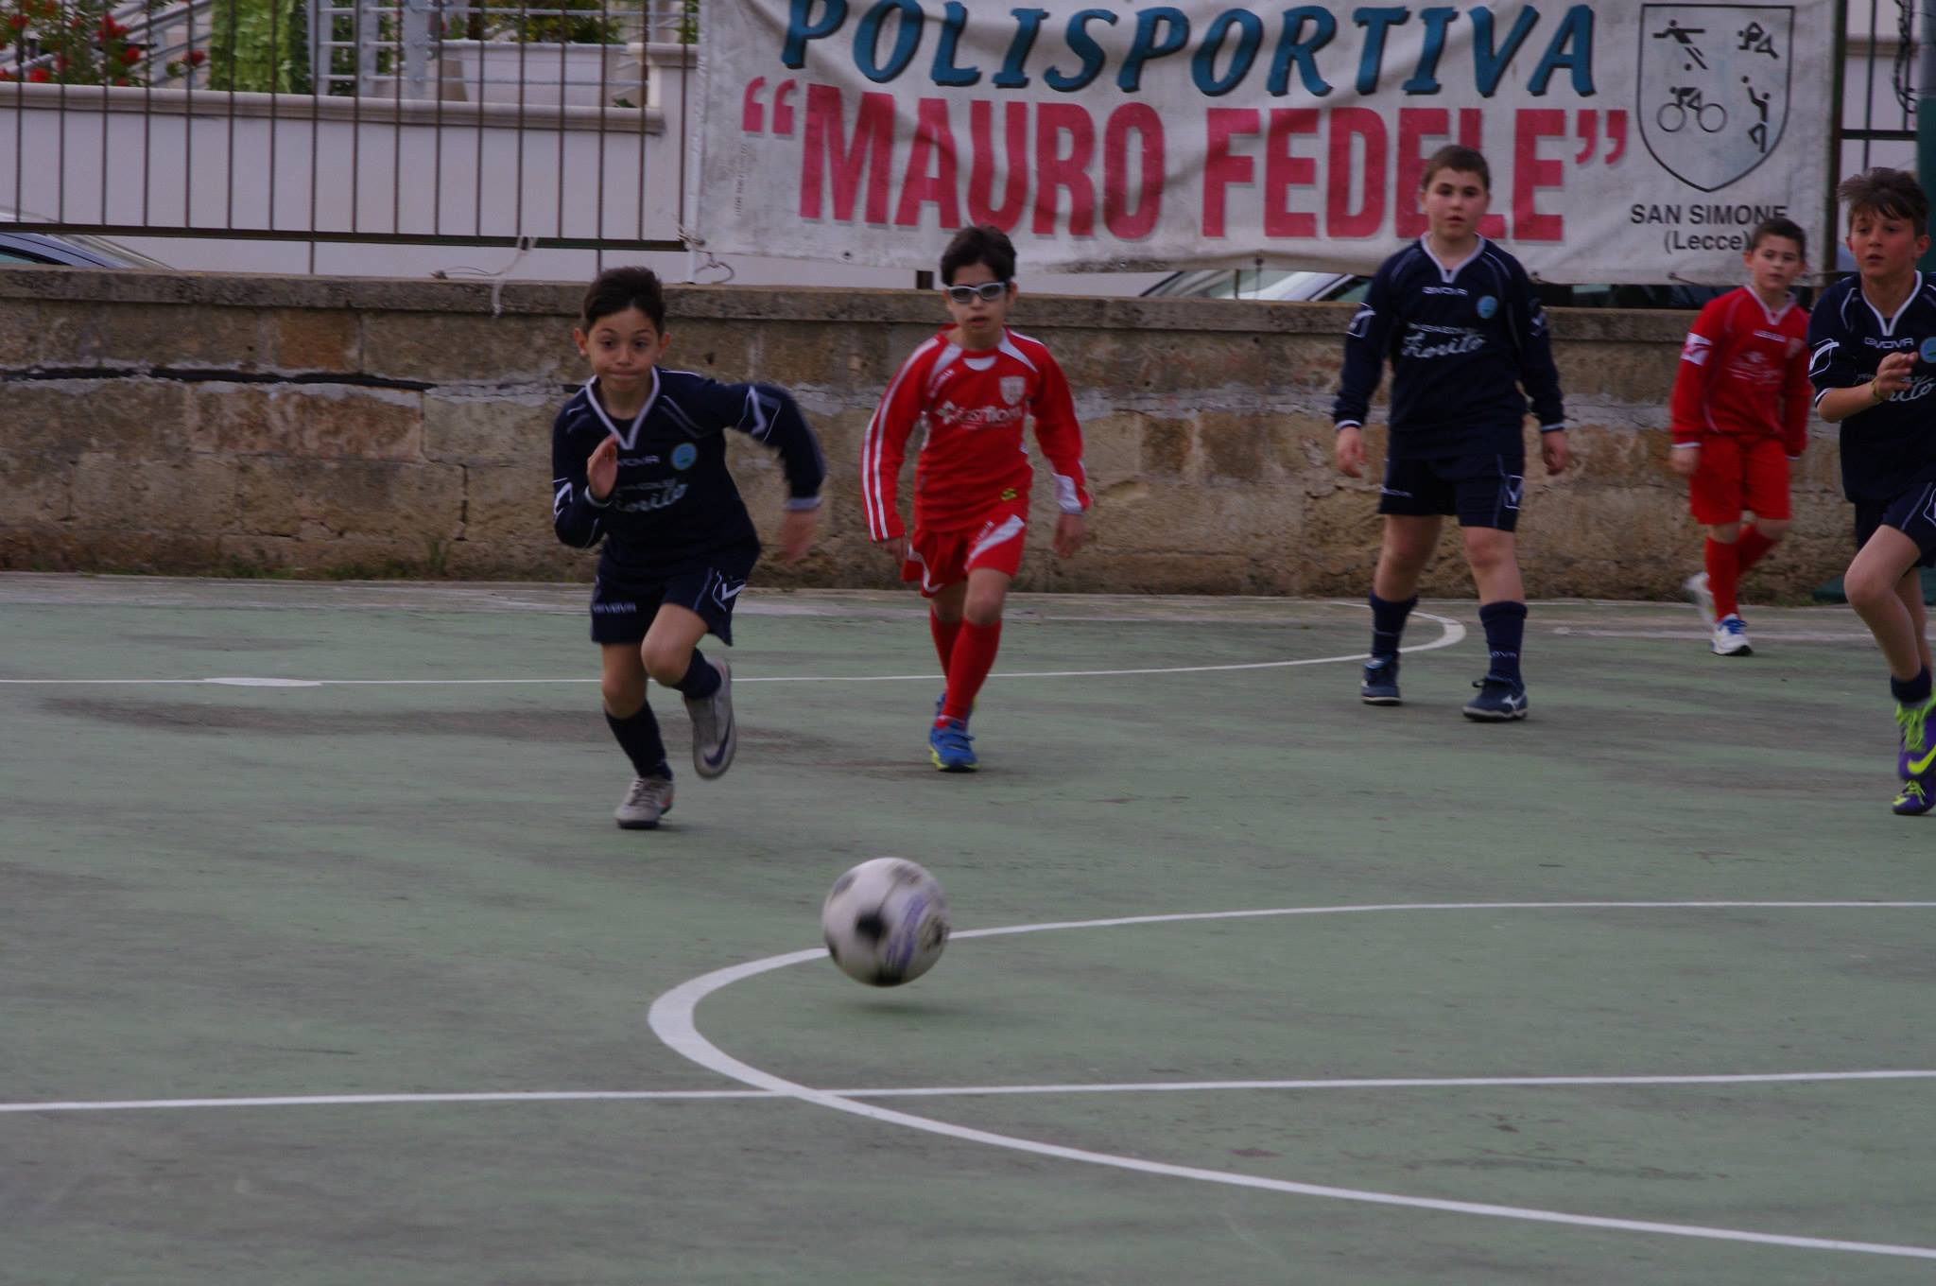

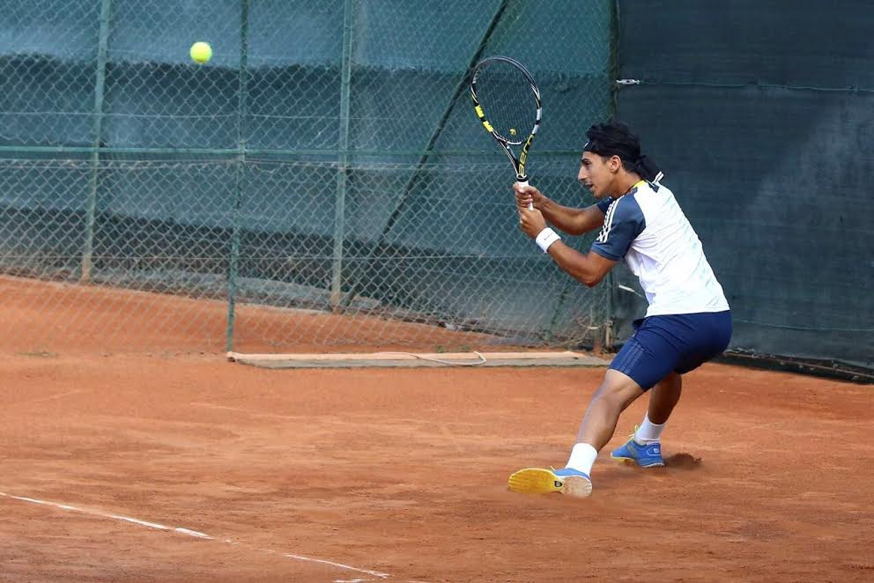

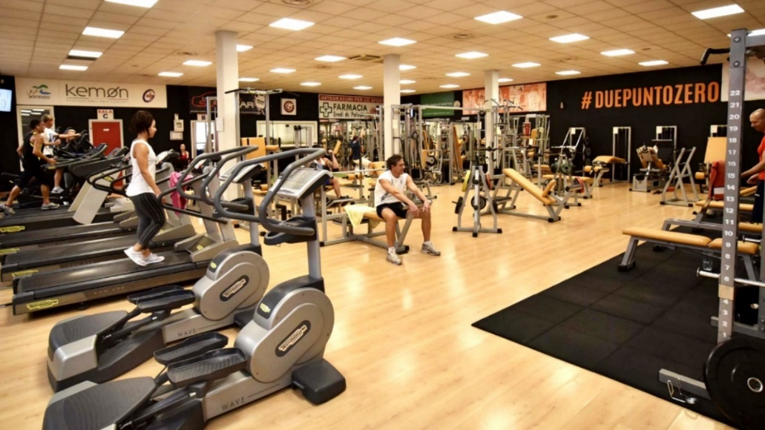

B)
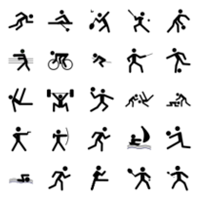

C)

