Language Support for Migrants
A Council of Europe Toolkit

Tool 69 – Scenario: Participating in meetings with school staff about one’s children
Aim: To introduce some expressions and questions that migrant parents may use when having meetings with teachers or other school staff about their children’s progress and behaviour at school.
Communicative situations
- Understanding invitations to meetings with school staff
- Preparing questions and information for these meetings
- Asking and answering questions from teachers and other school staff
Materials
- Pictures of a meeting between parents and teachers.
- An invitation to a parents’ meeting.
- A school report.

Language activities
Activity 1
Use material A) to introduce the topic; ask learners to describe the pictures and to refer to their personal experineces.
Activity 2
Use material B) below. Learners read an invitation to a parents’ meeting (received by e-mail or in printed form) and answer some simple questions. Help learners with any new words or expressions.
Dear Mr & Mrs Khan,
You are invited to attend a parents’ meeting on 24th March at 18.00. The meeting will be held in the main hall of the school. You will meet your child’s teachers and discuss his/her progress with them.
Please inform us whether you can attend the meeting no later than 17th March. You can do this by e-mail: secretary@westonprimary.org or by telephone 03754 076543 (Mondaty to Friday between 9.00 and 17.00).
Please read the enclosed mid-year report berfore the meeting.
Yours sincerely,
M. Smith
Deputy Head
After they have read the letter, ask learners questions such as:
- What time is the parents’ meeting?
- Where will it be?
- What is the purpose of the meeting?
- What do the parents need to do before the meeting? etc.

Activity 3
Learners listen to a recording of a phone call between a member of school staff and parents, then read a dialogue like this example (which can be adapted to local circumstances):
A. Hello. Is that Mrs Khan? This is Barbara. I’m a receptionist at Yusef’s school.
B. Hello. Yes, I’m Yusef’s mother. Is there a problem?
A. No, no. Did you receive our letter inviting you and Yusef’s father to a meeting with Yusef’s class teacher?
B. Oh yes – sorry. When is the meeting?
A. Next Tuesday at 5.30. Is that convenient?
B. Yes, next Tuesday is OK. What is the meeting about?
A. It is a normal meeting about your son’s progress at school. These meetings happen every three months.
B. Good. Can Yusef come too?
A. Yes, of course.
Check learners’ understanding of days of the week, dates and times, for example: what day is it tomorrow? What is the date today? What time does the class begin on Friday?
Use simple questions to check learners’ understanding of key words and expressions, e.g. Who is speaking? Why is Barbara phoning Yusef’s mother? When is the parents’ meeting?

Activity 4
Ask learners in pairs to have a similar conversation with a partner taking the roles of school secretary and parent, changing names, the times and purpose of the meeting, etc.

Activity 5
Learners imagine that they are at a meeting with their child’s teacher. The teacher has given them a school report (see sample materials below).
Teacher: we are very pleased with Asman. She is doing well.
Parent: the new language is difficult for her. Is this a problem?
Teacher: in some lessons, my assistant teacher helps her with language. She now speaks quite well and is learning to read and write. But she is good at maths.
Parent: what about geography? Is she good at that?
Teacher: yes, and she is doing a project on her country with a classmate next week. Can you help her find pictures for that?
Parent: yes of course. Does she work hard and behave well?
Teacher: yes, she is a hard-worker and has made some good friends.
Parent: Thank you. We are happy that Asman is doing well at school now.
To check comprehension, ask questions like: which subjects are difficult for Asman? Why is the teacher happy with her work? What is the project about? Etc.

Activity 6
Ask learners in pairs to change the report (material C). It can be about a different child who is good at different subjects, does not always behave well, is sometimes late etc. Then ask learners to invent a different conversation with a teacher using similar vocabulary and expressions.

Sample materials
A)
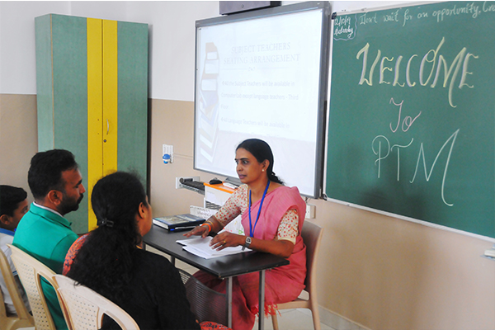
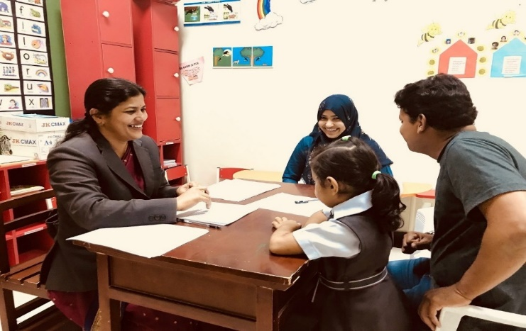

C)
Name: Asman Rahmani. Year: 5. Class 5B. Teacher: Karen Lopez. Date: 12th February
Mid-year report
Language | Asman is making good progress with the language and is now learning to write.
Maths | Asman’s maths is very good. She knows how to multiply big numbers.
Science | Asman is learning more science vocabulary and is very interested in biology, but she has difficulty reading the texts and doing her homework.
Art and design | I love the way Asman draws and paints in bright colours.
Physical education | Asman needs to be encouraged to participate in more sports or exercise.
General | Being in a new school and learning a new language was difficult for Asman, but she is a very intelligent girl and is now making good progress. She needs to work on her reading and to do more homework – she can do this with the help of a teacher after school every Tuesday.  Asman is enthusiastic and popular with her classmates.

