 | Language Support for Migrants  A Council of Europe Toolkit | 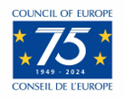

67 – Scenario: Using postal and banking services
Aim: To inform migrants about postal and banking services and enable them to use these services.
Communicative situations
- Understand the signs related to postal and banking services.
- Understand simple information about postal and banking services.
- Use a cash machine (ATM).

Materials
- Pictures of places and signs related to postal and banking services.

Language activities
Activity 1
Use the pictures to:
- Elicit some basic information and vocabulary about postal and banking services asking e.g. Where do you have to go to send a letter to another country? And where can you change money?
- Migrants may be able to talk about these services in their own country.

Activity 2
Use the pictures to explain relevant signs. Participants can:
- Write the key words and expressions on cards. Read the same signs in other photos (e.g. a photo of a street with the same signs).
- Check their understanding by asking them to match words with pictures and signs.

Activity 3
Hand out an illustrated sheet with information about the location and the opening times of the nearest post office or bank.
- Check learners’ comprehension by asking questions such as: Where is the bank? Is it open on Saturdays? When is the post office open? What time does the bank close? Migrants can practise times of the day and days of the week, (e.g. The bank is open from 9.00 to 4.30 from Monday to Friday).
- Then, ask them to work in pairs and to exchange information about the information sheet
- Ask them to share their information with the group.

Activity 4
Learners imagine they are outside a bank – or, better, organise a visit to a bank or post office, or to an office specialised in international money transfer with a group of migrants. If this is not possible:
- Show photos of a cash machine and ask: How do you use a cash machine or ATM?
- If possible, show photos of some cash machine screens that explain the procedure for using a debit/credit card to withdraw cash. Ask participants to explain the procedure in simple language, e.g.:
- First you put in your card.
- Then you have to choose whether you want to withdraw cash, buy credit for your mobile phone etc.
- Next you have to key in your pin code and choose how much cash you want, etc.
- You have to take back your card before receiving your cash etc.

Activity 5
Migrants practise language they may need in a post office:
A. How can I help you?
B. I want to send this letter to Iraq please.
A. OK put it on the scales – that’s 3 euros 50.
B. Right. Here you are. Where can I post it?
A. Put it in the box marked ‘overseas’.
B. OK. Thanks. Goodbye.

Activity 6
Migrants practice language they may need for sending money abroad by international money transfer
A. Hello. I would like to send some money to ****** (name of place)
B. OK, first you need to fill in this form.
A. How long will it take for the money to arrive in ****** (name of place)?
B. It is more-or-less immediate
A. How do I pay you?
B. With cash or a debit card from a bank.
A. How will my friend collect the money?
B. You must send this reference number to your friend so they can use it to collect the money in one of our offices.
A. That’s good. Thank you.
Sample materials
- Pictures of places and signs related to postal and banking services.
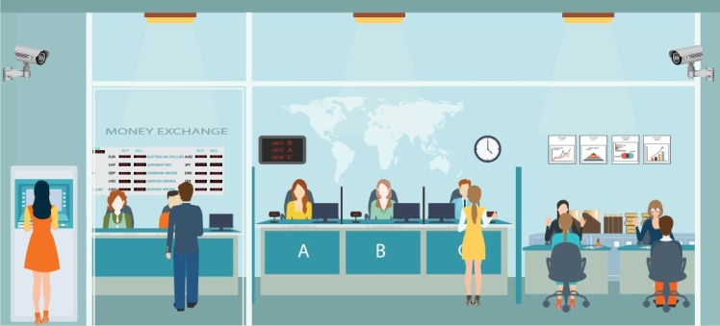 | 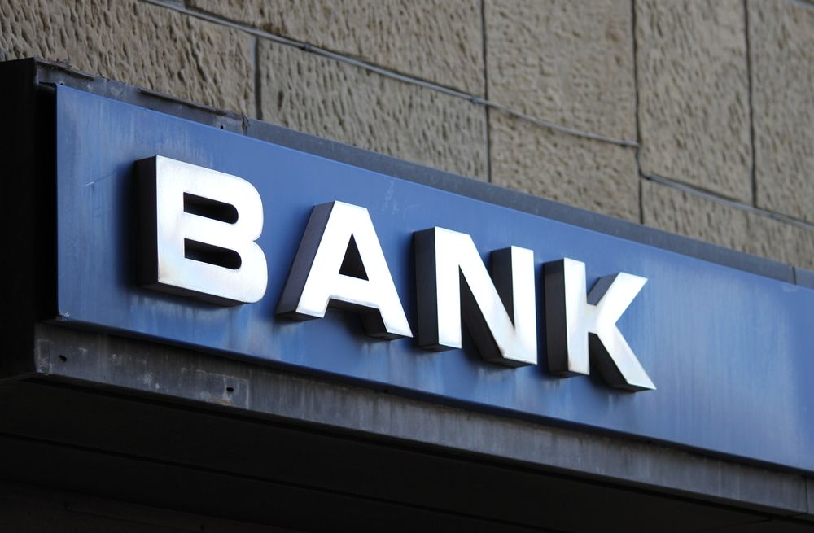
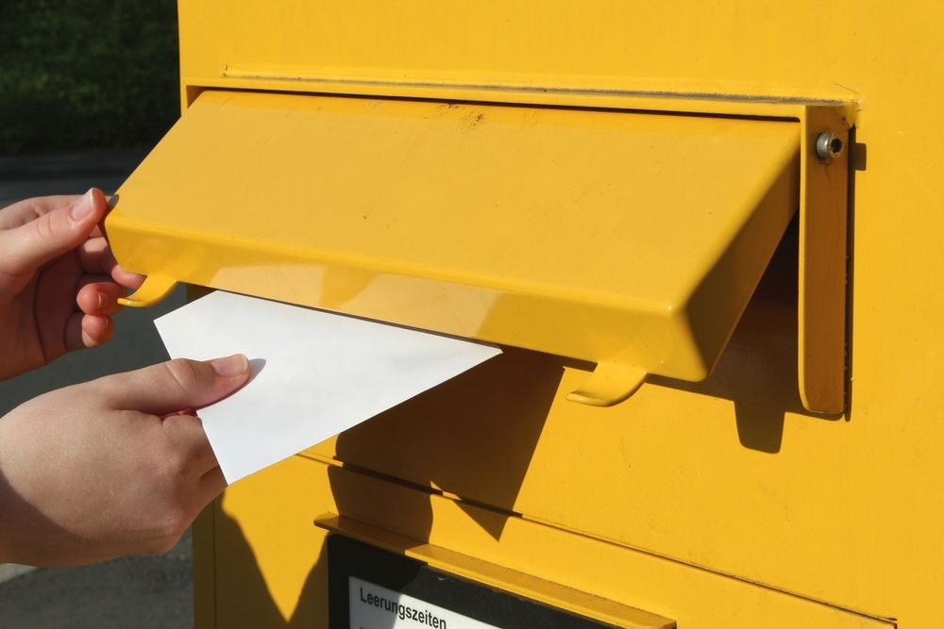
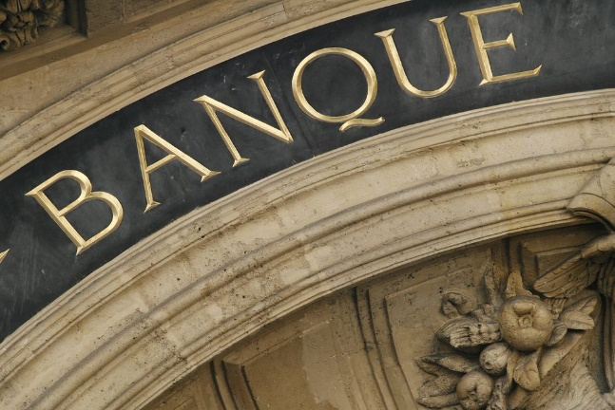 | 