Language Support for Migrants
A Council of Europe Toolkit

Tool 66 – Scenario: Finding accommodation
Aims: To inform migrants about housing in the host country and enable them to communicate about accommodation.
Communicative situations
- Understand advertisements for apartments and houses to let.
- Understand and be able to give simple information.

Materials
- Pictures related to housing.
- Floorplans of apartments.

Language activities
Activity 1
Use the pictures related to housing to get learners to talk about:
- Accommodation and housing in their own country.
- Similarities and difference between homes in the host country and in their own countries.
Activity 2
Use the pictures to introduce some key-words related to housing (e.g. flat, apartment, house, bedroom etc.).
- Ask participants to write these words on cards.
- Check comprehension by asking them to match the words with pictures.
Activity 3
Show migrants one of the floorplans and introduce or check their knowledge of keywords by asking e.g. Where is the kitchen? And the bathroom? Then ask them to point to these rooms on the floorplan.
Activity 4
Ask migrants to draw a floorplan by following simple instructions, e.g. an apartment with one large bedroom, a kitchen, a big living room, and a very small bathroom.

Activity 5
- Hand out the two floorplans and describe one of the apartments.
- Ask learners to indicate which is the apartment you described.
- Then, allowing time for preparation, ask them to describe the other floorplan in a simple way.

Activity 6
Find some advertisements (with pictures) of flats or houses to let in the area.
- Ask questions such as: Have you ever tried to find an apartment or house to rent? Where did you look for advertisements? Was it hard/easy to find one? Why? etc.
- Invite participants to exchange information in pairs about the advertisements: the price, the location, the description of the apartment etc., recycling language from the previous activities.

Activity 7
Migrants practice language they may need for speaking to an estate agent or a letting agent
A. Hello, I’m looking for a house/apartment to rent. Do you have anything suitable for me?
B. Where do you want to live and what sort of accommodation do you need?
A. I’d like an apartment near the centre with two bedrooms.
B. We have a number of properties that might suit you – have a look at these details.
A. I’ll take these away and look at them. I’ll come back tomorrow. Thank you.

Sample materials
- Pictures related to housing
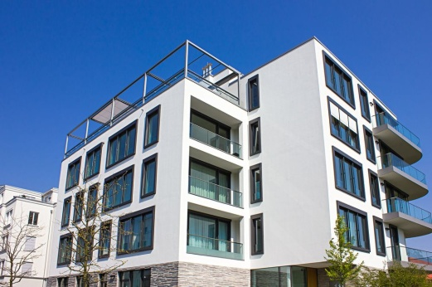

- Floorplans of apartments
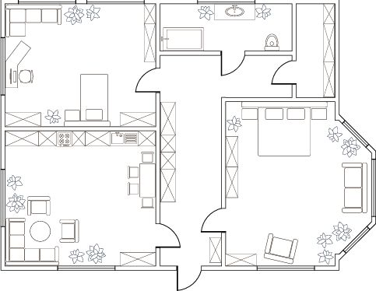 | 