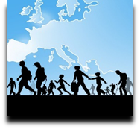 | Language Support for Migrants  A Council of Europe Toolkit

Tool 65 - Scenario: Getting involved in lifelong learning
Aim: To give migrants information related to educational opportunities in the host country and to talk about these.

Communicative situations
- Talk about lifelong learning.
- Understand and ask for information about education and training opportunities.
Materials
A) Pictures of people engaged in different learning environments
B) Flashcards of learning environments
Language activities

Activity 1
Invite migrants in pairs to talk about school and the educational system in their country, asking questions such as "At what age do people go to school in your country?”.

Activity 2
Print materials A). Then divide learners into three groups and give each group a sheet with the three pictures of different courses (second language course, driving course and computer course). Ask learners to describe them orally by asking each other the following questions: "Where are these people? What are they doing?" etc.

Activity 3
Ask learners to look at the pictures again and talk about the similarities and differences between educational settings in the host country and their countries of origin, such as the organization of the classroom, the space provided, the way students sit, etc.
Then, ask them to find pictures of learning environments in their countries on their mobile phones (including using the microphone for oral requests) and to take turns describing them to the whole group.

Activity 4
Write the key words SCHOOL or COLLEGE on the board and invite learners to copy them into their notebooks.
Take turns asking each learner to say out loud the first word that comes to mind associated with “school” or “college”. If appropriate, ask some learners to write one of these words on the board, or write up some of the words yourself, for example as part of a spider gram.
Get the help of “participant-mediators” (learners who are helpful and whose oral skills in the target language are more advanced), to summarise what descriptions using the words mentioned by learners.

Activity 5
Familiarise learners with typical environments in the host country educational system:
- Step 1 – cut out the pictures and words in materials B) and stick them on cards. Divide them into two groups. Show the pictures and indicate which learning environments they illustrate. Then link them to the cards with the written words.
- Step 2 – get learners to play Memory to memorise the words through oral repetition and at the same time to reinforce reading (see Tool 49 - Language games and activities for migrants). Arrange the cards upside down, separating the pictures and the words. Learners take turns to turn over one of the word cards, then read it aloud and find the matching picture cards. If they don’t find the correct word card, they should put both cards back in exactly the same place face down.

Activity 6
Using an audio or video recording, if possible, introduce a short and simple model dialogue such as the following:
A: Good morning.
B: Good morning.
A: I would like to learn how to use a computer. Is there a computer course here at the college?
B: Yes, it’s on Tuesdays and Fridays from 4pm to 6pm.
A: How much does it cost?
B: The course is free. Do you want to enrol?
A: Yes.
B: Well, we can fill out the form and then you can sign it here.
A: Ok. Thank you.

Check understanding by asking learners to answer the 2 questions below about each picture.

Question 1: Where are the people in these three pictures?

Question 2: What kind of course do they want to take?

Activity 7
Organise a role-play between learners adapting and extending the model dialogue in activity 6. Allow time for preparation.

Materials
A)
Second language course
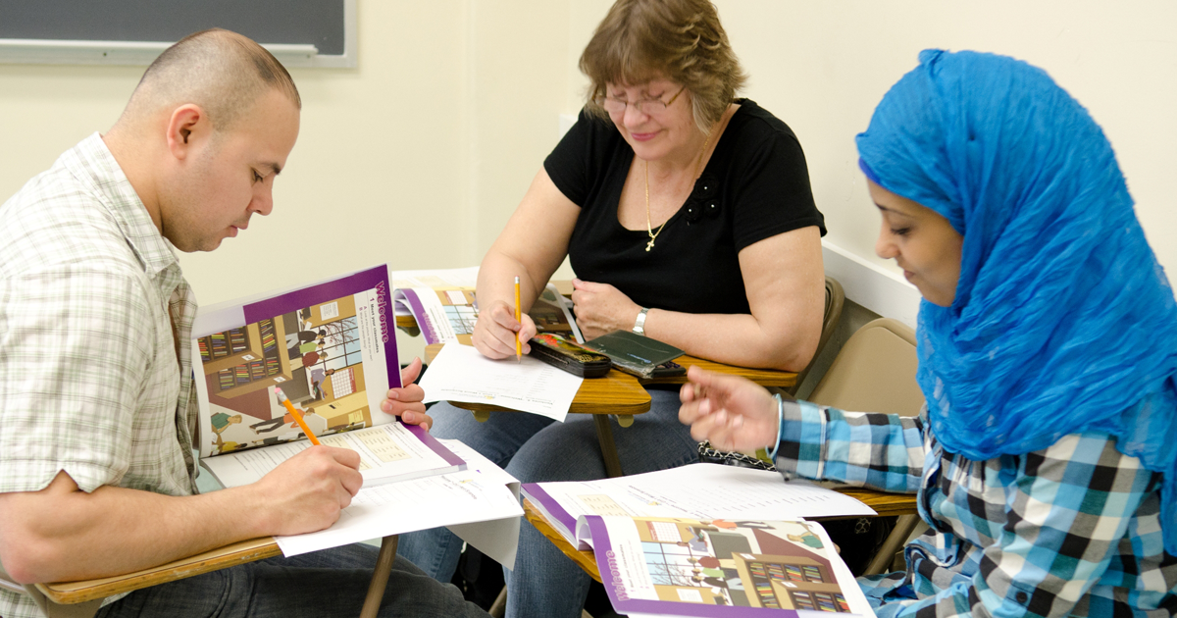
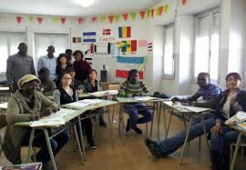

Computer course
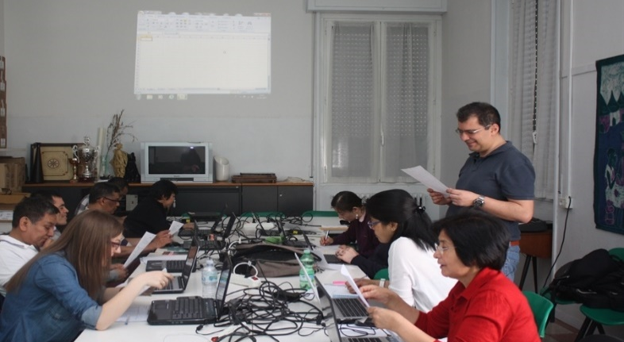

Driving school course
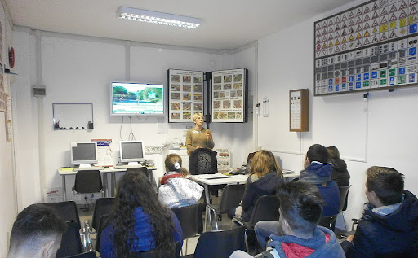
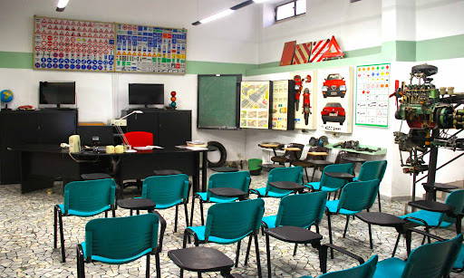

B) Learning environments

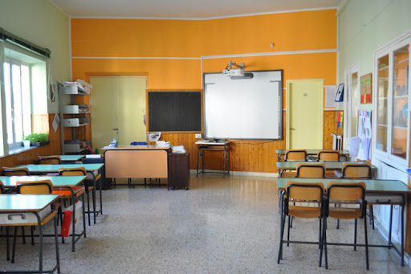 | CLASSROOM
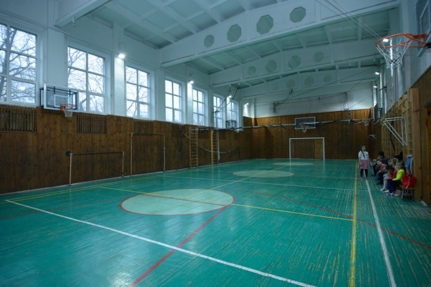 | GYM
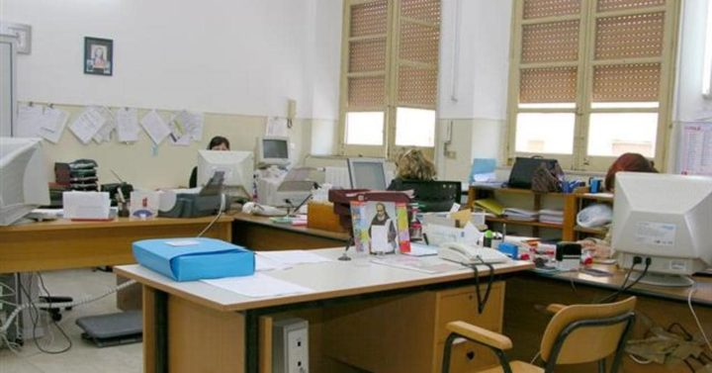 | SECRETARY’S OFFICE
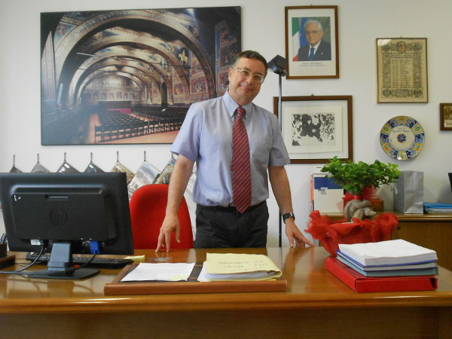 | PRINCIPAL’S OFFICE
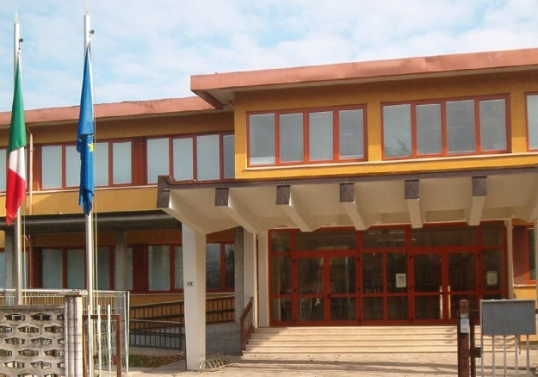 | SCHOOL or COLLEGE

