Language Support for Migrants
A Council of Europe Toolkit

Tool 63 - Scenario: Shopping for clothes
Aim: To enable migrants to learn vocabulary and key expressions related to clothing and enable them to talk about clothing and to ask for clothes in a shop.
Communicative situations
- Express a need (for clothing) and understand the answer.
- Talk about clothing.

Materials
- Pictures related to clothes.
- Pictures of different seasons in the host country.

Language activities
Activity 1
Use the pictures or real clothes to
- introduce some key vocabulary related to clothing
- ask learners to write these words on cards
- check their comprehension of words by asking them to match words with pictures of clothes or real items of clothing. The game of Bingo can be a fun way of exploring and learning this kind of vocabulary (see Tool 49 - Language games and activities for migrants).

Activity 2
Use the pictures of clothes to talk about:
- clothing in learners’ own countries (traditional clothes, most common clothes, etc.)
- similarities and difference between the way people dress in the host country and in their own countries.

Activity 3
Show learners the pictures of the seasons (if possible, using pictures of the nearest city/town/village) and check their understanding of the four European seasons asking e.g. What season is shown in this picture? How do you know?
- Then ask them to describe these pictures in more detail.
- Next, ask learners to talk about the seasons in their own countries (temperature, rainfall and the clothes needed).

Activity 4
Use both sets of pictures together. Spread out the pictures of the four seasons. Then ask learners to put the various pictures of clothing that they consider most appropriate for each season in the right groups beside the seasons.
While doing this, learners can explain their choices in a very simple way, e.g. this jacket is warm. It’s good for winter.

Activity 5
Introduce a dialogue like the following:
A. Good morning.
B. Good morning, how can I help you?
A. It is very cold. I need a coat for the winter.
B. What size are you?
A. Medium.
B. Ok, come this way. The coats are over here.
A. Can I try this one on?
B. Yes, the fitting room is over there.

Check comprehension, especially of:
- the key expression I need
- the word size (write on the board the various sizes: small, medium, large, extra-large etc.).
Learners then do a role play adapting and extending the model dialogue. Allow time for preparation and repeat the activity using the different pictures of seasons and different clothes to contextualize the role play.

Sample material
- Pictures related to clothes.
 | 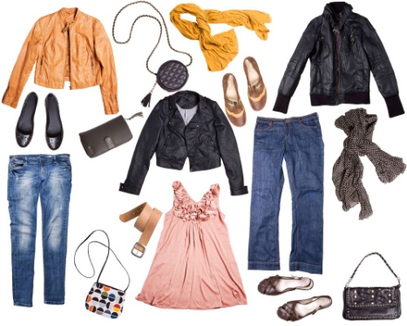 | 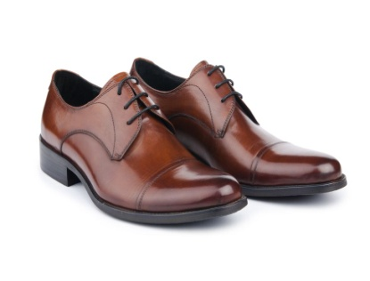
 | 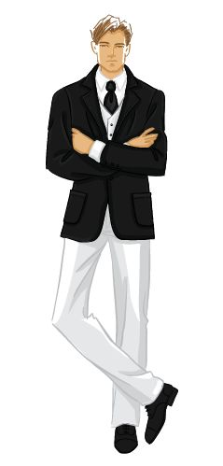 | 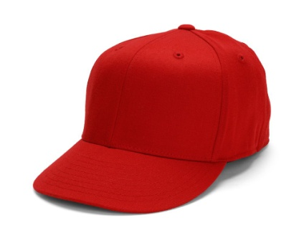

- Pictures of the host country in different seasons
*