Language Support for Migrants
A Council of Europe Toolkit

Tool 61 - Scenario: Talking about food
Aim: To enable migrants to and to practise vocabulary and expressions and to communicate about food, eating and inviting someone to a meal.
Communicative situations
- Ask for information about food and understand the answer.
- Understand simple instructions.

Materials
- Flashcards related to food, and pictures of typical host country dishes.

Language activities
Activity 1
Ask learners to talk about popular dishes in their countries and traditions related to food. Acknowledge their contributions.

Activity 2
Use the materials to get learners to talk about:
- what they already know about dishes in the host country
- similarities and differences between food in the host country and in their own countries, and also mealtimes (e.g. breakfast, lunch, and dinner).

Activity 3
Write on the board some food categories such as meat; fish; vegetables; fruit; dessert. Then, using the pictures/flashcards or, if possible, real items of food, ask individual participants to put the pictures/items in the right category. You may wish to use a mind map for this (see Tool 35 - Techniques to aid vocabulary learning, page 2). Ask learners to say whether they like the food selected and what other food they enjoy. Focus on key expressions such as: I like/ I don’t like/ I like very much.

Activity 4
Ask learners to write down (for example, on cards) the common words related to food that came up in the previous activities. Then check comprehension by asking them to match the words with the relevant pictures. You may wish to use the Memory game or Bingo for this (see Tool 49 - Language games and activities for migrants).

Activity 5
Give an example of a dialogue like the following:
A. Hello Amir.
B. Hello Sofia. How are you?
A. Fine thanks. Do you want to come to lunch? I would like to prepare a traditional dish from my country.
B. Fantastic! So, what will you cook for me?
A. My favourite dish, which is….
Check comprehension, then organize role-plays between learners based on the model dialogue, inviting them to describe their favourite dish. Allow time for preparation.

Activity 6
Ask learners in pairs to explain the ingredients of the traditional dishes they plan to prepare and to write (imaginary) shopping lists for these.

Activity 7
Ask participants to imagine they are setting the table for the meal planned in the previous activity. Show them some items (or pictures) of cutlery and crockery (i.e. fork, knife, glass, plate, salt, pepper, oil, sauces etc.), Then, ask individual participants to follow your instructions, e.g. put the glass on the right of the plate, put the fork on the left etc. Focus their attention on the words for position and orientation (left, right, next to, near, below, above etc.). Then ask them to talk about how the table is set for a meal in their countries. Acknowledge their contributions.

Activity 8
Hand out a short text, preferably with illustrations, containing a recipe for a traditional host country dish, preferably a dish from the region where learners are living. Participants talk in pairs about the text: the ingredients, the key steps in the recipe, etc. Then, if permitted, work with the group to actually prepare the dish described in the recipe, for example using the kitchen facilities in the centre.

Activity 9
Learners taste the dish that has just been prepared: introduce expressions like: enjoy your meal, I hope you like it, it looks delicious etc.
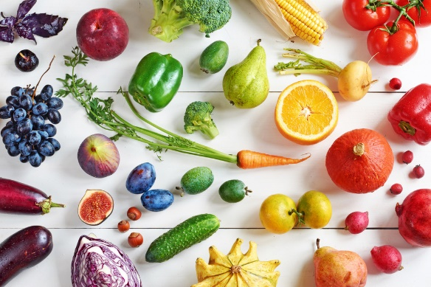
Sample materials
A)

