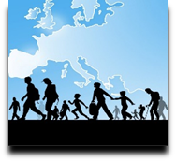 | Language Support for Migrants  A Council of Europe Toolkit

Tool 57 - Scenario: Using apps like Google Maps in the new language
Aim: To practise some relevant key words and expressions related to finding your way,
and to inform migrants about different ways of using apps like Google Maps.
Communicative situations
- Understanding and being able to give simple information.
- Understanding simple instructions.
Materials
- Pictures, icons and logos relating to WIFI and apps.
- Screenshots of apps (e.g. Google Maps).
- Pictures of traffic lights and roundabouts.
- Pictures and a map of the nearest town.
Language activities
Activity 1
Use the pictures of icons etc. to ask learners some questions such as:
- You can use your mobile phone to make a call. What else can you use your phone for?
- Which apps do you find useful? Why? How do you use them?
- Is there WIFI access here?
Activity 2
Show learners, or get one of them to show the group, how to use the language of the host country when showing how to get from one place to another on Google Maps.
- On the enlarged screenshot or PC screen get them to show where to put the place of departure, the destination, the type of transport (car, public transport, on foot, etc.).
- Then ask learners to write on a printed copy of the screenshot the information needed to display the route to a place they choose, e.g. the train station, the nearest hospital, the main square of the nearest town etc.
- Ask them to type this kind of information into their mobile phones to show how to get to places they know in the town or in the new country.

Activity 3
Play an audio clip from Google Maps giving details of the route, e.g. After 150 metres turn left and go straight on for 500 metres until you get to the traffic light.
Then check learners’ understanding by asking them to describe the route using pictures, asking about the meaning of the colours of the traffic light, etc.
Activity 4
Learners work in pairs to exchange information:
A chooses a destination where he/she would like to go, and B finds the way using Google Maps in the new language and explains it, mentioning the time needed to reach the destination. Then learners reverse roles and do the activity again.
Activity 5
Use the pictures and a printed map of the nearest town.
- Ask learners to find a good route using Google Maps and to draw it on the map.
- Then ask them to identify places along the route using the pictures (e.g. the station, the main square, monuments, post office etc.).
- Ask the learners to work together to put the pictures in the right places on the map.
- Finally, ask them to describe one or more pictures they put in the map in simple language.

Sample materials
- Pictures, icons and logos relating to WIFI and apps.
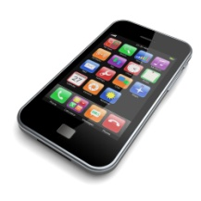 |  | 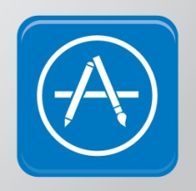

B) Screenshot of a map app (e.g. Google Maps) C) traffic and pedestrian lights D) Roundabout
