 | Language Support for Migrants  A Council of Europe Toolkit | 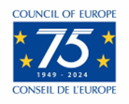

Tool 50 - Plurilingual portraits: a reflective task for migrants
Aim: To encourage migrants to reflect on the languages they know, how they use them, and what they mean to them.
The concept “language repertoire” refers to the fact that all individuals are potentially or actually plurilingual, capable of communicating in more than one language. A language portrait is one way of making a person’s language repertoire visible and reinforcing the importance of first languages and the value for adults and children in being plurilingual.

The woman who created the example below has used the colours red, orange, purple and blue to show the languages she is able to use.
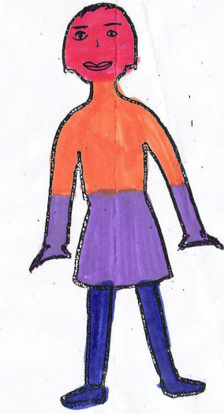 | red = Panjabi
 | orange = German
 | purple = English
 | blue = Hindi

This activity has often been used with migrants. It has proved to be a good way of helping them to become aware of the “linguistic capital” they already possess, which enhances their self-esteem, especially in circumstances where they may be defined by the languages they don’t know rather than the languages they know. In the case of parents who are language learners, this activity also provides a good opportunity to stress the importance continuing to use their home languages with their children and the many benefits this will bring for the children.

Awareness-raising activity for migrants
Show your learners the example on the previous page and get them to draw a blank figure and create their own language self-portrait.
- Explain to them that this is a spontaneous, intuitive activity; the time for reflection is after they have created their language self-portrait.
- Encourage them to include all linguistic varieties: dialects are as important as standard languages.
- Explain that competence levels are not important. If they know just one word in a language it is worth making it visible.
- Invite them to assign to each language a colour, a space (more or less large) and a location within the outline of the body.
- If they prefer, allow them to write the names of their languages on the figure instead of colouring it in or to use a tablet or a computer to draw the figure and colour it.
When they have completed their language portraits:
- Invite them to present and describe their own self-portrait by explaining why they assigned a colour, a space and a location to each language
- Get them to form pairs and discuss the following questions with their partner:
  - In which contexts do they use their different languages (in the family, with friends, at school, at work, in playing sport etc.)?
  - Are there situations where they mix languages when they communicate with other people?
- Ask them to share the following with the whole group:
  - What they can say in the different languages, e.g. the names of fruit and vegetables, numbers from one to ten, please, thank you etc.
  - Any special words or songs or rhymes in one or more of these different languages.
Conclude the activity by making it clear that within and outside the learning environment, you welcome any and all of the languages in all their plurilingual portraits.

