Language Support for Migrants
A Council of Europe Toolkit

Tool 42 - Finding out about migrants’ literacy and
language profile in the target language (written skills)
Aim: To offer guidance on how to gather information about the literacy profile in a language the learners know (Part 1) and their written skills in the target language (Part 2).
More specific aims are:
- Part 1: to enable evidence to be collected about the learners’ literacy profile in any language they know.
- Part 2: to provide tasks to help in assessing reading and writing skills in the target language.

First part

Format
The first part has 2 tasks addressing the learners’ ability to read (Task 1) and to write (Task 2) in a language they know.

Some guidelines
When using the first part of this tool:
- give the task instructions orally in a language that the learner knows which is different from the target language. Any shared oral language can be used, and a mediator may be needed if necessary/available, for example for scripts and words that are not familiar to you.
- prepare a kit in advance with the materials needed for the tasks, as described below.

Task 1 – Reading in a language that the learner knows
(Your turns in italic) Can you read this?
Showing a couple of simple and familiar words in the learner’s first or second language.
Materials to be prepared in advance: a sheet with two words written in a language and script which the learner knows and which is different from the target language.

Task 2 – Writing in a language that the learner knows: here the purpose is to find out whether the learner can hold a pen/pencil, write in a straight line, maintain pressure on the pen/pencil, how long it takes them to write words etc. You do not need to know the language chosen.
Offer the learner a pen and a blank sheet of lined paper. Can you write [dictate a word]?
Use the information collected during the interview e.g., if the learner lives in the host country with their children, they can write the names of the children; if he or she expressed an interest in cooking, they can write the names of their favourite dishes; if the learner is a music lover, he or she can write the name of their favourite song or music genre, etc.
Materials to be prepared in advance: a pen and a blank sheet (lined paper).

Outcomes
There are 2 possible outcomes as a result of this first part:
- The learner doesn’t demonstrate any ability to read and/or write in any language. In this case the use of this tool stops here: the learner is not literate in any language.
- The learner demonstrates some ability to read and/or write in at least one language. In this case, you can go on with the second part.

Second part

Format
The second part has 4 components which gradually increase in difficulty depending on, for example, vocabulary, length, task type and layout. It will take a maximum of about 1 hour. Depending on how the learner deals with each component, there are two options:
- to stop if the learner is not able to complete the tasks, or
- to continue with the next component.
Each component has 3 tasks, always in the same order: reading, written production and written interaction, which is an integrated task because it involves both reading and writing.

Some guidelines
When using the second part of the tool:
- reassure the learners by giving instructions such as "This isn’t a test: you don't have to finish every task; please stop if the task becomes too difficult for you".
- before and after each task explain to the learners that their work will help you to organise the language support and do a better job
- where necessary, reinforce task instructions by using both the target language and gestures
- where needed, other different languages can be used orally to provide a summary of the instructions
- ensure written samples are graphically clear: see the given examples, where the font is clear and readable and there is generous line spacing
- If your learners are doing these tasks at the same time in a group, you can show that you are interested in their work and appreciate their efforts.
- when they finish, collect their papers and thank them for their work.

First component
Look at the picture and underline:
- the number you see
- street
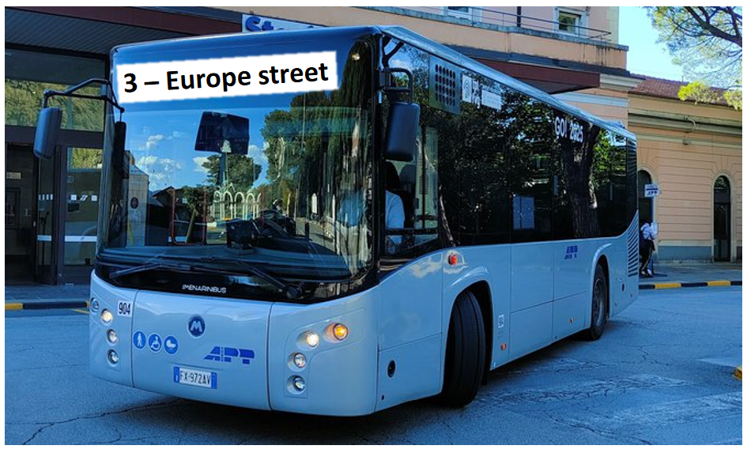

Copy the 3 words. See the example.
 | house | house
 | child | ___________________
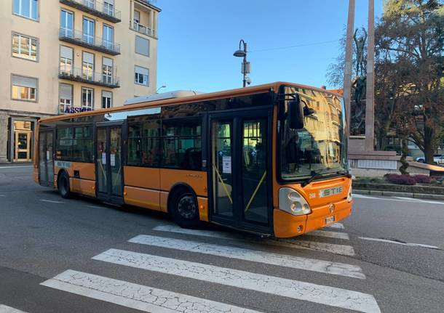 | bus | ___________________
 | dog | ___________________

Copy your name from a document you have.

Name …………………………………………………………………………………………

Second component
Read the sentence and draw a line to the right picture. See the example.
Today there is a special price for fresh fruit.

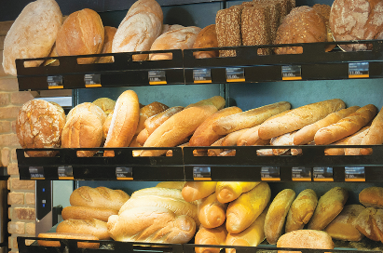

In the pharmacy you can pay with your card.

The train is in the station.

Here you can find many types of bread.

Write what you see in the picture. See the example.
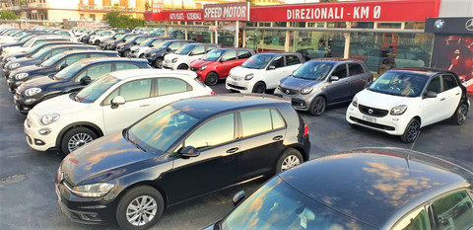 | cars  ___________________________
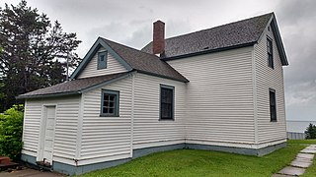 | (Expected outcome: house / home)  ____________________________
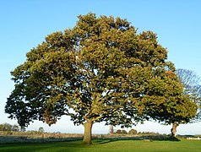 | (Expected outcome: tree / forest /nature, sky blue)  _____________________________
(Expected outcome: children /kids /football /play grass/ball)
_____________________________
Read the form and fill it out.
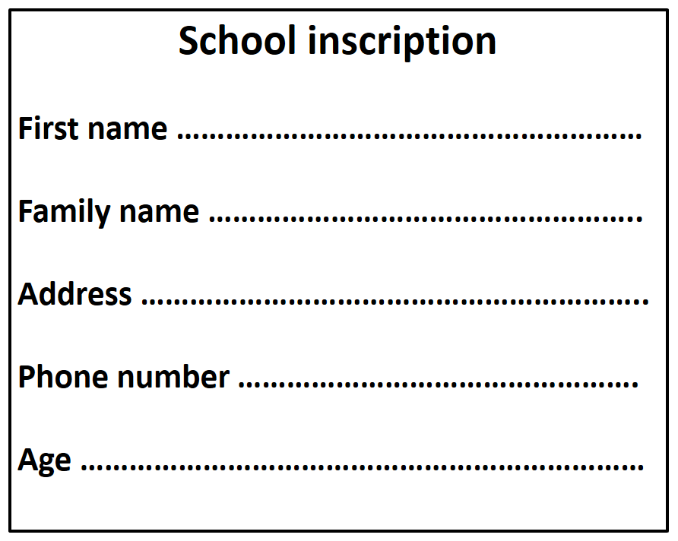

Third component

Read the texts and draw a line to the right picture. See the example.
Ana often works late at night. She works as a cook at a restaurant.

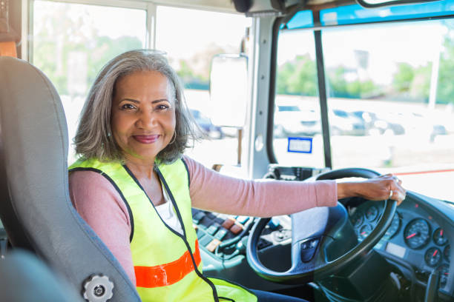

Lemlem enjoys working with children. She works as a teacher in primary school.

Jessica helps old people. She works as a nurse.

Eva likes driving. She works as a bus driver.

Write two or three sentences about yourself. Start like this: “My name is …”
________________________________________________________________________________________________________________________________________________________________________________________________________________________________________________________________________________________________________________________________________

Answer the message below from your friend.

Start like this: “Hi…”
__________________________________________________________________________________________________________________________________________________________________________________________________________________________________________________________________________________________________________________________________________________________________________________

Fourth component
Read the text and answer the questions below. See the example.

Trains to Rome leave every day from Florence’s central station. Tickets cost 28 euros. You can buy tickets at the ticket office at the central station. The ticket office is in front of the bar and has a red door.
 |  | Yes | No
1. | Do the trains leave from Florence? | X
2. | Is the price of the train tickets 28 euros?
3. | Is the ticket office behind the bar?
4. | Is the door of the ticket office red?

Describe this room: the room where you are now.
Start like this: “In this room I see …”
__________________________________________________________________________________________________________________________________________________________________________________________________________________________________________________________________________________________________________________________________________________________________________________________________________________________

Read the email from Lina.
Reply to Lina. Write a short e-mail. In the e-mail you should:
- thank her for the invitation
- tell her you may be late
- ask a question.

Start like this: “Hi Lina, …”
____________________________________________________________________________________________________________________________________________________________________________________________________________________________________________________________________________________________________________________________________________________________________________________________________________________________________________________________________________________________________________

This tool is based on materials developed by ALTE-LAMI.
Depending on the educational context and the language, the wording of the instruction could be adjusted, e.g. it may be more appropriate to replace “underline” with “mark” or “circle”.
Depending on the language and the context, it may be more appropriate, for example to replace the word “street” with the word “avenue”.
In translating this task into different languages, select short, familiar words with a simple syllabic structure.
You may wish to clarify the prompt by writing their name on the blackboard or on paper while pretending to copy it from a personal document (e.g. ID card) they have. Then invite learners to to take a document they have with their name on it, written in the target language. Once they have such document in front of them, they can copy their name as indicated in the task instruction.
In selecting the pictures, choose ones that will elicit short words with simple, highly frequent syllabic structure which learners already know and have practised.
Any appropriate word related to the field is acceptable (it may depend on where and with whom the person learned the target language).

