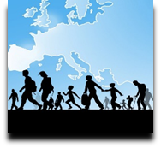 | Language Support for Migrants  A Council of Europe Toolkit | 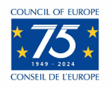

Tool 34 - Ideas for supporting migrants’ learning of basic vocabulary for
everyday life

Aim: To provide resources for activities to teach everyday vocabulary.
Using images to support basic vocabulary learning
Pictures, as well as real-life objects (realia), are excellent resources for elementary level language learning. Both for children and for older learners. When you have a good bank of pictures you can use them for a range of different but basic activities. Pictures can be used to support many different language-learning activities as well as providing support when there are communication difficulties.
The pictures below provide examples of the type of images that are suitable for elementary language learning. For more information about selecting pictures and realia see Tool 22 – Selecting pictures and realia for language activities: some guidelines.
Some suggested activities for using pictures
1. Flashcards to learn new words
Make cards with the word on one side and the picture on the other side. Focus on a particular theme related to a scenario. For example, ‘shopping’ or ‘health’. The theme should of course be relevant to the interests and needs of the group.
- Place the cards with the word down and the picture visible.
- Learners must pick a card and say the word in the target language. Then they check on the back to see if they are correct.
- The card is then put to one side.
This activity can be organized as a team-based competition. The team with the most correct answers wins.
Learners could write or copy the words into their vocabulary notebooks, adding a translation in their first language if they wish.
The words could be revisited in a later session to see how many words have been remembered.
2. Using flashcards to organize words
Place several cards on a mixture of different subjects with the pictures down and the words visible.
- First the learners sort cards into the different themes/subjects simply by looking at the word and not looking at the picture.
- Then a learners take turns to read a word and say what it is. For example, ‘apples are fruit/food’, ‘shirts are clothes’, etc.
- Then learners look at the back to check the picture. If the answer is not correct, the card is mixed with the other cards again, with the picture down and the word visible. Another learner can try to identify the correct word.
3. Using pictures to create spoken (or written) text
Place the cards on the table with the pictures visible.
Check that everybody knows what the words are and what the pictures relate to. They should belong to the same thematic group.
Learners work together or in small groups to create some sentences based on the pictures. For example, ‘I go to the market and I buy vegetables’. They can say their sentences and one member of the group could write them.
Food
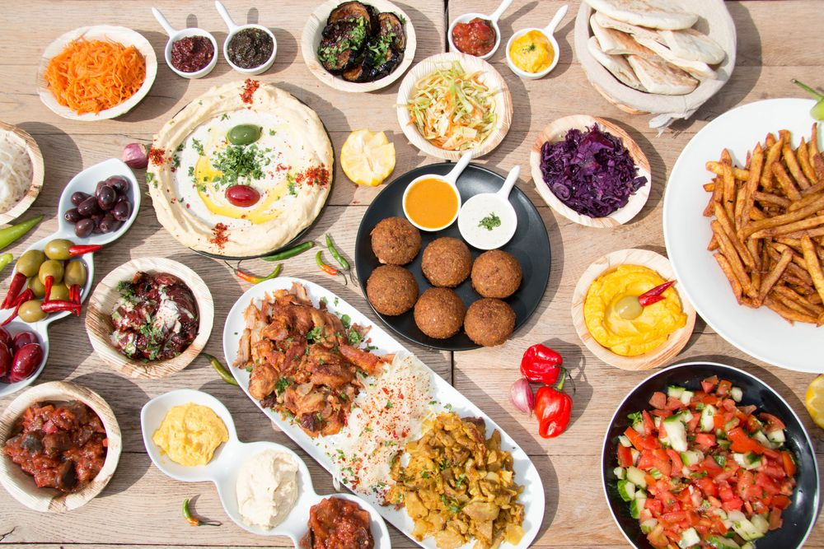 | 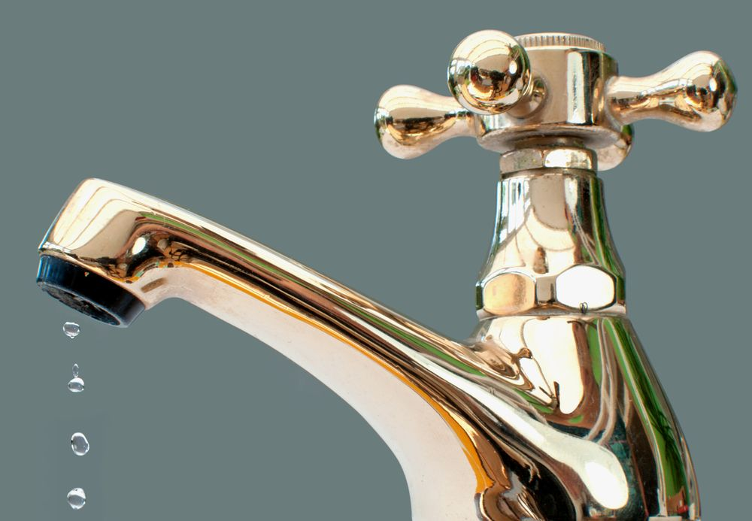
food | water
Expand: milk, coffee, tea, etc.

Health
medicine | injection
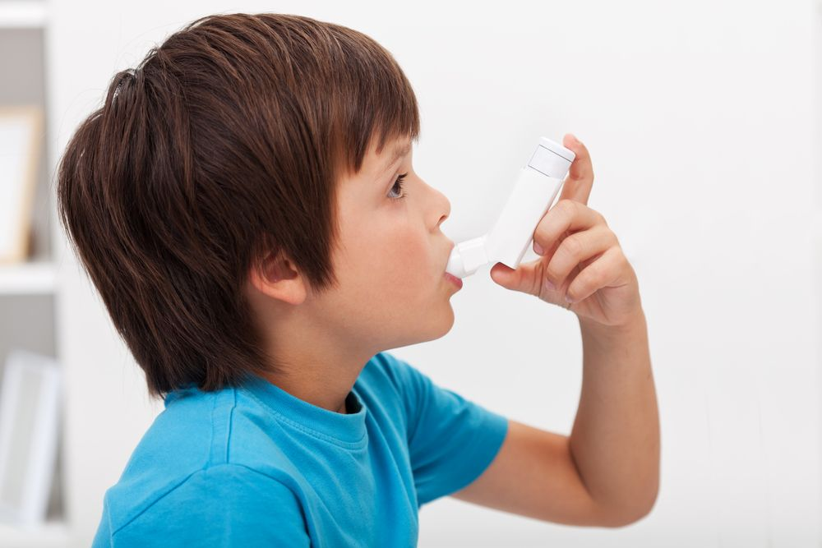
inhaler | doctor
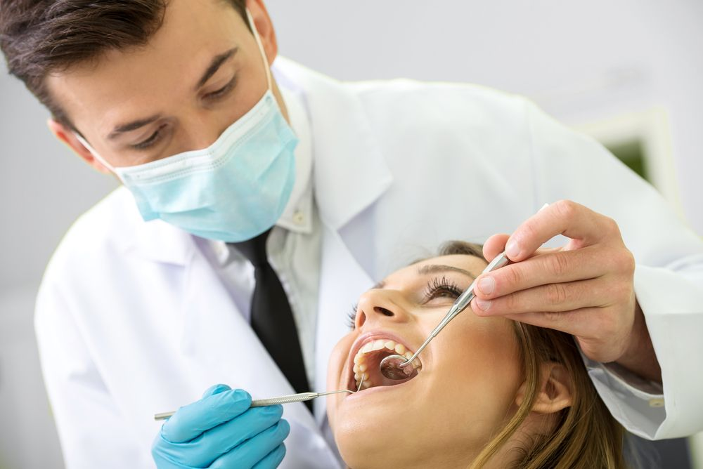 | 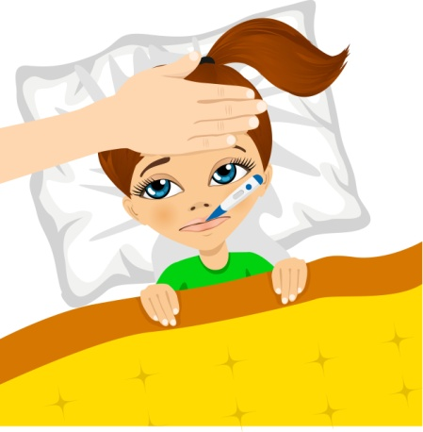
dentist | temperature /fever

Clothes
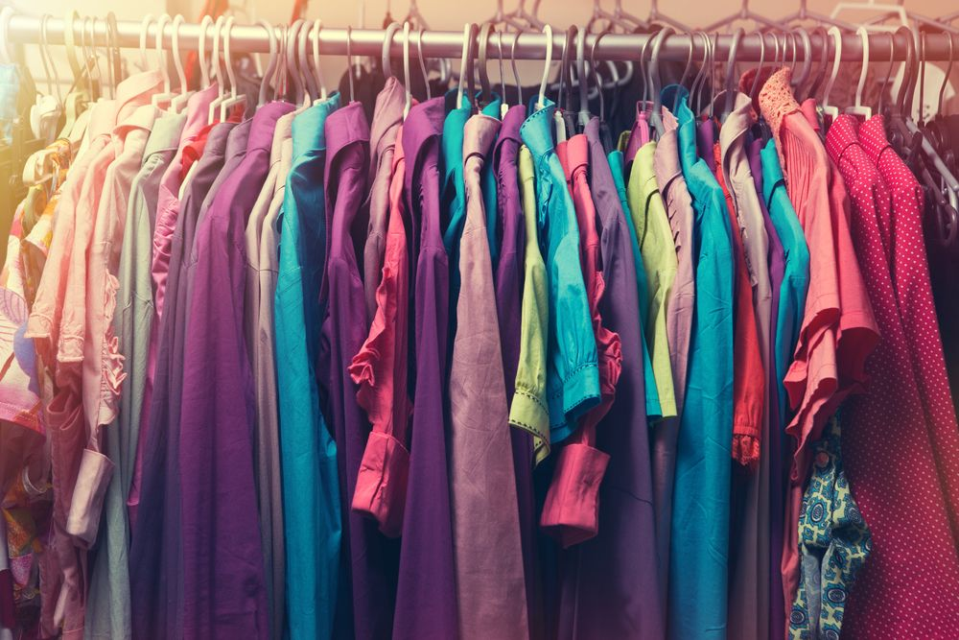 | 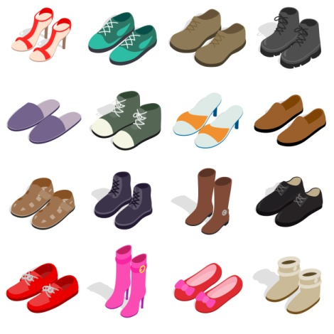
clothes | shoes
Expand: trousers; jumper; skirt; jacket, …

Hygiene
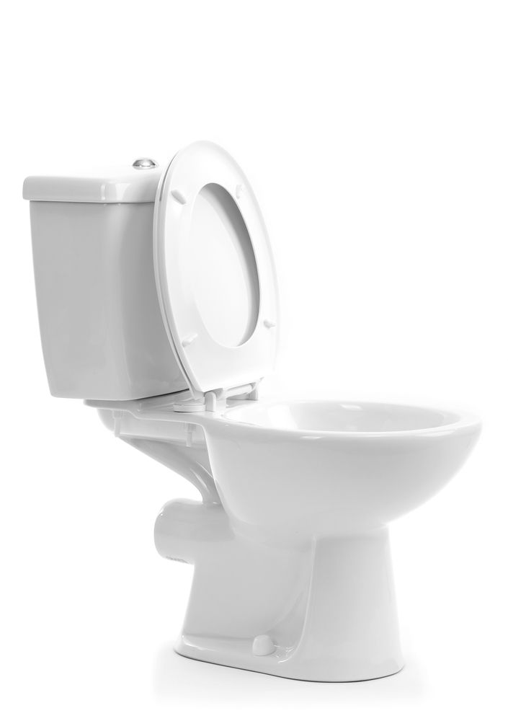
toilet | shower
 | 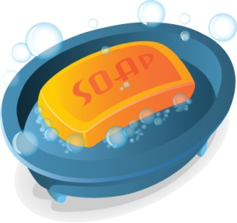
nappy/diaper | soap
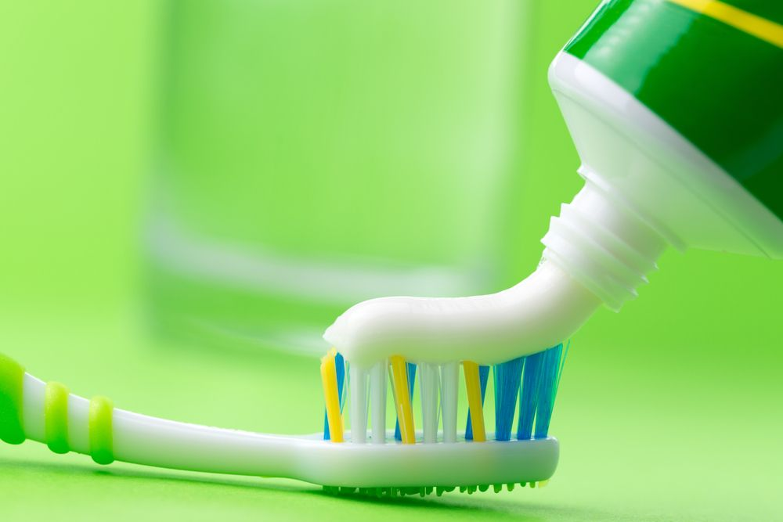
toothbrush /toothpaste

Telephone
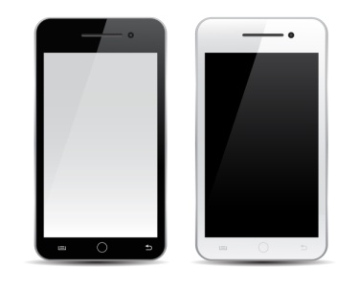
mobile phone | internet
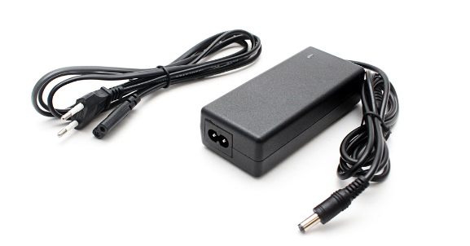
charger | WiFi

Furniture / Home
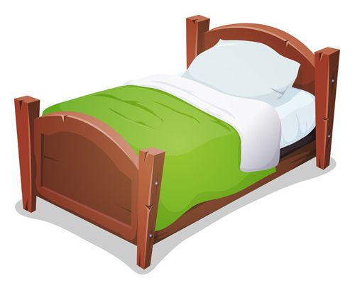 | 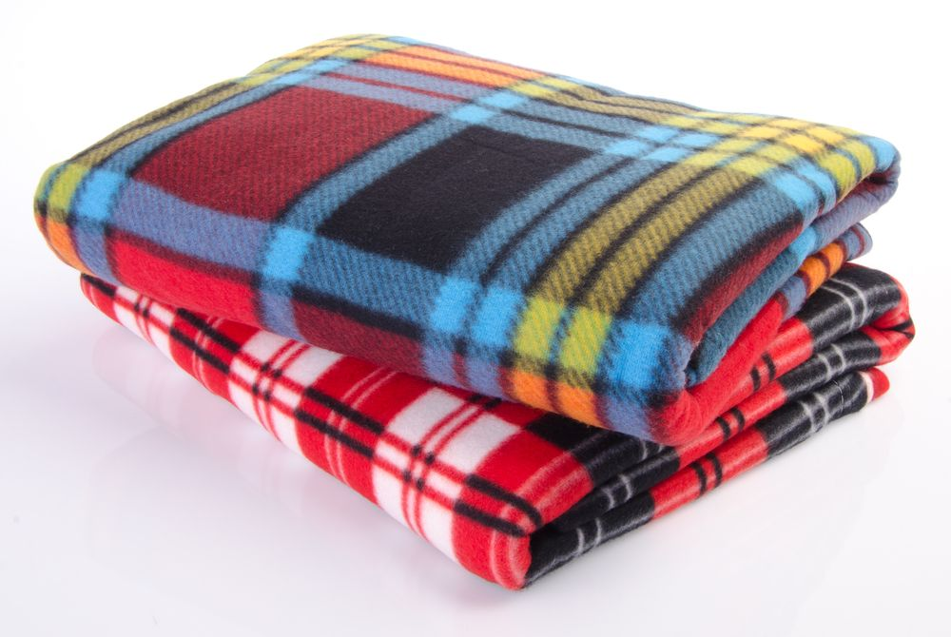
bed | blanket
pillow

Family
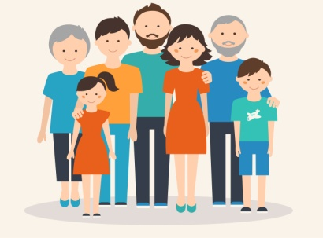 | 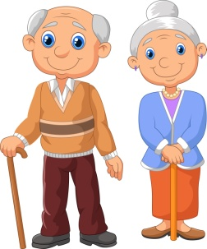
family | grandfather / grandmother
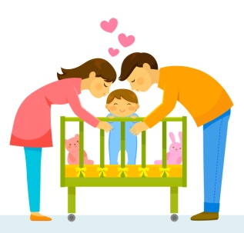 | 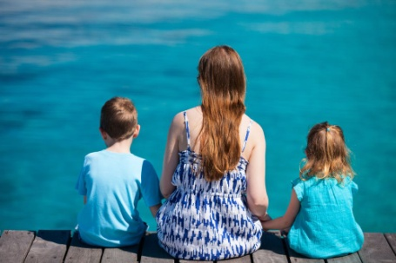
father / mother | son / daughter
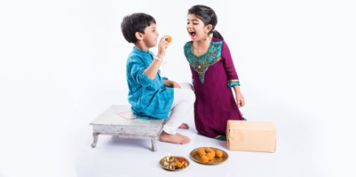
brother / sister | baby

Other important words
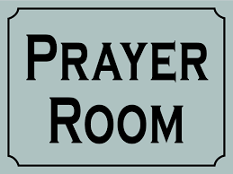
prayer room | documents
interpreter | legal advice
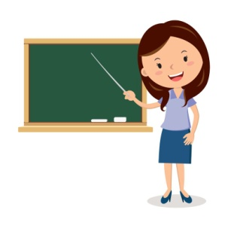 | 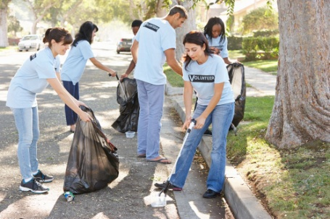
teacher | volunteer

