26 - First steps in the host country language
Aim: To help volunteers who are beginning language support activities to gather information beforehand about refugees’ proficiency in the host country language and their level of literacy.
Using this tool will help you to define a linguistic and literacy profile for each refugee and enable you (where possible) to form groups with shared interests and similar linguistic and literacy profiles.
Suggested use:
- Inform refugees about the goal of the activity (“This is not a test. I need this information in order to better organize our language activities”).
- If refugees have difficulty with reading and writing activities, focus on speaking and listening skills, in line with their literacy profile (see Tool 27 Refugees’ linguistic profiles).
- In the activities section of the Toolkit some language activities are identified as being suitable for refugees with low competence in reading and writing, and with whom a sensitive approach is likely to be needed. In this case, it could be useful to take into account some suggestions, as follow:
In reading activities
- Make sure letters of the alphabet are separated
- If printed, use a large font - if possible, 16 or 18 points and a clear font such as Tahoma or Arial
- Try not to include more than 6-10 words on a single page
- Where necessary, guide participants in reading from left to right.
In speaking activities
- Help participants to learn the pronunciation of letters of the alphabet so that they can, for example, spell their own names.
In writing activities
- Offer guidance, where necessary, in the use of writing conventions (from left to right, with lines, separation of words, etc.)
Please, answer these questions
- Can you talk about yourself? Your name, your country, your age, whatever you like
- Can you describe what you did this morning?
Please, read and say the following words
NOW | I | AM | IN | [COUNTRY]

Please, read and copy the following words
THIS
IS
MY
DOCUMENT
(This activity is designed for use with refugees with low levels of literacy)
Please match the words in the box with a picture
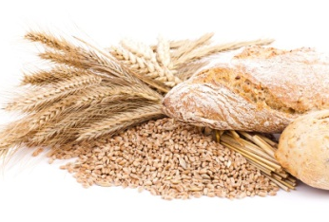  A | I see some fruit in the picture | B
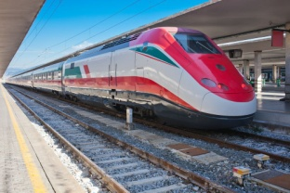  A | The train is in the station | 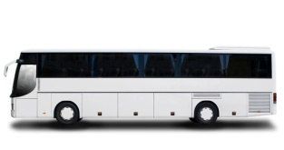  B
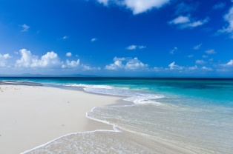  A | This is a picture of the sea | 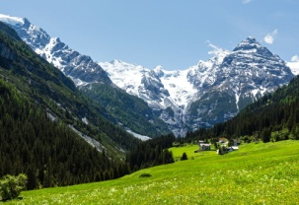  B
Please, read and complete the following
My name is: ____________________________________________________________________________
My family name is: _______________________________________________________________________
I was born in (place of birth): _______________________________________________________________

Please, read the SMS and answer

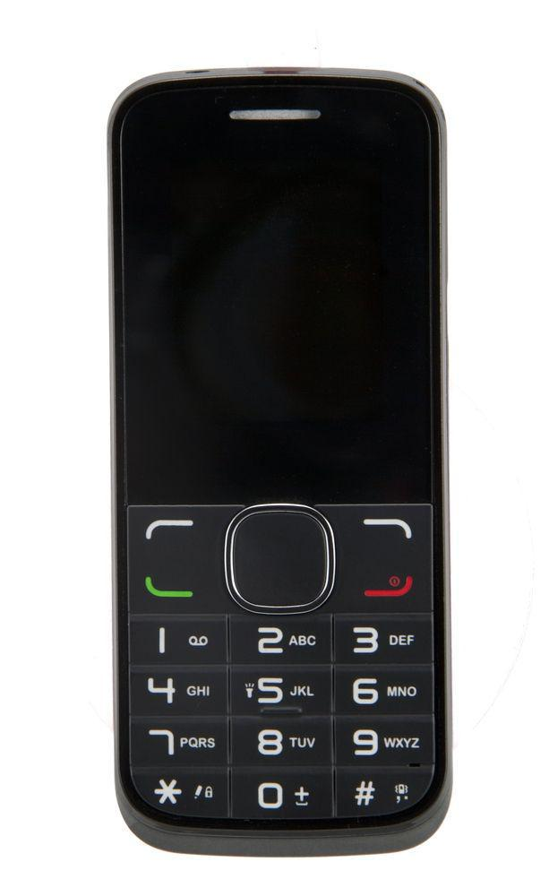
_____________________________________________
What did you do yesterday?
_____________________________________________
_____________________________________________
_____________________________________________
_____________________________________________
_____________________________________________
_____________________________________________
_____________________________________________
_____________________________________________
_____________________________________________
_____________________________________________
_____________________________________________
_____________________________________________
_____________________________________________
_____________________________________________
_____________________________________________
_____________________________________________
_____________________________________________

