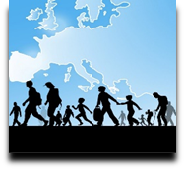 | Language Support for Migrants  A Council of Europe Toolkit | 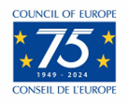

Tool 13 – Kurdish : some information

Aim: To provide a brief overview of a language spoken by a large number of migrants.

Having an insight into how the Kurdish language works may be helpful in understanding the challenges speakers of this language face when learning a new one and, on the other hand, what aspects may be relatively easy for them. Also, migrant learners may appreciate it if you ask them to help you to pronounce the names of persons and places correctly and if you at least try to use some words or phrases of their language (see "Language of Origin" for more background).
Where Kurdish is spoken
Linguists disagree about whether Kurdish is a language with many dialects, or whether there are several closely related languages. Kurdish-speaking areas extend over territories in Turkey, Iraq, Syria and Iran. The number of speakers of Kurdish dialects is estimated at 20 to 30 million.
Both Arabic and Kurdish are official languages in Iraq. In the autonomous region of Kurdistan (Iraq) Kurdish is used in everyday life as well as by the authorities and in education. Outside Iraq Kurdish is not an official language in any state.
Kurdish dialects
In Turkey and in Syria the Kurmancî dialect is dominant. In Turkey the Zazakî dialect, which is also called Dimilkî, Kirdkî or Kîrmancik, is also spoken.
The two main dialects of Kurdish in the autonomous region of Kurdistan (Iraq) are Soranî and Badhînî, the Iraqi variety of Kurmancî. Further south the Gûranî (Goranî) dialects, for example, Hawramî and Schabakî, are spoken in an area north-east of Mosul. Various other dialects are also used in the different regions.
Media and literature
The earliest examples of Kurdish literature dating from the 16th and 17th centuries, are the chants of the religious minorities Ezidi (Yezidi) and Yarsanism.
Apart from Kurmancî, Gûranî/ Hawramî was the most important literary language. Other Kurdish dialects were only used for written literature from the 19th century onwards.
In the 20th century a generation of young Kurds has rediscovered Kurdish as a literary language. More literary works than ever before have been published in Sorani and Kurmancî.
Some phrases in Kurdish
 | Soranî | Zazakî | Kurmancî
Hello! | 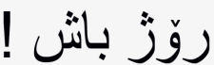  Roj baș! | Roza to xêr bo! | Roș baș!
How are you? | 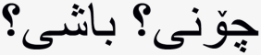  Çonî? Bașî? | Ti se kenî? | Tu çawa yî, baș î?
Welcome! | 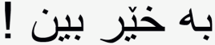  Bexêr bên! | Xêr ama! | Tu bi xêr hatî!
Goodbye! | 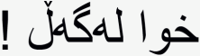  Xwa legeḻ! | Xatir bi to! | Bi xatirê te!

The Kurdish script
There are not only various Kurdish dialects but also different writing systems. The use of the Berdixan alphabet is widespread for Syrian and Turkish Kurmancî and is based on the Latin alphabet. The Soranî alphabet is used not only for Soranî but also for Bahdîni (or Bahdînanî). It is based on the Arabic script and has been extended to include other letters. Although only a small part of Kurdistan was part of the former Soviet Union, the Cyrillic alphabet was also used at that time.
For the Zazakî dialect, the Berdixan alphabet is used in addition to the Zazakî alphabet, which is influenced by the Turkish language. Yekgirtú was an attempt to create a unified writing system for all Kurdish dialects.
Kurdish Numbers
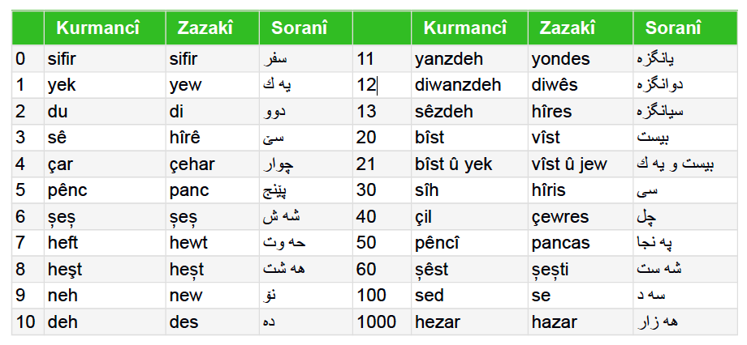
Source: Sprachensteckbrief Kurdisch, Schule Mehrsprachig, Eine Information des Bundesministeriums für Unterricht, Kunst und Kultur – © Thomas Schmidinger (translated in English and adapted).

