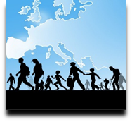 | Language Support for Migrants  A Council of Europe Toolkit | 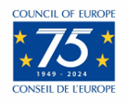

Tool 12 - Arabic : some information

Aim: To provide a brief overview of a language spoken by a large number of migrants.

Having an insight into how the Arabic language works may be helpful in understanding the challenges speakers of this language face when learning a new one and, on the other hand, what aspects might be relatively easy for them. Also, migrants may be pleased if you ask them to help you to pronounce the names of persons and places correctly and if you at least try to use some words or phrases of their language (see "Language of Origin" for some background on migrants’ languages).
Where the language is spoken
Standard Arabic is the official language of 25 countries in the Middle East and North Africa and is one of six official languages of the United Nations. In Arabic-speaking countries different dialects are spoken, and there are several regional variants, for example daridscha maghribijja (colloquial Moroccan), and ammijja misrijja (colloquial Egyptian).
About 280 million people speak Arabic as their first language. Geographically, the Arabic language extends from North and Sub-Saharan Africa, including Libya and Tunisia, to the Middle East, including Iraq, Syria and Yemen. Furthermore, there are many Arabic language communities and Arabic-speaking minorities outside this region.
Art, media and literature
Of particular importance is the fact that classical Arabic is the language of the Koran, the holy book of Islam. This classical Arabic is still considered as the standard for written Arabic, but spoken Arabic often differs from it since the spoken language is constantly changing.
There is an enormous variety of poetry and prose in Arabic, but there are rather few translations, which are not representative of the diversity of Arabic literature. Very well-known (in Europe) Arab writers and poets include the Nobel laureate Nagib Mahfuz (1911–2006) and the author Khalil Gibran (1883–1931).

Borrowings from Arabic
Common words in English (and other languages) that originate from Arabic include:
- algebra (al-jabr).
- cotton (koton).
- sugar (succar).
- guitar (qithara).
- lemon (laymoon).
- alcohol (al-kuħuul).
European numerals are also derived from Arabic.

Some features of Arabic script
The Arabic script is cursive, and is written and read from right to left. The Arabic alphabet has 28 characters and essentially only consonants are written, unlike languages with Latin characters, in which vowels are written too. These features and the positioning of characters may make it difficult for Arabic users to master the left right direction and alignment of the scripts of most European languages.

The Arabic alphabet

Numbers
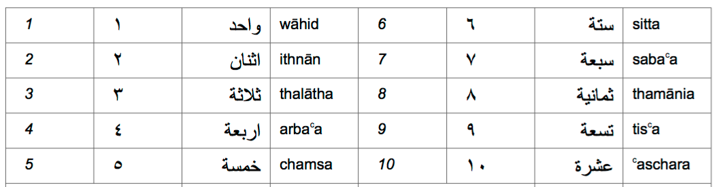
Some phrases
Hello (first meeting) | السلام عليكم | assalamu a’alaikum (peace be upon you)
Goodbye | مع السلامة | maʕ as-salaama! (Say goodbye to a person)
Goodbye! | الله يسلمك، الله يسلمكم | allaah jusallimuka (m.)! allaah jusallimuki (f.)! allaah jusallimkum (pl.)! (As an answer)
How are you? | كيف الحال؟ | kayf il-ħaal?
Yes | نعم | naʕm
No | لا | la
Please | من فضلك، من فضلكم | min fadʕlika (m.), min fadʕliki (f.), min fadʕlikum (pl.)
Thank you | شكرا | šukran
You are welcome | عفوا | ʕafwan
I am sorry! | أنا آسف | ana asif

Source: Sprachensteckbrief Arabisch, Schule Mehrsprachig, Eine Information des Bundesministeriums für Unterricht, Kunst und Kultur – © Dina el Zarka (translated in English and adapted). www.worldatlas.com/articles/arabic-speaking-countries.html

