

Appendix I

TECHNICAL SPECIFICATIONS

Development of a web-based software solution for managing free legal aid cases

Authors:
Nikola Cacanoski, IT consultant for the Council of Europe
Zoran Velichkov, IT consultant for the Council of Europe

Skopje, January 2026

Contents
1. Introduction 3
2. Goals 3
3. Legal regulations 3
4. General technical requirements 4
5. General principles for the functioning of the Solution 7
5.1. Administrative and organizational structure 8
5.2. Types of data that the system needs to process 8
6. Functions covered by the Solution 9
6.1. PRIMARY LEGAL AID (PLA) 9
6.1.1. Submitting data for an SLA request to a RU 13
6.1.2. Supervision of the primary legal aid provided 13
6.1.3. Expenses – payment of compensation 14
6.1.4. Work of the RU with subjects for PLA and SLA 15
6.2. SECONDARY LEGAL AID 15
6.2.1. Data collection 17
6.2.2. SLA approval 18
6.2.3. SLA rejection 18
6.2.4. Approved SLA 19
6.2.5. Deciding by cost estimate 20
6.2.6. Administrative dispute 21
7. Other functional system requirements 22
7.1. User authentication and authorization 22
8. Templates and forms 24
9. SEARCHES AND SUBJECT SELECTION 28
10. REPORTS AND STATISTICS 29
11. DATA REGISTERS 30
12. REGISTRATIONS 36
13. DATA MIGRATION 36
14. OBLIGATION OF THE BIDDER 37
15. IMPLEMENTATION 38
16. INSTALLATION, TESTING AND VALIDATION OF THE SOLUTION 38
17. TRAINING OF ADMINISTRATORS AND END USERS 39
18. Handover of the software 39
19. WARRANTY PERIOD AND MAINTENANCE OF THE SOLUTION 39
20. SOURCE CODE 39
21. Abbreviations 40
22. Hardware 40

Introduction
The Ministry of Justice has a need for the procurement, development of a web-based software solution – (hereinafter referred to as the Solution) for managing free legal aid (FLA) cases from start (receipt of the request) to finish (case closure). The procurement includes analysis, design, development, implementation, training, included support and maintenance of the entire case management solution for the duration of the contract.
The technical specification was prepared with the support of the Action “Towards a Consolidated and More Efficient Free Legal Aid (FLA) System in North Macedonia” which is implemented within the joint programme of the European Union and the Council of Europe “Horizontal Facility for the Western Balkans and Türkiye”.
The solution should follow modern trends (adaptable for mobile devices, tablets, etc.), both aesthetically and functionally, with improved intuitiveness of the user interface.
The solution should enable rational management and easy administration of cases, receipt and registration of requests, recording, storage of documents collected from other institutions, workflow and reminders, time recording, preparation of documents (decisions, complaints), document management, and reports, granting legal remedies, data analysis, cost control and preparation of invoices, and decision-making.
The procurement envisages more efficient implementation of the Law on Free Legal Aid (LFLA), insight into the number and type of applicants, the work of each regional department, and the employees of the ministry will have secure access to information related to applicants and cases, which allows for effective monitoring of the status of the case and the position of the case in the system, helps in the detection of accumulated unresolved cases, produces statistical data on the volume of work and management reports and supervises the procedures in the cases. All this contributes to monitoring efficiency. It can also reveal "bottlenecks" in the procedures, as well as delays, and this information can be used to adjust resources and processes. It helps in the location and preservation of case files.

Goals
The software solution should achieve the following goals for the Ministry of Justice:
- Data storage – a central database where all cases related to legal aid requests are stored.
- Document preparation – to have quick and easy document preparation available.
- Document Management – Central document archive with search function.
- Task Management – A complete calendar linked to all course activities, with automatic reminders to ensure important events are not forgotten.
- Monitoring – Monitoring of all cases managed by the Ministry of Justice.

Legal regulations
The solution should provide the possibility of performing all functions provided for by the applicable legal regulations, which define the conditions in the domain of free legal aid, such as the following acts that are an integral part of the technical specifications and tender documentation:
- Law on Free Legal Aid and
- Regulations
- Instructions
The law, bylaws and forms are available on the website of the Ministry of Justice, https://www.pravda.gov.mk/mk-MK/resursi/besplatna-pravna-pomos/besplatna-pravna-pomos-resursi .

General technical requirements
Considering the technical equipment, the available licenses of the Purchaser and the cost effectiveness and principle of economy, the web-based software solution should have and satisfy the following general requirements and characteristics:
# | Description of requirements
1 | WEB-based software solution for an unlimited number of users (limited only by the system platform)
2 | The system should implement an authentication system based on the interoperability platform.  Note: Communication with the Ministry of Digital Transformation and agreement on procedures for using the services of the interoperability platform will be ensured through the mediation of the Ministry of Justice.
3 | The system should implement an authorization system (assigning privileges for individual system functions) with support for individual privileges, as well as defining groups of users with shared privileges.  The system has to incorporate security by design principles, ensuring confidentiality, integrity and availability are embedded throughout the system lifecycle
4 | The WEB solution must be compatible with all standard WEB browsers without the need to install additional extensions.
5 | Web solution accessible via computer, laptop and mobile devices with support for responsive design design)
6 | For hosting the WEB solution, an existing server should be used (see Hardware chapter).
7 | The system should have a single relational database: MS SQL Server, MySQL, PostgreSQL etc. In the case of an offer of a commercial database, the bidder must also provide a permanent license for an unlimited number of users.
8 | The solution should enable the possibility of automatic and manual backup and restore of the database. The bidder should provide a clear procedure for backup and restore of the database.
9 | The solution should offer the possibility of future expansion with new modules, functionalities based on other workflows, without disrupting current business processes.
10 | The solution must support an audit trail, recorded in the database and/or a separate file, to track every action in every module and for every user. Each action, activity must be recorded with sufficient data to identify the user, the time, and the action taken.
11 | The solution must provide a WEB interface for analysing and searching audit trails.
12 | Data access restrictions based on defined user permissions and functions by an administrator
13 | Each user must be authorized before accessing the system. Authentication is done at the user level, and also based on the rights of the user group to which the user belongs.  However, the system must implement privacy by design and by default, ensuring that personal data is processed lawfully, minimally and with appropriate safeguards.
14 | The solution must ensure that the session expires. If the user is inactive for a certain period of time, the system logs them out automatically. An administrator should configure this via system settings.
15 | The software vendor must develop the user interface in Macedonian. The solution must provide a simple way to add additional localizations (languages) without the need to upgrade the software.
17 | The solution should enable working with lookup tables (registers) for a high degree of automation and control of entered data, thus reducing the likelihood of error.
18 | The solution must provide a notification module that will automatically generate notifications for all important events in the system. The module should have the ability to assign a specific type of notification to a specific user or group of users. The notification should be visible on the user interface, with the option (configurable by the administrator) the same notification to be send also by email. to.
19 | Ability to print and export (at least in PDF format) all necessary forms and reports according to the format and content of existing documents (templates).
20 | Implementation of standard user-friendly and content-sensitive help (guidelines) interface.
21 | The source code, fully and clearly documented, should be delivered to the client in a version that corresponds to the latest installed and accepted platform. The source code is the property of the client.
22 | Technical support during the contract validity period to remove and correct all errors that arise during operation. New or changed functionalities are not part of the support.
23 | The database architecture should follow the principles of:  - "Data integrity", which refers to the accuracy and consistency of data stored in the database  - "Referential integrity" refers to a relational database, in order to ensure the consistency and accuracy of relationships between tables. It guarantees that the values in a foreign key (Foreign Key) are always valid and are linked to existing records in the primary key (Primary Key) of another table.  - Database normalization is a methodology for logically organizing data in order to reduce redundancy (duplication), prevent anomalies, and ensure data integrity and consistency.
24 | The principle of "soft" deletion should be used, as it marks records as deleted without actually deleting them from the database.
25 | It is mandatory to use the HTTPS protocol, as it protects all communication by using the SSL/TLS protocol to encrypt communications, adding an additional level of security.

General principles for the functioning of the Solution
The web-based case management software solution for processing free legal aid requests should be able to perform the following functions:
- Alignment of the database content and user interface with standard forms used in practice, as well as the ability to upload documents in electronic form at each stage.
- Establishing control over case records. The solution sets a framework for controlling the records of each case, whereby, in addition to the system identifiers, it should provide possibility for the assignment of additional identifiers for the case. This include, but not limited to, the archive numbers and dates within the specific institution. These identifears must also be the basis for searching and identification of the specific cases.
- Case Work Management and Record Updates The solution maintains and continuously updates case records and events so that case status and progress can be tracked and delays noted.
- The solution should have the ability to define the timeframe for each specific process in the procedure, with the ability to notify the responsible persons about it. These timeframes should be optional and system administrator should have ability to add or remove them for each specific state of the case.
- Controlling and maintaining final records. The solution should provide the ability to define a time frame for access to the cases. After the time frame expires, the data should remain in the database, but not be visible to users. Only system administrators can access them. This ensures that the case is archived as closed.
- Reports with management information. The solution should provide statistics and other reports on the nature and number/percentage of resolved cases, the volume of unresolved cases, identification of cases that are long in the system, as well as delays from registration to resolution. Reports should be generated upon user request, as well as presented on dedicated dashboards. These reports, in addition to the level of the entire system, should also be provided at the level of each regional department and other stakeholders in the system. This functionality will provide the Ministry of Justice with the necessary data for appropriate budgeting and staffing of the regional departments. The software should be able to provide data on the following indicators, but not limited to, at any time:
  - Number of people who requested and received primary legal aid (with data on: regional department, municipality, gender, nationality, age, type of legal aid provided legal question for which the Legal aid is provided);
  - Number of submitted requests for secondary legal aid (with data on: regional department, municipality, gender, nationality, age, type of legal aid provided, type of case, result of the request, length of the procedure, status);
- Electronic document creation and management. This function provides creation of standardized and automated forms (e.g. for decisions, reminders, letters, etc.), which improves the efficiency and accuracy of regional departments and the Ministry of Justice. Documents are generated exclusively from data already entered in the database, without the ability to change the content in the generated PDF document. Generated documents can be printed, but are not stored with the database, since all their content is already in the database. Option for attaching scanned documents should also be provided. Each uploaded document should be possible to download or print, based on the logged user access privileges.
- Electronic access to data of од other public institutions – The solution should enable automatic connection with relevant institutions (Real Estate Cadastre Agency, Public Revenue Office and Ministry of Interior – vehicle data, social work centres and others). This process should be established through the interoperability platform of the Ministry of Digital Transformation, according to the documentation available at the following link: https://servicecatalog.interop.gov.mk/Node/DocumentationPage#/documentationPage

Administrative and organizational structure
The central database and software solutions will be managed by the Ministry of Justice. Employees of the Ministry of Justice and its regional departments, depending on their job position and authorizations, should have specific permissions and be able to enter data into the system upon receiving the client and during the case. There should be two levels of access to the system. The Legal Aid Department of the Ministry of Justice should have access to the progress of the work and all pending and closed cases, as well as access to statistical information. The level of access for other employees will be determined by the Minister, who will also authorize some employees to have access to enter data into the system.

Types of data that the system needs to process
The data that the case management system needs to process is grouped into six (6) main data groups, depending on the type of data. The table below provides a general overview of the data.
1 | Person
 | Information about the applicant – name, address, ID number, sex, ethnicity, marital and family status, income and assets
2 | Subject
Case type: (e.g. labor dispute, domestic violence, etc.)
Facts about the case: A brief description of the facts about the case
3 | Event
Information about past and future events in the procedure.
- submissions
- decisions
- activities after the decision
4 | Generating documents and reports
Information about official documents from the Ministry of Justice.
- forms, decisions and other documents issued by the Ministry of Justice
- reports and statistics
5 | Financial
 | Financial data for course activities – detailed overview of costs for each course
6 | System and service
Information about functions that are additional to the object processing functions:
- Materials
- file management
- document management

Functions covered by the Solution
The solution is intended to manage cases in the area of providing:
- Primary legal aid (PLA);
- Secondary legal aid (SLA);

PRIMARY LEGAL AID (PLA)
In accordance with the legal regulations and established practice, the procedure for providing PLA is shown in the following UML diagram, which clearly delimits the functions of all stakeholders in the process:
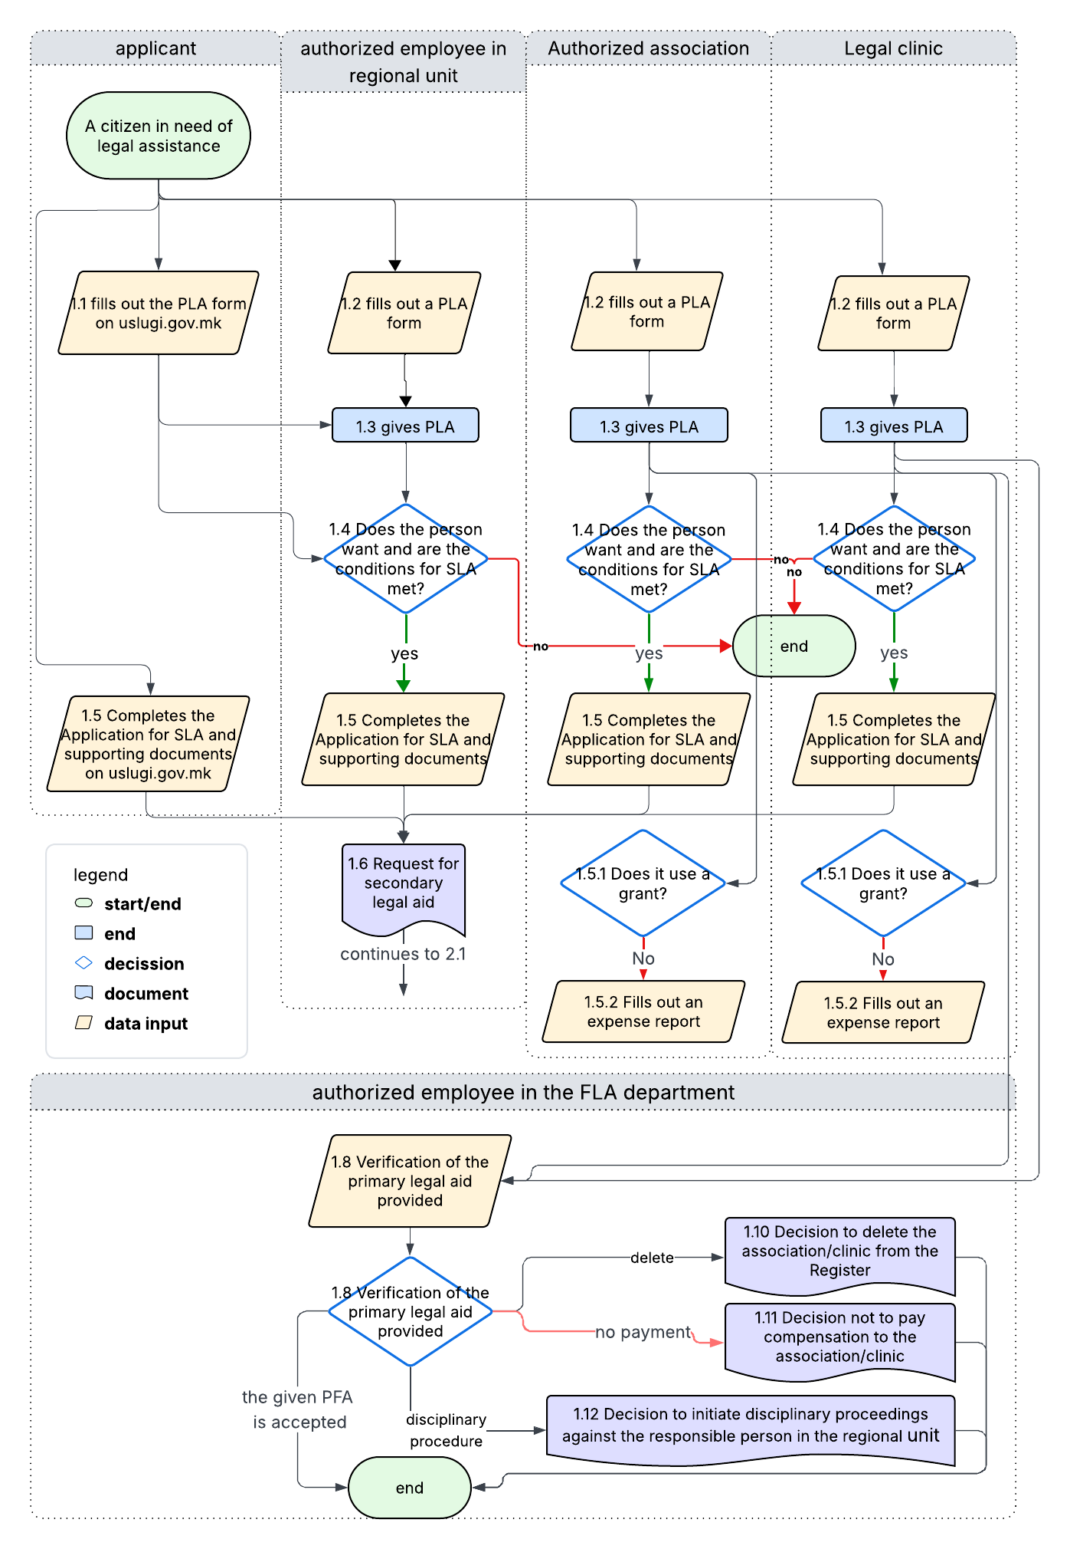
Primary legal aid providers are the Ministry of Justice with its regional departments, associations and legal clinics. A register for a given PLA is kept for the current year and contains basic data on the given PLA. The bidder should create a module that will enable keeping records of a given PLA by PLA providers for each interested person, with the following functionalities: entering, updating, deleting data and searching by various criteria.
Every request for PLA and SLA submitted through uslugi.gov.mk will reach the Ministry of Justice and from there it should be manually assigned to one of the FLA providers.
Each request for PLA is registered in the system in one of the following ways:
- Self-registration through the uslugi.gov.mk system
- Sign up through one of the PLA Providers
The following data is entered during registration:
- Data about the PLA provider
  - Full name of the PLA provider, with details of the employee/engaged lawyer providing the primary legal assistance
- General data about the person receiving assistance
  - First name, last name and middle name;
  - Date and place of birth;
  - Unique personal ID number;
  - zip code, municipality, country, citizenship;
  - ID card or travel document details
    - type of identification document;
    - identification document number;
    - place and authority that issued it;
  - contact information (place of residence, residential address, postal code, municipality, country and contact telephone number, mobile phone, email address);
  - gender,
  - ethnicity;
- Regional department of the Ministry of Justice to which the person belongs according to the address. Note: there should be possibility Regional department to forward the Case to other Regional department, that could happen in the case wrong department is selected during registration.
- Date and duration of admission to an interested person
- Description of relevant facts about the legal issue
- Area of legal aid (multiple choice from the following options: property and legal issues, social protection and insurance, child protection and justice for children; pension and disability insurance, health insurance and protection; labor relations, gender-based and domestic violence; status issues, protection of human rights and other legal issues, victims of crime, asylum seekers, etc.)
- Forms of provided LPA (multiple choice of the following options: initial legal advice on the right to use free legal aid; general legal information; general legal advice; assistance in completing the application for secondary legal aid; assistance in filling out forms, templates)
- Statement of consent for the use of personal data. Considering that this statement is signed on paper, it should be checked in the system that statement is signed and, where possible (optional) the scanned statement to be uploaded in the system.
- Data for submitting an application for SLA (if SLA is needed)
  - documents attached to the application for SLA that the applicant has, data on the date of submission of the application and the competent regional department of the Ministry of Justice.
- Note (records actions to be taken)
Based on the initial meeting with the applicant, the entire documentation and the data, an analysis is made as to whether the case has grounds for obtaining a SLA and a brief written opinion on the case is prepared. At this stage of the procedure, until the eventual generation of a SLA request to the RU, the case may have the following statuses:
- "Working on PLA". This status is automatically generated by the system when the PLA request is recorded in the system;
- “Rejected for PLA.” This status indicates that the request was not based on the grounds for obtaining a PLA and SLA;
- "Completed in PLA, without SLA basis". This status is obtained when the procedure is closed after services have been provided in the PLA section (for example: filling out forms or preparing acts for beneficiaries of social protection benefits, disability pension recipients and victims of domestic and gender-based violence), but without grounds to obtain a SLA.
- " Completed in PLA and accepted for SLA request". This status is automatically generated by the system when the service provider generates an SLA request to the RU.
In all cases, data on the services provided and the written opinion prepared on the issue of legal aid are entered into the system.

Submitting data for an SLA request to a RU
The completed case with data relevant to the SLA automatically becomes available, together with the previously entered data, to the regional department located in the territory where the person has a place of residence or stay, i.e. to the head or authorized person in the relevant RU. For the needs of the RU, the Bidder should create a module through which the head or authorized person of the RU will assign the cases to employees in the relevant RU with at least the following data:
- Date of assignment of the subject;
- Person in charge of the case;
Users of the solution who are representatives of legal clinics and authorized associations should only have access to the cases they have created for the PLA, up to the stage of requesting the SLA. They should not have access to the further stages of the case.

Supervision of the primary legal aid provided
FLA Department Employees, after the provision of primary legal aid by associations and legal clinics, are obliged, in accordance with the LFLA, to supervise the provision of primary legal aid and check whether it was in accordance with the provisions of this law and to approve or reject the request for the assignment of a lawyer.
If the responsible person in regional unit encounters irregularities in the previous procedure, notifies the FLA Sector of the Ministry of Justice through a module of the system and additionally enters information about the adopted proposal. The case is then automatically assigned to the FLA Sector, which, in accordance with the provisions of the law, is authorized to adopt one of the possible decisions:
- Decision to delete the association from the Register of Associations Authorized to Provide Primary Legal Aid;
- Decision not to pay compensation to the association;
- Initiated disciplinary proceedings against the responsible person in the regional department;
- Submit a response on the outcome of the supervision performed;
Within the system module, the user interface for a given primary care and based on the entered data, the user should have the ability to generate and print the following forms:
- notification of refusal;
- confirmation of acceptance;
- referral letter – letter to the organization where the applicant is referred (e.g. non-lawyer assistance, non-governmental organization - self-help group);

Expenses – payment of compensation
Associations and legal clinics shall submit a cost estimate for the work performed in cases where the case is completed in the PLA grant phase with the status "Closed" or after the SLA request has been forwarded for approval. In case the association or legal clinic has an active grant at the time of providing the services, they are not entitled to submit a cost estimate.
The system should have the ability to record grants for each association and legal clinic with all necessary information, and at a minimum:
- Grant provider
- A brief description of the areas and scope of work covered by the grant;
- Amount received;
- Grant validity period.
- After the grant is completed, the association and legal clinic are obliged to submit a report on the activities carried out.
The items from the cost estimate are submitted through the system and are part of the documentation for the specific case. The submitted cost estimate is approved by the MoJ based on the entered data for the specific case and the justification of the items from the submitted cost estimate.
Each submitted expense report must contain at least the following data:
- Data about the association from the Register of Associations;
- Data from the PLA Request;
- Name and surname of the person employed by the association who worked on the legal work;
- Number and date of the decision approving the SLA application
- List of primary legal aid provided with points
  - Initial legal advice on the right to use legal aid
  - General legal information – 10 points
  - General legal advice – 20 points
  - Assistance in completing an SLA application - 40 points
  - Assistance in filling out forms – 40 points
  - Drafting complaints to the Commission for Protection against Discrimination and to the Ombudsman and requests for protection of freedoms and rights to the Constitutional Court of the Republic of North Macedonia. - 80 points
The system should support:
- Option to submit a Cost Sheet by selecting items from the official cost sheet
- Notification of the submitted cost estimate to the responsible person;
- Full insight by the responsible person into all previously entered data for the case;
- Checking the request with the possibility of correcting each item, checking scoring and arithmetic errors;
- Option to go back on the request to provide additional data;
- Reject the request completely and do not approve payment.
- Printing of appropriate legally prescribed forms, decisions and reports.

Work of the RU with subjects for PLA and SLA
The regional department has the obligation to provide LPA itself and to cooperate with associations and legal clinics, as well as the obligation to complete the request with all necessary documents obtained from the competent institutions and documents for the person, which relate to the legal issue for which the LPA is requested. The request for LPA to the RU can be submitted in person, by mail or, after the decision is prepared, through the WEB application. Requests submitted by an authorized association or authorized legal clinic for the provision of LPA will be received exclusively through the system. Regardless of how the request is received (personal visit to the applicant, mail, the system's website or the interoperability portal), it must be recorded in the system in a unique manner, content and procedure. The minimum number of data that the system must accept, organize and further process is defined by Form 2: Request for secondary legal assistance and Form 2-a: Request for LPA in the procedure for recognition of the right to asylum.

SECONDARY LEGAL AID
After the request for SLA is received by an authorized employee in the appropriate RU (according to the geographical location of the applicant), the verification of the justification of the request begins and the type of procedure is decided. The SLA process is presented in the diagram below and it presents all the stakeholders in the process:
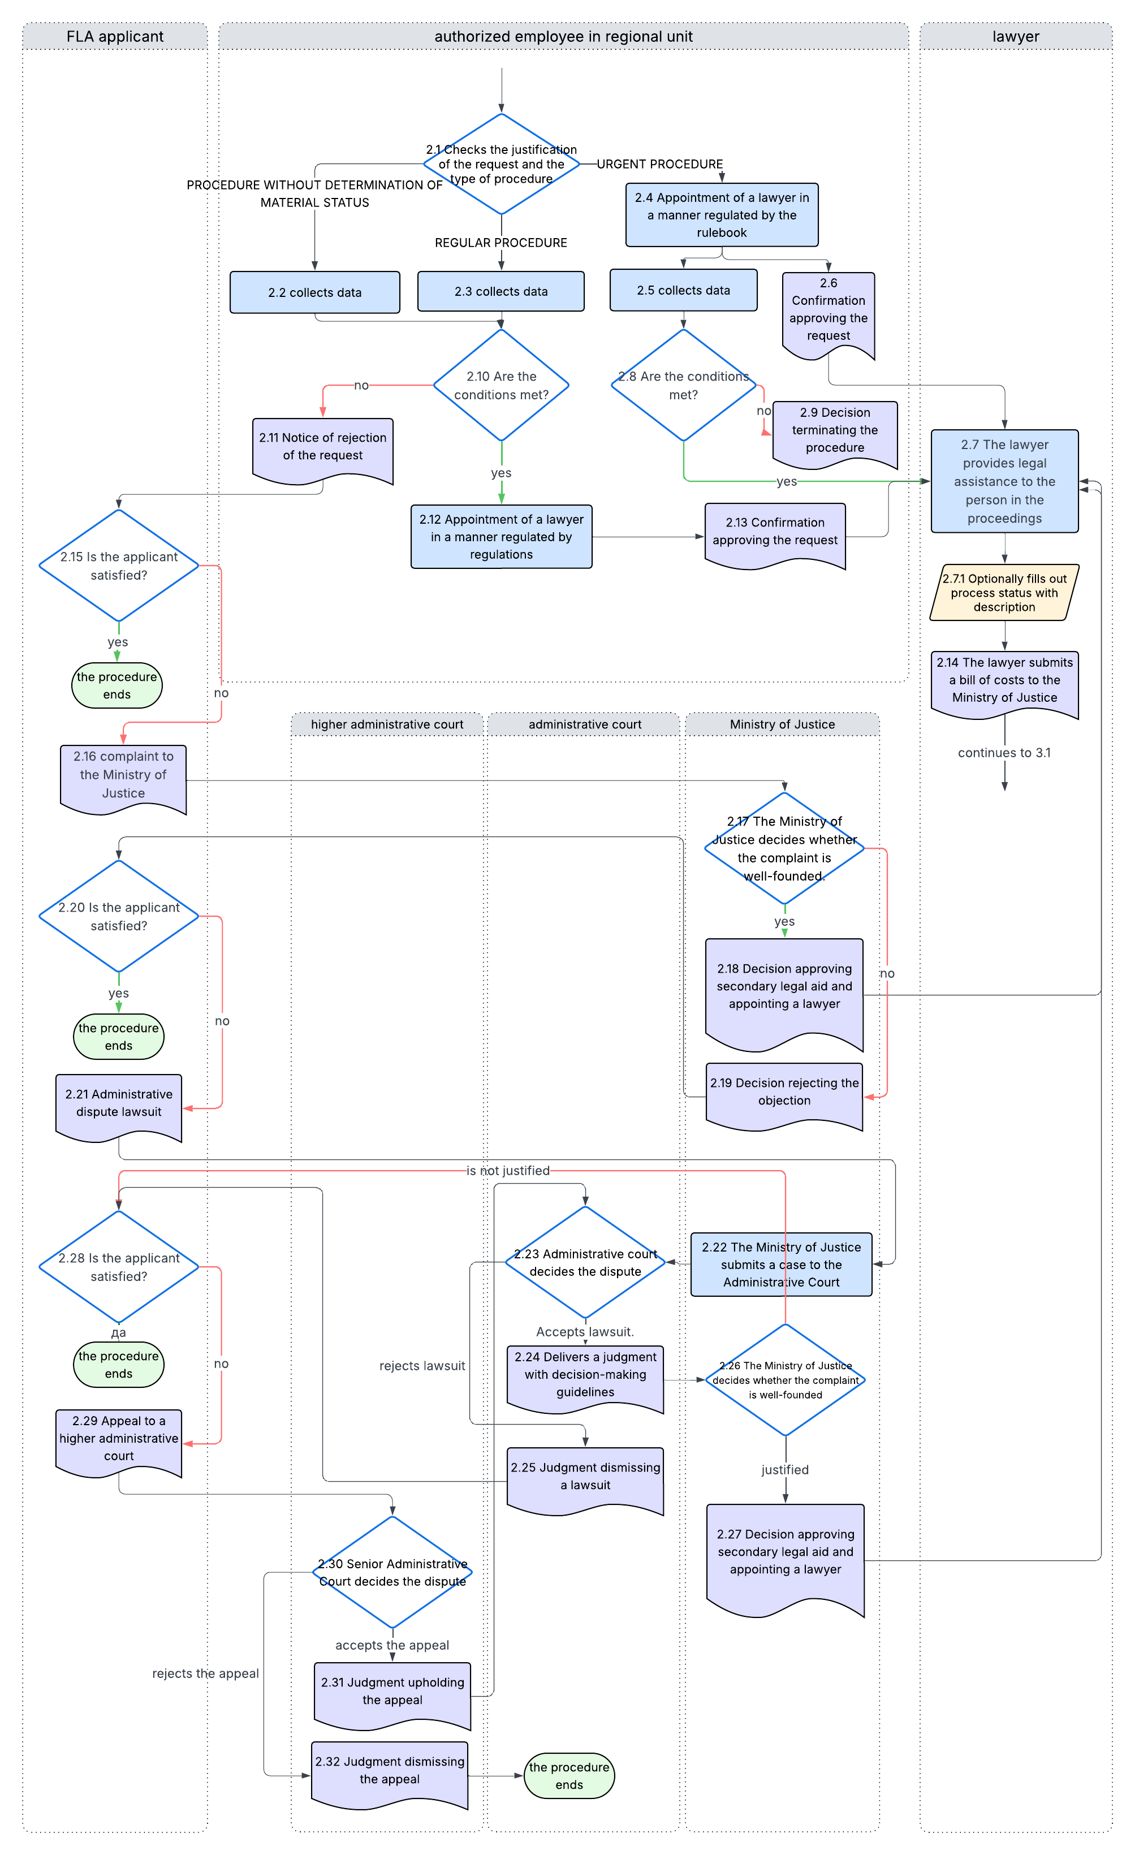
Between steps 2.7 and 2.14 the lawyer should have the option to enter a descriptive current status of the case, any number of times.
At each step of the process, the MO should have the options (defined by appropriate permissions):
- to terminate the process for various reasons, which must be specified;
- to enter an expert witness's cost estimate.

Data collection
Collection and recording of data on the SLA applicant and his/her family members is the obligation of the Ministry of Justice and the regional departments.
The solution must support 2 ways of collecting data from competent institutions:
- Automatically, through the National Interoperability System.
- Manual, by printing standard forms, filled with data previously entered into the system. After receiving the response from the competent institution, the data should be manually entered into the system.
The following forms are currently used:
- request for obtaining data ex officio, for a competent authority (form 3);
- letter for urgent action (competent institutions) (form 3a);
- letter requesting additional data from the applicant (form 14).
The minimum number of competent authorities from which data is collected are:
- The Public Revenue Office, for income,
- Real Estate Cadastre Agency, for real estate, and
- Ministry of Interior, for motor vehicle ownership
- Social work centres
The solution should enable a simple comparison of the data obtained from the SLA applicant with the data obtained from the competent institutions.

Family member information
The decision should support the legal obligation of the regional department to collect data, documents on the financial and property status of members of his family, who live in the same household with the applicant for legal aid and jointly bear the living expenses. The decision should enable the request for data from other institutions exclusively for persons for whom an application for SLA has been submitted or for their family in accordance with the law (described below). For this purpose, all persons must be entered into the system.
The bidder should create functionality that will allow the user of the system to record data to determine the financial situation of his family members. The user should have the opportunity to define the elements used to determine the financial situation of the applicant and his family members, such as: monthly salary income, individual residential building or apartment, vehicle, land, etc.
Conditions on the right to secondary legal aid are defined by law (according to the ownership of properties, vehicles etc.).

SLA approval
The authorized official, after verifying the financial and property status and the merits of the request, determines that the applicant meets the conditions for approval of secondary legal aid, prescribed in Section 3, Chapter II of the LFLA, then issues a certificate approving secondary legal aid, after which a lawyer for the SLA from the Register of Lawyers is appointed according to the regulations and data is entered into the case for:
- Notification and date of meeting with the applicant
- The date the certificate was delivered to the applicant and the attorney.
The forms used are:
- Certificate of approval SLA (form 4)
- Cover letter for the appointed attorney (form 4-a)
The entire confirmation and notification procedure goes through the system. The notification module must inform all interested parties. Additionally, the notification is also forwarded to the email address of the applicant and the lawyer. The system must have the ability to print the specified forms, but this should only be done in situations where it is necessary.

SLA rejection
If the authorized official, after checking the financial, property status and the merits of the application, determines that the applicant does not meet the conditions for approval prescribed in Section 3, Chapter II of the LFLA, then he/she issues a notification of rejection of the SLA and this is entered into the case file.
The forms used are:
- Notification of SLA Rejection (Form 5)
- A cover letter, sent along with the rejection notification, written in understandable language
Just as in the case of acceptance of the request, the entire procedure for rejection and notification goes through the system. The notification module must inform all interested parties. Additionally, the notification is also forwarded to the email address of the requester (if entered). The system must have the ability to print the specified forms, but this should only be done in situations where it is necessary.

Approved SLA
Once the case is transferred to the lawyer, the case is in the legal aid phase and is considered active. The regional department, upon change of circumstances, at the request of the applicant or ex officio, shall by decision change the appointed lawyer who does not meet the conditions and obligations under Article 37 of this Law and shall authorize a new lawyer from the Register of Lawyers and these changes shall be entered into the case.
The system should enable data entry by lawyers for the following categories:
- Cases resolved by a lawyer,
- Submitted expense reports for resolved cases, and appropriate payment decisions
For all cases resolved by the lawyer, the following should be entered as a minimum:
- The date of the resolved case,
- Basic court where the case was decided
- Date of submitted cost sheet for work performed
- Cost sheet data:
- Data from the Register of Lawyers (name, surname, address, date of registration in the Register);
- Number and date of the decision determining the provision of legal aid,
- Name and surname of the applicant for legal aid,
- Date of commencement and completion of the legal work,
- Type of legal assistance provided (representation in court proceedings, representation in administrative proceedings, drafting of documents in court and administrative proceedings),
- Description of actions taken,
- Amount for the work performed according to the lawyer's fee schedule;
- Amount reduced by 30% (automatically calculated),
- Date and place.
Evidence of actions taken (submissions, minutes of hearings held, etc.). If the cost estimate is submitted in writing, the appropriate Employee in FLA department must enter it into the system. Responsible employee receives a notification of the entered cost estimate and within 15 days from the date of receipt of the cost estimate, he has the obligation to:
- To check the cost sheet,
- To prepare a proposed solution and enter it into the system.
The Department receives notification that a draft decision has been prepared and is obliged to adopt a decision approving or disapproving the payment of the lawyer's fee in accordance with the submitted cost estimate. Partial approval of the fee is also possible if, upon inspection or verification of the cost estimate, it is determined that the lawyer has not fulfilled his obligations and responsibilities under Article 32 of this Law.
After the check is completed, the correction, if any, is recorded in separate fields:
- Approved payment amount
- VAT 18% (automatically calculated)
- Actual payout amount (automatically calculated)

Deciding by cost estimate
After the lawyer submits a bill of costs to the MOJ, the decision-making process begins according to the diagram below.
After receiving official information from other entities in the process, an authorized person in the FLA Sector enters data into the system for each stage the process has reached. Each stage of the case should be recorded with its own status in the system.

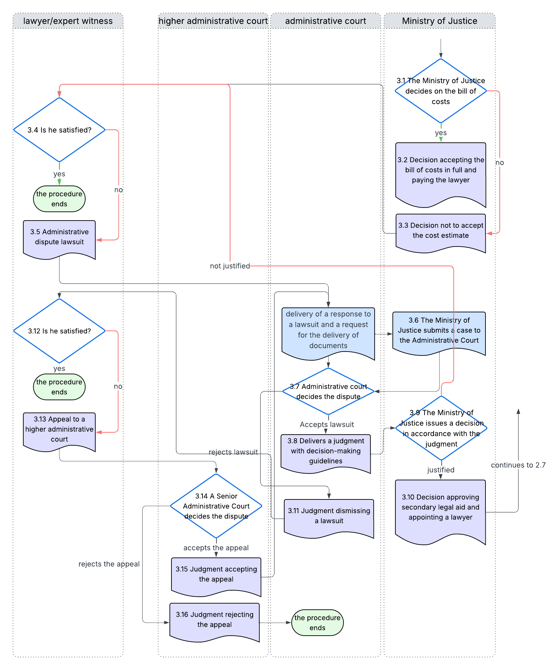

Administrative dispute
The system should create a module for keeping records of administrative disputes initiated before a competent court, with the following functionalities: entering, updating, forwarding complaints and searching by various criteria. A complaint in accordance with the LFLA can be filed by a dissatisfied applicant regarding the received:
- Notification to an applicant not approving the request for secondary legal aid.
- Decision of the Ministry rejecting the applicant's request for secondary legal aid
When entering each objection, it should be linked to the specific case, given a new number, just like the decisions following the objection, and if the party has filed a lawsuit against the MO due to dissatisfaction with the decision made, the administrative dispute should be recorded with all responses to the lawsuit (form with explanation). The new decisions that honour the request or the decision to maintain the first-instance confirmation should be registered by the RU or MO under the same case number, but a different sub-number.
The data that should be kept for a submitted complaint are:
- Contact details of the complainant,
- Data on the complaint subject
- Textual description of the complaint
- Attached scanned document (evidence attached with the complaint)
All documents related to the administrative dispute are entered into the system by an authorized person from the Ministry of Justice, after receiving an appropriate document proving a change in status regarding the case. The lawyer, the expert, the administrative court and the higher administrative court do not enter documents into the system.

Other functional system requirements
The bidder will need to develop the following functionalities:
- User authentication and authorization module
- Forms/Templates
- Lookup tables
- Searches
- Reports and statistics
- Registers

User authentication and authorization
A solution for managing free legal aid cases must provide access for users via the Internet from different locations on the territory of the country. Individual user access to the software solution is checked and verified with a username and password.
The authentication process should be ensured through the National Interoperability System, for which a documented procedure already exists. Communication with the Ministry of Digital Transformation will be ensured through the MoJ.
The authorization process should be resolved within the system. This process should allow each user, after logging into the system, to access their personal workspace. The modules and functions that the user can access are those that are enabled based on their user rights.
Each user should be able to add/edit/delete their data:
- Name;
- Last name;
- User
- Email​ address.
Optionally, as an additional email address, different from the one entered in the National Interoperability System;
- User group type:
  - lawyers
  - employees in the MP
  - authorized legal clinics
  - authorized associations
  - applicants
- Regional Department (For employees of the Ministry of Justice)
- Title (For employees of the Ministry of Justice, authorized legal clinics, authorized associations):
  - Head of Department
  - Lawyer
  - Assistant Head of Department
  - Head of Department
  - Advisor
  - Senior Associate
  - Collaborator
  - Junior Associate
  - Independent referent
  - Junior officer
  - Referent
The system should support grouping users into user groups, where all members will share the same privileges in the system. The system administrators group, is the group with the highest privileges and access level to all modules, is responsible for managing user profiles and maintaining the system. This group of system users has access to all data and records of files / databases, and has the right to add, modify, delete user groups by defining privileges and access control.
An administrator is responsible for defining and maintaining roles, as well as granting authorization to users using the system application procedure. The system should also allow login to the system for authorized persons of associations, legal clinics and lawyers.

Templates and forms
The template module should enable the creation of documents in Word (docx) or other format, based on data from objects and documents in the request or case. Templates are documents that have a defined format.
The template module should offer the ability to generate, create standardized and automatic forms (e.g. requests, decisions, notifications, correspondence, resolutions, etc.), thereby increasing the efficiency and accuracy in the work of regional departments, as well as the Ministry itself.
The table lists all forms mentioned in the case management process and they will be available.
Table of templates
O1 | Form 1: Form for documenting the given PLA for each interested person
O1-A | Form 1-a: The Registrar for a given PLA
O2 | Form 2: Application for SLA
O2-A | Form 2-a: Request for SLA in the procedure for recognition of the right to asylum
O2-B | Form 2-b: Declaration of consent for personal data
O3 | Form 3: Request for obtaining data ex officio
O3-A | Form 3-a: Letter for urgent action
O4 | Form 4: Certificate of Approval for SLA
O4-A | Form 4-a: Cover letter for appointed attorney
O5 | Form 5: Notification of rejection of SLA
O6 | Form 6: Referral Letter
O7 | Form 7: Objection, Complaints Form
O8 | Form 8: Proposed decision for termination
O9 | Form 9: Decision to change appointed lawyer
O10 | Form 10: Decision on payment of attorney's fees
O11 | Form 11: Request for entry in the register of associations authorized to provide PLA
O12 | Form 12: Request for entry in the register of law faculties authorized to grant PLA
O13 | Form 13: Request for registration in the register of lawyers for the SLA
O14 | Form 14: Request for additional data from the applicant
T1 | Cost estimate for the scope of work performed by associations and legal clinics
T2 | Cost of secondary legal assistance provided by a lawyer
T3 | Cost of legal aid provided to children
T4 | Cost of secondary legal aid provided in a procedure for recognition of the right to asylum
RL1 | Worksheet 1: Income and Assets Records
RL2 | Worksheet 2: Checklist – Competent Authorities

Form 2: Request for secondary legal aid
Form 2 lists data about the applicant for the SLA.
- PERSONAL DATA
  - First and last name
  - Middle name
  - Date and place of birth
  - EMBG
  - Postal code, Municipality, State, Citizenship
  - Temporary residence permit number/ asylum decision number
  - Type of identification document (ID card or passport)
  - Identification document number
  - Place and authority that issued it
- RESIDENCE/RESIDENCE
  - Place of residence/stay
  - Address of residence/residence
  - Postal code, Municipality, State
  - Contact phone number
Information about the legal representative or guardian
- PERSONAL DATA
  - First and last name
  - Middle name
  - Date and place of birth
  - EMBG
  - Postal code, Municipality, State, Citizenship
  - Temporary residence permit number/ asylum decision number
  - Type of identification document (ID card or passport)
  - Identification document number
  - Place and authority that issued it
- DATA ABOUT THE ACT BY WHICH HE IS APPOINTED AS LEGAL REPRESENTATIVE/GUARDIAN
  - Act number
  - Body that adopted the act
- RESIDENCE/RESIDENCE
  - Place of residence/stay
  - Address of residence/residence
  - Postal code, Municipality, State
  - Contact phone number
- Legal issue requiring SLA
- SLA format (select one or more options)
  - Representation in all levels of civil court proceedings
  - Representation at all levels in administrative proceedings
  - Representation at all levels in administrative disputes
  - Representation in a probate proceeding before a notary public
  - Drafting of debtor's submissions before a competent enforcement agent
  - Legal aid for victims of crimes
Form 4: Certificate of approval of secondary legal aid
The confirmation approving the SLA request contains:
- Name of the authority issuing the certificate;
- Archive number and date of issue;
- Preamble to the certificate stating the legal basis for issuing the certificate and the name and surname of the applicant;
- Title "CONFIRMATION OF APPROVAL OF REQUEST FOR SECONDARY LEGAL AID";
- Name and surname of the person whose SLA application has been approved;
- A brief description of the legal matter for which legal aid has been approved;
- Appointment of a lawyer;
- Indication that the user of the SLA is:
  - exempts from court fees and costs related to the procedure before a court in accordance with the law;
  - exempts from the costs of the expert examination; and
  - exempts from administrative fees;
- Note that in the event of a change in the facts and circumstances that affect or could affect the exercise of the right to SLA, the beneficiary is obliged to notify the Ministry within seven days from the day he learned about the change and the legal consequences of failure to fulfil this obligation (Article 26 paragraph 1 lines 3,4 and 5 of the LFPP);
- Date of the first meeting between the lawyer and the beneficiary of secondary legal aid;
- Explanation;
Form 10: Decision on payment of attorney's fees
This form – decision for payment of attorney's fees contains the following data:
- Basic information about the lawyer:
- Name and surname of the lawyer;
- Address, street and number of the office and municipality;
- Name and surname of the applicant;
- Number and date of approved request;
- Payment amount;
- Giro account, depository bank and EDB;
- Explanation
- Date of submitted bill of costs;
- Amount of requested payment;
- Amount of approved payment;
- VAT;

SEARCHES AND SUBJECT SELECTION
The system should enable searching across all sections where data is entered, down to the level of detail of object phases and document content. For each term found, the type of object should be displayed, in which part of the solution it was found, and a description of the object where it was found. The search for objects should be made as flexible as possible, allowing the user to include or exclude some of the data for the objects, such as:
- the date of receipt of the request;
- number of subjects
  - using a whole number or any part of the object number;
- information about the applicant or participants in the case;
- search through attached documents, acts, data relevant to the acts and all records for the request;
- type of object;
- information whether the entity is active or not (entity status);
- archived or not;
- keywords;
- subject status
- different time intervals related to the resolution deadline;

REPORTS AND STATISTICS
The reports must enable the Department of Legal Aid to analyse the effectiveness of the legal aid granted and through this module, reports should be generated according to various criteria that have so far been prepared manually, and relate to the work of the Department of Legal Aid, regional departments, applicants for legal aid, lawyers, associations, legal clinics, all stakeholders, as well as the needs of the Ministry of Justice. The reports should be available to users, depending on their user privileges. The bidder in the created user interfaces, depending on the type of user (MP, RU, association, legal clinic) and the granted privileges should enable the generation and printing of reports according to various criteria. These include reports and statistics for:
- Annual report on free legal aid
  - the number of people who were provided with primary legal aid;
  - the number of SLA applications submitted;
  - the number of approved SLA requests
  - number of rejected requests for free legal aid;
  - the number of decisions adopted terminating the approved SLA;
  - the legal matter for which legal aid is approved or denied;
  - number of associations and legal clinics providing primary legal aid;
  - number of lawyers providing SLA;
  - budget allocated for free legal aid;
  - amount of funds paid for free legal aid;
  - the amount of the returned funds from collected legal aid costs.
- Report on SLA Annex 2 of the Rulebook on the content, form and manner of keeping records of data relating to the resolution of SLA requests and the content of reports
- Report on the given PLA of associations and legal clinics (monthly, six-monthly) based on the Form of reports submitted to the Ministry of Justice by associations and legal clinics on the given PLA
- number of submitted requests for free legal aid under RU;
- number of cases received and completed per lawyer;
- total cases completed by all lawyers;
- total cases that are not closed for a certain period (= active);
- total payments made to lawyers per case for a certain period;
- total number of payments per lawyer
- total costs for lawyers, associations and legal clinics for a certain period
- number of cases by type of legal aid provided, legal problem
- average time required to resolve cases;
- report on the number of initiated and completed procedures in primary free assistance, with percentages of initiated procedures per RU;
- a report on cases that were carried over from the previous year to the current year and when they were resolved - this report must be made for each of the POs;
- Printing registers

DATA REGISTERS
Within the framework of a web-based software solution, all registers (records) provided for by the Law on FLA must be included, namely:
# | Register
1 | R01 - Register of Regional Offices
2 | R02 - Register of employees in RU
3 | R03 - Register of Advocates
4 | R04 - Register of associations
5 | R05 - Registry of Legal Clinics
7 | R07 - Register of allocated financial resources for providing primary legal aid to authorized associations and legal clinics providing primary legal aid
The Bidder should implement a user interface for each Registry separately, allowing users to easily add, update and search data from these registries.
R01 - Register of Regional Offices
The register records data related to the regional departments and the bidder should design a user interface with the features described below and with a minimum of data to be entered:
- Regional department
- Address
- City
- Phone number
- Email
- Status (active, inactive)
R02 - Register of employees in RU
The register records data related to employees in regional departments and the FLA Sector, which will be used in the solution in the section for administration of users and user groups. The Bidder should design a user interface with the features described below and with a minimum of data to be entered:
- Name and surname of employee
- Regional department, sector, department
- Address, City
- Title
- Personal data (phone, e- mail address)
Data from this registry will be used when creating a username to log in to the solution.
R03 - Register of lawyers
The Ministry of Justice maintains a register of lawyers who provide legal assistance and a list of lawyers is published on the website of the Ministry https://www.pravda.gov.mk/mk-MK/registri/registar-na-advokati-za-davanje-na-pravna-pomos and the bidder should take over all lawyers once and transfer them to the register of lawyers. A lawyer who is interested in providing legal assistance submits a completed form o13 request for registration in the Register of Lawyers for legal assistance to the Ministry and within 15 days from the date of receipt of the request, the data from it is checked in cooperation with the Bar Association and a decision is made to register the lawyer in the Register of Lawyers.
The bidder should create a user interface for the registry of lawyers, with the following functionalities: entering, updating, deleting data, searching by various criteria and should contain at least the following data:
- Basic information about the lawyer:
- Name and surname of the lawyer;
- EMBG
- place of birth;
- contact information
- Address, street and number of residence;
- Postal code and city;
- Telephone/Fax;
- mobile phone;
- E- mail address;
- Address, street and number of the office and municipality;
- Date of submission of the application for enrolment;
- Registration number of entry in the register of lawyers;
- Number and date of the decision for entry in the Directory of Lawyers;
- number and date of operating license;
- Legal matter/area in which legal assistance can be provided (civil matter/area/sub-area, administrative matter/area)
- Languages in which legal assistance can be provided
- Number and date of the decision to reject the request;
- Number, date and type of decision on an administrative dispute;
- Number, date of the decision to delete from the register;
- Reason for deletion of a lawyer registered in the Register of Lawyers;
- Giro account, depository bank and EDB;
- Note;
- Attachments, attached documents
  - photocopies of the decision for entry in the register, the decision for deletion from the register, Certificate/Confirmation of passing the bar exam.
System administrators, i.e. persons employed in the Information and Communication Technologies Sector of the Ministry of Justice or an authorized person from the FLA Sector, will be able to enter, update, and delete data about lawyers.
R04 - Register of associations
An association that, in accordance with the provisions of the Law on BPL, meets the requirements for providing primary legal aid and, based on a decision of the Ministry, is authorized to provide primary legal aid and is registered in the Register of Associations for Primary Legal Aid.
The Bidder should create a user interface for the association register, with the following functionalities: entering, updating and deleting data, searching by various criteria and should contain at least the following data from the Application Form for Entry in the Register of Associations Authorized to Provide PLA:
- Basic information about the association:
- the name of the association (full and abbreviated name),
- contact information (address, contact phone number, email address, EMBS, transaction account number and depositor bank),
- data about the association's representative (name and surname, EMBG, contact phone number and email address);
- number and date of decision by which it was entered in the register of authorized associations
- Information about the person who will provide primary legal assistance in the association
- the name and surname of the lawyer,
- contact information (phone number, email address)
- number and date of the certificate/confirmation of passing the bar exam,
- legal basis for engagement in the association with number and date,
- Data on the contract for insurance of liability for possible damage
- the policy number,
- insurer,
- insurance amount,
- insurance period
- Data on completed projects
- project title,
- donor,
- implementation period,
- objectives, project results and
- contact person from the donor.
- Attachments, attached documents
- photocopies of the decision for registration in the Central Register, Statute of the association, legal basis for the engagement of the lawyer in the association, Certificate/Confirmation of passing the bar exam, ID card of the engaged lawyer, Insurance policy, submitted annual tax returns, Confirmation, statement of the accuracy of the data
R05 - Registry of Legal Clinics
A legal clinic that, in accordance with the provisions of the Law on Primary Legal Aid, meets the requirements for providing primary legal aid and, based on a decision of the Ministry, is authorized to provide primary legal aid and is registered in the Register of Legal Clinics for Primary Legal Aid. The Bidder should create a user interface for the register of legal clinics, with the following functionalities: entering, updating and deleting data, searching by various criteria and should at least contain the following data from the Application Form for registration in the Register of Law Faculties Authorized to Provide Primary Legal Aid:
- Law School Information
- Name of the law school;
- contact information (Address, Telephone, Fax, Email address);
- Name and surname of the Rector / Dean;
- Legal Clinic Information
- Name of the legal clinic;
- Act establishing the legal clinic as an organizational unit, Number and date of the act, Note;
- Responsible person (legal clinic mentor), Contact details of the legal clinic mentor (telephone and email address), Note;
- Attachments, attached documents
- photocopies of the act establishing the legal clinic, mentor's ID card, Confirmation, statement of accuracy of data;
R07 - Register of allocated financial resources for providing primary legal aid to authorized associations and legal clinics providing primary legal aid
The Ministry of Justice annually announces and implements the public competition for the allocation of financial resources for the provision of primary legal aid to authorized associations and legal clinics and exercises control over the spending of funds. The bidder should create user interfaces that will enable keeping records of all public competitions and allocated financial resources to associations and legal clinics based on the LFLA, Article 11 - financing of associations and legal clinics as providers of primary legal aid, with the following functionalities: entering, updating, deleting data and searching by various criteria. The register will record at least the following data:
- Records of announced and implemented public competitions for awarded financial resources
- Total budget of approved funds for the current year
- Year
- Public competition data (number, date, total amount of funds to be awarded, etc.)
- Records of allocated financial resources for providing primary legal aid to authorized associations and legal clinics
- Name and headquarters of the association/Faculty of Law,
- Legal status
- Bank details:
  - Bank account owner:
  - Unique identification number of the entity (EMBS)
  - Unique Tax Number (UTN):
  - Bank account number:
  - Depositor bank:
  - Account signatory:
- Address
- Contact details: telephone and e- mail address of the authorized association/legal clinic;
- Number of the decision issued by the Ministry of Justice;
- Name and surname of the legal representative of the authorized association or name and surname of the Dean of the Faculty of Law;
- Name and surname, telephone number and email address of the hired lawyer and information about his/her work experience.
- Name and surname, telephone number and email address of the contact person from the legal clinic
Project information:
  - Total project budget in denars
  - Requested from the Ministry of Justice in denars:
  - City, planning region where the project will be implemented:
  - Implementation period:
  - Project partners (if any):
- Project description
- Project objectives
- Project activities
- Expected results
- Grant agreement number
- Approved budget

REGISTRATIONS
According to the LFLA, the Ministry of Justice and its regional departments should maintain a single Register for Free Legal Aid, where each new request or case will receive its own basic number, and all acts related to the case (decisions, confirmations, objections, etc.) will have their own sub-numbers. The decision should offer the possibility of generating a report from a selected Register for Free Legal Aid for regional departments or Register for Free Legal Aid for the BLA Sector, BLA Department.
The system should enable the recording of multiple numbers for each case, regardless of whether it refers to a transfer from one year to another, or whether it concerns the recording of archival numbers when the case is transferred to the jurisdiction of another organization.
The item should be available for search by all entered archive numbers, with all data associated with it, regardless of its current status.

DATA MIGRATION
The Bidder should make all preparations and implement the transfer and migration of data from existing databases to a new FLA database, namely:
- register of lawyers
- register of free legal aid associations
- register of free legal aid provided by associations

OBLIGATION OF THE BIDDER
The economic operator accepts the following general responsibilities:
- The selected Economic Operator must record the manner of operation of the FLA Sector, and upon completion of the analysis of the needs of the Contracting Authority, it should submit an appropriate report containing:
- a description of the needs that are common to all regional departments;
- description of needs specific to the FLA Sector;
- defining the scope of needs and functionalities that should be covered by the solution.
- The detailed functional specification of the solution, as well as the detailed user requirements, will be agreed with the contractor during the analysis phase.
- The delivered solution should be fully functional. Additional software licenses, if necessary for the functioning of the solution, should be part of the solution and included in the offer.
- The economic operator should submit all necessary licenses (with unlimited duration), which must be clearly indicated in the offer and which must be part of the total price.
- The economic operator should provide automated testing and deployment scripts, if used and applicable, based on the best practices.
- The economic operator is obliged to train all employees in the FLA sector, and the IT staff who will manage and maintain the new software.
- The economic operator will provide User Instructions, Software Administrator Instructions and full Software Documentation.
- Documentation for System Administration, among other specific implementation information, shall also focus on:
  - Data management, including recommendations for administrators on maintaining security best practices during system operation and maintenance;
  - Guidance on planning periodic security and regulatory compliance audits throughout the system’s operational life;
  - Description of the incident management approach, including detection, communication, response timelines, and post-incident review procedures, together with recommendations for its continued use during system operation.

IMPLEMENTATION
The economic operator is obliged, ten (10) days from the date of signing the Agreement, to submit a detailed project plan that should contain all phases of preparation and implementation of the entire solution.
The project plan should contain:
1. Project organization and management plan
2. Software module development plan
3. Delivery and installation plan
4. Training plan
5. Documentation preparation plan
6. Plan for verification, testing and acceptance of program modules
7. Timetable of tasks and required resources of all parties involved
Project plan is subject for approval by the Contracting Authority.

INSTALLATION, TESTING AND VALIDATION OF THE SOLUTION
The bidder must develop the software solution based on the requirements specified in the technical specification, and is obliged to establish a technical environment for delivery, installation and configuration of the software and database in the IT centre of the ministry on available hardware and virtual environment.
The bidder must guarantee that the delivered solution will function properly in an established technical environment and should simultaneously establish a test environment in the IT centre of the ministry.
The Bidder shall prepare a complete testing and validation plan for the solution. The Bidder is expected to implement standard testing and quality assurance procedures and shall maintain test records, which must be submitted to the Contracting Authority upon request. The Bidder shall first conduct the testing in its own testing and development environment, after which the Ministry of Justice shall perform software acceptance testing, validation of the complete software solution and if during the user testing phase deficiencies in the solution or functions that have not been implemented are discovered, the testing shall be suspended until the problems have been resolved. The Bidder shall have an additional period of up to 10 working days if there are functionalities that were not foreseen by the requirements of the specification.

TRAINING OF ADMINISTRATORS AND END USERS
Before putting the system into production and exploitation, all users and administrators must be trained. The training program offered must guarantee independence and self-reliance in the work of all categories of users after the training has been conducted.
The training plan should specify in detail the number of participants and the time schedule of the trainings. The trainings will be held at locations previously defined together with the Contracting Authority, in premises that meet the necessary technical prerequisites. The final number of users who will attend the trainings will be defined by both parties during the implementation of the contract (maximum 3 administrators and 70 users).
The economic operator undertakes, at its own expense, to hold training sessions on the functioning and use of the software program for the administrators responsible for this system, and for end users employed by the Contracting Authority, at the premises of the Contracting Authority. The economic operator shall provide all supporting materials and instructions necessary for the training itself in electronic form for users and administrators.
The duration and content of the training program should be specified in the offer.

Handover of the software
The handover of the software will be carried out at the Ministry of Justice by 20 November 2026 at the latest.

WARRANTY PERIOD AND MAINTENANCE OF THE SOLUTION
The economic operator undertakes that the warranty period and user support are 2 years from the moment of signing the Act of Acceptance - qualitative and quantitative acceptance of the web application. During the warranty period, the bidder is obliged to remove all security vulnerabilities, identified deficiencies, errors identified in the implemented solution in relation to the functional specification, which are not caused by the user and are at the expense of the bidder. In the event of changes in the way the ministry works, due to legal or organizational changes, it is necessary to make the appropriate changes within a realistic period and deliver a solution with upgraded functionality at the expense of the bidder.
Detected defects are reported by phone or email, and are removed immediately, or by agreement, depending on their severity and the resources required for a solution.

SOURCE CODE
The source code of the software solution written for the needs of the Ministry of Justice shall be the property of the Ministry of Justice. The source code must be adequately documented and packaged in a form that will enable the user to easily maintain and further develop or upgrade the system.

Abbreviations
RU – regional unit of the Ministry of Justice
PLA – primary legal aid
SLA – secondary legal aid
FLA – free legal aid
LFLA – Law on Free Legal Aid
MoJ or MJ – Ministry of Justice
UML - Unified Modelling Language

Hardware

Item | Value
OS Name | Microsoft Windows Server 2019 Standard
Version | 10.0.17763 Build 17763
Other OS Description | Not Available
OS Manufacturer | Microsoft Corporation
System Name | MPBPPSRV
System Manufacturer | FUJITSU
System Model | PRIMERGY RX2520 M5
System Type | x64-based PC
System SKU | S26361-K1656-V208
Processor | Intel (R) Xeon (R) Silver 4210 CPU @ 2.20GHz, 2195 Mhz, 10 Core (s), 20 Logical Processor (s)
Processor | Intel (R) Xeon (R) Silver 4210 CPU @ 2.20GHz, 2195 Mhz, 10 Core (s), 20 Logical Processor (s)
BIOS Version/Date | FUJITSU // American Megatrends Inc. V5.0.0.14 R1.26.0 for D3386-B1x, 12/2/2020
BIOS Mode | UEFI
BaseBoard Manufacturer | FUJITSU
BaseBoard Product | D3386-B1
BaseBoard Version | S26361-D3386-B13 WGS04 GS02
Platform Role | Enterprise Server
Secure Boot State | Off
PCR7 Configuration | Not Available
Windows Directory | C:\Windows
System Directory | C:\Windows\system32
Boot Device | \Device\HarddiskVolume2
Locale | United States
Hardware Abstraction Layer | Version = "10.0.17763.4644"
Username | Not Available
Time Zone | Central European Standard Time
Installed Physical Memory (RAM) | 192 GB
Total Physical Memory | 192 GB
Available Physical Memory | 145 GB
Total Virtual Memory | 220 GB
Available Virtual Memory | 173 GB
Page File Space | 28.0 GB
Page File | C:\pagefile.sys
Kernel DMA Protection | Off
Virtualization-based security | Running
Virtualization-based security Required Security Properties
Virtualization-based security Available Security Properties | Base Virtualization Support, DMA Protection, UEFI Code Readonly, Mode Based Execution Control
Virtualization-based security services configured
Virtualization-based security services Running
Device Encryption Support | Not Available
A hypervisor has been detected. Features required for Hyper-V will not be displayed.
Resources | Device
Memory Address 0xB8100000-0xB82FFFFF | PCI Express Upstream Switch Port
Memory Address 0xB8100000-0xB82FFFFF | PCI Express Downstream Switch Port
I/O Port 0x00000000-0x0000000F | Direct memory access controller
I/O Port 0x00000000-0x0000000F | PCI Express Root Complex
Memory Address 0xB4000000-0xB70FFFFF | PCI Express Upstream Switch Port
Memory Address 0xB4000000-0xB70FFFFF | PCI Express Downstream Switch Port
Memory Address 0xB4000000-0xB70FFFFF | Intel (R) Xeon (R) processor P family/Core i7 PCI Express Root Port C - 2032
Memory Address 0xB4000000-0xB70FFFFF | Intel (R) Ethernet Connection X722 for 1GbE #2
Memory Address 0xFE010000-0xFE010FFF | Intel (R) C620 series chipset SPI Controller - A1A4
Memory Address 0xFE010000-0xFE010FFF | PCI Express Root Complex
Memory Address 0xB8400000-0xB86FFFFF | Intel (R) Xeon (R) processor P family/Core i7 PCI Express Root Port A - 2030
Memory Address 0xB8400000-0xB86FFFFF | Intel (R) Ethernet Server Adapter I350-T2 #2
Memory Address 0x9B000000-0x9C8FFFFF | PCI Express to PCI/PCI-X Bridge
Memory Address 0x9B000000-0x9C8FFFFF | Intel (R) C620 series chipset PCI Express Root Port #6 - A195
Memory Address 0x9B000000-0x9C8FFFFF | Microsoft Basic Display Adapter (Low Resolution)
IRQ 16 | LSI Embedded MegaRAID
IRQ 16 | LSI Embedded MegaRAID
Memory Address 0xAAD00000-0xAADFFFFF | Intel (R) Xeon (R) processor P family/Core i7 PCI Express Root Port A - 2030
Memory Address 0xAAD00000-0xAADFFFFF | Emulex LightPulse HBA - Storport Miniport Driver

