Study visit to Lyon: Prevention of radicalisation through intercultural policies
  - Report on visit, October 2017

Adaptation of policies, stakeholders and actions to the challenge of preventing ideological recruitment and radicalisation
The role of cultural policies

18-19 October 2017
REPORT

Introduction to the background to the visit
Intercultural Cities’ policies aim to ensure the conditions that enable individuals and groups to live together in diversity, by promoting opportunities and positive interactions which build trust and break down divides.
However, Europe is now more divided than ever about the key principles of integrating migrants and refugees, particularly following a series of terrorist attacks that have in some cases fuelled authoritarian populist discourse and triggered greater restrictions of fundamental freedoms on security grounds.
The issues relating to violent extremism and radicalisation have become a real subject of concern for various players: Council of Europe member States, which have the right to defend their territories and a duty to keep their citizens safe from the various threats; European cities, especially the members of the Intercultural Cities Network, which have to juggle the constraints of ensuring security with the need to open up the public space to facilitate interaction between communities and exchanges; and the Council of Europe whose approach to the fight against violent extremism and radicalisation advocates international co-operation and is based on respect for human rights, the rule of law and democracy. Combating terrorism is not incompatible with promoting human rights: rather, the two are complementary.
At their annual meeting in Reykjavik in September 2016, the Intercultural Cities co-ordinators therefore agreed to include a study visit on the subject in their work programme for 2017.
The city of Lyon seemed an obvious choice for the visit: over the past 20 months, France has been among the countries hardest hit by a spate of terrorist attacks that have sent shockwaves through the public and stakeholders at the local level and in politics. In Lyon, the need to create spaces for exchange and dialogue became apparent very quickly. The stakeholders involved in the city’s neighbourhoods, associations, public bodies, citizens and religious groups have responded in different ways to the rise of radicalism – in this case religious – partly fuelled by urban and social failings, which uses social media to recruit children, young adults, men and women.
Developing training, building understanding, inventing new forums for exchanges, promoting innovative measures, moving onto social media and rethinking educational processes and how to use the public space have been – and still are – the challenges for the stakeholders in the Lyon area in a French context governed by the values of the republic and the expression of secularism. The study visit to Lyon sought to showcase the city’s approach to the current dilemmas and provide examples of how the intercultural approach involving education (adult, informal and state), culture, mediation and conflict prevention can help mitigate growing fears of terrorism and radicalisation. It also led to reflection on the role which local stakeholders in Intercultural Cities can play in preventing violent extremism and radicalisation in the long term.

Violent extremism and radicalisation from the Intercultural Cities’ point of view
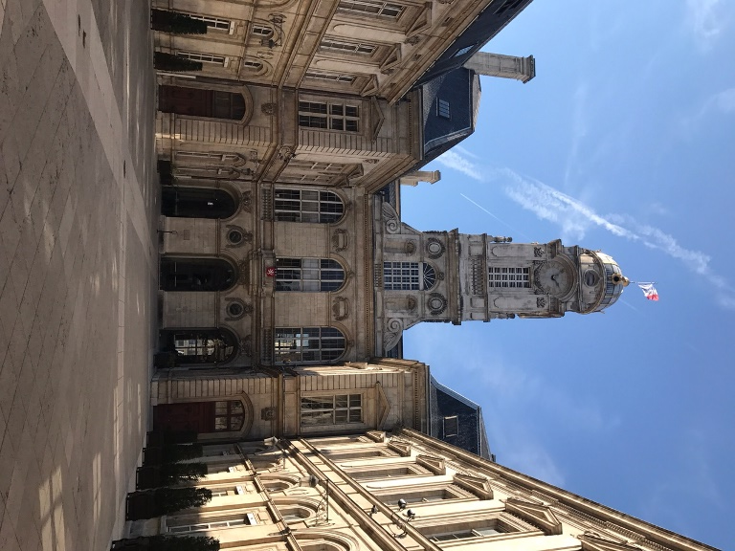
Violent extremism and radicalisation leading to terrorism are very sensitive issues, the ideological reasons for which keep on changing. In the recent past, Europe and the West first experienced extremism and “domestic” terrorism closely related to national policies (e.g. ETA in Spain, the IRA and the UDA in the British Isles, the Red Brigades (Brigate Rosse) in Italy, Baader-Meinhof in Germany and the Quebec Liberation Front (FLQ) in Canada); since the 2000s, in Europe as in the United States, terrorist attacks by extremists have acquired an international dimension, often being motivated by racism, xenophobia or anger against policies promoting the integration of migrants or universal access to entitlements, as was the case in Norway with the terrorist attack by the ultranationalist militant, Anders Breivik, in Germany with attacks against refugee hostels, in the UK with the murder of the MP, Jo Cox, and in the United States with the rise of nationalism and white supremacy.
However, the religious dimension of radicalisation is now becoming more significant, with the presence of ISIS in the international arena. Yet the debate here is all too often poisoned by simplistic, toxic discourses on the part of certain populists who equate Islam with terrorism. It is therefore important to make sure that policies to combat ideological recruitment are not manipulated for the purpose of stigmatising part of the population on account of their religious background.
Some of the measures taken in response to the spate of terrorist attacks that have hit Europe over the last two years raise questions concerning not only their effectiveness but also with regard to respect for individuals’ fundamental rights and freedoms in connection with security. For instance, prevention strategies involving increased police surveillance in individual neighbourhoods or concerning certain population groups often have the effect of undermining community cohesion, mutual trust and the sense of belonging to society.
It is therefore vital to understand the processes which facilitate ideological recruitment rather than analysing the ideologies behind it: the latter are only the pretext that triggers the violence. In contrast, studying the techniques and methods of recruitment and the causes and circumstances which make some individuals more receptive to extremist recruitment helps identify solutions to make society more resilient.
Numerous studies have shown that – especially among young people – marginalisation (economic, social and political) and lack of hope, ambitions or opportunities generate feelings of uselessness, alienation and exclusion from the development of society. The extremists’ message finds a very fertile breeding ground in this context.
The intercultural political model responds to a need to promote a fresh, alternative approach geared towards democracy, human rights and the rule of law in efforts to prevent violent extremism. The intercultural approach involves promoting trusting relations between communities, the opening up of public spaces for citizens’ benefit, the desegregation of housing and neighbourhoods, dialogue and interaction, access to high-quality, inclusive education, social justice and efforts to combat discrimination, and conflict mediation. It is therefore a matter of preventing extremism and radicalisation through inclusion.

Evolution of legislation and public responses in France
The statements by the representatives of the Prefecture of the Rhône (from the Department for Equal Opportunities and Territories and the Radicalisation Prevention Unit) and the Security and Prevention Directorate of the City of Lyon underlined the importance – in the French context – of the principle of secularism in the fight against radicalisation and violent extremism. The state is completely disconnected from the religious sphere on account of a strict application of the principle of separation of powers laid down in legislation from 1905. This principle means that the state is completely neutral with regard to religious issues, while individuals’ freedom of religion and conscience is guaranteed in the private sphere. The principle of secularism is also intimately linked with the values of the republic and, in particular, the principle that all citizens are equal before the state.
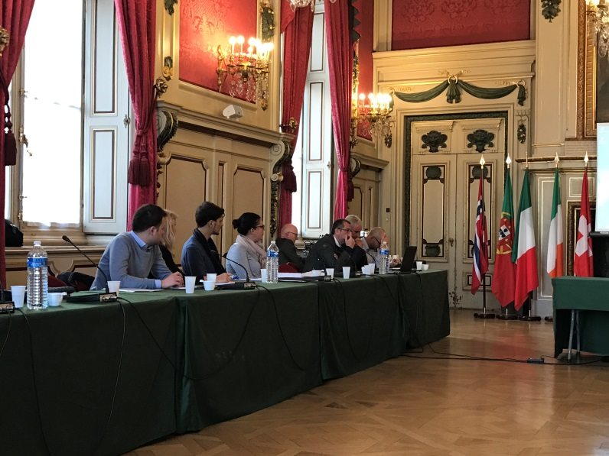
The concept of secularism has, however, evolved over the years. The 1905 law was passed with a view to limiting the influence of the Catholic Church in the life of the state; for instance, church buildings predating 1905 became state property belonging to everyone. Migration and post-colonialism have, however, increased religious diversity in France. While Catholicism is still the main religion, other religions have emerged and Islam is now the second-largest in the country. This diversity has necessarily produced new circumstances and sometimes new conflicts, which are often politicised and have brought about changes in the concept of secularism and the law.
In particular, when these conflicts began to arise in schools, the state had to introduce new administrative and legal instruments to try and deal with them.
The terrorist attacks which have taken place in France in recent years have also prompted the authorities to do more in terms of prevention, in particular in the education sector, by promoting the conditions for living together in harmony. In 2014, the central government stepped up co-operation with the local and regional levels and adopted an action plan to combat violent radicalisation and terrorist networks. The plan provided for the establishment of radicalisation prevention units in the département prefectures, tasked with dealing with the increase in the number of French citizens who had been radicalised or were becoming radicalised, with measures covering both them and their families. A freephone hotline was also set up to enable citizens to obtain information, ask questions or report suspicious circumstances.
The representatives of the Prefecture of the Rhône taking part in the study visit underlined that it was important to pay attention to the prejudices and suspicion that the issue of radicalisation could trigger among public opinion. They stressed that the purpose of the prevention units was not to make official reports of offences but to prevent extremist recruitment and support the individuals who were its victims, as well as their families and friends. They then explained how the system operated: when there was evidence of extremist recruitment and the situation was not a matter for the police or the courts, non-punitive monitoring mechanisms were put in place through ordinary law procedures and specific support arrangements for the persons reporting individuals and those reported. It was a personalised approach, which took account of the psychological and social circumstances of the individuals concerned. That was why co-operation with local stakeholders and local authorities was very important.
The support activities included the deconstruction of cyber-recruitment, the setting up of discussion groups and theatre groups, and social mediation. They involved a multifaceted response in terms of child protection, educational integration and vocational integration.
The representatives of the Muslim community and other local stakeholders (social housing bodies, associations, etc.) were involved in the process. In spite of the principle of secularism, the state was able to co-operate with representatives of religions. In particular, in 2003, it had called for and supported the setting up of the French Council of the Muslim Faith (CFCM) to ensure representation of the Muslim faith. In December 2016, a new body had been set up to revive interfaith and intercultural dialogue under a partnership approach.
Another area of action that had to be stepped up was the training of religious leaders (including women) and imams. Preachers who came from other countries were not necessarily aware of the values of the republic and it had to be ensured that their messages were compatible with those standards and the principle of secularism. This work had to be done jointly with all the stakeholders, which was why France had chosen not to assign responsibility here to religious communities alone.
The discussions which followed the presentation of the prevention measures adopted by the state mainly highlighted the following issues:
- The compatibility of a strict interpretation of the principle of secularism with fundamental rights and freedoms, in particular freedom of religion. The national authorities mentioned that this issue had been dealt with in a judgment by the European Court of Human Rights relating to the restrictions introduced concerning the wearing of full-face veils, which had confirmed the French position. The European Court had dismissed some of France’s arguments and held that neither respect for equality between men and women, nor respect for human dignity, which had both been invoked by France, legitimately justified a ban on the wearing of full-face veils. However, it had found that in the French case, the ban was justified by the aim pursued by the law, namely the preservation of the conditions of “living together”. In this connection, some participants pointed out that the usual interpretation of the principle of secularism entailed transferring the neutrality of the state to the users of public services (in the case of schools and pupils) by requiring them also to be neutral in the public sphere, which could lead pupils practising particular religions to move to private schools or education systems not recognised by the state.

- The need to build trust in the system of prevention based on reporting, in particular among social workers. In terms of the dialogue with local stakeholders, it had been difficult for them to report suspicions, especially when they were involved in social mediation processes which were based on trusting relationships between the mediators and the persons concerned. Moreover, in most cases, it was difficult to detect signs of radicalisation among young people, firstly because withdrawal from society and refusing to go out could be common, passing phases among teenagers and, secondly, because radicalised young people often adopted deceptive forms of behaviour and conduct that were not in line with their actual beliefs. Municipal units for exchanges on radicalisation had therefore been set up and specific training courses introduced. As far as religion was concerned, all participants agreed that converting to a particular religion or starting to practise a religion could not in any circumstances be regarded as an early sign of radicalisation.

- The need to introduce specific training courses for professionals working within the prevention units and at grassroots level (mediators, teachers and psychologists, etc.). In France, there were specific training courses concerning reporting, intelligence, mediation and detection of signs of radicalisation.

- Lastly, some participants mentioned the fact that telephone hotline systems could also give rise to inaccurate or overhasty reporting; the risk here was that the authorities would spend too much time checking reports rather than focusing on support, prevention or punishment. The representatives of the prefecture preferred not to disclose details concerning statistics for reasons of confidentiality. Nevertheless, over 8 000 reports have already been made to the anti-jihadist website, Stop Djihadisme, set up in 2014.
Focus on an online game

As part of their studies, a group of journalism students from the University of Lyon developed an online game called ISIS The End to combat recruitment mechanisms and their development, in particular as regards young people. Players of this “serious game” take on the role of members of the National Intervention Unit against Radicalisation (UNIR) to detect the radicalisation of four young people reported by their families and friends. The aim of the game is to prevent the young people from becoming radicalised and players therefore have to understand and dismantle the recruitment mechanisms.

3.2 City of Lyon
The representatives of the City of Lyon stressed their willingness to welcome new citizens and engage in dialogue with them and to regard the city as a place where diversity is an opportunity. This involved cultural issues and the cultures for living together in harmony.
As its angle of attack to promote living together in diversity, the City of Lyon had chosen to apply French urban cohesion policy (Politique de la Ville) in the neighbourhoods with the greatest needs. This approach was also used for addressing the new challenges relating to fundamentalism, including religious fundamentalism.
The city carries out work involving all stakeholders to find solutions at different levels. Training courses and opportunities for exchanges were quickly introduced regarding ways to use public spaces, education and social media to instil the values of the republic, in particular secularism, which is a feature specific to France. This was made possible by the city’s ability to bring all the stakeholders from different areas together around the joint goal of building collective responses.
It should be stressed that in Lyon culture has historically been closely involved in the processes of restoring social and urban balance in the city, taking account of diversity, memories and intercultural dialogue and supporting the most vulnerable individuals. The city’s understanding of cultural issues (and related policies) is very broad: culture is used as a means of understanding citizens’ practices (anthropological approach to culture) and also to stimulate creativity in the city (through the work of museums, theatres and the opening up of the public space); it is a tool for building ties, improving the quality of life and facilitating integration into society or employment. In Lyon, great efforts were made following the attacks, making it possible to give structure to this work in terms of establishing relations at local level, with networks of players in each neighbourhood, and building connections between them (different cultures, different religions and different neighbourhoods, etc.). At present, some 1 500 people are active in the city’s various working forums and cultural networks.
After the attack on the Charlie Hebdo newspaper, serious questions were asked about the shortcomings in the system and the responses to adopt. In an approach being continued today, the city identified general lines of conduct for implementing its policies, and in particular:
- The value of the networking and dialogue work done is not called into question by the attack, but it must surely be stepped up, without stigmatising people and taking care instead to cover the whole city. The victims of ideological recruitment do not all live in social housing estates and it is important not to leave anyone behind. At the same time, the urban cohesion policy makes it possible to boost means of action and prevention mechanisms in the neighbourhoods where the social fabric is weakest;
- The public space must remain open and citizens must use it in order to ensure the dynamism of the city, crowdsourcing and access to culture for all. Nevertheless, account must now be taken of the need to make the areas concerned safe and to find creative solutions to that end;
- It is necessary to provide scope for debate about religions in public and cultural spaces in order to instil the values of the republic. For instance, there are young people who are upset by works of art representing nude figures in museums or who refuse physical contact with members of the opposite sex in dance or gym classes, as well as parents who refuse to allow their children to perform in plays unless they wear face masks on stage. These issues have a religious background which culture can help to address and defuse;
- Artists offer a complex approach to the world, with differing views being expressed. It is necessary to continue presenting these debates so as to avoid a binary vision of the world. Culture forms part of this process of demonstrating the diversity of the world;
- Social media: there are some highly organised forms of propaganda online, using marketing-type techniques and approaches, which target various profiles vulnerable to ideological recruitment. Deciphering these messages, providing corresponding training for professionals and educating young people in debunking online conspiracy theories are all vital;
- It is necessary to introduce training concerning the issues of secularism and also to open up debate and dialogue with the representatives of religious communities, while providing training and information about religions.

Focus on education for imams concerning religions in Zarqa (Jordan)

The representative of the city of Zarqa gave details of a capacity-building project for communities carried out in his city with a view to preventing radicalisation, which is a major subject of concern there, too. The project includes a section concerning religions which involves training imams about other religions so that they can identify and pass on shared values found in all religions (tolerance, solidarity and social cohesion).

During the visit, the participants also met an education inspector responsible for art and cultural education. As he plays a part in implementing the urban cohesion policy in schools, he often has to work in the neighbourhoods where secularism is most frequently undermined. With regard to the issues of radicalisation, the public authorities operating throughout Lyon work on the assumption that approaching matters from the cultural angle can provide answers to the questions facing us all. Secularism is often undermined in schools in relation to the content addressed (historical considerations, religions, scientific questions concerning creation and also with regard to literary issues). Education is therefore seen as a means of building a shared culture that can preserve secularism, as schools have long been the vehicle for a secular republic in France.
Apart from teacher training, the state education system fosters work with parents to help address teachers’ reluctance to address certain issues. Through dialogue with parents, it is possible to tone down children’s attitudes, which are sometimes stricter at school than in their families. The dialogue usually takes place at group meetings; in some schools, there are places where parents can meet mediators and exchanges can take place between parents and professionals. Parents are invited to attend artistic performances by children and, for instance in Lyon La Duchère, the work in this connection has succeeded in moderating many attitudes that had seemed hardened.
The role of the co-ordinating teachers is therefore important because they co-ordinate the measures (in this case, cultural) with school heads and work with the cultural mediators from the cultural agencies outside the schools.

Good practices

  - Good practice at regional level (France): a resource and exchange centre
The resource and exchange centre for social and urban development (CRDSU) is an association founded in Lyon in 1993 that operates throughout the region (Auvergne Rhône-Alpes). It is a resource centre for professionals from local authorities as well as representatives of associations and researchers interested in and concerned by urban cohesion policies. Its main activities include networking of relevant professionals from the region; meetings to exchange and share experiences; training courses on various issues; and pooling and dissemination of resources through a database of documents and online publications. Its activities involve around 1 000 professionals every year. The centre has many funding partners, but the state is the main funder.
Since 2016, the centre has also provided training courses on secularism and the values of the republic, in response to a need expressed by local stakeholders, including in the education sector. A teaching tools kit has been produced to ensure the consistency of the message of the public sector players. The training courses last two days and promote an approach based on law and dialogue.
  - Good practices of the city of Lyon

- Desegregation and urban planning: La Duchère Major Urban Project (GPV)
Built on the north-western outskirts of Lyon in the 1960s, the La Duchère social housing estate had become one of the poorest and least attractive neighbourhoods in the city, whose residents faced a combination of several factors of social and economic vulnerability. In 2002, a major long-term urban regeneration project for the neighbourhood was launched, due to be completed in 2018. The aim of the project was to turn La Duchère into an attractive, open and socially mixed place to live, thereby transforming the neighbourhood in urban and social terms.
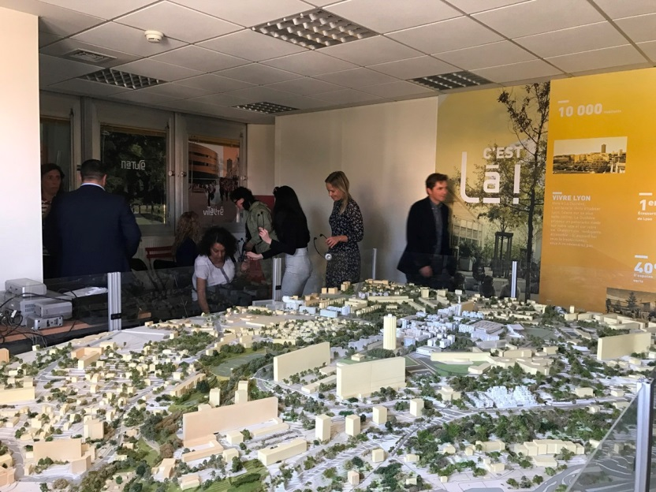
To this end, 1 700 social housing units were demolished (in 2005, 2010 and 2015) and then rebuilt, partly in La Duchère and partly in other neighbourhoods in Lyon. This also reduced the concentration of social housing units in La Duchère (80% in 2000, 60% now, 55% by 2018) and opened up the neighbourhood for non-social housing, thereby attracting middle-class residents seeking a good living environment.
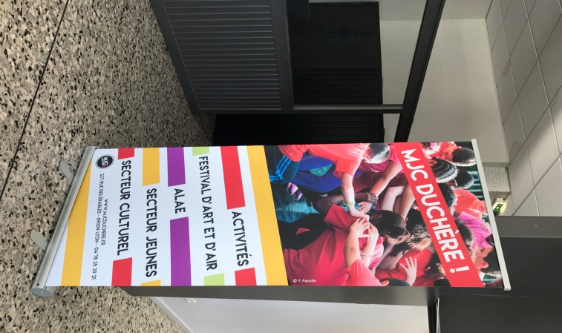
The families who lived in the neighbourhood before the demolitions were rehoused during the works and were then able to choose whether to return to La Duchère or move to other parts of the city. La Duchère now has spaces for shops, new public facilities (construction of two primary schools, reconstruction of a gymnasium, construction of an athletics centre, reconstruction of a senior secondary school, construction of a multimedia library, etc.), services (public transport and cycle tracks leading to the city centre) and attractive premises to encourage businesses and healthcare professionals to move in. From an architectural point of view, the neighbourhood has been designed to foster mobility, economic potential, interaction and a better image (there are plans to build a hotel, for instance) as a way of stopping residents from keeping themselves to themselves. That is also important when it comes to preventing violent extremism and radicalisation.
A participatory committee was set up halfway through the process so that residents were represented regarding certain issues concerning the regeneration of the neighbourhood. Residents are now excluded only from major strategic town planning decisions, which are taken by the public authorities on their own. However, encouraging young people’s involvement in consultative bodies remains a challenge, but the city is seeking ways of getting them interested and preventing them from staying away.
Culture is again becoming a tool here. For instance, the city has developed a major festival which is held in La Duchère with a view to combining more traditional cultural products with artistic creativity from the neighbourhood.
Some figures: the overall budget for the project is 750 million euros, mostly funded by the central government and local authorities, but with the participation of private developers and social housing organisations.

- Youth and Culture Centre (MJC) and grassroots initiatives
The Youth and Culture Centre in La Duchère is a meeting place for young people and local stakeholders. It is mostly funded by the City of Lyon under an agreement covering its entire term (five years); the remainder of the budget comes from the central government, with a small amount being covered by the centre itself, which uses the profits from its own activities.
During the study visit, the participants met professionals from the following departments:
- Crime prevention department: this department receives special funding from the state, which has been expanded so that it can also deal with preventing radicalisation. In addition, it funds an association which does social mediation between La Duchère residents and has the task of sounding the alarm about risks of radicalisation and cases of potential radicalisation.

- Youth sector: pays particular attention to groups in difficulty. Following the Charlie Hebdo attacks, it worked on developing training for professionals working on the ground, taking into account the issue of radicalisation. Since 2015, the department has held seven days of training for 70 professionals from different fields, jointly co-operating with the professionals working on the ground (social housing organisations, sports managers, the city, the state education system, etc.) and senior figures with a view to finding collective responses. A common challenge is how to find the right starting points, the right subjects of mediation to address the issue and the right techniques. Speakers must be credible so that the right messages get across.

- Le Lien theatre company: this is a theatre company in residence in La Duchère, which uses co-creation as a means of entering into mediation with groups in difficulty in the neighbourhood so as to offer them open views of topical issues and living together in harmony. It is a great tool for making contact with young people and other groups who otherwise would not participate (for instance, women).
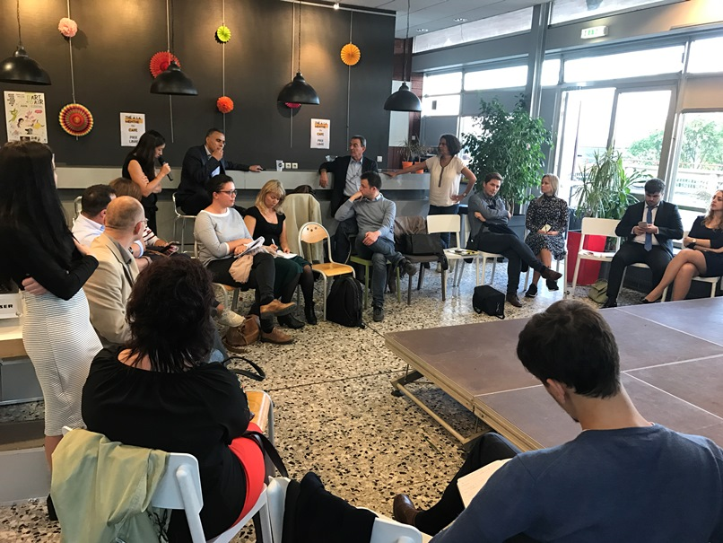

- Abraham group: this is an interfaith group that operates as an interfaith dialogue platform so that residents of different faiths recognise and respect one another’s differences, rejecting any types of sectarianism or isolationism. The group does a lot of work with young people and conducts various activities, including a radio broadcast concerning views of young people’s faiths and young people’s views of other people’s faith. Following the Charlie Hebdo attacks, they set up a discussion group in response to a strong need for to expression concerns; this led to the adoption of a joint declaration against all attempts to categorise people, dehumanise them or divide them, etc.

- City of Lyon history museum: the museum has developed an interfaith “urban walk” (guided cultural and tourist route) in La Duchère, which ends in “Little Jerusalem”, where there are four places of worship. This gives the museum a presence in neighbourhoods other than the (very central and touristy) one where it is based. In turn, this helps to boost the image of the neighbourhood.

- AS Duchère: this is a recognised and respected football club which uses sport as a means of promoting living together in harmony and respect for diversity. The club has an educational drive and focuses not only on sporting performance but also on equality policies (promoting participation by girls, openness towards the business community, participation by people with disabilities, etc.). The club has also been active in debunking conspiracy theories with the aid of a specialised social worker.

- La Maison des Passages
This is a historic place in Lyon known for its role in having hosted the social movement to the left of the parliamentary left. It is also a project aimed at taking on board the diversity of society and promoting intercultural relations. It operates in working-class neighbourhoods, as well as and above all in the city centre, where it is based, and holds lectures and debates about living together on the basis of symmetry between the various cultures that make up the city.
- Les Francas
Francas are lifelong and social education organisations that operate throughout France. In Lyon, the federation mainly focuses on children and, for instance, holds forums for child citizens addressing citizenship issues in cultural facilities in the city (opera, theatres, libraries). It has also held training courses for community youth workers and cultural mediators, and the various professionals involved have written a book describing their experience of interaction between cultural workers and lifelong education. The issues covered by Francas mainly relate to gender equality, intercultural dialogue, secularism and living together in harmony. Its members believe that culture is a good way of addressing secularism somewhat more indirectly and less formally. Francas Lyon co-operates closely with the national education system (state level), the regional office of cultural affairs (DRAC, regional office of the ministry of cultural affairs) and the city of Lyon. This co-operation is particularly important, for example, in the case of a new project entitled City Class, which is currently being experimented and consists of a week’s work with and in schools on the subject of living together in harmony. The project will use the theme of travel and the children will be asked to produce a travelogue describing their experience of getting to know other people’s cultures. It will involve studying and deciphering works of art lent by the museum of contemporary art which will be exhibited in the schools. The works selected will be related to the following issues: individuals’ relationships with their bodies, nudity, religious imagery, freedom of expression, science, travel, meeting others, the universality of art, relationships between boys and girls and the role of spectators. On the last day of the week, the children themselves will present the work done during the project.
- Museum of Contemporary Art
As a municipal museum, the museum of contemporary art is involved in implementing the charter for cultural co-operation with the city. This commitment leads its stakeholders to carry out public awareness-raising in priority districts, using modern art as a mechanism for cultural encounters. Museum staff is increasingly faced with hesitations and misgivings concerning nudity and other taboo subjects. This is also felt by teachers who are afraid to address certain issues as it could offend parents. The museum is therefore working to link art with being a citizen.
- Acte Public
Acte Public is a company of producers and performers set up over 20 years ago and specialising in audiovisual productions concerning art and culture (mainly documentaries and recording of performances and shows). It operates with the support of the French national film centre and now covers three main areas: 1) memory, transmission and teaching; 2) performing artists from migrant backgrounds; 3) young people.
Acte Public uses art to shed light on complex situations. For instance, it was after the Charlie Hebdo and then the Bataclan attacks that Acte Public decided to start addressing the issue of young people. Its producers came up with a project combining art, culture and complex issues, which gave rise to a thematic television programme called Culture and Diversity. The project is carried out with local television partners and involves a programme comprising a background documentary that asks a specific question, a studio broadcast to foster debate and exchanges and then a recording of a performance that presents a given performer’s view on the issue discussed.
It should be noted that various school classes from Lyon have taken part in the studio broadcasts, the aim being to establish dialogue between junior/senior secondary school pupils and a historian. The schools’ participation in the studio broadcast enables teachers to work on the selected issues throughout the year in preparation for the television debate. Under the project, teachers are therefore able to work on topical issues with the aid of the tools offered by the audiovisual sector. For their part, the young people become active participants in the project because they can also choose to work on scripts and produce short films on the issues addressed (in particular, discrimination, migration, diversity, etc.).
After the recording of the studio broadcasts, Acte Public visits the participating schools and shows the pupil’s previews of the work, including any short films made, giving them a further opportunity for discussion, sharing ideas and exchanges.

Conclusions

- Public policies that aim to prevent radicalisation must be planned on a medium to long-term basis and, as far as possible, must be shared and supported across political divides. They involve measures that can reach the whole population with a view to creating inclusive societies characterised by greater cohesion, relations based on mutual trust, a culture of conflict resolution through dialogue, respect for human dignity and a shared feeling of belonging to a common project thanks to the active participation of all citizens. The intercultural approach and the valuing of diversity applied to urban management policies seem to be effective tools for carrying out upstream work to prevent radicalisation.
- Combating radicalisation and violent extremism requires close and co-ordinated collaboration between a whole range of stakeholders, at all levels of governance (local, regional and national) and with civil society working on the ground. In France, for instance, there is a very finely meshed network, which means that there are many different stakeholders who can work together and therefore reach a very broad range of people. At the same time, the burden of the country’s colonial past has tended to produce tensions in contemporary society, especially among young people. In this particular case, it also seems important to work on recovering memory so as to help young people from colonial migrant backgrounds to build an identity (or identities) that is (are) strong but peaceful. Education and training of public service professionals in intercultural competences can clearly foster more consistent work around a common goal.
- Actions to prevent radicalisation and violent extremism must ensure that the root causes (often social) that make a particular section of society vulnerable to radicalisation are addressed, not just the ideologies. That would break the mechanisms that trigger all forms of radicalisation and extremism, without reducing the problem to religious radicalisation alone and without stigmatising a section of society.
- Public policies must promote the development among young people of (a) healthy and strong identity(ies) free of any complexes so as to prevent alienation, lack of a sense of belonging, marginalisation and community isolationism from gaining the upper hand and providing a fertile breeding ground for radicalisation. To this end, states and local authorities should promote a positive image of diversity in all professions, as well as in the public and cultural spheres.
- Social and ethnic mixing must be pursued in spatial planning policies, as well as in social housing and access to education. If necessary, territorial de-segregation measures must be adopted on a resolute, long-term basis, as they are investments that foster well-being for all. In general, however, the relevant social inclusion policies should be conceived, understood and developed as policies “Pro/For” (inclusion, welfare, peace, development, etc.) rather than as policies “Against” (radicalisation, extremism, etc.). This would make it possible to reach out to the whole population and foster the participation of all – without suspicion or mistrust – in building societies where it is possible to live well in diversity.

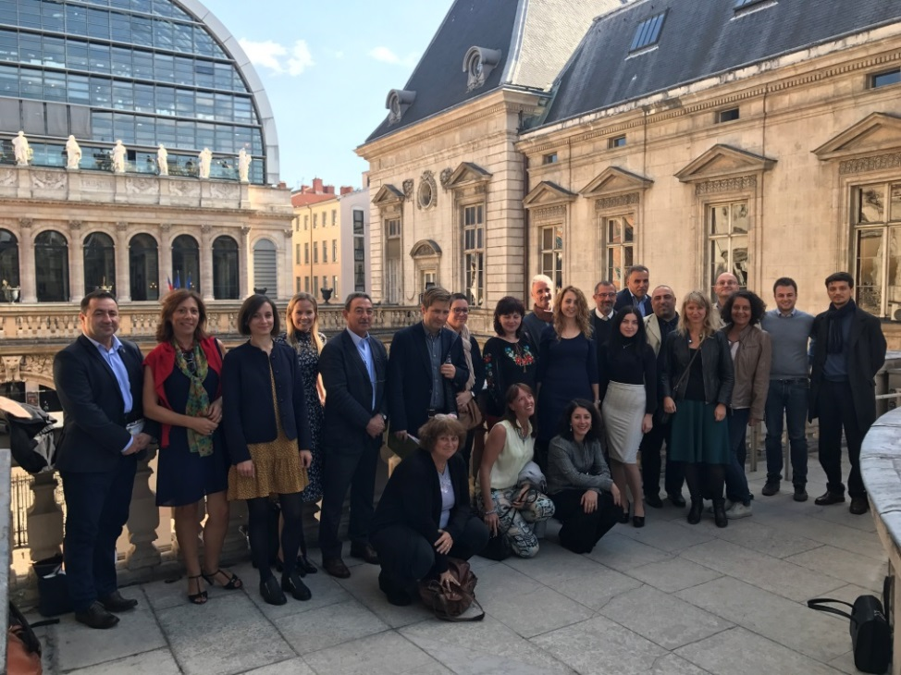
Ivana d’Alessandro, 28 October 2017

Cf. Resolution 2090 (2016) of the Parliamentary Assembly of the Council of Europe on “Combating international terrorism while protecting Council of Europe standards and values”.
Cf. Law No. 2004-228 of 15 March 2004 on the wearing of signs or clothing displaying religious allegiance in state primary, lower secondary and upper secondary schools.
Cf. Grand Chamber judgment in the case of S.A.S. v. France.
http://fr.euronews.com/2017/02/28/isis-the-end-un-jeu-serieux-pour-detecter-la-radicalisation-islamiste
In France, “urban cohesion policy” is a special public policy designed to reduce social inequalities and discrepancies in levels of development between different areas by stepping up public action in the most vulnerable urban neighbourhoods. Neighbourhoods in difficulty have higher levels of inequality than elsewhere, including high school dropout rates, high numbers of single-parent families, high unemployment levels, less public transport and fewer public services and hospitals. In Lyon, the priority neighbourhoods covered by the policy are home to 7% of the population. In the Rhône-Alpes region, the figure is 400 000, or 5% of the population.
The public culture service is a key asset for Lyon in this area. It is funded by local/regional authorities or the state; 20% of the city’s budget goes on cultural activities, which are attracting larger and larger audiences (for instance, a million people visit the city’s museums every year), making it possible to reach large numbers of citizens.
Cf. http://www.gpvlyonduchere.org/projet/gpv-accueil-projet/
Central Lyon has not yet reached the 25% share of social housing required by law, but the project has brought it closer to the target.
The festival (D’art et d’air) is designed to cultivate living together in harmony.
https://lapasseduvent.com/Au-beau-milieu.html
http://www.polville.lyon.fr/des-quartiers-lechelle-de-la-ville/les-thematiques/culture/la-charte-de-cooperation-culturelle

