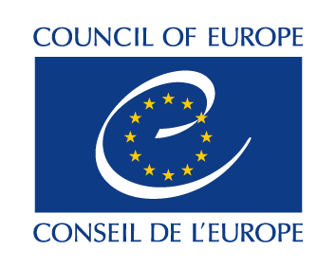

GRANT AWARD PROCEDURE
EXPLANATORY TEXT
(APPENDIX III)

Call for proposals for “Schools of Political Studies” Project
<Call for projects 2026-28>

Project proposal supporting Competences for Democratic Engagement and Culture (CDEC)
The funding that successful applicant organisations receive from the Council of Europe should develop their competences for engaging in democratic initiatives, fostering democratic culture, and contributing to the implementation of the Reykjavik Principles for Democracy adopted by the Heads of State and Government of Council of Europe member states at their Fourth Summit in Reykjavik in May 2023, thereby building political momentum for decisive actions to safeguard and enhance Europe’s democratic model.

Your CDEC Plan should answer one key question: “how democracy should respond to new realities against the backdrop of the core values of the Council of Europe.?” Explain the expected benefits for your learners and society at large.

A good CDEC Plan must be coherent with and appropriate for your organisation, its experience and its ambition. The application should be an original proposal. When answering questions and defining objectives, you should be as concrete as possible and refer to your other answers. You should also refer to any strategic documents you may have submitted with your application. Do not hesitate to repeat an important piece of information if you think it will help the assessors understand your plans and objectives.

This application should be the result of joint work in your organisation. You are free to decide on the number of objectives, giving priority to the most necessary developments, and explain the reasons behind your choices. Taking a gradual approach in your CDEC Plan will not reduce your chances of being successful.

In section 6. Project objectives, you are asked to define the objectives your organisation wants to achieve by promoting the CDEC in the areas of:

- Overall rationale: benefits for learners and society at large
- Curriculum and planning of educational offers
- Methodology of educational offers
- Assessment

The following possible guiding questions for each of those areas may inspire you:

- Overall rationale: benefits for learners and society at large
  - How will the learners’ experience and competences acquired by participating in your programme(s) contribute to their development?
  - How will you support the learners in acting as democratic leaders?
  - What change do you expect your programmes to bring to the society in which you operate as an agent for democratic culture? How do you make a difference?

- Curriculum and planning of educational offers
  - Please indicate any implicit or explicit references to democratic and intercultural competences in your present framework.

- Methodology of educational offers
  - How will the methods that you choose foster a culture of democracy?
  - How do you apply a participatory and inclusive approach that enables participants to develop democratic competences?
  - What methodological approaches do you envisage to be effective with regard to CDEC?

- Assessment
  - How do you measure the impact of your educational offer with regard to CDEC?
  - How do the assessment methods you have chosen show the gain in CDC of participants?
  - Which steps, if any, do you intend to take in order to align your methods for assessment with those suggested in the RFCDEC?

Your objectives should be concrete, realistic, and represent a real benefit for your learners, community and society. If you have attached any strategic documents, you should make sure that relevant objectives from those documents are considered in your CDC Plan in this section. If needed, you can repeat information from your earlier answers, or simply refer to them as part of your explanations for defined objectives.

In the section 7. Activities you are asked to propose a broad plan for activities, initiatives, changes and developments you want to promote. Make sure that you clearly link those with the objectives and explain how that is done and how you intend to organise, document and evaluate the activities.

Reykjavík Principles for Democracy – Appendix III of the Reykjavík Declaration

