2024 Council of Europe “Raoul Wallenberg” Prize

Nomination Form
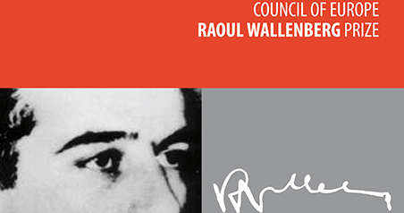

Deadline: 31 October 2023
Please read the regulations and instructions before completing this form electronically

Instructions

Nominations must be submitted on the present electronic form. All the rubrics of the form should be duly completed, in electronic format. If necessary, the form can be requested to the address wallenberg.prize@coe.int
The nomination form and the supporting documents must be submitted in English or French.
The nomination file for the 2024 Prize must reach the Secretariat of the Council of Europe at the latest on 31 October 2023.
It should be sent by e-mail, to the following address: wallenberg.prize@coe.int.
Where this is not possible, the nomination file may be sent by post, to the following address:

Secretary General of the Council of Europe
Raoul Wallenberg Prize
Council of Europe
67075 Strasbourg cedex
France

We will confirm receipt of your submission, but we cannot subsequently comment on the status of a nomination.

1. Nominee:

Please indicate the name and contact details of the person / group of persons / institution / organisation nominated.

Title: [Mr, Mrs, Ms, other…]
Family name:
First name:
Nationality:
Address:
Telephone:
Fax:
E-mail:
Website (if appropriate):

2. Sponsors:

Please indicate the name and contact details (address, telephone, fax, e-mail) of at least 5 persons / institutions / organisations putting forward the nomination.

Main sponsor:

Other sponsors:

3. Description of the nominee’s actions in the humanitarian field or in the promotion and defence of human rights:

Please summarise (maximum one page) the nominee’s main actions.

4. Specific merits of the nominee:

Please give the reasons (maximum one page) why the sponsors consider the nominee has made an outstanding contribution to the humanitarian cause (e.g. the action(s) has (have) made a real difference for the situation of the target group concerned, has (have) been instrumental in uncovering systemic violations of human rights on a large scale, has (have) successfully mobilised public opinion/the international community for a given cause, has (have) been successful in securing genuine improvements in a given area, has (have) been carried out at a great personal/physical risk).

5. Supporting documents:

Please insert links to supporting documents (maximum 5).
If the supporting documents are not available on the internet, please attach them to the form (electronic version if possible).

6. Date and signature:

