RPCI Webinar: "Communication, Gender equality and Interculturalism"

27 June 2022

Summary report

Report prepared by the RPCI Cooperative

On 27th June 2022 the Portuguese Network of Intercultural Cities (RPCI) held the webinar on Communication, Gender equality and Interuclutralism. The event started with a brief presentation of the RPCI Cooperative as well as of the “Gender equality and Interculturalism Project”. The webinar counted with four guest speakers: Alice Marcelino (visual artist), Yolanda Tati (radio presenter and influencer), Sónia Matos (AMUCIP) and Ana Paula Costa from Casa do Brasil Lisboa (Project MigraMyths ).
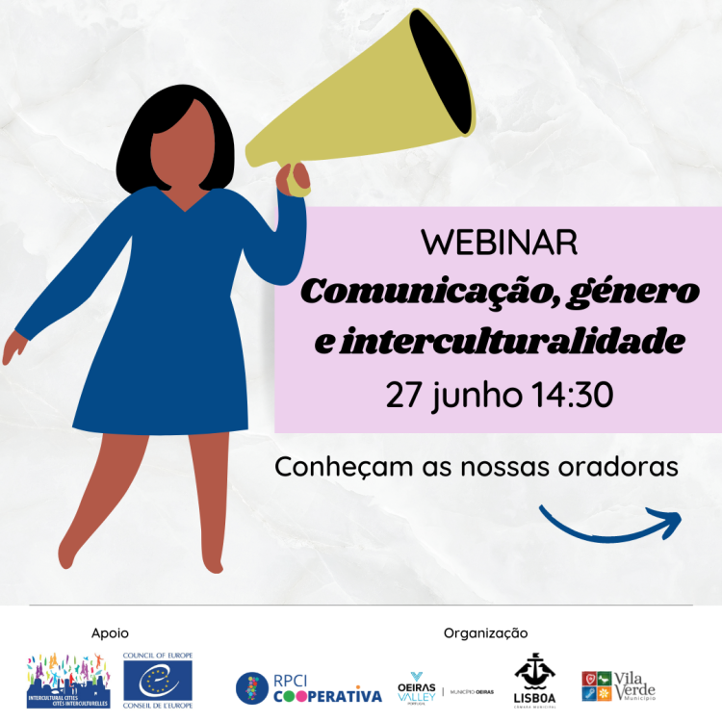
After the opening, journalist Catarina Marques Rodrigues, expert on gender issues and inequalities and founder of the Gender Calling platform, introduced the topic. She stressed the lack of representation of women and people representing socio-cultural diversity in the media, both in news and in leadership and management positions of media organisations.
The journalist referred to data that shows that gender equality issues are considered very important for the general public and, in particular, for generation Z. Most of the people interviewed consider that the media have made progress in these matters, but that there is still a lot of work to be done. Generation Z considers that the media has an important role to play in this area.
She further stressed that media vehicle images which may favour unconscious biases, namely in relation to appearance, age, gender, among others. She also mentioned that, according to the last European Social Survey, 62% of people in Portugal manifest some form of racism.
Catarina Marques Rodrigues also suggested that when we write a text and want to ensure that our communication is being done in a correct and inclusive way, we should answer the following questions: Could I be offending someone? ; Am I putting someone off?; Am I propagating a stigma or a preconceived idea? And that for a person to become anti-racist they have to go through a process, which goes through three zones: zone of fear, zone of learning and zone of growth.
After her presentation, Catarina Marques Rodrigues asked the guests to participate in the round table about their personal experiences and the work they have been developing.
Social scientist and board member of the Casa do Brasil Association, responsible for the Migra Myths Project, Ana Paula Costa, highlighted that the immigration process is a crisis process, it is never comfortable. At first there is always a process of adjustment, which is felt in a more pressing way in the case of migrant women, because the pre-established inequality that exists between men and women also arises in migration. In many cases, men migrate first and find jobs and women come in later, in a situation of financial dependence.
The reports of the Migra Myths project also report about discrimination against women in several public services. Health is the area where the highest rates of discrimination are reported, including harassment due to the language barrier. Regarding the service received by the Foreigners and Borders Service, there are reports of xenophobia, racism and blockages in the process of accessing rights. In the field of Social Security and Finance Services, the officials in charge of providing services to migrants are often unaware of the procedures. Until a person obtains a residence permit they are often in limbo, a situation that increases their vulnerability.
Another issue is the fact that migrants end up not reporting about discrimination because they are afraid being sent back to their home countries while being in an irregular and vulnerable situation.
It is important to work on communication to combat prejudice, including through social networks. In this sense, the guest pointed out that there are associations of migrant people that are at the forefront in Portugal and that work in a coordinated way.
The visual artist, Portuguese of Angolan origin, Alice Marcelino said that the black body is very stigmatised by society, including dress style, body language, hair. A black woman who wears her hair naturally is the target of various judgements and stereotypes.
As a black woman who has lived in several countries (Portugal, France, UK, Greece), Alice also addressed the circumstances of integration. She explained that the challenges to integration for a black person start right at the moment of the trip. Before migrating to another country, a black person needs to do some research to find out if in the chosen country they could face blatant racism, if there are hairdressers able to deal with their hair type, if there are products for their skin type, for example.
In the professional field, the first challenge is the advertising industry, because this is still an area dominated by white men, and the system is designed for the needs of men from job opportunities to who makes the decisions. She also mentioned that there is an expectation from black women to have one narrative only, that of oppression which, although it is part of the experience of many black individuals, it is not the only issue and it ends up closing many doors.
In this scenario, there is yet another question regarding women. It is noted that there are still very few opportunities for artists who are also mothers when compared to male artists who are also fathers, but who continue to develop their careers without paretnhood being an obstacle.
Speaker and influencer, Yolanda Tati, shared her experience of early career and motherhood. At the beginning of her career in the media field, she faced some barriers, as there was a widespread idea among media agents that her profile as a black woman would not be a voice that people wanted to hear. Gradually this situation changed, space exist but is not being adequately explored.
Yolanda has a very significant presence on social media and when she became a mother to a child who has a white man as father, there was much speculation about the skin colour of the baby. The influencer mentioned that often her skin colour and gender immediately created an expectation that she will be an aggressive person, a domestic worker or with a promiscuous personality, as these are stereotypes and prejudices suffered by black women, as if their place was only that and they could not occupy other places, including a successful place.
The movement Black lives matter has contributed to change the global landscape. From the debate started by this movement, brands changed their positioning and Yolanda increased her client portfolio. Another curious situation was when she took part in an advertising campaign in which she wore her hair straight and was criticised for doing so. The conclusion she comes to is that black women are so poorly represented that from the moment a black woman appears, she has to wear her hair naturally so that she can represent other women. We still haven't reached the point where a black woman can be whatever she wants and wear her hair as she wants. In the Portuguese media there is still a long fight ahead to achieve greater representation, particularly on television.
Sónia Matos, president of the Association for the Development of Roma Women (AMUCIP), focused on the issue of education and the importance of full access to it for Roma women, in order to break the cycle of social exclusion to which they are often condemned.
In her words, Roma culture in Portugal still sees women as housewives and mothers due to the predominant role of men in the organisation of community life.
Portuguese Roma women are just starting conquering space and independence and, in her opinion, the kick-start for this to happen begins with school integration.
AMUPIC works with women and men from the Roma community to make access to education a reality, even for women who are already married and left school a long time ago. Today there are more than 40 Roma people with university degrees in Portugal and this reality is encouraging but requires more perseverance and dedication to be mainstreamed. Raising the awareness of education professionals is extremely important, mainly because some Roma children enter the first cycle without having had any school experience and therefore have more difficulties. In this context, it is even more important for teachers to transmit positive expectations to Roma girls at school and help them to believe in themselves, increasing their self-esteem and avoiding perpetuating negative stereotypes and beliefs about the Roma community.
Another important issue regarding Roma people is social and neighbourhoods’ segregation, which increases stigmas and stereotypes. It is necessary to involve the community, work with the socio-cultural mediators in schools, encourage Roma representation in schools, and make Roma children feel that public space is also theirs.
Other issues deeply affect the community, such as stereotyping language, the fact that social projects take place with limited and often short timeframes.

