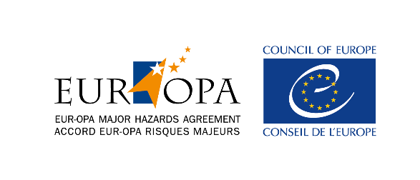
Strasbourg, 11 March 2021 AP/CAT(2020)01rev REC
Orig. English

EUROPEAN AND MEDITERRANEAN MAJOR HAZARDS AGREEMENT
(EUR-OPA)

DRAFT RECOMMENDATION

Enabling and protecting persons with disabilities during a viral or other pathogenic pandemic, as well as another biological disaster

Proposed for adoption at the 14th Ministerial Conference on
24 November 2021 in Matosinhos, Portugal

The Committee of Permanent Correspondents of the European and Mediterranean Major Hazards Agreement (EUR-OPA),
- Recalling its Recommendation 2013 - 1 on the inclusion of people with disabilities in disaster preparedness and response, adopted at the 64th meeting of the Committee of Permanent Correspondents of the European and Mediterranean Major Hazards Agreement (EUR-OPA), Paris, France, 24-25 October 2013;

- Noting the Disability Considerations during the COVID-19 outbreak published by the World Health Organisation on 2 June 2020;

- Noting the Statement of interpretation on the right to protection of health in times of pandemic adopted by the European Committee of Social Rights on 21 April 2020;

- Recalling its Resolution 2020–1 recognising the inclusion of biological hazards in the EUR-OPA Partial Agreement adopted on 3 November 2020;

- Recognising that people with disabilities have a fundamental right to protection against disasters, including those resulting from viral or other pathogenic pandemics as well as other biological risks that is comparable with that enjoyed by the rest of the population;

- Desirous to promote a more integrated, efficient and effective approach of public authorities and health professionals to ensure appropriate protection to people with disabilities during biological emergencies and disasters;

- Noting with interest of the report “Disabled Persons in Viral Pandemics: The Example of Covid-19”, prepared at the request of the Agreement;

Recommends that member States of the European and Mediterranean Major Hazards Agreement (EUR-OPA):

- Design and promote national standards for the protection and care of people with disabilities in particular by making public health information and health care facilities accessible to persons with all forms of disabilities, including testing and isolation services, in particular in disasters and emergency situations;

- Review, in consultation with persons with disabilities and their representatives, national biological risk reduction policies, planning processes, training curricula and emergency response practice with a view to integrating specific measures that would reduce the vulnerability and exposure of people with disabilities to disasters, caused by biological hazards;

- Review the Medical Code of Ethics and other deontological codes of practice to ensure that the provision of healthcare during disasters conform fully with the provisions of the Article 25 of the UN Convention on the Rights of Persons with Disabilities and jurisprudence of the UN Committee on the Rights of Persons with Disabilities and do not discriminate against people with disabilities;

- Ensure that measures adopted to counteract disasters caused by biological hazards provide for people with disabilities to have access to flexible work arrangements that take into account their form of disability and potentially increased vulnerability; give adequate support to caregivers, including family members, in particular by including them in flexible work arrangements and other specific measures designed to protect employment, and by providing them with appropriate moral support that could reduce their mental stress;

- Support the initiatives of the EUR-OPA Major Hazards Agreement to promote, with respect to disasters caused by biological hazards, inclusive disaster risk reduction strategies for people with disabilities in its member States, in particular through the promoting adequate regulations, sharing expertise, awareness raising, undertaking training programmes and promoting good practice;

Invites the Secretariat to submit the Recommendation 2020-1 to the Committee of Ministers for information and possible distribution to all member States of the Council of Europe.

