Questions received related to Tender BH4783/94
- Can you please send us the tender dossier for the BH4783/94!!
- Our company is interested in participating in the tender with ID: COE-28-10-2022 and titled: ``Catering printing photography and local transportation services.''
Please send us the file of this tender.
- Our company is interested in participating in the tender with ID: COE-28-10-2022 and titled: Catering printing photography and local transportation services. Please send us the file of this tender.

Answer:

To download the documents (Act of Engagement and Tender File) related to the tender, please click on this link:
https://www.coe.int/en/web/pristina/call-for-tenders
Then click on the Act of Engement and Tender file links, as shown in the yellow highlighted part in the screenshot below circled in blue:
https://www.coe.int/en/web/pristina/call-for-tenders
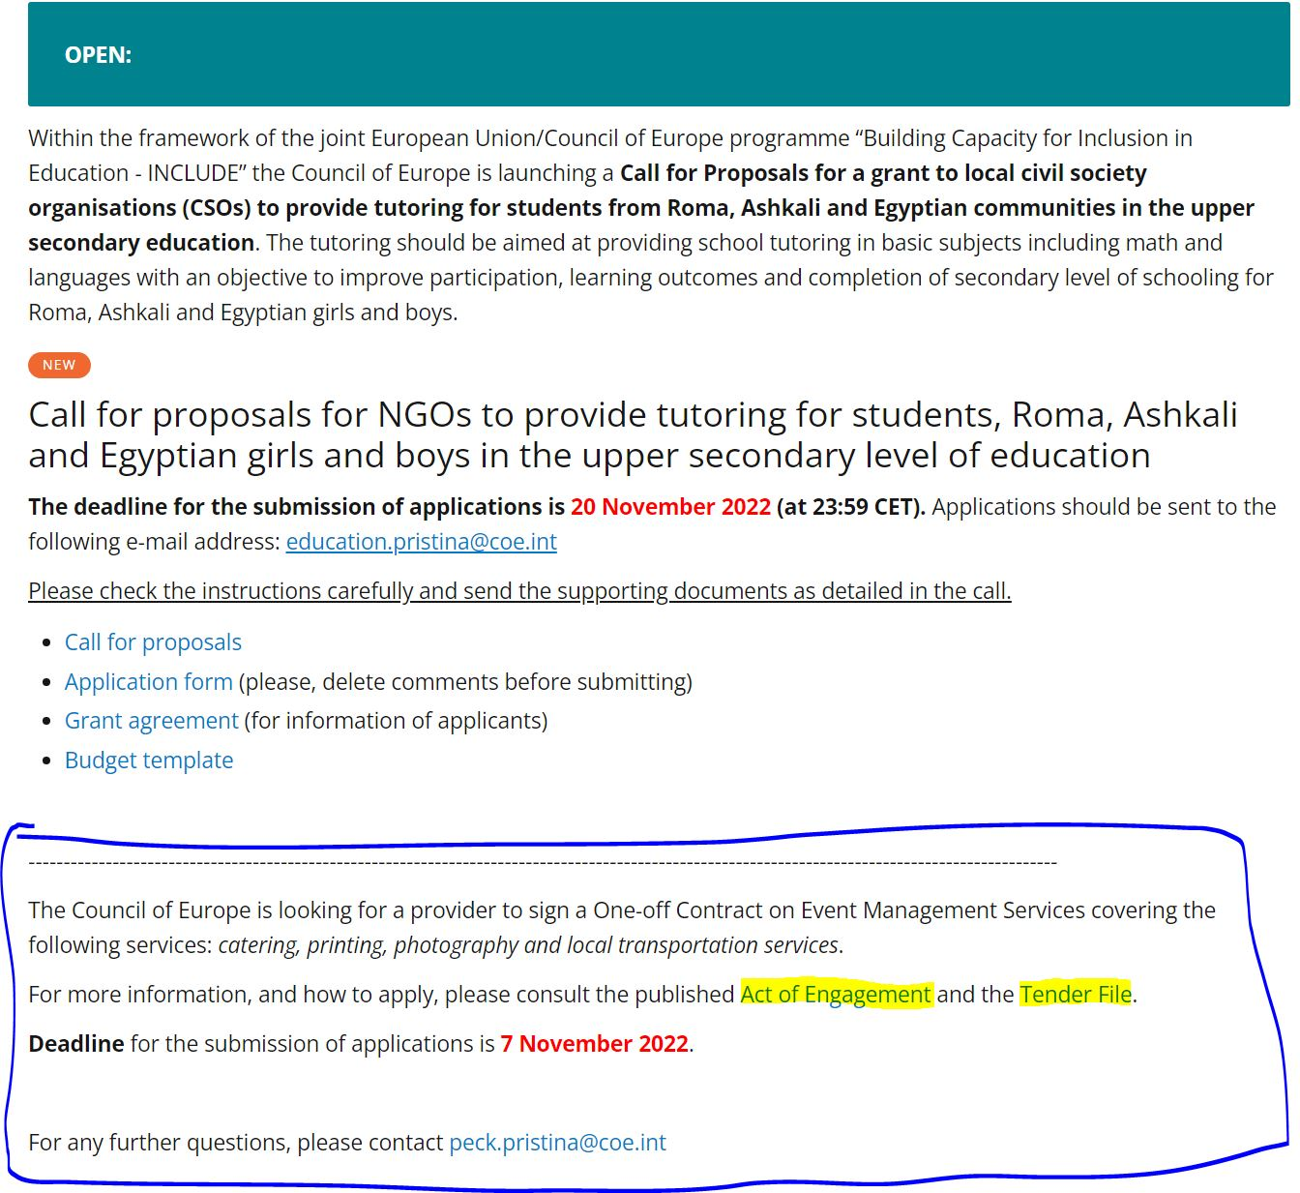

Best regards,
PECK Project Team.

