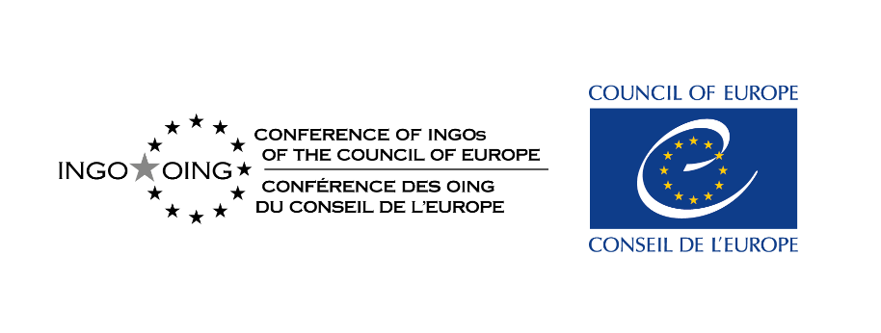
Conference of INGOs of the Council of Europe - Expert Council on NGO Law
Preparation of a study on
“Restrictions on NGOs Representing or Providing Support to National Minorities”

Questionnaire for Civil Society Groups, National Human Rights Institutions
and Others Working on National Minority Issues

Instructions: Please answer directly in the present form (adding any links or attachments), and send back your responses by 31 July 2026 to Carla Ferstman at cf16045@essex.ac.uk with copy to ngo-unit@coe.int , indicating in object “CINGO-EC study on NGOs and national minorities”
a. Contact details (Name, email, organisation, country(ies) concerned by the responses):

b. Consent - Please indicate if you consent for the Expert Council on NGO Law to use the material you provide in its upcoming study.
YES / NO
If there are any limitations on your consent (e.g., limitations related your name, organisation or similar, please indicate:
c. The Definition of "National Minorities" for the purposes of this questionnaire
For the purposes of this questionnaire, the term “national minority” is taken to mean: persons who:
(a) belong to a group which is smaller in number than the rest of the population of a State;
(b) are citizens of that State; and
(c) have, through their antecedent family members, a significant connection with another State as a result of either:
(i) the redrawing of territorial boundaries in Europe or of
(ii) migration from that State (whether it is in Europe or elsewhere).
- Does your country recognise and protect in its constitutional or other law the existence of national minorities as defined above?

- If not, does your country so recognise and protect persons as belonging to a minority who might fall within either (c)(i) or (c)(ii) in the definition above? If so, please explain and provide a link to the legislation or policy document relevant for such recognition and protection.

- Are there any debates in your country about whether any such recognition and protection is over-inclusive or under-inclusive? If so, please explain the nature of these debates and indicate whether there are any specific groups who argue that they should be similarly recognised and protected but who have not been.

- Are there any examples in your country of groups of persons who might fall within (c)(ii) in the definition above requesting recognition and protected as a minority and in such cases, please explain whether they have been so recognized and protected.

- Is there any specific regulation governing the work of civil society groups/NGOs on issues relevant for persons who fall within the recognition and protection accorded in your answers to either Q3 or Q4? or who seek such recognition and protection If so, please explain and provide links to relevant legislation, regulations and any other policy documents. Also, are there any proposals to change/introduce such regulation and, if so, who is making such proposals?

- Have any submissions to regional or international monitoring bodies/courts which address concerns facing either
(a) persons who might fall within the definition of national minority for the purpose of this questionnaire (whether so recognised by the State) or
(b) civil society groups/NGOs who work on issues relevant to them?
- If so, please indicate the nature of the submissions/applications (e.g., the exercise of particular freedoms, bans on forming political parties and contacts with persons in other States) and provide links to reports, judgments and any other information.

- Are there are any other issues you would like to raise facing civil society groups/NGOs who work on issues relevant to persons who might fall within the definition of national minority for the purpose of this questionnaire (whether so recognised by the State), such as:
- freedom of peaceful assembly, freedom of association, freedom of expression, and freedom of thought, conscience and religion
- The ability to establish and maintain free and peaceful contacts across frontiers with persons lawfully staying in other States, in particular those with whom they share an ethnic, cultural, linguistic or religious identity, or a common cultural heritage.
- The ability for national minority groups to establish and maintain their own associations, or whether failure to register NGOs, delays to register; de-registration of NGOs who are promoting minority issues.
- Use of national security rationales to deny rights to national minority groups.
- Whether “minority parties” have been banned or restricted from standing for election.
- Please add any further information

