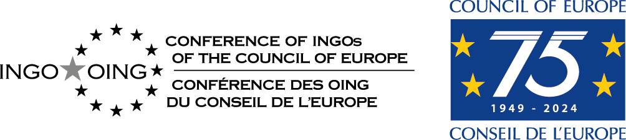

General Assembly of the Conference of INGOs
7-9 April 2025

PROXY VOTING FORM

For the decisions and votes to be taken during the meeting

Please send to the Secretariat (emelyne.dentinger@coe.int )
before 4 April 2025 at 14:00

I hereby certify that I am unable to attend the meeting of the General Assembly on …. April 2025, but delegate authority to

Name of the person entitled to vote :

Date he/she will represent me:

……………………………………………………………………………………

to represent me and vote on my behalf on all questions put to the vote during the meeting.

Done at on 2025

Signature

