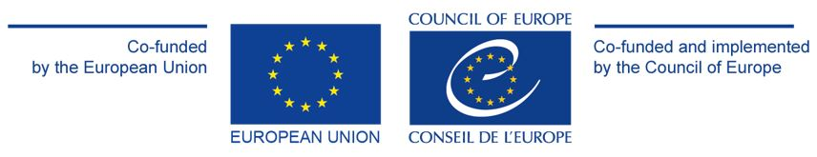
Strengthening access to justice in Latvia through fostering mediation and legal aid services (Phase II) 2022 – 2023
The project “Strengthening access to justice in Latvia through fostering mediation and legal aid services” builds upon another project successfully implemented by CEPEJ and the European Commission’s Directorate-General for Structural Reform Support (DG REFORM) between 2019-2021. Following the experts’ assessment report and recommendations that were formulated during this previous phase, this project aims to support the development of an effective preliminary legal aid mechanism in Latvia while encouraging recourse to mediation.
Project’s objectives
The project’s first objective is widening the scope, availability, and quality of state ensured legal aid in Latvia. In addition, it aims to increase the awareness of and recourse to mediation in Latvia as a means of conflict resolution.
Expected Results
The preliminary legal aid system, which would refer persons to the specific type of legal advice they require, will work using a new model specifically adapted to its national context using a combination of European good practices, and experience from the previous project. A module to train frontline advisers that will provide preliminary legal aid and have the capacity to refer cases to mediation when appropriate, will exist. A quality assurance mechanism will have been developed that enables efficient monitoring of the quality of the provided legal aid services. Lastly, specific groups will be identified for targeted campaigns to raise awareness on the advantages of mediation as an alternative method to judicial dispute resolution.
Main activities
- Report and recommendations on the establishment of quality standards and a quality assurance mechanism for state ensured legal aid, also considering an increased recourse to mediation
- Offering capacity building activities for those involved in providing legal aid by developing and testing a training programme in various focus areas including mediation
- Design, implementation, and analysis of a pilot project using a tailored preliminary legal aid mechanism that considers the possible recourse to mediation. The quality assurance mechanism and training module above will also be tested.
- Report and recommendations on how mediation can be promoted strategically, according to the needs of specific target groups, and development of materials for a communication and public awareness campaign

Project beneficiaries and stakeholders
The main partners of the project are the Ministry of Justice, the Legal Aid Administration of Latvia, the Council of Certified Mediators, and the Judicial Training Centre.

