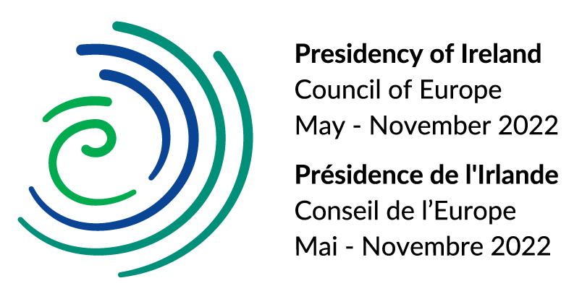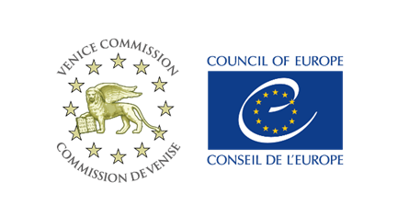

INTERNATIONAL ROUND TABLE

“CIVIL SOCIETY: EMPOWERMENT AND ACCOUNTABILITY”

STRASBOURG, COUNCIL OF EUROPE and ONLINE

13 SEPTEMBER 2022

CONCEPT

A vibrant and diverse civil society is an essential part of the system of checks and balances in a stable and effective democracy. Civil society organizations depend on enabling legal environments that safeguard freedom of association and interrelated rights such as the right to freedom of expression and opinion, freedom of assembly, freedom of thought, conscience and religion and the right to participate in public affairs. Supporting the role and diversity of civil society in member States, including human rights defenders, is one of the key strategic priorities of the Council of Europe and the OSCE.

The Venice Commission and ODIHR have devoted a lot of attention to freedom of association. In particular, in 2014, the Commission and ODIHR issued Joint Guidelines on Freedom of Association (CDL-AD(2014)046). Since then, important new issues have come to the forefront. A compilation of the Commission’s work on this topic shows the variety of issues which it has addressed.

Recently, two opposing trends have emerged. On the one hand, NGOs have become more involved in public life, although at times they may face challenges in this process. Both the Venice Commission and ODIHR stress the importance of such involvement in order to make public decision-making more participative. NGO participation in public life also serves to improve the quality of policy and legislative decisions, to enhance the potential for their successful implementation and ultimately to increase public trust in public institutions.

On the other hand, some member States see a risk of undue interference with their internal affairs, especially when associations that receive foreign funding are involved in public affairs. For the Venice Commission and ODIHR, overregulation in this sphere may have adverse effects on public life and feed anti-democratic and illiberal political narratives. Limitations to the right of freedom of associations must always be prescribed by law, have a legitimate aim and be necessary in a democratic society. Legal instruments aimed at combating terrorism and money laundering should not be abused or result in the suppression or dissuasion of dissident political voices.

In the past decade, the Venice Commission and ODIHR have assessed legislation regulating foreign-funded associations, issues related to registration, reporting and disclosure obligations, and compliance of the national legislation with applicable international standards. In 2019, the Venice Commission adopted a report on the funding of associations. These matters deserve further reflection with a view to developing concrete solutions on how to meet international standards while catering for the legitimate concerns of States.

The proposed roundtable, organised under the auspices of the Irish Presidency of the Committee of Ministers of the Council of Europe, will contribute to this reflection process by bringing together speakers from different, relevant fields: experts in international standards (including money laundering), members of the Venice Commission and ODIHR experts, representatives of domestic and international NGOs and of the national authorities from countries with a relevant experience. The roundtable will last one day (13/09/2022) and will start with opening addresses, followed by two thematic panel sessions.

The first panel session will focus on various forms of participation of civil society organisations in public life, and in particular in law-making procedures and in the work of independent institutions. The speakers will be invited to reflect on the distinction between political activities, lobbying, and civic activism.

The second panel session will focus on regulations concerning foreign-funded NGOs related to reporting obligations, labelling requirements, and their effect on the freedom of association.

Speakers will be encouraged not only to identify problems but also propose solutions (already existing or possible). At the end of the roundtable, participants will be invited to discuss the main conclusions of the exchange.

INTERNATIONAL ROUND TABLE

“CIVIL SOCIETY: EMPOWERMENT AND ACCOUNTABILITY”

PRELIMINARY SHORT PROGRAMME

STRASBOURG, COUNCIL OF EUROPE and ONLINE

13 SEPTEMBER 2022

9:00 – 10:00 OPENING SESSION
- High-level representative of the Irish Presidency (Minister Thomas Byrne, tbc)
- Secretary General of the CoE (Ms Marija Pejčinović Burić)
- President of PACE (Mr Tiny Kox, tbc)
- President of the Venice Commission, Mme Claire Bazy Malaurie
- Director of OSCE/ODIHR, Mr Matteo Mecacci
- UN Special Representative on the right to peaceful assembly and association (Mr Clément N. Voule, tbc)
- CoE Human Rights Commissioner (Ms Dunja Mijatović)
- Director of the FRA (Michael O'Flaherty )

10:00 – 13:00 PART I: PARTICIPATION OF THE CIVIL SOCIETY IN POLITICAL PROCESSES
10:00 – 11:00 Defining the framework
- Presentations by representatives of the Venice Commission, OSCE/ODIHR, CoE Expert Council on NGO Law, on the forms of participation of the civil society in the political decision-making and work of the public institutions.

11:30 - 13:00 First panel: public participation in political processes
- Discussion among representatives of the authorities, of independent institutions, and of NGOs from selected jurisdictions and international experts.

13:00 – 14:30 LUNCH
14:30 – 18:00 PART II: FOREIGN FUNDING OF ASSOCIATIONS
14:30-15:30 Defining the framework
- Presentations by representatives of the ECtHR, the Venice Commission, and the OSCE/ODIHR on the legal framework of regulations of the foreign-funded NGOs

15:30 – 16:00 Coffee-break
16:00 – 17:30 Second panel: legitimate obligations of foreign-funded NGOs
- Discussion among representatives of the authorities and judiciary and NGOs from selected jurisdictions and international experts on the practice of regulations of foreign-funded NGOs.

17:30 – 18:00 CONCLUDING SESSION

