Report

Portuguese Network of Intercultural Cities

April-June 2024

# Summary

During the second quarter of 2024 RPCI´s work focused mostly on managing projects and other initiatives, preparing new funding applications and finishing the 2 EU Grants. The annual joint project “Intercultural schools” started. The cooperative RPCI, created in 2021 to support the Network, maintains two member cities (Oeiras and Loures) and has managed during this period the closing phases of 2 projects funded by the European Commission (“NET-IDEA” - finished in 30th April 2024 and “DiverCities” - finished at 30th June 2024). In total, eight different cities are actively engaged in these projects, one of them being engaged in more than one project.

# Network coordination

RPCI´s coordination was ensured based on **regular contact** with the member cities via email (around four emails were sent to all member cities) and bilateral phone calls, emails or meetings when needed.

As part of the coordination activities, messages with information on how to join RPCI were sent to new cities. Support was provided on request, via phone calls or online meetings, including questions about filling in the INDEX, participating in projects managed by RPCI, information about the RPCI network and ICC programme (for ex. to Vila Nova de Gaia), events and seminars, and others.

## **RPCI** **advertised all the ICC initiatives and news,** such as the training on Anti-Rumours and the DiverCities event in Strasbourg.

## Negotiations are being held with Vila Verde and Braga for the hosting of an ICC coordinators meeting in November 2024.

Finally, RPCI coordinator was also engaged in preparing a **study visit** to Lisbon, Loures and Cascais by Finnish cities, held on 10th and 11th April where the RPCI was presented.

# Activities

## RPCI coordination led the activities of 2 projects. Besides, oversaw and had an active role in all the activities developed within the Network and the RPCI cooperative, and prepared 2 new funding applications: for consultancy services with the Council of Europe on Anti-Racism and preventing AI Discrimination.

## Annual project - Intercultural Schools

This project was built collaboratively, arising from the brainstorming meeting held in 2023 with RPCI cities, and has the goal to foster intercultural competencies among school staff and strategic partners. The project was submitted in February and approved in March, and started on 1st April 2024. All RPCI cities were invited to be part of the consortium to co-manage the Grant, and 4 cities have manifested their availability - Lisboa, Oeiras, Barcelos and Paranhos. These cities will have monthly consortium meetings.

The project envisioned to promote awareness raising activities, workshops and webinars, respectively to students, families and school staff, as well as to establish a connection between RPCI and the REEI - Network of Schools for Intercultural Education, managed by AIMA, Aga Khan Foundation and the MInistry of Education. A meeting with REEI is already set for the 19th July.

Meetings were held with several schools from these cities to set the dates for the workshops that will occur in September.

The webinars for teachers and other education professionals will occur in October, and the cities have been listing experts and schools to invite.

NET-IDEA project

NET-IDEA is a European-funded project, coordinated by ICEI in partnership with RPCI, RECI, the Swedish Network of Intercultural Cities, and the cities of Lublin and Erlangen. This project has the goal to develop local Intercultural Strategies, by fostering Intercultural competencies in cities. The project started in May 2022, and, in Portugal, three cities are engaged in this project: Vila Verde, Braga, and Santa Maria da Feira. RPCI is responsible for WP4 and WP5, respectively designing and testing and Intercultural Competencies Training in all sixteen cities and fostering Communities of Practice (CoP) at international and national levels. During the 2nd quarter of this year, our activities were focused on the final event in Sweden (to which RPCI took a delegation of 9 people, including 3 youngsters form the participating portuguese cities), the final communication campaign “Be Everything, Belong” and delivering the final report and deliverables of the project. A podcast episode was launched with interviews to the youngsters that participated in the event.

## DiverCities project

## DiverCities is an European-funded project, coordinated by ICEI in partnership with RPCI and RECI and engaging the cities of Logrono, Castello de La Plana and Zaragoza (Spain), Modena and Pontedera, Reggio-Emilia (Italy), Ioannina (Greece). During this period, two intercultural Assemblies were held, with more than 40 participants from Apelação, a neighbourhood in Loures (6th April and 4th May). The Assemblies were prepared jointly between the RPCI, the Municipality and 2 local based organisations/ grassroots.

During the month of June, the refurbishment of a local garden was prepared jointly with the community. On the 15th June, an inauguration event was held with 55 people.

On the 19th June, a final seminar and workshop on “Participatory Assemblies” was held with an external trainer. Around 26 people took part in this event, among them 3 cities other than Loures: Lisboa, Porto and Viseu.

A media campaign was also held, on social media and 1 podcast episode was launched about the project.

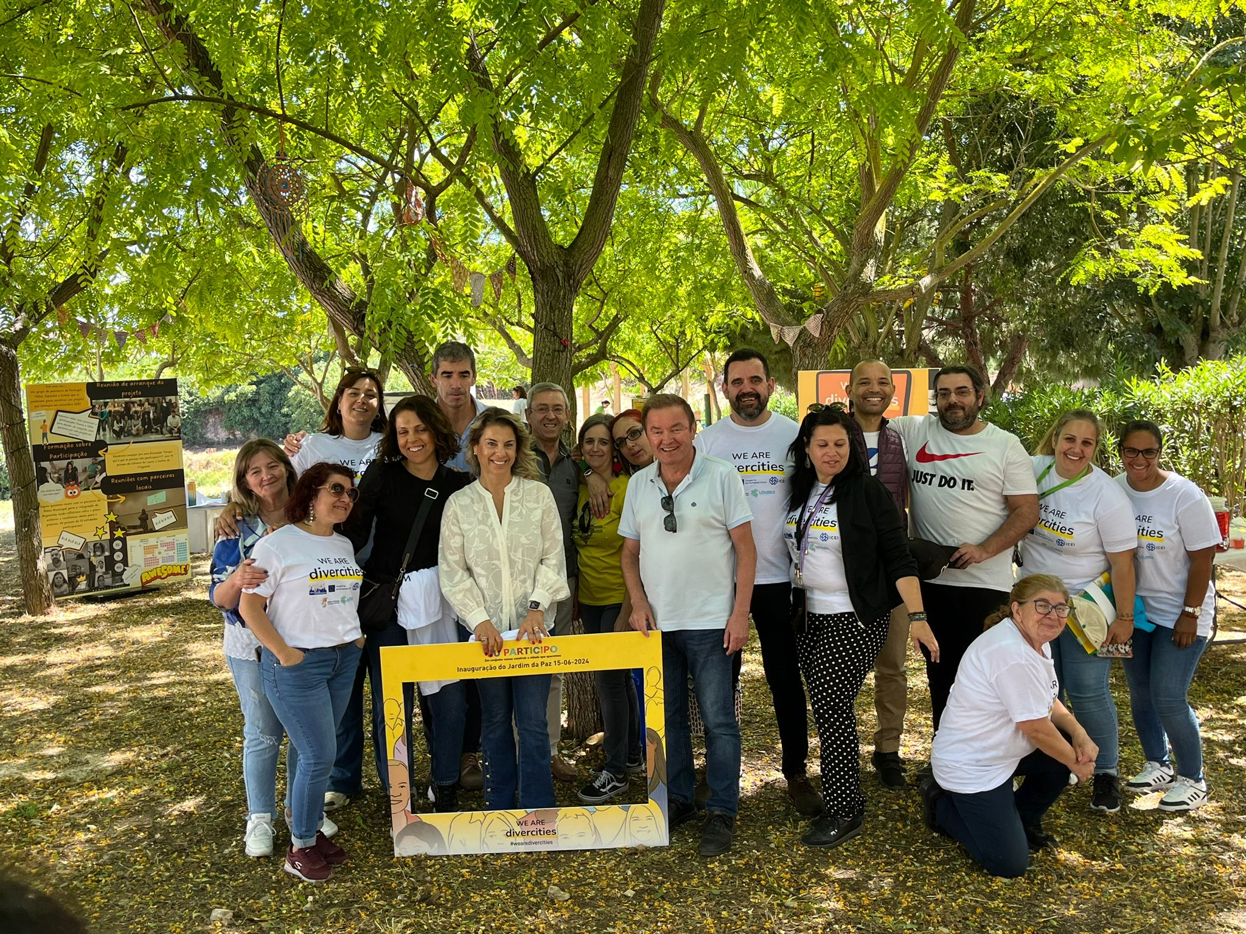

# Communication

During this quarter,10 posts were written and promoted, such as:

- One original article on World Refugee Day: <https://cidadesinterculturais.pt/2024/06/20/hoje-e-o-dia-internacional-da-pessoa-em-situacao-de-refugio/>

- One original article about EU Diversity Month: <https://cidadesinterculturais.pt/2024/06/06/celebrar-maio-o-mes-europeu-da-diversidade/>

- One original article about the April Portuguese Revolution: <https://cidadesinterculturais.pt/2024/04/24/25-de-abril-a-revolucao-que-mudou-portugal/>

- One news about the DiverCities event in Strasbourg: <https://cidadesinterculturais.pt/2024/06/17/partilha-de-praticas-a-nivel-internacional-divercities-em-estrasbourgo/>

- One news to advertise the inauguration of the garden on the 15th June (DiverCities): <https://cidadesinterculturais.pt/2024/06/14/divercities-inauguracao-do-jardim-da-paz-na-apelacao-loures/>

- One news to advertise the final seminar of DiverCities in Loures: <https://cidadesinterculturais.pt/2024/05/27/divercities-evento-final-em-loures-no-dia-19-de-junho/>

- One news to advertise the NET IDEA podcast episode: <https://cidadesinterculturais.pt/2024/05/10/novo-episodio-de-podcast-juventude-interculturalidade-e-inclusao/>

- One news about the final event of NET IDEA in Sweden: <https://cidadesinterculturais.pt/2024/04/23/mais-de-130-ativistas-de-toda-a-europa-juntam-se-em-acao-coletiva-de-arte-publica-para-promover-a-inclusao-e-a-interculturalidade/>

- One article for the Communication Campaign of NET IDEA: <https://cidadesinterculturais.pt/2024/04/13/be-everything-belong-celebra-o-projeto-net-idea-que-juntou-16-cidades-europeias-em-nome-da-interculturalidade-e-contra-todas-as-formas-de-odio-e-discriminacao/>

- One article about the local exhibitions for the PhotoVoice of NET IDEA in Vila Verde: <https://cidadesinterculturais.pt/2024/04/13/inauguracao-da-exposicao-o-poder-atraves-das-fotos-na-escola-basica-e-secundaria-da-arrifana/>

A new page was created on RPCI website to describe the projects developed and their results: <https://cidadesinterculturais.pt/projetos/>

Regarding social media, RPCI maintained the existing Facebook, Linkedin and Instagram pages with regular posts. Below is a summary of the main activities and reach of each channel, for the relevant period (January-March):

* [**Facebook**](https://www.facebook.com/RPCIPortugal)

Reach (average): 1,4 thousand

Visits:711

New likes: 14

Publications: 44

* [**Instagram**](https://www.instagram.com/cidadesinterculturais/)

Reach: 515

Visits: 125

Stories: 50

Publications: 37

New followers: 47

* [**Linkedin**](https://www.linkedin.com/company/70400375)

Page Visits: 53

Followers: 545 (13 new), most from Great Lisbon and Porto regions

Average impressions: 658

Total Posts: 7

|  |  |
| --- | --- |
| * [**Website**](https://cidadesinterculturais.pt/) **“Cidades Interculturais”**   Views (average): 530  Visitors (average): 245  Articles/ posts: 10 articles (3 original)  1 new page |  |

* **Podcast Channel** [**“Portugal Plural”**](https://open.spotify.com/show/6OOLtIdwKSm1i3QrGYslIA?si=0a01a4bfc59c4bab)

New episodes: 2

Average play per episode: 2

Followers: 40

Total reproductions: 207 (mostly women from Portugal and Brazil)

* **YOUTUBE @redeportuguesadecidadesint2259**

All time: 18 subscribers | 12 videos | 558 views

1 new video - NET IDEA (20 views)

<https://www.youtube.com/watch?v=6eNnXyEXRzc&t=4s>

# Other activities

RPCI coordinator prepared a study visit from 6 Finnish cities to Portugal, to the cities of Loures, Lisboa and Cascais, that was held on the 10th and 11th April, with the presence of 19 people from the CoE, 6 Finnish cities and 3 people from the Finnish Government.

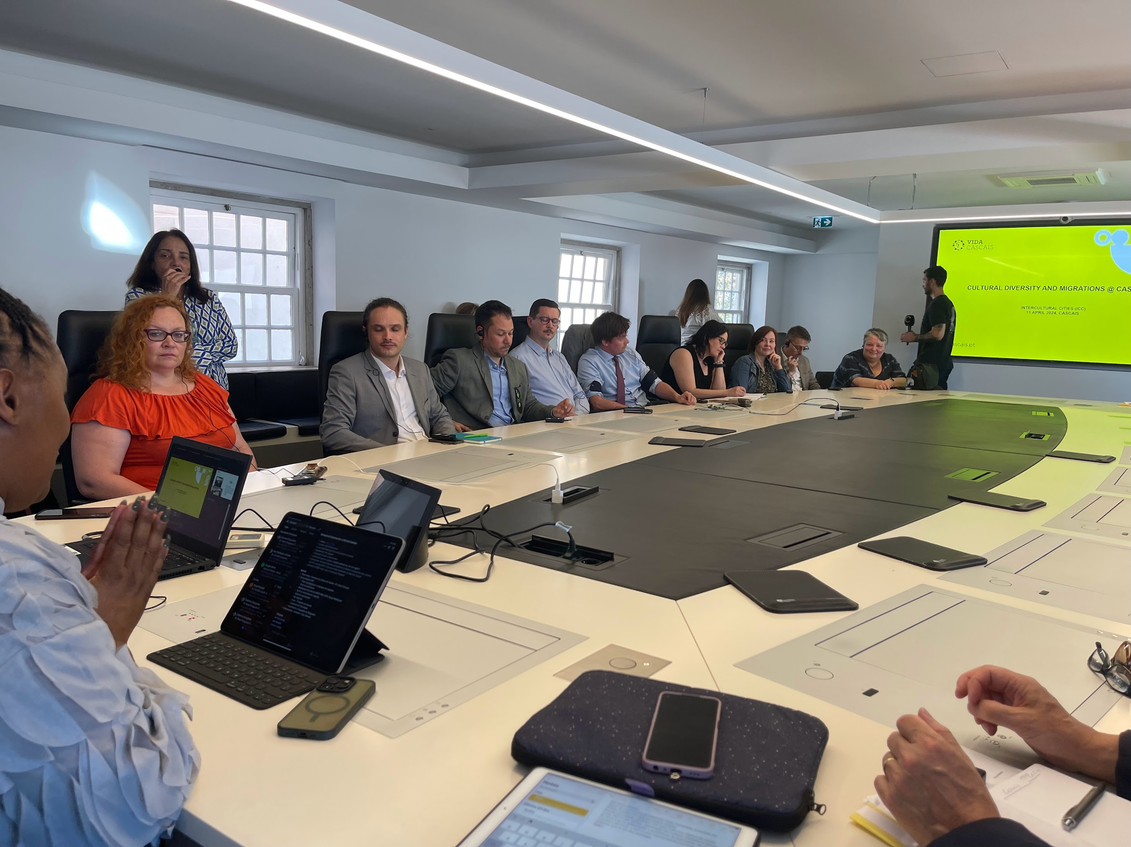

A partnership was established with a public University, so that RPCI will be part of the 1st [Postgraduate course on Diversity, Equity and Inclusion with the Polytechnic University of Porto](https://www.pea.iscap.ipp.pt/programas/pos-graduacoes-executivas-1/sectoriais/diversidade-equidade-e-inclusao), Porto Business Academy starting in October. The cities that are sponsoring RPCI have a right to a 10% discount on this course.

# Next steps

During the next quarter RPCl will continue the activities of the **“Intercultural Schools”** project, mainly preparing the webinar and delivering the workshops in 4 schools.

For “**DiverCities”**, the final report is being prepared.

Regarding **Communication**, three new articles are being prepared, and a new page on RPCI´s website will be published, advertising RPCI´s training and consultancy offers. A new campaign to invite more cities as members of the RPCI Cooperative is also predicted and other RPCI activities, such as the webinars, workshops in schools and podcasts, will also be a priority for next quarter, under the project “Intercultural Schools”.

Loures Municipality asked RPCI to become a formal financial partner for their next 3 year Action Plan for the Integration of Migrants, and the month of July the partnership will be preparing the application.

Vila Verde Municipality asked RPCI to become partners of a project to develop participatory approaches with the migrant population, and a proposal will be prepared for that purpose.

An Italian Youth NGO asked RPCI to become partners in a new call to work with youth, and RCPI will meet with this NGO in the next quarter.