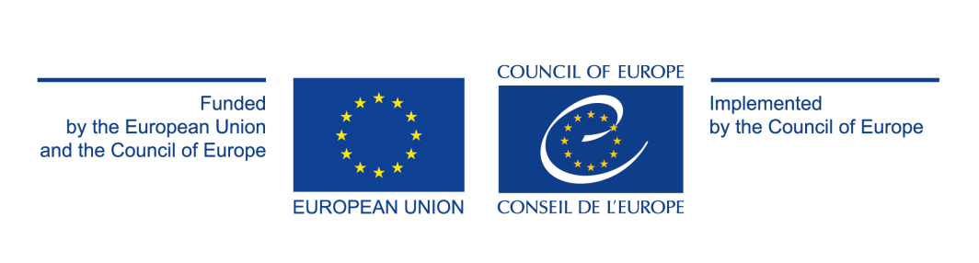

**POOL OF INTERNATIONAL EXPERTS ON SAFE SPORT**

*European Union – Council of Europe joint project “Child Safeguarding in Sport”*

**Call for applications**

The Council of Europe (CoE) is currently implementing a joint project co-funded by the European Union (EU) entitled “[CHILD SAFEGUARDING IN SPORT. Up your game, strengthen your squad!](https://pjp-eu.coe.int/en/web/pss/home)” (CSiS).

This 20-month-long[1] project, which started on 1 March 2020, provides technical assistance to public authorities responsible for sport, sports organisations and their stakeholder organisations to implement (more) effective and integrated child safeguarding policies for better prevention of violence against children in sport (sexual, physical, emotional/psychological, etc.) and for the protection of victims.

**In this framework a** **Pool of International Experts on Safe Sport will be set up by updating and expanding the already existing Pool of European Experts on Sexual Violence in Sport (set up in 2017 within the EU-CoE Pro Safe Sport+ project). The Pool of International Experts on Safe Sport provides opportunities for peer-learning, capacity building and fostering exchanges between those who have a role to play in combating and preventing violence towards children in the field of sport.**

**Call for applications**

This call for applications is launched to invite interested and qualified candidates to submit their applications to become a member of the Pool of International Experts on Safe Sport. Current members of the Pool are kindly asked to renew their membership as well by submitting an application.

In the following pages you will find terms of reference and the application form.

All applications will be evaluated on the basis of expertise and experience and those in line with the Pool requirements will be selected. Those candidates who are selected as well as those who are unsuccessful will be notified by the Secretariat. The profiles of those experts who have been selected will be published on the CSiS project website.

**Please send the completed application form to** [**adela.cujko@coe.int**](mailto:adela.cujko@coe.int) **and** [**celia.biedma-mendes@coe.int**](mailto:celia.biedma-mendes@coe.int) **by 27 October 2021.**

**Members**

The current Pool of Experts will be extended, involving three new categories: (Child) Safeguarding Officers, Trainers/Consultants and Agents of Change (including advocates and people with lived experience within the world of sport). The current Practitioners category will be removed, and its members can be redistributed to other categories defined in the application form, according to their main activity and their profile. Members of the Pool of Experts shall have expertise and/or experience in the field of safeguarding in sport.

The Pool of International Experts on Safe Sport will therefore bring together:

* Policy-makers, responsible for the development of safeguarding policies and strategies in public authorities responsible for sport or sports organisations, at both national and international level.
* Trainers/Consultants, providing any kind of support on safeguarding in sport, including educational/training resources and activities.
* Researchers/Academics, with an expertise in safeguarding in sport.
* Specialists in supporting adults and/or children with lived experience of violence in sport, including harassment and abuse (legal, psychological support…).
* (Child) Safeguarding Officers, appointed by a sport organisation or public authority to work on preventing and/or responding to all forms of violence in sport, including against children.
* Agents of Change, including advocates and people with lived experiences within the world of sport, who are actively contributing to improve safeguarding measures in sport and raising awareness about the issue.

**Membership**

Membership of the Pool of International Experts on Safe Sport is voluntary. Members are free to relinquish their membership at any point in time. The Pool will be regularly updated; its members will be asked to provide the most recent information.

Members will be asked to provide a short annual summary (max. 1 page) on their activity in relation to safe sport and, in particular, the themes covered by the Pool of Experts, as a way of expressing their commitment to the Pool and their interest in membership. These reports will also provide an insight into activities carried out in different countries and organisations, as well as priorities, trends and concerns in this field.

**Mandate**

Members of the Pool of International Experts on Safe Sport are invited to contribute to the work of EPAS and the CoE as a whole in the field of safe sport:

* Participate as speakers in relevant events, conferences, seminars etc. to share knowledge and experience on safe sport;
* Engage in the Pool of Experts meeting(s) and actively contribute to the development of topical issues and outputs;
* Provide advice and support to the EPAS Secretariat, member states and partner organisations when developing their strategies, projects or activities on safe sport;
* Disseminate information and expertise on safe sport.

The Council of Europe allows members to:

* Take part in the annual meeting, network, share their experience and learn from their peers;
* Increase the visibility of their profile and promote their work at European and international level;
* Participate in and be informed about the work of relevant services of the Council of Europe and of its partner organisations;
* Be invited to take part in restricted calls for tenders.

**Activities**

* An annual meeting to set out a working programme for the year. Additional ad hoc meetings (online or physical) can be organised throughout the year to follow up on the decisions taken during the annual meeting.
* Use of an online collaborative platform to share resources with the group.
* An internal newsletter to present activities of the members of the Pool, as well as relevant Council of Europe activities that could be of interest to the Pool. This newsletter could eventually evolve into an external, widely disseminated newsletter, depending on feasibility.

**Pool of International Experts on Safe Sport – APPLICATION FORM**

|  |  |
| --- | --- |
| **Profile** | |
| Category  *(Please only choose the one category that corresponds to your main activity)* | Policy-makers  Trainers/Consultants  Researchers/Academics  Specialists supporting people with lived experience  (Child) Safeguarding Officers  Agents of Change (including advocates and people with lived experience within the world of sport)[2] |
| **General information** | |
| Name |  |
| Relevant occupation at the moment |  |
| Organisation |  |
| Country |  |
| Working language(s) |  |
| Email address[3] |  |
| **A few words about yourself** | |
| Who are you?  *(Briefly explain who you are, your occupation at the moment, your fields of work/research, your role, responsibilities and tasks, etc.)* | *(About 1000 characters – including spaces)* |
| Does your work concern children/minors? | Yes  No |
| Please list no more than five of your/your organisation’s main achievements and/or experiences in the field of safe sport[4]. | * … * … * … * … * *…*   *(Please add web links if possible)* |
| How do you see your contribution to the work of the Pool of International Experts on Safe Sport?[5] | *(up to 1000 characters – including spaces)* |
| Link(s) to a personal webpage, LinkedIn profile, twitter account, etc. |  |
| What are your expectations for the Pool of International Experts on Safe Sport? |  |
| **Additional comments** | |
|  | |

1. The current COVID-19 pandemic has impacted the project timeline and therefore a no-cost project extension until January 2022 has been requested.
2. Please provide information you find applicable.
3. The email address will only be used for communication between the expert and the EPAS Secretariat and will not be disseminated or made public.
4. Please provide information you find applicable.
5. All experiences in the field of safe sport and expertise are valuable contributions of equal importance.