**Information documents**

**SG-AS (2025) 02**

**4 February 2025**

**————————————————  
Communication by the Secretary General**

**of the Parliamentary Assembly**

**at the 1518th meeting of the Ministers’ Deputies[1]**

**(5 February 2025)**

**————————————————**

**I. First part of the Ordinary Session of 2025 (27 – 31 January 2025)**

1. **Assembly’s response to the Russian Federation’s war of aggression against Ukraine**

The Assembly [approved](https://pace.coe.int/en/news/9767/europe-must-show-unwavering-support-for-a-just-and-lasting-peace-in-ukraine-) [Resolution](https://pace.coe.int/en/files/34153/html) 2528 (2025) on the European commitment to a just and lasting peace in Ukraine based on a report by Miapetra Kumpula-Natri (Finland, SOC), stating that any peace negotiations must involve Ukraine and respect its right to determine its own future. Political, economic and military support from Council of Europe member states, as well as international partners, was considered essential to strengthen the position of Ukraine in future negotiations. A settlement should include national sovereignty and territorial integrity, the right to reparation or compensation and respect international law. The Assembly advocated for the finalisation of negotiations on establishing a special tribunal to prosecute Russian and Belarusian leaders for the crime of aggression, for transferring frozen Russian State assets to fund compensation, and for initiating a reconstruction plan.

A joint hearing was held on *Ukrainian prisoners of war, journalists and other civilians held in captivity by the Russian Federation*, in the framework of several reports prepared by Ms Yelyzaveta Yasko (Ukraine, EPP/CD), Mr Eerik-Niiles Kross (Estonia,ALDE), Ms Mariia Mezentseva-Fedorenko (Ukraine, EPP/CD) and   
Ms Yevheniia Kravchuk (Ukraine, ALDE), with the participation of Mr Maksym Butkevych, Human rights defender, officer of the Ukrainian Armed Forces, ex-POW, journalist; Ms Leniie Umerova - recently exchanged Crimean Tatar and civilian hostage (Ukrainian citizen); Mr Yulian Pylypei, Ukrainian marine, Mariupol defender, 2.5 years in Russian captivity and Ms Nataliia Yashchuk, Senior War Consequences Officer, Center for Civil Liberties, Kyiv. The participants detailed their experiences of being held in Russian captivity, their return to their families and homes and how their captivity had affected them and their families. The four rapporteurs underlined the importance of hearing such witnesses, issued a call to take action and invited their fellow parliamentarians to be the voice of Ukrainian captives and share their stories.

1. **Follow-up to the Reykjavik Summit**

The Assembly adopted [Resolution](https://pace.coe.int/en/files/34152/html) 2587 (2025) following an [urgent debate](https://pace.coe.int/en/news/9765/-there-are-no-grounds-for-recognising-the-legitimacy-of-aliaksandr-lukashenka-as-president-of-belarus-pace-says) on "The urgency of organising free and fair elections in Belarus", calling on Council of Europe Member states to reject the legitimacy of the elections in Belarus and to strengthen sanctions targeting the regime and its allies. The Resolution, adopted on the basis of the report prepared by Ryszard Petru (Poland, ALDE), also calls on member states to step up support for the structures of the Belarusian democratic forces, to intensify investigations into Human rights abuses, to support accountability mechanisms and to facilitate the return of refugees fleeing the regime. The representative delegation of the Belarusian democratic forces, present for the first time at a part-session of the Assembly, actively participated in the debate.

The Assembly [welcomed](https://pace.coe.int/en/news/9764/pace-gives-green-light-to-new-council-of-europe-treaty-which-protects-the-profession-of-lawyer) the draft Council of Europe Convention for the Protection of the Profession of Lawyer, pointing out that lawyers play a key role in administering justice and ensuring public confidence in the law. Approving [Opinion](https://pace.coe.int/en/files/34151/html) 304 (2025) based on a report by Vladimir Vardanyan (Armenia, EPP/CD), the Assembly said lawyers are increasingly becoming targets of harassment, intimidation and attacks. The Convention would set standards for the profession and establish monitoring mechanisms. However, the Assembly regretted the lack of specific provisions on the use of secret surveillance against lawyers, and called for the addition of a clause specifically prohibiting states from entering reservations to the Convention, to ensure it is fully implemented. The Attorney-General for England and Wales Lord Hermer, present at the debate, welcomed this Convention, that would grant lawyers independence and protection from harassment and interference.

1. **80th anniversary of the liberation of the Auschwitz-Birkenau camp**

At a [ceremony to commemorate](https://pace.coe.int/en/news/9758/pace-commemorates-the-80th-anniversary-of-the-liberation-of-the-auschwitz-birkenau-camp) the 80th anniversary of the liberation of the Auschwitz-Birkenau camp, which took place in Strasbourg as part of the winter session of the Parliamentary Assembly of the Council of Europe (PACE), Chief Rabbi Israel Meir Lau – President of the Yad Vashem Memorial, former Chief Rabbi of Israel, and the youngest survivor of Buchenwald – recalled the vivid memories of his deportation as a child, the loss of his family, and the conditions of his liberation, while denouncing the persistence of antisemitism.

During the ceremony – which was preceded by a plenary debate on “Multiperspectivity in remembrance and history education for democratic citizenship” – the Secretary General of the Council of Europe, the leaders of the Assembly’s political groups, as well as representatives of the Roma and LGBTIQ+ communities, took the floor, and a question-and-answer session was held with a group of secondary school pupils. The President of PACE, Theodoros Rousopoulos, underlined the need to support and develop remembrance sites and to mainstream their history into educational curricula in order to remember and prevent history from repeating itself.

The ceremony was followed by a moment of reflection, during which wreaths paying tribute to the victims of the Holocaust were laid in front of the commemorative stele on the forecourt of the Palais de l'Europe, and a minute of silence was observed.

1. **Election of judges to the European Court of Human Rights**

On 28 January 2025, the Assembly elected [Ms Canòlic Mingorance Cairat](https://pace.coe.int/en/news/9751/-pace-elects-canolic-mingorance-cairat-judge-to-the-european-court-of-human-rights-in-respect-of-andorra), [Mr Vahe Grigoryan](https://pace.coe.int/en/news/9752/-pace-elects-vahe-grigoryan-judge-to-the-european-court-of-human-rights-in-respect-of-armenia) and [Ms Vasilka Sancin](https://pace.coe.int/en/news/9753/pace-elects-vasilka-sancin-judge-to-the-european-court-of-human-rights-in-respect-of-slovenia) as judges to the European Court of Human Rights in respect of respectively Andorra, Armenia and Slovenia.

**E. Personalities**

The following personalities addressed the Assembly (in chronological order):

* His All Holiness Ecumenical Patriarch BARTHOLOMEW I
* Mr Xavier BETTEL, Minister for Foreign Affairs and Foreign Trade of Luxembourg, Chair of the Committee of Ministers
* Mr Marko BOŠNJAK, President of the European Court of Human Rights
* Mr Alain BERSET, Secretary General of the Council of Europe
* Mr Luc FRIEDEN, Prime Minister of Luxembourg
* The Rt Hon Lord HERMER KC, Attorney General for England and Wales and Advocate General for Northern Ireland

Their speeches can be found on the web site of the Assembly: <https://pace.coe.int>.

1. **Current affairs debates and debates under urgent procedure**

The Assembly held three debates under urgent procedure on " Opinion on a draft convention for the protection of the profession of lawyer" (Rapporteur: Mr Vladimir VARDANYAN (Armenia, EPP/CD)), “The urgent need for free and fair elections in Belarus " (Rapporteur: Mr Ryszard PETRU (Poland, ALDE)) and on " European commitment to a just and lasting peace in Ukraine ” (Rapporteur: Ms Miapetra KUMPULA-NATRI (Finland, SOC)).

1. **Media coverage**

The media coverage of the first part-session of 2025 was outstanding. With 62 journalists accredited, there were more than 510 articles (provisional figures) in the international and key national print and electronic media, the highest figure for a January part-session in the last two years. Their geographic distribution very well reflected the PACE agenda, with strong coverage found in Ukraine and Georgia, as well as in Greece, Italy and many relevant international media.

The statement by His All-Holiness Ecumenical Patriarch Bartholomew I was largely reflected in international media, but the highest impact in number of articles was the debate on the European commitment to a just and lasting peace in Ukraine. The challenge of the credentials of the parliamentary delegation of Georgia was widely covered in the country, as was in Greece the election of Theodoros Rousopoulos as new PACE President for a second one-year term. Other items widely covered were the report on multi-perspectivity in remembrance and history education followed by the ceremony to commemorate the 80th anniversary of the liberation of the Auschwitz-Birkenau camp in the Chamber.

Over session week, total social media engagement according to standard metrics was around 162,000. “X” posts on the main PACE account received 54,000 impressions and the Assembly’s YouTube videos were viewed around 24,000 times, the most viewed video being the ceremony to commemorate the 80th anniversary of the liberation of the Auschwitz-Birkenau camp.

The MediaBox, a web-TV studio available to all those making news at the Assembly, once again proved its usefulness for Assembly members as a way of raising the institution’s profile: 21 interviews with parliamentarians and other participants were recorded.

1. **Adopted texts**

Further to debates, the Assembly adopted the following texts:

**Opinion**

|  |  |
| --- | --- |
| [Opinion 304 (2025)](https://pace.coe.int/en/files/34151) | Opinion on a draft convention for the protection of the profession of lawyer ([Doc. 16102](https://pace.coe.int/en/files/34023)) |

**Recommendations**

|  |  |
| --- | --- |
| [Recommendation 2288 (2025)](https://pace.coe.int/fr/files/34099) | The need for a renewed rules-based international order ([Doc. 16087](https://pace.coe.int/en/files/33948)) |
| [Recommendation 2289 (2025)](https://pace.coe.int/fr/files/34104) | Addressing risks to human rights and the rule of law posed by mercenaries and private military and security companies: a call for comprehensive regulation ([Doc. 16092](https://pace.coe.int/en/files/33949)) |
| [Recommendation 2290 (2025)](https://pace.coe.int/fr/files/34121) | Multiperspectivity in remembrance and history education for democratic citizenship ([Doc. 16090](https://pace.coe.int/en/files/33942)) |
| [Recommendation 2291 (2025)](https://pace.coe.int/en/files/2580) | Overcoming age-based discrimination against older persons ([Doc. 16091](https://pace.coe.int/en/files/33938)) |

**Resolutions**

|  |  |
| --- | --- |
| [Resolution 2580 (2025)](https://pace.coe.int/fr/files/34061) | The progress of the Assembly's monitoring procedure (January-December 2024) ([Doc. 16086](https://pace.coe.int/en/files/33941)) |
| [Resolution 2581 (2025)](https://pace.coe.int/fr/files/34090) | The need for a renewed rules-based international order ([Doc. 16087](https://pace.coe.int/en/files/33948)) |
| [Resolution 2582 (2025)](https://pace.coe.int/fr/files/34105) | The absolute and urgent need to end the humanitarian crisis for women, children and the hostages in Gaza ([Doc. 16093](https://pace.coe.int/en/files/33956#trace-2)) |
| [Resolution 2583 (2025)](https://pace.coe.int/fr/files/34103) | Addressing risks to human rights and the rule of law posed by mercenaries and private military and security companies: a call for comprehensive regulation ([Doc. 16092](https://pace.coe.int/en/files/33949)) |
| [Resolution 2584 (2025)](https://pace.coe.int/fr/files/34120) | Multiperspectivity in remembrance and history education for democratic citizenship ([Doc. 16090](https://pace.coe.int/en/files/33942)) |
| [Resolution 2585 (2025)](https://pace.coe.int/fr/files/34147) | Challenge, on substantive grounds, of the still unratified credentials of the parliamentary delegation of Georgia ([Doc. 16104](https://pace.coe.int/en/files/34080)) |
| [Resolution 2586 (2025)](https://pace.coe.int/fr/files/34148) | Immigration, one of the answers to Europe's demographic ageing ([Doc. 16072](https://pace.coe.int/en/files/33912)) |
| [Resolution 2587 (2025)](https://pace.coe.int/fr/files/34152) | The urgent need for free and fair elections in Belarus ([Doc. 16105](https://pace.coe.int/en/files/34042)) |
| [Resolution 2588 (2025)](https://pace.coe.int/fr/files/34153) | European commitment to a just and lasting peace in Ukraine ([Doc. 16106](https://pace.coe.int/en/files/34046)) |
| [Resolution 2589 (2025)](https://pace.coe.int/fr/files/34155) | Women in the economy: employment, entrepreneurship and gender-responsive budgeting ([Doc. 16068](https://pace.coe.int/en/files/33905)) |
| [Resolution 2590 (2025)](https://pace.coe.int/en/files/34156) | Regulating content moderation on social media to safeguard freedom of expression ([Doc. 16089](https://pace.coe.int/en/files/33939)) |
| Resolution 2591 (2025) | “Long Covid” and access to the right to health ([Doc. 16088](https://pace.coe.int/en/files/33943)) |
| Resolution 2592 (2025) | Overcoming age-based discrimination against older persons ([Doc. 16091](https://pace.coe.int/en/files/33938)) |

These texts can be found on the web site of the Assembly: <https://pace.coe.int>.

**II. Hearings and exchanges of views organised during the part-session**

|  |  |
| --- | --- |
| **Monday 27 January 2025** | |
| **2pm – 3:30pm**  **Room 9, Palais**  **Committee on Political Affairs and Democracy** | ► **Exchange of views** on *Co-operation with the Canadian Observer delegation*, as suggested by Ms Marietta Karamanli (France, SOC), with the participation of:   * the Canadian Observer delegation   ► **Hearing** on *Situation in the Middle East*, in the context of a report prepared by Ms Dora Bakoyannis (Greece, EPP/CD), with the online participation of:   * Ms Signe Brudeset, Director General at the Department for Regional Affairs, Norwegian Ministry of Foreign Affairs |
| **2.15pm – 3.30pm**  **Room 7, Palais**  **Committee on Equality and Non-Discrimination** | ► **Joint seminar with the Nordic Council of Ministers** on *Calling men and boys into Gender Equality - How can parliamentarians be agents of change?* with the participation of:   * Ambassador Ragnhildur Arnljótsdóttir Permanent Representative of Iceland to the Council of Europe; * Mr Xavier Bettel, Chair of the Committee of Ministers of the Council of Europe, Minister for Foreign Affairs, Luxembourg; * Mr Theodoros Rousopoulos, President of the Parliamentary Assembly of the Council of Europe; * Mr José Campi Portaluppi, Director of Communications and Advocacy Equimondo; * Ms Elisa Fernandez Saens, UN Women Deputy Regional Director for Europe and Central Asia; * Ms Etilda Gjonaj, General Rapporteur on Violence against Women; * Ambassador Pap Ndiaye, Permanent Representative of France to the Council of Europe; * Ms Ragna Árnadóttir, Secretary General of the Parliament of Iceland, Alþingi; * Ms Yevheniia Kravchuk, Member of PACE; * Mr Wessel Van Den Berg, Equimundo; * Ms Bibi Gramson, Deputy to the Swedish Permanent Representation to the Council of Europe. |
| **Tuesday 28 January 2025** | |
| **8:30am – 10am**  **Room 20 RC Garden European Court of Human Rights**  **Committee on the Election of Judges to the European Court of Human Rights** | ► **Exchange of views** on topics of common interest with the Bureau of the European Court of Human Rights. |
| **8:30am – 10am**  **Room 8, Palais**  **Committee on Rules of Procedure, Immunities and Institutional Affairs** | ► **Exchange of views** in the context of the project on *Strengthening ethics and integrity in Parliaments* with the participation of:   * Ms Estelle Martin, Ethics Officer of the Council of Europe |
| **Wednesday 29 January 2025** | |
| **1pm – 2pm**  **Room 11, Palais**  **Parliamentary Network for a healthy environment of the Committee on Social Affairs, Health and Sustainable Development** | ► **Presentation** by Mr Rafael Benitez, Director, Directorate of Social Rights, Health and Environment: the state of work of the Steering Committee for Human Rights (CDDH), the timetable towards the adoption of the Council of Europe Convention on the protection of the environment through criminal law, the construction of the Environment Strategy by the *ad hoc* Multidisciplinary Group on the Environment (GME). |
| **1pm – 2pm**  **Room 8, Palais**  **Elections Division** | ► **Launching** **event of the Parliamentary Assembly Network of Election Observers**, with the online participation of:   * Katharina Pabel, substitute member of the Venice Commission and of the Council for Democratic Elections and Stewart Dickson, Congress spokesman for election observation and President of the Council for Democratic Elections |
| **2pm – 3.30pm**  **Room 7, Palais**  **Committee on Equality and Non-Discrimination** | ► **Hearing** on *Violent pornography*,in the framework of a report prepared by  Ms Laura Castel (Spain, UEL), with the participation of:   * Ms Noelia Igareda, Director, Antígona Research group, Autonomous University of Barcelona *(online);* * Dr José Luís García Fernández, sexologist, clinic psychologist and researcher on the impact of violent pornography on children; * Ms Johanna Nelles, Head of Division and Executive Secretary of the Istanbul Convention. |
| **2pm – 3pm**  **Room 9, Palais**  **Committee on the honouring of obligations and commitments by Member States of the Council of Europe (Monitoring Committee)**  **and**  **Committee on Legal Affairs and Human Rights** | ► **Joint hearing** on *The implementation of judgments of the ECtHR by Türkiye*, in the context of a report prepared by Mr Constantinos Efstathiou (Cyprus, SOC),with the participation of:   * Mr Yıldırım Tuğrul Türkeş (Türkiye, NR), Chairperson of the Turkish delegation * Mr Alper Hakkı Yazıcı, Vice-Chairman of Human Rights Department of Ministry of Justice |

|  |  |
| --- | --- |
| **2pm – 3.30pm**  **Room 6, Palais**  **Committee on Migration, Refugees and Displaced Persons** | ► **Exchange of views** on *Artificial Intelligence and migration*, in the framework of a report prepared by Mr Petri Honkonen (Finland, ALDE), with the participation of:   * Mr Philippe Harant, Head of Unit - Strategy, Capabilities and Coordination, EU-LISA |
| **Thursday 30 January 2025** | |
| **1pm – 2pm**  **Room 11, Palais**  **Parliamentary Network on the situation of the children of Ukraine (Committee on Social Affairs, Health and Sustainable Development)** | ► **Exchange of views** on *The situation* *of children in the temporarily* *occupied territories*, with the participation of:   * Ms Olga Altunina, Representative of the Ombudsman for the rights of citizens affected by the armed aggression against Ukraine; * Ukrainian teenager who returned from the occupied territory. |
| **2pm – 3pm**  **Room 9, Palais**  **Committee on Political Affairs and Democracy**  **and**  **Committee on Legal Affairs and Human Rights**  **and**  **Committee on Migration, Refugees and Displaced Persons**  **and**  **Committee on Culture, Science, Education and Media** | **► Joint hearing** on *Ukrainian prisoners of war, journalists and other civilians held in captivity by the Russian Federation,* inthe framework of several reports prepared by Ms Yelyzaveta Yasko (Ukraine, EPP/CD), Mr Eerik-Niiles Kross (Estonia, ALDE), Ms Mariia Mezentseva-Fedorenko (Ukraine, EPP/CD) and Ms Yevheniia Kravchuk, Ukraine, ALDE), with the participation of:   * Mr Maksym Butkevych, Human rights defender, officer of the Ukrainian Armed Forces, ex-POW, journalist * Ms Leniie Umerova - recently exchanged Crimean Tatar and civilian hostage (Ukrainian citizen) * Mr Yulian Pylypei, Ukrainian marine, Mariupol defender, 2.5 years in Russian captivity * Ms Nataliia Yashchuk, Senior War Consequences Officer, Center for Civil Liberties, Kyiv |

**III. Decisions taken by the Bureau (27 January 2025 and 31 January 2025)**

**The Bureau of the Assembly**, meeting on Monday, 27 January 2025, in Strasbourg, with Mr Theodoros Rousopoulos, President of the Parliamentary Assembly, in the Chair, as regards:

* **Communications**: took note of the communications by the President, the Secretary General and the Deputy Secretary General of the Council of Europe; and held an exchange of views with the Secretary General of the Council of Europe;
* **First part-session of 2025 (Strasbourg, 27-31 January)**:
  + *Requests for debates under urgent procedure*: took note of requests to hold debates on:
* *Opinion on a draft convention for the protection of the profession of lawyer,* tabled by the chairpersons of the five political groups: decided to recommend to the Assembly to hold this debate and to refer the matter to the Committee on Legal Affairs and Human Rights for report;
* *The urgent need for free and fair elections in Belarus,* tabled by Mr Ryszard Petru and other members of the Assembly: decided to recommend to the Assembly to hold this debate and to refer the matter to the Committee on Political Affairs and Democracy for report;
* *European Commitment to a Just and Lasting Peace in Ukraine*, tabled by Mr Olena Khomenko and other members of the Assembly: decided to recommend to the Assembly to hold this debate and to refer the matter to the Committee on Political Affairs and Democracy for report;
  + *Draft agenda:* updated the draft agenda of the part-session (Appendix 1) and, taking into account the high number of registered speakers, decided to reduce the speaking time on Monday to two minutes;
  + *Election of judges to the European Court of Human Rights*: took note of the report drawn up by the Committee on the election of judges to the European Court of Human Rights in respect of Andorra, Armenia and Slovenia ([Doc. 16096 Add. 2](https://pace.coe.int/en/files/33954));
  + *Joint Committee (Strasbourg, 30 January 2025)*: prepared the meeting of the Joint Committee;
* **Progress report of the Bureau of the Assembly and of the Standing Committee (4 October 2024 – 26 January 2025)** (Rapporteur: Mr Pablo Hispán, Spain, EPP/CD): approved the Progress report;
* **Election observation**:
  + *Assembly of Kosovo[2]*: elections (9 February 2025):* took note of the statement of the pre-electoral mission of 16-17 January 2025 and approved the revised list of members of the ad hoc committee to observe these elections (Appendix 2);
  + *Albania: parliamentary elections (11 May 2025)*: decided to observe these elections and to set up an ad hoc committee composed of 20 members (SOC: 6; EPP/CD: 6; ECPA: 4; ALDE: 3; UEL: 1), as well as the two co-rapporteurs of the Monitoring Committee, and to conduct a pre-electoral mission (subject to receiving an invitation);
  + *Poland: presidential election (18 May 2025)*: decided to observe this election and to set up an ad hoc committee composed of 30 members (SOC: 9; EPP/CD:9; ECPA: 6; ALDE: 5; UEL: 1); as well as the two co-rapporteurs of the Monitoring Committee, and to conduct a pre-electoral mission (subject to receiving an invitation);
  + *Parliamentary Assembly Network of Election Observers*: approved the list of members of the Network (Appendix 15);
  + *Schedule of the elections in 2025*: took note of the calendar;
* **Vice-Presidents of the Assembly for 2025**: took note of the list of candidates for Vice-Presidents of the Assembly (Appendix 3);
* **Václav Havel Human Rights Prize**: nominated Mr Tiny Kox, former President of the Parliamentary Assembly, as member of the Selection Panel for a first term of two years starting from 1 June 2025; and took note of the press release of the launch of the 2025 edition of the Prize;
* **Issues raised by committees**:
  + *Committee on Political Affairs and Democracy*: took note of the letter by the Chairperson of the Committee on the implementation of [Resolution 2492 (2023)](https://pace.coe.int/en/files/31755) *Assessing the functioning of the partnership for democracy* and decided to grant the additional rights to the Moroccan delegation provided in sub-paragraphs 64.7.a. to 64.7.e. of the Rules of Procedure as of the 2025 January part-session of the Assembly, subject to ratification by the Assembly through the Progress report (Appendix 4);
  + *Committee on Culture, Science, Education and Media*: took of the letter by the Chairperson of the Committee and approved the terms of reference of the Parliamentary Alliance for Good Governance and Integrity in Sport, subject to ratification by the Assembly through the Progress report (Appendix 5);
* **Meeting between parliamentarians from the Nordic Council and the Parliamentary Assembly of the Council of Europe (PACE), Kristiansand, Norway, 4-5 May 2025**: decided to set up an *ad hoc* Committee of the Bureau to participate in this event, composed of the President of the Assembly, the chairpersons of the five political groups and a member of each of the following committees: Committee on Political Affairs and Democracy; Committee on Legal Affairs and Human Rights; Committee on Social Affairs, Health and Sustainable Development and Committee on Culture, Science, Education and Media;
* **Composition of the Monitoring Committee, the Committee on Rules of Procedure, Immunities and Institutional Affairs and the Committee on the Election of Judges to the European Court of Human Rights**: on the basis of proposals by the political groups, nominated members of these three committees and decided to submit them to the Assembly for ratification ([Commissions (2025) 01 Add.1](https://rm.coe.int/commissions-2025-01-add-1-nomination-of-members-to-general-committees-/1680b3afce));
* **Resolution 1376 (2004) relating to Cyprus**: took note of the letters from the two Turkish Cypriot political parties informing the President of the Assembly of the names of the “elected representatives of the Turkish Cypriot community” entitled to sit in the Assembly in 2025, namely Oğuzhan Hasipoğlu and Armağan Candan, subject to ratification by the Assembly through the Progress report;
* **Resolution 2094 (2016) on the situation in Kosovo* and the role of the Council of Europe**: took note of the letter by the President of the Assembly of Kosovo* informing the President of the Assembly of the names of the members of the delegation of the Assembly of Kosovo* for the 2025 ordinary session and approved the list of the delegation, subject to ratification by the Assembly through the Progress report:

*Members*:

* Ms Saranda Bogujevci, Self-Determination Movement, Head of Delegation
* Mr Arben Gashi, Democratic League of Kosovo
* Mr Enis Kervan, Parliamentary Group “Multiethnic”

*Substitutes*:

* Ms Ariana Musliu-Shoshi, Democratic Party of Kosovo
* Mr Besnik Tahiri, Alliance for the Future of Kosovo
* ZZ
* **Resolution 2530 (2024) on a democratic future for Belarus**: took note of the letter by the Speaker of the Coordination Council of Belarus informing the President of the Assembly of the names of the members of the representative delegation of Belarusian democratic forces for the 2025 ordinary session and approved the list of the delegation, subject to ratification by the Assembly through the Progress report:

*Members*:

* Ms Anzhalika Melnikava, Speaker of the Coordination Council
* Mr Pavel Latushka, leader of the ‘Latushka Team and Movement for Freedom’ Group
* Ms Alexandra Mamaeva, member of the ‘European Choice’ Group

*Substitutes:*

* Ms Marharyta Vorykhava, member of the ‘Youth Act’ Group
* Mr Valery Matskevich, member of the ‘European Choice’ Group
* Mr Pavel Tereshkovich, member of the ‘Nasha Sprava/Belarusian Christian Democrats’ Group

**The Bureau of the Assembly**, meeting on Friday, 31 January 2025, in Strasbourg, with Mr Theodoros Rousopoulos, President of the Parliamentary Assembly, in the Chair, as regards:

* **Follow-up to the first part-session of 2025 (Strasbourg, 27-31 January)**:heard a statement by the Secretary General of the Assembly and discussed the follow-up to the part-session;
* **References to committees**: approved the references as set out in Appendix 6, subject to ratification by the Assembly through the Progress report;
* **Election observation**:
  + *Albania: parliamentary elections (11 May 2025)*:approved the list of members of the *ad hoc* committee to observe the elections and appointed Mr Simone Billi (Italy, ECPA) as its Chairperson (Appendix 7);
  + *Poland: presidential election (18 May 2025)*:approved the list of members of the *ad hoc* committee to observe the election and appointed Mr Iulian Bulai (Romania, ALDE) as its Chairperson (Appendix 8);
* **PACE Youth Rapporteurs**: took note of the list of the Assembly Youth Rapporteurs (Appendix 9) and decided to set up an *ad hoc* committee of the Bureau, composed of the PACE Youth Rapporteurs, to participate in the Youth Conference organised under the chairmanship of the Committee of Ministers, in Malta on 8- 9 October 2025;
* **Issues raised by committees**:
  + *Committee on Political Affairs and Democracy*: took note of the letter by the Chairperson of the Committee and decided to authorise Mr George Papandreou (Greece, SOC), Rapporteur on *A closer cooperation between the Parliamentary Assembly of the Council of Europe and the United States Congress*, to carry out a fact-finding visit in the framework of the preparation of his report, to Washington on 12 and 13 March 2025 to meet with representatives from the United States Congress and the State Department;
  + *Committee* *on Equality and Non-Discrimination*: took note of the letter by the Chairperson of the Committee and:
    - approved the terms of reference of the Parliamentary Network Women Free from Violence (Appendix 10) and the No Hate Parliamentary Alliance (Appendix 11), subject to ratification by the Assembly through the Progress report;
    - took note of the change of wording in the English title of the *Parliamentary Platform on the Rights of LGBTI Persons in Europe*, and in the title of the General Rapporteur, co-ordinator of this Platform;
    - agreed to recommend to committees to consider revising the terms of reference of their networks to include representatives from political groups;
* **OECD Global Parliamentary Network, Paris, 5-7 February 2025**:approved the list of members of the *ad hoc* committee and appointed Mr Damien Cottier (Switzerland, ALDE) as its Chairperson (Appendix 12);
* **Parliamentary Conference on “Envisioning effective public policy to prevent & address cases of missing migrants” organised as a follow-up to Resolution 2569 (2024) *Missing migrants, refugees and asylum seekers – A call to clarify their fate*, Strasbourg, 23-24 April 2025**: approved the list of members of the *ad hoc* committee of the Bureau to participate in this event (Appendix 13);
* **Black Sea Security Forum, Odessa, Ukraine, 30-31 May 2025**: decided to set up an *ad hoc* committee of the Bureau to participate in this event;
* **Progress report of the Bureau of the Assembly and of the Standing Committee (31 January – 7 April 2025)**: appointed Mr Andrej Hunko (Germany, UEL) as Rapporteur;
* **Meeting between parliamentarians from the Nordic Council and the Parliamentary Assembly of the Council of Europe (PACE), Kristiansand, Norway, 4-5 May 2025**: decided to revise the composition of the *ad hoc* Committee of the Bureau to participate in this event, to include members of the Committee on Migration, Refugees and Displaced Persons and the Committee on Equality and Non-Discrimination;
* **Composition of committees**:
* *Committee on the Honouring of Obligations and Commitments by Member States of the Council of Europe (Monitoring Committee)*:
  + - on the basis of a proposal by the SOC Group, nominated Ms Wanda Nowicka (Poland) as member;
    - on the basis of proposals by the EPP/CD Group, nominated Mr Christophe Brico (Monaco); Ms Carmen Leyte (Spain), Ms Saara-Sofia Sirén (Finland) and Ms Albana Vokshi (Albania) as members;
    - on the basis of a proposal by the ALDE Group, nominated Mr Régis Bergonzi (Monaco) as member;
* *Committee on Rules of Procedure, Immunities and Institutional Affairs:* on the basis of proposals by the EPP/CD Group, nominated Mr Gustaf Göthberg (Sweden) and Mr Niklaus-Samuel Gugger (Switzerland) as members;
* *Committee on the Election of Judges to the European Court of Human Rights*: on the basis of a proposal by the EPP/CD Group, nominated Mr Benjamin Dalle (Belgium) as an alternate;
* **Institutional representation of the Parliamentary Assembly in 2025**: approved the proposals as set out in Appendix 14;
* **European Committee for the Prevention of Torture and Inhuman or Degrading Treatment or Punishment (CPT) - List of candidates in respect of Croatia**: approved the list of candidates in respect of this country to be forwarded to the Committee of Ministers;
* **Parliamentary Assembly Network of Election Observers**: approved the revised list of members (Appendix 15);
* **Meetings elsewhere than Strasbourg and Paris**: authorised:
  + the *ad hoc* sub-committee of the Committee on Rules of Procedure, Immunities and Institutional Affairs to meet in London on 31 March 2025 to attend the Round Table on Strengthening ethics and integrity in Parliaments;
  + the Committee on Social Affairs, Health and Sustainable Development and the Network on the situation of the children of Ukraine to meet in Helsinki on 15-16 May 2025;

**IV. Prizes**

* **Europe Prize**

On 27 January 2025, the Sub-Committee on the Europe Prize elected the members of its Bureau. The Sub-Committee was also informed about the celebration on the 70th anniversary of the Europe Prize in Donostia San Sebastián (Spain) on 6 June 2025 (to be confirmed).

* **Human rights in Motion Award**

The “Human Rights in Motion” Award was granted on Friday 31 January 2025 in Biarritz by PACE President Theodoros Rousopoulos to Lina Vdovîi and Radu Ciorniciuc, the directors of the documentary [Papa-Tata](https://fipadoc.com/en/laureat/prix-droits-humains-en-action-2025), in the framework of the [Fipadoc](https://fipadoc.com/en) International Documentary Film Festival in Biarritz.

The €5,000 Prize honours the director of the documentary which best promotes human rights and the fight for democratic values. It is awarded to films submitted to four international documentary film festivals taking place across the year, by a jury selected by the festival.

The winners also received a certificate and a plaque.

**V. Future activities of Committees and Networks, and election observation missions**

* A PACE delegation will observe the elections to the Assembly of Kosovo[3]* scheduled on 9 February 2025.
* On 7 March 2025, in Paris, the **Committee on Social affairs, Health and Sustainable Development:**

. will hold a hearing on “Social mobilisation, social unrest, and police reaction in Council of Europe member States: need for a new social contract?”,in the context of a report prepared by   
Mr Fridez (Switzerland, SOC);

. will hold an exchange of views on “Children participation in the Parliamentary Assembly work”.

* On 10-12 March 2025, in New York, the **Ad Hoc Sub-Committee from the Committee on Equality and Non-Discrimination:**

. will participate in the United Nations plenary session of the Commission on the Status of Women (CSW69) and in the side events taking place on 10-12 March 2025;

. will take part in side events on 10-11 March 2025 on “Social Norms change, Networking and Global Advocacy to Advance Women’s Political Participation”, “Women’s equal representation – obstacles and solutions”, “Threats and opportunities of digital technologies: women in the public eye”;

*.* will take part in a parliamentary event“Parliaments and Beijing +30: Resisting backlash and shifting paradigms towards gender equality”.

* On 18 March, in Strasbourg, the **Committee on Equality and Non-Discrimination**:

. will hold a hearing on *Sexual violence against men and boys.*

**VI. Fact-finding visits in the framework of the preparation of reports**

* ***Elections in times of crisis***

**Mr Damien Cottier** (Switzerland, ALDE), rapporteur of the *Committee on Political Affairs and Democracy*, will carry out a fact-finding visit to Stockholm on **23 and 24 February 2025**.

* **Interconnections between the Council of Europe and the European political community**

**Mr Zsolt Németh** (Hungary, ECPA), rapporteur of the *Committee on Political Affairs and Democracy,* will carry out a fact-finding visit to Paris on **4 March 2025**.

* ***A closer cooperation between the Parliamentary Assembly of the Council of Europe and the United States Congress***

**Mr George Papandreou** (Greece, SOC), rapporteur of the *Committee on Political Affairs and Democracy*, will carry out a fact-finding visit to Washington on **12 and 13 March 2025**.

**VII. Other activities of members of the Assembly**

**An ad hoc Committee of the Bureau of the Assembly** will participate in the OECD Global Parliamentary Network, from 5 to 7 February in Paris.

**Ms Yevheniia Kravchuk** (Ukraine, ALDE) will participate in the International Conference on Democracy and Youth in the Digital Age from 19 to 21 March 2025 in Belval (Luxembourg).

**VIII. Seminars and conferences to be organised by the Assembly**

* **14 February 2025, Luxembourg:** the *Committee on Social affairs, Health and Sustainable Development* will organise a conference on “The Role of National Parliaments in Safeguarding the Right to a Healthy Environment”.
* **5 March 2025, The Hague:** the *Committee on Social affairs, Health and Sustainable Development* will organise a conference on “The Role of the Dutch Parliament in protecting the Right to a Healthy Environment”.
* **January-March 2025, Chisinau:** the *PACE Parliamentary and Electoral Cooperation Division,* through the Project “Improving Electoral Practice in the Republic of Moldova, 2025-2028”

. will develop amendments to the legal framework governing the implementation of the postal vote outside the Republic of Moldova (including Law 109/2024 on partial implementation of the postal vote) based on the results of implementation of the postal vote in six countries (USA, Canada, Norway, Sweden, Finland, Iceland) at the Presidential election and the Republican Constitutional Referendum of 20 October 2024.

. will revise the Training Centre’s existing curriculum (questions) for the certification procedure of electoral officials for 2025 certification/examining sessions.

* **18-19 March 2025, Chisinau:** the *PACE Parliamentary and Electoral Cooperation Division,* through the Project “Improving Electoral Practice in the Republic of Moldova, 2025-2028”, will organise, in cooperation with the Central Electoral Commission of the Republic of Moldova, the *Post-Election Analysis Conference on Presidential Election and Republican Constitutional Referendum in the Republic of Moldova, 20 October 2024: lessons learned, recommendations and steps ahead*. The Conference will gather important stakeholders, notably electoral management bodies, political parties, national and domestic observers, development parties, interested institutions to discuss the lessons learned about 2024 elections and generate solutions, including amendments to the electoral legislation and procedures ahead of the Autumn 2025 Parliamentary elections.
* **January – March 2025, Kyiv**: the *PACE Parliamentary and Electoral Cooperation Division*, in the framework of the project “Supporting democratic post-war elections in Ukraine”:

. will prepare the online training course for political parties and candidates "Balanced representation of women and men in political parties and electoral processes". It will be available on the “CEC: prosvita” educational and awareness-raising platform and to the public. The training course is aimed at raising the awareness of political parties and candidates on international and national standards and framework related to balanced participation of women and men in political and electoral processes, combatting gender-based discrimination, sexism and hate speech, as well as on available instruments to strengthen gender balanced representation within political parties’ structures.

. will ensure technical and maintenance support for the operation of the information and educational online platform (https://www.cvkpro.com), a joint project of the Central Election Commission and the Council of Europe aimed at providing Ukrainian voters with updated election related information and materials (infographics, leaflets, documents, videos), including information about existing international and Ukrainian electoral standards and legislation.

* **February-March 2025, Tirana**: the *PACE Parliamentary and Electoral Cooperation Division*, through the Project “Strengthening Elections Integrity in Albania” and in coordination with the Central Election Commission and other relevant partners, will organise a training session on the use of the Live Reporting Platform. Target groups include public institutions and civil society organisations, and the objective is to ensure visibility and increase the use of the Live Reporting Platform by relevant stakeholders.
* **March 2025, Tirana**: the *PACE Parliamentary and Electoral Cooperation Division*, through the Project “Strengthening Elections Integrity in Albania”, will run a one-year activity on ‘Mock Elections Program’ starting March 2025. It aims to foster civic engagement, raise awareness about elections, and prepare young people for an active participation during the election process and targets to reach about 3000 pupils throughout Albania. A Memorandum of Understanding will be signed between the Central Election Commission and the Ministry of Education and Sports to support the education institutions to include education of first-time voters in their yearly extracurricular education programmes.

**IX. Cooperation with the Venice Commission**

* **28 January 2025:** the*Committee on the honouring of obligations and commitments by Member States of the Council of Europe (Monitoring Committee),* in the context of a report on “The honouring of membership obligations to the Council of Europe by Hungary” by the co-rapporteurs Mr Eerik-Niiles Kross (Estonia, ALDE) and Mr George Papandreou (Greece, SOC) requested two opinions to the Venice Commission on: 1/ the fourteenth amendment to the Fundamental Law of Hungary and Act LXVII of 2024 on the amendment of Act CLI of 2011 on the Constitutional Court and on the legal status of the Prosecutor General, prosecutors and other prosecutorial employees and on the career of a prosecutor and 2/ the December 2024 electoral reform.
* **13 March 2025, Venice (Italy):** the *Committee on Legal Affairs and Human Rights*’ representative*,*   
  Mr Pablo Hispán (Spain, EPP/CD) is foreseen to attend the 82nd meeting of the Council for Democratic Elections
* **14-15 March 2025, Venice (Italy):** the *Committee on Legal Affairs and Human Rights*’ representative,Mr Antonio Guttiérez Limones (Spain, SOC) is foreseen to attend the 142nd Plenary session of the Venice Commission.
* **18-19 March 2025, Chisinau:** the *PACE Parliamentary and Electoral Cooperation Division* through the Project “Improving Electoral Practice in the Republic of Moldova, 2025-2028” will organise, in cooperation with the Central Electoral Commission of the Republic of Moldova, the “Post-Election Analysis Conference on Presidential Election and Republican Constitutional Referendum in the Republic of Moldova, 20 October 2024: lessons learned, recommendations and steps ahead”. Representatives of the Venice Commission will share their election-related specific expertise at the event.

**X. External relations**

* **Relations with other international partners**
* **Date tbc, Zurich (Switzerland):** the *Committee on Culture,. Science, Education and Media* has approved the establishment of a delegation composed by the following members to attend an in-person meeting at FIFA headquarters, at the invitation of this organisation:
  + Ms Linda Hofstad Helleland (Norway, EPP/CD), Chairperson of the Committee;
  + Ms Morgen Jensen (Denmark, SOC), General Rapporteur on Governance and Ethics in Sport and rapporteur on *Olympic peacekeeping: is sport neutrality serving sport values?*
  + Mr Kim Valentin (Denmark, ALDE), rapporteur on *Protecting human rights in and through sport: obligations and shared responsibilities*;
  + Lord George Foulkes (United Kingdom, SOC), former rapporteur on *Football governance, business and values*.

**XI. List of meetings of the committees, the Bureau and the Presidential Committee**

. **31 January 2025, Strasbourg:** *Bureau meeting*

. **3 March 2025, Paris:** *Committee on Legal Affairs and Human Rights*

. **4 March 2025, Paris:** *Committee on the honouring of obligations and commitments by Member States of the Council of Europe (Monitoring Committee)*

. **5 March 2025, Paris:** *Committee on Political Affairs and Democracy*

. **7 March 2025, Paris:** *Committee on Social Affairs, Health and Sustainable Development*

. **11 March 2025, Paris:** *Committee on Migration, Refugees and Displaced Persons*

**12 March 2025,** **Paris**: *Committee on Culture, Science, Education and Media*

. **18 March 2025, Strasbourg:** C*ommittee on Equality and Non-Discrimination*

. **19 March 2025, Strasbourg:** *Committee on Rules of Procedure, Immunities and Institutional Affairs*

. **19 March 2025:** *Presidential Committee*

. **19 March 2025, Strasbourg:** *Bureau meeting*

**Appendix 1 – Agenda of the 2025 first PACE part-session**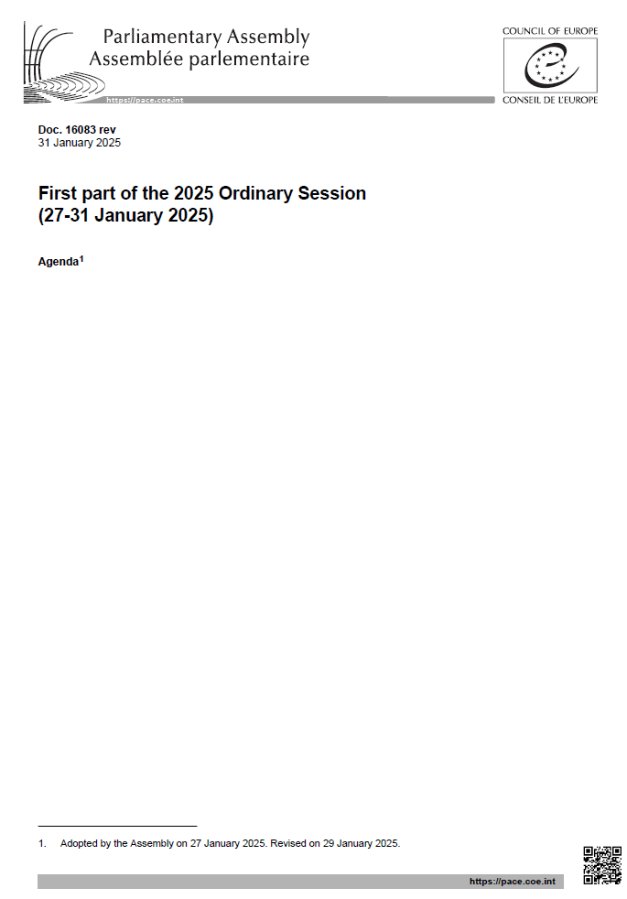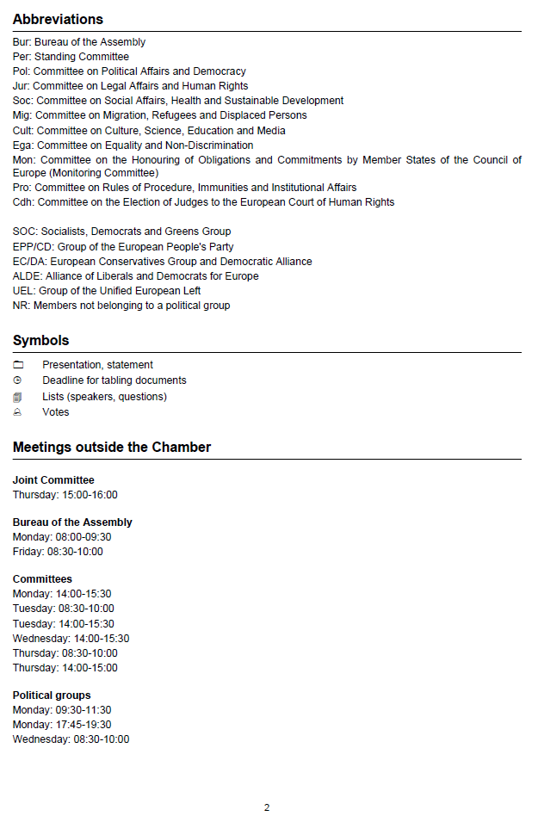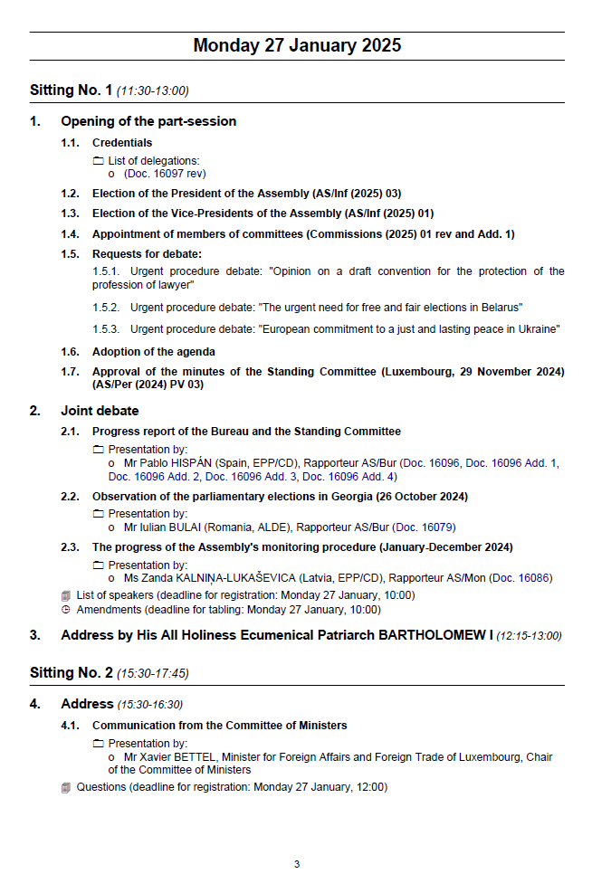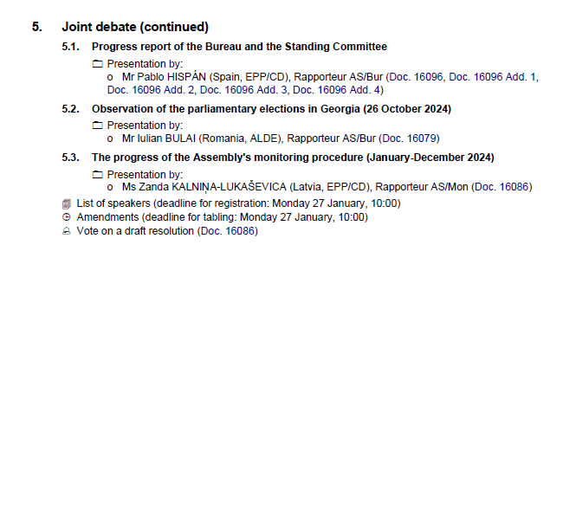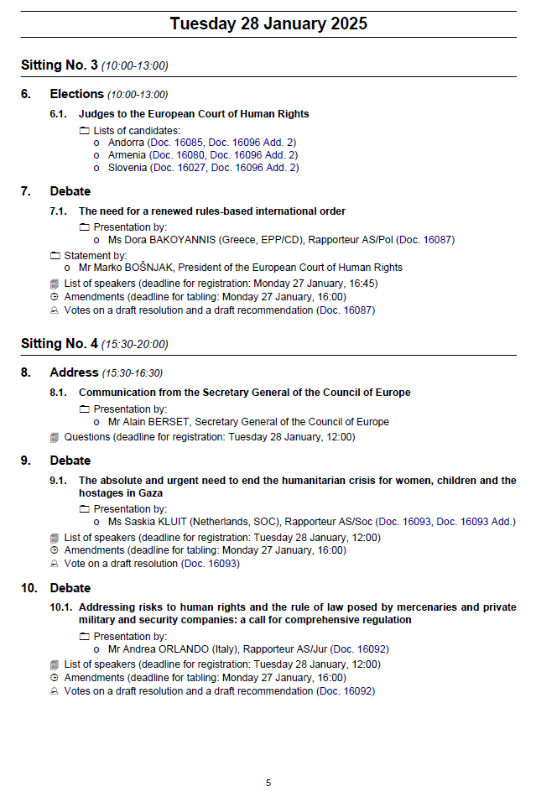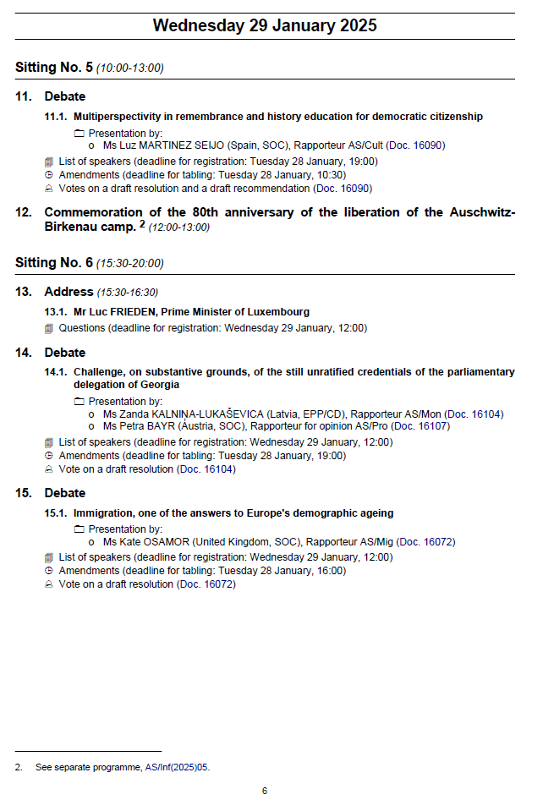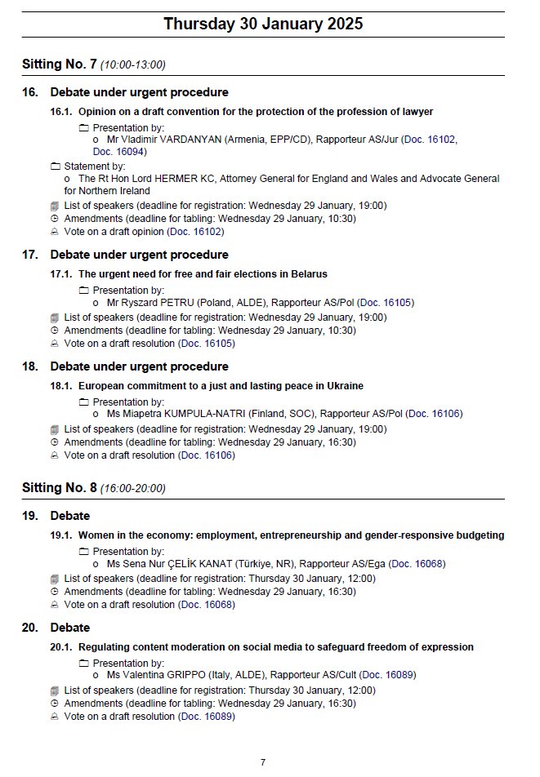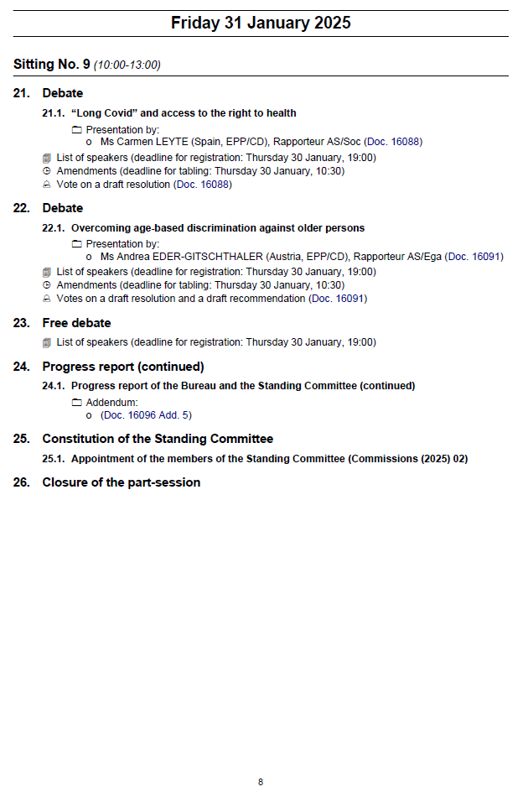

**Appendix 2 – Revised list of members of the *ad hoc* committee to observe the elections in the Assembly of Kosovo[4]* (9 February 2025)**

**Chairperson / Présidente:** Ms / MmePetra BAYR, Austria / Autriche

**Socialists, Democrats and Greens Group / Groupe des socialistes, démocrates et verts (SOC)**

Ms / MmeSibel ARSLAN, Switzerland / Suisse ****

Ms / MmePetra BAYR, Austria / Autriche **

Mr / M. Christophe CHAILLOU, France

Mr / M. Titus CORLĂŢEAN, Romania / Roumanie

Mr / M. Yves CRUCHTEN, Luxembourg

Mr / M. Yunus EMRE, Türkiye

Ms / MmeEdite ESTRELA, Portugal ****

Ms / MmeAnnick LAMBRECHT, Belgium / Belgique

**Substitutes / Suppléant·es**

Mr / M. Jone BLIKRA, Norway / Norvège

Ms / MmeCat ECCLES, United Kingdom / Royaume-Uni

Mr / M. Cerni ESCALE CABRE, Andorra / Andorre

Mr / M. Pierre-Alain FRIDEZ, Switzerland / Suisse ***

Mr / M. Gerardo GIOVAGNOLI, San Marino / Saint-Marin

Ms / MmeBisera KOSTADINOVSKA-STOJEVSKA, North Macedonia / Macédoine du Nord

Ms / MmeMiapetra KUMPULA-NATRI, Finland / Finlande ***

Mr / M. Didier MARIE, France

Ms / MmeAnna-Kristiina MIKKONEN, Finland / Finlande

Mr / M. Paulo PISCO, Portugal

Mr / M. Stefan SCHENNACH, Austria / Autriche

Ms / MmeCéline THIÉBAULT-MARTINEZ, France

**Group of the European People’s Party (EPP/CD) / Groupe du Parti populaire européen (PPE/DC)**

Ms / Mme Andrea EDER-GITSCHTHALER, Austria / Autriche **

Mr / M. Pablo HISPÁN, Spain / Espagne

Mr / M. Cristian-Augustin NICULESCU-ȚÂGÂRLAȘ, Romania / Roumanie

Mr / M. Georgios STAMATIS, Greece / Grèce

**European Conservatives, Patriots & Affiliates (ECPA)/ Conservateurs européens, Patriotes et Affiliés (CEPA)**

Mr / M. Oleksii GONCHARENKO, Ukraine

ZZ

ZZ

**Alliance of Liberals and Democrats for Europe (ALDE) / Alliance des démocrates et des libéraux pour l’Europe (ADLE)**

Mr / M. Mehmet AKALIN, Türkiye ****

Mr / M. Nikolla CAMAJ, Montenegro / Monténégro

Ms / MmeDiana STOICA, Romania / Roumanie

Ms / MmeLiliana TANGUY, France

**Group of the Unified European Left (UEL) / Groupe pour la gauche unitaire européenne (GUE)**

Ms / MmeNina KASIMATI, Greece / Grèce

**Substitutes / Suppléant·es**

Mr / M. George LOUCAIDES, Cyprus / Chypre

* All reference to Kosovo, whether to the territory, institutions or population shall be understood in full compliance with United Nations Security Council Resolution 1244 and without prejudice to the status of Kosovo. / Toute référence au Kosovo, que ce soit le territoire, les institutions ou la population, doit se comprendre en pleine conformité avec la Résolution 1244 du Conseil de sécurité des Nations Unies et sans préjuger du statut du Kosovo.

** Pre-electoral mission / mission prélectorale

*** Awaiting the non-conflict of interest declaration / en attente de la déclaration de non-conflit d’intérêt

**** Members appointed in line with paragraph 14 of the Guidelines for the observation of elections by the Parliamentary Assembly / Membres désignés conformément au para.14 des Lignes directrices pour l’observation des élections par l’Assemblée parlementaire

**Appendix 3 – Vice-Presidents of the Assembly in 2025**

|  |  |  |
| --- | --- | --- |
| **GROUPS / GROUPES** | **COUNTRY /**  **PAYS** | **CANDIDATURES** |
| GROUP I / GROUPE I | France | Mr Bertrand BOUYX |
| Germany / Allemagne | Mr Armin LASCHET |
| Italy / Italie | Ms Elisabetta GARDINI |
| Türkiye | Mr Yıldırım Tuğrul TÜRKEŞ |
| United Kingdom / Royaume-Uni | Lord Don TOUHIG |
| GROUP II / GROUPE II | Poland / Pologne | Ms Agnieszka POMASKA |
| Spain / Espagne | Mr Antonio GUITÉRREZ LIMONES |
| GROUP III / GROUPE III | Azerbaijan / Azerbaïdjan | Vacant seat / siège vacant |
| Belgium / Belgique | Mr Andries GRYFFROY |
| Bosnia and Herzegovina / Bosnie-Herzégovine | Vacant seat / siège vacant |
| Bulgaria / Bulgarie | Vacant seat / siège vacant |
| Croatia / Croatie | Mr Marko PAVIĆ |
| Czechia / Tchéquie | Ms Miroslava NĚMCOVÁ |
| Denmark / Danemark | Mr Mogens JENSEN |
| Finland / Finlande | Ms Miapetra KUMPULA-NATRI |
| GROUP IV / GROUPE IV | Albania / Albanie | Ms Blerina GJYLAMETI |
| Andorra / Andorre | Ms Bernadeta COMA |
| Armenia / Arménie | Ms Arusyak JULHAKYAN |
| Cyprus / Chypre | Vacant seat / siège vacant |

**Appendix 4 – Special guests, observers, partners for democracy and other guests, Rules of Procedure of the Assembly**

**Rule 64 – Partners for democracy**

64.7. On a proposal by the Committee on Political Affairs and Democracy, the Bureau may decide to grant some additional rights to partner for democracy delegations which have shown outstanding results in achieving the goals of the partnership and participate fully in the work of the Assembly. The decision of the Bureau shall be ratified by the Assembly at the beginning of a new session (in January) and shall be valid for the duration of the session (one year), with the possibility or not of extension at each following session depending on the results and according to the same procedure. Such additional rights for the delegations and their members may include:

64.7.a. the right to table motions for recommendations and resolutions, subject to co-signature by a member of the Assembly, with both names appearing as authors of the motion;

64.7.b. the right to table amendments, subject to co-signature by a member of the Assembly, with both names appearing as authors of the amendment;

64.7.c. the right to request current affairs debates and to be chosen to open such debates. If such a request is made by an individual member of a partner for democracy delegation, it should be subject to co-signature by a member of the Assembly, with both names appearing as authors of the request, and to having the support of 19 more members of the Assembly. If a request is made by a partner for democracy delegation, it should be supported by a political group, a national delegation or a committee, as provided by Rule 53.2;

64.7.d. the right to table written declarations, subject to co-signature by a member of the Assembly, with both names appearing as authors of the written declaration;

64.7.e. the right to be appointed as rapporteur for information reports which do not contain a draft resolution and/or recommendation.

**Appendix 5 – Parliamentary Alliance for Good Governance and Integrity in Sport**

**Terms of reference[5]**

Duration: February 2025 – January 2027

1. In **Resolution 2199 (2018) “Towards a framework for modern sports governance”**, the Parliamentary Assembly of the Council of Europe (hereinafter the Assembly) invited its Committee on Culture, Science, Education and Media to consider setting up a **Parliamentary Alliance for Good Governance and Integrity in Sport** **(hereinafter the Alliance)** as a discussion forum bringing together representatives of national parliaments and international parliamentary bodies.
2. The Alliance’s terms of reference were adopted by the Committee on Culture, Science, Education and Media at its meeting on 3 and 4 December 2024 and submitted to the Bureau of the Assembly.
3. The Alliance was set up during the Assembly’s January 2025 part-session, under the auspices of the Committee on Culture, Science, Education and Media, for an initial two-year period, from 1 February 2025 to 31 January 2027.
4. The Alliance shall submit a progress report to the Bureau of the Assembly by 10 January 2026, with a view to a decision on renewing the Alliance for a further two-year period.
5. **Role and aims of the Alliance**
6. The role of the Alliance shall be to:
   1. Reinforce the Assembly’s capacity to address sports issues and promote a values-based approach to national sports policies and sports governance, at both the national and international levels;
   2. Support the role of national parliaments in the design and implementation of sports policies, by promoting sports ethics and a vision of sport as a tool for building social cohesion and instilling values, including respect for fundamental rights and freedoms and human dignity;
   3. Promote the right to sport for all and to safe, healthy and inclusive sport, and incorporate this right in national law, public policies and the standards underpinning the sports movement, ensuring its effective implementation in Europe and beyond;
   4. Work to improve sport governance at all levels.
7. Under its remit and based on the Council of Europe conventions, texts adopted by the Committee of Ministers of the Council of Europe and Assembly resolutions, the Alliance shall have the following specific aims:
   1. Embedding the highest ethical standards in national and international sport policies and governance;
   2. The promotion of human rights and their effective protection in and through sport, and in particular the fight against violence and sexual abuse in sport, as well as the promotion of gender equality and inclusion in sport at all levels and through sport in society.
8. **Composition of the Alliance**
9. The Alliance shall be composed of:
10. In respect of the 46 member States of the Council of Europe:

* one member of parliament for each unicameral parliament, and one member of each chamber for bicameral parliaments, appointed by the national parliament or chamber respectively, regardless of whether or not they are members of the Parliamentary Assembly of the Council of Europe;
* a member of parliament appointed by their parliamentary delegation to the Parliamentary Assembly of the Council of Europe from among its members.

1. In respect of the parliaments with Observer or Partner for Democracy status with the Parliamentary Assembly of the Council of Europe: one member of parliament for each unicameral parliament, and one member of each chamber for bicameral parliaments, appointed by the national parliament or chamber respectively;
2. The immediate past President of the Assembly and the General Rapporteur on Governance and Ethics in Sport, as ex officio members of the Alliance;
3. One member appointed by each of the Assembly’s political groups;
4. One member appointed by the following Committees of the Assembly:

* Committee on Political Affairs and Democracy,
* Committee on Legal Affairs and Human Rights,
* Committee on Social Affairs, Health and Sustainable Development,
* Committee on Migration, Refugees and Displaced Persons,
* Committee on Culture, Science, Education and Media,
* Committee on Equality and Non-Discrimination;

1. Two members appointed by the European Parliament;
2. Two members appointed by the Inter-Parliamentary Union.
3. Two associate members appointed by the Congress of Local and Regional Authorities of the Council of Europe, one in respect of the Chamber of Local Authorities, the other in respect of the Chamber of Regions, may participate in the work of the Alliance.
4. The following institutional partners may participate in the work of the Alliance and appoint one representative each:

* Governing Board of the Council of Europe’s Enlarged Partial Agreement on Sport (EPAS),
* EPAS Consultative Committee,
* Conference of International Non-Governmental Organisations (INGOs) of the Council of Europe,
* International Olympic Committee (IOC),
* European Olympic Committees (EOC),
* International Paralympic Committee (IPC),
* European Paralympic Committee (EPC),
* sports organisations or federations which have signed a memorandum of understanding with the Council of Europe;[6]
* Play the Game.

1. Other sports organisations or federations, relevant multistakeholder platforms dealing with issues related to the integrity of sport, anti-corruption or human rights issues (e.g. the International Partnership Against Corruption in Sport – IPACS, or the Network of Judges/Prosecutors Responsible for Sports – MARS) and other stakeholder groups (e.g. the media, sports industry, corporate sponsors, academic institutions, etc.) likely to broaden the scope and impact of the Alliance’s work, may be involved on an ad hoc basis, depending on the issues at stake.
2. Partners invited to participate in the Alliance’s activities on an ad hoc basis and wishing to do so must commit to upholding the values of the Council of Europe.
3. **Working methods**
4. In terms of the application of the Rules of Procedure of the Assembly, the Alliance shall be assimilated to a Sub-Committee of the Committee on Culture, Science, Education and Media. All members of the Committee on Culture, Science, Education and Media shall be entitled to attend the Alliance’s meetings.
5. The following provisions of the Rules of Procedure of the Assembly shall not apply to the Alliance:
   1. Rule 49.3 concerning the limit on the number of standing sub-committees that may be appointed by the same committee;
   2. Rule 49.6 concerning the maximum number of members of a sub-committee and the limit on the number of sub-committees to which members of a committee may belong.
6. The Alliance may hold its meetings during part-sessions of the Assembly, meetings of the Committee on Culture, Science, Education and Media outside Strasbourg or on the margins of international conferences or events which it organises or to which it is invited.
7. The working languages of the Alliance shall be English and French. Other languages may be used for specific meetings or events, provided that the additional cost is not borne by the Assembly budget.
8. At its first meeting, the Alliance shall elect its Chairperson and its Vice-Chairperson from among its members who are also members of the Assembly, who shall make up the Bureau, for the initial two-year period. The two members of the Bureau may not belong to the same Parliament. When electing the Bureau, each parliament represented shall have a maximum of two votes; where appropriate, the national delegation concerned shall indicate the members entitled to vote. As an exception to the Assembly’s Rules of Procedure, the Alliance shall renew its Bureau every two years, at its first meeting of the new two-year period. If a member of the Bureau ceases to hold office or must step down before the end of their term, the Alliance shall hold new elections to replace them until the end of the two-year period.
9. The list of Alliance members, associate members and representatives of the Alliance’s institutional partners shall be updated each year during the first part-session of the Assembly. Subsequent updates may occur during the year. Membership of the Alliance shall not be automatically renewed and must be confirmed at the beginning of each year.
10. The Alliance shall adopt its work programme for 2025 at its first meeting. The programme for each subsequent year shall be adopted no later than the fourth part-session of the Assembly preceding the year in question. When voting on the adoption of the work programme or in any formal vote required for its implementation, each parliament represented shall have a maximum of two votes; where appropriate, the national delegation concerned shall indicate the members entitled to vote.
11. The Alliance shall facilitate synergy and consistency between the work of the Assembly and the work of the Council of Europe intergovernmental sector, including EPAS, in the field of sport.
12. The Alliance shall develop appropriate forms of co-operation with the national parliaments of Council of Europe member States. It may co-operate with parliamentarians and parliaments outside Europe, and with parliamentary networks and international parliamentary assemblies developing measures in the field of good governance and integrity in sport or in the promotion of human rights in and through sport.
13. To achieve these goals, the Alliance shall, inter alia, seek to:
14. Raise parliamentarians’ awareness of their role in their respective assemblies in connection with the direction, content and funding of sports policies and the adoption of legislation affecting access to sport and the development of recreational, amateur and professional sport;
15. Inform parliamentarians about standards and supervisory mechanisms regarding sport and human rights which exist within the Council of Europe and other relevant bodies;
16. Enhance interaction between parliamentarians and representatives of the sports movement at international and national level, to work together to promote and better protect the right to safe, healthy and inclusive sport.
17. The Assembly shall support the Alliance by ensuring that it can meet at least three times a year, during part-sessions or meetings outside Strasbourg of the Committee on Culture, Science, Education and Media.
18. The Alliance may hold additional meetings, including meetings on the margins of international conferences or events that it organises or to which it is invited, provided that the costs of such meetings are met by voluntary contributions from member States or that the Secretary General of the Assembly grants authorisation for them to be met from the Assembly budget. Meetings of the Alliance outside Strasbourg, Paris or Brussels are subject to prior authorisation by the Bureau of the Assembly.
19. In its relations with parliaments and partners, the Alliance shall be represented by its Chairperson and/or Vice-Chairperson. Their travel on Alliance business shall in principle be paid for by their respective parliaments. However, the Assembly shall bear the cost of up to two such journeys per financial year, subject to the availability of funds.
20. Costs incurred by the participation of members, associate members, representatives of institutional partners and other participants at Alliance meetings shall be borne by the parliaments, institutions, organisations and partners represented.
21. The Alliance’s projects shall be funded with voluntary contributions from the member States.

**Appendix 6 – References to committees**

**A.      References to committees**

* *The role of diasporas and migrants in building social cohesion and progress*, [Doc. 16095](https://pace.coe.int/en/files/33953), motion for a resolution: reference to the Committee on Migration, Refugees and Displaced Persons *for report*;
* *A closer co-operation between the Parliamentary Assembly of the Council of Europe and the United States Congress*, [Doc. 16109](https://pace.coe.int/en/files/34134), motion for a resolution: reference to the Committee on Political Affairs and Democracy *for report*.

**B. Extension of references**

* *Olympic movement and peacekeeping*: is sport neutrality serving sport values? (former title: Excluding the athletes and officials of the Russian Federation and Belarus from participating in the international Olympic movement), [Doc. 15721](https://pace.coe.int/en/files/31670), motion for a resolution, reference 4716 of 2 March 2023 – validity : 31 March 2025: extension until 30 April 2025;
* *The role of youth in revitalising democracy*, [Doc. 15756](https://pace.coe.int/en/files/31778), motion for a resolution tabled by Ms Yevheniia Kravchuk (Ukraine, ALDE) and other members of the Assembly, reference 4746 of 19 June 2023 – validity : 19 June 2025: extension until 30 June 2025.

**Appendix 7 – List of members of the *ad hoc* Committee for the observation of the parliamentary elections in Albania (11 May 2025)**

**Chairperson / Président·e** :Mr / M. Simone BILLI (Italy, ECPA / Italie, CEPA)

**Socialists, Democrats and Greens Group / Groupe des socialistes, démocrates et verts (SOC)**

Mr / M. Jone BLIKRA, Norway / Norvège* ***

Mr / M. Cerni ESCALE CABRE, Andorra / Andorre***

Ms / Mme Sascha FAXE, Denmark / Danemark***

Mr / M. Pierre-Alain FRIDEZ, Switzerland / Suisse***

Ms / Mme Luz MARTINEZ SEIJO, Spain / Espagne ***

Mr / M. Axel SCHÄFER, Germany / Allemagne***

**Substitutes / Suppléant·es**

Mr / M. Yunus EMRE, Türkiye***

Mr / M. Gerardo GIOVAGNOLI, San Marino / Saint-Marin***

Mr / M. Antonio GUTIERREZ LIMONES, Spain / Espagne***

Ms / Mme Bisera KOSTADINOVSKA-STOJEVSKA, North Macedonia / Macédoine du Nord***

Mr / M. Saša MAGAZINOVIĆ, Bosnia and Herzegovina / Bosnie-Herzégovine***

Mr / M. Perran MOON, United Kingdom / Royaume-Uni***

Mr / M. Christian PETRY, Germany / Allemagne***

Mr / M. Stefan SCHENNACH, Austria / Autriche***

Mr / M. Roberto SPERANZA, Italy / Italie***

Ms / Mme Ann TAYLOR, United Kingdom / Royaume-Uni***

Ms / Mme Céline THIEBAULT-MARTINEZ, France***

Ms / Mme Birute VĖSAITĖ, Lithuania / Lituanie***

Ms / Mme Sandra ZAMPA, Italy / Italie

**Group of the European People’s Party (EPP/CD) / Groupe du Parti populaire européen (PPE/DC)**

ZZ

ZZ

ZZ

ZZ

ZZ

ZZ

**Substitutes / Suppléant****·es**

Ms / Mme Borianna ÄBERG, Sweden / Suède** ***

Mr / M. Branislav BORENOVIĆ, Bosnia and Herzegovina / Bosnie-Herzégovine** ***

Ms / Mme Edina DEŠIĆ, Montenegro / Monténégro** ***

Ms / Mme Linda Hofstad HELLELAND, Norway / Norvège** ***

Mr / M. Pablo HISPÁN, Spain / Espagne** ***

Ms / Mme Belén HOYO, Spain / Espagne** ***

Mr / M. Jan Filip LIBICKI, Poland / Pologne** ***

Mr / M. Joseph O’REILLY, Ireland / Irlande ** ***

Ms / Mme Denitsa SACHEVA, Bulgaria / Bulgarie** ***

Mr / M. Chris SAID, Malta / Malte** ***

**European Conservatives, Patriots & Affiliates (ECPA) / Conservateurs européens, Patriotes et Affiliés (CEPA)**

Dame Karen BRADLEY, United Kingdom / Royaume-Uni ***

Mr / M. Simone BILLI, Italy / Italie* ***

Ms / Mme Elisabetta GARDINI, Italy / Italie***

Mr / M. Malte KAUFMANN, Germany / Allemagne***

**Substitutes / Suppléant·es**

Mr / M. Oleksii GONCHARENKO, Ukraine***

**Alliance of Liberals and Democrats for Europe (ALDE) / Alliance des démocrates et des libéraux pour l’Europe (ADLE)**

Mr / M. François BONNEAU, France ***

Ms / Mme Valentina GRIPPO, Italy / Italie* ***

Ms / Mme Rian VOGELS, Netherlands / Pays-Bas***

**Substitutes / Suppléant·es**

Mr / M. Mehmet AKALIN, Türkiye***

Ms / Mme Yevheniia KRAVCHUK, Ukraine***

Mr / M. Arminas LYDEKA, Lithuania / Lituanie***

Ms / Mme Yuliia OVCHYNNYKOVA, Ukraine***

**Group of the Unified European Left (UEL) / Groupe pour la gauche unitaire européenne (GUE)**

Mr / M. Andrej HUNKO, Germany / Allemagne* ** ***

**Substitutes / Suppléant·es**

Mr / M. Arnaldo LOMUTI, Italy / Italie ***

* Pre-electoral mission / mission préélectorale

**       Awaiting the non-conflict of interest declaration / en attente de la déclaration de non-conflit d’intérêt

****     Awaiting PACE 2025 declaration of interest / en attente de la déclaration d’intérêt 2025 de l’APCE

**Appendix 8 – List of members of the *ad hoc* Committee for the observation of the presidential election in Poland (18 May 2025)**

**Chairperson / Président·e** :Mr / M. Iulian BULAI (Romania, ALDE / Roumanie, ADLE)

**Socialists, Democrats and Greens Group / Groupe des socialistes, démocrates et verts (SOC)**

Ms / Mme Zita GURMAI, Hungary / Hongrie ***

Mr / M. Antonio GUTIERREZ-LIMONES, Spain / Espagne * ***

Ms / Mme Bisera KOSTADINOVSKA-STOJEVSKA, North Macedonia / Macédoine du Nord ***

Mr / M. Christophe LACROIX, Belgium / Belgique ***

Mr / M. Saša MAGAZINOVIĆ, Bosnia and Herzegovina / Bosnie-Herzégovine ***

Mr / M. Perran MOON, United Kingdom / Royaume-Uni ***

Ms / Mme Sandra REGOL, France ***

Mr / M. Stefan SCHENNACH, Austria / Autriche ***

Mr / M Roberto SPERANZA, Italy / Italie ***

**Substitutes / Suppléant·es**

Mr / M. Jone BLIKRA, Norway / Norvège ***

Mr / M. Yunus EMRE, Türkiye ***

Mr / M. Gerardo GIOVAGNOLI, San Marino / Saint-Marin ***

Ms / Mme Annick LAMBRECHT, Belgium / Belgique ** ***

Mr / M. Axel SCHÄFER, Germany / Allemagne ***

**Group of the European People’s Party (EPP/CD) / Groupe du Parti populaire européen (PPE/DC)**

Ms / Mme Deborah BERGAMINI, Italy / Italie ** ***

Mr / M. Ricardo CARVALHO, Portugal ** ***

Mr / M. Pablo HISPÁN, Spain / Espagne ** ***

Ms / Mme Belén HOYO, Spain / Espagne ** ***

ZZ

ZZ

ZZ

ZZ

ZZ

**European Conservatives, Patriots & Affiliates (ECPA) / Conservateurs européens, Patriotes et Affiliés (CEPA)**

Lord David BLENCATHRA, United Kingdom / Royaume-Uni

Ms / Mme Elisabetta GARDINI, Italy / Italie * ***

Mr / M. Armen GEVORGYAN, Armenia / Armenia ***

Ms / Mme Jessica STEGRUD, Sweden / Suède ***

Ms / Mme Victoria TIBLOM, Sweden / Suède ***

Mr / M. Morten WOLD, Norway / Norvège ***

**Substitutes / Suppléant·es**

Mr / M. Simone BILLI, Italy / Italie ***  
Mr / M. Malte KAUFMANN, Germany / Allemagne ***

Mr / M. Michael RUBBESTAD, Sweden / Suède ***

**Alliance of Liberals and Democrats for Europe (ALDE) / Alliance des démocrates et des libéraux pour l’Europe (ADLE)**

Mr / M. Iulian BULAI, Romania / Roumanie * ***

Mr / M. Alfred HEER, Switzerland / Suisse ***

Ms / Mme Fiona O’LOUGHLIN, Ireland / Irlande ***

Ms / Mme Liliana TANGUY, France ***

Ms / Mme Lesia ZABURANNA, Ukraine ***

**Substitutes / Suppléant·es**

Ms / Mme Lucia PLAVAKOVA, Slovak Republic / République slovaque ***

Ms / Mme Yuliia OVCHYNNYKOVA, Ukraine ***

Mr / M. Cees van de SANDEN, Netherlands / Pays-Bas ***

**Group of the Unified European Left (UEL) / Groupe pour la gauche unitaire européenne (GUE)**

Ms / Mme Laura CASTEL, Spain / Espagne * ** ***

**Accompanying person / personne accompagnante**

Lady Tara BLENCATHRA, accompanying / accompagne Lord David BLENCATHRA

* Pre-electoral mission / mission préélectorale

**       Awaiting the non-conflict of interest declaration / en attente de la déclaration de non-conflit d’intérêt

***     Awaiting PACE 2025 declaration of interest / en attente de la déclaration d’intérêt 2025 de l’APCE

**Appendix 9 – PACE Youth Rapporteurs**

|  |  |  |  |  |
| --- | --- | --- | --- | --- |
| **Committees / *Commissions*** | **Rapporteurs / *Rapporteur·es*** | **Country / *Pays*** | **Political Group / *Groupe politique*** | **appointed on: *désigné·e le :*** |
| Committee on Political Affairs and Democracy / *Commission des questions politiques et de la démocratie* | Max LUCKS | Germany/ *Allemagne* | SOC | 11.12.2024 |
| Committee on Legal Affairs and Human Rights / *Commission des questions juridiques et des droits de l'homme* | Saara-Sofia SIRÉN | Finland / *Finlande* | EPP/DC /  *PPE/DC* | 30.01.2025 |
| Committee on Social Affairs, Health and Sustainable Development / *Commission des questions sociales, de la santé et du développement durable* | Aurora FLORIDIA | Italy / *Italie* | SOC | 06.12.2024 |
| Committee on Migration, Refugees and Displaced Persons / *Commission des migrations, des réfugiés et des personnes déplacées* |  |  |  |  |
| Committee on Culture, Science, Education and Media / *Commission de la culture, de la science, de l'éducation et des médias* | Yevheniia KRAVCHUK | Ukraine | ALDE /  *ADLE* | 28.01.2025 |
| Committee on Equality and Non-Discrimination / *Commission sur l'égalité et la non-discrimination* | Aysu BANKOĞLU | Türkiye | SOC | 05.12.2024 |
| Committee on the Honouring of Obligations and Commitments by Member States of the Council of Europe (Monitoring Committee) / *Commission pour le respect des obligations et engagements des Etats membres du Conseil de l'Europe (commission de suivi)* | Naomi CACHIA | Malta / *Malte* | SOC | 29.01.2025 |
| Committee on Rules of Procedure, Immunities and Institutional Affairs / *Commission du Règlement, des immunités et des affaires institutionnelles* | Sona GHAZARYAN | Armenia / *Arménie* | ALDE /  *ADLE* | 12.12.2024 |

**Appendix 10 – Parliamentary Network Women Free from Violence**

**Terms of Reference**

1. The Parliamentary Network Women Free from Violence (“the Network”) was established under the auspices of the Committee on Equality and Non-Discrimination, following the Council of Europe campaign “Stop domestic violence against women” in 2006.

**Aim of the Network**

1. In accordance with [Resolution 1512 (2006)](https://pace.coe.int/en/files/17464/html) “Parliaments united in combating domestic violence against women”, it is the task of the Network to facilitate co-operation between national parliaments aimed at ending violence against women and domestic violence throughout the continent, and at promoting the ratification and implementation of the Istanbul Convention.

**Composition of the Network**

1. The Network is composed of:

3.1. In respect of Council of Europe member States: each national delegation appoints members from each parliamentary chamber;

3.2. In respect of the parliaments with Observer or Partner for Democracy status with the Parliamentary Assembly of the Council of Europe: for each unicameral parliament, one member of parliament, appointed by the national parliament; for each for bicameral parliament, one member of each chamber of the parliament, appointed by their chamber.

1. The members of the Bureau of the Committee on Equality and Non-Discrimination are *ex officio* members of the Network.
2. The Network may invite members of other similar interparliamentary networks to participate in its work.

**Working methods of the Network**

1. All members of the Committee on Equality and Non-Discrimination are entitled to attend the meetings of the Network.
2. The working languages of the Network are English and French.
3. The Network is co-ordinated and its meetings chaired by the General Rapporteur on violence against women. In the absence of the General Rapporteur, a meeting of the Network may exceptionally be chaired by a member of the Bureau of the Committee on Equality and Non-Discrimination, or, in their absence, by the oldest member present.
4. The Network shall submit to the Committee on Equality and Non-Discrimination, for approval and transmission to the Bureau of the Assembly any decisions that may have consequences for the ordinary budget of the Assembly.
5. Except where alternative arrangements are expressly made, the costs of participation of members of the Network in its events shall be borne by their national parliaments.
6. In fulfilling its task set out in paragraph 1 of these terms of reference, the Network shall be inspired by the European Convention on Human Rights, the Council of Europe Convention on preventing and combating violence against women and domestic violence (Istanbul Convention), and other relevant international and European treaties, texts adopted by the Parliamentary Assembly, as well as by other relevant international declarations and reports relevant to prevent and combat violence against women and domestic violence.
7. The Network may co-operate with parliamentarians and national parliaments outside of Europe, as well as with parliamentary networks and regional and international parliamentary assemblies.
8. The dissolution of the Network shall be subject to a decision of the Committee on Equality and Non-Discrimination and to the latter’s approval by the Bureau.

**Appendix 11 – No Hate Parliamentary Alliance**

**Terms of Reference**

1. The No Hate Parliamentary Alliance (“the Alliance”) shall be established under the auspices of the Committee on Equality and Non-Discrimination, following the [Resolution 1967 (2014)](https://pace.coe.int/en/files/20431/html) “A strategy to prevent racism and intolerance in Europe”.

**Aim of the Alliance**

1. In accordance with the Resolution 1967 (2014), it is the task of the Alliance to facilitate co-operation between national parliaments aimed at tackling racism, hate speech and hate crime, intolerance, antisemitism, islamophobia, anti-Gypsyism, homophobia and transphobia in Europe.

**Composition of the Alliance**

1. The Alliance shall be composed of:

3.1. In respect of Council of Europe member States: each national delegation appoints multiple members from each parliamentary chamber;

3.2. In respect of the parliaments with Observer or Partner for Democracy status with the Parliamentary Assembly of the Council of Europe: for each unicameral parliament, one member of parliament, appointed by the national parliament; for each for bicameral parliament, one member of each chamber of the parliament, appointed by their chamber.

1. The members of the Bureau of the Committee on Equality and Non-Discrimination shall be *ex officio* members of the Alliance.
2. The Alliance may invite members of other similar interparliamentary networks to participate in its work.

**Working methods of the Alliance**

1. All members of the Committee on Equality and Non-Discrimination shall be entitled to attend the meetings of the Alliance.
2. The working languages of the Alliance shall be English and French.
3. The Alliance shall be co-ordinated and its meetings chaired by the General Rapporteur on combating racism and intolerance. In the absence of the General Rapporteur, a meeting of the Alliance may exceptionally be chaired by a member of the Bureau of the Committee on Equality and Non-Discrimination, or, in their absence, by the oldest member present.
4. The Alliance shall submit to the Committee on Equality and Non-Discrimination for approval and transmission to the Bureau of the Assembly any decisions that may have consequences for the ordinary budget of the Assembly.
5. Except where alternative arrangements are expressly made, the costs of participation of members of the Alliance in its events shall be borne by their national parliaments.
6. In fulfilling its task set out in paragraph 2 of these terms of reference, the Alliance shall be inspired by the European Convention on Human Rights and other relevant international and European treaties, texts adopted by the Parliamentary Assembly, as well as by other relevant international declarations and reports.
7. The Alliance may co-operate with parliamentarians and national parliaments outside of Europe, as well as with parliamentary networks and regional and international parliamentary assemblies.
8. The dissolution of the Alliance shall be subject to a decision of the Committee on Equality and Non-Discrimination and to the latter’s approval by the Bureau.

**Appendix 12 – List of members of the *ad hoc* Committee of the Bureau to participate in the OECD Global Parliamentary Network, Paris, 5-7 February 2025**

**Chairperson / Président∙e**: Mr / M. Damien COTTIER (Switzerland, ALDE / Suisse, ADLE)

**Committee on Political Affairs and Democracy / Commission des questions politiques et de la démocratie**

Ms /Mme Dora BAKOYANNIS (Greece, EPP/CD / Grèce, PPE/DC)

Ms /Mme Deborah BERGAMINI (Italy, EPP/CD / Italie, PPE/DC)

Mr / M. Titus CORLĂŢEAN (Romania, SOC / Roumanie, SOC)

Ms /Mme Marietta KARAMANLI (France, SOC)

Ms/Mme Miapetra KUMPULA-NATRI (Finland, SOC / Finlande, SOC)

Ms/Mme Liliana TANGUY (France, ALDE / ADLE)

**Committee on Legal Affairs and Human Rights / Commission des questions juridiques et des droits de l'homme**

Mr / M. Damien COTTIER (Switzerland, ALDE / Suisse, ADLE)

**Committee on Social Affairs, Health and Sustainable Development / Commission des questions sociales, de la santé, et du développement durable**

Mr / M. Armen GEVORGYAN (Armenia, ECPA/ Arménie, CEPA)

Ms / Mme Saskia KLUIT (Netherlands, SOC / Pays-Bas, SOC)

**Committee on Culture, Science, Education and Media / Commission de la culture, de la science, de l’éducation et des médias**

Ms / Mme Valentina GRIPPO (Italy, ALDE / Italie, ADLE)

**Appendix 13 – List of members of the *ad hoc* Committee of the Bureau to participate in the** **Parliamentary Conference on “Envisioning effective public policy to prevent & address cases of missing migrants” organised as a follow-up to Resolution 2569 (2024) *Missing migrants, refugees and asylum seekers – A call to clarify their fate***, **Strasbourg, 23-24 April 2025**

**Chairperson / Président∙e**: …

**Committee on Social Affairs, Health and Sustainable Development / Commission des questions sociales, de la santé, et du développement durable**

Mr Pierre-Alain FRIDEZ (Switzerland, SOC / Suisse, SOC)

**Committee on Migration, Refugees and Displaced Persons / Commission des migrations, des réfugiés et des personnes déplacées**

Ms / Mme Larysa BILOZIR (Ukraine, ALDE / ADLE)

Ms / Mme Sena Nur ÇELİK KANAT (Türkiye, NR / NI)

Ms / Mme Christiana EROTOKRITOU (Cyprus, SOC/ Chypre, SOC)

Lord Michael GERMAN (United Kingdom, ALDE / Royaume-Uni, ADLE)

Ms / Mme Meryem GÖKA (Türkiye, NR / NI)

Mr / M. Oleksii GONCHARENKO (Ukraine, ECPA / CEPA)

Mr / M. Julian PAHLKE (Germany, SOC / Allemagne, SOC)

Mr / M. Paulo PISCO (Portugal, SOC)

Ms / Mme Pelin YILIK (Türkiye, NR / NI)

Ms / Mme Sandra ZAMPA (Italy, SOC / Italie, SOC)

**Committee on Culture, Science, Education and Media / Commission de la culture, de la science, de l’éducation et des médias**

Mr Stefan SCHENNACH (Austria, SOC / Autriche, SOC)

**Committee on Equality and Non-Discrimination / Commission sur l'égalité et la non-discrimination**

Mr / M. Giorgios STAMATIS (Greece, EPP/CD / Grèce, PPE/DC)

**Appendix 14 – Institutional representation of the Assembly in 2025**

| **Body / *Organe*** | **Reference / *référence*** | **Members / *membres*** | **Substitutes / *remplaçant∙es*** |
| --- | --- | --- | --- |
| **I. Council of Europe bodies / *Organes du Conseil de l'Europe*** |  |  |  |
| European Commission for Democracy through Law  Venice Commission  *Commission européenne pour la démocratie par le droit  Commission de Venise* | Article 2.4 of the Venice Commission Statute [Res(2002)3](https://www.venice.coe.int/webforms/documents/default.aspx?pdffile=CDL(2002)027-e)  *Article 2.4 du statut de la Commission de Venise* *[Res(2002)3](https://www.venice.coe.int/webforms/documents/default.aspx?pdffile=CDL(2002)027-f)* | **Ingjerd Schie SCHOU**  Norway / *Norvège*  EPP/CD / *PPE/DC* (Appointment by the President) *(Désignation par le/la Président∙e)*  **Antonio GUTIÉRREZ LIMONES**  Spain / *Espagne* SOC (AS/Jur) | **Sergiy VLASENKO**  Ukraine EPP/CD / *PPE/DC* (AS/Jur) |
| Council for Democratic Elections of the Venice Commission  *Conseil des élections démocratiques de la Commission de Venise* | [Bureau decision](https://assembly.coe.int/committee/BUR/2003/BUR033E.pdf) of 10 March 2003 [*Décision du Bureau*](https://assembly.coe.int/committee/BUR/2003/BUR033F.pdf) *du 10 mars 2003* | **Titus CORLĂŢEAN** Romania / *Roumanie* SOC (AS/Pol)  **Pablo HISPÁN**  Spain / *Espagne* EPP/CD / *PPE/DC*  (AS/Jur)  …  (AS/Mon) | **Michael Georg LINK**  Germany / *Allemagne*  SOC (AS/Pol)  **Octavie MODERT** Luxembourg EPP/CD / *PPE/DC*  (AS/Jur)  … (AS/Mon) |
| European Centre for Global Interdependence and Solidarity – North-South Centre  *Centre européen pour l’interdépendance et la solidarité mondiales – Centre Nord-Sud* | Article 4.2 (b) of the North-South Centre revised Statute [CM/Res(2011)6](https://search.coe.int/cm/Pages/result_details.aspx?ObjectId=09000016805ccc5b)  *Article 4.2 (b) du statut révisé du Centre Nord-Sud* [*CM/Res(2011)6*](https://search.coe.int/cm/Pages/result_details.aspx?ObjectId=09000016805c0abe) | **Edite ESTRELA**  Portugal SOC (AS/Cult)  **Stefan Schennach**  Austria / *Autriche* SOC (AS/Soc) | ZZ (AS/Cult)  **Carmen Leyte**  Spain / *Espagne* EPP/CD / *PPE/DC*  (AS/Soc) |
| European Commission Against Racism and Intolerance  ECRI  *Commission européenne contre le racisme et l’intolérance ECRI* | Article 5 of the ECRI Statute  [Res(2002)8](https://rm.coe.int/0900001680973356)  *Article 5 du statut de l’ECRI* [*Res(2002)8*](https://rm.coe.int/CoERMPublicCommonSearchServices/DisplayDCTMContent?documentId=0900001680973355) | **Sibel ARSLAN** Switzerland / *Suisse* SOC (AS/Pol)  **Zeynep YILDIZ**  TürkiyeSOC  (AS/Cult)  **Petra Bayr**  Austria / *Autriche* SOC  (AS/Ega) | **George LOUCAIDES**  Cyprus / *Chypre* GUE /*UEL* (AS/Pol)  **Baroness Ruth HUNT**  United Kingdom / *Royaume-Uni* (AS/Cult)  **Francesco VERDUCCI**  Italy / Italie  SOC (AS/Ega) |
| Group of States against Corruption (GRECO)  *Groupe d'états contre la corruption (GRECO)* | CM decision of 717th meeting in 2000 in accordance with Article 7.2 of the Statute of the GRECO  *Décision du CM lors de la 717ème réunion en 2000 selon l'Article 7.2. du Statut du GRECO* | **Agnes Sirkka PRAMMER**  Austria / *Autriche* SOC  (AS/Jur) | **Arusyak JULHAKYAN**  Armenia / Arménie  EPP/CD / *PPE/DC* (AS/Jur) |
| Committee of Experts on Artificial Intelligence, Equality and Discrimination  (GEC/ADI-AI)  *Comité d’expert∙e∙s sur l’intelligence artificielle, l’égalité et la discrimination* (GEC/ADI-AI) | CM/Res(2021)3 | **Edite ESTRELA**  Portugal  SOC (AS/Ega) |  |
| Committee for Works of Art (C-ART)  *Comité des œuvres d'art* (C-ART) | CM decision of 482nd meeting in 1992  *Décision du CM lors de la 482ème réunion en 1992* | **Constantinos EFstathiou** Cyprus / *Chypre* SOC (AS/Cult)  **Luz MARTINEZ SEIJO**  Spain / *Espagne*  SOC  (AS/Cult) |  |
| MONEYVAL | Article 4.1 of Resolution CM/Res (2010) 12  *Article 4.1 de la Résolution CM/Res (2010) 12* | **Klotilda BUSHKA**  Albania / *Albanie* SOC (AS/Jur) | ZZ…  (AS/Jur) |
| Committee on offences relating to cultural property (PC-IBC) / Steering Committee for Culture, Heritage and Landscape (CDCPP)  *Comité sur les infractions visant les biens culturels  (PC-IBC) / Comité directeur de la culture, du patrimoine et du paysage (CDCPP)* | STCE n°221  CM(2017)32, Chapter V, Article 23.1  SG/Inf(2012)12 | **Stefan Schennach**  Austria / *Autriche* SOC (AS/Cult) |  |
| **II. Others / *Autres*** |  |  |  |
| EUROPA NOSTRA Pan-European Federation for Heritage  *EUROPA NOSTRA - Fédération paneuropéenne du patrimoine* | Article 21.4 of the Statute of Europa Nostra | **Luz Martinez Seijo**  Spain / *Espagne* SOC  (AS/Cult) | **Andries Gryffroy**  Belgium / *Belgique* NR / *NI* (AS/Cult) |

**Appendix 15 – List of members of the Parliamentary Assembly Network of Election Observers**

**Chairperson / Président**: Lord David BLENCATHRA, United Kingdom, ECPA / Royaume-Uni, CEPA

**Socialists, Democrats and Greens Group / Groupe des socialistes, démocrates et verts (SOC)**

Ms / Mme Petra BAYR Austria / Autriche

Mr / M. Andrea CRISANTI Italy / Italie

Mr / M. Constantinos EFSTATHIOU Cyprus / Chypre

Mr / M. Yunus EMRE Türkiye

Mr / M. Piero FASSINO Italy / Italie

Mr / M. Pierre-Alain FRIDEZ Switzerland / Suisse

Mr / M. Gerardo GIOVAGNOLI San Marino / Saint-Marin

Mr / M. Antonio GUTIERREZ LIMONES Spain / Espagne

Ms / Mme Saskia KLUIT Netherlands / Pays-Bas

Mr / M. Max LUCKS Germany / Allemagne

Mr / M. Jamila MADEIRA Portugal

Mr / M. Sasa MAGAZINOVIC Bosnia and Herzegovina / Bosnie-

Herzégovine

Mr / M. Didier MARIE **\*** France

Ms / Mme Kate OSBORNE United Kingdom / Royaume-Uni

Mr / M. Paulo PISCO Portugal

Mr / M. Stefan SCHENNACH Austria / Autriche

**Group of the European People’s Party (EPP/CD) / Groupe du Parti populaire européen (PPE/DC)**

Mr / M. Pauli AALTO-SETÄLÄ Finland / Finlande

Mr / M. Christophe BRICO Monaco

Ms / Mme Andrea EDER-GITSCHTHALER Austria / Autriche

Ms / Mme Arusyak JULHAKYAN Armenia / Arménie

Mr / M. Yuriy KAMELCHUK Ukraine

Mr / M. Cristian-Augustin NICULESCU-ȚÂGÂRLAȘ Romania / Roumanie

Mr / M. Tekke PANMAN Netherlands / Pays-Bas

Ms / Mme Catia POLIDORI * Italy / Italie

Mr / M. Chris SAID Malta / Malte

Mr / M. Georgios STAMATIS Greece / Grèce

Ms / M. Maria SYRENGELA Greece / Grèce

Mr / M. Nicos TORNARITIS Cyprus / Chypre

**European Conservatives, Patriots & Affiliates (ECPA) / Conservateurs européens, Patriotes et Affiliés (CEPA)**

Lord David BLENCATHRA* United Kingdom / Royaume-Uni

Mr / M. Armen GEVORGYAN Armenia / Arménie

Mr / M. Oleksii GONCHARENKO Ukraine

Mr / M. Jan KANTHAK Poland / Pologne

Mr / M. Axel KASSEGGER Austria / Autriche

Mr / M. Malte KAUFMANN Germany / Allemagne

Mr / M. Norbert KLEINWÄCHTER Germany / Allemagne

Mr / M. Daniel MILEWSKI Poland / Pologne

Mr / M. Kacper Maciej PŁAŻYŃSKI Poland / Pologne

Mr / M. José María SÁNCHEZ GARCÍA Spain / Espagne

Ms / Mme Victoria TIBLOM Sweden / Suède

Mr / M. Harald WEYEL Germany / Allemagne

Mr / M. Markus WIECHEL Sweden / Suède

Mr / M. Morten WOLD Norway / Norvège

**Alliance of Liberals and Democrats for Europe (ALDE) / Alliance des démocrates et des libéraux pour l’Europe (ADLE)**

Mr / M. Mehmet AKALIN Türkiye

Mr / M. François BONNEAU France

Mr / M. Damien COTTIER Switzerland / Suisse

Ms / Mme Valentina GRIPPO Italy / Italie

Mr / M. Claude KERN* France

Ms / Mme Yevheniia KRAVCHUK Ukraine

Mr / M. Michael LINK Germany / Allemagne

Ms / Mme Fiona O’LOUGHLIN Ireland / Irlande

Mr / M. Dean PREMIK Slovenia / Slovénie

Ms / Mme Liliana TANGUY France

Mr / M. Kim VALENTIN Denmark / Danemark

Ms / Mme Lesia VASYLENKO Ukraine

Ms / Mme Rian VOGELS Netherlands / Pays-Bas

Ms / Mme Lesia ZABURANNA Ukraine

**Group of the Unified European Left (UEL) / Groupe pour la gauche unitaire européenne (GUE)**

Ms / Mme Laura CASTEL Spain / Espagne

Ms / Mme Sevilay ÇELENK Türkiye

Mr / M. Paul GAVAN Ireland / Irlande

Ms / Mme Nina KASIMATI Greece / Grèce

Mr / M. George LOUCAIDES* Cyprus / Chypre

**Non-registered PACE members / Membres APCE non-inscrit·es**

…

**Ex officio members / Membres ex officio**

|  |  |  |
| --- | --- | --- |
| PACE President/ Président de l’APCE | Mr / M. Theodoros ROUSOPOULOUS | Greece / Grèce |
| POL | Mr / M. Bertrand BOUYX | France |
| JUR | Lord Richard KEEN | United Kingdom / Royaume-Uni |
| MON | Ms / Mme Zanda KALNIŅA-LUKAŠEVICA | Latvia / Lettonie |
| SOC | Mr / M. Frank SCHWABE | Germany / Allemagne |
| EPP/CD / PPE/DC | Mr / M. Pablo HISPÁN | Spain / Espagne |
| ECPA / CEPA | Mr / M. Zsolt NÉMETH | Hungary /Hongrie |
| ALDE / ADLE | Mr / M. Iulian BULAI | Romania / Roumanie |
| UEL / GUE | Ms / Mme Laura CASTEL  Mr / M. Andrej HUNKO | Spain / Espagne  Germany / Allemagne |
| General Rapporteur on Democracy / Rapporteur Général sur la Démocratie | Mr / M. George PAPANDREOU | Greece / Grèce |
| PACE members of the Council of Democratic Elections /  Membres APCE du Conseil des Elections Démocratiques | Mr / M. Titus CORLĂŢEAN | Romania / Roumanie |
| Mr / M. Pablo HISPÁN | Spain / Espagne |
| Mr / M. Michael LINK | Germany / Allemagne |
| Ms / Mme Octavie MODERT  ZZ  ZZ | Luxembourg |
|  |  |

**Observers / Observateurs**

Mr / M. Claude CARIGNAN Canada

**Congress of Local and Regional Authorities / Congrès des pouvoirs locaux et régionaux**

Mr / M. Stewart DICKSON United Kindgom / Royaume-Uni

**Venice Commission / Commission de Venise**

Mr / M. Srdjan DARMANOVIC Montenegro / Monténégro

* Bureau member appointed by the Political Group / Membre du Bureau désigné.e par le Groupe politiqu

1. This document covers the activities of the Assembly since the meeting of the Bureau on 27 January 2025 and future activities up to the meeting of the Bureau on 19 March 2025.
2. * All reference to Kosovo, whether to the territory, institutions or population shall be understood in full compliance with United Nations Security Council Resolution 1244 and without prejudice to the status of Kosovo.
3. * All reference to Kosovo, whether to the territory, institutions or population shall be understood in full compliance with United Nations Security Council Resolution 1244 and without prejudice to the status of Kosovo.
4. * All reference to Kosovo, whether to the territory, institutions or population shall be understood in full compliance with United Nations Security Council Resolution 1244 and without prejudice to the status of Kosovo.
5. Approved by the Committee at its 4 December meeting in Paris.
6. On the date of adoption of the terms of reference, two sports organisations already had a memorandum of understanding with the Council of Europe: FIFA and UEFA.