Youth Work and sustainable communities:
the role of the European Youth Card in delivering youth work services

5 – 7 May 2019
Helsinki, Finland

Seminar of the Partial Agreement on Youth Mobility through the Youth Card
and the European Youth Card Association (EYCA)

Call for applications
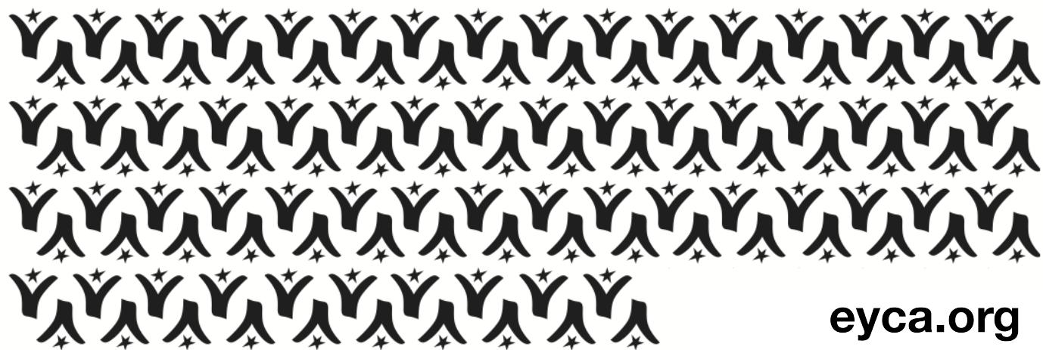

Introduction

The Seminar “Youth Work and sustainable communities: the role of European Youth Card in delivering youth card services” will take place in Helsinki, Finland, on 5-7 May 2019 as part of the programme of Partial Agreement on Youth Mobility through the European Youth Card, of the Council of Europe.

Three partners joined forces for its implementation: the Partial Agreement on Youth Mobility through the Youth Card of the Council of Europe (Finland is part of the Partial Agreement), the European Youth Card Association (EYCA) and its Finnish member organization - Finnish Youth Co-operation – Allianssi.

About the organisers

The Partial Agreement on Youth Mobility through the Youth Card exists since 1991 and is a programme of the Council of Europe aimed at developing the youth card scheme, particularly at European level, in the best interests of young people with a view to facilitating their mobility as well as access to the various goods and services necessary for their personal and cultural development.
The European Youth Card Association (EYCA) groups around 37 youth card organisations all over Europe and is the Partial Agreement’s statutory partner. EYCA’s vision is a Europe where all young people are mobile and active (socially, culturally, educationally and economically). EYCA’s mission to reach this objective consists in delivering quality youth card services and in contributing to a better policy on youth mobility and active citizenship. Today, over six million youth card-holders benefit from youth card opportunities.
The EYCA’s Finnish member involved in the preparations of the seminar is the Finnish Youth Co-operation – Allianssi, a national service and interest organisation within the field of youth work. It is a politically and religiously independent trustee hosting 125 national youth work and educational organisations as its members.
Its purpose is to promote the development of youth into responsible members of the society and to encourage youth participation in decision-making as well as international activities. Allianssi serves youth organisations and youth work.

Aim of the Seminar

As one of the leading European countries in promoting qualitative youth work services, Finland is the perfect location to host one of the Partial Agreement’s seminars, especially as it holds the Chairmanship of the Committee of Ministers for the period of November 2018 - May 2019. It will be a follow-up to the main activity of the Finnish Chairmanship in the field of youth, namely the seminar “Educational Pathways for Youth Workers” (20-22 February 2019, Helsinki).

The main objectives of the event are:

a) Explore the understanding of ‘youth work services’ and the variety of models across CoE countries;

b) Promote the importance of youth work in building sustainable communities, based on access to rights and social inclusion of vulnerable young people;

c) Consider the role of the European Youth Card in implementing specific CoE legislation, in particular the recommendation on youth work CM/Rec (2017).

The seminar will offer the space to learn from the Finnish model of youth work and understand the process from policy design to implementation. The event is expected to bring together youth workers, young people (beneficiaries), representatives of Ministries responsible with youth work in the Partial Agreement member states and researchers.

Profile of the participants
This one-day-and-a-half seminar is open to up to 50 participants with expertise in youth affairs/youth mobility, social issues, youth work, who will include:

- Governmental representatives of the Council of Europe member states;
- Researchers;
- EYCA member organisations, partners and networks;
- International organisations;
- Youth organisations and civil society organisations.

The programme of the seminar appears in Appendix I.

Practical information

The working language of the seminar will be English.

Travel

The participants will be requested to book their travel themselves in the most cost-effective way. EYCA will reimburse international travel costs upon receiving the justificative documents:
- Request for reimbursement (to be sent to all attendees)
- E-ticket/ invoice / train/bus tickets clearly showing the paid amount
- Traveling by car: 0.25 Euros/km, upon receiving the gas receipt

Venue meeting and accommodation

Lodging is ensured for all guests at a hotel to be confirmed at a later stage. All guests will be accommodated in single rooms, unless other agreement was set. Participants, who required an extra night of accommodation due to flight connections, will be offered one in the same hotel, unless something else was agreed (arrangement on their own and reimbursement).

Meals will be ensured for the whole duration of the event, starting with a welcome dinner on 5th May and finishing with the lunch on 7th May 2019.

Accommodation and meals will be covered by the organisers.

Contact:
For practical information please contact Corina Pirvulescu, EYCA: +32 471 08 79 88

Visas: Nationals who do not belong to the Schengen area need a visa to enter Finland.

All participants are kindly requested to check whether they need a visa before they fill in the application form.

If you need a visa, please fill in the table in Appendix III, join the copy of your passport and send it together with your application form.

Application/expression of interest procedure

All candidates should express their interest by filling in the application form below (see Appendix II). The applications should be sent to the following e-mail: youthmobility@coe.int by Tuesday 9 April 2019 midnight (ECT).

The results of the selection procedure will be made known by the end of the week following the deadline.

A request for confirmation will be sent to all selected participants with a short deadline for replies. Following the confirmation, official invitation letters will be sent to the selected participants.

Participants needing a visa will be sent a special invitation for the purpose of acquiring a Schengen visa.

APPENDIX I

DRAFT SEMINAR PROGRAMME

DAY 1 | SUNDAY, 5th MAY 2019
 | Arrival of participants
20.30 | Welcome dinner at the hotel
DAY 2 | MONDAY, 6th MAY 2019
09.15 – 09.30 | Welcome  - Government of Finland  - Council of Europe representative.  - EYCA Director.
09.30 – 10.00 | Aim and objectives of the Seminar  Introduction of the facilitator, presentation and expectations of participants  EYCA presentation
10.00 –11.15 | State of affairs of Youth Work in Europe  - Prof. Howard Williamson – Youth Work transforming communities over the past 30 years.  - Jarkko Lehikoinen - Finnish model of Youth work - How and why it actually works  - Trends in the recognition of youth work – a profession to aspire to?
11.15 - 11.45 | Coffee break
11.45 – 13.00 | New and old challenges in youth work  - Youth work in the digital era: what is next?  - Layne Robinson, Head of Social Policy Development at The Commonwealth Secretariat – Setting up new models of youth work services around the world
13.00 – 14.30 | Lunch break (at the hotel)
14.30 – 16.00 | Presentations: European Youth Card and the Youth Work Recommendations  - Youth work and civic youth participation: Aġenzija Żgħażagħ – Malta  - Youth work and promoting social inclusion, tolerance and multicultural communities - Youth Board of Cyprus  - Youth work and media literacy – Carnet Jove Andorra
16.00 – 16.30 | Coffee break
16.30 – 18.30 | Field visit to a youth work centre / Attending a youth work activity
19:00 | Dinner
DAY 3 | TUESDAY, 7th MAY 2019
9.30 – 11.15 | Presentations: European Youth Card and the Youth Work Recommendations  - Youth work and civic youth participation: Agencia Catalana de la Joventut – Spain  - Youth work and promoting social inclusion, tolerance and multicultural communities - Youth Work Ireland  - Youth work and media literacy - Young Scot – Scotland, UK
11.15 - 11.45 | Coffee break
11.45 - 13.00 | Conclusions  Wrapping up: summary of the groups discussions  Possible recommendations to the EYCA organisations and policy-makers  Next steps and closing of the Seminar
13.00 | Lunch (at the hotel)

APPENDIX II

Application form/Expression of interest

Personal detaIls
First name
Last name
Date of birth (dd/mm/yyyy) |  | Nationality |  |  | Gender (M/F)
Permanent address
 | Postal code
 | Town |  |  | Country
Place of work
Address of the employer
Email
Telephone (with country and city codes!)
Mobile
Emergency contact details

DETAILS OF THE NOMINATING ORGANISATION
Name of organisation
Postal address
 | Zip code
 | City |  | Country
Email address
Telephone
Fax
Brief info about your organisation (field of work, activities etc.)

What are your role and tasks within your organisation?

Do you have any special needs or requirements that the hosting organisation should know about? (E.g. mobility, medical needs, allergies, dietary restrictions)

APPENDIX III

Do you need a visa?

□ No
□ Yes

If yes, please fill in the following information (as spelled out in your passport) and attach a copy of your passport:

First name
Last name
Date of birth
Passport number
Time and place of issue
Valid till
Place where you will apply for a multiple Schengen visa

Place of studying/ work and your position

Address of the educational establishment/ employer

DEADLINE – Tuesday 9 April 2019 midnight ECT

All applications should be sent to
youthmobility@coe.int

