OBJECTIVE BOOKLET

Web Based Game on Digital Citizenship Education within the Scope of HF III Pilot Project on Digital Citizenship Education in Türkiye

This document is the property of the Council of Europe. The supplier will treat this document as strictly confidential. It may not be reproduced or communicated without the author's prior agreement. The content of this document will be disclosed to potential business partners in good faith by the supplier. No part of this document may, in itself, constitute a commitment of the Council of Europe or its staff.

Purpose of this document

The purpose of this document is to provide each competitor the necessary information on how we will proceed and what we expect from them during the selection process:

• The proposal document model expected by the CoE,
• Each competitor must provide proof of their eligibility and demonstrate their strengths in terms of the selection criteria,
• Each competitor will also provide his vision regarding the theme chosen by the CoE

We will select and invite the companies that fulfil the eligibility and selection criteria described in the document Tender Rules to participate to a competitive dialogue that will enable us to identify the company that best fits our needs and establish the final technical specifications of the contract.
We want to proceed to the selection in a step-by-step approach.
The first step will be to establish a shortlist of maximum 3 Bidders, based on the best submissions evaluated with our first selection criteria, who will be invited to participate in the Competitive Dialogue sequence.
The competitive dialogue phase:
• provide bidders with a better understanding of the CoE requirements,
• give both parties the opportunity to clarify gray areas,
• give the CoE a better understanding of the bidders' offer,
• allow bidders to further analyze and refine their offer and resubmit a more competitive proposal.
This will create a win-win situation to achieve a successful statement of work for the services to be provided at the end of the process.
This process will also ensure the fair and transparent sharing of information between bidders so that all bids are evaluated and compared equally.

Project description

The action aims to promote human rights, fundamental freedoms and democracy in schools by empowering students in their digital presence through Digital Citizenship Education (DCE) at the lower secondary level in Türkiye. The action proposes a series of measures to introduce the concept of digital citizenship and its essential core competences, which are grouped under three clusters as being online, well-being online and rights online with reference to the DCE tools of the Council of Europe in education institutions in Türkiye in consultation with key stakeholders and end beneficiaries.

In the context of the project, the Council of Europe is looking for a qualified game development provider to design, develop, and launch a web-based applied game on DCE targeting children aged 10-14 years old.

The purpose of the game is to provide a fun tool to play with for the children aged between 10-14 through which they acquire competencies for digital citizenship. Although, the game should not inherit didactic approaches to teach competencies explained under 10 domains of the DCE (kindly refer to the DCE handbook in ENG and/or TR), it should embody a story line and game mechanic which foster these competencies. The online web-based game should also allow in-class activities, group works as an extension/addition so that children who does not have access to online-game have the opportunity to enjoy the non-digital elements while teachers have the opportunity to facilitate the conversations, activities on DCE in the classroom.

The game:
- should be accessible for single-player and support local multiplayer functionality for groups of up to four players,
- should foster in-class collaboration and teamwork suggesting collateral activities after the playing experience,
- shall have inclusive features to accommodate students with learning difficulties,
- encourage reflection on digital citizenship topics,
- progressively impart knowledge related to the 10 domains,
- ensure that players do not require prior knowledge of the 10 Domains,
- have a seamless learning experience integrated into gameplay.

The game should also avoid gamification effects as a learning leverage and/or artificial incentives and avoid conventional quiz-based assessments.

Please refer to the technical specifications for further information on the game development and technical aspects.

The primary goal is to create an engaging and educational gaming experience that promotes digital citizenship awareness and encourages reflection. The game should be ready for launch in October 2024, with a budget of € 150.000 maximum for development, design and testing.

Therefore, the Council of Europe is looking for one Provider (provided at least one tender meets the criteria indicated below) in order to develop such a game. This Framework Contract will take effect as from the date of its signature by both parties and is concluded until: 30 June 2025

Technical & functional needs

The offers will include the different topics below:

- the providers’ background, experience, and portfolio;
- understanding of the assignment, and proposed approach to project implementation; including the design and functionality of the platform, the usability and user-friendliness of the platform, and the ability of the platform to meet the needs of the end users;
- Risk assessment and mitigation plan: A risk assessment and mitigation plan that outlines the potential risks that the project may face and the steps that the bidder will take to mitigate those risks.
- Communication plan: A communication plan that outlines how the bidder will communicate with stakeholders and keep them informed throughout the project.
- Security plan: A security plan that outlines how the bidder will ensure the security and protection of sensitive data on the platform, and its stability.
- Staffing plan: A staffing plan that outlines the personnel and resources needed to complete the project, and how they will be allocated, in other terms - team composition and division of labor;
- Project plan: A detailed project plan that outlines the bidder's plan for delivering the project on time and within budget, including timelines, milestones, and key deliverables.
Platform and Technology
Develop the game as a web-based application accessible through standard web browsers. Utilize modern web technologies, frameworks, and programming languages (e.g., HTML5, CSS, JavaScript, and WebGL) to ensure compatibility, performance, and longevity of the application.
Accessibility and Inclusivity
Implement accessible design principles to cater to players with various learning difficulties (dyslexia-friendly). Incorporate adjustable settings for customization, such as font size, colour schemes, and audio cues.
The game should include handling user input (keyboard, mouse, touch) to allow inclusivity.

Progressively Structured Gameplay
Design the game to have levels or scenarios that align with each of the 10 domains of Digital Citizenship Education (kindly see the DCE Handbook in ENG and TR for further information about the domains). Ensure that each level introduces and reinforces knowledge about a specific domain while allowing for reflection and exploration.

Interactive Narrative
Craft a cohesive and engaging narrative that guides players through the game, providing context for the digital citizenship topics. Use storytelling, visual-storytelling or/and environmental storytelling techniques, to integrate knowledge transfer seamlessly into the narrative.

Multiplayer Functionality
Implement a local multiplayer mode, either synchronous (real-time) or asynchronous (turn-based) to boost collaboration.
Assessment and Progress Tracking
Develop a mechanism for tracking player progress and knowledge acquisition.
Provide informative feedback on the player's understanding of digital citizenship concepts.

Security and Privacy
Implement robust security measures to protect user data and ensure player privacy.
Comply with relevant data protection regulations.

Localization
The game primary languages are Turkish and English. Localization in all EFIGS languages (English, French, Italian, German and Spanish) will be considered a plus.

Hosting the platform
The game will be hosted under an external domain and the subscription/fee of the domain will be covered by the project budget. Therefore the cost of the domain should be included to the financial proposal.

Intellectual Property and Ownership
The selected game development company will be expected to grant the [Ministry] ownership of the game and all related intellectual property upon completion.

Maintenance and Updates
The game to be developed will be hosted by an external server to be provided by the service provider. In order to ensure the game’s sustainability, the game will be transferred to MoNE’s and/or CoE’s servers following the completion of the project. During the transfer of the game, the selected company is expected to provide technical support to MoNE’s and/or CoE’s IT Department. The selected company should be willing to provide maintenance and support services for three months after the launch of the game, addressing potential issues, ensuring compatibility with evolving web technologies, and making necessary updates to maintain the game's relevance and functionality.
Accordingly, technical maintenance support is needed to ensure the game is up and running, including patches and updates if needed. These additional costs needs to be added to the financial proposal as well

Methodology, Reporting and Communication
The selected candidate will follow a protocol for project progress as shown below.

Project process protocol
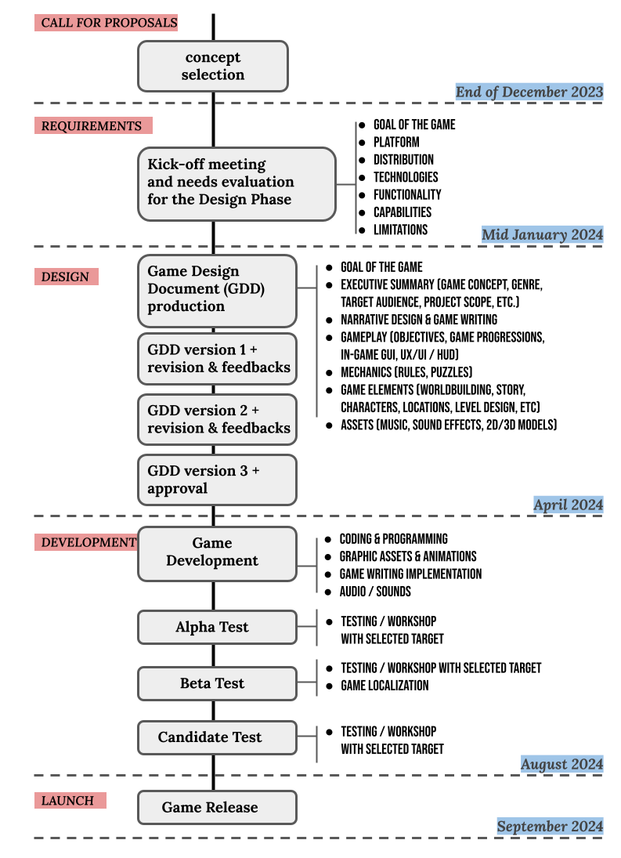
December 2024
September 2024
November 2024
June 2024
May 2024

