55 - Mapping refugees’ journeys and the local area

Aim: To enable volunteers to run and provide language support for simple activities based on mapping refugees’ journeys to their current location, and, in the case of refugees who are allowed to move freely in the area, also mapping the local area..

**Activity 1 – mapping journeys to refugees’ current location**

1. Find a wall map or make copies of a map (such as the one in tool 1: [*The geopolitical context of migration*](http://rm.coe.int/tool-1-the-geopolitical-context-of-migration-language-support-for-adul/1680716c0d)). Ask simple questions such as ‘Where is [this country] on the map?’, ‘What is this country to the west/east/north/ south of [xxx country of current location]?’, ‘Where is Turkey on the map? Can you show me?’, ‘Where is your country on the map?’ etc. If necessary, give examples: e.g. Mosul is in Iraq. Iraq is here on the map, Turkey is to the north of Syria. The distance from Munich to Berlin by road is nearly 600 km. etc.
2. Give an example of the journey a refugee may have taken. This can be the route taken by an imaginary refugee or by someone in the group who is willing to give you information. Tell the story using simple language, for example:

“Ahmed is from Aleppo in Syria, which is here in the map. He left his home in 2016. He first went by bus to Turkey and crossed the border, here. He stayed in Turkey for 6 weeks. Then he travelled by boat to an island in Greece, here on the map…” And so on. Use the vocabulary and expressions in sections 7.1 and 7.2 of tool 33 ‘[*A list of expressions for everyday communication’*](http://rm.coe.int/tool-33-a-list-of-expressions-for-everyday-communication-language-supp/16807171b7). From time to time during the story stop to ask simple questions (e.g. where is Ahmed from? When did he leave? Where did he go first, etc.). End the story of the journey with “he arrived here in June, and now he is living in….”.

1. Tell (or read) the story again, or tell another similar story. This time ask refugees to mark the route of the journey on the map. Tell them to ask you questions if they are not sure (e.g. where did he go from Greece? Where is Lampedusa? How many weeks was he in….?).
2. Now ask refugees to tell some of their stories. Give them some time to prepare, and offer help. If they have a smart phone they can also check maps and information that way.  
   **Important note**: *refugees must be willing to do this: if anyone is shy or unwilling to talk about their journey, do not ask any further questions*.   
   If refugees prefer, they can talk about a family member or someone else they know who is not in the group. While a refugee is talking, others can ask questions and mark the journey on the map.

If several refugees want to tell the story of their journeys, spread the activity over several sessions.

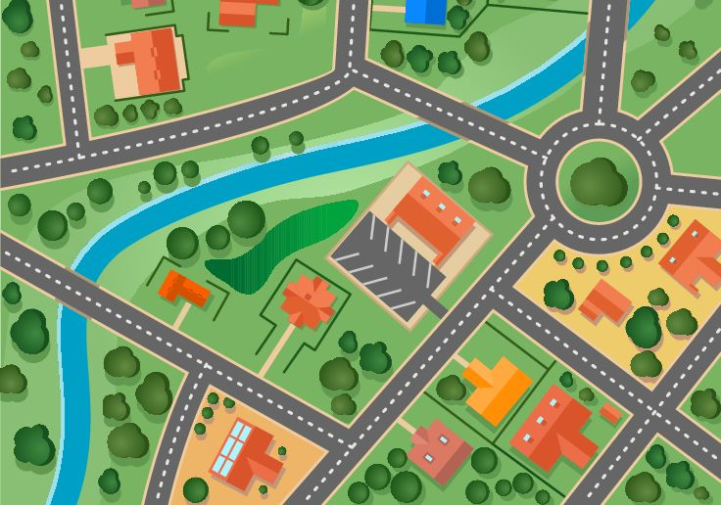

Activity 2 – mapping the local area

* Ask refugees to work together in groups to create a shared map of the local area or of places where people meet, such as a welcome centre, a sports centre, a cinema, a market place etc. This will depend on the local situation and the interests of the refugees.
* Ask refugees to use their maps as the basis for conversations. For example, they can ask each other questions and share important and useful information about the local area such as the places they know, like going to and can recommend, and then practise giving directions to these places.
* Refugees can display their maps for other people, who may be able to add more information.

Activity 3

Refugees can produce a short information sheet about the local area for new arrivals. This could either be in their first language only, or in their first language and the language of the country they are in.

Examples of useful language for this activity

|  |  |  |
| --- | --- | --- |
| Get information. | *Where do you get free Wi-Fi access?*  *Where is the market?*  *Who can help with … (legal advice, food vouchers, information about …. etc.)?*  *What time does it open?* | *At the …*  *In the centre of town.*  *Ask for … at the …*  *It’s open from … to …* |
| Ask for and give directions and tell each other where places are. | *Where is the …., please?* | *Go straight on.*  *Turn right.*  *It’s on the left/behind the/next to …. etc.*  *Go straight ahead and turn left at the second traffic lights.*  *The …… Clinic is near here.*  *The Advice Centre is opposite the school.* |
| Describe places/buildings. | *The training centre is very nice. The courses are free. It’s got a cheap café and a garden.*  *It’s the tall building next to the bus station.* | |
| Express likes/dislikes. | *I like … supermarket. It’s very cheap.*  *That shop is too expensive.* | |
| Make comparisons. | *... is more useful than …….*  *... are cheaper than ……* | |
| Languages used in different places. | *They speak Arabic in that centre.*  *Is there an interpreter at the clinic?* | |
| Ask for help. | *We need more bins for our rubbish.*  *Can you give us another voucher, please?* | |

Observation task:

Ask refugees to listen to people when they want information or ask for something: Can they remember any useful phrases?

It may be helpful to collect such phrases or to do role plays to practise using them.

See also Tool 48 [*Finding your way in town: the local library*](http://rm.coe.int/tool-48-finding-your-way-in-town-the-local-library-language-support-fo/16807171c8)*.*