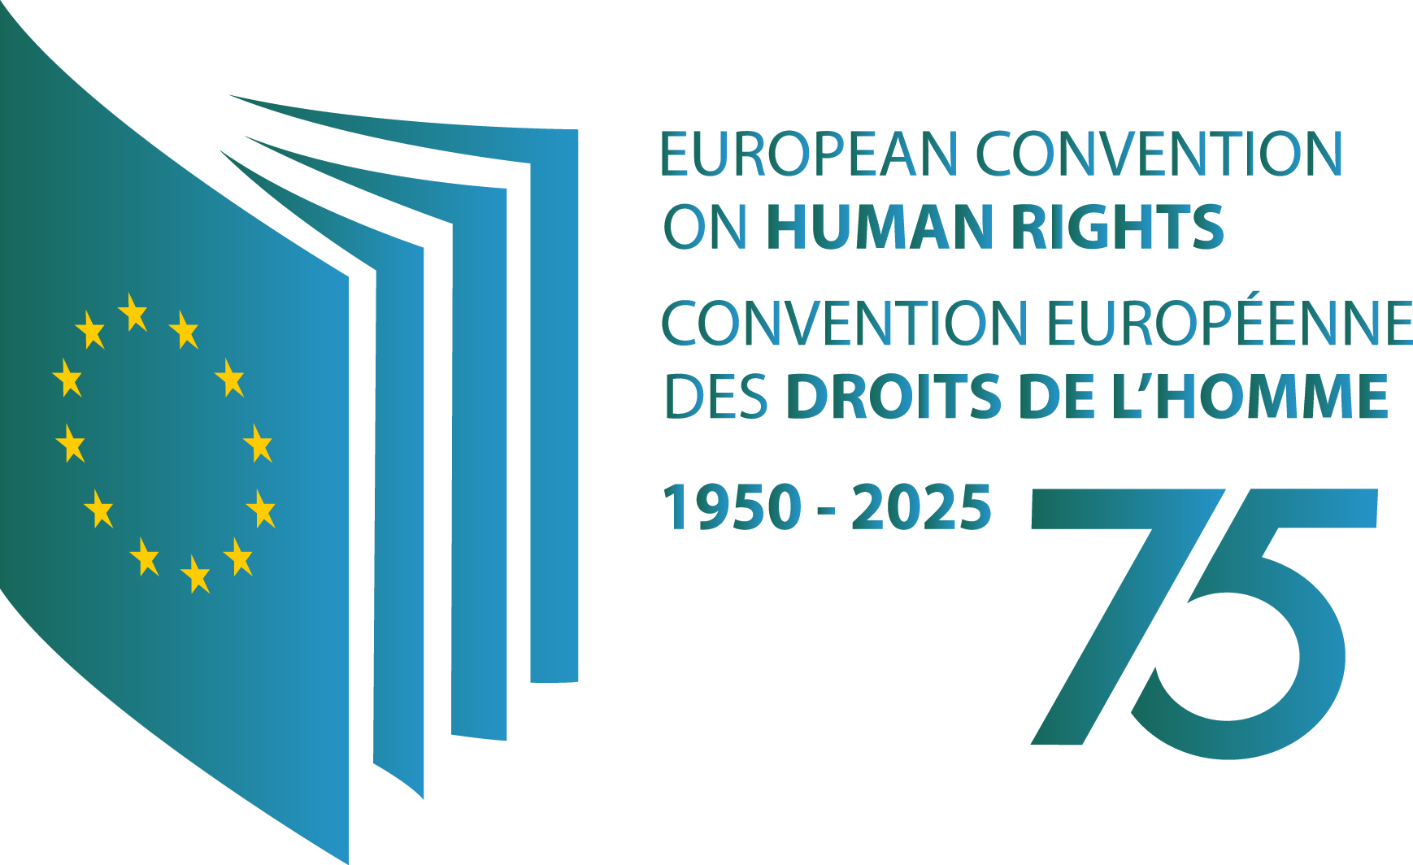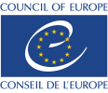
MEDIA RELEASE
Communications
Ref. DC 093(2025)
Secretary General highlights next steps on Special Tribunal for Ukraine in moment of unity in Lviv
Strasbourg, 09.05.2025 – The Secretary General of the Council of Europe, Alain Berset, has made the following statement concerning the political backing expressed today for the Special Tribunal for the Crime of Aggression against Ukraine:
“Today’s event in Lviv demonstrates our unity and resolve to ensure a just and lasting peace for Ukraine.
“Ukraine is part of our European family and remains the Council of Europe’s top priority. We have already developed an Action Plan on Resilience, Recovery and Reconstruction. We have established a fully functioning Register of Damage for Ukraine. The European Court of Human Rights is examining thousands of cases of alleged human rights violations resulting from Russia’s aggression. And we have made the plight of Ukrainian children our own.
“We are providing the framework for the Special Tribunal for the Crime of Aggression against Ukraine. This is the moment for states to follow up on the political will they have shown today. Justice also needs resources. Funding must be secured, and the necessary support provided for the functioning of the future tribunal.
“This Special Tribunal can help shape Ukraine’s future for generations to come.”
Frequently Asked Questions - Special Tribunal for the Crime of Aggression against Ukraine

Press Contacts
Andrew Cutting, Spokesperson/Media officer, Tel. +32 485 21 72 02
Tatiana Baeva-Frachon, Media officer, Tel. +33 3 88 41 21 41 or Tel. +33 6 85 11 64 93

Council of Europe, Media Assistance Unit / Conseil de l’Europe, Unité d’assistance aux médias
Tel. +33 (0)3 88 41 25 60 - www.coe.int - pressunit@coe.int

