MINISTERS’ DEPUTIES | CM Documents | CM(2025)55 | 26 March 2025

1528th meeting, 7 May 2025
11 Programme, Budget and Administration

11.2 Progress report on administrative reform measures

Item to be considered by the GR-PBA at its meeting on 24 April 2025

- This ninth progress report on administrative reform measures provides a detailed overview of ongoing progress and achievements in alignment with the Reykjavík Declaration from the 4th Summit of the Council of Europe (Reykjavík, 16-17 May 2023) and subsequent decisions.

- Since 2009, the Council of Europe has implemented reforms focusing on three main tracks - the political reform, the reform of the Court and the Convention system and the administrative reform - to reinforce its capacity to continuously adapt to current and future challenges.

- This report specifically addresses administrative reform measures and reviews progress of each reform area between January 2024 and January 2025, including a set of dashboards (Appendix 1) and Key Performance Indicators (KPIs) (Appendix 2).

Administrative reform framework

- The overall aim of the administrative reform is to enable the Organisation to meet its current and future challenges in an effective and efficient way, by continuously improving its culture, governance, working methods, tools and internal regulations. Ultimately, the reform aims to promote an agile Organisation, confident in its expertise and talents, operating in a suitable working environment, whilst contributing to strengthening a results-oriented culture. This drive is embedded in the Organisation through an improved Results Based Management (RBM) approach and its results-oriented management strategy 2023-2027 which places a particular emphasis on learning and synergies between this approach and relevant parts of the administrative reform agenda.

- Pivotal in the implementation of reform, change management processes are integrated into each layer of the reform strategy, thus aiming to impact the Organisation’s culture towards reaching the desired objectives and supporting all stakeholders in embracing new solutions, tools and methods.

- At the 4th Summit of the Council of Europe, leaders called for “a modern Council of Europe enabling [the Organisation] to meet current and future challenges” and committed to ongoing reforms for greater transparency, efficiency and effectiveness. This was confirmed by the Foreign Affairs Ministers who, at the 133rd Session of the Committee of Ministers (Strasbourg, 17 May 2024), “welcomed the Secretary General’s [previous] progress report on administrative reform measures, including work on sustainable development and reducing the carbon footprint within the Council of Europe”, and “reiterated the critical importance of continuing the reform process for a modern and flexible Council of Europe to achieve its objectives”.

- Aiming for a modern and attractive Organisation, as encapsulated in the motto “Improving the way we work together”, is important and will remain one of the guiding principles of the administrative reform and, in light of the above, the Secretary General, the Deputy Secretary General and the whole Organisation remain fully committed to its pursuit throughout the quadrennium.

- The core strategic documents setting the overall administrative reform framework over the reference period are the People Strategy 2024-2027, the Information Technology Strategy 2023-2027, and the Capital Master Plan.

- The main reference documents related to the administrative reform are available on the reform intranet site, which provides a single-entry point for all administrative reform matters and is also accessible from the Committee of Ministers’ website.

People Strategy

- Drawing from dashboard 1 (Appendix 1), an overview of some of the key outcomes in 2024 and key steps foreseen in 2025 is provided below:

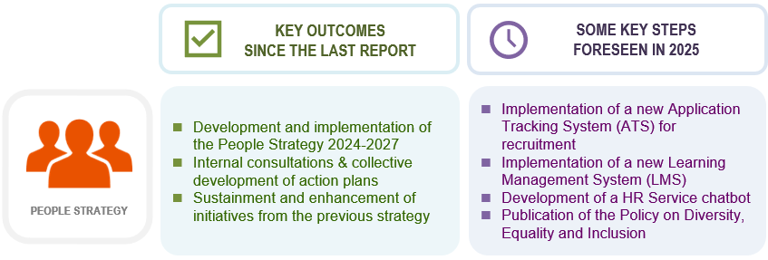

- The Council of Europe’s People Strategy 2024-2027 not only builds on the solid foundation established by the previous strategy (2019-2023), notably with the comprehensive review of the regulatory framework, but it also takes into account further priorities and direction to the Council of Europe’s work provided by the Heads of State and Government in the final declaration of the Reykjavík Summit. Through the instrumental role it plays in the administrative reform, the Strategy aims to positively contribute to an agile, resilient and results-oriented Organisation that can adapt to its current and future challenges, in line with the Programme and Budget.

- To ensure that the Organisation moves towards a transparent, efficient and effective management of human resources and that staff members are empowered, engaged and excel, three substantive strategic priorities and a supportive strategic priority emerged - workforce management, diversity, inclusion and well-being, organisational development and modernisation of the HR function.

- Building on the four strategic priorities of the People Strategy, a series of Action Plans were collectively developed during the fourth quarter of 2024 following internal consultations. This concluded the design phase of the Strategy with a clear roadmap indicating specific and operational objectives, change management measures to reach these objectives, along with associated indicators enabling the measurement of achievements at the end of the implementation phase.

- The performance indicators in Appendix 2 demonstrate progressions in all key areas during the period, from training and assessment to staff movement and recruitment. In 2024, overall staff movements continued to increase during the period from 635 in 2023 to 696, an increase of 9.6%, and the number of international external competitions organised rose by 20% with the number of external candidates increasing by almost 22% from 7 750 in 2023 to 9 431. Furthermore, the number of junior professionals recruited and the number of trainee applications rose by 27% and almost 200% respectively.

- A Committee on Diversity, Inclusion and Non-Discrimination, chaired by the Deputy Secretary General, was created in 2024 with the primary objective of providing advice and guidance to the Secretary General on matters relating to diversity, inclusion, non-discrimination and equity, to monitor and evaluate the implementation of policies relating to these areas. It replaces the former Equal Opportunities Board with an expanded mandate to include other aspects of diversity, in particular disabilities, age, nationality, ethnicity and sexual orientation.

- In 2024, new rules were introduced to modify the current framework on teleworking to enhance flexibility while maintaining operational efficiency, such as reinforcing managerial approval to ensure teleworking compatibility with departmental operations and streamlining the teleworking request process.

Digital transformation


- Drawing from dashboards 2, 3, 4 and 5 (see Appendix 1), an overview of some of the key outcomes in 2024 and key steps foreseen in 2025 is provided below:
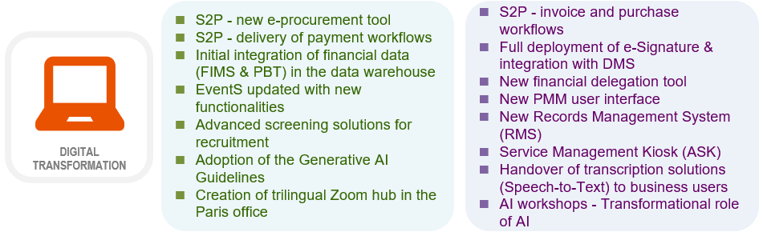

- Digital transformation is a key reform enabler to facilitate the streamlining of work procedures and to support staff in their daily work. Organised around five main areas, it is supported by the Information Technology Strategy 2023-2027 which outlines measures to implement innovative and cost-effective systems that will enhance the efficiency and productivity of the Organisation. Initially set for the period 2023-2025, the Strategy was extended to 2027 in alignment with the Programme and Budget cycle and adopted by the Ministers’ Deputies in April 2024.

- In order to continue modernising the Organisation’s digital work environment, the Source to Pay (S2P) programme has continued to consolidate common working methods and simplify financial processes through the introduction of electronic signatures and by facilitating management reporting systems. In this context, a new e-procurement tool and payment workflows were delivered to users in 2024, with invoice and purchase workflows foreseen in 2025. Digital transformation initiatives also support the implementation of IT tools and applications linked to the People Strategy, such as the Application Tracking System for recruitment and a new Learning Management System, and contribute to improving the visibility of the Organisation’s activities.

- Further contributing to increased agility and stronger business continuity, the IT Strategy supports a number of New Way of Working (NWoW) initiatives such as the full provision of portable computers and the future computer telephony integration. The extension of VPN (Virtual Private Network) technology to all professional laptops distributed to staff member ensures a faster, and a more secure and stable connection to the Organisation’s IT network, in line with the mission to modernise the digital working environment. Furthermore, with regard to cybersecurity, the strategy adopted by the IT Governance Board will continue to provide a robust and effective cyber defense, notably in the context of new and ongoing threats facing the Organisation.

- In the field of Artificial Intelligence (AI), a set of guidelines on the use and risks of online available generative artificial intelligence tools was published, representing the first written guidance put in place by the Organisation in this relatively recent and constantly evolving field of technology. Among the projects implemented were the Speech-to-Text transcription system, which will be handed over to business users in 2025, as well as an advanced preselection solution for recruitment using AI tools.

- The AI Working Group, which was set up at the end of 2023, focused on evaluating potential applications and benefits of AI, with the aim to support the Organisation’s missions and objectives and to enhance overall productivity and effectiveness. During 2024, working group members participated in training sessions on the impact of generative AI and initiation to prompt engineering, and in workshops, to discover and experiment with a secure AI platform and to run tests on the Speech-to-Text system.

Capital Master Plan and sustainable development

- Drawing from dashboards 6, 7 and 8 (see Appendix 1), an overview of some of the key outcomes in 2024 and some key steps foreseen in 2025 is provided below:
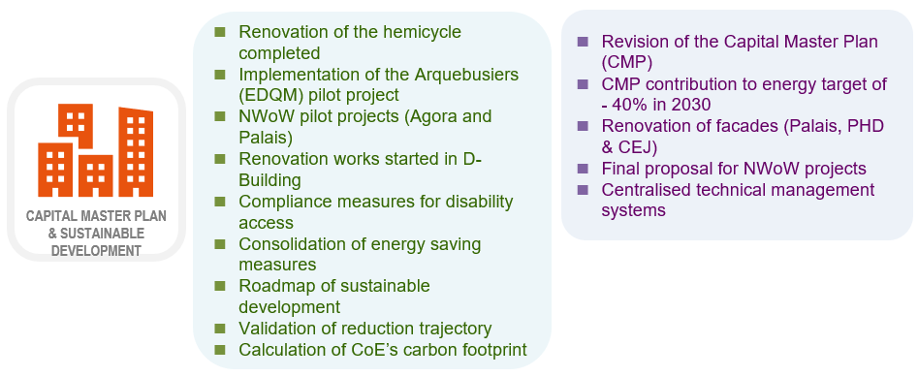

- The Capital Master Plan (CMP), as approved in 2021, significantly contributes to addressing the many challenges facing the Organisation in the field of real estate, such as the Organisation’s continued efforts and actions in terms of controlling energy consumption to limit both budgetary and environmental impacts. A revised CMP, for the period 2026-2035, will be presented to the Ad hoc Committee of Experts on Buildings (CAHB) in May 2025 and then to the Budget Committee and the GR-PBA. It will be structured around four main areas including energy and workspace efficiency, business continuity and security, and new technologies.

- Supported by investment projects outlined in the CMP, and as part of the Organisation’s efforts to meet the European regulatory objective of a 40% cut in energy consumption by 2030, the EEAP 2 (Energy Efficiency Action Plan 2022-2032) continues to ensure that measures to reduce energy consumption are implemented consistently.

- As a major project of the CMP, renovation work on the Palais hemicycle was completed in May 2024. The renovation, whilst respecting the historic architectural features of the hemicycle, included measures to meet accessibility requirements, modernisation of the technical installations to save energy and the installation of the latest multimedia technology.

- Following the Reykjavik Declaration, a commitment was made to strengthen the Organisation’s work on environmental aspects. To this effect, a roadmap for sustainable development and the reduction of the carbon footprint within the Council of Europe was presented to the Ministers’ Deputies in April 2024. This roadmap sets out the approach aimed at limiting or even reducing the impact of activities on the environment and, more broadly, contributing to strengthening the sustainability of the Organisation in its day-to-day operations and development.

- In this context, a Sustainable Development Study Group (GEDD) was created in 2024 with the aim to work on a cross-sectoral and collaborative basis to assess and subsequently reduce the carbon footprint of the Organisation’s activities. A calculation of the Organisation’s carbon footprint, as well as the Organisation’s carbon trajectory for its reduction were presented to the Ministers’ Deputies in December 2024. This will be accompanied by an action plan for sustainable development and carbon footprint reduction to be presented in early 2025. Furthermore, as part of the new events policy, a travel policy will also include measures which will aim to help reduce the Organisation’s carbon footprint.

- The New Way of Working (or NWoW) project provides a basis upon which the Organisation is defining new methods in occupying its workspaces, whilst ensuring complementarity with appropriate information technologies, human resources policies and taking into account the environmental impact. Pilot projects implemented in 2024 notably include the “Arquebusiers” project, involving over 60 EDQM staff members, Agora pilot projects targeting specific teams, and a new working environment for ITEM in the Palais de l’Europe. Other developments, including those earmarked for 2025, are summarised in dashboard 8.

Consolidation of governance

- Drawing from dashboard 10 (see Appendix 1), an overview of some of the key outcomes in 2024 and some key steps foreseen in 2025 is provided below:

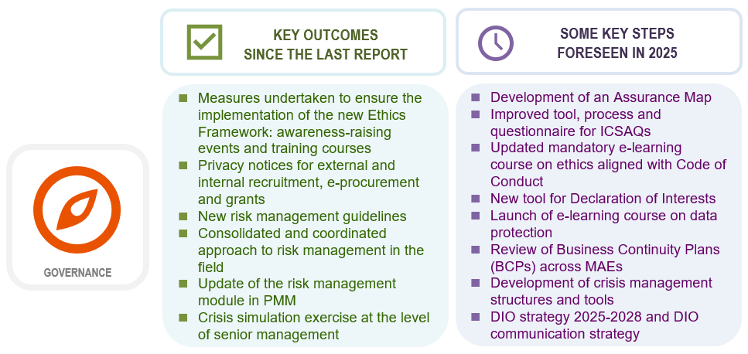

- Risk management, crisis management and business continuity, as well as internal control, ethics and data protection are interrelated topics at the heart of the Organisation’s robust governance system. In all these areas, the Organisation developed appropriate policies and tools aiming at consolidating its decision-making and the responsible management of its resources, whilst adhering to international standards and adapting to future evolutions.

- In 2024, developments to further strengthen the Organisation’s maturity aimed, as in previous years, to reinforce links between the various governance systems and promote a culture of accountability and organisational learning. The Intranet page on governance provides an overview of the framework (bodies and systems) in place.

- With the recruitment of the new Ethics Officer in 2024, measures aimed at raising awareness of the Organisation’s Ethics Framework were undertaken including the preparation of a mandatory e-learning course aligned with the Code of Conduct, and the development of a new tool designed to improve the declaration of interests’ process. Furthermore, the Ethics Office was reinforced in 2024 with the approval of a second full-time staff position.

- In the field of data protection, the development of privacy notices in areas such as recruitment and procurement have contributed to further safeguard the processing of personal data within the Organisation. Furthermore, an e-learning course on data protection for staff was developed during the year for deployment in 2025.

- In the field of internal control, actions were undertaken to further strengthen the Council of Europe’s internal control framework and practices in 2024. These include initiating the development of an Assurance Map which, once completed, will aim to clarify the assurance given by the different control and audit functions of the Organisation on a selection of risks and processes, and launching the development of an IT tool to improve the internal control self-assessment process.

- In 2024, the Organisation continued to promote greater maturity in managing risks and in enhancing its crisis management capabilities. Following the adoption of a revised Risk Management Policy in 2023, a set of guidelines was published in 2024 to clarify the roles and responsibilities of key actors involved in the process, and provide essential and practical knowledge to all those managing risks throughout the Organisation. Supported by a series of training sessions and workshops, a thorough review of external offices’ risk registers was undertaken in 2024 and, for the first time, integrated in the Risk Management Tool (RMT). In November 2024, a crisis simulation exercise was organised at the level of senior management to enhance of the Organisation’s crisis management capabilities. Based on the lessons learned, a series of strategic improvements to develop the Organisation's overall resilience and emergency response abilities will be implemented in 2025, including a set of management tools, training and communication plans.

- With regard to the implementation of recommendations stemming from the Directorate of Internal Oversight (DIO - audit and evaluation), the External Auditor and the Oversight Advisory Committee (OAC), 143 recommendations were implemented in 2024, representing over 61% of all open recommendations at the end of 2023. Dashboard 11 provides an overview of both implemented and new recommendations in 2024, aligning them, where possible, with the main drivers of the reform.

Focus on efficiency gains

- With its main drivers - People Strategy, Digital Transformation, the Capital Master Plan and governance - the administrative reform aims to deliver value for money, improve collaboration, productivity and effectiveness, streamline procedures and promote flexibility in resource allocation.

- At their 1513th meeting in November 2024, the Ministers’ Deputies recalled “the determination of the Heads of State and Government to ensure a modern Council of Europe”, reiterated “the utmost importance of continuing and strengthening the focus and momentum of the reform agenda” and “invited the Secretary General to seek further budgetary efficiency with quantifiable results whenever possible, aiming for annual efficiency gains of at least 2% to allow reinvestment in priority sectors to be agreed by member States within the Programme and Budget cycle”.

- In 2024, sustainable savings of €2.4 M were identified, of which €1.9 M were due to staff cost containment measures taken over the years as part of the continuous reform efforts, and €0.5 M as a result of energy efficiency measures put in place to reduce energy consumption. It was proposed to use these savings to invest in priority areas and actions.

- As part of the ongoing administrative reform initiatives, significant efficiency gains are being achieved across the Organisation, including those that are challenging to quantify, such as the time saved resulting from streamlined workflow processes, improved team collaboration, knowledge and skill-sharing, or more effective IT and communication tools.

- Many of these efficiency gains have enabled the Organisation to effectively manage the growing volume and complexity of tasks, some of which are highlighted in the examples provided below:

 |  | - Purchasing performance: the procurement unit has taken on the role of enhancing purchasing performance across the whole Organisation.  - Treasury operations: Treasury, Payments and Accounting (TPA) has faced increased complexity due to sanctions against the Russian Federation and a 20% rise in payment transactions over two years, alongside a 17.5% increase in financial reports related to EBR (Extra Budgetary Resources) co-operation projects in the same period.  - Technology infrastructure: the Organisation’s technological footprint continues to grow, with DiT partially absorbing this expansion.  - Recruitment and mobility: DHR sustained its efforts to improve both staff mobility, with a 10% increase in mobility for the last year, and administering external competitions, with a 22% increase in the number of candidates.  - Governance requirements: the implementation of governance-related requirements and initiatives have predominantly been supported by efficiency gains.

- The Organisation continued to offset inflationary pressures for the purchase of goods and services, with inflation indices of over 20% in the construction sector and almost 7% for IT related expenses, representing a significant effort to maintain financial stability and sustainability during the period.

Conclusions and next steps

- Over the reference period, administrative reform measures and initiatives continued to contribute to modernising the Organisation, increasing productivity, and absorbing cost pressures within a constantly evolving environment. These measures have also provided substantial efficiency gains that are crucial for maintaining operational resilience.

- In addition to the qualitative impacts highlighted in previous progress reports, reform efforts have driven operational efficiencies across various areas - from administrative procedures and recruitment processes to purchasing and payment workflows. These efficiencies have enabled the Organisation to manage increases in workloads and the capacity to invest further in reform initiatives. Recently, the Ministers’ Deputies at their 1513th meeting (November 2024) reaffirmed that these reforms are enhancing the Organisation’s “agility and adaptability, increasing effectiveness, and orientation towards sustained efficiency and cost containment.”

- The effects induced by the reform, as outlined in the Programme and Budget 2024-2027, demonstrate a consistent link between efficiency gains, cost reduction, and their reinvestment in priority areas. These gains will be progressively achieved over the quadrennium and complemented by new initiatives for the 2026-2027 biennium, in light of the 2025 mid-term review.

- The main drivers underlying the administrative reform process (People Strategy, Digital Transformation, Capital Master Plan, and governance) will persist in 2025, shaping the organisational culture and enhancing collaboration among key stakeholders to achieve the Organisation’s objectives. That said, reform measures will continue to be adapted in real time to ensure that the Organisation can effectively and efficiently meet new and evolving challenges.

Ninth progress report on administrative reform measures: table of appendices

Appendix 1: Detailed dashboards of each initiative of the administrative reform

→ People Strategy

Dashboard 1: People Strategy - implementation overview of the 2024-2027 strategy

→ Digital transformation

Dashboard 2: Digital transformation - implementation overview of the 2023-2027 IT strategy

Dashboard 3: Innovation (Emerging and innovative technologies, Artificial Intelligence)

Dashboard 4: Online meetings (2024-2025) – implementation overview

Dashboard 5: Online Events Management System

→ Capital Master Plan and sustainable development

Dashboard 6: Capital Master Plan (CMP)

Dashboard 7: Energy Efficiency & Sustainable Development

Dashboard 8: New Way of Working (NWoW)

Dashboard 9: Zero paper policy

→ Consolidation of governance

Dashboard 10: Governance system – a selection of key milestones and indicators

Dashboard 11: Overview of new and implemented recommendations in 2024

→ Streamlined working methods

Dashboard 12: Travel management

Dashboard 13: Translation management

Dashboard 14: Procurement performance

Appendix 2: Table of Key Performance Indicators (KPIs) of the administrative reform

Appendix 3: Glossary of acronyms

Appendix 4: Useful links on the administrative reform

Appendix 1: Detailed dashboards of each initiative of the administrative reform

Specific dashboards, focusing on strategies and projects with defined objectives and deadlines, display dials illustrating the progress made between January 2024 and January 2025, which can be read as follows:

How to read the progress dials
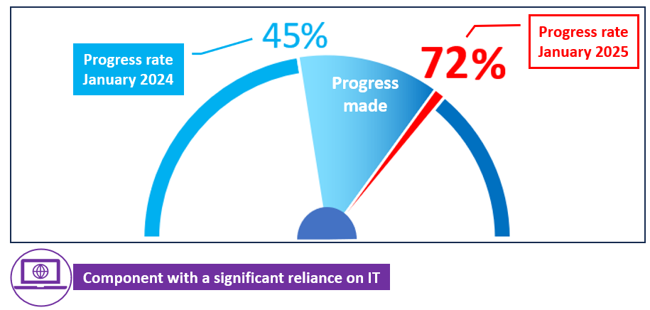

The values displayed in each dial are based on a self-assessment provided by each project team or by the entity responsible for it.

Appendix 1: Detailed dashboards of each initiative of the administrative reform

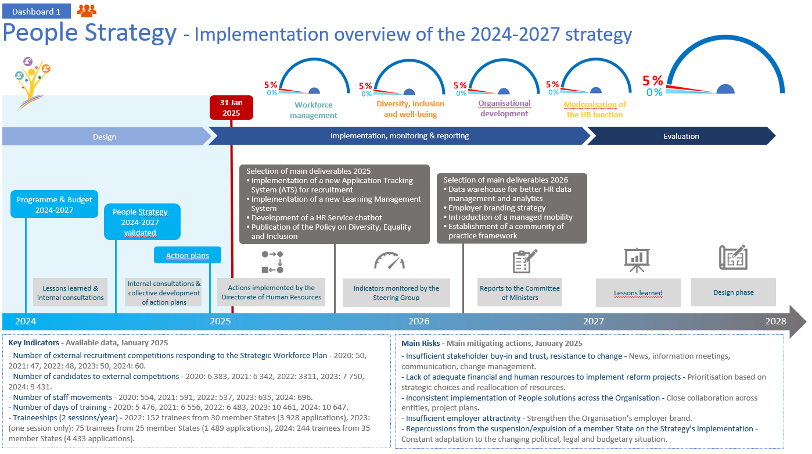

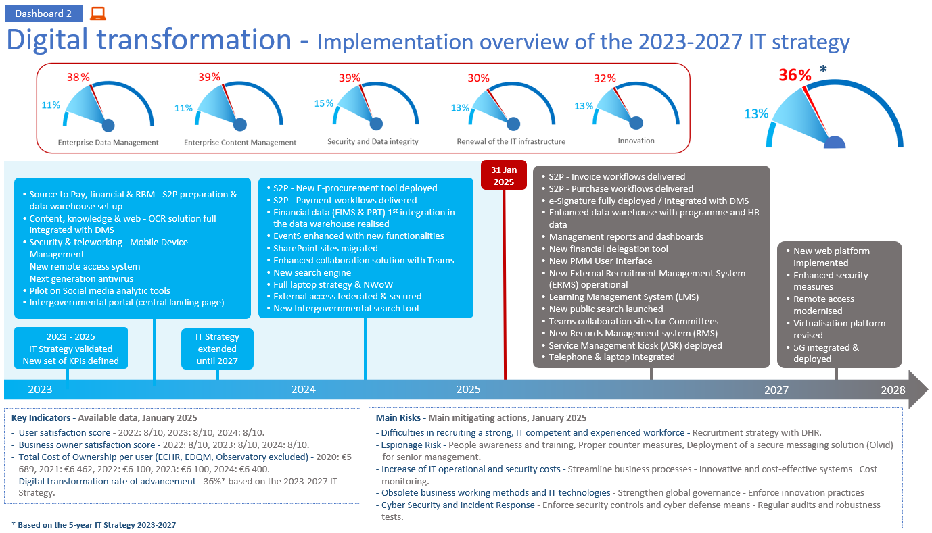

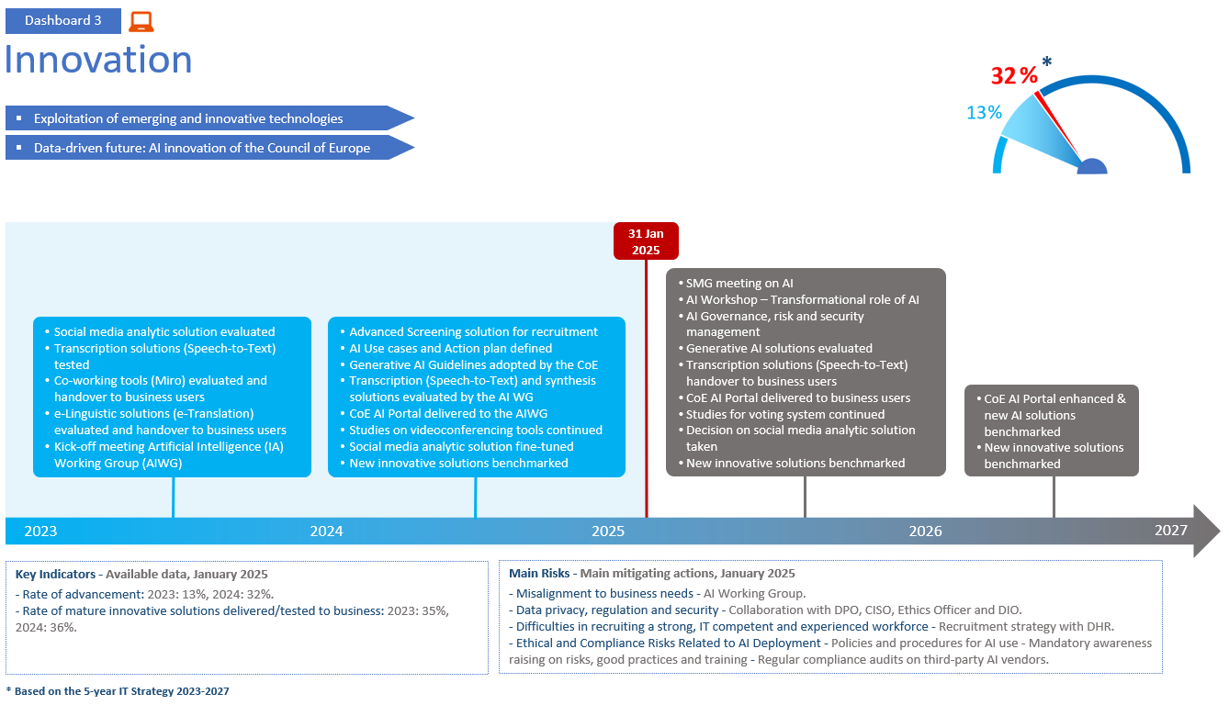

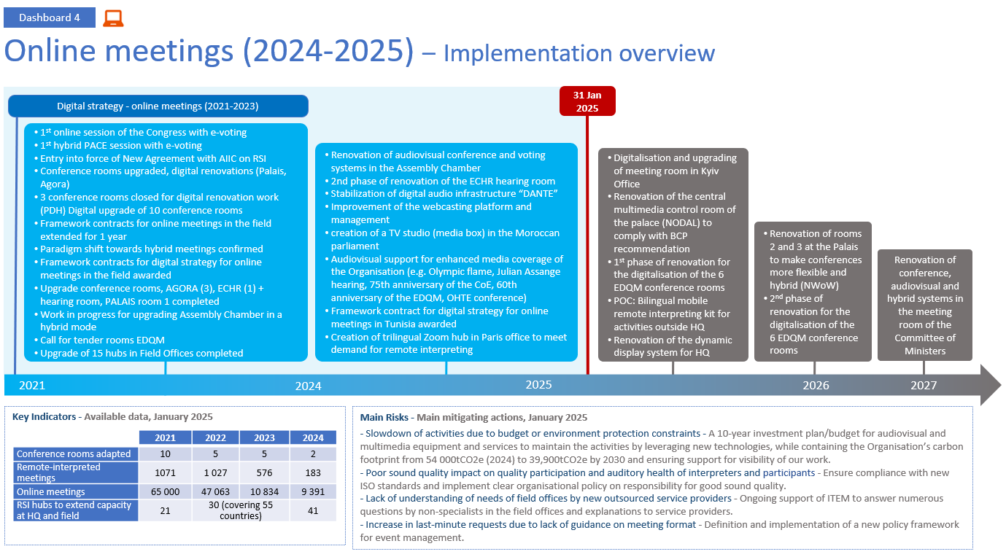

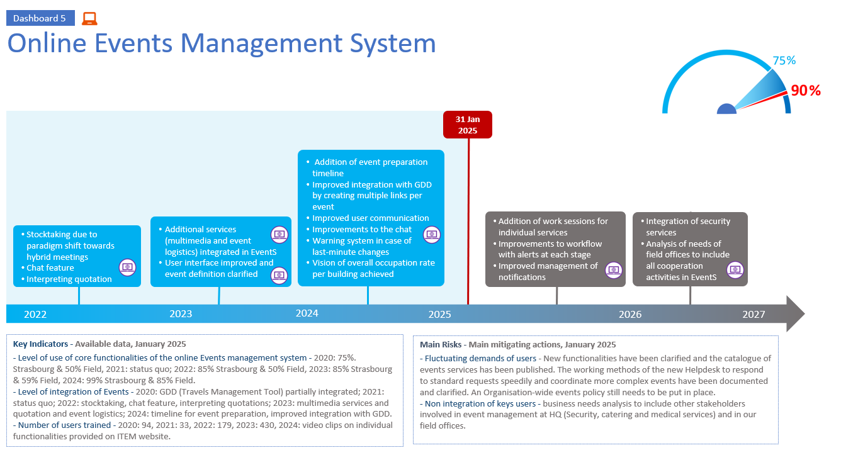

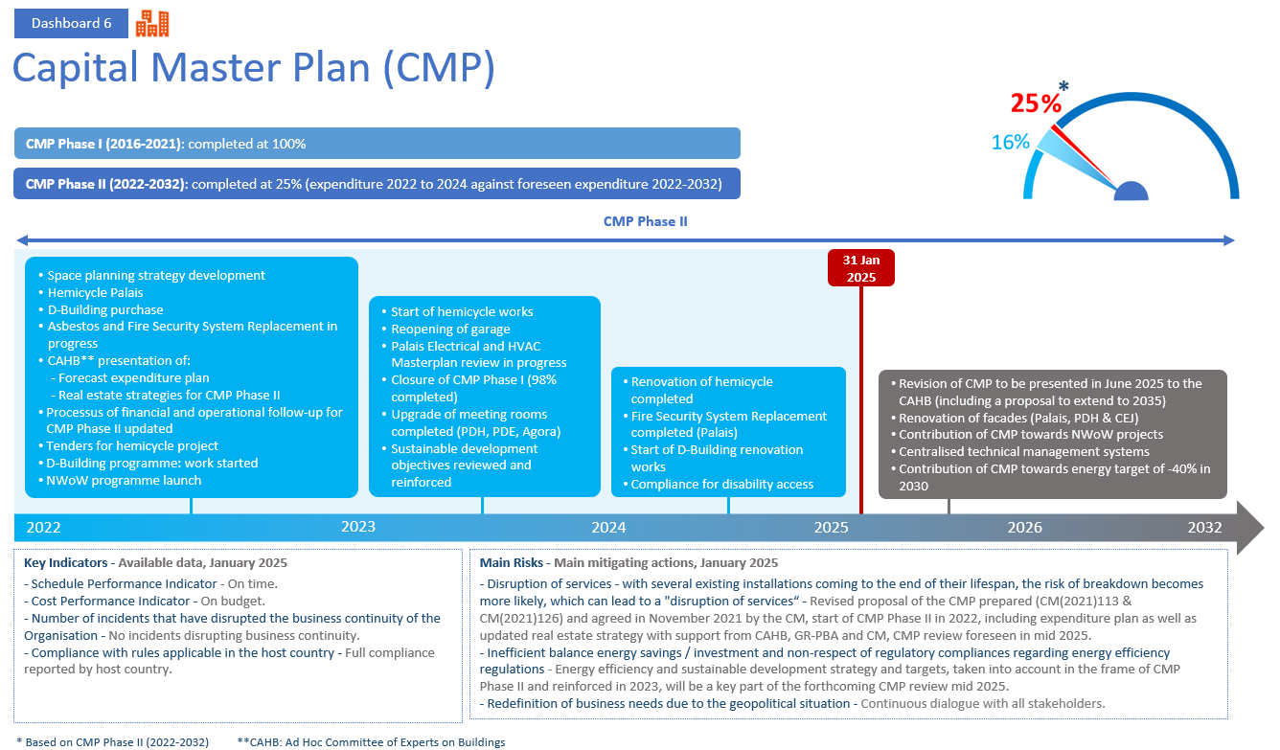

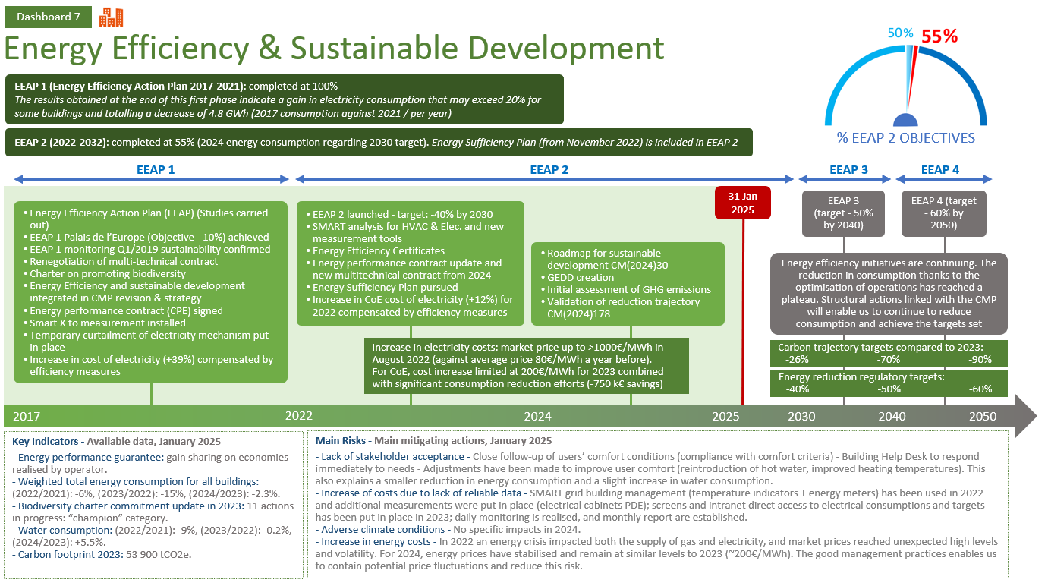

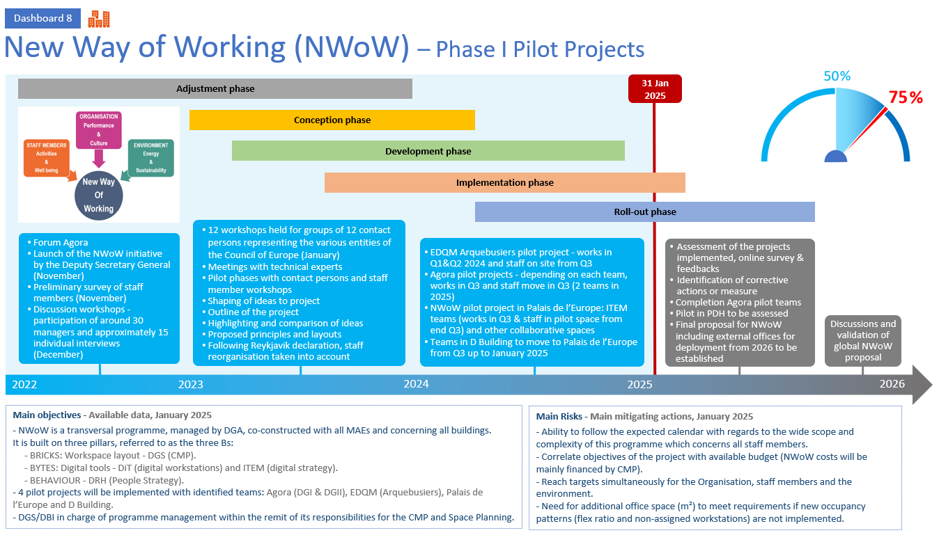

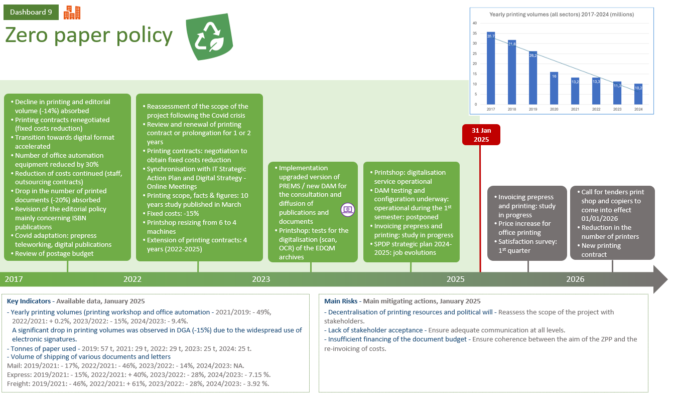

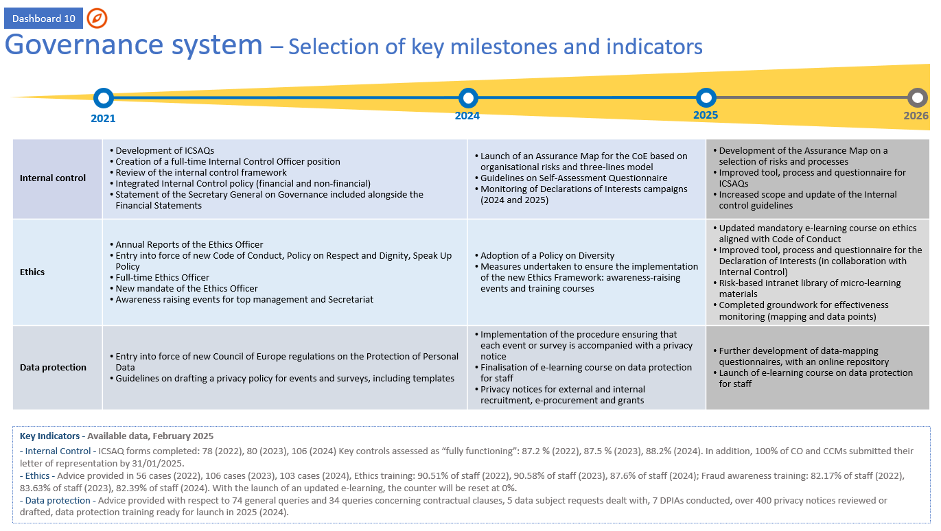

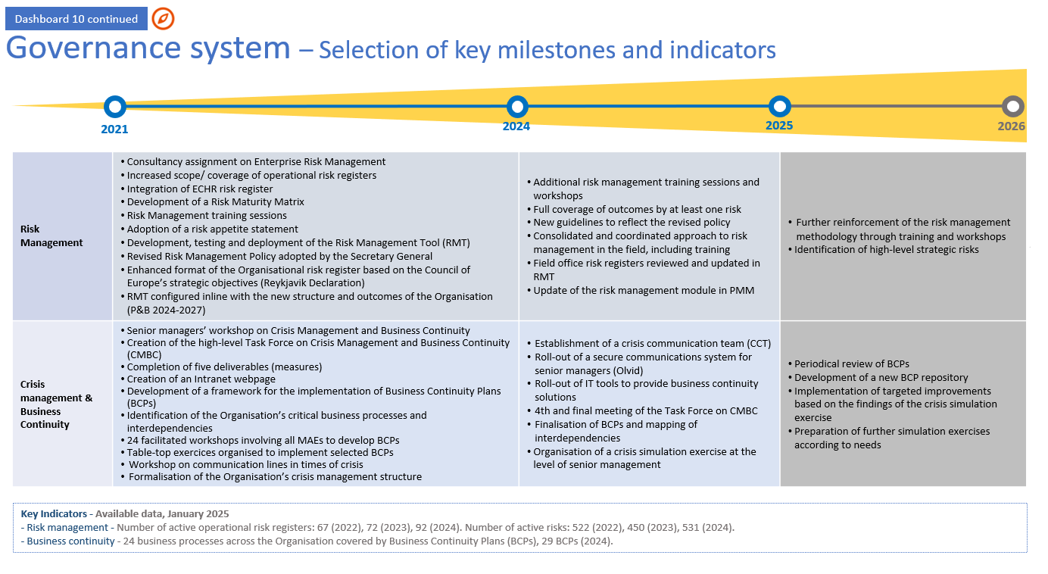

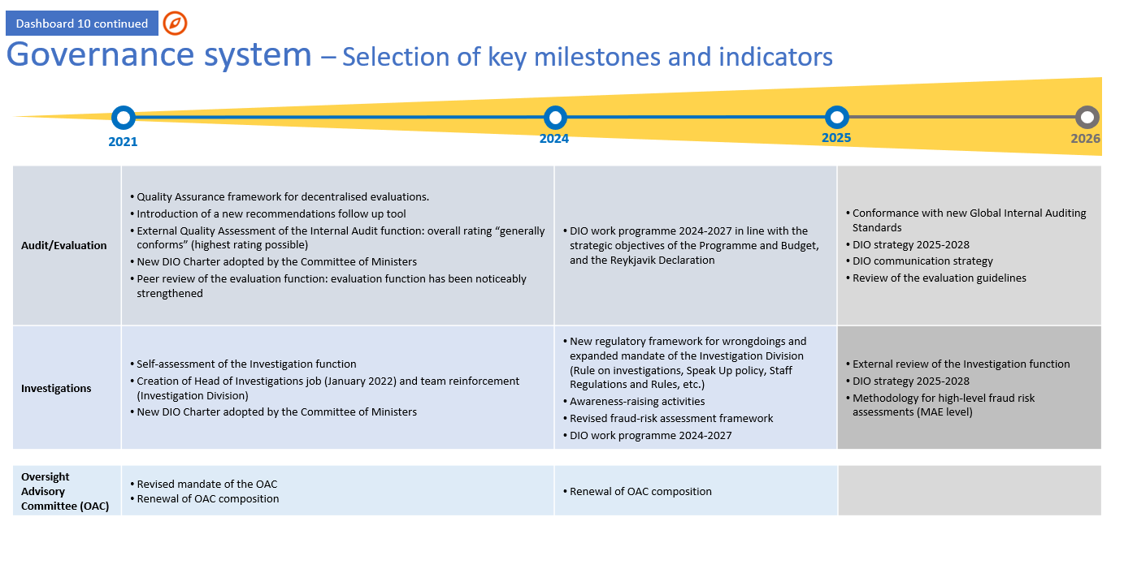

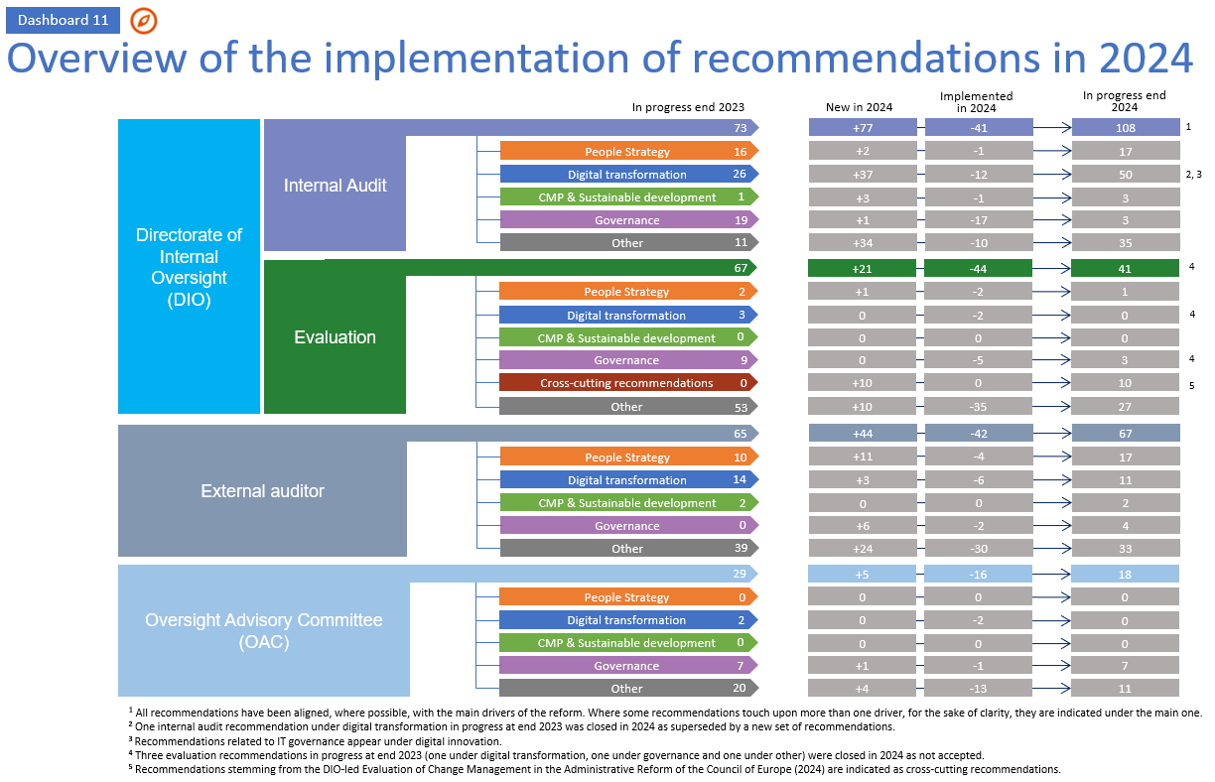

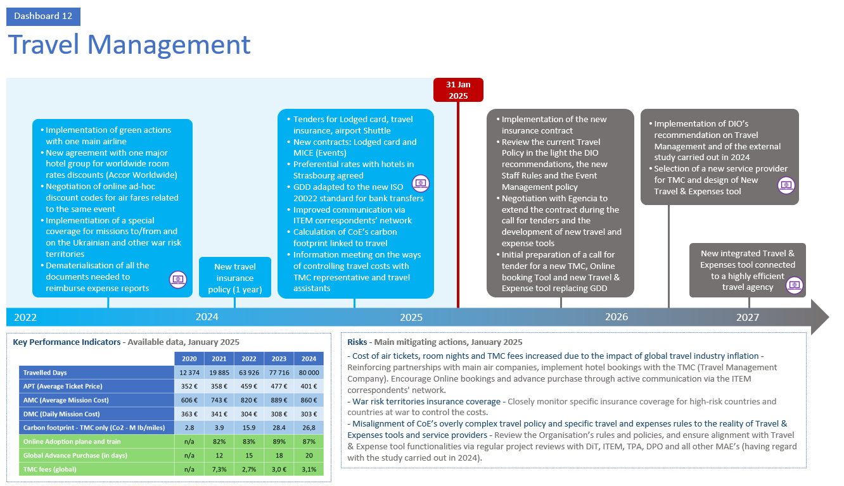

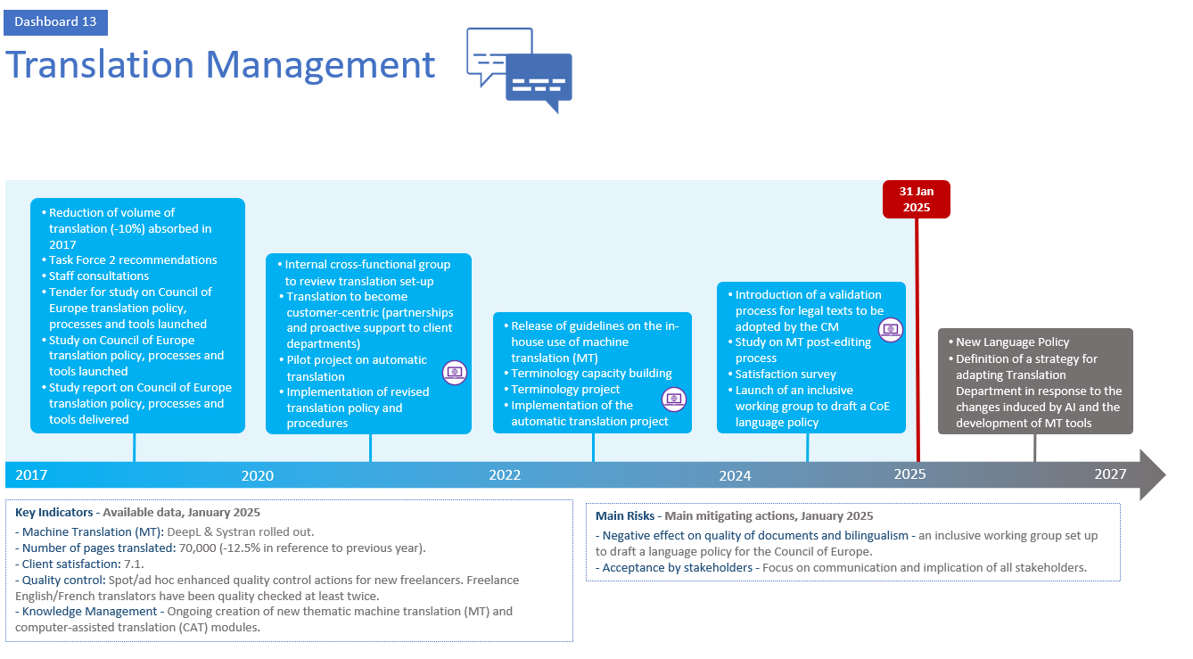

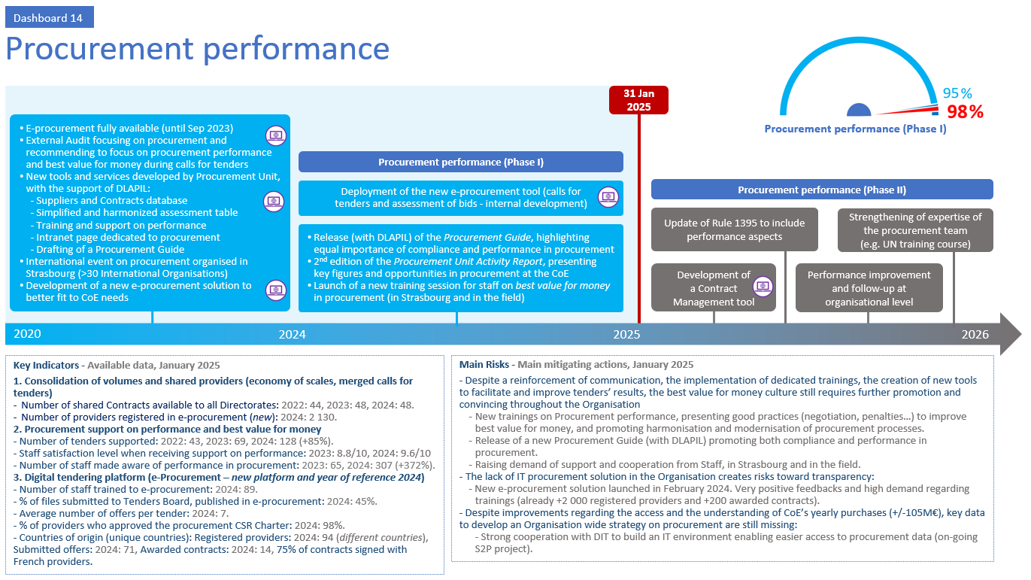

Appendix 2: Table of Key Performance Indicators (KPIs) of the administrative reform

Appendix 3:

Appendix 3: Glossary of acronyms / Annexe 3 : Glossaire des acronymes
English |  | Français
AI | Artificial intelligence | IA | Intelligence artificielle
AIIC | International Association of Conference Interpreters | AIIC | Association internationale des interprètes de conférence
BCP | Business Continuity Plan | BCP | Plans de continuité des opérations
CAHB | Ad hoc Committee of Experts on Buildings | CAHB | Comité ad hoc d'experts sur les bâtiments
CCM | Cost Center Manager | CCM | Gestionnaire de Centre de coût
CISO | Chief Information Security Officer | CISO | Responsable de la sécurité des systèmes d’information
CM | Committee of Ministers | CM | Comité des Ministres
CMBC | Crisis Management and Business Continuity | CMBC | Gestion de crise et continuité des opérations
CMP | Capital Master Plan | CMP | Schéma directeur immobilier
CoE | Council of Europe | CdE | Conseil de l’Europe
CPE | Energy Performance contract | CPE | Contrat de performance énergétique
CSR | Corporate Social Responsibility | RSE | Responsabilité Sociétale des Entreprises
DBI | Division of Buildings and Installation | DBI | Division Bâtiments et Installations
DGA | Directorate General of Administration | DGA | Direction Générale de l’administration
DGS | Directorate of General Services | DGS | Direction des services généraux
DHR | Directorate of Human Resources | DRH | Direction des ressources humaines
DIO | Directorate of Internal Oversight | DIO | Direction de l'Audit interne et de l'Évaluation
DIT | Directorate of Information Technology | DiT | Direction des technologies de l'information
DLAPIL | Directorate of Legal Advice and Public International Law | DLAPIL | Direction du Conseil juridique et du droit international public
DMS | Document Management System | DMS | Système de gestion des documents
DPIA | Data Protection Impact Assessment | AIPD | Analyse d’impact relative à la protection des données
DPO | Data Protection Officer | DPO | Délégué·e à la protection des données
ECHR | European Court of Human Rights | CEDH | Cour européenne des droits de l’homme
EDM | Enterprise Data Management | EDM | Gestion des données d’entreprise
EDQM | European Directorate for the Quality of Medicines and HealthCare | EDQM | Direction européenne de la Qualité du médicament et soins de santé
EEAP | Energy Efficiency Action Plan | PAEE | Plan d'action pour l'efficacité énergétique
EventS | Events Management Tool | EventS | Outil de gestion des événements
EYC | European Youth Centre | CEJ | Centre Européen de la Jeunesse
FIMS | Financial Information Management System | FIMS | Système de gestion de l'information financière
GEDD | Sustainable Development Study Group | GEDD | Groupe d’Étude Développement Durable
GDD | Travels management tool | GDD | Outil de gestion des déplacements
GHG | Greenhouse gas | GES | Gaz à effet de serre
GR-PBA | Rapporteur Group on Programme, Budget and Administration | GR-PBA | Rapporteur Group on Programme, Budget and Administration
ICSAQ | Introduction of Internal Control Self-Assessment Questionnaires | ICSAQ | Questionnaire d’auto-évaluation du contrôle interne
IT | Information Technology | TI | Technologies de l'information
ITEM | Interpreting,Travel, Events and Multimedia Department | ITEM | Service de l’interprétation, des déplacements, des évènements et multimédia
KPI | Key Performance Indicator | KPI | Indicateur clé de performance
MAE | Major Administrative Entity | MAE | Entité administrative principale
NWoW | New Way of Working | NWoW | Nouvelles méthodes de travail
OAC | Oversight Advisory Committee | CCAE | Comité consultatif d’Audit et d’Evaluation
OCR | Optical Character Recognition | OCR | Reconnaissance optique des caractères
OHTE | Observatory on History Teaching in Europe | OHTE | Observatoire de l’enseignement de l’histoire en Europe
PDE | Palais de l’Europe | PDE | Palais de l’Europe
P&B | Programme and Budget | P&B | Programme et Budget
PBT | Programme and Budget Tool | PBT | Programme et Budget Tool
PDH | Human Rights Building | PDH | Palais des Droits de l’Homme
PMM | Project Management Methodology | PMM | Méthodologie de gestion de projet
RBM | Results Based Management | RBM | Gestion basée sur les résultats
RSI | Remote Simultaneous Interpretation | RSI | Interprétation simultanée à distance
SMG | Senior Management Group | SMG | Senior Management Group
TMC | Tender for a Travel Management Company | TMC | Appel d’offre pour une agence de voyage
TPA | Treasury, Payments and Accounting | TPA | Trésorerie, paiements et comptabilité
UN | United Nations | ONU | Organisation des Nations Unies
ZPP | Zero-Paper Policy | ZPP | Politique zero papier

Appendix 4: Useful links on the administrative reform

Context of the reform | Reform  Reform timeline
Reform documents | Documents on the Reform
People Strategy | People Strategy 2024-2027 - Human Resources
Digital Transformation | Information Technology Strategy 2023-2027
Capital Master Plan | Capital Master Plan
New Way of Working (NWoW) | New Way of Working
Governance | Governance at the Council of Europe
Risk Management | Risk Management at the Council of Europe
Internal Control | Internal Control at the Council of Europe
Crisis Management and Business Continuity | Crisis management & Business continuity at the Council of Europe
Ethics | Ethics Officer
Data Protection | Processing of Personal Data within the Council of Europe

This document has been classified restricted until examination by the Committee of Ministers.
Link: Reykjavík Declaration
The Council of Europe results-oriented management strategy 2023-2027
Cf. CM/Del/Dec(2024)133/2b
https://intranet.coe.int/group/organisation/documents-on-the-reform
Cf. CM(2024)63-final
Cf. CM(2024)54
Cf. CM(2021)126.
https://intranet.coe.int/reform/
Link: GR-PBA homepage, “Reform of the Council of Europe” section
Two traineeship sessions were organised in 2024 whereas there was only one in 2023
Enterprise Data Management (EDM), Enterprise Content Management (ECM), Security and data integrity, Renewal of IT infrastructure and Innovation
Link: Source-to-Pay (S2P) programme.
https://intranet.coe.int/en/group/organisation/reform/nwow
Link: Guidelines on the use and risks of online available generative artificial intelligence tools
Cf. CM/Del/Dec(2021)1418/11.3.
Cf. DD(2022)393
Cf. CM(2024)30 and DD(2024)341
Cf. CM(2025)33
https://intranet.coe.int/group/organisation/reform/nwow
https://intranet.coe.int/governance/
Cf. CM/Notes/1513/11.2 - 1513th meeting, 27 November 2024, 11.2 Council of Europe Programme and Budget 2024-2027 – adjustments to 2025.
Cf. CM(2025)1 Appendix X.
Cf. CM/Del/Dec(2024)1513/11.2-Part1 - 1513th meeting, 27 November 2024, 11.2 Council of Europe Programme and Budget 2024-2027 – adjustments to 2025.

