|  |  |  |  |
| --- | --- | --- | --- |
| **MINISTERS’ DEPUTIES** | CM Documents | **CM(2024)53** | 12 March 2024[1] |

|  |
| --- |
| **1496th meeting, 24 April 2024**  11 Programme, Budget and Administration    **11.1 Progress report on administrative reform measures**  **Item to be considered by the GR-PBA at its meeting on 11 April 2024** |

1. In line with the Reykjavík Declaration from the 4th Summit of Heads of State and Government of the Council of Europe (16-17 May 2023) and the relevant follow-up decisions of the Committee of Ministers,[2] the present document, which forms the **eighth progress report on administrative reform measures**, enables the Ministers’ Deputies to follow the ongoing progress and achievements.
2. Since 2009, the Council of Europe has been implementing a series of reforms focusing on **three main tracks** - the political reform, the reform of the Court and the Convention system, and the administrative reform - aimed at reinforcing the Organisation's role and capacity to continuously adapt to current and future challenges. The current report focuses on the **administrative reform measures**.

1. In order to facilitate its follow-up, this report and its appendices are presented in the same format as the previous progress report on administrative reform measures ([CM(2023)56](https://search.coe.int/cm/Pages/result_details.aspx?Reference=CM(2023)56" \o "[1465/11.1] Progress report on the administration reform measures)). For the sake of thoroughness and comparability, a list of all **previous reports** has also been included.[3]
2. The present report provides an **overview of progress** in theimplementation of the administrative reform **from January 2023 to January 2024** (see details in sections below), based notably on updated timelines for **each administrative reform area** in Appendix 1 (see dashboards 1 to 11), complemented by additional information on the **consolidation of governance** (see dashboards 12 to 15), and on **streamlined working methods** (see dashboards 16 to 18). The report also provides cross-cutting **key performance indicators** (see Appendix 2), a glossary of **acronyms** (see Appendix 3), as well as a list of **useful links** related to the administrative reform (see Appendix 4).
3. Since the previous report, the Organisation has continued to demonstrate its **resilience**, its **adaptability** and its **capacity to achieve its reform objectives** in the midst of a complex and ever-changing environment, notably thanks to its agile administrative reform process.
4. Over the reference period, the **4th Summit of Heads of State and Government** witnessed the leaders of the Organisation’s 46 member States agreeing to strengthen the Council of Europe, recommitting to its values and defining the long-term strategic role of the Organisation. In this context, the **administrative reform will contribute to the follow-up to the Reykjavík Declaration** as necessary, notably by building on lessons learned and on ongoing achievements to positively contribute to a strong and focused Council of Europe that can adapt to its current and future challenges.

**reform framework**

1. At the **4th Summit of the Council of Europe** (Reykjavík, 16-17 May 2023), the Heads of State and Government called for “a modern Council of Europe enabling [the Organisation] to meet current and future challenges” and pledged to “**continue the reform process to achieve greater transparency, efficiency and effectiveness**”.[4]
2. This was confirmed by the Committee of Ministers, whose Deputies “invited the Secretary General to **continue to enhance the ongoing administrative reforms**, notably in light of the outcome of the 4thSummit of Heads of State and Government”.[5] Underlining “the determination of the Heads of State and Government to ensure a modern Council of Europe, that is more agile, resilient and results-oriented”, the Ministers’ Deputies also “**welcomed the commitment of the Secretary General** to continue the reform process to achieve greater transparency, efficiency and effectiveness”.[6]
3. In line with the above, the Secretary General**,** the Deputy Secretary General and the whole Organisation are committed to **continue delivering the Council of Europe’s reform agenda**, thereby contributing to its agility and adaptability, increasing its effectiveness and orientation towards efficiency. The current report constitutes a direct follow-up to the Deputies’ decisions in this respect.
4. The **main aim of the administrative reform** is to strengthen the Organisation’s resilience and agility, so that it is best placed to meet its numerous challenges and can **constantly adapt to a complex and ever-changing environment**. The administrative reform is an **ongoing process** which aims to not only deliver “**value for money**”, but also “**improve the way we work together**”. Whilst the main drivers underlying the administrative reform process contribute to an increase in productivity and to the absorption of cost pressures through the identification of efficiency gains, cost reductions and cost avoidance measures, they also improve our working methods and tools, while streamlining organisational structures and operations, promoting transversality and providing additional flexibility in the allocation of human resources.

1. In its report on the administrative and organisational reform of the Council of Europe,[7] the **External Auditor** acknowledged this **positive** **impact of the administrative reform process**.The External Auditor notably mentioned that “the previous decade was marked by **numerous far-reaching reforms** which profoundly changed the Organisation. These **considerable achievements**, of which the Organisation has a strong institutional memory, have not necessarily been perceived by the representatives of the (…) member States” (para. 136) and that “the information provided to the Committee of Ministers has made significant progress in various areas of management reform” (para. 145). The External Auditor then formulated **14 recommendations**, which were accepted by the Secretary General, in order to **further consolidate the achievements** of the reform and to remedy any possible gaps. Nine recommendations have already been implemented since then, while the remaining five are in the course of being implemented: see **dashboard 15** for a detailed overview of the **implementation of these recommendations**.
2. The administrative reform also contributes to strengthening a **results-oriented culture** across the Organisation, ensuring the timely delivery and monitoring of results, whilst achieving ever more coherent, responsible and effective action. This is notably undertaken through an improved Results Based Management (RBM) approach, which combines reform initiatives with an increased focus on lessons learned and examples provided on the achievement of intermediate outcomes in the annual **Progress Review Report** on the implementation of the Programme and Budget. Additionally, the recent Council of Europe **results-oriented management strategy** 2023-2027[8] puts a particular emphasis on learning and synergies between the RBM approach and relevant parts of the administrative reform agenda. In order to ensure overall consistency, the **Programme and Budget 2024-2027** also reflects the main administrative reform measures foreseen for the first biennium, which aim to contribute as relevant to the implementation of the outcomes of the **4th Summit** of Heads of State and Government.[9]
3. The **core strategic documents** setting the overall administrative reform framework[10] over the reference period are as follows:
   1. The **People Strategy** 2019-2023[11] and the foreseen **follow-on strategy** (People Strategy 2024-2027);
   2. **Digital Transformation**, as encapsulated in the Information Technology Strategy 2023-2027;[12]
   3. The **Capital Master Plan**.[13]
4. The main reference documents related to the administrative reform are available on the [reform intranet site](https://intranet.coe.int/en/group/organisation/reform),[14] which provides a single-entry point for all administrative reform matters and is also accessible from the Committee of Ministers’ website (see [GR-PBA homepage](https://www.coe.int/en/web/cm/gr-pba), “reform of the Council of Europe” section).
5. A **graphical overview** of some **key outcomes** of the administrative reform since the last progress report (March 2023) and some **key steps** foreseen in 2024 (non-exhaustive list) is provided below. A **detailed overview** of progress made in each area of the administrative reform is presented from paragraph 16 onwards.

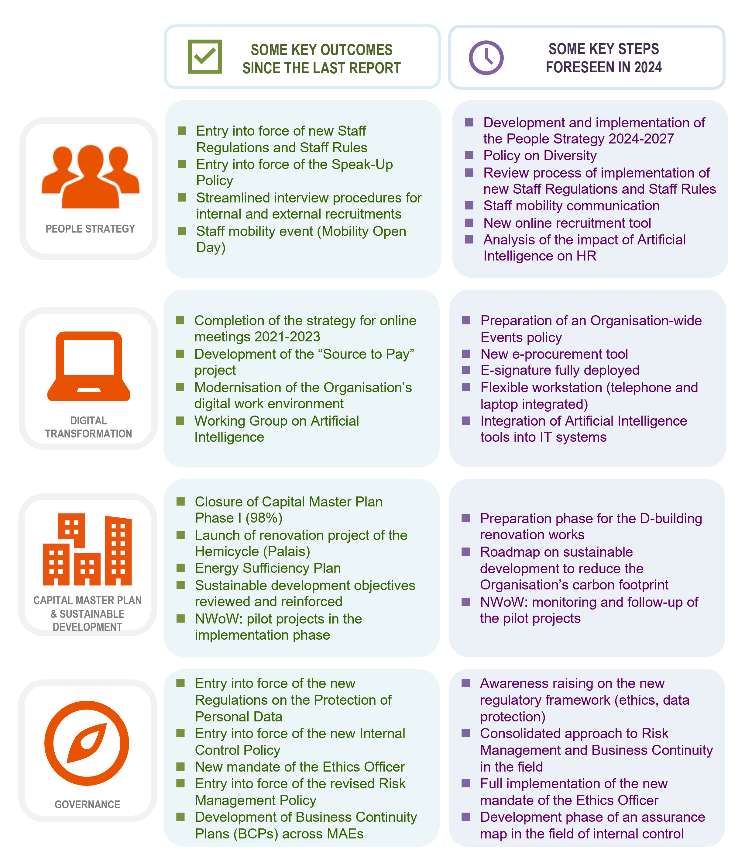

**People Strategy**

1. The **People Strategy** aims at ensuring that staff possess the necessary competences, and maintain motivation and consistent high-performance to achieve the organisational objectives.
2. The **People Strategy** covers all major aspects of **human resources management**, organised around **three main areas**:

* People Management, aiming at achieving a flexible, resilient and high-performing workforce which can adapt to changing needs and effectively carry out the Organisation’s mission;
* Working Environment and Culture, with the aim of modernising the way in which staff members work, further developing an organisational results-oriented culture and ensuring the right conditions for a motivated and engaged workforce, in which every staff member fully contributes and embodies the Organisation’s core values;
* Human Resources policies, regulations and procedures, aiming at simplifying and optimising the framework in place and maximising the efficiency of administration.

1. Over the reference period, the **successful implementation of the People Strategy 2019-2023** has remained key to the administrative reform agenda. The entry into force of the **new Staff Regulations** on 1 January 2023 represented a significant **milestone** in this respect. They were complemented by **revised secondary legislation** providing coherent rules, policies and procedures, and organised according to the main principles of staff rights and obligations. In this context, new Staff Rules progressively entered into force in 2023. Open-ended contracts were also introduced over the reference period, while **streamlined procedures** (such as facilitated passage between categories, shortened probationary period and redefined interview procedures forinternal and external recruitments) combining quality, efficiency and fairness were aimed at attracting and retaining talent in the Organisation.
2. The main progress and developments related to **selected projects and initiatives** of the **People Strategy 2019-2023** are listed in **dashboard 1a** (People Strategy 2019-2023 - implementation overview). Additional information on key developments in this area since the last progress report is also provided hereafter. While the number of external recruitment competitions responding to the Strategic Workforce Plan has remained stable over the reference period (from 48 in 2022 to 50 in 2023), the overall number of candidates to external competitions has risen sharply (from 3 311 in 2022 to 7 750 in 2023). The overall **number of staff movements** has also **increased significantly** over the same period (from 537 in 2022 to 635 in 2023). More detailed indicators on staff movements are also available in **Appendix 2**: Table of Key Performance Indicators (KPIs) of the administrative reform.
3. This **increase of 18.25%** in the overall number of staff movements shows a **steady growth in mobility** in 2023. This demonstrates that staff mobility remains a priority for the Council of Europe as a means to become a more agile Organisation, and better placed to respond to current and future challenges. It notably offers staff the chance to further nurture their skills as well as to increase competencies that match the demands of an ever-changing workplace. In line with the Deputies’ decision inviting the Secretary General to continue fostering an **organisational culture of mobility**,[15] an **Intranet page dedicated to mobility**[16] lists the numerous advantages of mobility for staff members, as well as the corresponding benefits for the Organisation. It also includes practical references and links for staff interested in mobility. In the same vein, a **staff mobility event** (Mobility Open Day, organised on 18 January 2024) provided an opportunity for staff from all entities, with a diverse array of profiles and responsibilities, to network and to share information about their work and the competencies both available and sought. It was also an opportunity to raise awareness on how mobility could contribute to career development as well as its Organisation-wide results and impact.
4. As the **People Strategy 2019-2023** concluded during the reference period, some of the **results achieved** over its entire duration are listed in **dashboard 1b** (People Strategy 2019-2023 - key results). The dashboard notably lists some key achievements in recruitment and employment (with an overall increase in staff movements of 73% between 2018 and 2022), as well as in the fields of performance and development, legislation, human resources tools, diversity, well-being and ethics (with the introduction of the **Ethics Framework**: see paragraph 43 for more details). A review of implementation of the People Strategy 2019-2023 also showed that the consultation process of staff members launched in 2018 (ahead of the development of the strategy) had been successful with some 70% of the numerous suggestions made on this occasion (some 150) being partly or fully taken on board and implemented to date. This demonstrates that the involvement of individuals with different profiles is crucial when it comes to drawing up a strategy that concerns the Organisation’s key asset, namely its staff.
5. Last but not least in the field of human resources management is the **development of the** **People Strategy 2024-2027** (to follow on from the People Strategy 2019-2023). In this context, the Directorate of Human Resources (DHR) is holding **renewed consultations** (e.g. consultations with the Staff Committee; interviews with Heads of Major Administrative Entities (MAEs); a working session between staff in DHR and human resources correspondents across the Organisation; a facilitated brainstorming session with staff; an informal GR-PBA meeting) to facilitate an **informed contribution** **from the main stakeholders**. Results of two **staff surveys** undertaken in 2023 on **occupational health, vulnerability and staff engagement**[17]and on **organisational culture**[18] will also feed into discussions on the People Strategy 2024-2027 as a contribution to the consultative phase, providing food for thought on various topics such as organisational values, ethical behaviour, well-being at work, performance, mobility and staff representation.
6. With the support of the project's Steering Group and the Staff Committee, this consultative phase will help establish a **strategic vision** which will contribute to the elaboration of the **People Strategy 2024-2027** and its future action plans. The aim, scope and initial timeline of the People Strategy 2024-2027 will be presented to the GR-PBA in due course. Future updates will also be available on the **Intranet page dedicated to the People Strategy**.[19]

**Digital Transformation**

1. **Digital transformation** is a key enabler in organisational reform to streamline work procedures and support staff in their daily work. Moreover, the majority of reform projects presented in this report are reliant on tools, projects and innovations in the area of Information Technology (IT). Digital transformation is also accompanied by a comprehensive reengineering process and solid change management to maximise its impact.
2. Digital transformation is organised around **five main areas**:

* Enterprise Data Management (EDM),[20] which aims to consolidate the main existing EDM systems through their upgrade and by introducing new functionalities and connectivities, therefore providing a solid basis on which to support the implementation of the organisational Results-Based Management (RBM) approach and further consolidate a results-oriented culture;
* Enterprise Content Management (ECM),[21] which aims to increase overall efficiency of the Secretariat through greater collaboration and by facilitating the use, sharing and searching of information;
* Security and Data Integrity, which aims to ensure higher resilience of IT services and business continuity in case of major incident, and to protect users against viruses, hacking and other IT-related risks;
* Renewal of IT Infrastructure, which aims to provide users with a modern, efficient and flexible work environment;
* Innovation,[22] which aims to connect people, partners and ideas, align business needs, identify synergies and catalyse collaboration to encourage new technology exploration.

1. During the reference period, a new **Information Technology Strategy**[23] came into force. Initially set for the period 2023-2025, the strategy is to be **extended to 2027** in alignment with the Programme and Budget cycle. The Information Technology Strategy 2023-2027 was adopted by the IT Governance Board in January 2024. The strategy’s **mission** is to continue to implement innovative and cost-effective systems that will enhance the efficiency and productivity of the Council of Europe, digitally transform the Organisation to become user focused and data-driven, to harmonise, align and streamline business processes, and to provide both internal and external stakeholders with effective tools to implement the Organisation’s operational objectives.
2. Over the reference period of the current report, the roll-out of videoconferencing, remote interpretation and e-voting services was also be pursued in the context of the **completion of the** **Strategy for online meetings 2021-2023**, in order to further support the organisation of hybrid sessions and meetings, in line with business requirements.
3. The main progress and developments related to selected projects and new initiatives on Digital Transformation are listed in **dashboard 2** (implementation overview of the 2023-2027 IT Strategy), **dashboard 3** (innovation and artificial intelligence), **dashboard 4** (implementation overview of the Strategy for online meetings 2021-2023), **dashboard 5** (online events management system), **dashboard 6** (travel management), **dashboard 7** (translation management), **dashboard 8** (zero-paper policy), and **dashboard 9** (portal for intergovernmental meetings). Additional information on some key developments in the area of digital transformation since the last report is also provided hereafter.
4. As shown in dashboard 3, a cross-secretariat Working Group on **Artificial Intelligence** has been created in order to explore **innovative emerging technologies** and to evaluate their potential use in the Council of Europe. In 2023, various transcription solutions (Speech-to-Text), social media analytic solutions, co-working tools (Miro) and e-Linguistic solutions (e-Translation) were evaluated and handed over to business users. The Working Group will continue to explore potential applications and benefits of artificial intelligence (AI) to enhance the functioning, effectiveness and impact of the Council of Europe. It will also aim to identify innovative ways in which AI can be strategically leveraged to support the Organisation's missions, objectives and initiatives and to enhance overall productivity and effectiveness.
5. In order to continue **modernising its digital work environment**, by making it mobile and cloud-ready, a “full laptop strategy” is being progressively rolled out, whereby all users will ultimately be provided with laptop computers instead of desktops. The possibility of working with tablets and smart phones has also been enhanced. This contributes to increased agility, stronger business continuity, as well as to an integrated approach of the Organisation’s working environment where human resources, information technologies and workspaces complement each other as part of the **New Way of Working** (NWoW): see paragraphs 47 and 48, as well as dashboard 17, for more details.
6. In the field of **cybersecurity**, the Organisation continued to face an important number of cyber-attacks over the reference period (an average of 5 000 per day, some of which were major). The security measures in place, coupled with the Security Operation Centre (SOC), have protected the Organisation’s IT system and secured business continuity. The cybersecurity strategy adopted by the IT Governance Board will continue to provide a robust and effective cyber defense, notably in the context of new threats facing the Organisation.
7. The “**Source-to-Pay**” (S2P) project continued to be developed over the reference period. Its ultimate aim is to consolidate common working methods and simplify financial processes, notably through workflows, electronic signatures and robust management reporting systems with enhanced coding. This will strengthen and improve the overall quality control of financial management.

**Capital Master Plan and sustainable development**

1. The **Capital Master Plan** (CMP) approved in 2021[24] guarantees the continuity of activities in a safe, adapted and efficient working environment, whilst reducing the Organisation's carbon footprint.
2. The main progress and developments with regard to the implementation of the Capital Master Plan are listed in **dashboard 10** (implementation overview of the CMP) and in **dashboard 11** (energy efficiency and sustainable development). Additional information on some key developments in this area since the last progress report is also provided hereafter.
3. The CMP significantly contributes to addressing the **many challenges facing the Organisation in the field of real estate**, such as increasing energy costs, energy efficiency and high occupancy levels in its various buildings. This is achieved by, among others, accelerating the implementation of energy savings and **sustainable development actions**, as well as by defining new approaches in occupying the Organisation’s workspaces. In so doing, the CMP also contributes to the **New Way of Working** initiative: see paragraphs 47 and 48 for more details.
4. In 2023, **energy prices** continued to be impacted by a notable **volatility** resulting from uncertainties related to the global energy crisis. Owing to **good management** practices and despite this instability, average prices for the Council of Europe remained limited at around €200 per MWh in 2023 and were combined with significant **consumption reduction efforts** (which resulted in savings in the magnitude of €750 K). The GR-PBA was regularly updated on the situation with regards to energy costs and savings, with the latest update (4th quarter 2023)[25] having been examined in February 2024.
5. In parallel, the Organisation continued to step up its efforts and actions in terms of **controlling energy consumption** in order to **limit both budgetary and environmental impacts**. More broadly, the Council of Europe also subscribes to **environmental targets** and relevant European regulations which provide for financial penalties in the event of inaction or non-compliance with consumption reduction targets. As can be seen in dashboard 11, the EEAP 2 (Energy Efficiency Action Plan 2022-2032) aims at enabling the Organisation to meet the European regulatory objective of a 40% cut in energy consumption by 2030 (reference year: 2017). As of January 2024, the rate of implementation of the EEAP 2 was 50% (compared to 15% as of January 2023). Throughout 2023, an **Energy Sufficiency Plan** was pursued, which notably included the reinforcement of internal communication on simple but effective energy-saving tips[26] and the use of information displays at the main entrances of buildings, displaying real-time energy consumption per building. This information is also available on the Intranet.[27]

1. In November 2023, the Ministers’ Deputies[28] **welcomed the efforts undertaken towards a greener Council of Europe** and **invited the Secretary General to submit**, in the first quarter of 2024, a **roadmap towards an even more sustainable reduction of the carbon footprint**. In line with this decision, a **roadmap for sustainable development and carbon footprint reduction** within the Council of Europe,[29] presented to the GR-PBA in March 2024, aims at reducing the impact of its activities on the environment, whilst ensuring overall consistency with the strengthening of the Organisation’s work on the human rights, democracy and rule of law aspects of the environment (Reykjavík process).

**Consolidation of governance**

1. Risk management, crisis management and business continuity, internal control, ethics and data protection are interrelated topics at the heart of a **robust governance system** for the Council of Europe. In all these areas, the Organisation proposes appropriate policies and tools aiming at **consolidating its decision-making** and the **responsible management** of its resources, whilst adhering to international standards and adapting to future evolutions. Since the previous report, a number of significant developments have contributed to **strengthening** **the Organisation’s maturity** in governance matters. As in previous years, a **pragmatic, consistent and transparent approach** was favoured, aiming at reinforcing links between the various governance systems and at promoting a culture of accountability and organisational learning. The Intranet page on governance[30] provides an **overview of the framework** (bodies and systems) in place.
2. Recent developments in the field of **risk management**[31]are summarised in **dashboard 12**. Since the previous report, the Organisation has continued to promote **greater maturity in managing its risks**, in line with the **Risk Maturity Matrix** adopted by the Senior Management Group (SMG). In 2023, the recently launched **risk management IT tool (RMT)** was reconfigured to fully reflect the new structure and outcomes of the Organisation, as defined in the Programme and Budget 2024-2027. A **risk appetite statement**, defining the types of risk for which the Organisation has either a zero, low or medium appetite, was signed by the Secretary General in May 2023. It was subsequently published in the Financial Statements and will be reviewed each year. In addition, the SMG adopted an enhanced **organisational risk register**, based on the Council of Europe’s strategic objectives stemming from the Reykjavík Declaration. To conclude, in December 2023, the Secretary General adopted a **revised Risk Management Policy**, which came into force immediately. Fostering a coherent approach to risk management across the Council of Europe, this Policy updates the provisions of the previous version (adopted in 2016) by placing risk management in a wider institutional perspective, ensuring complementarity with the other components of the Organisation’s governance system, implementing recommendations from the Directorate of Internal Oversight (DIO) and the Oversight Advisory Committee (OAC), as well as clarifying **roles and responsibilities** in risk management throughout the Organisation.
3. Recent developments in the field of **crisis management and business continuity**[32] are summarised in **dashboard 13**. Over the past few years, the Council of Europe has had to manage the impact of multiple ongoing crises. In so doing, it has shown **resilience** at multiple levels, as well as the overall robustness of its crisis management structures. In parallel, the Organisation has continued to reinforce its crisis management and business continuity processes in the longer term. As a follow-up to the audit carried out by DIO in 2020, a high-level **Task Force on Crisis Management and Business Continuity** chaired by the Deputy Secretary General[33] was set up in 2021. Over the reference period, the Task Force **completed its mandate**. In this context, the Task Force notably formalised the Organisation’s **crisis management structure**, process and its main actors.[34] According to the type of crisis and to the requirements of the situation, only selected elements of this structure would be mobilised in a flexible way. In addition, the Council of Europe developed a series of interlinked **Business Continuity Plans** (BCPs)[35] covering its main processes at headquarters. The BCPs aim to ensure that the Organisation can continue delivering its most critical services following a possible disruptive event (for example, the loss of a key building, the loss of Information Technology or the loss of key staff). In 2023, a series of 24 workshops as well as table-top exercises gathered more than 100 colleagues across the Organisation to assist MAEs in developing their BCPs, based on a thorough analysis of the risks affecting their critical processes. This also resulted in the mapping of links and dependencies between BCPs (BCP “pyramid”). A pragmatic approach was adopted, notably by taking into account existing business continuity procedures in the areas of Information Technology and General Services (safety and security). Lessons learned from the Covid-19 pandemic were also included if and when relevant. The collaborative process received **positive feedback from MAEs** and the **integrated approach** promoted by the Task Force will contribute to enhance the Council of Europe’s overall resilience in the longer run.
4. In the field of **internal control**,[36] a series of actions were undertaken over the reference period in order to further strengthen the Council of Europe’s internal control framework and practices. In addition to several initiatives aimed at building internal control into business processes (whereby management and all staff members are the owners of internal controls), the Organisation’s **internal control policy** entered into force in March 2023. The policy, signed by the Secretary General, defines the **key principles** of the internal control framework of the Organisation as well as the **roles and responsibilities** of its main stakeholders. The policy also **extends the scope** of the internal control framework to all processes of the Organisation, by integrating both financial and non-financial aspects, thus positioning internal control as an integrated component at the heart of the Organisation’s governance system. The policy is complemented by a strong control **environment** and solid **business practices**, which consider internal control as integral to every aspect of business, while remaining flexible in its application through a balance of explicit hard controls (contained in policies and procedures) and soft controls (which can influence staff behaviour).
5. In the field of **ethics**,[37] three key texts forming an essential part of the Organisation’s Ethics Framework entered into force in 2023: a **Code of Conduct** (setting out the standards of behaviour expected of all staff such as integrity, independence, prevention of conflicts of interest, respect between colleagues and ethical conduct), a **Policy on Respect and Dignity** (introducing procedures to prevent and combat harassment and other disrespectful behaviour), and the **Speak Up Policy** (setting out the Council of Europe’s guidelines for reporting wrongdoing affecting the public interest and ensuring protection of those who report such wrongdoing). Moreover, the Ethics Officer became a full-time function and a **new mandate of the Ethics Officer** entered into force in 2023. It provides that the Ethics Officer acts as a focal point for ethics-related questions and standards in the Organisation by providing independent advice to the Secretary General and, on a confidential basis, to members of the Secretariat and other persons participating in Council of Europe activities. In December 2023, the Secretary General opened an **awareness-raising event** which was organised for all staff to present the Organisation’s new Ethics Framework. Last but not least, a draft **Policy on Diversity, Inclusion and Non-Discrimination** is currently under review and will be adopted in due time, after the required statutory consultations.
6. In the field of **data protection**,[38] the new Regulations on the Protection of Personal Data[39] entered into force on 1 January 2023 thus establishing the post of the Data Protection Officer who has an advisory function within the Organisation. At the same time, the Data Protection Commissioner retains a supervisory function. The new Intranet page on the processing of personal data within the Organisation explains the basic concepts relevant to data protection, as well as the respective roles of the Data Protection Officer (DPO) and the Data Protection Commissioner. This page also provides information on the new procedures, guidelines and templates, as well as on topics such as the data protection impacts assessments (DPIA) or dealing with data subject access requests (DSAR).
7. Other **key milestones** related to **governance** are recorded in **dashboard 14**.

**Streamlined working methods**

1. Since the previous report, several initiatives have continued to **streamline working methods**, in particular through the development of a more **task-oriented approach[40]** at the Council of Europe. Recent developments in this field are summarised in **dashboard 16**. As underlined in the Programme and Budget 2024-2027,[41] “*the promotion of a task-oriented approach at the Council of Europe (…) will continue to support transversality, improve working methods and provide additional flexibility in the allocation of human resources*”. This initiative is sponsored by the Deputy Secretary General and supported by a cross-Secretariat working group. In this context, a **Human Capital Pool**[42] (composed of approximately 5% of staff from each MAE, nominated by the head of MAE) was created with the aim of it being mobilised if and when needed, and assigned to a specific priority area. This pilot initiative notably makes it possible to identify resources to respond to urgent requests. In 2023, a few staff members from the Human Capital Pool were mobilised and assigned to a specific priority area, to assist with a task limited in duration. The Secretary General notably called on the Human Capital Pool, gaining from its ability to provide a cross-functional team, to prepare her roadmap on the Council of Europe’s Engagement with civil society.[43] This subject, at the heart of the Reykjavík Declaration, required rapid action for it to be fully integrated into the Secretary General's 2024-2027 Programme and Budget proposal. In the light of this positive experience, it was decided to extend the Human Capital Pool, in its current composition, for the years 2024 and 2025.
2. In the same vein, the **New Way of Working**[44] (or NWoW), introduced by DGA, promotes an integrated approach of the Council of Europe’s working environment, providing a basis upon which the Organisation can define new methods in occupying its workspaces, whilst ensuring complementarity with appropriate information technologies and human resources policies. Recent and future developments with regard to the New Way of Working are summarised in **dashboard 17**. Several factors have prompted the Organisation to introduce such an initiative, notably staff surveys (illustrating that the Covid-19 crisis had also been associated with new opportunities and expectations with regard to ways of working), building occupation ratios (showing that the policy of densifying office spaces and “traditional” models of assigning workspace had reached their limits), budgetary restraint, the consequences of inflation and soaring energy costs, and the Organisation’s sustainable development goals. The renovation of two buildings (D Building and Palais de l'Europe) will also provide an ideal opportunity for the Organisation to redefine and optimise the use of the space available.
3. The New Way of Working is built upon **three pillars**, referred to as the 3Bs: **Bricks** (workspace layout; working towards an innovative and effective buildings strategy); **Bytes** (workstations and remote meeting technologies); and **Behaviours** (Establishing a new regulatory framework for human resources; increased flexibility and talent retention). Since the launch of the initiative by the Deputy Secretary General in November 2022, a combination of **surveys, workshops and interviews** have provided an opportunity to assess the appropriateness of these measures while identifying in detail what support was needed. On this basis, in 2023, **pilot projects** were initiated in the Agora and EDQM, and a development charter was approved on this occasion. Experiments within these pilot projects will be based mostly on the introduction of a flex ratio of 0.8 (8 workstations for 10 occupants, adjustable according to the entity concerned), the possibility to telework appropriately, discontinuation of office space assignation according to grade or systematic grouping of entities, and the increased provision of varied workspaces (to concentrate or work online, for collaborative work in small groups, for socialising and exchange, etc.). Although it relies on the implementation of pilot projects, the NWoW transversal initiative also permeates all dimensions of the Council of Europe's buildings strategy.
4. Recent developments in the field of **procurement performance**[45] are summarised in **dashboard 18**. With approximately €100 M spent each year on the purchasing of goods and services, procurement is another area where the Organisation continuously develops streamlined working methods (notably through tools to digitalise tenders, consolidate and share information on existing contracts and new providers), whilst promoting a “best value for money” culture (through a wider publication of tenders, an increased number of negotiations and competitive dialogues, and training courses).

**Monitoring progress through Key Performance Indicators**

1. A selection of robust **Key Performance Indicators** (KPIs) is set out in **Appendix 2** to monitor progress in the implementation of the administrative reform. With regard to the **overview of the number of implemented and pending recommendations**, the KPIs show that, as of January 2024, a total of **756 recommendations** had been or were in the process of being implemented (in contrast to 775 recommendations in January 2023): 483 recommendations from the External Auditor (in contrast to 436), 110 recommendations from the Internal Auditor (in contrast to 189; this decrease of 42% means that a high number of recommendations were considered as implemented in 2023 and subsequently closed by the Internal Auditor), 99 evaluation recommendations (in contrast to 90) and 64 recommendations from the Oversight Advisory Committee (OAC) (in contrast to 60). Based on these indicators, the **overall** **implementation rate** of these recommendations in January 2024 is **70%**.
2. As in previous years, the indicators provided in the current report take into account the suggestions from the Organisation’s governance bodies and auditors to identify annual benchmarks and to set quantifiable targets whenever possible - see notably recommendations from the **Budget Committee**,[46]from the **Oversight Advisory Committee**[47] (OAC), and from the **External Auditor**.[48]

**Conclusions and next steps**

1. Over the reference period, the administrative reform agenda contributed to modernising the Organisation. As underlined in previous progress reports on the administrative reform measures, increased task orientation, greater flexibility, technological developments or alignment with international standards cannot easily be translated into identifiable and quantifiable gains. This is accentuated by the fact that reform measures need to **adapt in real time** and within a constantly evolving environment, in order for the Organisation to meet a series of challenges. However, **quantifiable targets** have been set in the Programme and Budget whenever possible, and a clear link has been established between **savings or efficiency gains** and their **reinvestment**, notably in priority areas across the Organisation.
2. In the context of the adoption of the Programme and Budget 2024-2027 at their 1481st (Budget) meeting (21-23 November 2023), the Ministers’ Deputies[49] **welcomed the commitment of the Secretary General to continue the reform process** to achieve greater transparency, efficiency and effectiveness and **invited the Secretary General to seek further budgetary efficiency with quantifiable results whenever possible**, aiming for at least 1% annual efficiency gains, notably to be able to reinvest in priority sectors. **Future annual progress reports** on the administrative reform measures will enable the Ministers’ Deputies to follow the ongoing progress and achievements, including the above target on efficiency gains.
3. In light of this, the overall [reform](https://intranet.coe.int/reform/en) process will continue to focus on three main tracks - the political reform, the reform of the Court and the Convention system and the administrative reform - aimed at reinforcing the Organisation's role and capacity to continuously adapt to current and future challenges. As foreseen in the Programme and Budget 2024-2027,[50] the **main drivers** underlying the administrative reform process (People Strategy, Digital Transformation, Capital Master Plan and governance) **will be pursued in 2024-2027**. The administrative reform will also contribute to shaping the **organisational culture** and improving the way key stakeholders **work together** in view of the accomplishment of the Organisation’s mission and in reaching its objectives.

**Eighth progress report on administrative reform measures: table of appendices**

**Appendix 1: Detailed dashboards of each initiative of the administrative reform**

**→ People Strategy**

* Dashboard 1a: People Strategy (2019-2023) - implementation overview
* Dashboard 1b: People Strategy (2019-2023) - key results

**→ Digital transformation**

* Dashboard 2: Digital transformation: implementation overview of the 2023-2027 IT Strategy
* Dashboard 3: Innovation and Artificial Intelligence
* Dashboard 4: Digital strategy – online meetings (2021-2023) – implementation overview
* Dashboard 5: Online events management system
* Dashboard 6: Travel Management
* Dashboard 7: Translation management
* Dashboard 8: Zero-paper policy
* Dashboard 9: Portal for intergovernmental meetings

**→ Capital Master Plan and sustainable development**

* Dashboard 10: Capital Master Plan (CMP)
* Dashboard 11: Energy efficiency and sustainable development

**→ Consolidation of governance**

* Dashboard 12: Risk management
* Dashboard 13: Crisis Management and Business continuity
* Dashboard 14: Governance and compliance – selection of key milestones and indicators
* Dashboard 15: Implementation of the External Auditor report on the administrative reform

**→ Streamlined working methods**

* Dashboard 16: Task-oriented approach
* Dashboard 17: New Way of Working (NWoW)
* Dashboard 18: Procurement performance

**Appendix 2: Table of Key Performance Indicators (KPIs) of the administrative reform**

**Appendix 3: Glossary of acronyms**

**Appendix 4: Useful links on the administrative reform**

**Appendix 1:** **Detailed dashboards of each initiative of the administrative reform**

Specific dashboards focusing on strategies and projects with defined objectives and deadlines display dials illustrating the progress made between January 2023 and January 2024, which can be read as follows:

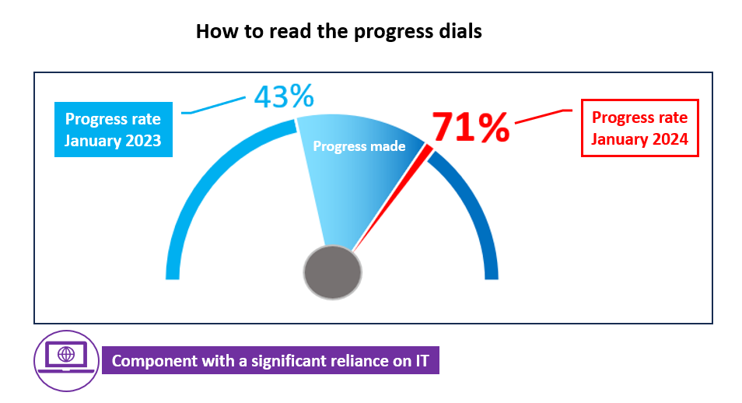

The values displayed in each dial are based on a **self-assessment** provided by each project team or by the entity responsible for it.

**

**

**Appendix 2: Table of Key Performance Indicators (KPIs) of the administrative reform**

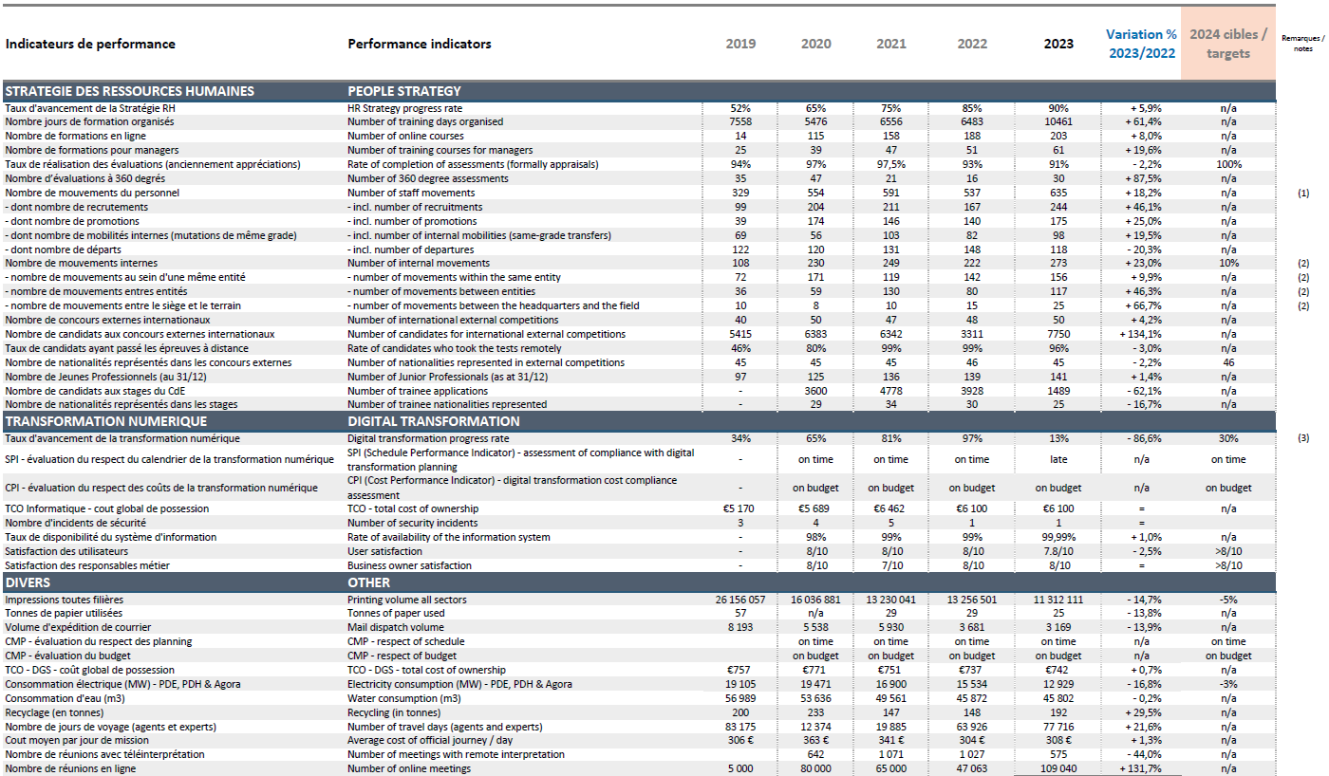

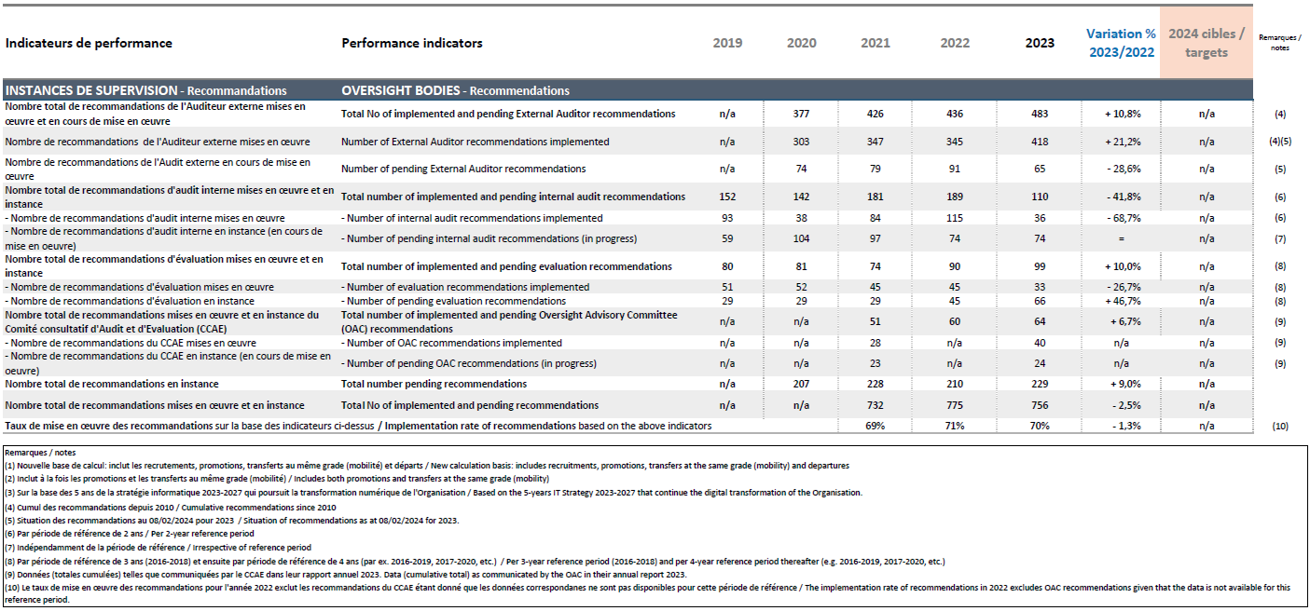

**Appendix 3:**

|  |  |  |  |
| --- | --- | --- | --- |
| Appendix 3: Glossary of acronyms / Annexe 3 : Glossaire des acronymes | | | |
| English | | **Français** | |
| AIIC | International Association of Conference Interpreters | AIIC | Association internationale des interprètes de conférence |
| API | Application Programming Interface | API | Interface de programmation applicative |
| ATCE | Administrative Tribunal of the Council of Europe | TACE | Tribunal administratif du Conseil de l’Europe |
| BC | Budget Committee | BC | Comité du Budget |
| CAHB | Ad hoc Committee of Experts on Buildings | CAHB | Comité ad hoc d'experts sur les bâtiments |
| CM | Committee of Ministers | CM | Comité des Ministres |
| CMP | Capital Master Plan | CMP | Schéma directeur immobilier |
| COSO | “Committee of Sponsoring Organisations of the Treadway Commission” (internal control framework) | COSO | « *Committee of Sponsoring Organisations of the Treadway Commission »* (référentiel de contrôle interne) |
| CPE | Energy Performance contract | CPE | Contrat de performance énergétique |
| DGA | Directorate General of Administration | DGA | Direction Générale de l’administration |
| DFC | Central Financial Division | DFC | Division financière centrale |
| DIO | Directorate of Internal Oversight | DIO | Direction de l'Audit interne et de l'Évaluation |
| DMS | Document Management System | DMS | Système de gestion des documents |
| eComms | Electronic communication | eComms | Communication électronique |
| EDM | Enterprise Data Management | EDM | Gestion des données d’entreprise |
| EDQM | European Directorate for the Quality of Medicines & HealthCare | EDQM | Direction européenne de la qualité du médicament et des soins de santé |
| EEAP | Energy Efficiency Action Plan | PAEE | Plan d'action pour l'efficacité énergétique |
| EventS | Events Management Tool | EventS | Outil de gestion des événements |

|  |  |  |  |  |
| --- | --- | --- | --- | --- |
| English | | Français | | |
| EYC | European Youth Centre | CEJ | | Centre Européen de la Jeunesse |
| FIMS | Financial Information Management System | FIMS | | Système de gestion de l'information financière |
| FO | Financial officer | | FO | Agent financier |
| FTE | Full-time equivalent | | ETP | Equivalent Temps Plein |
| GDD | Travels management tool | | GDD | Outil de gestion des voyages |
| ICSAQ | Introduction of Internal Control Self-Assessment Questionnaires | | ICSAQ | Questionnaire d’auto-évaluation du contrôle interne |
| ITGB | IT Governance Board | | ITGB | Conseil de gouvernance informatique |
| KPI | Key Performance Indicator | | KPI | Indicateur clé de performance |
| MAF | Common Procurement and Finance Department | | MAF | Service mutualisé d’achats et finances |
| NMR | Nuclear Magnetic Resonance. | | RMN | Résonance magnétique nucléaire |
| OAC | Oversight Advisory Committee | | CCAE | Comité consultatif d’Audit et d’Evaluation |
| PDE | Palais de l’Europe | | PDE | Palais de l’Europe |
| PDH | Human Rights Building | | PDH | Palais des Droits de l’Homme |
| PMM | Project Management Methodology | | PMM | Méthodologie de gestion de projet |
| RBM | Results Based Management | | RBM | Gestion basée sur les résultats |
| RM | Risk Management | | RM | Gestion des risques |
| RSI | Remote Simultaneous Interpretation | | RSI | Interprétation simultanée à distance |
| SCN | Superior Courts Network | | RCS | Réseau des Cours supérieures |
| TCO | Total Cost of Ownership | | TCO | Coût total de possession |
| TMC | Tender for a Travel Management Company | | TMC | Appel d’offre pour une agence de voyage |
| ZPP | Zero-Paper Policy | | ZPP | Politique zero papier |

**Appendix 4: Useful links on the administrative reform**

|  |  |
| --- | --- |
| **Context of the reform** | <https://intranet.coe.int/reform>  <https://intranet.coe.int/en/group/organisation/reform#reform-timeline> |
| **Reform documents** | <https://intranet.coe.int/en/group/organisation/documents-on-the-reform> |
| **People Strategy** | <https://intranet.coe.int/en/group/human-resources/people-strategy> |
| **Task-oriented approach (including Human Capital Pool)** | <https://intranet.coe.int/en/group/organisation/reform/task-oriented-approach>  <https://intranet.coe.int/en/group/human-resources/human-capital-pool> |
| **Digital Transformation** | [Information Technology Strategy 2023-2025](https://search.coe.int/cm/Pages/result_details.aspx?ObjectId=0900001680a91dcb) |
| **Capital Master Plan** | [Capital Master Plan](https://search.coe.int/cm/Pages/result_details.aspx?ObjectId=0900001680a3e937) |
| **New Way of Working (NWoW)** | <https://intranet.coe.int/en/group/organisation/reform/nwow> |
| **Governance** | <https://intranet.coe.int/governance> |
| **Risk Management** | <https://intranet.coe.int/risk-management/> |
| **Internal Control** | https://intranet.coe.int/internal-control |
| **Crisis Management and Business Continuity** | <https://intranet.coe.int/business-continuity> |
| **Ethics** | <https://intranet.coe.int/en/group/ethics/home> |
| **Data Protection** | <https://intranet.coe.int/data-protection> |

1. This document has been classified restricted until examination by the Committee of Ministers.
2. Notably those adopted at the 1481st (Budget) meeting of the Ministers' Deputies (21-23 November 2023).
3. First progress report on reform measures: [CM(2018)97](https://search.coe.int/cm/Pages/result_details.aspx?Reference=CM(2018)97" \o "Administrative Reform of the Council of Europe – Measures foreseen for the 2018-2019 biennium - Preliminary follow-up report [1321 meeting]) (July 2018): second report: [GR-PBA(2018)16](https://search.coe.int/cm/Pages/result_details.aspx?Reference=GR-PBA(2018)16" \o "Reform framework in the current organisational context) (November 2018); third report: [CM(2019)88](https://search.coe.int/cm/Pages/result_details.aspx?Reference=CM(2019)88" \o "Administrative Reform of the Council of Europe – Measures foreseen for the 2018-2019 biennium - a. Third follow-up report [1351 meeting]) (June 2019); fourth report: [CM(2020)84](https://search.coe.int/cm/Pages/result_details.aspx?Reference=CM(2020)84" \o "Progress report on reform measures) (June 2020); fifth report: [CM(2021)49](https://search.coe.int/cm/Pages/result_details.aspx?Reference=CM(2021)49" \o "[1404/11.4] Progress report on reform measures) (April 2021); sixth report: [CM(2022)61](https://search.coe.int/cm/Pages/result_details.aspx?Reference=CM(2022)61" \o "[1434/11.1] Progress report on reform measures) (April 2022); 7th report: [CM(2023)56](https://search.coe.int/cm/Pages/result_details.aspx?Reference=CM(2023)56" \o "[1465/11.1] Progress report on the administration reform measures) (March 2023).
4. Cf. [Reykjavík Declaration - United around our values](https://rm.coe.int/4th-summit-of-heads-of-state-and-government-of-the-council-of-europe/1680ab40c1), page 8.
5. Cf. [CM/Del/Dec(2023)1469/11.1](https://search.coe.int/cm/Pages/result_details.aspx?Reference=CM/Del/Dec(2023)1469/11.1" \o "Progress report on administrative reform measures).
6. Cf. [CM/Del/Dec(2023)1481/11.1-Part1](https://search.coe.int/cm/Pages/result_details.aspx?Reference=CM/Del/Dec(2023)1481/11.1-Part1" \o "Council of Europe Budgets - Financial Years 2024-2027 - ) (paragraph 9).
7. Cf. ExtAud(2022)2, examined by the GR-PBA in July 2022 ([GR-PBA(2022)CB6](https://search.coe.int/cm/Pages/result_details.aspx?Reference=GR-PBA(2022)CB6" \o "Synopsis - Meeting of 5 July 2022 ), item 1.c).
8. Cf. [Council of Europe results-oriented management strategy 2023-2027 - Learning as a driver of change](https://rm.coe.int/CoERMPublicCommonSearchServices/documentAccessError.jsp?url=https://rm.coe.int:443/CoERMPublicCommonSearchServices/sso/SSODisplayDCTMContent?documentId=0900001680acb586), March 2023.
9. Cf. [CM(2024)1](https://search.coe.int/cm/Pages/result_details.aspx?Reference=CM(2024)1" \o "Council of Europe Programme and Budget 2024-2027 - United around our values), notably Part 1 – Section d (administrative reform).
10. Cf. <https://intranet.coe.int/group/organisation/documents-on-the-reform>
11. Cf. [CM(2019)58-final](https://search.coe.int/cm/Pages/result_details.aspx?Reference=CM(2019)58-final" \o "Administrative Reform of the Council of Europe - Measures foreseen for the 2018-2019 biennum - Council of Europe People Strategy 2019-2023 [1346 meeting]).
12. Cf. [CM(2022)190](https://search.coe.int/cm/Pages/result_details.aspx?Reference=CM(2022)190" \o "[1452/11.3] Information Technology Strategy 2023-2025) (Information Technology Strategy 2023-2025), to be extended to 2027 in alignment with the Programme and Budget cycle. The Information Technology Strategy 2023-2027 was endorsed by the IT Governance Board in January 2024 and will be presented to the GR-PBA at its meeting on 11 April 2024.
13. Cf. [CM(2021)126](https://search.coe.int/cm/Pages/result_details.aspx?Reference=CM(2021)126" \o "[1418/11.3] Real estate/Capital Master Plan (CMP)).
14. Cf. https://intranet.coe.int/reform/
15. [CM/Del/Dec(2023)1481/11.1-Part1](https://search.coe.int/cm/Pages/result_details.aspx?Reference=CM/Del/Dec(2023)1481/11.1-Part1" \o "Council of Europe Budgets - Financial Years 2024-2027 - ) (paragraph 10).
16. https://intranet.coe.int/group/human-resources/mobility
17. https://intranet.coe.int/en/group/human-resources/well-being-at-work
18. https://rm.coe.int/ia-a-cult-survey-summary-results-en/1680ae0e71
19. <https://intranet.coe.int/group/human-resources/people-strategy>
20. The main Enterprise Data Management (EDM) systems of the Council of Europe - FIMS (the financial management system), PeopleSoft (the human resources and payroll management system) and the related line-of-business applications - contain much of the operational data that allows the Council of Europe to effectively manage budgets, activities and resources.
21. Enterprise Content Management (ECM) aims at moving towards an increasingly paperless Council of Europe. The objective is to provide users with systems that enhance productivity and enable better communication of the Organisation’s content, within an appropriate governance and data protection framework.
22. Some of these innovation projects identified in this context are: collaboration technologies; speech to text; document automation; use of Artificial Intelligence for business applications; E-Translation; continued studies for video-conferencing tools and voting system linked to the on-line meetings digital strategy.
23. Cf. [CM/Del/Dec(2022)1452/11.3](https://search.coe.int/cm/Pages/result_details.aspx?Reference=CM/Del/Dec(2022)1452/11.3" \o "Information Technology Strategy 2023-2025) and [CM(2022)190](https://search.coe.int/cm/Pages/result_details.aspx?Reference=CM(2022)190" \o "[1452/11.3] Information Technology Strategy 2023-2025).
24. At their 1418th (Budget) meeting on 23-24 November 2021, the Ministers’ Deputies approved the proposals contained in document [CM(2021)126](https://search.coe.int/cm/Pages/result_details.aspx?Reference=CM(2021)126" \o "[1418/11.3] Real estate/Capital Master Plan (CMP)) on the implementation of the Capital Master Plan (CMP) and its restoration to its initial duration of 15 years, as well as the acquisition and renovation of D Building: cf. [CM/Del/Dec(2021)1418/11.3](https://search.coe.int/cm/Pages/result_details.aspx?Reference=CM/Del/Dec(2021)1418/11.3" \o "Ad hoc Committee of Experts on Buildings (CAHB) - a. Meeting report (Strasbourg, 7-8 September 2021) - b. Real estate/Capital Master Plan (CMP)).
25. Cf. [GR-PBA(2024)1](https://search.coe.int/cm/Pages/result_details.aspx?Reference=GR-PBA(2024)1" \o "Quarterly update on energy costs and savings (4th quarter) - Information document) for more details.
26. Cf. https://intranet.coe.int/group/administration/energy-sufficiency
27. Cf. https://intranet.coe.int/group/general-services/electricity-consumption
28. Cf. [CM/Del/Dec(2023)1481/11.1-Part1](https://search.coe.int/cm/Pages/result_details.aspx?Reference=CM/Del/Dec(2023)1481/11.1-Part1" \o "Council of Europe Budgets - Financial Years 2024-2027 - ) (paragraph 16).
29. Cf. [CM(2024)30](https://search.coe.int/cm/Pages/result_details.aspx?Reference=CM(2024)30" \o "[1494/11.1] Road map for sustainable development and carbon footprint reduction within the Council of Europe).
30. Cf. <https://intranet.coe.int/governance>/
31. Cf. <https://intranet.coe.int/risk-management>/
32. Cf. https://intranet.coe.int/business-continuity
33. Cf. https://intranet.coe.int/en/group/organisation/governance/crisis-management-business-continuity/task-force
34. Cf. https://intranet.coe.int/en/group/organisation/governance/crisis-management
35. Cf. https://intranet.coe.int/en/group/organisation/governance/business-continuity
36. Cf. https://intranet.coe.int/internal-control
37. Cf. https://intranet.coe.int/group/ethics/home
38. Cf. <https://intranet.coe.int/data-protection>
39. Cf. Resolution [CM/Res(2022)14](https://search.coe.int/cm/Pages/result_details.aspx?Reference=CM/Res(2022)14" \o "Resolution on establishing the Council of Europe Regulations on the Protection of Personal Data (Adopted by the Committee of Ministers on 15 June 2022 at the 1437th meeting of the Ministers’ Deputies)) on the Council of Europe Regulations on the Protection of Personal Data.
40. Cf. https://intranet.coe.int/group/organisation/reform/task-oriented-approach
41. Cf. [CM(2024)1](https://search.coe.int/cm/Pages/result_details.aspx?Reference=CM(2024)1" \o "Council of Europe Programme and Budget 2024-2027 - United around our values), page 34.
42. Cf. https://intranet.coe.int/group/human-resources/human-capital-pool
43. Cf. [SG/Inf(2023)28](https://search.coe.int/cm/Pages/result_details.aspx?Reference=SG/Inf(2023)28" \o "Secretary General's Roadmap on the Council of Europe's Engagement with Civil Society 2024-2027).
44. Cf. https://intranet.coe.int/group/organisation/reform/nwow
45. Cf. https://intranet.coe.int/en/group/administration/e-procurement
46. Cf. [CM(2021)135](https://search.coe.int/cm/Pages/result_details.aspx?Reference=CM(2021)135" \o "[1414/11.4] Meeting report of the Budget Committee – September 2021 session).
47. Cf. [CM(2022)38](https://search.coe.int/cm/Pages/result_details.aspx?Reference=CM(2022)38" \o "[1430/11.3a] Oversight Advisory Committee (OAC) - a. Annual report from 1 October 2020 to 30 November 2021), paragraph 19.
48. Cf. ExtAud(2022)2.
49. Cf. [CM/Del/Dec(2023)1481/11.1-Part1](https://search.coe.int/cm/Pages/result_details.aspx?Reference=CM/Del/Dec(2023)1481/11.1-Part1" \o "Council of Europe Budgets - Financial Years 2024-2027 - ) (paragraph 9).
50. Cf. [CM(2024)1](https://search.coe.int/cm/Pages/result_details.aspx?Reference=CM(2024)1" \o "Council of Europe Programme and Budget 2024-2027 - United around our values), section 1d (administrative reform), pages 32-40.