|  |  |  |  |
| --- | --- | --- | --- |
| **MINISTERS’ DEPUTIES** | CM Documents | **CM(2024)33-addfinal** | 24 April 2024 |

|  |
| --- |
| **133rd Session of the Committee of Ministers**  **(Strasbourg, 16-17 May 2024)**  **Joint Programmes between the Council of Europe and the European Union in 2023 – Information document** |

**I.** **GENERAL DEVELOPMENTS**

1. Co-operation within the framework of Joint Programmes (JPs) is one of the pillars of the strategic partnership between the Council of Europe and the European Union (EU), based on common values and shared priorities. At their Fourth Summit held in Reykjavik on 16-17 May 2023, Heads of State and Government of the Council of Europe recognised that the EU “is the main institutional partner of the Council of Europe in political, legal, and financial terms”. The Reykjavik Declaration further acknowledged“the importance of joint programmes between the European Union and the Council of Europe as a key expression of this strategic partnership and mutual commitment to promoting common values”.
2. On 30January 2023, the Council of the European Union approved the conclusions on EU priorities for cooperation with the Council of Europe in 2023-2024. These conclusions highlighted the extent and depth of this co-operation, including through Joint Programmes, in the fields of human rights, democracy and rule of law. The document also acknowledged “the Council of Europe’s important role in supporting the alignment with European Standards and strengthening the capacity building of important institutions during the reform processes in the Western Balkans and the Eastern Partnership countries” as well as the key nature of the Council of Europe’s Southern Neighbourhood Policy and the European Centre for Global Interdependence and Solidarity “in improving dialogue and co-operation between North and South, fostering solidarity and promoting stability and democratic security in both Europe and its neighbouring regions”.
3. In 2023, co-operation through Joint Programmes continued supporting member States and partners in the neighbourhood in strengthening democracy, human rights and the rule of law. Since the first joint co-operation undertakings in the early nineties, Joint Programme co-operation has grown significantly and brought tangible results. Three large-scale multiannual multi-Beneficiary programmes (known as “regional programmatic facilities”) have been implemented, in successive phases since 2015/2016, in South-East Europe, Türkiye and in the EU Eastern and Southern Neighbourhood. On 27 February 2023, the Secretary General of the Council of Europe and the European Commissioner for Neighbourhood and Enlargement launched the third phases of two of these major co-operation programmes for the promotion of the rule of law and fundamental rights, namely the Horizontal Facility for the Western Balkans and Türkiye - III and the [Partnership for Good Governance](https://pjp-eu.coe.int/en/web/pgg2/home) - III. The fifth phase of the South Programme started earlier, in September 2022. Increasingly, the facilities are being complemented by Beneficiary-specific and regional thematic programmes. Moreover, a new strand of co-operation started in 2019 intending to support the EU member States’ capacity to sustain structural reforms in the field of rule of law, human rights protection, and democratic governance, in collaboration with the European Commission’s DG REFORM. Furthermore, a large-scale rule of law Joint Programme has been developed for Central Asia.
4. In 2023, the consequences of the Russian Federation’s war of aggression against Ukraine and other geopolitical developments continued to impact the CoE’s co-operation activities, including Joint Programmes. These developments have required the flexibility that the EU/CoE programmatic facilities were able to offer. The Council of Europe responded to the needs of Ukraine by adjusting its ongoing support. The same flexibility allowed for the adjustment of cooperation to emerging needs relating to the consequences of the mass influx of refugees in the Republic of Moldova and more recently in Armenia.
5. In December 2023, EU leaders decided to open accession negotiations with the Republic of Moldova and Ukraine and granted the status of candidate country to Georgia on the understanding that the relevant steps set out in the Commission recommendation of 8 November 2023 are taken. These decisions gave an impetus for strengthening the Joint Programme co-operation. The assistance that the Council of Europe can provide to these countries can make a significant contribution to their respective reform agendas in the areas of democracy, the rule of law and human rights. The countries’ EU accession perspective will shape the priorities for co-operation (including through the Partnership for Good Governance), based on the recommendations of the Council of Europe’s monitoring and advisory bodies and the case‑law of the European Court of Human Rights. Building on the experience of Joint Programmes in the enlargement area in South-East Europe is key for joint co-operation in Ukraine, the Republic of Moldova and Georgia. The Partnership for Good Governance will at the same time remain instrumental in supporting Armenia and Azerbaijan in fulfilling their obligations as Council of Europe member States, addressing recommendations of the Council of Europe monitoring and advisory bodies and executing judgements of the European Court of Human Rights. Support and co-operation will continue with Belarusian democratic forces and civil society through the action plan for 2024-2025 agreed in the framework of the Contact Group.
6. In 2023, the financial volume of Joint Programme co-operation remained stable (for further information, see Section II). Contractual negotiations on new programmes have been facilitated by the European Union-Council of Europe Financial Framework Partnership Agreement (FFPA) of October 2020[1].
7. To accompany the development of Joint Programme co-operation, the Council of Europe continued to strengthen its project management capacity: training for project teams in the Council of Europe project management methodology (PMM) and result-based reporting continued. In the context of the digitalisation of the Joint Programmes’ reporting processes, finalising the work on a data transfer mechanism between the Council of Europe PMM IT tool and the EU electronic exchange system (OPSYS), agreed under the FFPA of October 2020, remains a priority for 2024.
8. Transversal dimensions were further strengthened, in particular regarding the human rights approach,[2] gender mainstreaming[3] and support of the UN 2030 Agenda for Sustainable Development. The gender dimension was mainstreamed into cooperation activities in line with the Council of Europe Gender Equality Strategy 2018-2023 and using theGender Mainstreaming Toolkit for cooperation projects*.* Training activities for project teams on gender mainstreaming in co-operation continued. The [UN 2030 Agenda for Sustainable Development](http://www.un.org/sustainabledevelopment/) has been highly relevant for the Council of Europe with its global and overarching political approach. The Council of Europe Programme and Budget indicates, where relevant, the link between the Organisation’s sector and programmes and the specific Sustainable Development Goals (SDGs). Most, if not all, Joint Programmes, contribute to the implementation of the UN 2030 Agenda and the achievement of the SDGs, supporting primarily SDG-16 “Peace, justice and strong institutions”. Joint Programmes also contribute to the achievement of SDG-1 “No poverty”, SDG-3 “Good health and well-being”, SDG-4 “Quality education”, SDG-5 “Gender equality”, SDG-8 “Decent work and economic growth”, SDG-10 “Reduced inequalities”, SDG-11 “Sustainable cities and communities” and SDG-17 “Partnerships for the goals”.

Another important cross-cutting dimension is the fight against climate change and for the protection of the environment. The Council of Europe's co-operation activities have an indirect positive contribution to environment protection through its support to member States with strengthening good governance structures and thus enabling a more effective tackling of environmental challenges. The Reykjavík Declaration acknowledged “the urgency of taking co-ordinated action to protect the environment by countering the triple planetary crisis of pollution, climate change and loss of biodiversity.” On the basis of the Council of Europe’s expertise “not only in the area of human rights, democracy and the rule of law, but with a long-standing and widely acknowledged track record in protecting the environment, environmentally friendly landscape management and public health”, co-operation sector has the potential to introduce a climate and environmental dimension into discussions in the sectors and among stakeholders not traditionally used to considering these themes. In doing so it can rely on the Council of Europe’s binding commitments and treaties directly or indirectly addressing environmental concerns. Within this context, the Council of Europe’s co-operation sector aims to make the fight against climate change and environmental degradation an integral and more visible part of its action. Further to the Reykjavík Declaration, the Secretary General has created a new Directorate in DGI on Social Rights, Health and Environment and, within this Directorate, a Department on the Reykjavík process and the Environment. This Directorate will develop co-operation in the field of the environment.

**II. STATISTICAL ANALYSIS**

1. In 2023, 54 EU-Council of Europe Joint Programme agreements were under implementation, with a multi-annual Cumulative Budgetary Envelope (CBE)[4] of € 245.9 million. The European Union’s contractual commitments to these programmes amounted to €210.2. million (85.5. %) and the Council of Europe’s co-financing – to €35.7 million (14.5%). The list of programmes under implementation in 2023 is presented in Appendix I.
2. The annualised envelope (Annual Budgetary Envelope prorated (ABE))[5] amounted in 2023 to € 54.7 million (European Union: € 46.3 million; 84.6%), Council of Europe: €8.4 million; 15.4%).
3. The total of EU payments under Joint Programmes received between 1 January and 31 December 2023 (JP annual receipts) stood at €37.3 million. With an additional €1.6 million of payments from the co-operation undertakings other than Joint Programmes, the European Union’s share in the Council of Europe’s revenue from all extra-budgetary resources in 2023 represented 47.9%. The European Union remains the largest single donor to the Council of Europe's co-operation activities.
4. In terms of new injections in Joint Programme co-operation, in 2023 the EU and the Council of Europe signed 13 new Joint Programmes, with an overall total of €53.1 million (European Union: € 33.1 million (62.3%), Council of Europe’s co-financing: €20 million (37.7%[6])). Some of these programmes were launched in 2023, others start in January 2024.[7] The list of programmes signed in 2023 can be found in Appendix II.
5. Overall, the financial situation of Joint Programmes remained stable. While the substantial new injections in Joint Programme co-operation have contributed to the exceptionally high value of the CBE in 2023, the latter also translates the accumulation of the relatively old programmes, that had been extended to mitigate delays encountered during the Covid-19 pandemic and which were finishing in 2023. The annualised envelope (ABE) decreased by 6.5% compared to the record high level of the ABE in 2022, yet, the ABE - 2023 remained firmly anchored within the range of the values observed in the past three years. The EU actual payments under the multi-annual contracts (JP annual receipts) showed a negative fluctuation of 16,5% compared to the exceptionally high level of payments received in 2022. This fluctuation can be attributed to the cyclical nature of Joint Programmes and the *aléas* of the payment schedules, yet the lack of absorption remains a factor strongly affecting JP annual receipts and needs to be paid close attention to. Part of this decrease can also be attributed to EU measures against Kosovo* imposed in June 2023, which prevented the signature of new projects in 2023.
6. The charts below show the evolution in the Joint Programme co-operation over the past ten years.

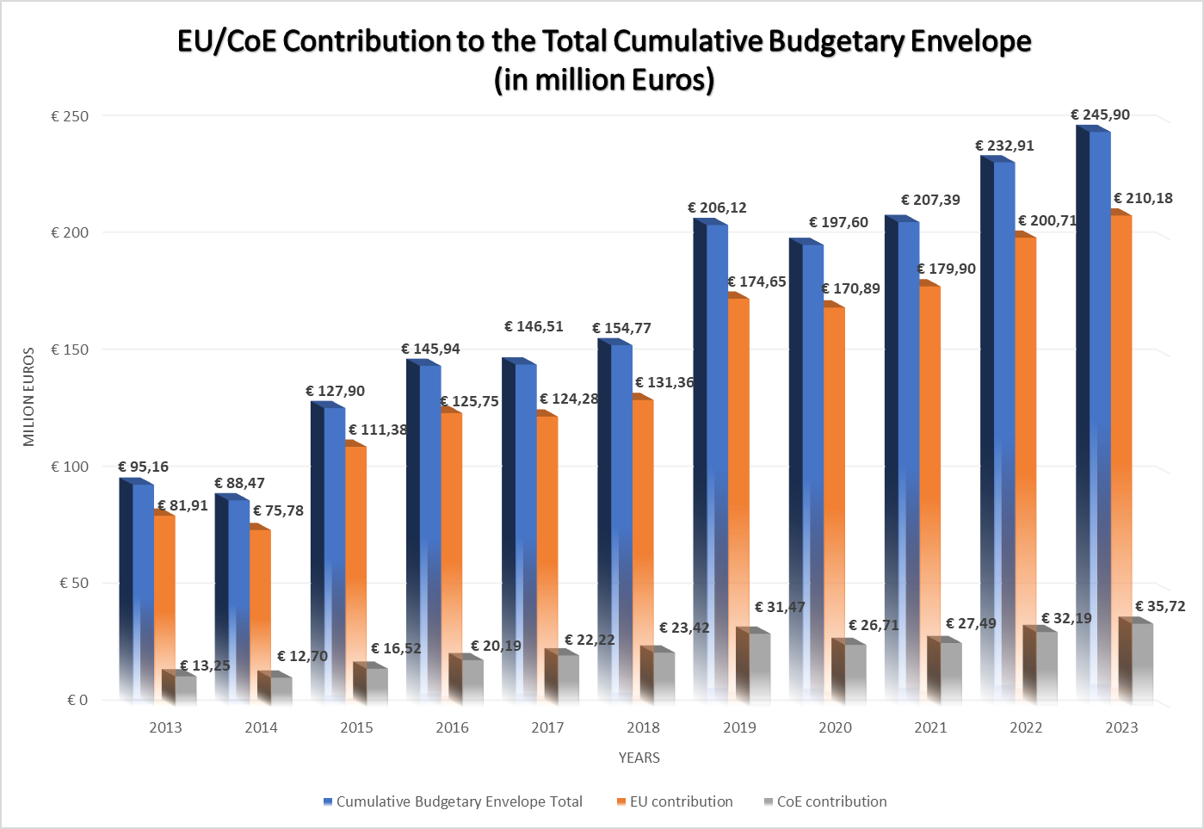

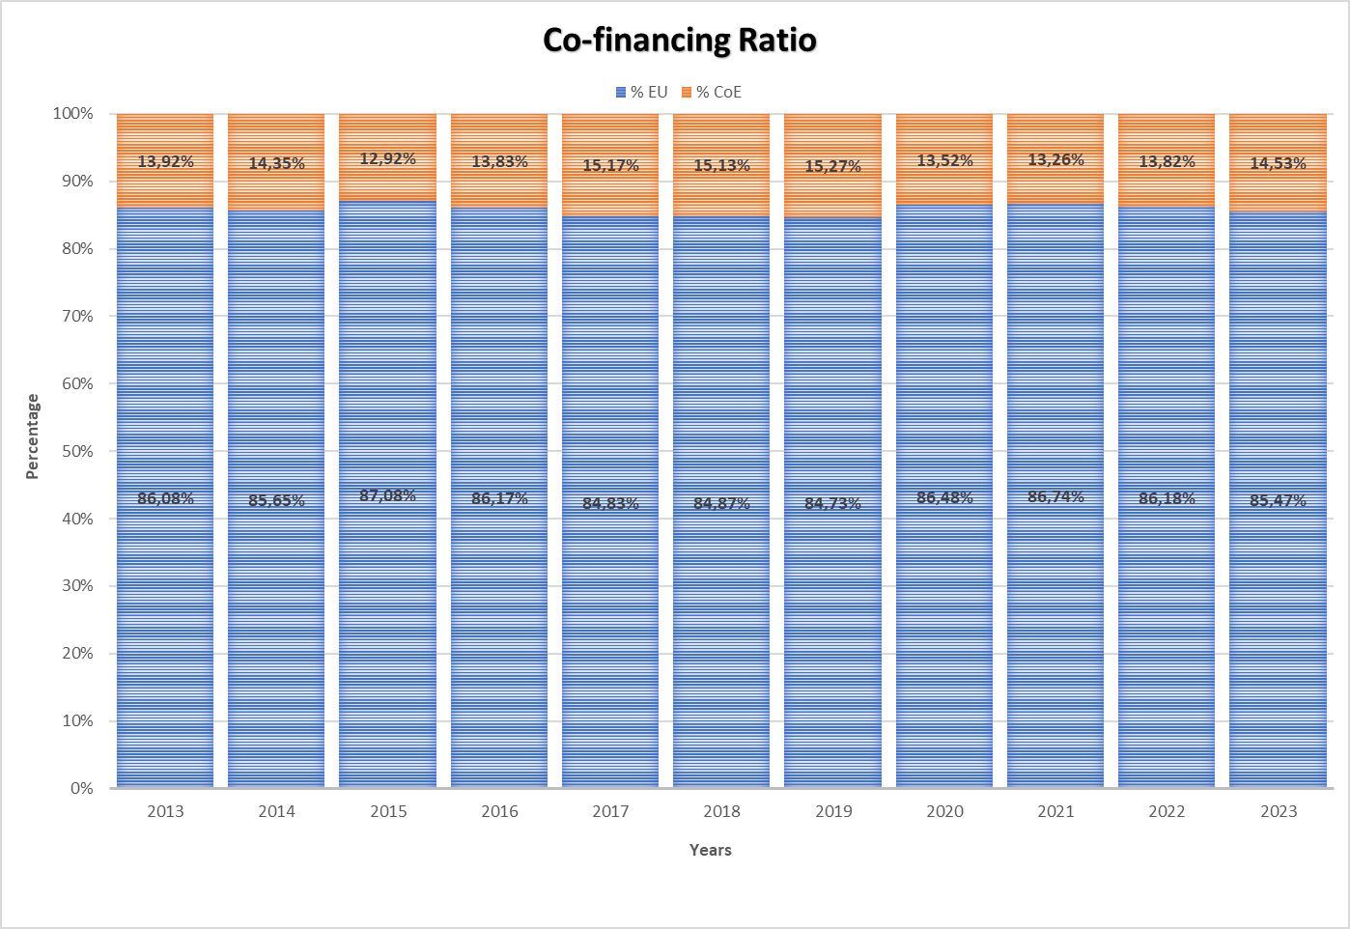

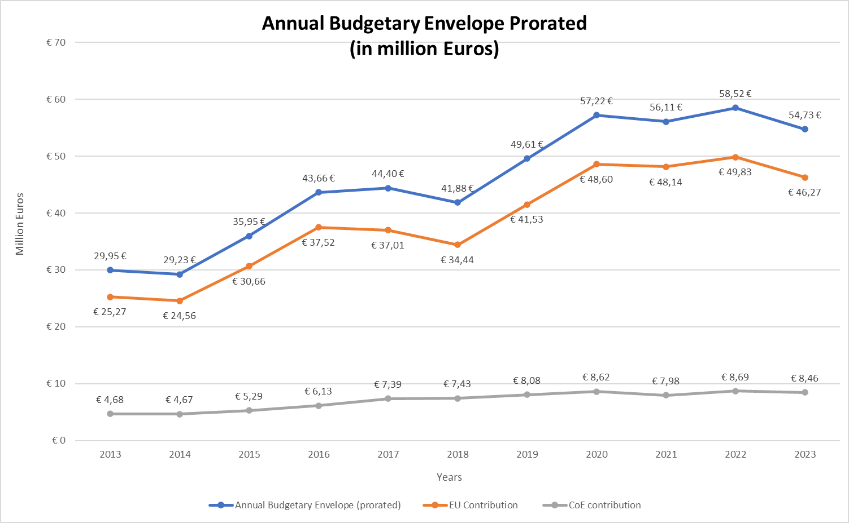

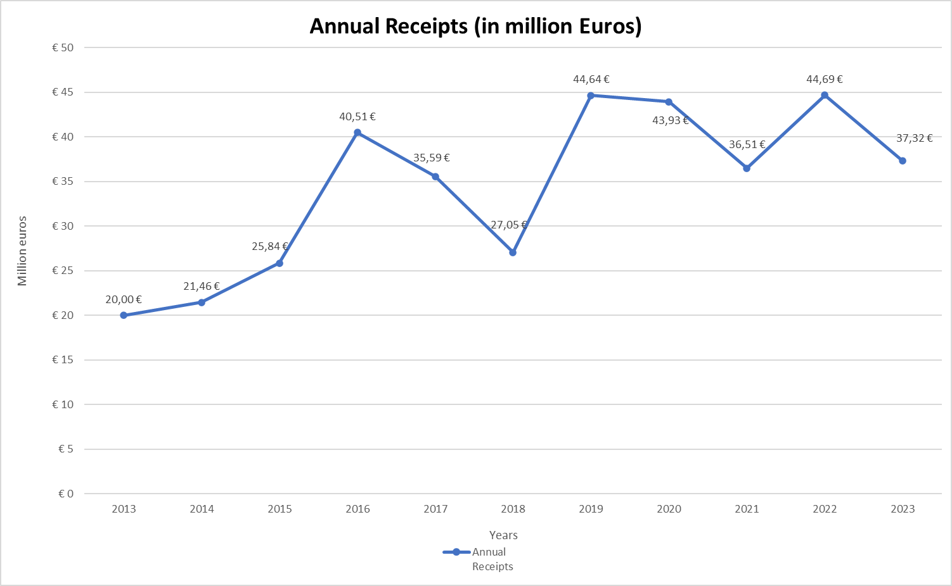

1. As regards Joint Programmes’ **geographical distribution**:

* In line with the long-lasting trend, more than half of the Joint Programmes' annualised financial volume continued to be channelled to the co-operation in **South-East Europe, Türkiye, Eastern Europe (Ukraine and the Republic of Moldova) and the South Caucasus** (54% of ABE 2023; €29.5 million in annualised figures[8]), with South-East Europe and Türkiye benefitting of the considerably larger financial injections. In both regions, the dedicated programmatic facilities (“Partnership for Good Governance” and “Horizontal Facility for the Western Balkans and Türkiye”) remained the cornerstone of the co-operation architecture; in parallel, the increased efforts have been deployed to complement these with the individual Joint Programmes, regional and Beneficiary-specific. In this respect, it is important to mention the speedy negotiation and launch of a new Beneficiary-specific programme for Ukraine, supporting the implementation of the standards on anti-discrimination and the rights of the persons belonging to the national minorities, and a new programme for the Republic of Moldova, focusing on the reform of the justice system in the country. Moreover, a new regional JP on Roma integration has begun implementation in South-East Europe and Türkiye. Furthermore, active negotiations on the next phases of the regional programmes i-Proceeds /CyberSEE and CyberEast continued throughout 2023, with signatures foreseen in early 2024. While Türkiye is part of the corresponding programmatic facility, the large-scale co-operation continued here primarily based on country-specific funds (seven individual programmes in 2023). The exhaustive list of the programmes of relevance to both geographical regions is presented in Appendix I. Information on the results under the facilities and other geographical Joint Programmes can be found in Section III.
* Importantly, the share of technical assistance programmes targeted at those **Council of Europe member States which are also member States of the European Union** continued to progress (17.8% of ABE 2023; €9.7 million in annualised figures), anchoring this strand of programmes at the forefront of the Council of Europe co-operation dimension. The main driver of this development was the structured co-operation with DG REFORM under the EU Technical Support Instrument. Four Council of Europe/DG REFORM tri-annual framework agreements, with an overall budget of €20.9 million, were under implementation in 2023, encompassing 37 projects in numerous EU member States. The preparation of the 2024 framework agreement started in autumn 2023, with the signature expected in spring 2024. Moreover, in 2023, cooperation with DG JUST gained momentum, with the signature of the three new sizable programmes to support respectively the combat against anti-LGBTIQ violence, the civil society's capacity to tackle hate speech online, and child-friendly justice. These new programmes join the co-operation undertakings that have been supported by DG JUST for several years, namely HELP-based judicial training programmes (currently implemented programmes Human Rights Education for Legal Professionals in the European Union - III and Judicial Training on Rule of Law and Fundamental Rights) and work on the rights of Roma (currently implemented JP EQUIROM on equality and freedom from discrimination for Roma). Furthermore, co-operation and technical assistance programmes towards EU member States are sustained also thanks to the well-established co-operation with DG EMPL (within the framework of JP ROMACT on Roma inclusion at the local level) and with DG EAC. With the latter, common work was underway notably in the area of language teaching, based on annual co-operation agreements implemented by the European Centre for Modern Languages of the Council of Europe. This co-operation aims to promote equality and non-discrimination through the definition of a common European approach to language learning and quality education in particular for migrant learners, linguistic competencies being a key in supporting integration, employability and social cohesion. Moreover, fruitful cooperation with DG EAC continued in the field of education, focusing on effective, equal and inclusive access to quality education for all, including Roma children (JP INSCHOOL - III). Importantly, the co-operation against cybercrime in EU member States has been given a new impetus, with the preparations for the new programme to support ratification and implementation of the Second Additional Protocol to the Budapest Convention on Cybercrime by EU member States; the programme is planned to be signed in early 2024 with DG HOME. It is also worth noting that many multilateral programmes (see the section below) are also primarily targeted at EU member States. For more information, see Section III and Appendices I and II.
* In 2023, the volume of **thematic multilateral Joint Programmes** continued to increase (16.3% of ABE 2023, € 8.9 million in annualised figures). This development is mainly due to the launch in 2023 of the JP Global Action against Economic Crime Enhanced (GLACY-e), a follow-up programme of the JP GLACY+ (2016-2024), a major undertaking in the field of action against cybercrime, implemented worldwide in collaboration with Interpol. The category of thematic multilateral programmes was also represented by many other important continuous co-operation undertakings aimed at strengthening democracy and human rights. In particular, the EU and the Council of Europe have a longstanding and impactful partnership in the field of youth, which promotes participatory youth policies across a range of fields, including support for education and providing the right tools for young people in view of the digital transition. Moreover, Joint Programme co-operation supports the HISTOLAB project of the Observatory of History Teaching in Europe which enhances the importance of history education in preserving democracy in Europe. The programme i-Legend-III, managed by North-South Centre of the Council of Europe fosters solidarity and raises awareness of global interdependence by supporting the intercultural learning exchange through global education, networking and dialogue. Vibrant co-operation exists in the field of sport, with two programmes - on combatting hate speech and on promoting gender equality in sports– underway in 2023 and a new one, to be launched in early 2024, focusing on strengthening the Safety and Service Pillars of the Saint-Denis Convention. The EU and the Council of Europe also continue to co-operate in the organisation of the European Heritage Days, the longest EU-Council of Europe joint action, aimed at raising the European citizens’ awareness of their shared cultural heritage and fostering their involvement in the safeguarding of this heritage for present and future generations. For several years, a DG JUST co-funded programme continues to support the Council of Europe's work with the National preventive mechanisms against torture, in particular the European network of prison monitoring bodies. EDQM implements a programme on the substances of human origin (SOHO), co-funded by DG HEALTH. Additionally, EDQM and DG HEALTH also co-operate in the domain of pharmaceuticals/biological standardisation, with the 2024 edition of the corresponding programme starting in January 2024. For more details on thematic multilateral programmes, see Appendices I and II.
* The share and volume of co-operation with non-member States in the **Southern Neighbourhood** and **Central Asia,** under the Council of Europe Policy towards Neighbouring Regions, decreased in the past year (11.9% of ABE 2023; €6.5 million in annualised figures). In the **Southern Neighbourhood**, the co-operation continued within the framework of the core South Programme, phase V of which started in September 2022 with an increased envelope. The South Programme was complemented by the regional programme CyberSouth (completed by the end of 2023), a country-specific programme in Morocco (focused on the role of the Parliament and the National Preventive Mechanism against Torture) and two country-specific programmes in Tunisia (assistance to the reform of the justice system and support to independent instances). The follow-up to the regional programme CyberSouth has been negotiated, with signature and start of implementation in January 2024. Active negotiations on the new programme for Morocco, in the judicial reform field, continued throughout 2023, to be concluded in 2024. In **Central Asia**, co-operation continued through the large-scale regional “Central Asia Rule of Law Programme”, extended by 6 months, to mid-2024. Following the signature of the programme “Support to democratic reforms, human rights mechanisms and rule of law principles in Latin America, Central Asia and Mongolia” at the end of 2023, the Venice Commission’s assistance to the countries of Central Asia will continue, building on the results of the earlier programme, completed in 2022. For more information, see Section III and Appendices I and II.

1. The chart below shows the geographical distribution of Joint Programme co-operation in 2023. 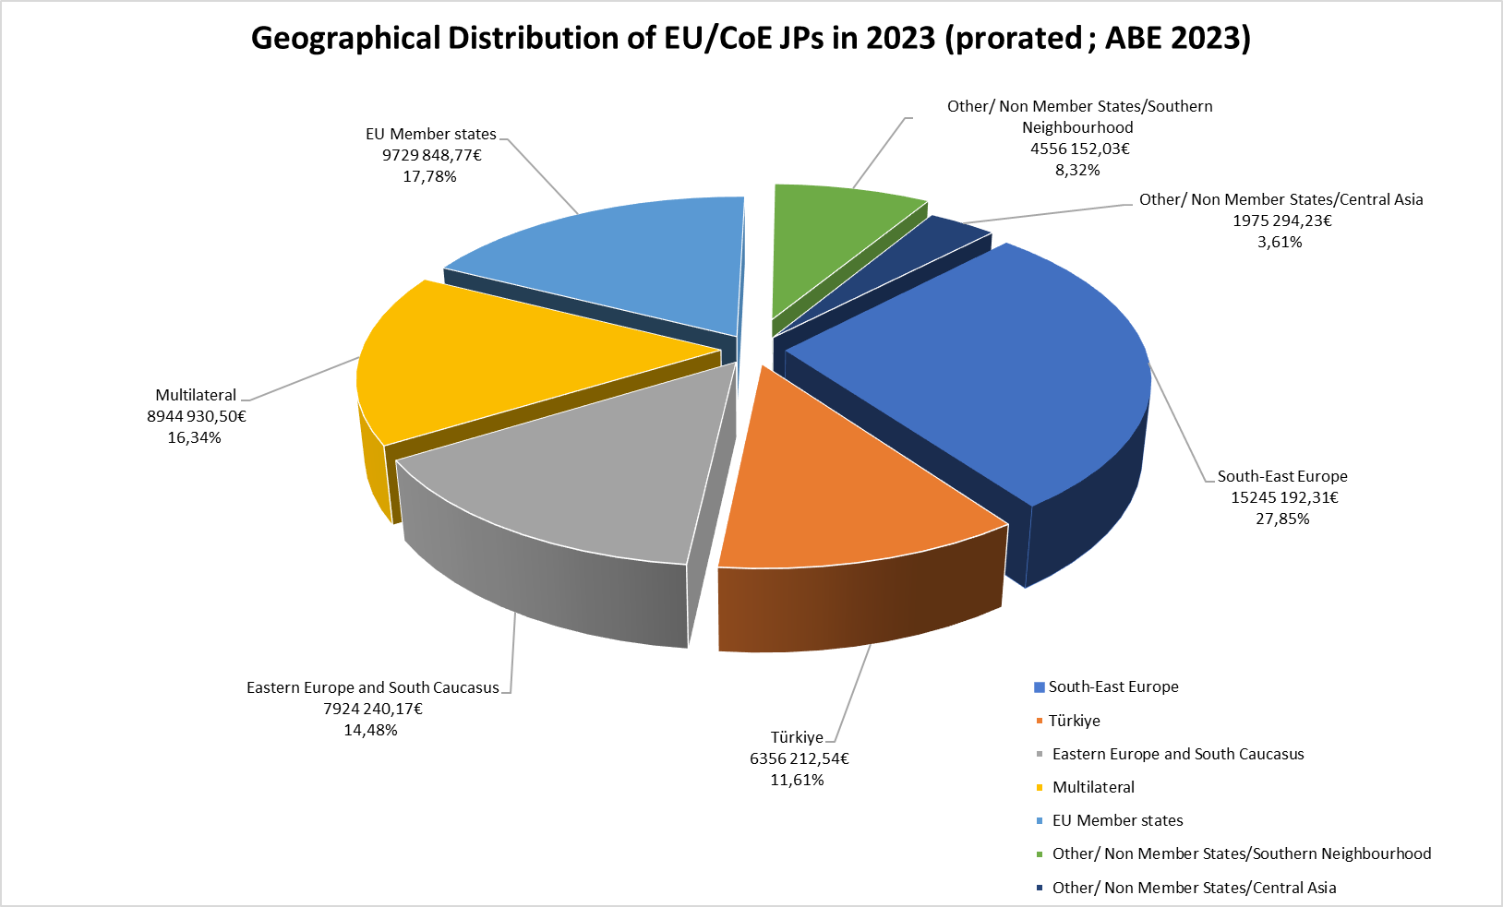
2. As regards Joint Programmes’ **thematic distribution in 2023**, the long-standing trends remained static:

* **Programmes of the Rule of Law pillar** continued to prevail in number and volume, accounting for 54.2% of ABE 2023 (€29.7 in annualised figures). These programmes were implemented over a wide range of areas of the Council of Europe expertise, with two sectors – fight against cybercrime and economic crime and independence and efficiency of justice – benefitting from the largest financial injections. The remainder of the funding is distributed between the programmes/projects on prisons and police, assistance activities of the Venice Commission, the EDQM’s actions on the quality of medicines /protection of health, and programmes related to sports conventions.
* The **Human Rights pillar’s programmes** accounted for 32.6% of ABE in 2023 (€17.8 million in annualised figures). The bulk of this funding continued to be channelled into enhancing the effectiveness of the ECHR system at national and European levels and into actions against discrimination and for Roma empowerment and inclusion. The remainder continued to finance programmes/projects on freedom of expression and information, children’s rights and equality and human dignity.
* **Programmes in the Democracy pillar** corresponded to 13.2% of ABE 2023 (€7.2 million in annualised figures) and concentrated mainly in education for democracy, youth for democracy and democratic governance sectors.

1. The chart below shows the thematic distribution of Joint Programmes in 2023.

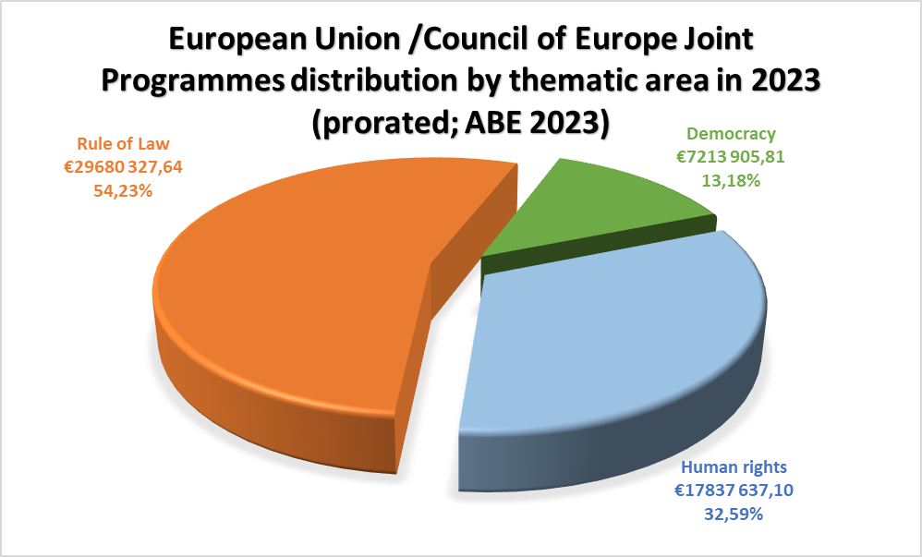

1. In terms of **funding instruments,** the EU instruments of External Action remained the main source of funding for the Joint Programme co-operation, with a preponderance of **the Instrument of Pre-accession** (36.5%) and the **European Neighbourhood Instrument** /**Neighbourhood, Development and International Cooperation Instrument (NDICI-Global Europe)** (34.3%). Several other instruments and funding programmes were involved (notably the Technical Support Instrument (TSI) and funding programmes managed by DG JUST and DG EAC), with their shares remaining under 10%.

**III. ACHIEVEMENTS OF JOINT PROGRAMME CO-OPERATION**

1. This section presents, in brief, the achievements of Joint Programme co-operation by geographical area, with a particular focus on the results of the corresponding regional programmatic facilities. It also describes other major co-operation undertakings such as the Central Asia Rule of Law Programme, and the co-operation framework with DG REFORM in EU member States.

**Joint Programme co-operation in Eastern Europe and the South Caucasus**

1. *Partnership for Good Governance*

The Partnership for Good Governance (PGG) for the Eastern Partnership (EaP) was the first European Union‑Council of Europe programmatic facility operationalised in 2015. Its Phase II (PGG II) with a total budgetary envelope of €17.5 million ran from January 2019 to the end of February 2023. It provided tailor-made support to the national reforms in the framework of Council of Europe country-specific action plans, also contributing to the achievement of the EU 2020 deliverables for the EaP countries and to the post-2020 Eastern Partnership priorities. The PGG II included 12 country-specific and four regional projects organised under three themes: i) strengthening the rule of law and mechanisms to combat corruption, money laundering and terrorist financing; ii) implementation of key judicial reforms; and iii) combating discrimination and protecting the rights of vulnerable groups and women (cross-cutting issues).

Following the Russian Federation’s war of aggression against Ukraine, the PGG II continued to address the Ukrainian partners’ emerging needs regarding the fight against economic crime, in consultation with the European Union, and with strict respect for the security requirements. PGG II projects accommodated the Moldovan partners' needs regarding the related migration crisis in the framework of the projects’ overall objectives. To allow for continued implementation, the PGG II applied a set of mitigation measures to address the political challenges in the region, adjusted the working methods and refocused some actions, while also taking into consideration the impact of the European Commission Opinion and European Council Decision on membership applications of Georgia, the Republic of Moldova and Ukraine.

The PGG II external evaluation confirmed that the Programme was a relevant and efficient co-operation tool, providing targeted support to the EaP countries for the implementation of national reforms in the PGG priority areas. The Quick Response Mechanism (QRM), channelling legal expertise and policy advice from Council of Europe bodies, and in particular that of the Venice Commission, to the beneficiary countries has proven its added value.

# The third phase of PGG started in March 2023 and will be implemented over four years until February 2027, with a total budgetary envelope of €19.3 million. 17 country-specific and four regional projects are implemented across PGG beneficiary countries under PGG III. Most PGG III projects are in the continuity of the programme’s previous phase. Novel interventions include projects in the field of efficiency of justice in Azerbaijan, the fight against economic crime in the Republic of Moldova, support for development of the constitutional justice in Ukraine and for promoting equality in Azerbaijan. The programme was designed based on findings of the Council of Europe monitoring and advisory bodies, and in line with the Council of Europe’s country-specific Action Plans and the European Union’s priorities for the EaP region. Progress in the implementation of the EU accession priorities is in focus for the Republic of Moldova, Ukraine, and Georgia. The QRM continues to function under the third phase of PGG and will offer important assistance in the context of the accession perspective for Georgia, the Republic of Moldova, and Ukraine. In October and December 2023, the Venice Commission adopted 10 Opinions and an amicus curiae brief concerning Armenia, Georgia, and the Republic of Moldova.

A non-exhaustive list of the results achieved by the time of completion of PGGII includes:

1. Improvedlegal andinstitutional framework in the area of anti-corruptionand anti-money laundering, countering of financing of terrorism, asset recovery as well as financing of proliferation of weapons of mass destruction in Armenia, Azerbaijan, Georgia, and Ukraine.
2. Adoption of anti-corruption strategies and update of the national risk assessments and respective action plans in Azerbaijan, Georgia, and Ukraine as a key step in implementing a risk-based-approach, increasing the integrity, transparency, and effectiveness of the anti-corruptionand anti-money laundering and terrorist financing measures.
3. Establishment of specialised anti-corruption and economic crime bodies in Armenia and Georgia and reinforcement of their institutional capacities to effectively address corruption, money laundering and terrorist financing as well as strengthening the capacities for asset recovery and international cooperation.
4. Adoption of relevant legislation in the field of criminal law, functioning of the judiciary, enforcement of the court judgments and strengthening the international co-operation in criminal matters in Armenia, Azerbaijan, Georgia, and the Republic of Moldova.

# In Armenia, the Judicial and Legal Reforms Strategy for 2022 – 2026 was adopted and includes a gender impact assessment. In Georgia, the Judicial Code was adopted by the Conference of Judges leading to strengthening judicial accountability and bringing judicial ethics in line with the Consultative Council of European Judges’ (CCJE) Opinion No. 3 on Ethics and Responsibility of Judges.

# Improved efficiency of the courts in Azerbaijan through the dissemination of CEPEJ tools. The Superior Council of Magistracy of the Republic of Moldova approved the JUSTAT[9] concept and improved the court management system through better collecting and interpreting data in line with CEPEJ recommendations. In Azerbaijan and the Republic of Moldova, the enforcement of court decisions was improved through legal and institutional modernisation of the enforcement system and strengthened capacities of the involved institutions.

# Development of a Constitutional Court’s Case Management System in Georgia to ensure access to justice, allowing citizens to file complaints electronically, which contributed to increase the citizens’ trust in the judicial system.

Improvement of the legal framework in the field of anti-discrimination in Armenia, Azerbaijan and the Republic of Moldova and further consolidated capacity of the Ombudsperson’s offices and Equality Councils in the EaP region to effectively fight against discrimination and tackling hate speech in light of the [ECRI General Policy Recommendation 15](https://www.coe.int/en/web/european-commission-against-racism-and-intolerance/recommendation-no.15) on combating hate speech.

# Enhanced capacity of relevant institutions in Armenia, Georgia, the Republic of Moldova and Ukraine through the provision of a methodology to monitor discrimination, hate speech and hate crime through disaggregated data collection mechanisms in line with ECRI’s recommendations.

1. The Istanbul Convention was ratified and entered into force in May 2022 in the Republic of Moldova and in November 2022 in Ukraine. Improvement of the national legislation in Armenia, Georgia and Ukraine in line with the Council of Europe standards and empowerment of the national institutions to effectively combat domestic violence.

# Capacities built among more than 200 justice sector professionals on equal access to justice and eliminating barriers across the EaP region.

# As regards the Quick Response Mechanism (QRM), 41 Opinions and one legal expertise were delivered under PGG II. In March 2023, three Opinions prepared under PGG II, have been adopted by Venice Commission following discussions with the national authorities.

While PGGIII is in its first year of implementation, some progress has been achieved in several areas:

1. In the field of strengthening justice, Armenian legal professionals have better access to the Cassation Court’s case law through the published Volume of Decisions. In the Republic of Moldova, monitoring has started on the use of JUSTAT AIS, the online application for consultation of statistical data from the judicial system launched in May 2023.
2. In the area of combating economic crime, political finance legislation and supervision tools were reviewed. In Ukraine the Government adopted the resolution “On approval of the Methodology for identifying the ultimate beneficial owner by a legal entity”, on 19 September 2023, paving the way for further implementation of the updated Ultimate Beneficial Owner reporting and verification mechanism. In Georgia, the institutional strategy and action plan for the newly established Anti-corruption Bureau were reviewed and comprehensive legislative measures to prevent and combat money laundering and terrorist financing were developed in view of enhanced alignment of the measures for non-financial Institutions with FATF recommendations.
3. In the area of promoting equality and non-discrimination, the capacities of the staff of the Ombudsperson Office to respond to different forms of discrimination affecting vulnerable groups were improved in Azerbaijan and the equality platform facilitated the dialogue among Civil Society Organisations (CSOs) and between CSOs and Ombudsperson Office. Expert support was provided to the Ministry of Justice of the Republic of Moldova in reviewing the Draft law on ensuring equality and the creation and translation of educational materials on combating hate speech and bullying. In Georgia and Ukraine, capacities and awareness of the national authorities and public were raised on combating hate speech.
4. In the field of combating violence against women and domestic violence, the HELP course on Violence Against Women was adapted and provided to Azerbaijani law enforcement officials. A multi-agency co-operation in combating violence against women was strengthened; The Council of Europe has adopted a comprehensive response package to address the refugee influx in Armenia. The package includes an assessment to address efficiently the new needs that occurred especially concerning the protection of human rights, protection against discrimination and in the field of economic crime to provide financial inclusion for the displaced persons.
5. *Other Joint Programmes implemented in the region*

Two important country-specific programmes for Ukraine and the Republic of Moldova were launched in 2023.

**In Ukraine**, the Joint Programme “Support for implementing European standards relating to anti-discrimination and rights of national minorities” (total: €2 million) started in July 2023 for three years. The programme aims to support Ukraine in implementing European standards and recommendations related to the protection from discrimination and regarding the rights of persons belonging to national minorities, notably in the context of the follow-up to the 2022 Opinion on Ukraine’s application for membership of the European Union. The programme focuses on the provision of legal and policy advice and entails engagement with civil society organisations and target communities. The programme also aims to raise awareness at the institutional and societal levels on issues related to diversity and combating intolerance and stereotypes against vulnerable groups.

**In the Republic of Moldova**, the three-year Joint Programme “Support to the Justice Reform” has been under implementation since May 2023 with a budget of €2.7 million. The programme aims at increasing the independence, professionalism, and transparency of the judiciary in the Republic of Moldova and supports the implementation of justice reform in line with European Commission for Democracy through Law (Venice Commission) Opinions, Group of States against Corruption (GRECO) compliance report, and other European standards. In this process, the programme supports enhanced co-operation between judicial bodies and national authorities, as well as broader networking with civil society institutions engaged in the reform of the judiciary in the country. It also targets the increased transparency and accessibility of the courts for its end beneficiaries. While the programme is still in its first year of implementation, some results can be acknowledged:

* a new regulation for organising and conducting competitions within the Prosecutors’ Inspection Service, shaped on the basis of a comprehensive assessment of the draft regulation, ensuring its coherence with CoE standards;
* an evaluation of the draft amendments regarding the National Institute of Justice as the basis for reform;
* amendments to the draft law regarding the external assessment of judges and prosecutors, marking a tangible impact on the legal framework on vetting, implementing recommendations of the Joint Follow-up Opinion of the Venice Commission and Directorate General of Human Rights and Rule of Law (DGI) on that draft law.

Two **thematic regional** Joint Programmes continued implementation in complementarity with PGG.

The Joint Programme “CyberEast - Action on Cybercrime for Cyber Resilience” (total €5.3 million) was launched in 2019 to strengthen the criminal justice capacities on cybercrime and electronic of the Beneficiary countries in terms of legislation and policies, capacities for investigation, prosecution and adjudication as well as international and public/private co-operation, in line with the Budapest Convention on Cybercrime. The programme has been completed by the end of 2023; its follow-up phase has been

negotiated, with the start of implementation foreseen in March 2024. Among the relevant achievements of the programme are:

* as regards legislation and policies, the programme’s focus on human rights safeguards and guarantees under Article 15 of the Budapest Convention contributed to keeping the beneficiary countries’ cybercrime policies grounded in the human rights approach. Discussion with countries on Xenophobia and Racism under the First Additional Protocol to the Convention further strengthens this approach, also securing further compliance with legal standards set by the Convention and the Protocol;
* as regards institutional capacity building and inter-agency cooperation, the programme has largely responded to the needs of countries – including Ukraine – for up-to-date skills for cybercrime investigations, prosecutions and criminal proceedings, targeting all relevant criminal justice authorities. Cyber exercises and training, organised under the programme, served as tools to establish and enhance interagency co-operation between cybersecurity and cybercrime experts. Engagement of defence attorneys and civil society in training and regional discussions supported the human rights approach to such co-operation;
* as regards international co-operation and public-private partnerships, the programme helped the countries’ relevant agencies to develop skills and competencies in line with European standards, especially the Cybercrime Convention and its Second Additional Protocol;
* following the Russian Federation’s aggression against Ukraine, the programme adapted its activities to Ukraine’s emerging needs and provided electronic evidence training for Ukrainian judges and prosecutors, as well as specialised digital forensics training for advanced groups of professionals.

The regional CEPEJ-implemented Joint Programme “Support for a Better Evaluation of the Results of Judicial Reform Efforts /Justice Dashboard EaP” (total: €2.23 million, launched in 2021) aims at achieving an effective, systematic and data-based evaluation of the results of judicial reform efforts in Armenia, Azerbaijan, Georgia, the Republic of Moldova and Ukraine, through the annual collection and processing of data on the functioning of judicial systems and relevant capacity-building. The programme has been extended until mid-July 2025 and has been further aligned with the Horizontal Facility Justice Dashboard. Among the achievements of the programme are :

* Finalisation of the assessment of each Beneficiary’s capacity to collect, process and transfer judicial data , in view of providing recommendations for capacity-building activities at national and regional level, as necessary;
* Completion of first (2022) and second (2023) exercise of data collection, during which the CEPEJ Secretariat provided hands-on assistance and expertise to CEPEJ national correspondents engaged in completing the CEPEJ questionnaire through the electronic system CEPEJ COLLECT. This technical expertise delivered according to the CEPEJ methodology assists with building the capacity and skills of national counterparts related to judicial statistics and judicial data collection;
* Finalisation of the comparative tables on all indicators, the beneficiary profiles for each beneficiary, as well as a condensed version of the analysis for a selected number of indicators and for all beneficiaries. Second condensed version was submitted in June 2023.

**Joint Programme co-operation in South-East Europe and Türkiye**

1. *The Horizontal Facility for the Western Balkans and Türkiye*

The Horizontal Facility for the Western Balkans and Türkiye (HF) is the second European Union-Council of Europe programmatic facility in order of time. It has been operating since 2016. Its third phase (HFIII), which began implementation in January 2023, (total: €41 million), encompasses four thematic fields, namely i) strengthening justice; ii) fighting against corruption, economic crime and money laundering; iii) anti-discrimination and protection of the rights of vulnerable groups; and iv) freedom of expression and freedom of the media. HFII follows a complementary two-fold approach, combining technical cooperation tailored to help the beneficiaries achieve increased compliance with European standards with the provision of Council of Europe expertise to respond to requests from HF beneficiaries for legislative analysis and policy advice.

The HFIII covers 43 actions (projects), out of which six are regional. The regional dimension of HFIII includes support in achieving an effective, systematic and data-based evaluation of the results of judicial reform efforts, countering terrorism and violent extremism by addressing radicalisation in prisons and disengaging radicalised prisoners from violence, action against economic crime, promoting equality and combating racism and intolerance, improving access to justice for women and enhancing freedom of expression and freedom of the media.

Actions under HF are designed based on findings of the Council of Europe monitoring bodies, providing also tight links to the relevant EU accession priorities. Under the third phase of the Horizontal Facility, the Expertise Co-ordination Mechanism (ECM), which allows delivering *ad hoc* legal expertise and policy advice upon request, continues to operate. In addition, expertise continues to be provided upon the requests of the beneficiaries under the technical cooperation part of the HFIII when such requests fall within the scope of the HFIII actions (in 2023 under HFIII the Council of Europe provided legal or policy expertise in over 165 instances). The implementationmethodology of HF is based on the coherent integration of the Council of Europe “strategic triangle” (standard-setting, monitoring, co-operation), a stringent results-based approach, strengthened human rights and gender dimensions and increased involvement at the local level, engagement of civil society and improved communication (including in local languages) to better reach out to citizens.

Most of the HFIII actions are in the continuity of the programme’s previous phase. Novel interventions include Beneficiary-specific actions in the field of efficiency of justice in Bosnia and Herzegovina, fight against economic crime in Bosnia and Herzegovina and Türkiye, and digital citizenship education in Türkiye. Throughout the region, a novel intervention strives to strengthen women’s access to justice, especially those who are victims of violence.

A non-exhaustive list of the results which have been achieved so far includes:

1. In **Albania**, following the drafting support of HFIII, two sub-legal acts were adopted by the Council of Ministers in 2023. These acts are crucial for implementing Law 133/2015 “on the treatment of property and finalisation of the process of compensation of property”, ensuring effective enforcement of property-related laws and regulations and the recommendations of the European Court in *Beshiri v. Albania*.
2. In 2023, the Albanian Media Regulator (AMA) amended the Broadcast Code taking into account 88% of the recommendations provided by HFII at the time. The other recommendations were mostly left to be defined in bylaws following the approval of the Broadcast Code.
3. The Central Election Commission (CEC) Electronic Platform on Financial Reporting was launched and made operational for the Albanian local government elections held in May 2023. The CEC Electronic Platform will increase the effective implementation of the legal safeguards of the Electoral Code and will facilitate the engagement and monitoring initiatives of civil society and media, increasing public scrutiny and accountability in political financing.
4. In **Bosnia and Herzegovina**, the fourth Pride March in Sarajevo - which gathered around 2 000 participants – was supported by HFIII. A very important improvement was the untightening of the security measures to a more adequate/reasonable size compared to the last Prides. This is a direct result of the peer-to-peer exchanges between the police from Montenegro and Bosnia and Herzegovina, which took place under HFII and focused on learning what are adequate/reasonable security measures during Pride marches. In addition, for the first time, police officers from Brčko were trained in combating hate crime/speech based on sexual orientation and gender identity.
5. To enable the Ombudsperson Institution of **Kosovo** (OIK) to report annually on the implementation of the Law on Protection from Discrimination, the first draft of the Monitoring and Reporting tool for the monitoring of the implementation of the Law on Protection from Discrimination was delivered by the programme. The framework proposed to the OIK builds on the tool already developed for the Office of Good Governance and resulted from a deliberative process, which included the perspectives and views of the parties concerned, therefore customising it to the extent possible and ensuring the institution’s ownership.
6. A new Memorandum of Understanding (MoU) on e-summonses has been implemented with the Municipality of Pristina, building on the results of the work done under the programme’s previous phase in support to the Basic Court of Pristina with the use of electronic communication.
7. **In Montenegro,** a "Training Plan" was developed to strengthen the capacities of the National Preventive Mechanism (NPM). This initiative stemmed from the evaluation of the professional competencies of the NPM monitoring officers to conduct visits to places of detention and enclosed institutions.
8. With the support from the programme, the revision of the Law on Free Legal Aid was finalised and endorsed by the Government of Montenegro.
9. In **North Macedonia**, more than 60 000 people were reached through the micro-promotions organised by the programme in 23 local communities as part of the awareness-raising initiative for free legal aid informing directly citizens about the related law. The initiative ensured that certain groups of potential beneficiaries that traditional advertising and online campaigns usually do not reach are made aware of their rights to free legal aid.
10. The programme has been supporting a multi-stakeholder working group by providing legal expertise with proposals for potential amendments to the Law on Whistleblowers in line with the Council of Europe Recommendation [CM/Rec(2014)7](https://search.coe.int/cm/Pages/result_details.aspx?Reference=CM/Rec(2014)7" \o "Recommendation of the Committee of Ministers to member States on the protection of whistleblowers (Adopted by the Committee of Ministers on 30 April 2014, at the 1198th meeting of the Ministers' Deputies)) on the protection of whistleblowers and the EU Directive (EU) 2019/1937 on the protection of persons who report breaches of EU law.
11. In **Serbia,** following the support of the programme, the draft amendments to the Law on the Protection of the Right to Trial Within Reasonable Time were submitted to the Parliament of Serbia for adoption.
12. The Reference Framework of Competences for Democratic Culture (RFCDC) was included by the Serbian education policy makers in the Rulebook on performing socially useful, i.e., humanitarian work in educational institutions, the Ministry’s Guidelines for Organisation and Implementation of Educational and Upbringing Process in the 2023/24 School Year. The Culture of Remembrance Resources related to the Holocaust and created by the Institute for Education Development and Ministry of Education were also connected with the RFCDC.
13. Thanks to the support provided by HFIII and the revision of indicators for pupils at risk/potential victims of trafficking in human beings, the number of referrals from the education system increased in Serbia.
14. Informed dialogue with institutions responsible for the execution of the individual measure in the ECtHR case *Dragan Petrovic v.Serbia* led to its final resolution.
15. In **Türkiye,** approximately 1 000 lawyers were trained, and 750 lawyers were certified to provide legal aid services to women in eight provinces in Türkiye.

The Council of Europe adapted its support following the devastating earthquakes in February 2023. For instance, the HELP course “Access to justice for women” was complemented with a module on women’s access to justice in the aftermath of natural disasters in Türkiye.

1. *Other Joint Programmes implemented in the region*

In **Serbia**, the Joint Programme on “Support for the Implementation of Judicial Reform” (total: €3.3 million) has been under implementation since 1 January 2022. Two programmes operated in **Kosovo**\* - “Building Capacity for Inclusion in Education – INCLUDE” (total: €2.2 million) and the “Project Against Economic Crime (PECK) Phase III” (total: €2.5 million), both launched in 2020. As regards **regional** thematic programmes, these included i-PROCEEDS-II (total: €4.9 million), a programme against cybercrime, targeting crime proceeds on the Internet and securing electronic evidence (completed in 2023) and ROMACTED II (total: €6.5 million) which promotes good governance and Roma empowerment at the local level. A new regional Joint Programme on Roma integration (total: €3 million) began implementation in May 2023 in South-East Europe and Türkiye for three years, while a new cybercrime programme - CyberSEE - has been negotiated, with signature and start of implementation in early 2024.

Some results of these programmes are as follows:

1. In **Serbia**, five key pieces of legislation for justice reform were adopted by the Parliament on 9 February 2023, namely the Law on the Organisation of Courts, the Law on Judges, the Law on the High Judicial Council, the Law on Public Prosecutors’ Office and the Law on High Prosecutorial Council. The Venice Commission, in its 134th Plenary Session, held on 10-11th March 2023, acknowledged the adoption of these laws as an important step forward;
2. To harmonise judicial practice, the Supreme Court of Serbia has entered more than 8000 decisions in the electronic database and to facilitate the harmonisation of prosecutorial practice 200 public prosecutors raised their awareness on the matter;
3. A Roma Cultural Centre was opened in Pirot, Serbia.
4. **Bosnia and Herzegovina** adopted the Law of Communications and Decision of the Council of Ministers imposing data retention and lawful interception obligations on telecom operators and ISPs;
5. The Romani language was introduced in the School Curriculum in Tuzla Canton, Bosnia and Herzegovina;
6. In **Kosovo**\*, the Law on the State Bureau for verification and confiscation of unjustified assets was adopted by the Assembly in February 2023;
7. 250 school representatives (school principals, educators, psychologists, parents, council representatives) from 25 pilot schools in Kosovo* (21 upper secondary and 4 primary ones) completed the training programme on “Creating a democratic and inclusive learning community”.
8. In **Montenegro,** the Judicial Training Centre has incorporated components on cybercrime and e-evidence into its training programs.
9. *Beneficiary-specific co-operation in Türkiye*

**Türkiye** has traditionally been the biggest single recipient of Joint Programmes co-operation and maintained this position in 2023, with seven individual programmes under implementation. More specifically, these include:

* three Joint Programmes launched in 2018/2019 - in the field of criminal justice (total €5 million), administrative judiciary (total €3.3 million)), and on the Court of Cassation (total €3 million). All three programmes were completed in 2023;
* four Joint Programmes launched in 2020/2021 – on international cooperation in criminal matters (total €3 million), on alternative dispute resolution methods (total €4 million), on family courts (total €2.2 million) and on the implementation of Turkish Constitutional Court judgments in the field of fundamental rights (total €5.5 million).

Some of the noteworthy results of these programmes are as follows:

1. The authorities were provided with recommendations on improving the effectiveness in divorce procedures and the framework of alimony and compensation determination by family courts.
2. Under the impulse of the support provided, the total number of cybercrime prosecution offices increased to 149 within Türkiye.
3. 52 trainer - lawyers from 13 provinces across Türkiye and rapporteurs of the Turkish Constitutional Court bolstered their knowledge on the use of the methodology for continuous training on the execution of the Turkish Constitutional Court judgments. Nineteen rapporteurs have benefitted from a placement at the Council of Europe (Department for the Execution of Judgments of the ECtHR) and the European Court.
4. A brand-new e-library system became operational in the Justice Academy of Türkiye in 2023.
5. 134 judges and prosecutors enhanced their knowledge on reasoning in criminal judgments and the right to liberty and security.
6. 300 mediators from all over Türkiye built their capacities concerning the elimination of joint ownership in shared properties, co-ownership and shared ownership, the formation of parties, enforceability statements, and report preparation practices.
7. 26 law enforcement and prosecution representatives from South-East Europe and Türkiye exchanged best practices on the newest intelligence support systems and information knowledge and tools for investigating high-tech crime with more than 1000 delegates of law enforcement, prosecution, intelligence and financial crime services from around the globe.
8. **Technical assistance in EU member States – co-operation with DG REFORM**

Four framework agreements with DG REFORM, with an overall budget of €20.9 million, were under implementation in 2023, encompassing 37 country-specific projects in a number of EU member States ( in Austria, Bulgaria, Croatia, Cyprus, Czech Republic, Estonia, Finland, France, Hungary, Ireland, Italy, Latvia, Lithuania, Malta, Poland, Portugal, Romania, Slovak Republic, Slovenia and Spain) and two multi-country projects. The thematic scope of this cooperation covered a wide range of areas of the Council of Europe’s expertise, including the various aspects of judicial reform (modernisation of the judicial system, efficiency of justice, access to justice and others), fight against economic crime, money-laundering and terrorist financing, anti-trafficking and migrants’ integration policies, protection of childhood and child-friendly justice, and local self-governance. The 2023 framework agreement was signed in June 2023 under the Technical Support Instrument (TSI) with a budgetary envelope of € 5 million). Additionally, one individual ad hoc project with DG REFORM continued in parallel in 2023 – in Cyprus – focused on intercultural integration.

A non-exhaustive list of results achieved so far includes:

1. Following the unanimous approval of the Barnahus Law by the National Assembly of Slovenia in April 2021, the Barnahus in Ljubljana has officially opened its doors in May 2022 and foresees to be able to take in 200 cases of child sexual abuse per year. The Barnahus model brings under the same roof all the relevant stakeholders involved in addressing child sexual abuse cases, and thus eliminates the revictimisation, reduces remarkably the duration of pre-trial processes and puts child-friendly justice at the centre of all procedures.
2. With support and advice of the Council of Europe the Bulgarian authorities adopted the action plan to mitigate money laundering and terrorist financing (ML/TF) risks identified in the National Risk Assessment (NRA) conducted pursuant to the Council of Europe NRA Methodology. The action plan contains legislative, regulatory, institutional and operational measures aimed at improving the effectiveness of preventing, detecting and combating ML/TF in Bulgaria. The project further launched the sectorial ML/TF risk assessments for virtual assets service providers (VASPs) pursuant to the methodology developed by the Council of Europe.
3. In order to address Slovakia’s problems of providing the same range and standard of services to citizens despite enormous differences in local authorities’ capacities (Slovakia has a highly fragmented local government with just under 3000 municipalities), the Council of Europe provided policy advice which empowered the authorities in preparing a comprehensive set of reform policies.
4. In Cyprus, the Project on the Implementation of the National Horizontal Action Plan Against Corruption enabled effective implementation and monitoring of anti-corruption actions by developing a Guidance paper on a methodology for evaluating and monitoring the implementation of anti-corruption actions.
5. The project regarding the enhancement of the capacity of the justice system in Cyprus provided technical support to the Cypriot judicial authorities preparing the ground for the establishment of a new Court Service responsible for the management and administration of the Cypriot courts, achieving consensus amongst the different authorities and actors on the necessity and usefulness of the new authority to be established.
6. A multi-country project on EU restrictive measures (sanctions) led to further coordinating Member States’ approaches as regards identification of effective ownership or control of a company and monitoring of crypto transactions to prevent sanctions’ circumvention through virtual assets. A second multi-country project on sanctions implementation started in late 2023 to map Member States’ competencies and powers as regards asset freezes.
7. **Joint Programmes in the South Mediterranean region**

The Council of Europe and the EU continued to partner in the Southern Mediterranean region to advance democratic reforms in the region in line with the European Union's Renewed Partnership with the Southern Mediterranean and the Council of Europe’s Policy towards its Neighbouring Regions.[10] Launched in 2012, **the South Programme** operationalises the close and long-standing tripartite partnership between the two organisations and the partner authorities in the Southern Mediterranean region based on common values.

The fifth phase of the South Programme, entitled “Protecting Human Rights, Rule of Law and Democracy through Shared Standards in the Southern Mediterranean “(South Programme V) has a budget of €5.6 million for a three-year implementation period (September 2022 – August 2025). It aims to continue to support democratic reforms of nine partner countries in the Southern Mediterranean (Algeria, Egypt, Israel, Jordan, Lebanon, Libya, Morocco, Palestine[11]* and Tunisia) through the establishment of a common legal space between Europe and this region. The South Programme also benefits from reinforced links with the Council of Europe’s North-South Centre, which provides its long-standing expertise in empowering civil society and youth organisations in the Council of Europe’s neighbouring regions.

Organised with the support of the Ministry for Foreign Affairs of Portugal and the CoE North-South Centre located in Lisbon, the official high-level launching event of the South Programme V gathered 130 participants from Europe and the Southern Mediterranean region in Lisbon on 13-14 March 2023. Focusing on the creation of a common legal space between the two shores of the Mediterranean, the event provided a platform for an exchange on the relevance and added value of Council of Europe standards and tools for the region[12].

The South Programme V is coordinated by the Council of Europe’s office in Tunis and implemented in synergy with joint EU/CoE regional and bilateral thematic initiatives implemented in the Southern Mediterranean. These include the regional programme CyberSouth to combat cybercrime in priority partner countries in the region (Algeria, Jordan, Lebanon, Morocco and Tunisia) as well as country-specific programmes PAII-T/“Support to Independent Bodies in Tunisia” implemented until March 2023 with a budget of €5.6 million and AP-JUST/”Improving the Functioning, Performance and Access to Justice in Tunisia”, implemented until September 2023 with a budget of € 5.9 million. In addition, the joint programme for Morocco “Support to the National Preventive Mechanism against Torture and to the Development of the Key Role of Parliament” is under implementation from November 2020 until April 2024 with a budget of €2.3 million.

In a challenging implementing environment, regional programme activities in the Southern Mediterranean as well as country-specific programmes in Morocco and Tunisia continued to deliver tangible results, a non-exhaustive list of which includes:

1. Progressive enlargement of the common legal space between the Southern Mediterranean region and Europe: Since 2012, the South Programme has counted up to 21 ratifications of Council of Europe conventions by five different partner authorities. In 2023, Tunisian authorities formally requested to be invited to the Macolin Convention on the manipulation of sports competitions[13] and the Lebanese authorities expressed an interest in the country becoming an observer of the 108+ Convention on the protection of personal data[14]. Despite the geopolitical turmoil, the increasing interest by partners in the Council of Europe flagship conventions, such as the Anti-trafficking Convention[15], the Budapest Convention on Cybercrime[16], the Lanzarote Convention on preventing child sexual abuse[17], and the Tromsø Convention on Access to Official Documents[18], underline the continued relevance of the Council of Europe standards in the region. Legislative support provided on partners’ demand on the basis of European standards with an objective to harmonise the national legal frameworks was further reinforced through the Quick Response Mechanism[19] of the South Programme, which was triggered in 2023 by the Lebanese authorities on their draft Law on the Administrative Judiciary.
2. Reinforced capacities of frontline professionals, experts and authorities in the Southern Mediterranean region on the protection of victims of trafficking in human beings through the development of tools at the national level and the provision of innovative training at the regional level. More than 100 participants and experts benefited from regional Training of Trainers (ToT) sessions in Tunis and Strasbourg as well as the second regional simulation-based training exercise “Towards a victim-centred approach in criminal proceedings” held in Spain in 2023. Representatives of governments, judges and prosecutors, law enforcement agencies, social and medical services, labour inspectorates and civil society from Belgium, Cabo Verde, Egypt, France, Jordan, Lebanon, Libya, Malta, Morocco, Palestine*, Portugal, Senegal, Spain and Tunisia were trained to detect and refer victims of human trafficking in line with a human-rights based approach centred on the victim. These capacity-building initiatives contribute to the Council of Europe’s work to establish a regional group of experts on combatting trafficking in human beings in the Southern Mediterranean.
3. Enhanced capacities of legal professionals in the region on human rights, European and international standards with more than 3000 users of the HELP platform, over 190 HELP tutors trained in the region (Algeria, Egypt, Jordan, Lebanon, Libya, Morocco and Tunisia) and a growing number of HELP courses translated into Arabic and contextualised to respond to the needs of partners in priority thematic areas.
4. Strengthened technical capacities of more than 3700 justice sector actors, including magistrates, lawyers, clerks and legal professionals, to improve the independence, efficiency and quality of justice in Tunisia through targeted capacity-building measures implemented by the end of September 2023. In addition, with the objective of improving the efficiency of legal proceedings, a digital platform “jShare” was set up in 2023 in partnership with the Tunisian Ministry of Justice to facilitate the exchange of documents and communication between courts and lawyers. The platform has the potential to reach up to 15000 users of which 9000 lawyers and it aims to further contribute to the modernisation of IT tools and infrastructures in the justice sector in line with the Tunisian government’s "Digital Justice 2000" strategy.
5. Increased justice performance through the use of CEPEJ tools in Morocco and Tunisia contributing to a better performance of the judicial system, including as regards remote trials, capacity building for judges and life-long learning for lawyers.
6. Improved skills and increased know-how of authorities and professionals in the region on the importance of the protection of personal data. A first inspection programme of the national data protection authority in Tunisia was completed with 336 inspections of companies and public administrations carried out by the end of January 2023 and 250 Data Protection Officer (DPO) posts created in the audited entities since the inspection started in 2019. In addition, journalists and media professionals as well as lawyers and professionals from different sectors benefited from HELP and other targeted training to enhance their knowledge and skills in respect for privacy and protection of personal data in Tunisia. Needs assessments in the field of personal data protection were conducted in Jordan, Lebanon and Libya in 2023 with priority areas for technical support identified jointly with relevant national authorities in these countries.
7. Reinforced peer-to-peer exchanges through Council of Europe networks, such as the University for Democracy for the Southern Mediterranean (UniDem Med) of the Venice Commission targeting senior civil servants in the region, Mediterranean School Survey Project on Alcohol and Other Drugs (MedSPAD) of the Pompidou Group on countering substance abuse, and the South-Mediterranean Network of Justice Inspection Services (SUDMEDIJ) of the CEPEJ, which was launched in 2022 in the framework of the fourth phase of the programme. The South Programme continues to encourage networking and dialogue through targeted support to 8 regional, sub-regional or north-south networks on the protection of human rights, the rule of law and democracy in the region.
8. Increased awareness and capacities of civil society organisations and youth through a regional seminar organised by the Tunis School of Politics on the effects of climate change on the Mediterranean region, and the creation of a new Rule of Law and Youth Network (RoLYN) which was launched at the 2023 Lisbon Forum on “Human Rights, Environment and Economic Crimes: Youth at the forefront".
9. **Joint Programmes in Central Asia**

The European Union-Council of Europe Joint “Central Asia Rule of Law Programme” (total budget: €8.9 million) has been implemented since 2020, with an initial duration of four years. In 2023, the programme benefitted from a 6-month extension to mid-2024. The Programme is open to all five countries of the region – Kazakhstan, Kyrgyzstan, Tajikistan, Turkmenistan, and Uzbekistan – and is in line with the Council of Europe Policy for Neighbouring Regions. The Programme is implemented by the Council of Europe in close collaboration with national partners and is based on a demand-driven approach. More specifically, the Programme aims at facilitating the creation of a common legal space between Europe and Central Asia, supporting the fight against economic crime and enhancing human rights protection by training legal professionals based on the Human Rights Education for Legal Professionals (HELP) methodology. It also includes the assistance of the Venice Commission on the functioning of state institutions and public administration. Some of the results are outlined below:

1. In view of itsinterest in Council of Europe Conventions, **Kazakhstan** was invited to accede to the [Convention on Cybercrime](https://rm.coe.int/1680081561) (2023). In March 2023, Kazakhstan officially submitted a request to obtain an observer status in MONEYVAL;
2. **Kazakhstan** received support to advance the implementation of the recommendations of the Group of States against Corruption (GRECO)[20] and enhance the transparency of beneficial ownership. In 2023, the anti-corruption Action of the Programme organised activities to support the Kazakh authorities to comply with the GRECO recommendations;
3. In 2023,the **Kyrgyz Republic** requested **opinions of the Venice Commission** on the Regulations of the Jogorku Kenesh and Amendments to the Law on the Regulations of the Jogorku Kenesh of the Kyrgyz Republic (1122/2023); on the Draft Law ‘On the Mass Media’ (1134/2023); and on the draft Constitutional Law on the Akiykatchy (Ombudsperson) (1144/2023);
4. In **Tajikistan** the capacities of national stakeholders to fight and prevent economic crime were strengthened. Recommendations on how to improve the legal framework protecting the rights of entrepreneurs that would enable businesses operating in Tajikistan to access to justice and resolve unfair treatment and abuses from public authorities in a pre-trial context were presented to the relevant institutions;
5. Co-operation with **Turkmenistan** was enhanced by raising awareness on issues related to the access to justice and to recovery of criminal proceeds and beneficial ownership;
6. **Uzbekistan** is the first country in the region to have launched a tutored HELP course (“Rights of Persons with Disabilities” for judges). In co-operation with the Law enforcement Academy of the Republic of Uzbekistan, two HELP courses “Violence against women and domestic violence” and “Combating trafficking in human beings”, translated and adapted to the national legal context of Uzbekistan, were launched for two groups of Uzbek prosecutors in April 2023. Moreover, Council of Europe experts contributed to discussions on the latest legal trends in the field of fundamental rights in the framework of the third International Tashkent Law Spring Forum, which took place in May 2023. Additionally, events were organised in the field of constitutional control, and training on financial investigations of economic crimes.

**IV. LESSONS LEARNED**

1. The following lessons learned can be drawn from the implementation of Joint Programmes during the reference period:
2. Maintaining dialogue with and seeking regular feedback from project stakeholders, including EU, and beneficiaries at different levels is essential to build flexibility and resilience into project design. It allows for identifying newly emerging needs and adapting project activities to realities on the ground in order to ensure that the project delivers on intended outcomes. Accommodating to the extent possible new and emerging needs boosts project performance and spurs common motivation along with that of the Council of Europe staff.
3. Facility-type regional programmes are a flexible and effective tool to address new challenges and risks. The right balance between flexibility and adaptability of these programmes is a strong added value, which allows them to achieve clearly defined objectives.
4. Council of Europe experience from the EU enlargement process in South-East Europe is very valuable for the enlargement perspective of Ukraine, the Republic of Moldova and Georgia. Cross fertilisation and synergies are increasingly sought among Joint Programmes in this respect.
5. Risk management is an integral element of the Joint Programmes’ monitoring with a view to timely develop and effectively implement mitigation measures to address the different risks and challenges. A constant risk assessment is particularly important given the developments linked to the consequences of the Russian Federation’s aggression against Ukraine notably, which can affect the implementation of Joint Programmes.
6. Regional actions, in complementarity to national ones, demonstrated a strong added value by providing a platform for the exchange of expertise and best practice, promoting peer-to-peer exchange, and reinforcing regional cooperation and dialogue. The flexibility of the structure of regional projects is key in view of the developments, in order to ensure the most appropriate composition and modalities of regional interventions.
7. The high quality of assistance provided through Joint Programmes both by technical support and the targeted expertise (Expertise Co-ordination Mechanism within the Horizontal Facility and the Quick Response Mechanisms within the Partnership for Good Governance and South Programme) is much appreciated by beneficiary institutions and brings tangible results.
8. Maintaining open communication channels with and between the authorities and partners on issues that are intersectional and involving multi-agency co-operation, allows to create synergies in the form of cross-fertilisation and mutualisation of certain tools or promotion efforts.
9. Along with tailor-made assistance encompassing legal expertise, capacity building and awareness raising, promoting a multi-stakeholder approach is key to achieving tangible results and ensuring a positive impact of actions for citizens. Strengthening an inclusive approach and involving all relevant stakeholders, including the civil society as right-holders, is relevant for reinforcing the ownership of the national partners, enhancing inter-agency cooperation, and increasing the role of civil society organisations in the Joint Programmes implementation as a promoter of change and as a direct vector of communication to citizens, reflecting concrete changes brought by Joint Programmes to their daily lives.

**ApPendix I. Joint Programmes UNDER IMPLEMENTATION in 2023**

|  |  |  |  |  |  |  |
| --- | --- | --- | --- | --- | --- | --- |
|  | | | | | | |
| **Financing instrument** | **Contract title** | **Start date of covenant** | **End date of covenant** | **Total programme envelope in €** | **Contribution of the European Union in €** | **Contribution of the Council of Europe in €** |
| **South-East Europe and Türkiye** | |  |  |  |  |  |
| **Serbia** |  |  |  |  |  |  |
| IPA | Support for the implementation of judicial reform in Serbia | 01/01/2022 | 31/12/2024 | 3 334 000.00 | 3 000 000.00 | 334 000.00 |
| **Türkiye** |  |  |  |  |  |  |
| IPA | Improving the Effectiveness of the Administrative Judiciary and Strengthening the institutional Capacity of Council of State | 21/12/2018 | 31/05/2023 | 3 335 000.00 | 3 000 000.00 | 335 000.00 |
| IPA | Strengthening the Institutional Capacity of Court of Cassation | 22/02/2019 | 21/08/2023 | 3 000 000.00 | 2 700 000.00 | 300 000.00 |
| IPA | Strengthening the Criminal Justice System and the Capacity of Justice Professionals on prevention of the European Convention on Human Rights Violations | 15/03/2019 | 14/12/2023 | 5 000 000.00 | 4 500 000.00 | 500 000.00 |
| IPA | Improving International Judicial Cooperation in Criminal Matters | 11/12/2020 | 10/12/2024 | 3 000 000.00 | 2 700 000.00 | 300 000.00 |
| IPA | Promoting Alternative Dispute Resolution (ADR) | 17/12/2020 | 16/09/2024 | 4 000 000.00 | 3 600 000.00 | 400 000.00 |
| IPA | Improving the effectiveness of family courts: better protection of the rights of family members | 20/03/2021 | 19/09/2024 | 2 223 000.00 | 2 000 000.00 | 223 000.00 |
| IPA | Supporting the Effective Implementation of Turkish Constitutional Court Judgments in the field of Fundamental Rights | 17/09/2021 | 16/09/2025 | 5 500 000.00 | 4 950 000.00 | 550 000.00 |
| **Kosovo\*** |  |  |  |  |  |  |
| IPA | Building capacity for inclusion in education - INCLUDE | 01/01/2020 | 31/12/2023 | 2 223 000.00 | 2 000 000.00 | 223 000.00 |
| IPA | Project against Economic Crime (PECK) Phase III | 01/07/2020 | 27/10/2024 | 2 460 000.00 | 2 214 000.00 | 246 000.00 |
| **Regional** |  |  |  |  |  |  |
| IPA | Cooperation on Cybercrime: targeting crime proceeds on the Internet and securing electronic evidence (“iPROCEEDS2”) | 01/01/2020 | 31/12/2023 | 4 945 000.00 | 4 450 000.00 | 495 000.00 |
| IPA | ROMACTED phase II: Promoting good governance and Roma empowerment at local level | 01/01/2021 | 31/12/2024 | 6 500 000.00 | 5 700 000.00 | 800 000.00 |
| IPA | European Union/Council of Europe Horizontal Facility for the Western Balkans and Türkiye – Phase III | 01/01/2023 | 31/12/2026 | 41 175 000.00 | 35 000 000.00 | 6 175 000.00 |
| IPA | Roma Integration Project - Phase III | 01/05/2023 | 30/04/2026 | 3 000 000.00 | 2 700 000.00 | 300 000.00 |
| **Eastern Europe and South Caucasus** | |  |  |  |  |  |
| **Republic of Moldova** |  |  |  |  |  |  |
| NDICI | Support to the Justice Reform in the Republic of Moldova | 27/05/2023 | 26/11/2026 | 2 700 000.00 | 2 430 000.00 | 270 000.00 |
| **Ukraine** |  |  |  |  |  |  |
| ENI | European Union and Council of Europe working together to strengthening the protection of human rights in Ukraine | 10/07/2019 | 17/12/2023 | 3 334 000.00 | 3 000 000.00 | 334 000.00 |
| ENI | Support for implementing European standards relating to anti-discrimination and rights of national minorities in Ukraine | 01/07/2023 | 30/06/2026 | 1 999 997.00 | 1 800 000.00 | 199 997.00 |

|  |  |  |  |  |  |  |
| --- | --- | --- | --- | --- | --- | --- |
| **Regional** | |  |  |  |  |  |
| ENI | Partnership for Good Governance - Phase II | 01/01/2019 | 28/02/2023 | 17 500 000.00 | 14 000 000.00 | 3 500 000.00 |
| ENI | CyberEast - Action on Cybercrime for Cyber Resilience in the Eastern Partnership Region | 20/06/2019 | 19/12/2023 | 5 333 333.00 | 4 800 000.00 | 533 333.00 |
| ENI | Support for a better evaluation of the result of judicial reform efforts in the Eastern Partnership ‘Justice Dashboard EaP’ | 15/01/2021 | 14/07/2025 | 2 223 000.00 | 2 000 000.00 | 223 000.00 |
| NDICI | Partnership for Good Governance - Phase III | 01/03/2023 | 28/02/2027 | 19 300 000.00 | 15 000 000.00 | 4 300 000.00 |
| **Multilateral** | |  |  |  |  |  |
| FPI/FS | Global Action on Cybercrime extended (GLACY+) | 01/03/2016 | 29/02/2024 | 18 890 000.00 | 17 000 000.00 | 1 890 000.00 |
| Creative Europe | European Heritage Days 2021-2022 | 01/10/2021 | 31/03/2023 | 800 000.00 | 400 000.00 | 400 000.00 |
| Erasmus + | Combating Hate Speech in Sport | 01/01/2022 | 30/06/2024 | 560 000.00 | 400 000.00 | 160 000.00 |
| Erasmus + | Partnership between the European Commission and the Council of Europe in the Field of Youth 2022-2023 agreement | 01/01/2022 | 31/12/2023 | 2 800 000.00 | 1 600 000.00 | 1 200 000.00 |
| DG SANTE | Improving the quality, safety and availability of Substances of Human Origin, disseminating best practices, implementing Union standards and tackling new challenges | 01/01/2022 | 31/12/2024 | 6 000 000.00 | 3 000 000.00 | 3 000 000.00 |
| JUST | SPACE reports and EU network of prison monitoring bodies | 01/03/2022 | 28/02/2023 | 187 500.00 | 150 000.00 | 37 500.00 |
| Erasmus + | Transnational History Education and Cooperation Laboratory (HISTOLAB) | 28/04/2022 | 27/04/2024 | 1 111 111.00 | 1 000 000.00 | 111 111.00 |
| NDICI -CSO | iLEGEND III - Intercultural Learning Exchange through Global Education, Networking and Dialogue | 20/12/2022 | 19/12/2026 | 2 000 000.00 | 1 500 000.00 | 500 000.00 |
| Creative Europe | European Heritage Days 2023 | 01/01/2023 | 30/06/2024 | 800 000.00 | 400 000.00 | 400 000.00 |
| Erasmus + | All In Plus - promoting gender equality in sport | 01/03/2023 | 28/02/2025 | 500 000.00 | 400 000.00 | 100 000.00 |
| JUST | Support to Council of Europe for EU network of prison monitoring bodies | 21/07/2023 | 20/07/2025 | 345 000.00 | 310 000.00 | 35 000.00 |
| NDICI | Global Action on Cybercrime Enhanced (GLACY-e) | 01/08/2023 | 31/01/2026 | 5 556 000.00 | 5 000 000.00 | 556 000.00 |
| **EU member States** | |  |  |  |  |  |
| **Cyprus** |  |  |  |  |  |  |
| SRSP | Building structures for intercultural integration in Cyprus | 02/06/2021 | 30/06/2023 | 444 444.00 | 400 000.00 | 44 444.00 |
| **Multi-beneficiary** | | | | | | |
| SRSP | Support to Member States in the Implementation of Structural Reforms II | 16/06/2020 | 15/06/2023 | 3 379 003.66 | 3 035 000.00 | 344 003.66 |
| CERV | Strengthening National Child Participation Frameworks and Action in Europe — CP4Europe | 01/04/2021 | 30/06/2023 | 950 374.00 | 760 299.20 | 190 074.80 |
| TSI | Support to EU Member States in the implementation of reforms under the Technical Support Instrument – 2021: Governance, Public Administration, Financial Sector and Access to Finance | 13/05/2021 | 12/05/2024 | 4 300 000.00 | 3 870 000.00 | 430 000.00 |
| Erasmus + | Inclusive Schools: Making a Difference for Roma Children (INSCHOOL 3) | 11/12/2021 | 31/05/2024 | 1 000 000.00 | 700 000.00 | 300 000.00 |
| Home | Building Futures, Sharing Good Practices: Migrant Children's Transition to Adulthood — UACFutures | 01/01/2022 | 30/06/2023 | 666 665.64 | 599 999.07 | 66 666.57 |
| JUST | Human Rights Education for Legal Professionals in the European Union III (EU CoE HELP EU III) | 01/03/2022 | 31/08/2024 | 1 389 448.50 | 1 250 503.65 | 138 944.85 |
| TSI | Support to EU Member States in the implementation of reforms under the Technical Support Instrument 2022: Border and migration policies and capacity building to absorb Union funds in relation to RRF, Revenue Administration and Public Financial Management, Governance and Public Administration and Financial Sector and Access to Finance | 22/04/2022 | 21/04/2025 | 8 227 806.00 | 7 410 014.00 | 817 792.00 |
| JUST | EU-CoE Judicial Training on Rule of Law and Fundamental Rights | 01/11/2022 | 31/10/2024 | 649 888.04 | 584 899.23 | 64 988.81 |
| CERV | Equality and freedom from discrimination for Roma (EQUIROM) | 20/12/2022 | 19/12/2024 | 850 000.00 | 680 000.00 | 170 000.00 |
| DG EMPL | ROMACT 9: Building Capacity for Roma Inclusion at Local Level | 01/01/2023 | 31/08/2024 | 1 670 000.00 | 1 500 000.00 | 170 000.00 |
| Erasmus + | Innovative Methodologies and Assessment in Language Learning - X | 01/01/2023 | 31/12/2023 | 873 606.85 | 698 885.48 | 174 721.37 |

|  |  |  |  |  |  |  |
| --- | --- | --- | --- | --- | --- | --- |
| TSI | Support to EU Member States in the implementation of reforms under the Technical Support Instrument 2023: Border and migration policies; Governance and public administration; Financial sector and access to finance | 01/07/2023 | 30/06/2026 | 5 000 000.00 | 4 500 000.00 | 500 000.00 |
| CERV | Increasing civil society organisations’ knowledge and capacity to tackle hate speech online | 01/09/2023 | 31/12/2024 | 223 000.00 | 200 000.00 | 23 000.00 |
| CERV | Combating anti-LGBTIQ violence and hate speech and strengthening awareness-raising and fact-based narratives about LGBTIQ persons | 04/11/2023 | 03/11/2026 | 1 334 000.00 | 1 200 000.00 | 134 000.00 |
| **Non-member States/Southern Neighbourhood** | |  |  |  |  |  |
| **Morocco** |  |  |  |  |  |  |
| ENI | Support to the national mechanism against torture and to the development of the key role of Parliament in Morocco | 14/11/2020 | 30/04/2024 | 2 316 000.00 | 2 200 000.00 | 116 000.00 |
| **Tunisia** |  |  |  |  |  |  |
| ENI | Project to Support Independent Bodies in Tunisia (PAII T) | 01/01/2019 | 31/03/2023 | 5 556 000.00 | 5 000 000.00 | 556 000.00 |
| ENI | Improving the functioning, performance and access to justice in Tunisia (AP-JUST) | 01/01/2019 | 30/09/2023 | 5 988 890.00 | 5 390 000.00 | 598 890.00 |
| **Regional** | |  |  |  |  |  |
| ENI | Cooperation on cybercrime in the Southern Neighbourhood Region - Cyber@South | 01/07/2017 | 31/12/2023 | 5 005 000.00 | 4 500 000.00 | 505 000.00 |
| NDICI | Regional Support to Reinforce Human Rights, Rule of Law and Democracy in the Southern Mediterranean (South Programme V) | 01/09/2022 | 31/08/2025 | 5 556 000.00 | 5 000 000.00 | 556 000.00 |
| **Non-member States/Central Asia** | |  |  |  |  |  |
| DCI | Rule of Law Programme | 02/01/2020 | 30/06/2024 | 8 888 824.03 | 8 000 000.00 | 888 824.03 |

**Appendix II. Joint Programmes signed in 2023**

|  |  |  |  |  |  |  |  |
| --- | --- | --- | --- | --- | --- | --- | --- |
| **Financing instrument** | **Contract title** | **Date of signature** | **Start date of covenant** | **End date of covenant** | **Total programme envelope in €** | **Contribution of the European Union in €** | **Contribution of the Council of Europe in €** |
| NDICI | Partnership for Good Governance - Phase III | 27/02/2023 | 01/03/2023 | 28/02/2027 | 19 300 000.00 | 15 000 000.00 | 4 300 000.00 |
| NDICI | Support to the Justice Reform in the Republic of Moldova | 26/05/2023 | 27/05/2023 | 26/11/2026 | 2 700 000.00 | 2 430 000.00 | 270 000.00 |
| CERV | Increasing civil society organisations’ knowledge and capacity to tackle hate speech online | 26/06/2023 | 01/09/2023 | 31/12/2024 | 223 000.00 | 200 000.00 | 23 000.00 |
| ENI | Support for implementing European standards relating to anti-discrimination and rights of national minorities in Ukraine | 30/06/2023 | 01/07/2023 | 30/06/2026 | 1 999 997.00 | 1 800 000.00 | 199 997.00 |
| TSI | Support to EU Member States in the implementation of reforms under the Technical Support Instrument 2023: Border and migration policies; Governance and public administration; Financial sector and access to finance | 30/06/2023 | 01/07/2023 | 30/06/2026 | 5 000 000.00 | 4 500 000.00 | 500 000.00 |
| JUST | Support to Council of Europe for EU network of prison monitoring bodies | 20/07/2023 | 21/07/2023 | 20/07/2025 | 345 000.00 | 310 000.00 | 35 000.00 |
| CERV | Combating anti-LGBTIQ violence and hate speech and strengthening awareness-raising and fact-based narratives about LGBTIQ persons | 03/11/2023 | 04/11/2023 | 03/11/2026 | 1 334 000.00 | 1 200 000.00 | 134 000.00 |

|  |  |  |  |  |  |  |  |
| --- | --- | --- | --- | --- | --- | --- | --- |
| Creative Europe | European Heritage Days – 2024 edition | 13/11/2023 | 01/01/2024 | 30/06/2025 | 800 000.00 | 400 000.00 | 400 000.00 |
| JUST | Support to Council of Europe’s project on child-friendly justice | 22/11/2023 | 01/01/2024 | 31/03/2026 | 950 000.00 | 855 000.00 | 95 000.00 |
| Erasmus+ | Balance S4 - Strengthening the Safety and Service pillars of the Saint-Denis Convention | 06/12/2023 | 01/01/2024 | 30/09/2025 | 445 000.00 | 400 000.00 | 45 000.00 |
| DG SANTE | Support for Pharmaceuticals to the Council of Europe/EDQM | 08/12/2023 | 01/01/2024 | 31/12/2027 | 18 400 000.00 | 4 600 000.00 | 13 800 000.00 |
| NDICI | Support to democratic reforms, human right mechanisms and rule of law principles in Latin America, Central Asia and Mongolia | 14/12/2023 | 01/01/2024 | 31/12/2026 | 763 160.00 | 725 000.00 | 38 160.00 |
| Erasmus+ | Innovative Methodologies and Assessment in Language Learning | 17/12/2023 | 01/01/2024 | 31/12/2024 | 875 000.00 | 700 000.00 | 175 000.00 |

1. The FFPA is a generic agreement on contractual, administrative, and financial aspects of European Union-Council of Europe programme co-operation
2. The Council of Europe Human Rights Approach Practical Guide for Co-operation Projects contributes to application of the human rights approach in project management and co-operation activities.
3. As a component of the human rights approach, the Council of Europe emphasises gender mainstreaming throughout its project activities in line with its Gender Equality Strategy 2018-2023. For more information, see the Council of Europeweb page on gender mainstreaming.
4. The Cumulative Budgetary Envelope (CBE) is a sum of the budgetary envelopes of all JP contracts that were registered as “active” between 1st January and 31st December of a given year.
5. The Annual Budgetary Envelope (ABE) is a statistical parameter calculated *pro rata temporis* to CBE.
6. Increase in the average CoE co-financing ratio in the newly signed programmes is due to the high rate of EDQM co-financing in its new programme “Support to Pharmaceuticals” (EU 25%, EDQM 75%).
7. Programmes sined in 2023 with the start in 2024, are not included in the calculation of CBE and ABE 2023.

   *All reference to Kosovo, whether the territory, institutions or population, in this text shall be understood in full compliance with United Nations Security Council Resolution 1244 and without prejudice to the status of Kosovo
8. Calculated *prorata temporis* to CBE 2023.
9. Aiming at publishing data about the judicial system, including statistical data, key performance indicators and other useful information for evaluating the results of the activity of the courts.
10. See the European Union [Renewed Partnership with the Southern Mediterranean](https://www.eeas.europa.eu/node/92844_fr) and the [Council of Europe Policy towards Neighbouring Regions](https://www.coe.int/en/web/der/policy-towards-neighbouring-regions#:~:text=The%20Policy%20of%20the%20Council,Europe%20and%20its%20neighbouring%20regions).
11. * This designation shall not be construed as recognition of a State of Palestine and is without prejudice to the individual positions of Council of Europe member States on this issue.
12. See the conclusions of the launching event for more information: <https://rm.coe.int/conclusions-south-programme-v-launching-event-fr/native/1680ab8262>
13. Convention on the Manipulation of Sports Competitions (CETS 215)
14. Convention for the Protection of Individuals with regard to Automatic Processing of Personal Data (ETS 108); Protocol amending the Convention for the Protection of Individuals with regard to Automatic Processing of Personal Data (CETS 223).
15. Convention on Action against Trafficking in Human Beings (CETS 197).
16. Convention on Cybercrime (Budapest Convention) (ETS 185).
17. Convention on the Protection of Children against Sexual Exploitation and Sexual Abuse (Lanzarote Convention) (CETS 201).
18. Convention on Access to Official Documents (CETS 205)
19. More information on the [Quick Response Mechanism](https://pjp-eu.coe.int/en/web/south-programme/quick-response-mechanism) (QRM): https://pjp-eu.coe.int/en/web/south-programme/quick-response-mechanism
20. Joint First and Second Rounds Evaluation Report on Kazakhstan: https://rm.coe.int/joint-first-and-second-evaluation-rounds-evaluation-report-on-kazakhst/1680a6e276