MINISTERS’ DEPUTIES | CM Documents | CM(2022)61 | 7 April 2022

1434th meeting, 11 May 2022
11 Programme, Budget and Administration

11.1 Progress report on reform measures

Item to be considered by the GR-PBA at its meeting on 3 May 2022

- The Secretary General is committed to continue delivering the Council of Europe’s ambitious reform agenda, in line with the decisions and priorities of the Committee of Ministers. In this context, the present document and its appendices form the sixth follow-up report on the administrative reform process. For the sake of thoroughness and comparability, a list of all previous progress reports on reform measures (including their references and distribution dates) has been included.

- In order to facilitate its follow-up, the present document is presented in the same format as the last progress report on reform measures (CM(2021)49). It provides an overview of the progress in the implementation of the reform since March 2021 (see below), as well as updated timelines on key steps for each reform area in Appendices 2 to 5 (see dashboards 1 to 13). It is complemented by a selection of key milestones on governance and compliance (see Appendix 6), as well as cross-cutting key performance indicators (see Appendix 7).

- Since the last progress report on reform measures, the ongoing Covid-19 pandemic has continued to strongly affect the functioning of the Organisation, requiring significant resources and additional efforts in order to maintain business continuity. As in the previous instance, some reform initiatives have therefore been slowed, whilst others have been accelerated. This impact has been taken into account in the current report (see dashboards of the main drivers of the reform for more details). In this context, the Organisation has demonstrated its resilience, its agility and adaptability, as well as its capacity to achieve the reform objectives in the midst of a constantly changing environment.

- In addition, even though it is impossible to assess the long-term impact of the latest dramatic and unprecedented events, the aggression of the Russian Federation against Ukraine and the resulting cessation of the membership of the Russian Federation to the Council of Europe will most certainly affect the implementation of the reform, both directly (People Strategy, Digital Transformation, Capital Master Plan) and indirectly (notably rising costs), the implications of which will be examined in a future report.

reform framework

- As indicated in the Secretary General’s Strategic Framework of the Council of Europe (2022-2025), the basic framework of the Programme and Budget 2022-2025, as well as in the Programme and Budget 2022-2025 adopted by the Committee of Ministers, continued reform remains a priority.

- The reform is an ongoing process which constantly adapts to the functioning of the Organisation. It not only adapts to evolving needs, the changing environment and constraints by delivering “value for money”, but also improves the way we work together.

- The overall aim of the reform is to enable the Organisation to meet its current and future challenges in an effective and efficient way, by continuously improving its governance, working methods, tools and internal regulations.

- The reform also contributes to strengthening a results-oriented culture, ensuring a timely delivery and monitoring of results, whilst achieving ever more coherent, responsible and effective action. This is principally undertaken through an improved Results-Based Management (RBM) approach, whose recent evaluation (January 2021) confirmed its success in meeting organisational accountability, as well as communication and operational management needs. In line with the action plan that accompanied the evaluation report, further actions in this domain continued: reform initiatives combined with awareness-raising and training activities, as well as the further development of monitoring, evaluation and learning across the Organisation all contributed to further consolidating a results-oriented culture in the Council of Europe. In this respect, the format of the Progress Review Report on the implementation of the Programme and Budget (CM/Inf(2022)7) has been reviewed and includes lessons learned and examples on the achievement of the intermediate outcomes.

- At its 131st Session in Hamburg (May 2021), the Committee of Ministers welcomed the Secretary General’s progress report on reform measures, expressed its appreciation for the Secretary General’s Strategic Framework of the Council of Europe (2022-2025) and resolved to uphold and promote the Organisation’s long-term strategic role. At the same Session, the Committee of Ministers agreed to move to a four-year programme, which was implemented for the first time in the Programme and Budget 2022-2025 and will contribute to building synergies with all parts of the reform agenda, with a view to achieving ever more far-reaching, coherent and operative results.

- In adopting the Programme and Budget 2022-2025, the Deputies also adopted a series of strategic decisions directly related to the reform. The Deputies notably “welcomed the ongoing efforts of the Secretary General with regard to administrative reforms, which [were] seen as critical, including the implementation of the People Strategy and the digital transformation of the Organisation. Furthermore, they strongly encouraged additional steps to increase the effectiveness of the Organisation’s activities, structures and working methods, focusing on value for money”.

- The core strategic documents setting the overall reform framework are as follows:
  - The People Strategy 2019-2023 (CM(2019)58-final) and its Action Plan (CM(2019)58-add);
  - The Digital Transformation, as encapsulated in the IT Strategic Action Plan 2018-2022 (GR-PBA(2018)9) and the Digital Strategy – online meetings (CM(2020)115-rev);
  - The Capital Master Plan (CM(2021)126) and its restoration to its initial duration of 15 years.

- The main blocks of the ongoing reform process are also set out in Appendix III to the Programme and Budget 2020-2021 (until 31 December 2021), as well as in Appendix III to the Programme and Budget 2022-2025 (as from 1 January 2022). The latter constitutes a clear roadmap for future reform measures, highlighting their qualitative and quantitative impact (including potential savings and efficiency gains).

- More detailed information on the institutional context and on the objectives of the reform in 2022-2025 is included in Appendix 1 of this report.

- The main reference documents relating to the reform are available on the Committee of Ministers’ website (section dedicated to the reform of the Council of Europe), as well as on a dedicated Intranet page regrouping all the strategic documents of the administrative reform.

People Strategy

- The People Strategy (2019-2023) aims at ensuring that staff possess the necessary competences, motivation and consistent high-performance to achieve the organisational objectives. It covers all major aspects of human resources management, organised around the following areas:

- People Management, aiming at achieving a flexible, resilient and high-performing workforce which can adapt to changing needs and effectively carry out the Organisation’s mission;
- Working Environment and Culture, with the aim of modernising the way in which staff members work, further developing an organisational results-oriented culture and ensuring the right conditions for a motivated and engaged workforce, in which every staff member fully contributes and embodies the Organisation’s core values;
- Human Resources policies, regulations and procedures, aiming at simplifying and optimising the framework in place and maximising the efficiency of administration.

- The main progress and developments related to selected projects and initiatives of the People Strategy are listed in Appendix 2 (see dashboard 1: People Strategy - implementation overview).

- Since the last progress report on reform measures, one of the main developments related to the People Strategy was the adoption of the new Council of Europe Staff Regulations by the Deputies at their 1412th meeting (22 September 2021). These new Staff Regulations represent a milestone in the implementation of the People Strategy. They lay the foundation of a new, streamlined regulatory framework and implement some of the key aspects of the strategy, including the possibility to convert fixed-term contracts into open-ended employment, and represent one of the key deliverables of a larger administrative reform process.

- The new Staff Regulations will be complemented by a revised secondary legislation, which will provide clear, coherent and streamlined rules, policies and procedures, and organised according to the main principles of staff rights and obligations. The main features of the secondary legislation to the new Staff Regulations are set out in DD(2022)29. A table summarising the main human resources topics covered in the secondary legislation and corresponding to each article of the new Staff Regulations is also set out in DD(2022)29-add. It is foreseen that the new regulatory framework enters into force on 1 January 2023.

- Mobility increased significantly in 2021 (+46% in same-grade transfers compared to 2020: cf. Appendix 7 for more detailed indicators). A mobility campaign, which was postponed due to the pandemic, is still foreseen. A communication strategy has been drawn up and the roll-out of such a campaign to encourage mobility among staff should start once the new Staff Regulations have entered into force. An exercise for staff mobility at middle-management level is currently under consideration, encouraging staff to switch roles, expand their skillsets and re-establish a dynamic approach to team management within the Organisation. This could be launched as soon as working conditions allow its effective implementation.

- The Junior Professionals programme continues to play its role in the Organisation’s external recruitment strategy. In 2021, the scheme was extended to recruit new profiles such as Junior Internal Auditors, in addition to the existing profiles of Assistant Lawyers, as well as Junior Project Officers in co-operation programmes and in the film/audio-visual and youth sectors. Due to high demand, and in order to fulfil the Organisation’s future needs, an additional external Junior Project Officer recruitment competition is foreseen in 2022. It is also foreseen that the scheme evolves into a fully developed programme, including training paths and mobility to the field, once the new contractual policy has entered into force.

Digital Transformation

- Digital transformation is a key enabler in organisational reform to streamline work procedures and support staff in their daily work. It is accompanied by a comprehensive reengineering process and solid change management to maximise its impact.

- Digital transformation is organised around four main areas:

- Enterprise Data Management (EDM), which aims to consolidate the main existing EDM systems through their upgrade and by introducing new functionalities and connectivities, therefore providing a solid basis to support the implementation of the organisational Results-Based Management (RBM) approach and further consolidate a results-oriented culture;
- Enterprise Content Management (ECM), which aims to increase overall efficiency of the Secretariat through greater collaboration and by facilitating the use, sharing and searching of information;
- Security and Data Integrity, which aims to ensure higher resilience of IT services and business continuity in case of major incident, and to protect users against viruses, hacking and other IT-related risks;
- IT Infrastructure Renewal, which aims to provide users with a modern, efficient and flexible work environment.

- The current IT Strategic Action Plan (2018-2022) will be substituted by a new IT Strategic Action Plan starting in 2023, which is currently under preparation and will be presented for information to the GR-PBA towards the end of 2022. All measures to be implemented from 2023 onwards in the various projects related to the new IT Strategic Action Plan are subject to its adoption by the IT Governance Board.

- The main progress and developments related to selected projects and new initiatives on Digital Transformation are listed in Appendix 3: see dashboard 2 (implementation overview), dashboard 3 (online meetings), dashboard 4 (portal for intergovernmental meetings), dashboard 5 (events management), dashboard 6 (travel management), dashboard 7 (translation management) and dashboard 8 (procurement management). Digital transformation also contributes to the zero-paper policy (see dashboard 10). Additional information on some key developments in the area of digital transformation since the last progress report is also set out hereafter.

- The overall objective of the intergovernmental portal is to facilitate stakeholders’ access to the activities and information of the different intergovernmental committees (IGCs), whilst guaranteeing access security. A central landing page grouping information on all IGCs with navigational links to sites concerned and a global calendar will be delivered. This will allow access to the mandate of each IGC, their specific calendars, relevant meeting documents, as well as the composition of the committees’ working groups and experts. A search tool will also be developed, giving access to the IGC final reports and recommendations. To enhance the management of meetings, a suite of management tools will be developed with the aim to streamline processes and to introduce common working methods.

- The objective of the “Source-to-Pay” project is to consolidate common working methods and to simplify financial processes. In practical terms, this involves putting into place workflows, electronic signatures and robust management reporting systems with enhanced coding. All financial documents will be stored electronically into a centralised, transversal Document Management System cabinet, and a paperless payment process will be introduced. The aim is to implement a uniform system that covers the needs of the Organisation and enhances the overall quality control and assurance of financial management.

- The aim of the cybersecurity strategy adopted by the IT Governance Board is to further enhance the operational security and cyber defence of the Organisation’s IT system. The objectives are to adopt common security practices and compliance, to implement the audit security recommendations, to reinforce the Organisation’s digital defences, to respond quickly to new threats and to further enhance the security awareness of its user base.

Capital Master Plan

- At the same meeting as the approval of the Programme and Budget 2022-2025, the Deputies also approved the proposals contained in document CM(2021)126 on the implementation of the Capital Master Plan (CMP) and its restoration to its initial duration of 15 years, as well as the acquisition and renovation of the D building.

- The main progress and developments with regard to the implementation of the Capital Master Plan are listed in Appendix 4 (see dashboard 9). Additional information on some key developments in this area since the last progress report is also provided hereafter.

- The new dynamic given to the CMP at the end of 2021 responds to a double challenge: to accelerate the implementation of energy saving and sustainable development actions and to prepare the Organisation’s workspaces for the changes that have accelerated during the Covid-19 crisis.

- The forecast rise in energy costs is accelerating sharply, with the war in Ukraine undoubtedly contributing to further increases over the coming months. This will lead the Organisation to increase its efforts and actions in terms of controlling energy consumption, in order to limit the budgetary and environmental impacts. More broadly, the Council of Europe also subscribes to environmental targets and European regulations which provide for financial penalties in the event of inaction or non-compliance with consumption reduction targets. The thermal renovation of D Building in 2024 and of the facades of the Palais from 2026 will be significant actions in this direction.

- These projects will also lead the Organisation to define new approaches in occupying its workspaces and in defining new layouts of its workspaces. The health crisis has accelerated changes in work arrangements (teleworking) and the development of digital technologies. The latest staff survey (see paragraph 46 below for more details) revealed new expectations and opportunities to optimise the Council of Europe’s real estate surfaces. Similar to several international organisations, the introduction of a flex-ratio (number of workstations lower than the number of occupants) and space sharing arrangements in the Council of Europe’s buildings will be a lever for saving real estate charges, profoundly affecting the Organisation’s working culture.

- This has led to a preliminary experimentation phase, entitled “New way of working”, planned in the Agora building in 2022. This experimentation will cover different dimensions (human resources, information technologies and real estate) and will aim to evaluate the performance of these proposals and to measure their impact on the Organisation’s activities. This integrated approach sponsored by the Directorate General of Administration (DGA) aims to enable the various aspects of the Organisation’s working environment to complement one another in order to promote a more robust and efficient Organisation, taking into account key lessons learned from the Covid-19 pandemic as well as the best practices developed since then.

Other initiatives and projects related to the reform

- The main progress and developments with regard to other initiatives and projects related to the reform are listed in Appendix 5: see dashboard 10 (Zero-paper policy), dashboard 11 (Energy efficiency and sustainable development), dashboard 12 (Programme and Budget, financial management) and dashboard 13 (Institutions - ECHR reform).

- With regard to the ECHR reform, as part of the campaign “A Court that matters” (which aims at making the Court’s work more immediately relevant for applicants and in the member States), the Court is also implementing a new approach to prioritisation in case-processing, targeting the most important “impact” cases.

- In addition, two reform projects are also planned within the Registry of the Administrative Tribunal of the Council of Europe: one focusing on a streamlined online access to the case law of the Administrative Tribunal and another focusing on digitalising the process for handling appeals lodged before the Administrative Tribunal. These two projects would be in line with the spirit of the administrative reform and could contribute to its main principles "value for money" and promoting a “modern and attractive Organisation”. These projects would also be complementary, in certain respects, to the two main drivers of the administrative reform: the People Strategy and Digital Transformation.

Consolidation of governance

- As recalled in the package of reform measures foreseen in the Programme and Budget 2022-2025 (see Appendix III to CM(2022)1), governance within the Organisation will be consolidated by proposing appropriate policies and tools in areas such as ethics, internal control, risk management, business continuity and crisis management. These interrelated topics are at the heart of a robust governance system for the Council of Europe.

- Since the last progress report on reform measures, there have been significant developments in a number of areas which have all contributed to consolidating the governance of the Organisation (improved decision-making and responsible management of its resources), with the aim of being in line with relevant international standards. Several recommendations stemming from past audits and evaluations carried out by the Directorate of Internal Oversight (DIO) have notably been taken into account in this respect.

- Developments in the field of risk management since March 2021 notably include: a DIO consultancy assignment on Enterprise Risk Management and its agreed action plan, which will lead to reform measures aiming at reinforcing risk management within the Organisation, in order to further strengthen its accountability and governance; the increased scope and coverage of the operational risk registers; an improved methodology and legibility of the organisational risk register; and initial steps to develop a future Risk Management IT Tool.

- In the field of internal control, an Internal Control Officer was appointed and a full review of the internal control framework of the Council of Europe was carried out with a view to developing the Organisation’s future internal control policy.

- With regard to crisis management and business continuity, as a follow-up to the audit on that same topic (2020), which was carried out by DIO on the basis of a review of policies, processes and decision-making by a specialised consultant, the Secretary General and the Deputy Secretary General pursued discussions on the assessment with the Organisation’s senior management by means of a facilitated workshop in 2021. A high-level Task Force on Crisis Management and Business Continuity, chaired by the Deputy Secretary General, was then set up in order to oversee the implementation of the required measures.

- In the field of ethics, a draft Code of Conduct, an updated policy on respect and dignity, as well as a “speak-up policy” were prepared with a view to their finalisation and adoption in 2022, as part as of the secondary legislation related to the new Staff Regulations (see above section on People Strategy for more details). A post of Head of Investigations was also created.

- The key milestones related to governance and compliance are recorded in Appendix 6.

Streamlined working methods

- Since the last progress report on reform measures, there have also been some developments in streamlining working methods, in particular, “a more task-oriented approach” as foreseen in the Programme and Budget 2022-2025. Such an approach was also identified as one of the deliverables over the next four-year period in the Strategic Framework of the Council of Europe and endorsed by the Deputies, who notably “invited the Secretary General to present timely concrete initiatives and pilot projects to foster (…) a more task-oriented approach with greater flexibility in the assignment of staff in order to assure the proper functioning of the Organisation and for the implementation of key strategic priorities”.

- In line with the above, a working group chaired by the Deputy Secretary General was created in order to explore the possibility to further develop a task-oriented approach across the Organisation, at both collective and individual level. This working group recognised that more flexibility might be necessary, especially when the Organisation needs to rapidly respond to evolving needs or to matters of a more cross-sectorial nature. Such an approach could be particularly useful when resources from various functional structures need to work together temporarily in order to complete a precise task. Furthermore, it could allow the flexible use of human resources from different sectors, without requiring a formal or permanent restructuring. In this perspective, it is foreseen to identify a pilot project where a task-oriented approach could be an alternative to a function-based one.

- In the same vein, the new way of working introduced by DGA (see paragraph 33 above for more details) promotes an integrated approach of the Organisation’s working environment, where human resources, information technologies and workspaces complement each other. In this context, a survey entitled "What working environment for the Organisation’s future?" was launched in 2021 in order to ensure inclusivity and to gather information on staff needs on possible changes in the way we work together. More than 1 100 staff members took part in the survey, drawing on their experience during the Covid-19 pandemic and reflecting on how the Organisation should function in the next few years. The survey also provided an opportunity to submit proposals and suggestions: more than 3 000 comments were collected and subsequently examined by the various entities concerned within DGA. As a result, some of the proposals stemming from the survey will be integrated into future actions and feed into the implementation of the Organisation’s reform initiatives, whilst taking into consideration their financial and technical feasibility.

Monitoring progress through Key Performance Indicators

- A selection of Key Performance Indicators (KPIs) is set out in Appendix 7 to monitor progress in the implementation of the reform. In order to respond to the request for additional information from the GR-PBA regarding the follow-up of the implementation of recommendations, new KPIs providing an overview of the number of implemented and pending recommendations have also been included in Appendix 7 (see "oversight bodies" section). They show that, as of March 2022, a total of 732 recommendations have been and are in the process of being implemented: 426 recommendations from the External Auditor, 181 recommendations from the Internal Auditor, 74 evaluation recommendations and 51 recommendations from the Oversight Advisory Committee (OAC): see Appendix 7 for the respective reference periods of these recommendations. Based on these indicators, the overall implementation rate of these recommendations is 69%.

- The indicators provided also take into account the suggestions from the Organisation’s governance bodies and auditors. In this respect, following the Budget Committee’s request, the KPIs included in Appendix 7 strive to identify baselines and to set quantifiable targets whenever possible, in order to monitor progress. Moreover, the reform measures set out in the Programme and Budget 2022-2025 identify potential savings or efficiency gains, establishing a link with their reinvestment across the Organisation when relevant. In its last meeting report (September 2021), the Budget Committee took note of Appendix III on the reform measures of the Programme and Budget 2022-2025 and commended the continued efforts of the Secretariat to better identify, formulate and use annual benchmarks, to set quantifiable targets whenever possible and to quantify potential savings or efficiencies.

- Similarly, in its last annual report (February 2022), the Oversight Advisory Committee (OAC) noted that baselines and KPIs for the administrative reform had been developed and that efforts to quantify efficiency gains had been made. In the same report, the OAC also noted that the administrative reform was progressing with many ongoing initiatives and concrete results, such as the implementation of the People Strategy 2019-2023 and the elaboration of new Staff Regulations. Furthermore, it noted substantial progress in areas such as contractual policies, staff mobility, remote working, online recruitment, the appraisal system and digital transformation. Activities had been launched on the “greening of the Council of Europe” and translation management as well as a new policy on diversity.

- The current progress report on reform measures also takes into account some of the findings and preliminary recommendations made by the External Auditor in the framework of its audit on the results of the organisation and administrative reforms of the Council of Europe (February 2022, final report to be distributed). In order to reflect these recommendations, new KPIs have been added in the field of human resources, especially with regard to mobility: see Appendix 7. Moreover, and in line with these recommendations, some selected targets for 2022 have been provided whenever possible and relevant (notably in the field of Digital Transformation), alongside the past and current levels of these indicators. Further integration between KPIs related to reform measures and those related to Results Based Management (RBM) will also be promoted. More generally, the implementation of the package of reform measures foreseen in the Programme and Budget 2022-2025 (see Appendix III to CM(2022)1) will contribute to establishing closer links between RBM and the overall reform process.

Financial and Budgetary Implications

- As underlined in the last progress report, identifying tangible gains from such a wide range of initiatives, some of which are of a fundamental nature, is not straightforward. Increased task orientation, better flexibility, technological developments or alignment with international standards cannot easily be translated into identifiable and quantifiable gains. This is all the more difficult as reform measures need to be adapted in real time to a constantly evolving environment, in order to enable the Organisation to meet a series of challenges stemming from multiple crises. However, further to the Budget Committee’s request, quantifiable targets have been set in the Programme and Budget 2022-2025 whenever possible, and a clear link has been established between savings or efficiency gains and their reinvestment, notably in priority areas across the Organisation (see Appendix III to CM(2022)1).

- As a consequence, the Programme and Budget 2022-2025 already anticipated savings to be gained through the implementation of the 2022 early departure scheme. The objective of this scheme, which was launched by the Secretary General in March 2022 and is expected to result in the departure of around 40 persons by 1 November 2022, is two-fold: 1) to achieve a level of savings that will enable the Organisation to meet the salary adjustment as decided by the Committee of Ministers for 2022, and to make the effect of these savings on the Ordinary Budget sustainable in subsequent years; and 2) to contribute to the objectives of the People Strategy, particularly with regard to the renewal of staff profiles and competencies. As foreseen in the Programme and Budget 2022-2025, the savings will also partly be used to reinforce priority areas. It is thus of utmost importance for the Council of Europe to maximise the investment of this departure scheme both in budgetary and human resources terms, so that the Organisation is able to fulfil its mission as defined in the Programme and Budget 2022-2025.

Sixth progress report on reform measures: table of appendices

Appendix 1: Institutional context and objectives of the reform in 2022-2025

Appendix 2: People Strategy (2019-2023)

- Dashboard 1: People Strategy: implementation overview

Appendix 3 : Digital transformation (2018-2022)

- Dashboard 2: Digital transformation: implementation overview

Specific initiatives and projects related to the digital transformation

- Dashboard 3: Digital strategy – online meetings

- Dashboard 4: Portal for intergovernmental meetings

- Dashboard 5: Online events management system

- Dashboard 6: Travel Management

- Dashboard 7: Translation management

- Dashboard 8: Procurement management

Appendix 4: Capital Master Plan

- Dashboard 9: Capital Master Plan (CMP) – Phase I & II

Appendix 5: Other initiatives and projects related to the reform

- Dashboard 10: Zero-paper policy

- Dashboard 11: Energy efficiency and sustainable development

- Dashboard 12: Programme and Budget, Financial Management

- Dashboard 13: Institutions – ECHR reform

Appendix 6: Governance and compliance

- Key milestones

Appendix 7: Key Performance Indicators of the administrative reform

- Table of Key Performance Indicators (KPIs)

Appendix 8

- Glossary of acronyms

Appendix 1 – Institutional context and objectives of the reform in 2022-2025

- Institutional context: the reform as an ongoing priority for the Organisation

The Secretary General is committed to continue delivering the Council of Europe’s ambitious reform agenda in 2022-2025, in line with the decisions and priorities of the Committee of Ministers.

At its 131st Session in Hamburg (May 2021), the Committee of Ministers welcomed the Secretary General’s progress report on reform measures, expressed its appreciation for the Secretary General’s Strategic Framework of the Council of Europe (2022-2025) and resolved to uphold and promote the Organisation’s long-term strategic role. On this occasion, the Committee of Ministers in particular noted: “There is a need to further strengthen and streamline the Council of Europe by increasing the effectiveness of its activities, structures and working methods, promoting its agility and adaptability, and enhancing transparency and efficiency, in order to ensure that it plays its due role in a changing Europe. The need for additional reforms throughout the entire Organisation is therefore critical and the efforts of the Secretary General in this regard are most welcome”.

When adopting the Programme and Budget 2022-2025, the Deputies also adopted a series of strategic decisions directly related to the reform. The Deputies notably “welcomed the ongoing efforts of the Secretary General with regard to administrative reforms, which are seen as critical, including the implementation of the People Strategy and the digital transformation of the Organisation, and strongly encouraged additional steps to increase the effectiveness of the Organisation’s activities, structures and working methods focusing on value for money”. In this framework, the Deputies also “invited the Secretary General to report annually, for discussion in the Committee of Ministers, on the progress and achievements of the ongoing reforms, using baselines, indicators and targets along with their timelines and quantifying the expected results, covering both quantitative and qualitative gains, focusing on modernising and streamlining wherever possible, thereby promoting the Council of Europe’s agility and adaptability, while enhancing transparency and efficiency”.

As indicated in the follow-up to the Programme and Budget 2022-2025 strategic decisions - preliminary timeframes, the current progress report on reform measures constitutes a direct follow-up to these decisions.

- Objectives of the reform in 2022-2025

Over the quadrennium, the administrative reform will remain guided by two main principles: value for money and aiming for a modern and attractive Organisation, encapsulated in the slogan “Improving the way we work together”.

Within the framework of the Programme and Budget 2022-2025, the reform will specifically aim at: further improving the efficiency and effectiveness of the Council of Europe, by streamlining its organisational structures and operations, introducing greater flexibility in the assignment of human resources and in working environment and methods through digital transformation; consolidating the Organisation’s governance and organisational developments in line with international standards (up-to-date policies).

The two main drivers underlying the reform process, the People Strategy and the digital transformation, will be pursued in 2022-2025. The corresponding reform measures will be continuously fine-tuned and adapted over the quadrennium, in order to meet changing needs and expectations. Synchronisation of the different strategies (including the Capital Master Plan, the IT Strategic Action Plan and the Digital Strategy - Online Meetings) will remain key to providing coherent implementation and ensure flexibility.

Ultimately, the reform will promote an agile Organisation, confident in its expertise and talents, operating in a suitable working environment, with efficient and secure working methods and tools. It will do so by focusing on six main axes (efficiency, effectiveness, economy, agility, expertise and responsibility), measured through a set of key indicators.

Appendices 2 to 5 – Detailed dashboard of each initiative of the reform

The dashboards listed in Appendices 2 to 5 display dials illustrating the progress made between March 2021 and March 2022, which can be read as follows:

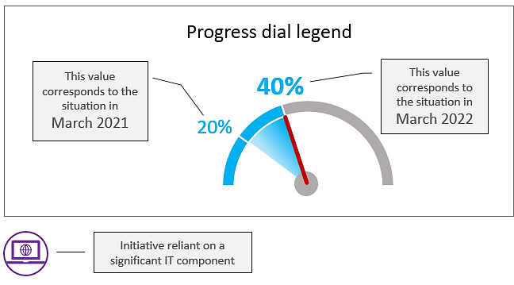

The values displayed in each dial are based on a self-assessment provided by each project team or by the entity responsible for it.

Appendix 2 – People Strategy (2019-2023)

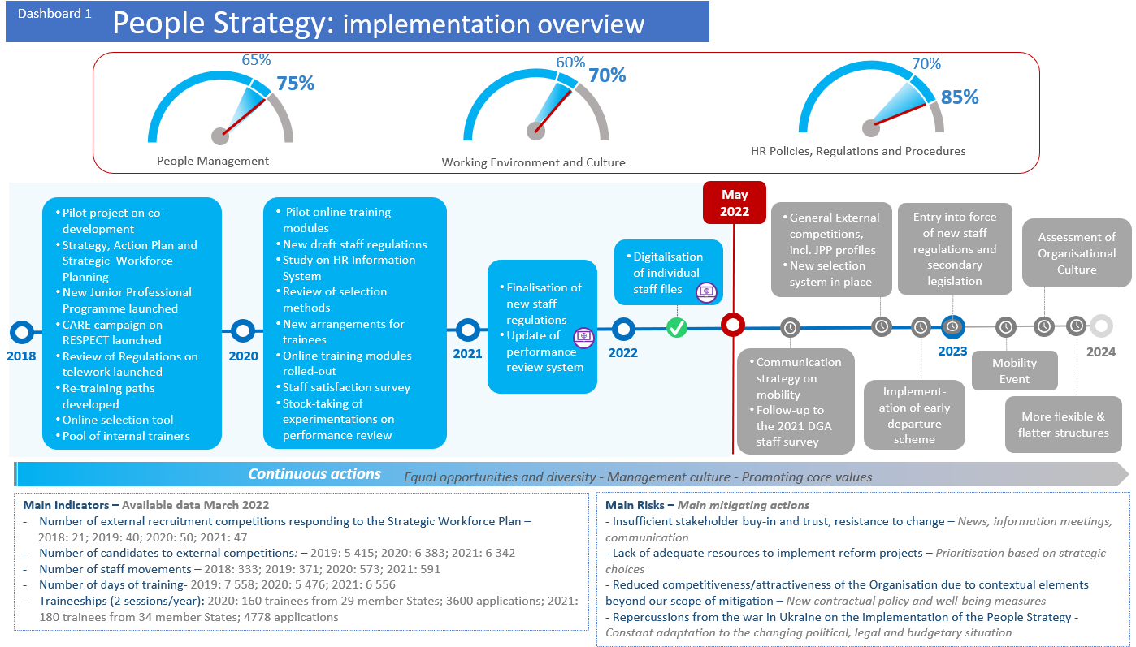

Appendix 3 : Digital transformation (2018-2022)

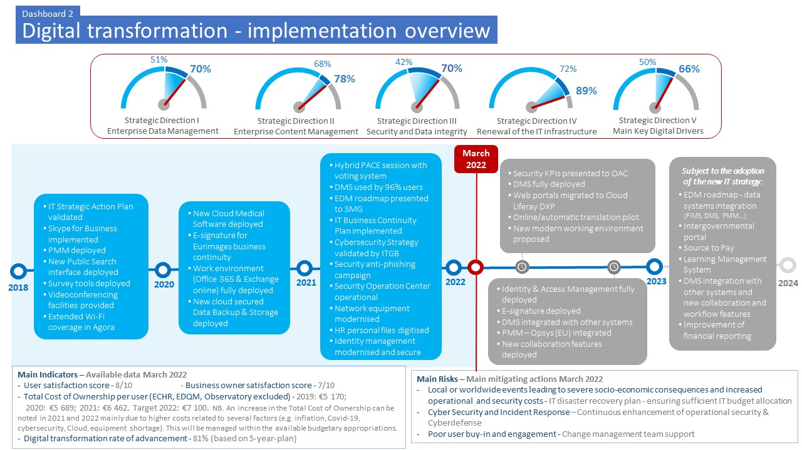

Specific initiatives and projects related to the digital transformation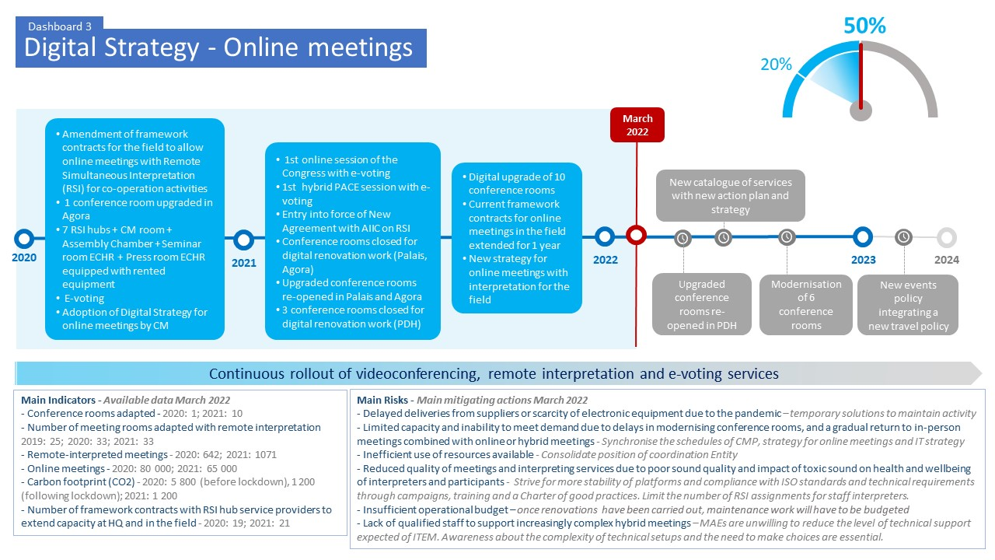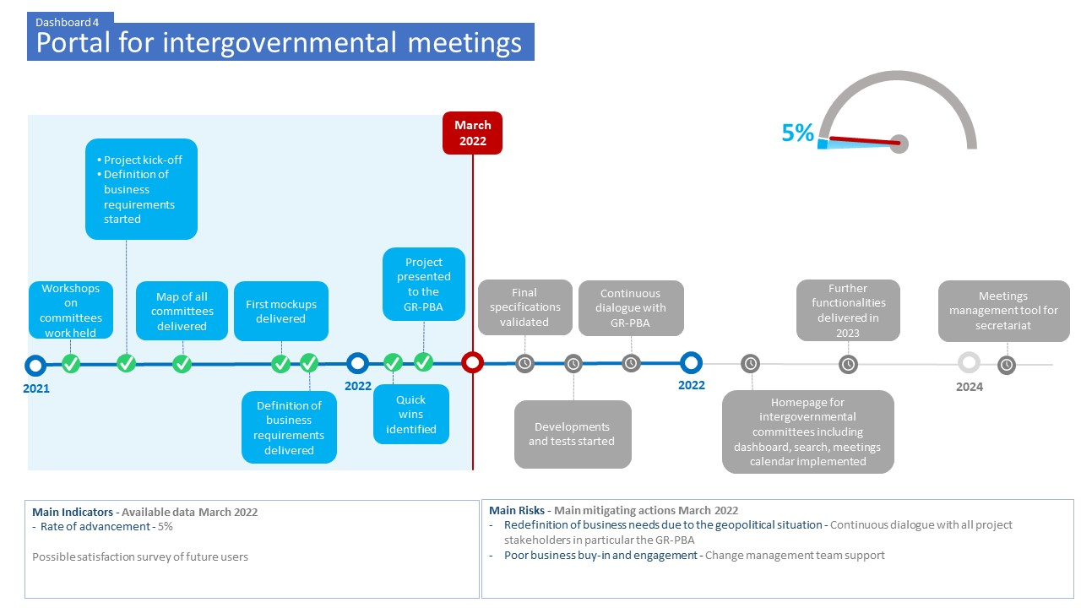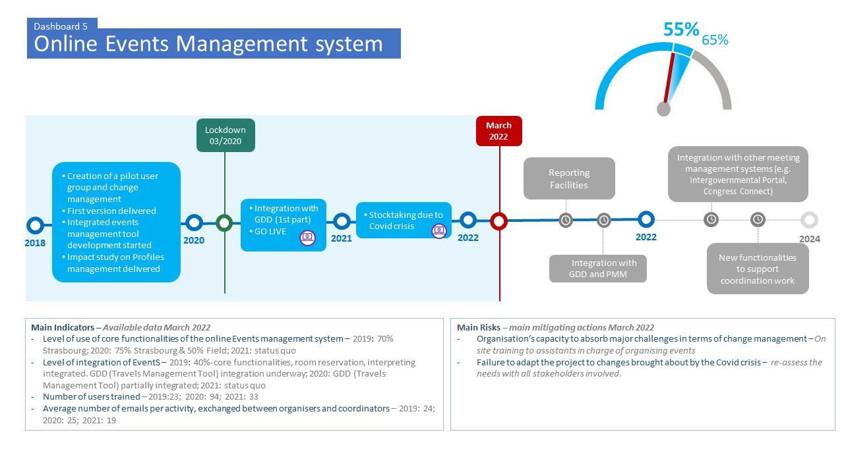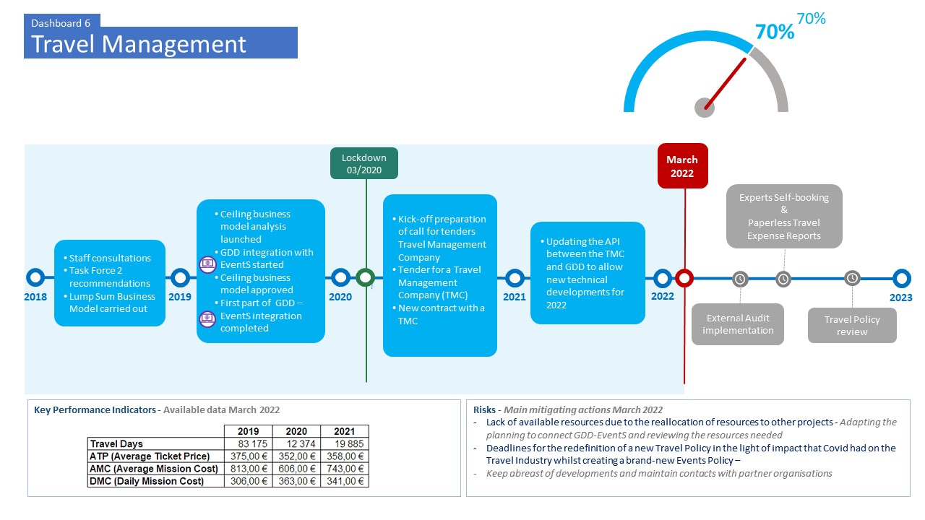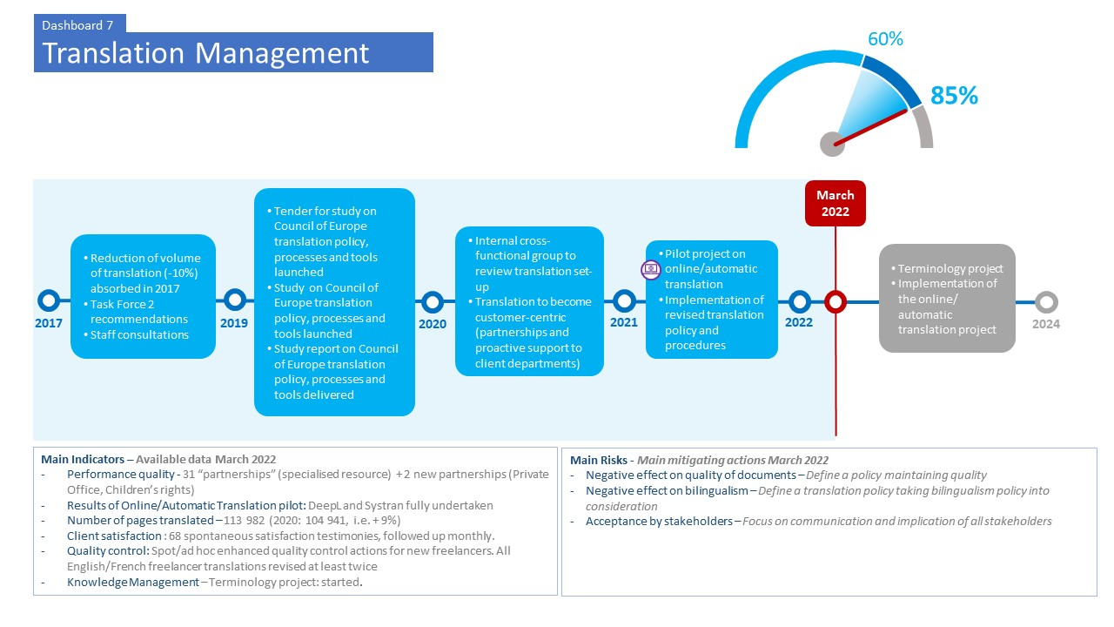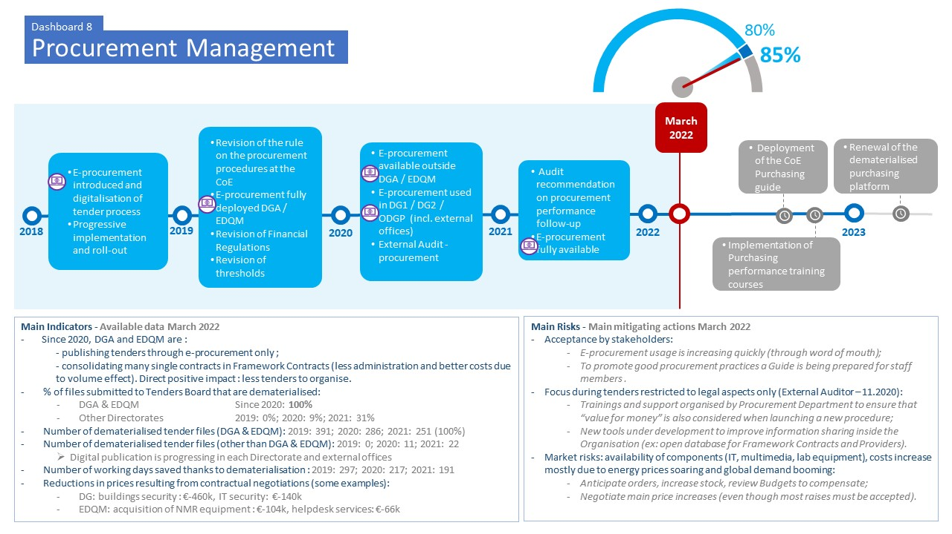

Appendix 4: Capital Master Plan

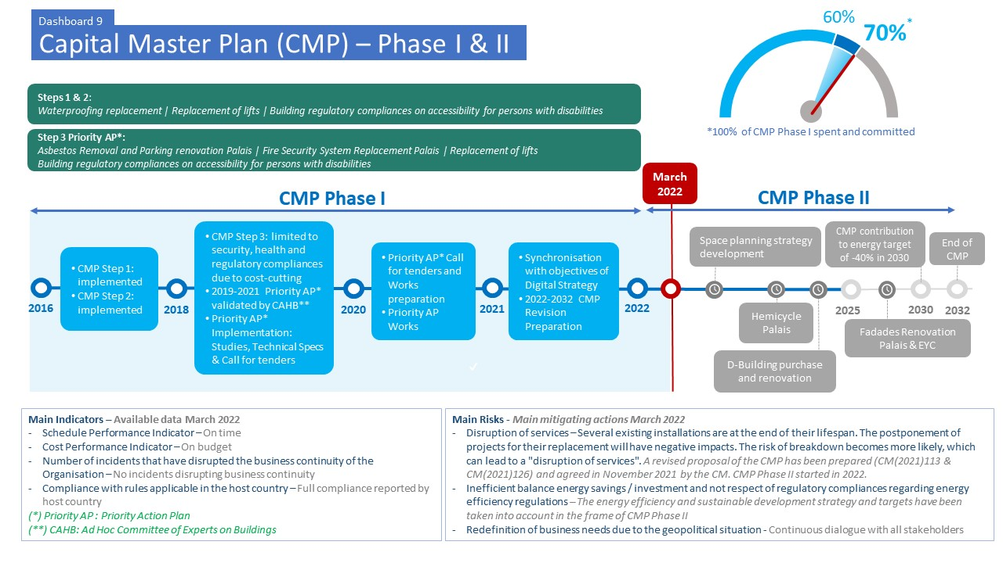

Appendix 5: Other initiatives and projects related to the reform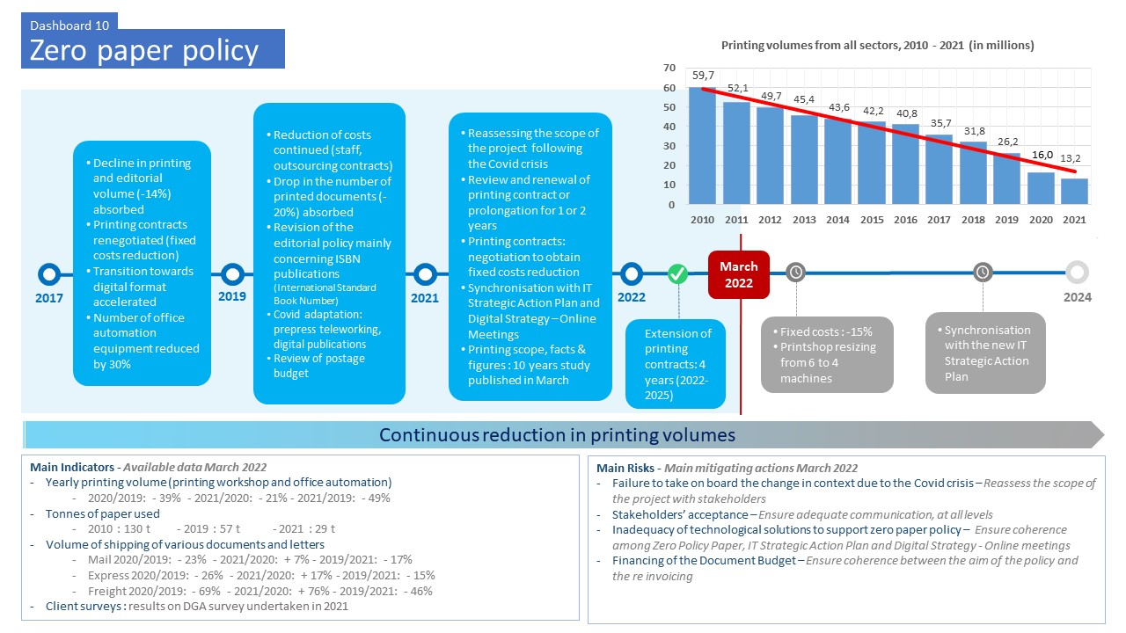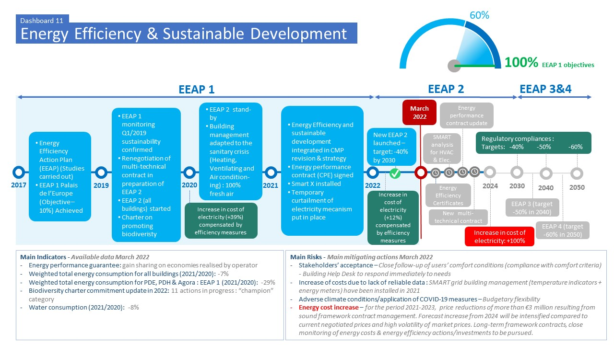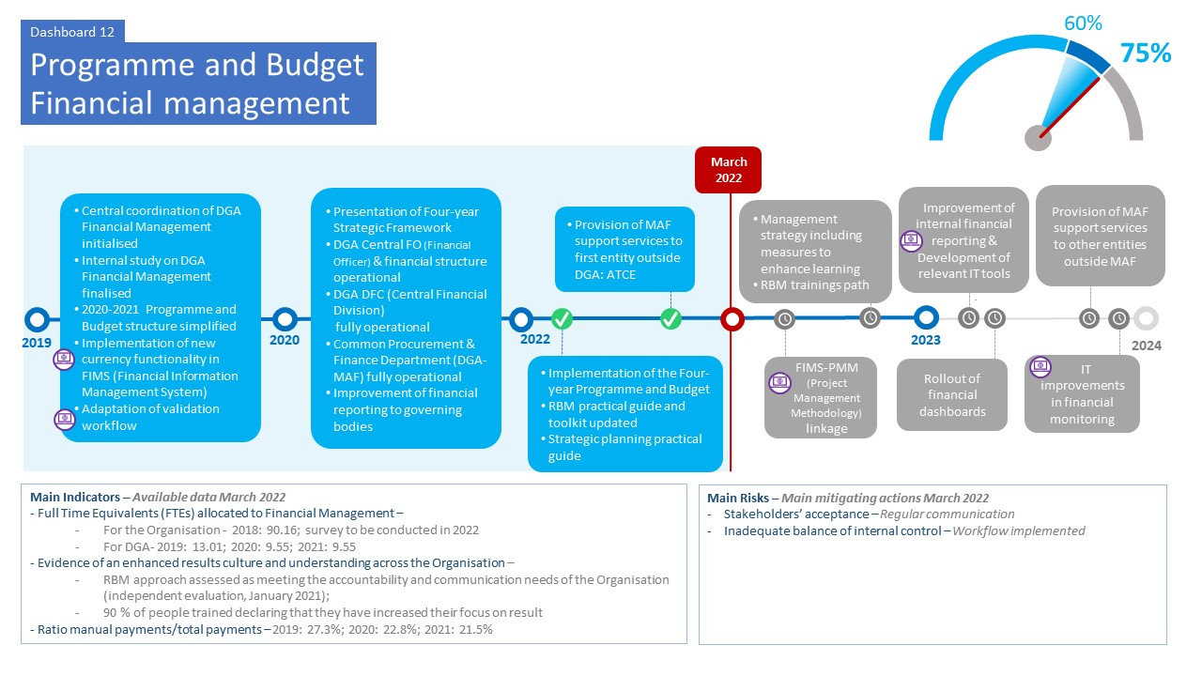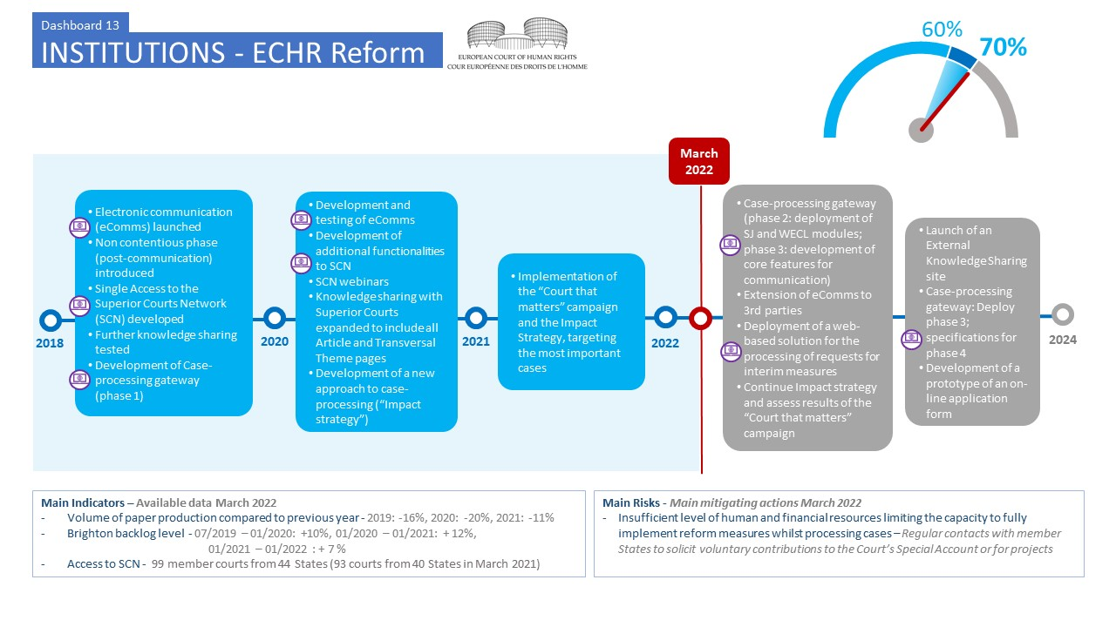

Appendix 6: Governance and compliance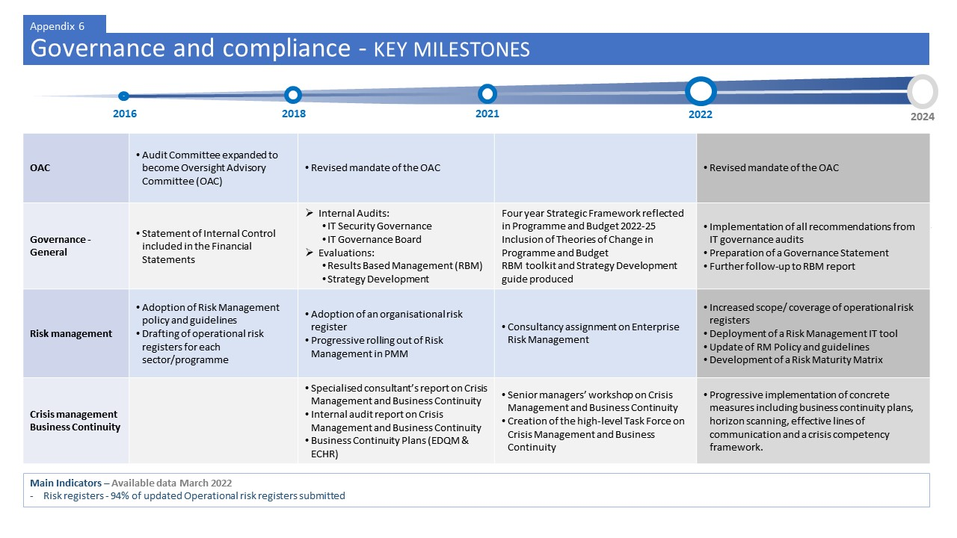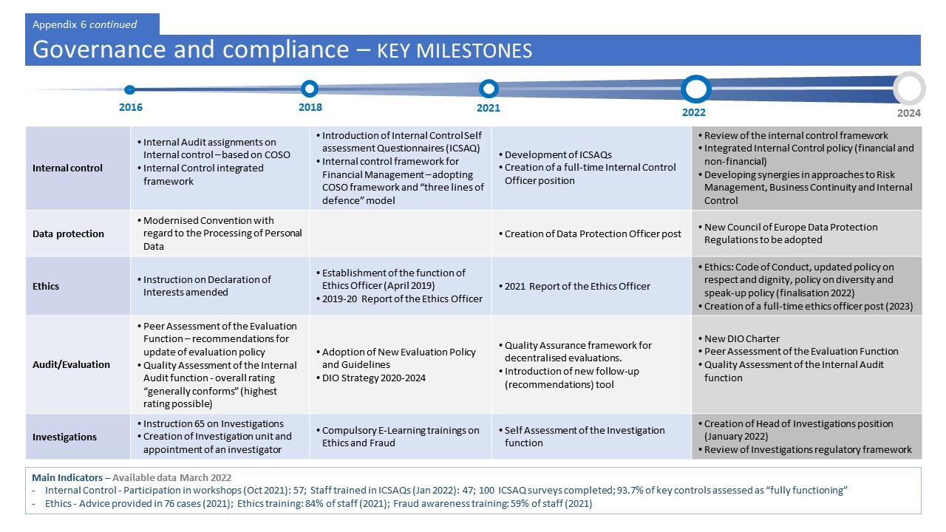

Appendix 7: Key Performance Indicators of the administrative reform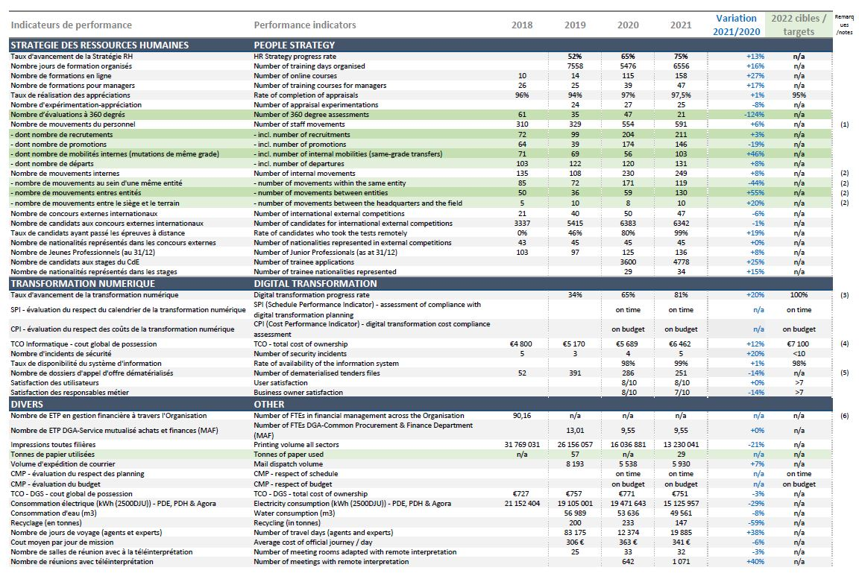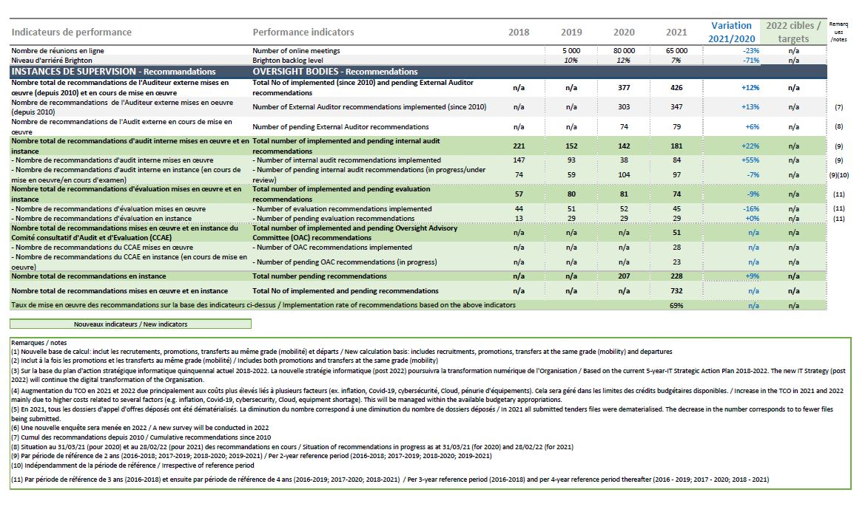

Appendix 8: Glossary of acronyms used in the dashboards

Appendix 8: Glossary of acronyms / Annexe 8 : Glossaire des acronymes
English |  | Français
AIIC | International Association of Conference Interpreters | AIIC | Association internationale des interprètes de conférence
API | Application Programming Interface | API | Interface de programmation applicative
ATCE | Administrative Tribunal of the Council of Europe | TACE | Tribunal administratif du Conseil de l’Europe
BC | Budget Committee | BC | Comité du Budget
CAHB | Ad hoc Committee of Experts on Buildings | CAHB | Comité ad hoc d'experts sur les bâtiments
CM | Committee of Ministers | CM | Comité des Ministres
CMP | Capital Master Plan | CMP | Schéma directeur immobilier
COSO | “Committee of Sponsoring Organisations of the Treadway Commission” (internal control framework) | COSO | « Committee of Sponsoring Organisations of the Treadway Commission » (référentiel de contrôle interne)
CPE | Energy Performance contract | CPE | Contrat de performance énergétique
DGA | Directorate General of Administration | DGA | Direction Générale de l’administration
DFC | Central Financial Division | DFC | Division financière centrale
DIO | Directorate of Internal Oversight | DIO | Direction de l'Audit interne et de l'Évaluation
DMS | Document Management System | DMS | Système de gestion des documents
eComms | Electronic communication | eComms | Communication électronique
EDM | Enterprise Data Management | EDM | Gestion des données de l’entreprise
EDQM | European Directorate for the Quality of Medicines & HealthCare | EDQM | Direction européenne de la qualité du médicament et des soins de santé
EEAP | Energy Efficiency Action Plan | PAEE | Plan d'action pour l'efficacité énergétique
EventS | Events Management Tool | EventS | Outil de gestion des événements

English |  | Français
EYC | European Youth Centre | CEJ |  | Centre Européen de la Jeunesse
FIMS | Financial Information Management System | FIMS |  | Système de gestion de l'information financière
FO | Financial officer |  | FO | Agent financier
FTE | Full-time equivalent |  | ETP | Equivalent Temps Plein
GDD | Travels management tool |  | GDD | Outil de gestion des voyages
ICSAQ | Introduction of Internal Control Self-Assessment Questionnaires |  | ICSAQ | Questionnaire d’auto-évaluation du contrôle interne
ITGB | IT Governance Board |  | ITGB | Conseil de gouvernance informatique
KPI | Key Performance Indicator |  | KPI | Indicateur clé de performance
MAF | Common Procurement and Finance Department |  | MAF | Service mutualisé d’achats et finances
NMR | Nuclear Magnetic Resonance. |  | RMN | Résonance magnétique nucléaire
OAC | Oversight Advisory Committee |  | CCAE | Comité consultatif d’Audit et d’Evaluation
PDE | Palais de l’Europe |  | PDE | Palais de l’Europe
PDH | Palais des Droits de l’Homme |  | PDH | Human Rights Building
PMM | Project Management Methodology |  | PMM | Méthodologie de gestion de projet
RBM | Results Based Management |  | RBM | Gestion basée sur les résultats
RM | Risk Management |  | RM | Gestion des risques
RSI | Remote Simultaneous Interpretation |  | RSI | Interprétation simultanée à distance
SCN | Superior Courts Network |  | RCS | Réseau des Cours supérieures
TCO | Total Cost of Ownership |  | TCO | Coût total de possession
TMC | Tender for a Travel Management Company |  | TMC | Appel d’offre pour une agence de voyage
ZPP | Zero-Paper Policy |  | ZPP | Politique zero papier

This document has been classified restricted until examination by the Committee of Ministers.
First progress report on reform measures: CM(2018)97 (July 2018): second report: GR-PBA(2018)16 (November 2018); third report: CM(2019)88 (June 2019); fourth report: CM(2020)84 (June 2020); fifth report: CM(2021)49 (April 2021).
Cf. SG/Inf(2020)34, CM(2021)38 and CM(2022)1 respectively.
Cf. CM/Del/Dec(2021)131/2a.
Cf. CM/Del/Dec(2021)1418/11.1-Part1 (paragraph 8d).
Cf. CM(2020)1.
Cf. CM(2022)1.
Cf. CM/Res(2021)6.
Cf. CM/Del/Dec(2022)1434/11.2.
The main Enterprise Data Management (EDM) systems of the Council of Europe - FIMS (the financial management system), PeopleSoft (the human resources and payroll management system) and the related line-of-business applications - contain much of the operational data that allows the Council of Europe to effectively manage budgets, activities and resources.
Enterprise Content Management (ECM) aims at moving towards an increasingly paperless Council of Europe. The objective is to provide users with systems that enhance productivity and enable better communication of the Organisation’s content, within an appropriate governance and data protection framework.
Cf. CM/Del/Dec(2021)1418/11.3.
Cf. CM(2022)1, page 13, paragraph 15.
Cf. SG/Inf(2020)34, page 5.
Cf. CM/Del/Dec(2021)1418/11.1-Part1 (paragraph 8h).
Cf. CM(2021)135.
Cf. CM(2022)38, paragraph 19.
Cf. Appendix 6 for the table of KPIs.
Cf. the corresponding dashboards in appendices for further information on each reform area.
Cf. CM(2021)49.
Cf. CM/Del/Dec(2021)131/2a.
Cf. CM/Del/Dec(2021)1418/11.1-Part1 (paragraph 8d).
Cf. CM/Del/Dec(2021)1418/11.1-Part1 (paragraph 8j).
Cf. DD(2022)28.
Cf. CM(2022)1, Appendix III.

