MINISTERS’ DEPUTIES | CM Documents | CM(2022)62-addfinal | 16 May 2022

132nd Session of the Committee of Ministers
(Turin, 20 May 2022)

Joint Programmes between the Council of Europe and the European Union in 2021 – Information document

- GENERAL DEVELOPMENTS

- Joint Programmes (JPs) between the Council of Europe and the European Union are an important expression of the EU-CoE partnership and mutual commitment to promoting democracy, human rights, and the rule of law at pan-European level and beyond. Since the Statement of Intent, signed in April 2014, Joint Programme co-operation has been following a strategic programmatic approach, which brought it to the current level. Three large-scale multiannual multi-country programmes (known as “regional programmatic facilities”) have been put in place in the EU Eastern Partnership area, in the EU Enlargement area and in the Southern Neighbourhood. The facilities have been complemented, where necessary, by country-specific and regional thematic interventions. Additionally, other important initiatives have been developed, including a structured co-operation framework, through which the CoE technical assistance is channelled to EU member States to facilitate the implementation of structural reforms. These co-operation modalities, conceived and fully operationalised during the EU multiannual financial cycle 2014-2020, are planned to continue in the EU multi-annual financial perspective 2021 - 2027.

- Similar to 2020, the year 2021 was largely marked by the unsettling circumstances of Covid-19 pandemic. With regard to Joint Programme co-operation, the Council of Europe continued to ensure business continuity, while respecting national sanitary measures. Work plans and working methods were largely adapted to face the challenges of the health crisis. Moreover, the pandemic-related restrictions triggered or accelerated innovation in some fields, especially in the area of IT-based solutions, in particular through hybrid events. Experience gained can be transferred to future implementation practice to a certain extent. On the other hand, for some activities, no adequate alternative solutions have been found. This concerns, in particular, the politically sensitive areas of co-operation, regional exchanges of best practices, study trips and certain type of training activities. The Council of Europe has sought to take advantage of all the windows of opportunity opened up by health improvements to implement these face-to-face activities. The flexible approach applied in the implementation of facility-type programmes in particular proved its value in reacting to the Covid crisis, as overall, activities were able to move online or were held in a hybrid format, and a good dissemination of information has been ensured. The mitigation measures applied allowed to reach some important results (for more information, see Section III).

- Throughout the pandemic period, the Council of Europe regularly informed the EU partners of the measures taken, the change in working methods and the results achieved. While the achievements in some areas could have been more prominent during the short periods of the health crisis’ lull, the substantial results achieved despite the circumstances demonstrate the commitment of the Joint Programmes beneficiaries. Enhanced co-ordination and communication between the Council of Europe and the European Union, both in headquarters and in the field, was indispensable.

- Whilst the Covid-19 pandemic posed challenges for the practical implementation of Joint Programmes, necessitating serious mitigation effort, it had no major far-reaching effects on the Joint Programme co-operation’s financial parameters – overall, the latter remained relatively stable (see statistical analysis in Section II). It should be noted, however, that the level of expenditure across Joint Programmes was lower than initially forecast, notably due to the reduced cost of online activities and the related low expenses for travel and event organisation. As a result of lower absorption, by common agreement, a number of programmes have been prolonged, with funding carry-over to 2022.

- Following the entry into force, in October 2020, of the new Financial framework partnership agreement (FFPA) between the European Commission and the Council of Europe, the contractual negotiations of new programmes have been unfolding seamlessly throughout 2021. The FFPA is a generic agreement on contractual, administrative, and financial aspects of EU-CoE programme co-operation, which is foreseen to remain in force during the EU multiannual financial cycle 2021-2027. Importantly, the FFPA heralds the shift at greater scale to a particular EU implementation mode - the so-called “indirect management” - whereby the Council of Europe becomes a partner entrusted with the implementation of EU budget.

- To accompany the development of Joint Programme co-operation, the Council of Europe continued to upgrade its project management capacity and dedicated IT tools: training for project teams in the CoE project management methodology (PMM) continued and the PMM IT tool’s imbrication with the CoE financial management system has been further advanced. In the context of digitalisation of the Joint Programme reporting processes, creation of a data transfer mechanism between the CoE PMM IT tool and the EU electronic exchange system OPSYS, agreed under the FFPA of October 2020, remains the main challenge and requires particular attention.

- Transversal dimensions were further strengthened, in particular regarding the human rights approach, gender mainstreaming and support to the UN 2030 Agenda for Sustainable Development. The gender dimension was mainstreamed into co-operation activities in line with the CoE Gender Equality Strategy 2018-2023 and using the Gender Mainstreaming Toolkit for co-operation projects. Trainings for project teams on gender mainstreaming in co-operation continued. The UN 2030 Agenda for Sustainable Development has been highly relevant for the Council of Europe with its global and overarching political approach. Starting with 2018-2019, the Council of Europe programme and budget started to indicate, where relevant, the link between the Organisation’s sector and programmes and the specific Sustainable Development Goals (SDGs). SDGs apply universally to all and are highly relevant for the Council of Europe. Countries are expected to take ownership and establish national frameworks for the achievement of the 17 goals. Most, if not all of the Council of Europe’s activities, and notably Joint Programmes between the Council of Europe and the European Union, are relevant and contribute to the implementation of the UN 2030 Agenda and the achievement of the SDGs. Extra-budgetary contributions primarily supported SDG-16 “Peace, justice and strong institutions”. They also contributed to the achievement of SDG-1 “No poverty”, SDG-3 “Good health and well-being”, SDG-4 “Quality education”, SDG-5 “Gender equality”, SDG-8 “Decent work and economic growth”, SDG-10 “Reduced inequalities”, SDG-11 “Sustainable cities and communities” and SDG-17 “Partnerships for the goals”. Another cross-cutting dimension to be mentioned is the fight against climate change and for the protection of environment. While the Council of Europe co-operation sector has an indirect positive impact on the environment through its support to countries in strengthening their good governance structures and thus enabling them to deal more effectively with their environmental challenges and goals, the Council of Europe co-operation sector strives to increase its action in this area.

II. STATISTICAL ANALYSIS

- 57 Joint Programmes were under implementation in 2021, with a Cumulative budgetary envelope (CBE) of €207.4 million. The EU’s share of the co-financing represented 86.7 % of CBE 2021 (€179.9 million) and the CoE’s - 13.3% (€27.5 million). On average, forty-eight programmes, worth €195 million, were active at any given moment of the year. The full list of programmes under implementation in 2021 can be found in Appendix I.

- The annualised envelope (Annual budgetary envelope prorated (ABE)) reached €56.1 million. The amount of EU payments under Joint programmes registered between 1 January and 31 December 2021 (JP Annual receipts) amounted to €36.5 million, corresponding to 57% of the total revenue from all extra-budgetary contributions in 2021. The EU remains the largest donor to the CoE co-operation and technical assistance activities.

- Negotiations for 15 new programmes were completed in 2021 for a total of €23.4 million (the list of new programmes is presented in Appendix II). Most of these programmes were launched in 2021, with few programmes being differed to early 2022. Taking into account the programmes signed in 2020 with start in 2021, the total of the new injections in Joint Programme co-operation amounted to € 27.4 million.

- Overall, the financial situation of Joint Programme co-operation remained stable. Whilst CBE increased in 2021, this increase was attributable not only to the new injections in Joint programme co-operation but also to the programmes’ budgets carry - over to 2021 through programme prolongations from 2020 (“no-cost-extensions”). Importantly, the annualised envelope (ABE 2021) remained quasi-stable, staying at the historically high level. As was anticipated in the annual report 2020, the most notable effect of the pandemic was the decrease in the JP Annual receipts (decrease by 16.9% compared to 2020). Annual receipts are highly dependent on the programmes’ absorption capacity, which was affected by the two consecutive years of the sanitary restrictions. Although the mitigation measures adopted by the Council of Europe were timely, flexible and ensured continued implementation of Joint Programmes, the level of expenditure across Joint Programmes was lower in 2020-2021 than initially forecast, mainly due to the reduced cost of online and hybrid activities and the related low expenses on travel and event organisation. On average, the programmes’ absorption decreased by 24.5% compared to the pre-pandemic situation. Hence, the payments (that are conditioned by contractual absorption threshold) were lower in 2021. Also, as a result of lower absorption, a number of programmes had to be prolonged through no-cost-extensions, with the funding’s carry-over to 2022. In turn, fewer new programmes were signed, which led to a reduced number of first pre-financing payments. On the positive side, these developments are not considered to be indicative of any tangible negative dynamic expected to last, but rather are a direct result of a temporary strain imposed by the pandemic crisis 2020-2021. Follow-up phases of the main facility-type programmes are under negotiation, and the dynamic of the Annual receipts is expected to redress in 2023 at the latest.

- The charts below show the evolution in the global financial volume of Joint Programme co-operation, its annual pro-rated envelope, the EU-CoE ratio of co-funding and JP Annual receipts over last ten years.

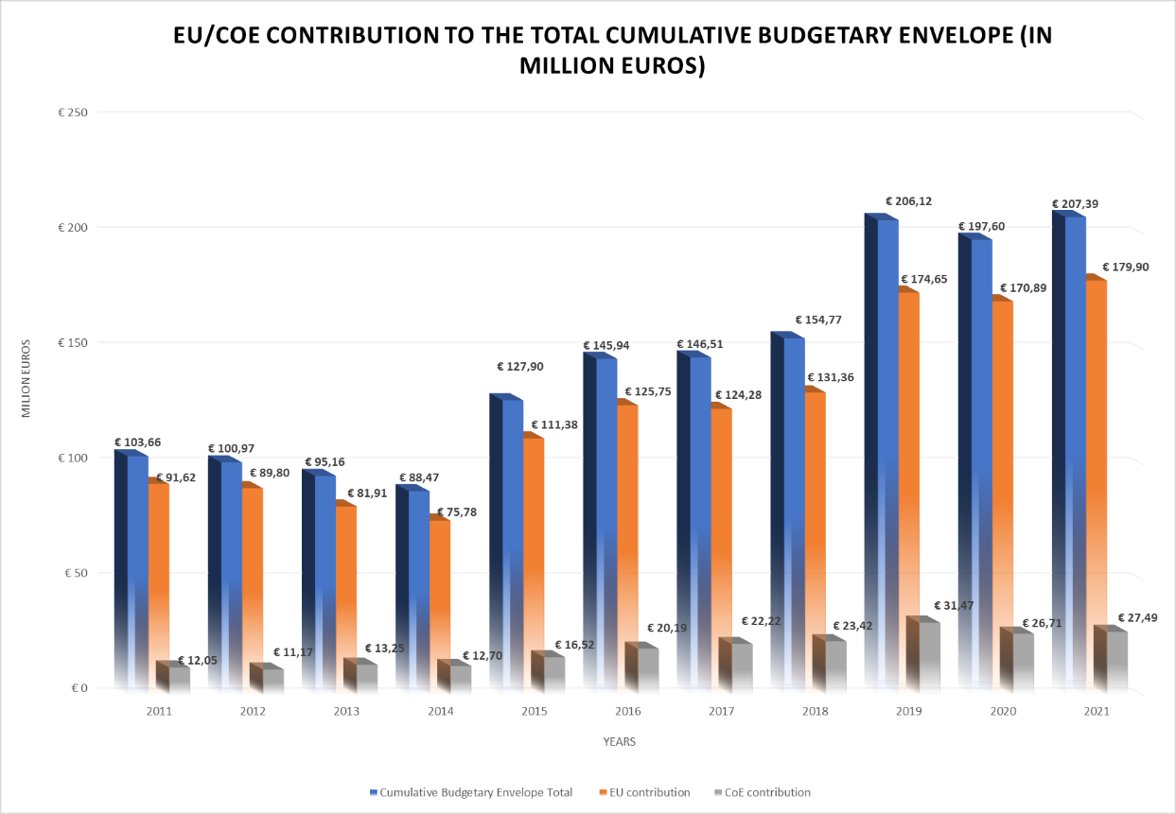
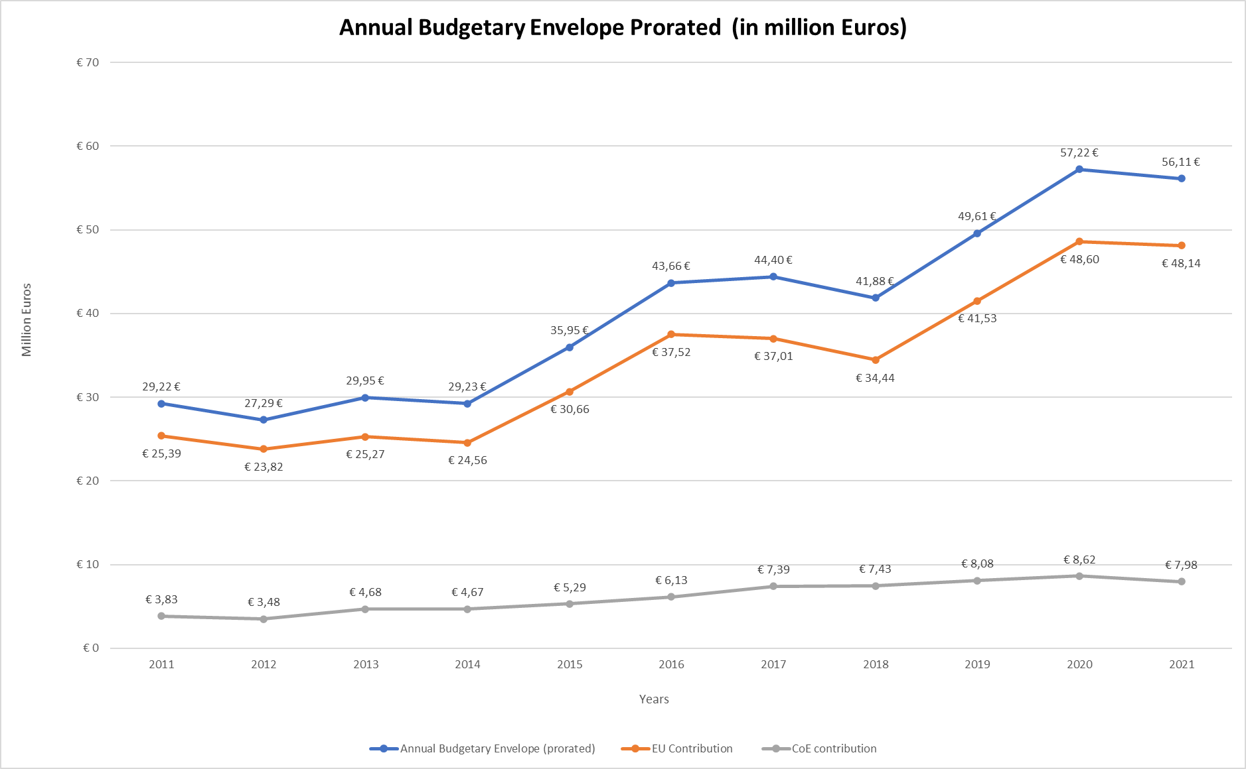

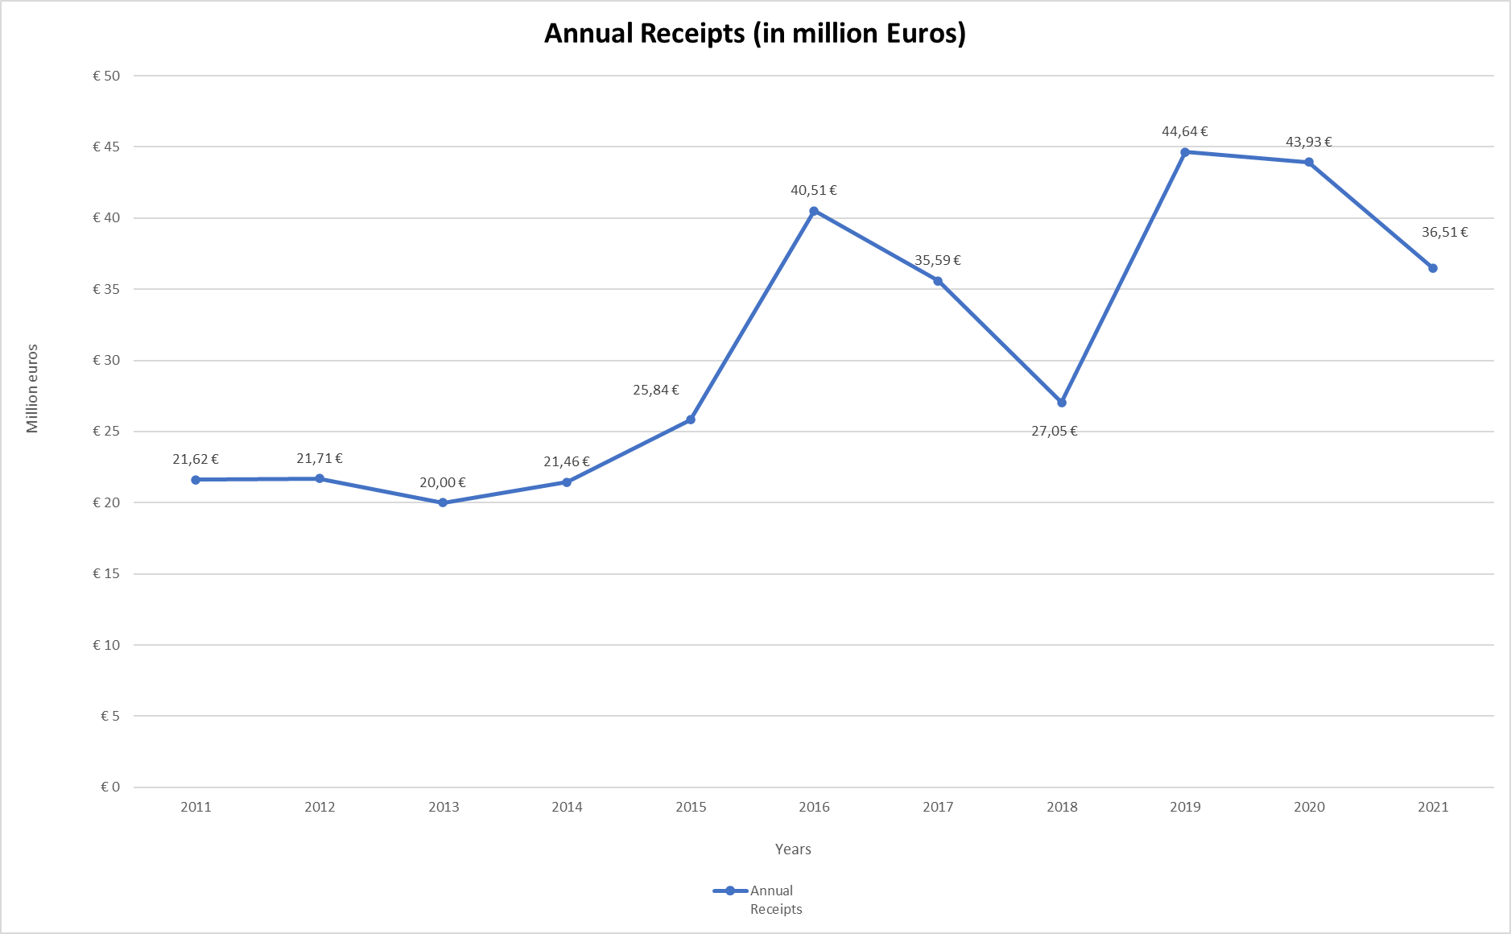

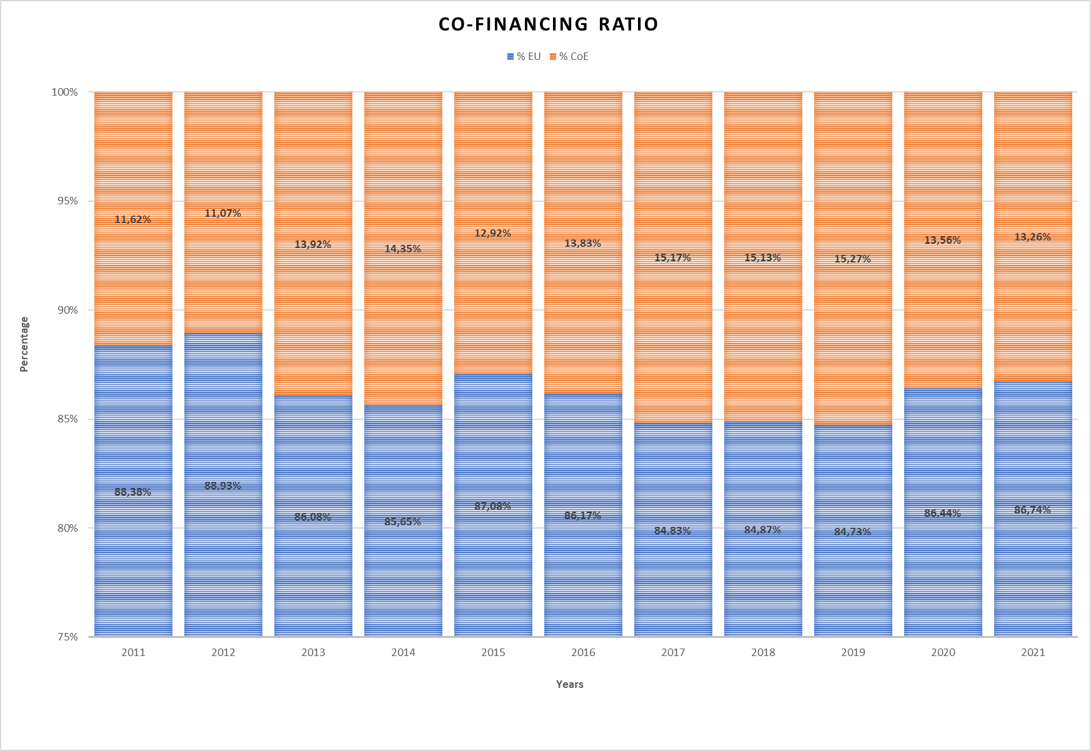

- In terms of geographical distribution, no substantial changes can be reported compared to 2020.

- Consistent with the long-standing trend, more than half of the Joint programmes global financial envelope was being channelled to co-operation in South-East Europe, Turkey, Eastern Europe and the South Caucasus (60% of CBE 2021; total €125 million; €33.8 million in annualised figures). In the Eastern Partnership and South-East Europe areas, the EU-CoE geographical programmatic Facilities (“Partnership for the Good Governance” and “Horizonal Facility for the Western Balkans and Turkey” respectively) remained the main channel of co-operation and technical assistance, complemented by certain number of individual Joint programmes, regional and country-specific. Whilst Turkey is part of the corresponding programmatic facility (with four on-going projects, including one launched in 2021 to further strengthen women’s access to justice) the large-scale co-operation continued here primarily on the basis of country-specific funds (nine active programmes, including a new one, signed in 2021, on the implementation of Turkish Constitutional Court’s judgments in the field of fundamental rights). As regards the Russian Federation, co-operation on the implementation of the national action strategy for women (2017-2022) continued, with the signature in September 2021 of a new programme. Information on the Facilities’ developments and full account of the programmes under implementation in both regions is presented under Section III and in Appendices I and II, however, it is opportune to mention here some programmes launched in 2021, namely the phase II of the sizable JP ROMACTED, a regional programme to improve local democracy, accountability, inclusiveness and responsiveness towards Roma citizens (in the Enlargement area) and JP “Justice Dashboard”, a regional programme supporting the evaluation of the results of the judicial reforms (in the countries of the Eastern Partnership). Moreover, the negotiations of an important new programme for Serbia, aimed at supporting the implementation of judicial reform, were finalised in December 2021, with the programme starting in January 2022.

- As regards co-operation with non-member States in the Southern Mediterranean and Central Asia, under the CoE Policy towards Neighbouring Regions, its share remained stable (15% of CBE 2021; total €30.6 million; €8.2 million in annualised figures). In the South Neighbourhood, the co-operation architecture continued to be composed of the core regional demand-driven South Programme (in its phase IV), regional programme CyberSouth (fight against cybercrime), two country-specific programmes in Tunisia (assistance to the reform of the justice system and support to the independent instances) and one two-strand programme in Morocco (focused on the role of the Parliament and on National preventive mechanism against torture). In Central Asia, the co-operation continued to be implemented through the large-scale regional programme EU/CoE “Central Asia Rule of Law Programme”. The region also benefits from the Venice Commission’s assistance in the electoral field, within the framework of a dedicated programme covering also Mongolia and Latin America. For more information, including on individual programme envelopes, see Section III and Appendix I.

- Importantly, the financial volume of the JPs implemented in those CoE member States which are member States of the EU continued to steadily increase (13% of CBE 2021; total: €26.9 million; €8.7 million in annualised figures). This development is due primarily to the structured co-operation with DG Reform, in place since 2019. In 2021, three framework agreements were being implemented, encapsulating more than 20 projects in numerous EU member States (Croatia, Cyprus, Estonia, Finland, Latvia, Lithuania, Malta, Portugal, Romania, Slovenia, Spain, the Czech Republic, the Slovak Republic). The thematic scope of these projects encompasses a number of areas of CoE expertise, including various aspects of judicial reform (modernisation of the judicial system, efficiency of justice, access to justice and others), fight against economic crime, money-laundering and terrorist-financing, strengthening local governance, and children rights. The development of the fourth framework programme started in autumn 2021, with signature expected in early spring 2022. Additionally, three individual programmes with DG REFORM continued in parallel: in Greece (on good governance; completed by mid-2021), in Bulgaria (on the fight against money-laundering and terrorism financing) and in Romania (EDQM-implemented project on reorganisation of the blood transfusion system). Additionally, one new programme was signed in mid-2021 for Cyprus (on intercultural integration). Moreover, co-operation and technical assistances activities towards EU member States continue to expand through programmes co-funded by DG JUST (inter alia HELP-based training programmes; launch of the new programme in the field of Rights of the Child), by DG HOME (new programme on unaccompanied minors, starting in early 2022), by DG EMP (on Roma inclusion, well established continued co-operation) and DG Education and Culture (inter alia on inclusive education, children in sports, language learning). For more information, see Section III and Appendices I and II.

- It is worth noting that the EU member States were also actively involved in thematic multilateral programmes, such as European Heritage Days, Youth Partnership, SPACE report and National Preventive Mechanisms, and the North-South Centre-managed programme i-LEGEND -II (“Intercultural learning exchange through global education, networking and dialogue”). Overall, the share of thematic multilateral programmes remained stable (12% of CBE 2021; total €24.8 million, €5.3 million in annualised figures), mainly due to the continuation of the JP GLACY +, the largest stand-alone programme of the CoE and a major undertaking in the field of action against cybercrime, implemented worldwide in collaboration with Interpol. For more information, including on individual programme envelopes, see Appendices I and II.

- The chart below shows the geographical distribution of Joint Programme co-operation in 2021.

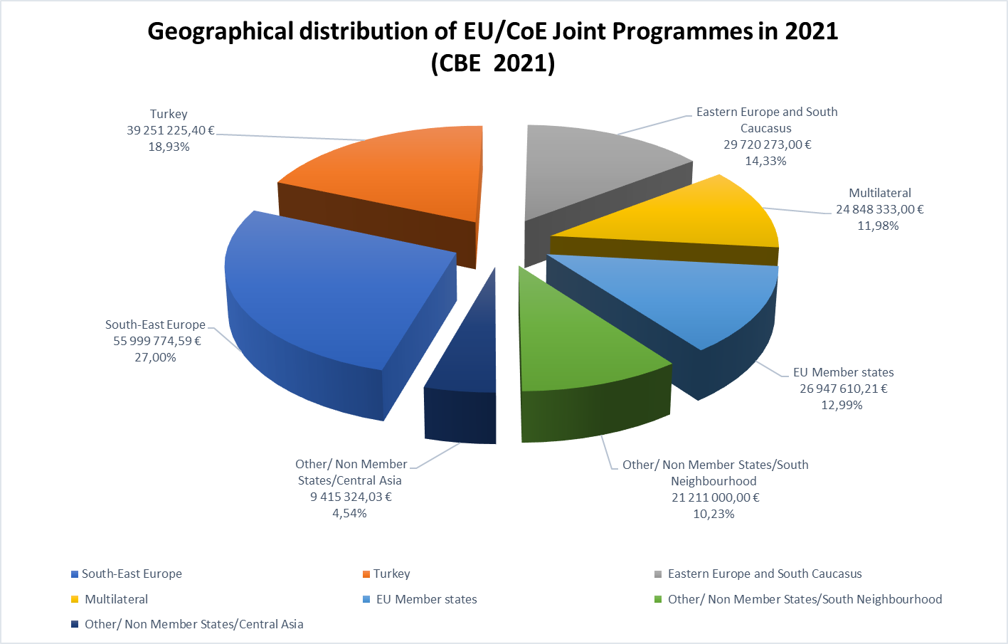

- Joint Programmes’ thematic distribution 2021 confirms the trend of the previous years:

- Programmes of the Rule of Law pillar continued to prevail in number and volume, accounting for 54.7% of CBE 2021 (total: €113.5 million). These programmes are implemented over a wide range of areas of CoE expertise, including fight against cybercrime, corruption, money-laundering and terrorism financing, support for judicial and penitentiary reforms, information society/internet governance, assistance activities of the Venice Commission etc.

- The share of the Human Rights pillar’s programmes continued to increase (33.7% of CBE 2021; total: €69.8 million). The bulk of this funding continued to be channelled into enhancing the effectiveness of the ECHR system at national and European levels and into actions for Roma empowerment and inclusion. The remainder was attributed to programmes and projects on anti-discrimination, protecting the rights of persons belonging to national minorities, equality and human dignity, and children’s rights.

- The share of the Democracy pillar’s programmes decreased to 11.6% (total: €24.1 million). The bulk of these programmes falls under Education for democracy.

- The chart below shows the thematic distribution of Joint Programmes in 2021.

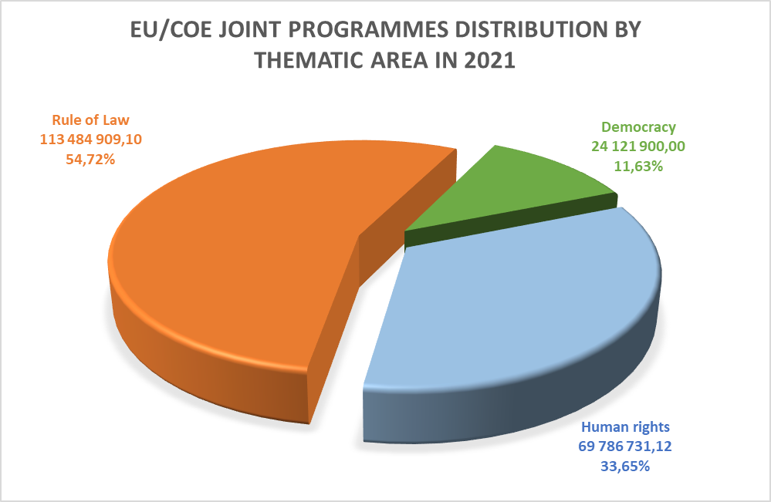

- In terms of funding instruments, the bulk of JP co-operation was funded through the EU instruments of External Action (with a high preponderance of the Instrument of Pre-accession (45.9%), followed by the European Neighbourhood Instrument (24.3%)). A number of other funding programmes and instruments were involved, with their individual shares remaining under 10%.

III. ACHIEVEMENTS OF JOINT PROGRAMME CO-OPERATION

- This section presents, in brief, the achievements of Joint Programme co-operation by geographical area, with a particular focus on the results of the corresponding regional “programmatic facilities”. It also describes other major co-operation undertakings such as the Central Asia Rule of Law Programme, co-operation framework with DG REFORM in EU member States and country-specific co-operation in Turkey.

- Partnership for Good Governance (PGG)

The Partnership for Good Governance for the Eastern Partnership (EaP), which encompasses Armenia, Azerbaijan, Georgia, the Republic of Moldova, Ukraine and Belarus, was the first EU-CoE “programmatic facility” to be put in place in 2015. Its second phase (total €17.5 million) started in 2019 and continues to provide tailor-made support to the national reforms in the framework of Council of Europe country-specific Action Plans, also contributing to the achievement of the EU 2020 Deliverables. The PGG includes a number of country-specific and regional projects organised under three themes: i) strengthening the Rule of Law and mechanisms to combat corruption, money-laundering and terrorist financing; ii) implementation of key judicial reforms and iii) combating discrimination and protecting the rights of vulnerable groups and women (cross-cutting issues).

The PGG regional dimension has shown a strong added value and has contributed not only to enhancing regional interaction and networking, but also to the transfer of knowledge and expertise among the EaP countries. The Quick Response Mechanism (QRM) channels CoE legal expertise, and in particular the expertise of the Venice Commission, to the beneficiary countries as a form of direct support to the legislative reforms in the field of electoral reform, referendums and political parties, functioning of democratic institutions, and constitutional and ordinary justice. The scope of expertise under the QRM has been extended to other Council of Europe bodies and a first expert opinion in the area of freedom of expression and freedom of the media was provided by the Directorate of Human Rights and Rule of Law for Armenia with the analysis of a draft law on Mass Media in 2021. The Quick Response Mechanism (QRM) has proven its added value in the context of PGG with 29 Opinions delivered since the start of the PGG II in 2019. 10 Opinions were delivered in 2021 at the request of national institutions in Armenia (2), Georgia (5), the Republic of Moldova (1) and Ukraine (2)).

A non-exhaustive list of the results includes:

- Improvement of the legislative framework in the field of anti-corruption and money laundering in Armenia, Azerbaijan, Georgia and Ukraine.

- Reinforcing the national institutions’ capacity to fight against corruption and money laundering in Azerbaijan, Georgia and Ukraine and strengthening mechanisms for regional co-operation among corruption prevention bodies at regional level, notably on seizure and confiscation of proceeds from crime.

- Adoption of relevant legislation in the field of criminal law, functioning of the judiciary, enforcement of the court judgments and strengthening the international co-operation in criminal matters in Armenia, Azerbaijan and Georgia.

- Reinforcing the capacity of the judicial supreme bodies in Armenia and Georgia, improvement of the court management and enforcement systems in Azerbaijan and the Republic of Moldova in line with the tools and methodology of the Council of Europe Commission for the Efficiency of Justice (CEPEJ).

- Enhancing the regional network and co-operation for lawyers and bar associations in the EaP region by launching a website as an information tool and a forum for addressing mutual issues.

- Improvement of the legal framework in the field of anti-discrimination in Armenia, Azerbaijan and the Republic of Moldova and further consolidated capacity of the Ombudsperson’s offices and Equality councils in the EaP region to effectively fight against discrimination.

- Promotion of multi-stakeholder comprehensive approach in combating hate speech across the region and boost of the engagement and awareness raising of the civil society on combating discrimination, hate crime and hate speech in Armenia, the Republic of Moldova and Ukraine through the launching of five grants under the PGG Programme.

- Improvement of the national legislation in Armenia, Georgia and Ukraine and in line with the Council of Europe standards and empowerment of the national institutions to effectively combat domestic violence. The Republic of Moldova ratified the Istanbul Convention and reviewed the national legislation to comply with the European standards.

The PGG II was extended until August 2022. Negotiations are under way with the EU for a further extension until February 2023 as well as on the PGG phase III.

In complementarity and synergy with the PGG, three country-specific programmes were also running. The Joint Programme “EU and CoE working together to protect human rights in Ukraine” (total: €3 million; launched in 2019) provides support to the Ombudsperson/National preventive mechanism and in the areas of media freedom and penitentiary reform. The programme was extended at no additional costs from July 2021 to April 2022. In 2021, the programme has contributed to the selection of the independent new members of the Supervisory Board of the Ukrainian public broadcaster, advised on best practices for state financial support to the local print media and to building law enforcement capacity to protect journalists.

It also provided legal advice on data protection, enhanced capacity of the national training institutions to deliver courses on countering ill-treatment and assisted in monitoring psychiatric institutions. In addition, the programme assisted in capacity building of prison staff to prevent and counter ill-treatment, improve prisons conditions and enhance social rehabilitation of offenders,

In Azerbaijan, the Joint Programme “Further support to the penitentiary reform” (total: €0.8 million) was finalised in October 2021. In the framework of the programme, action plans on prison management and prison healthcare were revised, approved and launched by the national authorities; new tools and practices were developed and introduced in the pilot prisons. Prison personnel in the pilot prisons increased their knowledge and capacities on medical examination upon admission; identification, documentation and recording of injuries; mental healthcare; preventing and handling aggression in the prison context; prison management. In the area of reintegration of prisoners, four grants were awarded to three NGOs working on providing vocational training, business mentoring, legal aid and psychological support. As a result of their work, 122 released persons enhanced their professional skills, 11 persons found jobs, 16 businesses were established, 342 released persons received legal aid, 398 released persons received psychological support.

A new regional Joint Programme “Support for a better evaluation of the results of judicial reform efforts in the Eastern Partnership/Justice Dashboard EaP” (total: €2.2 million) started in early 2021. It aims at achieving an effective, systematic and data-based evaluation of the results of judicial reform efforts in the Eastern Partnership countries through the annual collection and processing of data on the functioning of judicial systems and relevant capacity-building. In 2021, during the first exercise of data collection under the EaP Dashboard, the CEPEJ Secretariat provided hands-on assistance and expertise to CEPEJ national correspondents engaged in completing the questionnaire in CEPEJ COLLECT. This technical expertise delivered according to the CEPEJ methodology assists in building the capacity and skills of national counterparts related to judicial statistics and judicial data collection. The CEPEJ Secretariat completed the first round of the data Quality Check in line with the CEPEJ methodology in December 2021.

- Horizontal Facility for the Western Balkans and Turkey (“Horizontal Facility - II”)

The Horizontal Facility for the Western Balkans and Turkey (Horizontal Facility or HF) is the second EU-CoE “programmatic facility”, operating since 2016. The second phase currently implemented (total: €41 million; launched in mid-2019) encompasses four thematic fields, namely i) ensuring justice; ii) the fight against corruption, organised crime and economic crime; iii) anti-discrimination and the protection of the rights of vulnerable groups; and iv) freedom of expression and freedom of the media. The second phase of the HF follows a complementary two-fold approach, combining technical co-operation tailored to help the beneficiaries in achieving increased compliance with European standards with the provision of Council of Europe expertise to respond to requests from HF Beneficiaries for legislative analysis and policy advice. In 2021, the Horizontal Facility was extended until 31 December 2022 allowing also for some adjustments of the actions’ individual budgets.

The Facility covers 47 actions (projects), out of which nine are regional. CEPEJ provides support to the European Commission in achieving an effective, systematic and data-based evaluation of the results of judicial reform efforts in the Western Balkans. The regional dimension of the programme also includes countering terrorism and violent extremism through support aimed at enhancing regional security by addressing radicalisation in prisons and disengaging radicalised prisoners from violence. The actions were designed based on findings of the Council of Europe monitoring bodies and are also tightly linked to the relevant EU accession priorities. The Horizontal Facility operates an Expertise Co-ordination Mechanism (ECM), which delivers ad-hoc legal expertise and policy advice upon request, an instrument that has proven its added value. In addition, expertise is provided upon the requests of the Beneficiaries under the technical co-operation part of HF when such requests fall within the scope of the ongoing actions (only in 2021 the Council of Europe provided legal or policy expertise in over 200 instances). The implementation methodology is based on the coherent integration of the CoE “dynamic triangle” (standard-setting, monitoring, co-operation), a stringent results-based approach, strengthened human rights and gender dimensions and increased involvement at local level, engagement of civil society and improved communication (including in local languages) to better reach out to citizens.

In 2021, a mid-term evaluation conducted for HFII found that numerous, concrete outcomes were achieved in the improvement of legislative and policy frameworks and in the strengthening of beneficiary institutions’ capacities to execute their mandates in line with CoE recommendations and EU standards. It provided valuable recommendations for the implementation of the second phase of the Horizontal Facility Programme, which will feed into the preparation of its third phase.

A non-exhaustive list of the results which have been achieved so far includes:

- Establishment of a Helpline in Albania to support the process of registration of land property, providing valuable information and guidance to citizens, with a particular focus on women owners;

- Adoption in Albania of the Law on “Foreign Jurisdictional Relations”, the Law “On Notary” and the Electoral Code’s by-laws prepared with the Council of Europe’s assistance;

- Launch in Kosovo* of a new online service allowing citizens to apply for criminal record certificates and increasing their access to justice especially in the time of the pandemic;

- Adoption in North Macedonia of the amendments to the Law on Registry concerning Legal Gender Recognition;

- Wide-reach awareness-raising campaign in North Macedonia for Free Legal Aid, with a special focus on women, children, and vulnerable groups;

- Revision in Serbia of the Rules of Procedures of the High Judicial Council and the State Prosecutorial Council allowing judges and prosecutors to report undue influence from politicians, media, or business;

- Recommendations provided by the Council of Europe on the amended Anti-discrimination Law as well as on the new Law on Gender Equality and taken into account in the adopted legislation;

- In Montenegro, adoption of the new Code of Notary Ethics and the Code of Ethics of Court Interpreters and Translators with the support of the Council of Europe;

- Launch in Montenegro of the legal clinic on human rights improving access to free legal aid services for disadvantaged and marginalised groups;

- Launch of the local No Hate Speech campaign ‘Block the Hatred; Share the Love’ in Kosovo*, Montenegro and North Macedonia;

- In the region, launch of the third cycle of data collection on the platform CEPEJ Collect;

- Regional assessment of corruption risks in public procurement practices, including a comprehensive legal mapping of procurement-related laws in the region;

- As regards the ECM, assistance was provided to Albania, Bosnia and Herzegovina, Kosovo*, Montenegro, North Macedonia and Serbia in the areas of gender equality, electoral and constitutional matters, High Judicial and Prosecutorial Council, State Prosecutor’s Service, Prevention of Conflict of Interest in the Institutions etc.

The Horizontal Facility - II is complemented by four Beneficiary-specific and two regional programmes. The Joint Programme “Human resources management in local self-governments Phase II” (€4 million) has been running in Serbia since the end of 2018, and the Joint Programme on “Support for the implementation of judicial reform in Serbia” (total: €3.3 million) was signed in 2021 with a starting date on 1 January 2022. Two programmes operate in Kosovo* - “Building capacity for inclusion in education – INCLUDE” (total: €2.2 million) and “Project against economic crime (PECK) Phase III” (total: €2.5 million), both launched in 2020. As regards regional programmes, these include i-PROCEEDS-II (total: €4.9 million), a programme on co-

operation against cybercrime, targeting crime proceeds on the Internet and securing electronic evidence and ROMACTED II (total: €6.5 million) launched in 2021 which promotes good governance and Roma empowerment at local level and incorporates relief measures to address the negative effects of the pandemic on Roma.

- Joint Programmes in Turkey

Turkey has traditionally been the biggest single country-recipient of Joint Programme co-operation and maintained its position in 2021, with nine country-specific programmes under implementation in 2021.

More specifically, these include:
- the programmes “Generation Democracy - Strengthening a culture of democracy in basic education institutions” (total: €4 million) and “Strengthening the capacity of the bar associations and lawyers on European Human Rights standards” (SCOBAL; total €3.9 million), operating since 2018;

- three programmes launched in 2019 - in the field of criminal justice (total €5 million), administrative justice (total €3.3 million), and on the Court of Cassation (total €3 million);

- four launched in 2021 – on international co-operation in criminal matters (total €3 million), on alternative dispute resolution methods (total €4 million), on family courts (total €2.2 million) and on the implementation of Turkish Constitutional Court judgments in the field of fundamental rights (total €5.5 million).

In the context of the Covid-19 crisis, active mitigation measures continued to be deployed by the project management teams with the help of the Programme Office in Ankara. A no-cost extension was granted for the programme on administrative justice.

Some of the noteworthy results are as follows:
- the development of the IT Tool was completed. It will provide a communication network between the Union of Turkish Bar Associations (UTBA) and the Human Rights Centre (HRC) of regional bar associations and serve as a database of practice related to human rights violations at local level. The IT tool is in use by the UTBA and the pilot bar associations. A tutored HELP course on admissibility of applications before the ECtHR was made available to a group of 200 lawyers and 56 of them received completion certificates so far. More than 3 750 lawyers took part in the cascade training sessions;

- a “Whole School Model” was developed based on the CoE Reference Framework of Competences for Democratic Culture. A pilot implementation, starting in 110 schools throughout 10 pilot provinces, to test the educational materials and the “Whole School Model” was launched;

- a review of the legal framework of the Court of Cassation was completed. A Review of European standards and practices for comparative reference source was finalised;

- the Road Map for a Reformed Administrative Justice System was finalised in co-operation with institutional stakeholders. In addition, the testing phase of the court users’ satisfaction survey forms developed on the basis of CEPEJ methodology was completed and field work of face-to-face surveying of court users (lawyers and citizens) in six pilot courts (in Ankara, Istanbul, Izmir and Gaziantep) took place. This will create a baseline for the administrative judiciary;

- as part of the programme on alternative dispute resolution, on-site visits were carried out to assess the needs of mediation bureaux in Turkey;

- the criminal justice curricula for candidate judges and prosecutors of the Judicial Academy of Turkey were reinforced with gender-sensitive content and new pre-training modules on the works of criminal judge, of criminal peace judgeship and reasoning of judgments;

- recommendations on effective divorce proceedings were devised and discussed with family court judges and the Ministry of Justice. The recommendations suggest prospective legislative amendments and changes in practice about, primarily, the principle of fault, provisions on divorce in the Turkish Civil Code and the Code of Civil Procedure, legal aid, processes in which children are involved and other procedural issues to improve the effectiveness of divorce proceedings.

In addition to the above Joint Programmes, in the framework of the Horizontal Facility – phase II, four actions were put in place - on fostering a comprehensive institutional response to violence against women and domestic violence, on supporting the implementation and reporting on the Action Plan on Human Rights on strengthening the human rights protection of migrants and victims of human trafficking and on fostering women’s access to justice. The total budgetary envelope allocated to the interventions implemented within the framework of the Horizontal Facility in Turkey amounts to €4.7 million.

- Technical assistance programmes in EU member States

As mentioned earlier in this report, thanks to the reinforced co-operation with DG REFORM, the volume of CoE technical assistance to EU member States has increased. Three Framework agreements signed in 2019, 2020 and 2021 respectively (overall total: €11,4 million), were being implemented in 2021 encompassing more than twenty country-specific projects tailored to the needs of the EU member States concerned. These co-operation frameworks aim at strengthening the member States’ capacity to prepare growth sustaining structural reforms in the field of rule of law, human rights protection, and democratic governance. The fourth Framework agreement is under preparation, to be signed in early spring 2022.

A non-exhaustive list of results achieved so far includes:

- Measures adopted to switch to e-communications resulted in a positive impact on the work of judges in Croatia, enabling them to improve both the quality and speediness of the adjudication. An effective e-communication system was a particularly relevant tool for the smooth functioning of the judiciary in times of the pandemic. Strengthening and intensifying the take up of the e-communication application helped reducing the time needed for court proceedings, thereby increasing the efficiency and performance of the Croatian judicial system;

- new rules of Civil Procedure were drafted and adopted in full collaboration with the Supreme Court of Cyprus and new training programmes and awareness raising tools and activities to train judges, court staff and lawyers on the new Rules of Civil Procedure were developed;

- a technical paper on the assessment of ML/TF vulnerabilities with regard to legal persons and legal arrangements concerning major business activities and customers profiles was presented in the first quarter of 2021 and recommendations were produced on how to address those vulnerabilities.

- Programmes in the South Mediterranean region

The CoE and the EU also continued to work in close partnership with beneficiaries from the Southern Mediterranean region to advance democratic reforms in the framework of the South Programme - IV (total: €3.3 million). The programme covers nine beneficiaries from the Southern Mediterranean region (Algeria, Egypt, Israel, Jordan, Lebanon, Libya, Morocco, Palestine* and Tunisia). The overall objective of the programme is to reinforce human rights, rule of law and democracy in the region through the creation of a common legal space, institutional support, and networking among peers. The South Programme - IV has a stronger regional dimension which focuses on two thematic strands - preventing and combating violence against women and combating economic crime.

The South Programme is complemented by the thematic regional initiative CyberSouth, an action against cybercrime with a particular focus on Algeria, Jordan, Lebanon, Morocco and Tunisia (cost-extended to €5 million) and country-specific programmes PAII-T/“Support to independent bodies in Tunisia” (total: €5.6 million) and AP-JUST/”Improving the functioning, performance and access to justice in Tunisia” (total: €5 million). Moreover, the Joint Programme for Morocco - “Support to the National preventive mechanism against torture and to the development of the key role of Parliament” (total: €2.3 million) is implemented since November 2020.

The programmes targeted at the Southern Neighbourhood continued to be affected by the Covid-19 crisis and used modalities of implementation compatible with the sanitary situation and related restrictions. The reduced cost of activities allowed for an extension of the programmes’ implementation period (until December 2022 for PAII-T and AP-JUST programmes, for South IV– until end of August 2022). Furthermore, projects in Tunisia were impacted by a political context marked by the exceptional measures in place since 25 July 2021 that include, notably, freezing of the Parliament, ruling through presidential decrees and according to which a referendum on the constitution and anticipated parliamentary elections should take place in 2022.

Regional programme activities in the MENA region as well as country-specific programmes in Morocco and Tunisia were adjusted to mitigate the impact of the challenging implementation environment and continued to deliver results, a non-exhaustive list of which includes:

- Enlarged common legal space with the invitation by the CoE Committee of Ministers to Morocco to accede to the Criminal Law Convention on Corruption and to the Civil Law Convention on Corruption; entry into force of the Council of Europe Convention on Action against Trafficking in Human Beings in Israel; and increased harmonisation of legislation with the Budapest Convention, (Morocco has been a Contracting Party to the Convention since 2018, Lebanon and Jordan have adopted legislation largely compliant with the Budapest Convention);

- Launch of the National Referral Mechanism for victims of human trafficking in Tunisia, in connection with the Council of Europe convention against Trafficking in Human Beings and exchanges between Lebanese, Moroccan, and Tunisian authorities in charge of fighting against trafficking in human beings and civil society with a view to developing tools for regional co-operation;

- Increased awareness on media freedom standards in Tunisia following the creation of the Online Resource Centre for Regulation, Self-Regulation and Media Education (CRRM) of the Independent High Authority for Audiovisual Communication (HAICA);

- Enhanced capacities of legal professionals in the region on human rights, European and international standards as shown by a significantly increased number of users of the HELP platform (increase of around 33% in 2021) and of number of HELP courses translated into Arabic and contextualised;

- Increased awareness of persons in detention about their rights and duties thanks to the dissemination of a “Guidebook for Prisoners” in Tunisia and to the preparation of the first edition of the same document in Morocco;

- Reinforced collaboration and joint action by the independent bodies on access to information (INAI) and protection of data (INPDP) to step up efforts on systematic capacity building in these areas in Tunisia, including establishment of a pool of 20 master trainers and 80 information officers on access to information;

- Increased justice performance through the use of tools of the European Commission for the efficiency of justice in Morocco and Tunisia contributing to a better performance of the judicial system, including as regards remote trials, the reinforcement of capacities of judges and life-long learning for lawyers;

- Finalisation of the Corruption Risk Assessment of the Moroccan banking sector in close co-operation with the Moroccan banking sector and anti-corruption body (INPPLC) and the use of its recommendations by the Central bank of Morocco in the drafting of a directive on the prevention and management of corruption risks by credit institutions;

- Further development of the peer-to-peer exchanges through Council of Europe networks such as the UniDem Med campus (University for Democracy).

- Programmes in Central Asia

The EU/CoE joint “Central Asia Rule of Law Programme” (total budget €8.9 million) has been implemented since 2020. The programme is open to all five countries of the region – Kazakhstan, The Kyrgyz Republic, Tajikistan, Turkmenistan, and Uzbekistan – and is in line with the CoE Policy for Neighbouring regions. The programme is implemented by the CoE in close collaboration with national partners and is based on a demand-driven approach. More specifically, the programme aims at facilitating the creation of the common legal space between Europe and Central Asia, supporting the fight against economic crime and enhancing human rights protection by training legal professionals based on the HELP methodology. It also includes the assistance of the Venice Commission to the functioning of state institutions and public administration. Some of the results are outlined below:

- Regarding human rights protection, the programme carried out an assessment of the training needs allowing to identifying HELP courses to be implemented at the national level with all five of the Central Asian countries. The first regional HELP Training for Trainers for 37 legal professionals from the Central Asian region was organised in spring 2021 with the aim to equip future trainers with the necessary skills to play the role of tutors of HELP courses in Central Asia. Having a regional scope, the training gathered judges, prosecutors, lawyers, legal professionals and civil servants from Kazakhstan, the Kyrgyz Republic, Tajikistan and Uzbekistan;

- In the field of fight against economic crime, the programme facilitated a regional exchange among representatives of state authorities and law enforcement institutions of the region on the improvement of regulatory and procedural frameworks on financial investigations in the Kyrgyz Republic at the end of 2021;

- In Kazakhstan, the Programme, supported the Anti-corruption Agency and the Office of the Business Ombudsman in the areas of business integrity and the protection of the rights of entrepreneurs. The Programme also reviewed draft legislative amendments on whistle-blower protection to support ongoing efforts to improving the current legislative and institutional framework;

- As for the Kyrgyz Republic, the efforts focused on improving existing mechanisms and interagency co-operation in the area of protection of the rights of entrepreneurs as well as promoting Council of Europe conventions on laundering, search, seizure and confiscation of the proceeds from crime and on the financing of terrorism;

- In Uzbekistan, the programme supported the authorities in revising and improving the legal framework on establishment and regulation of the Anti-Corruption Agency (ACA) as well as in establishing and managing an electronic asset declarations system for the ACA staff. In addition, awareness-raising webinars were organised for public officials on ethics, integrity and conflict of interest. The programme also reviewed Uzbekistan’s current legislative framework, comparing it to the provisions of the Council of Europe Mutual Legal Assistance in Criminal Matters Convention and its Additional Protocols, and developed a model bilateral agreement on mutual legal assistance in criminal matters for Uzbekistan;

- In summer 2021 a co-ordination meeting on promoting transparency and action against economic crime was held in Tajikistan allowing to identify the authorities’ priorities in this area. A similar meeting was held with the authorities of Turkmenistan in early 2021;

- To promote efficient functioning of State institutions and public administration, the Venice Commission focused on delivering high-level expertise through the adoption of opinions and facilitating exchanges during high-level national and international events. Upon request from the national authorities of Kazakhstan, the Venice Commission prepared an opinion on the concept paper on improving the legal framework of the Constitutional Council. The Venice Commission also prepared a Joint Opinion of the OSCE/ODIHR and the Venice Commission on the Draft Constitution of the Kyrgyz Republic. In addition, the Venice Commission organised a number of high-level events on the issues pertaining to constitutional and administrative justice, including on the judiciary in Kazakhstan.

Additionally, the countries of Central Asia can benefit from support of the Venice Commission on electoral matters, in the context of another Joint Programme, “Support to reforms of electoral legislation and practice and regional Human Rights instruments and mechanisms” (total: €0.5 million), which also covers Mongolia and Latin America, which was extended until 30 April 2022. Within this Programme, the Venice Commission adopted an opinion on the draft law “On the Commissioner for Human Rights" of Kazakhstan in December 2021.

IV. LESSONS LEARNED

The following lessons learned can be drawn from the implementation of Joint Programmes during the reference period, including in terms of crisis management related to the pandemic:

- Facility-type regional programmes are a flexible and effective tool to address new challenges and risks. The right balance between flexibility and adaptability of these programmes is a strong added value, which allows to achieve clearly defined objectives;

- In a situation that continued to be influenced by the COVID-19 pandemic, a certain fatigue of purely online events has been noted. It was important to use all windows of opportunity to organise in-person events as sanitary constraints improved and related travel restrictions were relaxed for some geographical zones. In addition, the organisation of hybrid events allowed to overcome a number of challenges related to projects implementation in the time of pandemic;

- The high quality of expertise provided through Joint Programmes both by technical support and the targeted expertise (Expertise Co-ordination Mechanism within the Horizontal Facility and the Quick Response Mechanism within PGG) is much appreciated by beneficiary institutions and brings tangible results;

- An increased inclusion of representatives of civil society in Joint Programmes represents a real added value to interventions. CSOs and authorities at local level should be acting as a direct vector of communication to citizens, reflecting concrete changes brought by Joint Programmes to their daily lives.

Appendices

Appendix I. Joint Programmes active in 2021

Appendix II. Joint Programmes contracted in 2021

ApPendix I

JOINT PROGRAMMES IN OPERATION IN 2021
Financing instrument | Contract title | Start date of covenant | End date of covenant | Total programme envelope in € | Contribution of the European Union | Contribution of the Council of Europe
South-East Europe and Turkey
Serbia
IPA | Human resources management in local self-governments - Phase 2 | 19/12/2018 | 18/06/2022 | 4 000 000,00 | 3 600 000,00 | 400 000,00
Turkey
IPA | Strengthening the Capacity of Bar Associations and Lawyers on European Human Rights Standards (SCOBAL) | 01/04/2018 | 31/03/2022 | 3 890 000.00 | 3 500 000.00 | 390 000.00
IPA | Generation Democracy Strengthening a Culture of Democracy in Basic Education Institutions | 03/08/2018 | 02/11/2022 | 4 000 000.00 | 3 600 000.00 | 400 000.00
IPA | Improving the Effectiveness of the Administrative Judiciary and Strengthening the institutional Capacity of Council of State | 21/12/2018 | 20/12/2022 | 3 335 000.00 | 3 000 000.00 | 335 000.00
IPA | Strengthening the Institutional Capacity of Court of Cassation | 22/02/2019 | 21/02/2022 | 3 000 000.00 | 2 700 000.00 | 300 000.00
IPA | Strengthening the Criminal Justice System and the Capacity of Justice Professionals on prevention of the European Convention on Human Rights Violations in Turkey | 15/03/2019 | 14/03/2022 | 5 000 000.00 | 4 500 000.00 | 500 000.00
IPA | Improving International Judicial Cooperation in Criminal Matters in Turkey | 11/12/2020 | 10/12/2023 | 3 000 000.00 | 2 700 000.00 | 300 000.00
IPA | Promoting Alternative Dispute Resolution (ADR) in Turkey | 17/12/2020 | 16/12/2023 | 4 000 000.00 | 3 600 000.00 | 400 000.00
IPA | Improving the effectiveness of family courts: better protection of the rights of family members | 20/03/2021 | 19/12/2023 | 2 223 000.00 | 2 000 000.00 | 223 000.00
IPA | Supporting the Effective Implementation of Turkish Constitutional Court Judgments in the field of Fundamental Rights | 17/09/2021 | 16/09/2025 | 5 500 000.00 | 4 950 000.00 | 550 000.00
Kosovo*
IPA | Building capacity for inclusion in education - INCLUDE | 01/01/2020 | 31/12/2023 | 2 223 000.00 | 2 000 000.00 | 223 000.00
IPA | Project against Economic Crime (PECK) Phase III | 01/07/2020 | 30/06/2023 | 2 460 000.00 | 2 214 000.00 | 246 000.00
Regional
IPA | European Union/Council of Europe Horizontal facility for the Western Balkans and Turkey – Phase II | 24/05/2019 | 31/12/2022 | 41 175 000.00 | 35 000 000.00 | 6 175 000.00
IPA | Cooperation on Cybercrime: targeting crime proceeds on the Internet and securing electronic evidence (“iPROCEEDS2”) | 01/01/2020 | 30/06/2023 | 4 945 000.00 | 4 450 000.00 | 495 000.00
IPA | ROMACTED phase II: Promoting good governance and Roma empowerment at local level | 01/01/2021 | 31/12/2024 | 6 500 000.00 | 5 700 000.00 | 800 000.00
Eastern Europe and South Caucasus
Azerbaijan
ENI | Further Support to the Penitentiary Reform in Azerbaijan 2 | 01/02/2019 | 31/10/2021 | 773 940.00 | 619 152.00 | 154 788.00
Russian Federation
FPI | Co-operation for implementing the RF National Action Strategy for Women (2017-2022): Applying best practices | 18/09/2021 | 17/03/2023 | 556 000.00 | 500 000.00 | 56 000.00
Ukraine
ENI | European Union and Council of Europe working together to strengthening the protection of human rights in Ukraine | 10/07/2019 | 09/04/2022 | 3 334 000,00 | 3 000 000,00 | 334 000,00
Regional Eastern Europe and South Caucasus
ENI | Partnership for Good Governance II | 01/01/2019 | 31/08/2022 | 17 500 000.00 | 14 000 000.00 | 3 500 000.00
ENI | CyberEast - Action on Cybercrime for Cyber Resilience in the Eastern Partnership Region | 20/06/2019 | 19/12/2023 | 5 333 333.00 | 4 800 000.00 | 533 333.00
ENI | Support for a better evaluation of the result of judicial reform efforts in the Eastern Partnership ‘Justice Dashboard EaP’ | 15/01/2021 | 14/01/2024 | 2 223 000.00 | 2 000 000.00 | 223 000.00
Multilateral
DG JUST | Space reports and European NPM Forum | 01/10/2019 | 30/09/2021 | 375 000.00 | 300 000.00 | 75 000.00
IfSP | Global Action on Cybercrime extended (GLACY+) | 01/03/2016 | 29/02/2024 | 18 890 000.00 | 17 000 000.00 | 1 890 000.00
DCI - NSA | iLEGEND II, Intercultural Learning Exchange through Global Education, Networking and Dialogue | 24/10/2019 | 23/10/2022 | 1 333 333.00 | 1 000 000.00 | 333 333.00
DG EAC | Democratic and Inclusive School Culture in Operation (DISCO 2020-2021) | 01/01/2020 | 31/12/2021 | 1 150 000.00 | 690 000.00 | 460 000.00
DG EAC | European Heritage Days 2020 | 01/01/2020 | 31/12/2021 | 800 000.00 | 400 000.00 | 400 000.00
DG EAC | The Partnership between the European Commission and the  Council of Europe in the field of youth 2021 agreement (YP 2021) | 01/01/2021 | 31/12/2021 | 1 200 000.00 | 600 000.00 | 600 000.00
DG EAC | European Heritage Days 2021-2022 | 01/10/2021 | 31/03/2023 | 800 000.00 | 400 000.00 | 400 000.00
DG EAC | The Faro Convention Way: enhanced participation in cultural heritage | 16/06/2018 | 15/12/2021 | 300 000.00 | 150 000.00 | 150 000.00
EU Member States
DG REFORM | Technical assistance project on delivering good governance in Greece | 01/02/2019 | 31/05/2021 | 778 000.00 | 700 000.00 | 78 000.00
DG REFORM | Support to the EU member States in the implementation of Structural reforms | 05/06/2019 | 04/06/2022 | 3 680 238.00 | 3 295 000.00 | 385 238.00
DG REFORM | Support to member States in the Implementation of Structural Reforms II | 16/06/2020 | 15/06/2023 | 3 379 003.66 | 3 035 000.00 | 344 003.66
DG REFORM | Support to EU member States in the implementation of reforms under the Technical Support Instrument – 2021: Governance, Public Administration, Financial Sector and Access to Finance | 13/05/2021 | 12/05/2024 | 4 300 000.00 | 3 870 000.00 | 430 000.00
DG REFORM | Enhancing capabilities of Bulgarian authorities to effectively mitigate money laundering and terrorism financing risks | 17/07/2020 | 16/07/2022 | 458 889.00 | 413 000.00 | 45 889.00
DG REFORM | Reorganisation of the Romanian Blood System | 01/10/2020 | 30/11/2022 | 700 000.00 | 700 000.00 | 0.00
DG REFORM | Building structures for intercultural integration in Cyprus | 02/06/2021 | 01/06/2023 | 444 444.00 | 400 000.00 | 44 444.00
DG JUST | Combating discrimination and violence on the basis of sexual orientation and gender identity through improved legal frameworks and implementation of European standards (ENDSOGIDISC) | 01/08/2019 | 30/04/2021 | 290 635.54 | 232 508.42 | 58 127.12
DG JUST | EU-CoE HELP (Human Rights Education for Legal Professionals) in the EU II — EU-CoE HELP EU II | 01/09/2019 | 28/02/2022 | 1 350 313.25 | 1 080 250.60 | 270 062.65
DG JUST | Strengthening National Child Participation Frameworks and Action in Europe — CP4EUROPE | 01/04/2021 | 31/03/2023 | 950 374.00 | 760 299.20 | 190 074.80
DG JUST | Assessment of the concrete implementation and effective application of the 4th Anti-Money Laundering Directive in the EU member States | 24/07/2019 | 23/08/2022 | 691 000.00 | 691 000.00 | 0.00
DG JUST | Roma Women’s Access to Justice - JUSTROM 3 | 01/09/2019 | 28/02/2022 | 1 750 000.00 | 1 400 000.00 | 350 000.00
DG JUST | We CAN for Human Rights Speech — WECANHRS | 01/02/2020 | 31/03/2022 | 431 353.62 | 339 961.45 | 91 392.17
DG JUST | EU-CoE HELP Radicalisation Prevention, Judicial Response to Terrorism and International Cooperation in Criminal Matters - EU-CoE HELP RAD ICCM | 01/01/2020 | 31/05/2022 | 722 359.14 | 650 123.23 | 72 235.91
DG EAC | Promoting and Strengthening the Council of Europe Standards on Safety, Security and Service at football matches and other sports events (ProS4+) | 01/07/2018 | 31/03/2021 | 465 000.00 | 336 000.00 | 129 000.00
DG EAC | Inclusive Schools: making a difference for Roma children (INSCHOOL 2) | 01/10/2019 | 30/06/2021 | 1 000 000.00 | 700 000.00 | 300 000.00
DG EAC | Child Safeguarding in Sport | 01/03/2020 | 28/02/2022 | 560 000.00 | 400 000.00 | 160 000.00
DG EAC | Innovative methodologies and assessment in language learning VIII | 30/12/2020 | 29/12/2021 | 656 000.00 | 524 800.00 | 131 200.00
DG EAC | Inclusive Schools: Making a Difference for Roma Children (INSCHOOL 3) | 11/12/2021 | 10/08/2023 | 1 000 000.00 | 700 000.00 | 300 000.00
DG EMP | ROMACT 7 - Building capacity at local level for the integration of Roma | 01/10/2019 | 31/05/2021 | 1 670 000.00 | 1 500 000.00 | 170 000.00
DG EMP | ROMACT 8 - Building capacity at local level for the integration of the Roma | 01/06/2021 | 31/12/2022 | 1 670 000.00 | 1 500 000.00 | 170 000.00

Non-member States
ENI | Co-operation on cybercrime in the Southern Neighbourhood Region - Cybercrime@South | 01/07/2017 | 31/12/2023 | 5 005 000.00 | 4 500 000.00 | 505 000.00
ENI | Improving the functioning, performance and access to justice in Tunisia (AP-JUST) | 01/01/2019 | 31/12/2022 | 5 000 000.00 | 4 500 000.00 | 500 000.00
ENI | Project to Support Independent Bodies in Tunisia (PAII T) | 01/01/2019 | 31/12/2022 | 5 556 000.00 | 5 000 000.00 | 556 000.00
EIDHR | Support to Reforms of Electoral Legislation and Practice and Regional Human Rights Instruments and Mechanisms in Countries of Latin America, Central Asia and Mongolia | 01/05/2019 | 30/04/2022 | 526 500.00 | 500 000.00 | 26 500.00
DCI | Central Asia Rule of Law Programme | 02/01/2020 | 01/01/2024 | 8 888 824.03 | 8 000 000.00 | 888 824.03
ENI | South Programme IV | 01/03/2020 | 30/08/2022 | 3 334 000.00 | 3 000 000.00 | 334 000.00
ENI | Support to the national mechanism against torture and to the development of the key role of Parliament in Morocco | 14/11/2020 | 13/11/2023 | 2 316 000.00 | 2 200 000.00 | 116 000.00

Appendix II

JOINT PROGRAMMES CONTRACTED IN 2021

Financing instrument | Contract title | Start date of covenant | End date of covenant | Total programme envelope in € | Contribution of the European Union | Contribution of the Council of Europe
Negotiated and started in 2021
DG JUST | Strengthening National Child Participation Frameworks and Action in Europe - CP4 Europe | 01/04/2021 | 31/03/2023 | 950 374.00 € | 190 074.80 € | 760 299.20 €
DG EMP | ROMACT 8 - Building capacity at local level for the integration of the Roma | 01/06/2021 | 31/12/2022 | 1 670 000.00 € | 170 000.00 € | 1 500 000.00 €
DG REFORM | Support to EU Member States in the implementation of reforms under the Technical Support Instrument – 2021: Governance, Public Administration, Financial Sector and Access to Finance | 13/05/2021 | 12/05/2024 | 4 300 000.00 € | 430 000.00 € | 3 870 000.00 €
DG REFORM | Building structures for intercultural integration in Cyprus | 02/06/2021 | 01/06/2023 | 444 444.00 € | 44 444.00 € | 400 000.00 €
DG EAC | The Partnership between the European Commission and the  Council of Europe in the field of youth 2021 agreement (YP 2021) | 01/01/2021 | 31/12/2021 | 1 200 000.00 € | 600 000.00 € | 600 000.00 €
FPI | Co-operation for implementing the RF National Action Strategy for Women (2017-2022): Applying best practices | 18/09/2021 | 17/03/2023 | 556 000.00 € | 56 000.00 € | 500 000.00 €
IPA 2017 | Supporting the Effective Implementation of Turkish Constitutional Court Judgments in the field of Fundamental Rights | 17/09/2021 | 16/09/2025 | 5 500 000.00 € | 550 000.00 € | 4 950 000.00 €
DG EAC | Inclusive Schools: Making a Difference for Roma Children (INSCHOOL 3) | 11/12/2021 | 10/08/2023 | 1 000 000.00 € | 300 000.00 € | 700 000.00 €
DG EAC | European Heritage Days 2021-2022 | 01/10/2021 | 31/03/2023 | 800 000.00 € | 400 000.00 € | 400 000.00 €

Negotiated in 2021 and started in 2022
DG HOME | Building Futures, Sharing Good Practices: Migrant Children's Transition to Adulthood — UACFutures | 01/01/2022 | 30/06/2023 | 666 665.64 € | 66 666.57 € | 599 999.07 €
DG EAC | Combating Hate Speech in Sport | 01/01/2022 | 31/12/2023 | 560 000.00 € | 160 000.00 € | 400 000.00 €
DG EAC | Innovative Methodologies and Assessment in Language Learning IX | 01/01/2022 | 31/12/2022 | 793 549.38 € | 158 710.68 € | 634 838.70 €
IPA | Support for the implementation of judicial reform in Serbia | 01/01/2022 | 31/12/2024 | 3 334 000.00 € | 334 000.00 € | 3 000 000.00 €
DG JUST | SPACE reports and EU network of prison monitoring bodies | 01/03/2022 | 28/02/2023 | 187 500.00 € | 37 500.00 € | 150 000.00 €
DG JUST | Human Rights Education for Legal Professionals in the European Union III (EU CoE HELP EU III) | 01/03/2022 | 31/08/2024 | 1 389 448.50 € | 138 944.85 € | 1 250 503.65 €

The Council of Europe Human Rights Approach Practical Guide for Co-operation Projects is expected to contribute to improved application of a human rights approach in project management and co-operation activities.
As a component of the human rights approach, the CoE emphasises gender mainstreaming throughout its project activities in line with its Gender Equality Strategy 2018-2023. For more information, see the Council of Europe web page on gender mainstreaming.
The Cumulative budgetary envelope (CBE) is a sum of the budgetary envelopes of all JP contracts that were registered as “active” between January and December of a given year.
The Annual budgetary envelope (ABE) is a statistical parameter calculated pro rata temporis to CBE.
Programmes with start date in 2022 have been excluded from the calculation of CBE and ABE 2021.
Calculated prorata temporis to CBE 2021.
Among them are Dynamic Security practices; Risk and Needs Assessment (RNA) and Sentence Planning Tool developed to strengthen the Azerbaijani penitentiary staff's capacity and develop practical skills on individual sentence and pre-release planning for sentenced offenders; Mental Health Screening Tool developed for the prison medical staff to accurately assess prisoners' mental health on admission. Also, a training curriculum for prison staff was reviewed in consultation with national counterparts, and a “Training of Trainers” (ToT) course for senior prison managers on the protection of prisoners' rights in line with European standards was developed.
* All reference to Kosovo, whether to the territory, institutions or population, in this text shall be understood in full compliance with United Nations Security Council Resolution 1244 and without prejudice to the status of Kosovo.
*This designation shall not be construed as recognition of a State of Palestine and is without prejudice to the individual positions of Council of Europe member States on this issue.
Convention on Cybercrime of the Council of Europe (CETS No.185).

