|  |  |  |  |
| --- | --- | --- | --- |
| **MINISTERS’ DEPUTIES** | CM Documents | **CM(2021)25-addfinal** | 18 May 2021 |

|  |
| --- |
| **131st Session of the Committee of Ministers**  **(Hamburg, Germany, 21 May 2021)**    **Joint Programmes between the Council of Europe and the European Union in 2020 – Information document** |

1. **GENERAL DEVELOPMENTS**
2. The year 2020 was largely dominated by the Covid-19 pandemic**.** European societies, along with societies all over the world, faced major social and political challenges and mobilised in response to the crisis. The Secretary General’s toolkit for a value-based response became a centrepiece of the Council of Europe’s (CoE) approach to the pandemic and was translated into a number of member States’ languages, notably by the field offices.

With regard to Joint Programme co-operation, the Council of Europe aimed at ensuring business continuity, while respecting national sanitary measures. With this objective in view, the workplans of all individual projects under “programmatic facilities” and of numerous individual Joint Programmes were modified in compliance with the restrictions in force since Spring 2020.

This entailed replacing face-to-face interactions and international/domestic travel with on-line and/or written procedures. Training activities were transformed into distance learning, online training material developed, and priority given to desk studies, expert analysis, and questionnaire-based assessments, among others. Timelines had to be adapted, awareness-raising and communication material were developed. As a positive side-effect, this resulted in increased online presence of the projects through social media postings and newsletters. The in-built flexibilities and greater reactivity in response to emerging needs of the regional “programmatic facilities” were instrumental to the mitigation effort.

Specific Covid-19 related action was limited to situations and projects that allowed to integrate them into the project objectives easily. Capacity-building, information for vulnerable groups and in selected cases relief action were implemented where feasible.

The gender dimension was mainstreamed in all programmes and a human rights approach was ensured. The flexible approach applied in the implementation of the programmes proved its value in reacting to the Covid crisis, as overall, activities were able to move online and a good dissemination of information has been ensured.

Several months into the sanitary restrictions, the relevance, efficiency and effectiveness of mitigation measures were assessed with the help of a questionnaire. Overall, some 85% of activities could be implemented effectively, using the adapted implementation methods. More intensive use of communication tools, including social media, contributed to increasing the visibility of the work and expectations with regard to results. Difficulties were occasionally identified where beneficiaries’ and partner institutions’ access to new technologies did not match the needs created by the Covid-19 crisis; this led to an increase in *ad hoc* requests for hardware. In general, however, rapidly adopted mitigation measures facilitated progress towards the achievement of the objectives of the programmes and met with the satisfaction of beneficiaries,

whose commitment and efforts remained steadfast throughout. While workplans were largely implemented, the replacement activities did cost much less than traditional in-person training, conferences, experts’ travel, study visits, etc. under normal circumstances. In some cases, it was therefore possible to agree on budget reallocations for newly agreed interventions. Both the need to postpone some actions, notably politically sensitive ones, and the underspending due to change of methodology justify extending the duration of relevant programmes without extra cost (“no-cost extensions”). Such decisions have already been made for several Joint Programmes and are under consideration for others.

Throughout these processes, the Council of Europe regularly informed the EU partners of the measures taken, the change in working methods and the results achieved. It is important to underline that the work carried out would not have been possible without both the strong commitment of the programme beneficiaries and the enhanced co-ordination and communication between the Council of Europe and the European Union, both in headquarters and in the field. The annual Scoreboard meeting was organised on-line in January 2021 and brought together an outstanding level of participants from virtually all EU and CoE services/entities involved in Joint Programme co-operation. The parties took stock of the developments in 2020 and acknowledged the efforts deployed in crisis management, as well as the strength of their partnership translated through the depth and extent of their existing co-operation.

1. Whilst the Covid-19 pandemic posed challenges for the practical implementation of Joint Programmes, necessitating serious mitigation efforts, it had no perceptible effects on the Joint Programme co-operation financial parameters so far. Boosted by the financial injections from programmes negotiated in 2019 (an unprecedented €111.7 million), the financial volume of Joint Programme co-operation 2020 stabilised at its historic high, doubling the volumes observed before 2015 (see Section II for a detailed statistical analysis). This positive dynamic finds its origin in the Statement of Intent of April 2014 which laid the basis for the three large-scale, multi-annual programmes, better known as “programmatic facilities”, put in place since then. Comprehensive programmes, implemented in successive phases and streamlining dozens of projects in the numerous areas of CoE expertise, each of the facilities is dedicated to a specific geographical region: “Partnership for Good Governance” (PGG) - to the EU Eastern Partnership area, the “Horizontal Facility” (HF) - to the EU Enlargement area and the “South Programme” (SP) - to the Southern Neighbourhood. They are complemented by country-specific and regional thematic programmes. The “programmatic facilities” were undeniably the primary drivers in the upscaling of Joint Programme co-operation, but not exclusively. Other major co-operation initiatives in recent years played a role in the co-operation’s growth, notably the large-scale regional Rule of Law Programme for Central Asia (launched in early 2020), the co-operation framework with DG REFORM in support to structural reforms in EU member States (operates since mid-2019); large-scale co-operation on the fight against cybercrime, large-scale country-specific co-operation in Turkey and some other undertakings. (For more information, see Section III).
2. One of the highlights of 2020, equally unimpeded by the Covid-19 crisis, was the entry into force of the new Financial framework partnership agreement (FFPA) between the European Commission and the Council of Europe. The FFPA is a generic agreement on contractual, administrative, and financial aspects of EU-CoE programme co-operation, which is foreseen to remain in force throughout the duration of the EU Multiannual financial framework 2021-2027. Signed on 19 October 2020, after almost two years of negotiations, the FFPA introduces a new EU model contract for pillar - assessed organisations and optimises the Joint Programmes contractual framework. In order to avail itself of the full range of possibilities offered by the new model contract, the Council of Europe had to undergo an additional three-pillar exercise (complementary to the five-pillar exercise completed in 2014-2016) to accommodate the EU’s reliance on the Organisation’s rules and procedures in the fields of data protection, transparency and security of funds. It is important to underline that compared to its predecessor, the Framework administrative agreement of 2015, the new FFPA went beyond contractual technicalities *stricto sensu* and became a perfect opportunity for consolidating other important aspects of co-operation such as commitment to the transparency of the development aid and visibility and communication of the EU-CoE partnership (translated into the Joint communication and visibility guidelines, incorporated in the FFPA). The FFPA is an indispensable element of Joint Programme co-operation, creating a long-term environment for its development and facilitating individual contract negotiations. As an illustration of the FFPA’s positive effects,

within the two months (November – December 2020), which followed the Agreement’s entry into force, a record number of contracts were signed for such a short period of time.

1. To accompany the growth of Joint Programme co-operation, the Council of Europe continued to upgrade its project management capacity and dedicated IT tools: training for project teams in the CoE project management methodology (PMM) continued and the PMM IT tool’s user interface was optimised to facilitate navigation. In response to the digitalisation of the Joint Programme reporting and contracting processes, induced by the new FFPA, the development of a data transfer mechanism between the PMM IT tool and the EU electronic exchange system OPSYS is being explored. Transversal dimensions were further strengthened, in particular regarding the human rights approach, gender mainstreaming[1] and support to the UN 2030 Agenda for Sustainable Development. The gender dimension was mainstreamed into co-operation activities in line with the CoE Gender Equality Strategy 2018-2023 and using theGender Mainstreaming Toolkit for co-operation projects*.* Attention has also been paid to another dimension of implementation practice which is becoming increasingly important, namely environmental awareness.

**II. STATISTICAL ANALYSIS**

1. In 2020, the global financial volume of Joint Programme co-operation reached €197.6 million. This corresponded to the Cumulative budgetary envelope (CBE)[2] of sixty multiannual programmes underway in 2020 (the list of programmes is presented in Appendix I). The EU’s share of the co-financing amounted to €170.9 million (86.4%) and the CoE’s - to €26.7 million (13.6%) The annualised envelope (Annual budgetary envelope prorated (ABE))[3] reached an unprecedented €57.2 million. The JP Annual receipts registered between 1 January and 31 December 2020 amounted to €43.9 million, accounting for 60.3% of the total annual receipts from all extra-budgetary resources in 2020. The EU is the largest donor to CoE co-operation and technical assistance activities.
2. In terms of new programmes, seventeen have seen their negotiation completed by December 2020, for a total of €36.2 million. Some of these programmes started implementation soon after signature, and for some of them the start of implementation has been deferred, by common agreement, to early 2021 (the list of newly negotiated programmes is presented in Appendix II).[4]
3. Overall, in 2020 Joint Programme co-operation remained in an upward trend, boosted by the record high volume of programmes negotiated in 2019 (€111.7 million). Although most of the statistical parameters showed minor negative variations in 2020, these were of either a circumstantial character or related to the cyclical nature of Joint Programmes rather than being representative of any tangible negative dynamic. The situation related to the Covid-19 pandemic has not affected the statistical parameters in any perceptible way, at least not in 2020. A good indicator of the current level of the Joint Programme co-operation is the annualised envelope (ABE), which ties the global financial volume of programmes with their duration. In 2020, this indicator was a record high, showing an increase of 15% compared to 2019, which was a record-breaking year, with an 18% increase in the ABE compared to 2018. It is worth noting that in the period which followed the signature of the EU-CoE Statement of Intent of April 2014, the annualised envelope of Joint Programme co-operation roughly doubled in volume, closely linked with the annualised amount of EU contributions. In this situation, in 2020 the envelope of the Ordinary Budget Provision dedicated to CoE co-financing started demonstrating signs of an overstretch (following the reduction of its annual envelope in 2018, during the period of budgetary stringency).

The mitigation measures swiftly adopted under the coordination of ODGP to ensure continued implementation of Joint Programmes during the sanitary crisis have allowed to largely ensure business continuity. Follow-up phases of the main facility type programmes have already been agreed, as well as no-cost extensions to avoid gaps despite programming delays experienced by the European Commission. With regard to 2021, a notable negative variation (temporary decrease) in the annual receipts cannot be excluded at this stage. This would be linked to the programmes’ absorption capacity in 2021 and the extent to which it will continue to be affected by the sanitary crisis. The annualised envelope 2021 might also decrease as a result of a number of no-cost-extensions agreed or to be agreed. It is not excluded that such a potential decrease might be compensated by the programmes to be contracted in 2021.

1. The charts below show the evolution in the global financial volume of Joint Programme co-operation, its annual pro-rated envelope, and EU shares over the last decade.

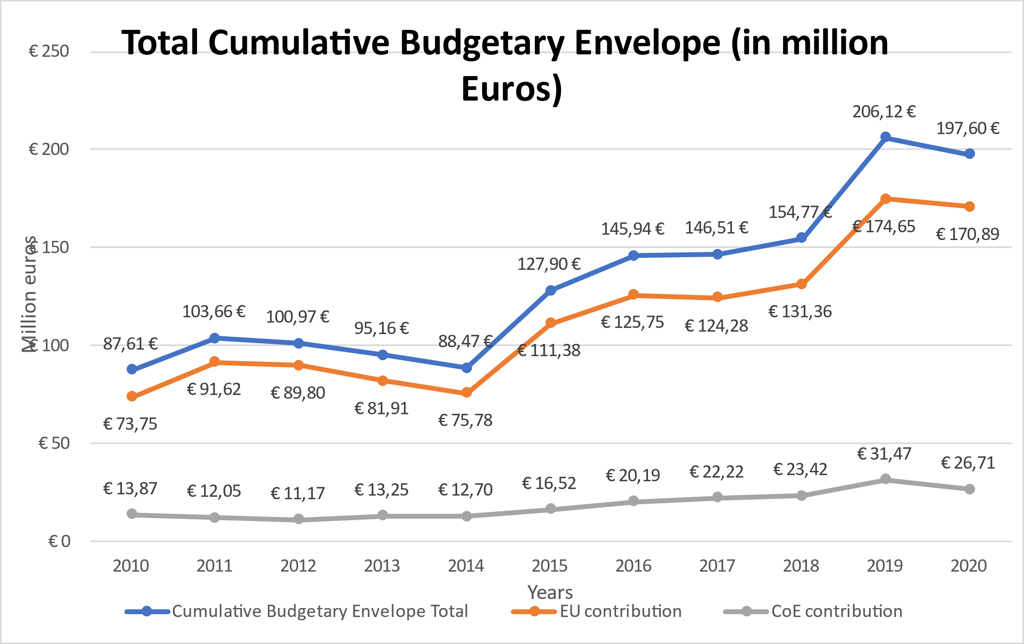

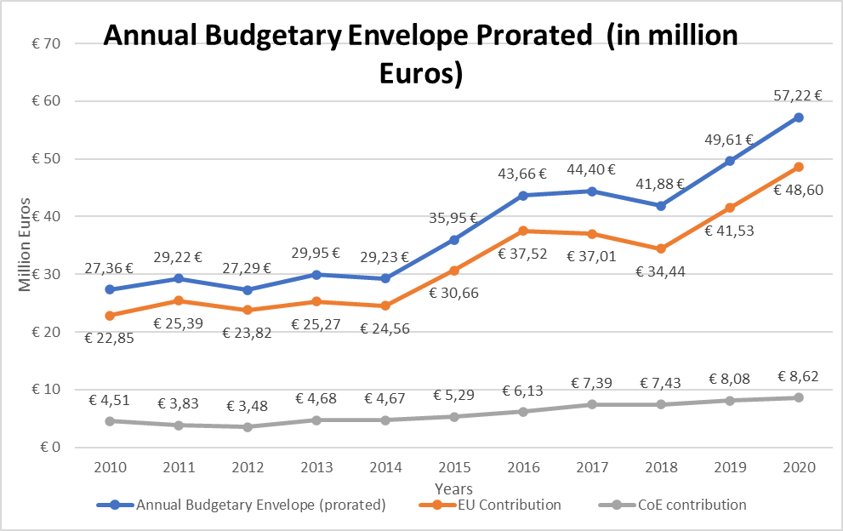

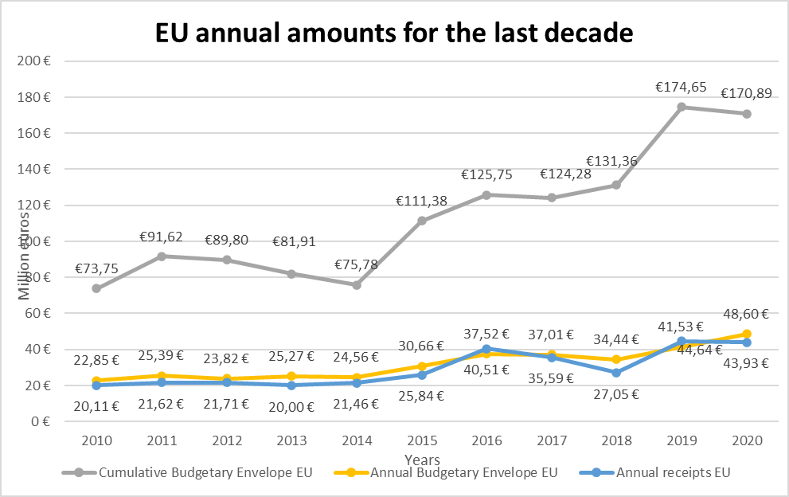

1. **Geographical distribution**

In terms of geographical distribution, the situation remained consistent with a long-standing trend. The bulk of Joint Programme funds continued to be channelled to co-operation in South-East Europe, Turkey, Eastern Europe and the South Caucasus (€115.6 million (58.5% of CBE 2020); €34.7 million in annualised figures).[5]

Among these regions, the Enlargement area continued to benefit from the biggest share (overall multiannual envelope of €87 million (44% of CBE 2020); €25.1 million in annualised terms). Co-operation in the Enlargement area continued to be driven by the Horizontal Facility, the second phase of which was launched in mid-2019 with a considerably increased budgetary envelope. Complementary to the Horizontal Facility, two other regional programmes were implemented in parallel - i-PROCEEDS, an action against cybercrime, and ROMACTED, an action fostering Roma* empowerment and inclusion. Both ROMACTED and i-PROCEEDS have successfully negotiated their renewal, with the second phase of i-PROCEEDS launched in January 2020, and the second phase of ROMACTED starting in January 2021, with a significantly increased envelope allowing to integrate activities aimed at mitigating the negative effects of the pandemic on Roma. The above large regional dispositive was complemented by a programme in Serbia (in the field of local governance) and two programmes in Kosovo[6]** (on inclusion in education and on action against economic crime; launched respectively in early and mid-2020). Moreover, country-specific co-operation further expanded in Turkey (traditionally the largest individual beneficiary of Joint Programme co-operation), with three newly negotiated programmes signed by the end of 2020, to support the development of international co-operation in criminal matters, alternative dispute resolution methods and family courts. (For more information, including on individual programme envelopes, see Section III and Appendices I and II).

Joint Programmes in Eastern Europe and the South Caucasus, with an overall multiannual envelope of €28.6 million (14.5% of CBE 2020, €9.6 million in annualised terms) replicate a similar co-operation architecture, albeit on a lesser scale. The “Partnership for Good Governance” (PGG), the second phase of which has been running since January 2019, remained the main driver of co-operation in the region. The PGG was complemented by a country-specific programme in Azerbaijan (in the field of penitentiary reform), a country-specific programme in the Republic of Moldova (in the field of anti-corruption), a sizable multi-strand programme in Ukraine (focused on the Ombudsman institution, penitentiary reform and freedom of the media) and a newly negotiated regional programme, supporting the evaluation of the results of judicial reform (“Justice Dashboard EaP”), starting in early 2021. (For more information, including on individual programme envelopes, see Section III and Appendices I and II).

Co-operation on the implementation of the national action strategy for women continued in the Russian Federation, with the programme completed by mid-2020, and negotiations started on the follow-up action, with the signature expected in the first half of 2021.

The share of programmes in support of reforms in non-member States increased significantly (overall multiannual envelope of approximately €34 million (17.2% of CBE 2020); €8.9 million in annualised figures). Framed by the CoE Policy towards Neighbouring Regions, co-operation has intensified in both the Southern Neighbourhood and Central Asia. In the Southern Neighbourhood (€24.5 million (12.4% of CBE 2020); €6.4 million in annualised terms), implementation of the South Programme continued, with the start of South Programme - IV in spring 2020. This demand-driven regional programme is complemented by the thematic regional programme CyberSouth, on action against cybercrime. The regional dispositive is complemented by three sizable country-specific programmes - two in Tunisia, providing assistance to the reform of the justice system and to the “independent bodies” and a newly negotiated two-strand programme in Morocco, supporting the role of the Parliament and National preventive mechanism against torture. As regards Central Asia (overall envelope of €9.4 million (4.8% of CBE 2020); €2.5 million in annualised terms), the financial volume available for co-operation in this region demonstrated the most drastic increase,

considering the low level of funding available to co-operation in this region in the past. This development is due to the launch, in early 2020, of a large-scale Central Asia Rule of Law Programme. The programme aims at promoting a common legal space between Europe and Central Asia, supporting the fight against economic crime, training of legal professionals based on the HELP methodology and includes the assistance of the Venice Commission to the functioning of State institutions and public administration. Moreover, the countries of Central Asia also benefit from the Venice Commission’s assistance in the context of another programme (with a larger geographical scope, extended to Mongolia and Latin America), which focuses on electoral reforms. (For more information, including on individual programme envelopes, see Section III and Appendices I and II).

Importantly, the share of Joint Programmes implemented with EU member States continued to steadily increase (overall multiannual envelope of €22 million (11.2% of CBE 2020), €7.7 million in annualised terms). This development is mainly due to strengthened co-operation with DG REFORM, operating on the basis of a structured and flexible framework, in place since mid-2019. Two framework programmes were underway in 2020, framing a number of country-specific projects in various fields of CoE expertise, including the modernisation of the judicial system (in Croatia, Cyprus, Malta, Spain, the Slovak Republic), efficiency of justice (in Cyprus), access to justice (in Latvia), fight against economic crime (in Cyprus), fight against money-laundering and terrorism financing (in Romania and the Czech Republic), strengthening local governance (in Lithuania and the Slovak Republic), and children rights (in Slovenia). Development of the third framework programme started in autumn 2020, with signature expected in spring 2021. Additionally, four stand-alone projects contracted by DG REFORM were running: in Malta (efficiency of justice), Greece (local governance), Bulgaria (fight against money-laundering and terrorism financing) and Romania (reorganisation of the blood transfusion system – project implemented by EDQM). It is also important to acknowledge the existing co-operation with DG JUST (HELP-based training programmes; programmes on penal statistics, on Roma women empowerment and anti-discrimination programmes), with DG EMP (on Roma inclusion) and with DG Education and Culture (in the field of inclusive education, on integrity in sports, on language learning and on cultural heritage) (For more information, including on individual programme envelopes, see Section III and Appendices I and II).

The share of thematic (multilateral) programmes also increased (€26 million (13.1% of CBE 2020); €5.9 million in annualised figures). Thematic multilateral co-operation is championed by GLACY +, the largest stand-alone programme of the CoE and a major global undertaking in the field of action against cybercrime, implemented in collaboration with Interpol. Thematic multilateral co-operation is also represented by other important co-operation endeavours, such as the longstanding European Heritage Days and Youth Partnership (both renewed each year), the North-South Centre programme “Intercultural learning exchange through global education, networking and dialogue - i-LEGEND”, the programme “Democratic and inclusive school culture in operation” along with some others. (For more information, including on individual programme envelopes, see Appendices I and II).

1. The chart below shows the geographical distribution of Joint Programme co-operation in 2020.

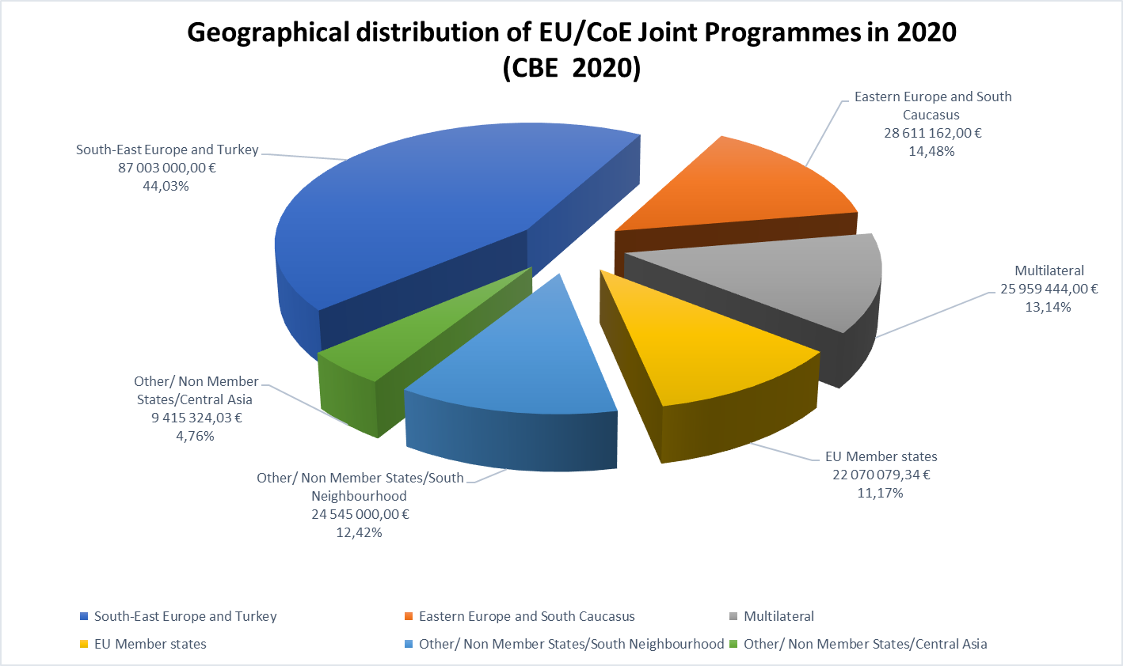

1. **Thematic distribution**

Joint Programmes’ thematic distribution remained largely the same as in 2019 albeit with some slight variations.

* The share of programmes underthe Rule of Law pillar slightly decreased but continued to prevail in number and volume (€107 million; 54.4% of CBE 2020). These programmes are implemented over wide range of areas of CoE expertise, among which are the fight against cybercrime, corruption, money-laundering and terrorism financing, support for judicial and penitentiary reforms, information society/internet governance, assistance activities of the Venice Commission, and integrity in sports.
* The share ofthe Human Rights pillar’s programmes (€63 million; 32% of CBE 2020) slightly increased, with the bulk of the funding continued being channelled into enhancing the effectiveness of the ECHR system at national and European level and into actions for Roma empowerment and inclusion. The remainder is attributed to programmes and projects on anti-discrimination, protecting the rights of persons belonging to national minorities, equality and human dignity, and children’s rights.
* The share of the Democracy pillar’s programmes (€26.9 million; 13.6% of CBE 2020) remained relatively stable. The bulk of these programmes falls under Education for democracy and Democratic governance sectors.

1. The chart below shows the thematic distribution of Joint Programmes in 2020.
2. As regards the funding instruments,the bulk of funding fell under the EU instruments of External Action, more specifically the Instrument of Pre-accession (IPA, 44%) and the European Neighbourhood Instrument (ENI/ENPI; 26.6%). A number of other EU funding programmes and instruments were involved, with their individual shares remaining under 10%.

**III. ACHIEVEMENTS OF JOINT PROGRAMME CO-OPERATION**

1. This section presents, in brief, the achievements of Joint Programme co-operation by region, with a particular focus on the results of the corresponding regional “programmatic facilities”. It also describes other major co-operation undertakings such as the Central Asia Rule of Law Programme, technical assistance programmes with DG REFORM in EU member States and country-specific co-operation in Turkey.

1. **Partnership for Good Governance (PGG)**

The Partnership for Good Governance for the Eastern Partnership (EaP), which encompasses Armenia, Azerbaijan, Georgia, Republic of Moldova, Ukraine and Belarus, was the first EU-CoE “programmatic facility” to be put in place in 2015. It’s second phase (total €17.5 million) started in 2019 and continues to provide tailor-made support to the national reforms in the framework of Council of Europe country-specific Action Plans, also contributing to the achievement of the EU 2020 Deliverables. The PGG includes a number of country-specific and regional projects organised under three themes: i) strengthening the Rule of Law and mechanisms to combat corruption, money-laundering and terrorist financing; ii) implementation of key judicial reforms and iii) combating discrimination and protecting the rights of vulnerable groups and women (cross-cutting issues).

The PGG regional dimension has shown a strong added value and has contributed not only to enhancing regional interaction and networking but also to the transfer of knowledge and expertise among the EaP countries. A new feature of the second phase of the PGG is the Quick Response Mechanism (QRM), a modality inspired by the Horizontal Facility, which has proven its added value in the context of PGG. The QRM channels CoE legal expertise, and in particular the expertise of the Venice Commission, to the beneficiary countries as a form of direct support to the legislative reforms in the field of electoral reform, referendums and political parties, functioning of democratic institutions, and constitutional and ordinary justice. The scope of expertise under the QRM has been extended to some other areas and other CoE bodies such as GRECO and MONEYVAL.

The PGG - II mid-term implementation results were presented at the online event “Improving the lives of citizens through better governance” held in October 2020 with an important outreach of 49,000 people. A non-exhaustive list of the results includes:

1. adoption of laws strengthening standards for the fight against corruption, money-laundering and terrorism financing in Armenia, Azerbaijan, Georgia, the Republic of Moldova and Ukraine;
2. reinstatement of illicit enrichment as a criminal offence in Ukraine;
3. contribution to optimisation of the day-to-day court administration in Azerbaijan and the Republic of Moldova in line with the tools and methodology of the Council of Europe Commission for the Efficiency of Justice (CEPEJ);
4. Georgian citizens can file complaints electronically following the introduction of the Constitutional Court case management system;
5. in Azerbaijan, adoption of the National action plan for combating domestic violence;
6. in Armenia, the Republic of Moldova and Ukraine, establishment of data collection tools allowing for more efficient monitoring of implementation of the anti-discrimination legislation;
7. reviewed legal framework and reinforced capacity of the Ombudsperson’ offices and Equality councils in the Eastern Partnership region to effectively fight against discrimination in line with European standards;
8. eight legal opinions were delivered by the Venice Commission in respect of three countries (Armenia, Georgia and the Republic of Moldova) in the field of constitutional and ordinary justice;[7]
9. five Human Rights Education for Legal Professionals (HELP) courses were launched for the representatives of legal professions.

In complementarity and synergy with the PGG, three country-specific programmes were also running. The Joint Programme “EU and CoE working together to protect human rights in Ukraine” (total: €3 million; launched in 2019) provides support to the Ombudsperson/National preventive mechanism and in the areas of media freedom and penitentiary reform. In Azerbaijan, the Joint Programme “Further support to the penitentiary reform” (total: €0.8 million, started in 2019) has contributed to the revision and launching of the Action plans on prison management and prison healthcare. In the Republic of Moldova, the Joint Programme “Controlling corruption through law enforcement and prevention” (total: €2.2 million) was completed by mid-2020, after three years of implementation. Moreover, a new regional Joint Programme “Support for a better evaluation of the results of judicial reform efforts in the Eastern Partnership/Justice Dashboard EaP” (total: €2.2 million) was signed at the end of 2020 and will start in early 2021; the programme aims at achieving an effective, systematic and data-based evaluation of the results of judicial reform efforts in the Eastern Partnership through the annual collection and processing of data on the functioning of judicial systems and relevant capacity-building.

1. **Horizontal Facility for the Western Balkans and Turkey (“Horizontal Facility -II”)**

The Horizontal Facility for the Western Balkans and Turkey (Horizontal Facility or HF) is the second EU-CoE “programmatic facility”, operating since 2016. The second phase currently implemented (total: €41 million; launched in mid-2019) encompasses four thematic fields, namely i) ensuring justice; ii) the fight against corruption, organised crime and economic crime; iii) anti-discrimination and the protection of the rights of vulnerable groups; and iv) freedom of expression and freedom of the media. The second phase of the HF follows a complementary two-fold approach, combining technical co-operation tailored to help the

Beneficiaries in achieving increased compliance with European standards with the provision of Council of Europe expertise to respond to requests from HF Beneficiaries for legislative analysis and policy advice. The Facility covers 46 actions (projects), out of which nine are regional. The projects were designed based on findings of the Council of Europe monitoring bodies and are also tightly linked to the relevant EU accession priorities.

Since its first phase, the Horizontal Facility operates an Expertise Co-ordination Mechanism (ECM), which delivers ad-hoc legal expertise and policy advice upon request, an instrument that has proven its added value. In addition, expertise is provided upon the requests of the Beneficiaries under the technical co-operation part of HF when such requests fall within the scope of the ongoing actions. Specific novel features of the second phase include a strengthened regional dimension and reinforced contribution to the flagship initiatives under the EU Strategy for the Western Balkans. For example, CEPEJ provides support to the European Commission in achieving an effective, systematic and data-based evaluation of the results of judicial reform efforts in the Western Balkans. The regional dimension of the programme also contributes to the achievement of the Strategy‘s flagship initiative no. 2 on countering terrorism and violent extremism through support aimed at enhancing regional security by addressing radicalisation in prisons and disengaging radicalised prisoners from violence. Moreover, the second phase integrated other new elements such as a new strand on freedom of expression and freedom of the media and involvement of Turkey by implementing beneficiary-specific actions. Furthermore, partially based on lessons learned from the first phase, the implementationmethodology was improved through the coherent integration of the CoE “dynamic triangle” (standard-setting, monitoring, co-operation), a stringent results-based approach, strengthened human rights and gender dimensions and increased involvement at local level, engagement of civil society and improved communication (including in local languages) to better reach out to citizens.

A non-exhaustive list of the results which have been achieved so far includes:

1. adoption of the Law on transitional ownership in Albania, in conformity with Article 1 Protocol 1 of the ECHR, following legal assistance provided by the CoE;
2. incorporation of the CEPEJ methodology by the Ministry of Justice in its working practices when launching the Third assessment report on the efficiency of justice in Kosovo*;
3. finalisation of the Suicide prevention strategy in North Macedonia;
4. anti-money-laundering legislation adopted in Montenegro in line with MONEYVAL recommendations enabling Montenegro’s readmission in the Egmont Group;
5. LGBTI Helpline launched in North Macedonia - being the first service of this kind ever established in SEE;
6. improved detection and preliminary identification of victims of trafficking in human beings in Serbia with approximately 90% of labour inspectors having seen their knowledge enhanced in this regard;
7. information technologies introduced in prisons for the smooth processing of law enforcement and incarceration-related data, thereby contributing to the efficient management of prisons in Bosnia and Herzegovina;
8. revision and development of new training programmes and materials on preventing and combating violence against women for key professionals in Turkey;
9. adoption of the Law on civil partnership in Montenegro;
10. adoption by the Council of Ministers of Bosnia and Herzegovina of the Policy Recommendation with a Roadmap for inclusive education;
11. Launch of a regional no-hate speech campaign “Block the Hatred, Share the Love” which is the first anti-racism initiative gathering personalities from the Western Balkan region, with a message of equality, combating discrimination and ultimately fostering reconciliation;
12. A “Comparatives study on strengthening equality bodies in the Western Balkans region in the field of hate speech” was prepared and its findings were discussed in the margin of the 2020 ECRI seminar with equality bodies;
13. as regards the ECM, assistance was provided in particular to Albania, Bosnia and Herzegovina, and Kosovo*, in the areas of the electoral code, laws on Public Gatherings, the government as well as on the High Judicial and Prosecutorial Councils.

The Horizontal Facility - II is complemented by three beneficiary-specific and two regional programmes. The Joint Programme “Human resources management in local self-governments Phase II” (€3.6 million) has been running in Serbia since the end of 2018, and two programmes operate in Kosovo* - “Building capacity for inclusion in education – INCLUDE” (total: €2.2 million) and “Project against economic crime (PECK) Phase III” (total: €2.5 million), both launched in 2020. As regards regional programmes, these include i-PROCEEDS-II (total: €4.9 million), a programme on co-operation against cybercrime, targeting crime proceeds on the Internet and securing electronic evidence and ROMACTED (total: €3.8 million) which promotes good governance and Roma empowerment at local level. The second phase of ROMACTED, to be started in early 2021, has seen a considerable increase in the budgetary envelope (total: €6.5 million) and incorporates relief measures to address the negative effects of the pandemic on Roma.

1. **Technical assistance programmes in EU member States**

Thanks to the reinforced co-operation with DG REFORM (formerly the Structural Reform Support Service), the volume of CoE technical assistance channelled to its members States which are EU member States, levelled up. Two Framework agreements signed in 2019 and 2020 respectively (overall total: €7.1 million), were being implemented in 2020 encompassing more than twenty country-specific projects tailored to the needs of the member States concerned. These co-operation frameworks aim at strengthening the member States’ capacity to prepare growth sustaining structural reforms in the field of rule of law, human rights protection, and democratic governance. More specifically, the technical assistance covered the following areas of CoE expertise: modernisation of judicial system (in Croatia, Cyprus, Malta, Spain, the Slovak Republic), efficiency of justice (Cyprus), access to justice (Latvia), fight against economic crime (Cyprus), fight against money-laundering and terrorism financing (Romania and the Czech Republic), strengthening the local governance (Lithuania and the Slovak Republic) and children rights (Slovenia). The third Framework agreement is under preparation, to be signed in spring 2021.

A non-exhaustive list of results achieved so far includes:

1. within the framework of the project “Delivering good governance in Lithuania”, a peer review on regional development was carried out and a final report of the findings, including specific recommendations, produced. Further to consultations with the relevant stakeholders, the Parliament adopted the corresponding law in summer 2020, as amended according to the CoE's recommendations;
2. within the framework of the project “Delivering good governance in Slovakia”, a training needs analysis for local authorities has been launched, as a prerequisite for the preparation of the national training strategy;
3. within the framework of the project “Continued support to a well performing Slovak judiciary”, the CEPEJ experts produced, in spring 2020, two comparative overviews, namely “Best practices of strategic planning of justice sector reform(s)” and “Good practices on the standardisation of court decisions from selected Council of Europe member States”, with recommendations;

1. within the framework of the project “Development of the Latvian judicial system”, the draft assessment report of the Latvian mediation scheme included the analysis of the scheme in itself, along with alternative examples from other member States and first recommendations;
2. within the framework of the project “Establishing a digital strategy for the Maltese justice sector”, preparations for the analysis of the current IT tools existing in the judiciary sector continued.

In addition, two separate projects were running in the areas of the efficiency of justice (Malta) and democratic governance (Greece), with two more projects launched in 2020 - to support the fight against money-laundering (in Bulgaria) and the reorganisation of the blood transfusion system (in Romania; implementation by EDQM). These stand-alone projects could not be incorporated into the above co-operation framework for procedural reasons.

1. **Joint Programmes in Turkey**

Turkey has traditionally been the biggest single country-recipient of Joint Programme co-operation and maintained its position in 2020, with five country-specific programmes under implementation in 2020. Three newly negotiated programmes were signed at the end of 2020, bringing the overall total of Turkey-specific programmes to €28.4 million (from January 2021).

More specifically, these include:

* the programmes “Generation Democracy - Strengthening a culture of democracy in basic education institutions” (total: €4 million) and “Strengthening the capacity of the bar associations and lawyers on European Human Rights standards” (SCOBAL; total €3.9 million), operating since 2018;
* three programmes launched in 2019 - in the field of criminal justice (total €5 million), administrative justice (total €3.3 million), and on the Court of Cassation (total €3 million);
* three new programmes, to be launched in 2021 – on international co-operation in criminal matters (total €3 million), on alternative dispute resolution methods (total €4 million), and on family courts (total €2.2 million).

In the context of the Covid-19 crisis, and despite active mitigation measures deployed by the project management teams with the help of the Programme Office in Ankara, the cost of programmes’ implementation has decreased, and no-cost extensions are being considered.

Some of the noteworthy results are as follows:

1. within the framework of the programme with the bar associations: five HELP courses - on admissibility criteria before the ECtHR, property rights, violence against women, data protection, right to liberty and security - have been translated and adapted. The pool of human rights trainers was enlarged to 150 with the help of the training-of-trainers programme;
2. within the framework of the programme on democratic culture in education – a “Whole School Model” was developed based on the CoE Reference Framework of Competences for Democratic Culture;
3. within the framework of the programme on administrative justice, the initial assessment report was completed, accompanied by concrete recommendations for Turkey’s administrative justice system and a framework of the Roadmap for an improved administrative justice was drafted in line with the Ministry of Justice’s Judicial Reform Strategy. Moreover, an in-depth training needs assessment was conducted to provide the basis for the development of in-service training of administrative judiciary and court staff, and six pilot courts drafted guidance materials and petition templates, standard operating procedures, and job descriptions for the court registries;
4. within the framework of the programme with the Court of Cassation, self -assessment and court user satisfaction surveys have been completed, focus groups discussions have been organised and a draft baseline study has been prepared and shared with the beneficiary;
5. within the framework of the programme on criminal justice, the training assessment tools have started to be developed jointly with the Judicial Academy of Turkey, recently reinstated as a beneficiary of the programme. Moreover, a synergy for joint capacity-building activities has been established with the regional programme i-PROCEEDS - II for exchanges on major problems and solutions related to the investigation of cybercrime and ensuring procedural safeguards.

In addition to the above Joint Programmes,in the framework of the Horizontal Facility – phase II, three projects were put in place - onfostering a comprehensive institutional response to violence against women and domestic violence, on supporting the implementation and reporting on the Action Plan on Human Rights, and on strengthening the human rights protection of migrants and victims of human trafficking.The total budgetary envelope allocated to the interventions implemented within the framework of the Horizontal Facility in Turkey amounts to €5 million.

1. **Programmes in South Mediterranean region**

The CoE and the EU also continued to work in close partnership with beneficiaries from the Southern Mediterranean region to advance democratic reforms in the framework of the South Programme - IV (total: €3.3 million), which succeeded to the South Programme - III since March 2020. The programme covers nine beneficiaries of the Southern Mediterranean region (Algeria, Egypt, Israel, Jordan, Lebanon, Libya, Morocco, Palestine*[8] and Tunisia). The overall objective of the programme is to reinforce human rights, rule of law and democracy in the region through the creation of a common legal space, institutional support, and networking among peers. TheSouth Programme - IV has a stronger regional dimension which focuses on two thematic strands - preventing and combating violence against women and combating economic crime.

The South Programme is complemented by the thematic regional initiative CyberSouth, an action against cybercrime with a particular focus on Algeria, Jordan, Lebanon, Morocco and Tunisia (cost-extended to €5 million) and country-specific programmes PAII-T/“Support to independent bodies in Tunisia” (total: €5.6 million) and AP-JUST/”Improving the functioning, performance and access to justice in Tunisia” (total: €5 million). Moreover, a new Joint Programme for Morocco - “Support to the National preventive mechanism against torture and to the development of the key role of Parliament” (total: €2.3 million) - was signed in November 2020.

The programmes targeted at the Southern Neighbourhood have been heavily affected by the Covid-19 crisis and had to put in place modes of implementation compatible with the sanitary situation. The reduced cost of activities should allow an extension of the programmes’ implementation period. Despite the negative consequences of the pandemic, the programmes continued to deliver results, a non-exhaustive list of which includes:

1. Tunisia has become the first country in the region to be invited to accede to the Istanbul Convention and to GRECO. Exchanges are underway in order to progress towards the completion of the accession procedures. Tunisia will in principle be the first country in the region adhering to these instruments;
2. Tunisia acceded to the Lanzarote Convention,[9] signed the Convention 108+;[10]
3. increased harmonisation of legislation with the Budapest Convention:[11] Morocco has been a Contracting Party to the Budapest Convention since 2018; Lebanon and Jordan have adopted legislation largely compliant with the Budapest Convention;
4. Algeria, Jordan, Lebanon, Morocco and Tunisia have set up a pool of national trainers actively engaged in the elaboration of national cybercrime and electronic evidence training manuals, that will be included into the training curricula of the judicial training institutions, to serve as reference for the national training programme for student and in-service magistrates;
5. the functioning of constitutional and independent bodies in Tunisia is supported by the Venice Commission, with the aim to enable them to advance on the adoption of pending legislation related to their independence and mandates. This support is based on the findings of a diagnosis of the legal and regulatory framework surrounding these bodies which was prepared in 2019;
6. important steps towards an increased human rights culture in prisons with the dissemination of the “Guidebook for Prisoners” presenting their rights and duties, and the drafting of a Prison law handbook to improve knowledge on the national legal framework and relevant European and international standards;
7. final steps towards the completion of the corruption risk assessment of the Palestinian judiciary and the corruption risk assessment of the Moroccan banking sector were undertaken. Both reports will be presented to national authorities in 2021;
8. Lebanese, Moroccan, and Tunisian representatives of authorities in charge of fighting against trafficking in human beings and the representatives of civil society had an exchange for the first time at regional level in November 2020. These exchanges enhanced their better understanding of the Council of Europe Convention on Action against Trafficking in Human Beings and explored possibilities for the development of concrete and practical tools for regional co-operation;
9. further development of the peer-to-peer networking through Council of Europe networks such as the UniDem Med campus (University for Democracy) which allowed senior civil servants of the region to exchange experiences and best practices in the field of public administration reform on two occasions in 2020;
10. enhanced capacities of legal professionals and other national stakeholders in the region, in particular in Tunisia and Morocco, by providing training in human rights through an increased number of online HELP courses.
11. **Programmes in Central Asia**

The EU**/** CoE joint “Central Asia Rule of Law Programme” (total: €8.9 million) officially started on 1 January 2020, after a launching event in November 2019. The programme is open to all five countries of the region – Kazakhstan, Kyrgyzstan, Tajikistan, Turkmenistan, and Uzbekistan – and is in line with the CoE Policy for Neighbouring regions. The programme is implemented by the CoE in close collaboration with national partners and is based on a demand-driven approach. More specifically, the programme aims at supporting the fight against economic crime, training of legal professionals based on the HELP methodology and includes the assistance of the Venice Commission to the functioning of State institutions and public administration.

A Programme Office was due to open in Kazakhstan; however, the national authorities withdrew their offer (despite very advanced negotiations for this purpose), and the negotiations are now in progress with Uzbekistan to open the office in Tashkent. In the context of the pandemic - related travel restrictions, the workplan of the programme had to be modified to align with the sanitary situation. Overall, the mitigation measures were effective and despite the absence of the Programme office in situ, the programme has managed to advance in its implementation.

Some of the results are outlined below:

1. as regards human rights protection, the programme has carried out an assessment of the training needs with all five of the Central Asian countries. The purpose of the assessment was to identify and to agree on the target groups of legal professionals, to estimate their training needs in the given area in each country, to understand the existing training arrangements, modalities and capacities of training institutions, to assess their capacity to utilise online training tools, as well as to identify specific courses in the HELP Programme that would be best to adapt for use in each country and would best serve the needs of the target audiences;
2. in the field of fight against economic crime at the regional level, the programme focused on developing educational modules for Master’s programmes on AML/CFT, in co-operation with law enforcement agencies and universities, and on conducting desk reviews of the anti-corruption framework (Kyrgyzstan, Uzbekistan), with around fifty online meetings organised from March to December 2020. In Kazakhstan, the Programme supported the Anti-corruption Agency. For Kyrgyzstan, the efforts focused on providing expert input on improvement of the regulatory framework pertaining to specialised anti-corruption bodies, immunities and whistle-blower protection. In Uzbekistan, the programme supported the implementation of the Business Anti-corruption Charter of Uzbekistan; Uzbekistan has expressed a clear interest in joining GRECO and further contacts in this regard are being maintained;
3. to promote efficient functioning of State institutions and public administration, the Venice Commission focused on delivering high-level expertise during national and international events; following exchanges with the High Judicial Council of Kazakhstan, experts prepared and presented a comparative study on the procedure of selection and appointment of judges of administrative courts. In Kyrgyzstan, the Venice Commission delivered an urgent joint *amicus curiae* brief on the postponement of the 2020 parliamentary elections motivated by the constitutional reform. Contacts between the Venice Commission and the relevant authorities in Uzbekistan have been pursued. Uzbekistan has expressed a clear interest in becoming a full member of the Venice Commission and discussions continued in this respect.

Additionally, the countries of Central Asia can benefit from support of the Venice Commission on electoral matters, in the context of another Joint Programme, “Support to reforms of electoral legislation and practice and regional Human Rights instruments and mechanisms” (total: €0.5 million), which also covers Mongolia and Latin America.

**IV. LESSONS LEARNED**

The following lessons learned can be drawn from the implementation of Joint Programmes during the reference period, including in terms of crisis management related to the pandemic:

* due to in-built flexibility and adaptability, the “programmatic facilities” have proved to be effective in deploying mitigation measures and delivering results in a difficult context. The tailor-made approach of the facilities ensures the local support and commitment of the beneficiary institutions to the implementation of the projects. The results-based approach reinforces project management, strengthens budgetary monitoring and improves co-ordination with the European Union, including European Union Delegations, enables better gender mainstreaming, improves communication on results and increases visibility. Co-operation in this format should be pursued further;
* the high quality of expertise provided through Joint Programmes both by technical support and the targeted expertise (Expertise Co-ordination Mechanism within the Horizontal Facility and the Quick Response Mechanism within PGG) meets with high appreciation from beneficiary institutions;
* the regional approach is substantial and complementary to country-specific actions and proved its added value through increased exchanges of information, knowledge and good practices;
* in the context of sanitary restrictions, the implementation concentrated on the activities that did not require physical interaction. The HELP platform proved to be a most efficient means to replace presential capacity-building activities. Yet, face-to-face meetings and events remain paramount to securing interest and good relations with beneficiaries and partners as well as for topics whose technicalities necessarily require simultaneous interpretation which can be challenging when provided online and for large-scale events;
* for some activities, especially study trips, some training activities and politically sensitive areas such as penitentiary monitoring, no adequate alternative solutions were found. While some activities could be converted relatively easily to online implementation, there remains a doubt whether the same quality of results can be achieved;
* reactivity to emerging needs and flexibility were key in the reporting period to respond positively to specific requests from partners to address the health crisis while upholding the objectives of the respective programmes;
* an increased inclusion of representatives of the civil society in Joint Programmes represents a real added value to interventions, and direct involvement of citizens in the action should be further promoted. CSOs and authorities at local level should be acting as a direct vector of communication to citizens, reflecting concrete changes brought by Joint Programmes to their daily lives.

**Appendices**

**Appendix I. Joint Programmes active in 2020**

**Appendix II. Newly negotiated Joint Programmes - 2020**

**ApPendix I**

| **JOINT PROGRAMMES IN OPERATION IN 2020** | | | | | | |
| --- | --- | --- | --- | --- | --- | --- |
| **Financing instrument** | **Contract title** | **Start date of covenant** | **End date of covenant** | **Total programme envelope in €** | **Contribution of the European Union** | **Contribution of the Council of Europe** |
| **South-East Europe and Turkey** | | | | | | |
| **Serbia** | | | | | | |
| IPA | Human resources management in local self-governments - Phase 2 | 19/12/2018 | 18/12/2021 | 4 000 000,00 | 3 600 000,00 | 400 000,00 |
| **Turkey** | | | | | | |
| IPA | Strengthening the Capacity of Bar Associations and Lawyers on European Human Rights Standards (BARI) | 01/04/2018 | 31/03/2021 | 3 890 000,00 | 3 500 000,00 | 390 000,00 |
| IPA | Generation Democracy Strengthening a Culture of Democracy in Basic Education Institutions | 03/08/2018 | 02/08/2021 | 4 000 000,00 | 3 600 000,00 | 400 000,00 |
| IPA | Strengthening the Institutional Capacity of Court of Cassation | 22/02/2019 | 21/02/2022 | 3 000 000,00 | 2 700 000,00 | 300 000,00 |
| IPA | Improving the Effectiveness of the Administrative Judiciary and Strengthening the institutional Capacity of Council of State | 21/12/2018 | 20/12/2021 | 3 335 000,00 | 3 000 000,00 | 335 000,00 |
| IPA | Strengthening the Criminal Justice System and the Capacity of Justice Professionals on prevention of the European Convention on Human Rights Violations in Turkey | 15/03/2019 | 14/03/2022 | 5 000 000,00 | 4 500 000,00 | 500 000,00 |
| IPA | Improving International Judicial Cooperation in Criminal Matters in Turkey | 11/12/2020 | 10/12/2023 | 3 000 000,00 | 2 700 000,00 | 300 000,00 |
| IPA | Promoting Alternative Dispute Resolution (ADR) in Turkey | 17/12/2020 | 16/12/2023 | 4 000 000,00 | 3 600 000,00 | 400 000,00 |
| **Kosovo\*** | | | | | | |
| IPA | Project against Economic Crime in Kosovo**\*** (PECK II) | 01/01/2016 | 31/03/2020 | 2 225 000,00 | 2 000 000,00 | 225 000,00 |
| IPA | Project against Economic Crime (PECK) Phase III | 01/07/2020 | 30/06/2023 | 2 460 000,00 | 2 214 000,00 | 246 000,00 |
| IPA | Building capacity for inclusion in education - INCLUDE | 01/01/2020 | 31/12/2023 | 2 223 000.00 | 2 000 000,00 | 223 000,00 |
| **Regional** | | | | | | |
| IPA | ROMACTED: Promoting good governance and Roma empowerment at local level | 01/05/2017 | 31/12/2020 | 3 750 000,00 | 3 000 000,00 | 750 000,00 |
| IPA | European Union/Council of Europe Horizontal facility for the Western Balkans and Turkey – Phase II | 24/05/2019 | 23/05/2022 | 41 175 000,00 | 35 000 000,00 | 6 175 000,00 |
| IPA | Cooperation on Cybercrime: targeting crime proceeds on the Internet and securing electronic evidence (“iPROCEEDS2”) | 01/01/2020 | 30/06/2023 | 4 945 000,00 | 4 450 000,00 | 495 000,00 |
| **Eastern Europe and South Caucasus** | | | | | | |
| **Azerbaijan** | | | | | | |
| ENI | Further Support to the Penitentiary Reform in Azerbaijan 2 | 01/02/2019 | 31/10/2021 | 773 940,00 | 619 152,00 | 154 778,00 |
| **Republic of Moldova** | | | | | | |
| ENPI | Controlling corruption through law enforcement and prevention (CLEP) - the Republic of Moldova | 01/06/2017 | 31/05/2020 | 2 225 000,00 | 2 000 000,00 | 225 000,00 |
| **Russian Federation** | | | | | | |
| FPI | Co-operation in the implementation of the Russian Federation National Action Strategy for Women (2017-2022) | 03/11/2018 | 02/05/2020 | 556 000,00 | 500 000,00 | 56 000,00 |
| **Ukraine** | | | | | | |
| ENI | European Union and Council of Europe working together to strengthening the protection of human rights in Ukraine | 10/07/2019 | 09/07/2021 | 3 334 000,00 | 3 000 000,00 | 334 000,00 |
| **Regional Eastern Europe and South Caucasus** | | | | | | |
| ENI | Partnership for Good Governance II | 01/01/2019 | 31/12/2021 | 17 500 000,00 | 14 000 000,00 | 3 500 000,00 |
| ENI | CyberEast - Action on Cybercrime for Cyber Resilience in the Eastern Partnership Region | 20/06/2019 | 19/06/2022 | 4 222 222,00 | 3 800 000,00 | 422 222,00 |
| **Multilateral** | | | | | | |
| FPI | Global Action on Cybercrime extended (GLACY+) | 01/03/2016 | 29/02/2024 | 18 890 000,00 | 17 000 000,00 | 1 890 000,00 |
| DG JUST | Space reports and European NPM Forum | 01/10/2019 | 30/09/2021 | 375 000,00 | 300 000,00 | 75 000,00 |
| DG REGIO | Fostering regional development through transnational cultural heritage policies and practices | 12/12/2017 | 31/07/2020 | 1 111 111,00 | 1 000 000,00 | 111 111,00 |
| DG EAC | Democratic and Inclusive School Culture in Operation (DISCO) - EU/CoE Joint Programme for International Co-operation Projects | 01/01/2018 | 31/12/2019 | 1 150 000,00 | 690 000,00 | 460 000,00 |
| DG EAC | The Faro Convention Way: enhanced participation in cultural heritage | 16/06/2018 | 14/06/2021 | 300 000,00 | 150 000,00 | 150 000,00 |
| DG EAC | European Heritage Days 2019 | 01/01/2019 | 30/06/2020 | 800 000,00 | 400 000,00 | 400 000,00 |
| DG EAC | European Heritage Days 2020 | 01/01/2020 | 30/06/2021 | 800 000,00 | 400 000,00 | 400 000,00 |
| DCI-NSA | iLEGEND II, Intercultural Learning Exchange through Global Education, Networking and Dialogue | 24/10/2019 | 23/10/2022 | 1 333 333,00 | 1 000 000,00 | 333 333,00 |
| DG EAC | The Partnership between the European Commission and the Council of Europe in the field of youth 2020 agreement (YP 2020) | 01/01/2020 | 31/12/2020 | 1 200 000,00 | 600 000,00 | 600 000,00 |
| **EU member States** | | | | | | |
| DG JUST | Roma Women’s Access to Justice - JUSTROM 3 | 01/09/2019 | 31/08/2021 | 1 750 000,00 | 1 400 000,00 | 350 000,00 |
| DG JUST | EU-CoE HELP Radicalisation Prevention, Judicial Response to Terrorism and International Cooperation in Criminal Matters - EU-CoE HELP RAD ICCM | 01/01/2020 | 31/12/2021 | 722 359,14 | 650 123,23 | 72 235,91 |
| DG JUST | EU-CoE HELP (Human Rights Education for Legal Professionals) in the EU II — EU-CoE HELP EU II | 01/09/2019 | 28/02/2022 | 1 350 313,25 | 1 080 250,60 | 270 062,65 |
| DG JUST | EU-CoE HELP (Human Rights Education for Legal Professionals) in the EU | 15/02/2018 | 14/02/2020 | 1 119 006,00 | 894 980,05 | 224 025,95 |
| DG JUST | "Combating discrimination and violence on the basis of sexual orientation and gender identity throughimproved legal frameworks and implementation of European standards (ENDSOGIDISC)" | 01/08/2019 | 30/04/2021 | 290 635,54 | 232 508,42 | 58 127,12 |
| DG JUST | Assessment of the concrete implementation and effective application of the 4th Anti-Money Laundering Directive in the EU member States | 24/07/2019 | 23/07/2021 | 691 000,00 | 691 000,00 | 0,00 |
| DG JUST | We CAN for Human Rights Speech — WECANHRS (EU member States) | 01/02/2020 | 31/01/2022 | 431 353,62 | 339 961,45 | 91 392,17 |
| DG REFORM | Support to the EU member States in the implementation of Structural reforms | 05/06/2019 | 04/06/2022 | 3 680 238,00 | 3 295 000,00 | 385 238,00 |
| DG REFORM | Support to member States in the Implementation of Structural Reforms II | 16/06/2020 | 15/06/2023 | 3 379 003,66 | 3 035 000,00 | 344 003,66 |
| DG REFORM | Enhancing capabilities of Bulgarian authorities to effectively mitigate money laundering and terrorism financing risks | 17/07/2020 | 16/07/2022 | 458 889,00 | 413 000,00 | 45 889,00 |
| DG REFORM | Reorganisation of the Romanian Blood System | 01/10/2020 | 30/11/2022 | 700 000,00 | 700 000,00 | 0.00 |
| DG REFORM | Technical assistance project on delivering good governance in Greece | 01/02/2019 | 31/01/2021 | 778 000,00 | 700 000,00 | 78 000,00 |
| DG REFORM | Supporting the efficiency of justice in Malta (Malta) | 07/12/2018 | 06/12/2020 | 278 000,00 | 250 000,00 | 28 000,00 |
| DG REFORM | Support the Improvement of Training Programs in the Judicial Sector - Portugal | 01/09/2019 | 17/02/2020 | 77 800,00 | 70 000,00 | 7 800,00 |
| DG REFORM | Promoting cyber justice in Spain through change management and improvement of data collection (Spain) | 07/11/2018 | 06/01/2020 | 278 000,00 | 250 000,00 | 28 000,00 |
| DG REFORM | Support to the Improvement of the Capacity of the Inspectorate to the Supreme Judicial Council of Bulgaria | 16/02/2019 | 15/02/2020 | 200 000,00 | 180 000,00 | 20 000,00 |
| DG EMP | ROMACT 6 - Building capacity at local level for the integration of Roma* | 26/10/2018 | 25/02/2020 | 875 000,00 | 700 000,00 | 175 000,00 |
| DG EMP | ROMACT 7 - Building capacity at local level for the integration of Roma* | 01/10/2019 | 31/05/2021 | 1 670 000,00 | 1 500 000,00 | 170 000,00 |
| DG EAC | Promoting and Strengthening the Council of Europe Standards on Safety, Security and Service at football matches and other sports events (ProS4+) | 01/07/2018 | 31/03/2021 | 465 000,00 | 336 000,00 | 129 000,00 |
| DG EAC | Innovative methodologies and assessment in language learning VII | 21/09/2019 | 31/12//2020 | 659 481,13 | 527 584,90 | 131 896,23 |
| DG EAC | Inclusive Schools: making a difference for Roma children (INSCHOOL 2) | 01/10/2019 | 30/06/2021 | 1 000 000,00 | 700 000,00 | 300 000,00 |
| DG EAC | Child Safeguarding in Sport | 01/03/2020 | 31/10/2021 | 560 000,00 | 400 000,00 | 160 000,00 |
| DG EAC | Innovative methodologies and assessment in language learning VIII | 30/12/2020 | 29/12/2021 | 656 000,00 | 524 800,00 | 131 200,00 |
| **Non-member States** | | | | | | |
| EIDHR | Support to Reforms of Electoral Legislation and Practice and Regional Human Rights Instruments and Mechanisms in Countries of Latin America, Central Asia and Mongolia | 01/05/2019 | 30/04/2021 | 526 500,00 | 500 000,00 | 26 500,00 |
| DCI | Central Asia Rule of Law Programme | 02/01/2020 | 01/01/2024 | 8 888 824,03 | 8 000 000,00 | 888 824,03 |
| ENI | Co-operation on cybercrime in the Southern Neighbourhood Region - Cybercrime@South | 01/07/2017 | 31/12/2021 | 5 005 000,00 | 4 500 000,00 | 505 000,00 |
| ENI | Ensuring Sustainable Democratic Governance and Human Rights in the Southern Mediterranean (South Programme III) | 01/03/2018 | 29/02/2020 | 3 334 000,00 | 3 000 000,00 | 334 000,00 |
| ENI | Improving the functioning, performance and access to justice in Tunisia (AP-JUST) | 01/01/2019 | 31/12/2021 | 5 000 000,00 | 4 500 000,00 | 500 000,00 |
| ENI | Project to Support Independent Bodies in Tunisia (PAII T) | 01/01/2019 | 31/12/2021 | 5 556 000,00 | 5 000 000,00 | 556 000,00 |
| ENI | South Programme IV | 01/03/2020 | 28/02/2022 | 3 334 000,00 | 3 000 000,00 | 334 000,00 |
| ENI | Support to the national mechanism against torture and to the development of the key role of Parliament in Morocco | 14/11/2020 | 13/11/2023 | 2 316 000,00 | 2 200 000,00 | 116 000,00 |

**Appendix II**

|  |  |  |  |  |  |  |
| --- | --- | --- | --- | --- | --- | --- |
| **NEWLY NEGOTIATED JOINT PROGRAMMES - 2020** | | | | | | |
| **Financing instrument** | **Contract title** | **Start date of covenant** | **End date of covenant** | **Total programme envelope in €** | **Contribution of the European Union** | **Contribution of the Council of Europe** |
| **With start in 2020** | | | | | | |
| DG EAC | Democratic and Inclusive School Culture in Operation (DISCO 2020-2021) | 01/01/2020 | 31/12/2021 | 1 150 000,00 | 690 000,00 | 460 000,00 |
| DG EAC | The Partnership between the European Commission and the Council of Europe in the field of youth 2020 agreement (YP 2020) | 01/01/2020 | 31/12/2020 | 1 200 000,00 | 600 000,00 | 600 000,00 |
| DG EAC | Child Safeguarding in Sport | 01/03/2020 | 31/10/2021 | 560 000,00 | 400 000,00 | 160 000,00 |
| ENI | South Programme IV | 01/03/2020 | 28/02/2022 | 3 334 000,00 | 3 000 000,00 | 334 000,00 |
| DG REFORM | Support to member States in the Implementation of Structural Reforms II | 16/06/2020 | 15/06/2023 | 3 379 003,66 | 3 035 000,00 | 344 003,66 |
| IPA | Project against Economic Crime (PECK) Phase III | 01/07/2020 | 30/06/2023 | 2 460 000,00 | 2 214 000,00 | 246 000,00 |
| DG EAC | European Heritage Days 2020 | 01/01/2020 | 30/06/2021 | 800 000,00 | 400 000,00 | 400 000,00 |
| DG REFORM | Enhancing capabilities of Bulgarian authorities to effectively mitigate money laundering and terrorism financing risks | 17/07/2020 | 16/07/2022 | 458 889,00 | 413 000,00 | 45 889,00 |
| DG REFORM | Reorganisation of the Romanian Blood System | 01/10/2020 | 30/11/2022 | 700 000,00 | 700 000,00 | 0,00 |
| ENI | Support to the national mechanism against torture and to the development of the key role of Parliament in Morocco | 14/11/2020 | 13/11/2023 | 2 316 000,00 | 2 200 000,00 | 116 000,00 |
| IPA | Improving International Judicial Cooperation in Criminal Matters in Turkey | 11/12/2020 | 10/12/2023 | 3 000 000,00 | 2 700 000,00 | 300 000,00 |
| DG EAC | Innovative methodologies and assessment in language learning VIII | 30/12/2020 | 29/12/2021 | 656 000,00 | 524 800,00 | 131 200,00 |
| IPA | Promoting Alternative Dispute Resolution (ADR) in Turkey | 17/12/2020 | 16/12/2023 | 4 000 000,00 | 3 600 000,00 | 400 000,00 |
| **With start differed to early 2021** | | | | | | |
| IPA | ROMACTED phase II: Promoting good governance and Roma empowerment at local level | 01/01/2021 | 31/12/2024 | 6 500 000,00 | 5 700 000,00 | 800 000,00 |
| IPA | Improving the effectiveness of family courts: better protection of the rights of family members | 20/03/2021 | 19/12/2023 | 2 223 000,00 | 2 000 000,00 | 223 000,00 |
| ENI | Support for a better evaluation of the result of judicial reform efforts in the Eastern Partnership ‘Justice Dashboard EaP’ | 15/01/2021 | 14/01/2024 | 2 223 000,00 | 2 000 000,00 | 223 000,00 |
| DG EAC | The Partnership between the European Commission and the Council of Europe in the field of youth 2020 agreement (YP 2021) | 01/01/2021 | 31/12/2021 | 1 200 000,00 | 600 000,00 | 600 000,00 |

1. As a component of the human rights approach, the CoE emphasises gender mainstreaming throughout its project activities in line with its Gender Equality Strategy 2018-2023. For more information, see the Council of Europeweb page on gender mainstreaming.
2. The Cumulative budgetary envelope (CBE) is a sum of the budgetary envelopes of all JP contracts registered as “active” between January and December of a given year.
3. The Annual budgetary envelope (ABE) is a statistical parameter calculated *pro rata temporis* to CBE.
4. Programmes with start date in 2021 have been excluded from the calculation of CBE and ABE 2020.
5. Calculated *prorata temporis* to CBE 2020.
6. * The term “Roma and Travellers” is used at the Council of Europe to encompass the wide diversity of the groups covered by the work of the Council of Europe in this field: on the one hand a) Roma, Sinti/Manush, Calé, Kaale, Romanichals, Boyash/Rudari; b) Balkan Egyptians (Egyptians and Ashkali); c) Eastern groups (Dom, Lom and Abdal); and, on the other hand, groups such as Travellers, Yenish, and the populations designated under the administrative term “Gens du voyage”, as well as persons who identify themselves as Gypsies. The present is an explanatory footnote, not a definition of Roma and/or Travellers.

   ** All reference to Kosovo, whether to the territory, institutions or population, in this text shall be understood in full compliance with United Nations Security Council Resolution 1244 and without prejudice to the status of Kosovo.
7. The list of opinions issued comprises three opinions for Armenia, including an *amicus curiae* from the Constitutional Court requested in 2019, one for Georgia and four for the Republic of Moldova, one of which requested in 2019. Other opinions in connection with these, such as an *amicus curiae* from the Constitutional Court of the Republic of Moldova, have been issued out of the QRM framework but are reported hereinafter.
8. *This designation shall not be construed as recognition of a State of Palestine and is without prejudice to the individual positions of Council of Europe member States on this issue.
9. Convention on the Protection of Children against Sexual Exploitation and Sexual Abuse (CETS 201).
10. A modernised version of the Convention 108 (Protocol amending the Convention for the Protection of Individuals with regard to Automatic Processing of Personal Data (CETS 223)).
11. Convention on Cybercrime of the Council of Europe (CETS No.185).