|  |  |  |  |
| --- | --- | --- | --- |
| **MINISTERS’ DEPUTIES** | CM Documents | **CM(2021)49** | 8 April 2021[1] |

|  |
| --- |
| **1404th meeting, 12 May 2021**  11 Programme, Budget and Administration    **11.4 Progress report on reform measures**  **Item to be considered by the GR-PBA at its meeting on 27 April 2021** |

1. As indicated in the Secretary General’s Strategic Framework document ([SG/Inf(2020)34](https://search.coe.int/cm/Pages/result_details.aspx?Reference=SG/Inf(2020)34" \o "Strategic Framework of the Council of Europe)), continued reform remains a priority. The main blocks of the ongoing reform process are also indicated in the Programme and Budget 2022-2025 – Basic framework ([CM(2021)38](https://search.coe.int/cm/Pages/result_details.aspx?Reference=CM(2021)38" \o "Programme and Budget 2022-2025 - Basic framework - Secretary General’s proposal)).
2. Core strategic documents set the overall reform framework:
   1. People Strategy 2019-2023 ([CM(2019)58-final](https://search.coe.int/cm/Pages/result_details.aspx?Reference=CM(2019)58-final" \o "Administrative Reform of the Council of Europe - Measures foreseen for the 2018-2019 biennum - Council of Europe People Strategy 2019-2023 [1346 meeting]));
   2. People Strategy Action Plan ([CM(2019)58-add](https://search.coe.int/cm/Pages/result_details.aspx?Reference=CM(2019)58-add" \o "Administrative Reform of the Council of Europe - Measures foreseen for the 2018-2019 biennum - Council of Europe People Strategy 2019-2023: Appendix II – Action Plan  [1346 meeting]));
   3. Strategic Workforce Plan 2019-2023 ([DD(2019)498](https://search.coe.int/cm/Pages/result_details.aspx?Reference=DD(2019)498" \o "GR-PBA – Strategic Workforce Plan 2019-2023 - Document distributed at the request of the Secretariat));
   4. IT Strategic Action Plan 2018-2022 ([GR-PBA(2018)9](https://search.coe.int/cm/Pages/result_details.aspx?Reference=GR-PBA(2018)9" \o "Information Technology Strategic Action Plan (2018-2022) - Information document));
   5. Digital Strategy – online meetings ([CM(2020)115-rev](https://search.coe.int/cm/Pages/result_details.aspx?Reference=CM(2020)115-rev" \o "Digital Strategy – online meetings - Secretary General’s proposal)); and
   6. Capital Master Plan ([CM(2018)156](https://search.coe.int/cm/Pages/result_details.aspx?Reference=CM(2018)156" \o "Ad Hoc Committee of Experts on Buildings (CAHB) - Meeting report (Strasbourg, 16-17 October 2018) [1332 meeting])).
3. The present document and its appendices form the fifth follow-up report on the administrative reform process. Previous follow-up reports date from July 2018 ([CM(2018)97](https://search.coe.int/cm/Pages/result_details.aspx?Reference=CM(2018)97" \o "Administrative Reform of the Council of Europe – Measures foreseen for the 2018-2019 biennium - Preliminary follow-up report [1321 meeting])), setting out the initiatives planned for the 2018-2019 biennium, November 2018 ([GR-PBA(2018)16](https://search.coe.int/cm/Pages/result_details.aspx?Reference=GR-PBA(2018)16" \o "Reform framework in the current organisational context)), specifying the reform framework in the organisational context, June 2019 ([CM(2019)88](https://search.coe.int/cm/Pages/result_details.aspx?Reference=CM(2019)88" \o "Administrative Reform of the Council of Europe – Measures foreseen for the 2018-2019 biennium - a. Third follow-up report [1351 meeting])) and June 2020 ([CM(2020)84](https://search.coe.int/cm/Pages/result_details.aspx?Reference=CM(2020)84" \o "Progress report on reform measures)) providing a timeline, selected indicators and dashboards summarising the progress made along all key lines of the administrative reform, as well as an update on the main risks, where relevant.
4. All the documents relating to the reform are available on the [Committee of Ministers’ website](https://www.coe.int/en/web/cm/reform-of-the-council-of-europe) on the Reform of the Council of Europe.
5. This document uses the same format as the last progress report to facilitate follow-up. It provides an overview of the progress in the implementation of the reform since April 2020, as well as an updated timeline on key milestones delivered and planned for each reform area, using a project monitoring approach. It is complemented by a selection of cross-cutting key indicators.
6. The administrative reform is guided by two main principles: *value for money* and *aiming for a modern and attractive Organisation*, encapsulated in the slogan *Improving the way we work together*. It is now grounded in two main thrusts: People Strategy and Digital Transformation.

**People Strategy**

1. The **People Strategy** aims at ensuring that staff possess the necessary competences, motivation, and consistently high performance to achieve the organisational objectives. It covers all major aspects of human resources management organised around the following areas:

* People Management, aiming at achieving a flexible, resilient and high-performing workforce which can adapt to changing needs to effectively carry out the Organisation’s mission;
* Working Environment and Culture, with the aim of modernising the way in which we work, further developing an organisational results-oriented culture, ensuring we have the right conditions for a motivated and engaged workforce, in which every staff member fully contributes and embodies our core values;
* Human Resources policies, regulations and procedures, aiming at simplifying and optimising the framework in place and maximising efficiency of administration.

1. The main progress related to selected initiatives are listed hereafter:

* **The reform of the regulatory framework for staff management**, presented to the GR-PBA in March 2021 ([CM(2021)35](https://search.coe.int/cm/Pages/result_details.aspx?Reference=CM(2021)35" \o "Council of Europe People Strategy 2019-2023 – Reform of the Regulatory Framework for Staff Management)).[2] It provides for a legislative architecture which is comprehensive, coherent, easy to understand and sufficiently solid to enable strategic human resources management with regular oversight by the Committee of Ministers. A large majority of delegations expressed their support for the proposals put forward and invited the Secretary General to bring forward the presentation of the new Staff Regulations, originally foreseen for adoption in December, to July 2021.
* **Recruitment methods** have been reviewed and now integrate online testing and online interviews, significantly reducing recruitment overheads and facilitating a wide geographical representation of external candidates in recruitment processes, thereby improving geographical distribution. Selection is closely based on the organisational needs identified through the workforce planning exercise, and a review of selection methods has been conducted with a view to placing more emphasis on potential for future development and mobility among candidates.
* **E-learning** has been significantly developed and the trend towards more on-line and distance learning accelerated during the lockdown period. Many courses were delivered via live video-sessions. Distance learning formats have been expanded to cover new topics, including a trial of two management training courses. An on-line e-learning training catalogue was made available to all staff, and interactive game-based e-learning was also introduced on a more restrained scale. These developments reduce costs and improve efficiency and flexibility compared to a full reliance on presence-based learning.
* **Mobility** is being targeted through a multi-faceted campaign, including internal job market events and targeted mobility drives at specific levels, which will be rolled-out when the working conditions allow. Initiatives already put in place to improve mobility include the organisation of a general competition for staff starting their career in the field, built-in turnover through the expansion of the junior professionals programme, and a rewording of contractual conditions to enable more flexibility in duty station assignment.
* The **results-based management** approach developed and applied within the Organisation for over a decade was assessed by a recent evaluation (January 2021) as successful in meeting the organisational accountability and communication needs, as well as the operational management needs. Further actions in this domain are set to continue in line with the action plan that accompanies this evaluation report. Reform initiatives carried out to foster mobility, flexibility in deployment, workforce planning, acquisition of competences, combined with awareness-raising and training activities on results-based management, as well as the implementation of the new evaluation policy, will all contribute to further consolidate a results-oriented culture in the Council of Europe.

**Digital Transformation**

1. **Digital transformation** is a key enabler in organisational reform to streamline work procedures and support staff in their daily work. It will be accompanied by thorough process re-engineering and solid change management to maximise its impact. It is organised around four main areas:

* Enterprise Data Management (EDM),[3] aiming to consolidate the main EDM existing systems by upgrading them and introducing new functionalities and connectivity therefore providing a solid basis to support the implementation of the organisational results-based management approach and further consolidate a results-oriented culture;
* Enterprise Content Management (ECM),[4] aiming to increase overall efficiency of the Secretariat through greater collaboration and by facilitating the use, sharing and searching of information;
* Security and Data Integrity, aiming to ensure higher resilience of IT services and business continuity in case of major incident, and to protect users against viruses, hacking and other IT-related risks;
* IT Infrastructure and Renewal, aiming to provide users with a modern, efficient and flexible work environment.

1. The main progress and new initiatives in this domain include:

* A dematerialised, rationalised and harmonised **tender and procurement management system** - an on-going business process re-engineering project and the introduction of an E-procurement system has enabled the rationalisation and optimisation of procurement rules and procedures, from the expression of needs through to the final selection of providers, including the constitution of consultation files, electronic consultation of companies, receipt of tenders, negotiations, selection of providers and consultation of the Tenders Board wherever necessary, in line with the relevant Financial Regulations in this domain.
* A **modern digital work environment** using Microsoft Office 365 and Exchange online, offering staff a more rapid, secure and intuitive cloud-based platform, facilitating mobility and teleworking.
* A new **Document Management System** (DMS) increasingly being used within the Organisation, the deployment of which will be finalised in Autumn 2021. It provides for an efficient and solid cloud-based, regulation-compliant, mobile-ready and secure platform to work on operational documents and to collaborate with parties both internally and externally, thereby ensuring that the knowledge capital of the Council of Europe can be stored, organised and easily-retrieved. The DMS, coupled with our Record Management System (RMS), will facilitate the digital transition to fully electronic paperless filing.
* A transversal **cybersecurity** action plan developed taking into account the findings and recommendations of the audit on IT Security Governance. A security anti-phishing campaign has been initiated and a cybersecurity Strategy is being developed. Cybersecurity risks are monitored on a regular basis by the IT Governance Board.
* An explosion in the use of online working tools (online meetings with and without interpretation, teleworking, …). More information is given in paragraph 13.
* A **Council of Europe** **Portal for intergovernmental meetings** currently being conceived to provide, inter alia, member States’ representatives with a single access point to all information and documents needed to participate in intergovernmental meetings. The portal will be developed following three criteria: completeness (integrated calendar, document search, notification system), ergonomics (ease of use, reduced number of clicks and manual entries) and security (document classification, simple access management).

**Impact of the Covid-19 Crisis**

1. Since March 2020, the **Covid-19 pandemic** has affected the functioning of the Organisation, calling for significant changes of focus in order to maintain business continuity and involving additional workload. As a consequence, some reform initiatives have been temporarily slowed whilst others have been significantly accelerated.
2. Initiatives negatively affected as a consequence of the pandemic crisis include:

* the events management tool (EventS), conceived as a “one-stop-shop” integrating all aspects of conference management and related services with the aim of increasing efficiency and reducing administrative burden. This tool needs to be adapted to the organisational changes in event co-ordination practices needed to maintain business continuity of the Organisation, which has led to delays and caused a setback in its overall implementation (see graphical representation on Events Management on page 10);
* the introduction of flexible workspaces in the remit of the Capital Master Plan,[5] aiming at modernising the use of office space, optimising office occupancy and fostering co-operation and exchanges within and between teams. This initiative has been suspended due to the constraints on office occupancy imposed by the sanitary protocols;
* energy saving initiatives, due to the constraints brought about by the sanitary crisis in terms of ventilation and air conditioning protocols.

1. An acceleration of reform implementation as a consequence of the sanitary crisis is particularly visible in relation to the increased use of remote working methods and tools:

* the remote videoconferences functionalities quickly expanded during 2020, allowing the Organisation to continue work in a “remote” mode (more than 80% of staff teleworked during the first lockdown in 2020 and current teleworking rates are around 60%);
* several large-scale remote meetings, including with remote interpreting, were successfully carried-out in advance of the planned schedule;
* remote voting systems have been introduced for Committee of Ministers’ meetings and Congress and Parliamentary Assembly sessions, they are also available to all other committees. The rate of participation in remote elections have reached record levels;
* a “Digital Strategy – online meetings” was welcomed by the Committee of Ministers in October 2020 to take account of evolving organisational needs.

1. In this field, the initial objectives have been largely exceeded, justifying the implementation rate of the videoconferencing and interpretation initiatives exceeding 100% (see graphical representation on Videoconferencing and Interpretation on page 12). New objectives are defined in the document “Digital Strategy – online meetings”. They have been included in a new slide and will be used for future follow-up and reporting.
2. Synchronisation of the different strategies, the Capital Master Plan, the IT Strategic Action Plan and the Digital Strategy - Online Meetings will be key to providing coherent implementation and ensure flexibility.
3. The experience during the Covid-19 crisis has confirmed the importance of physical meetings, nevertheless, hybrid and online meetings will gain in importance in the future. The medium-term perspective is for one-third of meetings to continue to be held online, and to replace travel for working meetings with online meetings.
4. As a result of the pandemic crisis, and further to recommendations of the oversight and advisory bodies, new initiatives have been launched and organisational arrangements are being put in place at policy and governance levels, providing for fresh impetus as well as internal coherence and alignment with international standards and their evolutions. These include initiatives in the field of ethics, internal control, risk management, business continuity and crisis management, IT governance and IT security governance. These areas will also be able to rely on up-to-date policies and adequate technological tools.
5. The reform touches upon diverse and multidisciplinary initiatives and points towards a vision of an Organisation that works transversally. More details on the progress of reform initiatives are presented in a synthetic and graphical view in Appendix 1 below, which presents the reform initiatives following a thematic rather than sectoral logic.

**Key Indicators**

1. Work on better identifying, formulating and using indicators is ongoing, as part of the Council of Europe’s commitment to implement a results-based management approach and further develop a results-oriented culture. It contributes to make more explicit the objectives intended to be achieved and ensure that processes, products and services actually contribute to the achievement of desired results.
2. Following the recommendations of the Oversight Advisory Committee and the Budget Committee to establish a baseline allowing for regular monitoring of the progress of the reform, a number of **key indicators** have been identified, taking where possible 2018 and 2019 as the baseline to monitor the progress made.
3. The indicators are different in nature, some qualitative, some quantitative, some directly linked to the objectives, others providing reasonable indications of progress along the pathway to change, taking as a reference the “theory of change” of the specific initiatives, one of the tools used in Results-based Management (RBM). The information related to most indicators are collected by the teams involved, exploiting the information available in the Organisation’s management tools. In some cases, the information relies on the findings and results of ad-hoc surveys, audits or evaluations and, whilst these are valuable sources of information based on in-depth assessments at a specific point in time, updates are not necessarily available on a regular basis. Independent assessments by advisory bodies such as the Oversight Advisory Committee are also taken into account.
4. A selection of these indicators is reported in the tables in Appendices 2 and 3. Appendix 2 provides an overall view of the selected indicators and maps them according to the six main axes of the reform: efficiency, effectiveness, economy, agility, expertise and responsibility. Some indicators are specific to one axis, while others provide information on more than one. Appendix 3 provides the available monitoring information related to each selected indicator.

**Financial and Budgetary Implications**

1. Identifying tangible gains from such a wide range of initiatives, some of which are of a fundamental nature, is not straightforward. Increased task orientation, better flexibility, technological developments, alignment with international standards are not easily transformed into identifiable and quantifiable gains. This is all the more difficult as some savings (both in financial and human resources) are destined to be immediately re-invested in order to adapt the Organisation in real time.
2. As anticipated in the last progress report, the reform was foreseen to generate approximately €1M in efficiency gains in 2020. This target has been exceeded as evidenced the tangible savings having materialised in the suppression and freezing of 33 posts.[6]
3. Similar to previous years, savings will be partly re-allocated, for instance to cover the running costs related to the ever-increasing technological solutions, and to reinforce staff in priority areas. This will be clearly reflected in the assessment of the positions freed-up by the natural retirements and the implementation of the next staff departure scheme envisaged for the coming biennium and for which the objective is to not replace one out of two positions. Proposals will be made in the Programme and Budget 2022-2025.

**Appendix 1 – Detailed dashboard of each initiative of the reform of working methods and procedures**

The dashboards listed in Appendix 1 display charts illustrating the progress made between April 2020 and March 2021, which can be read as follows:

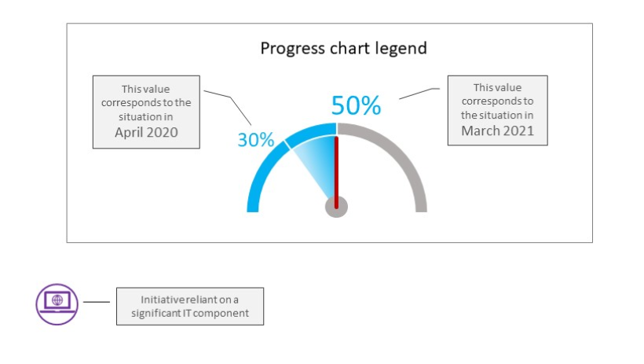

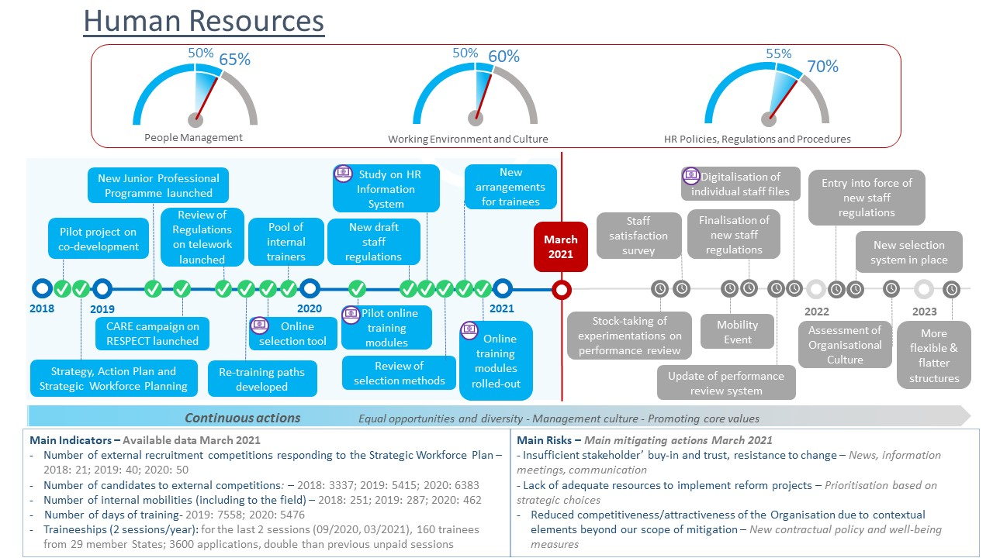

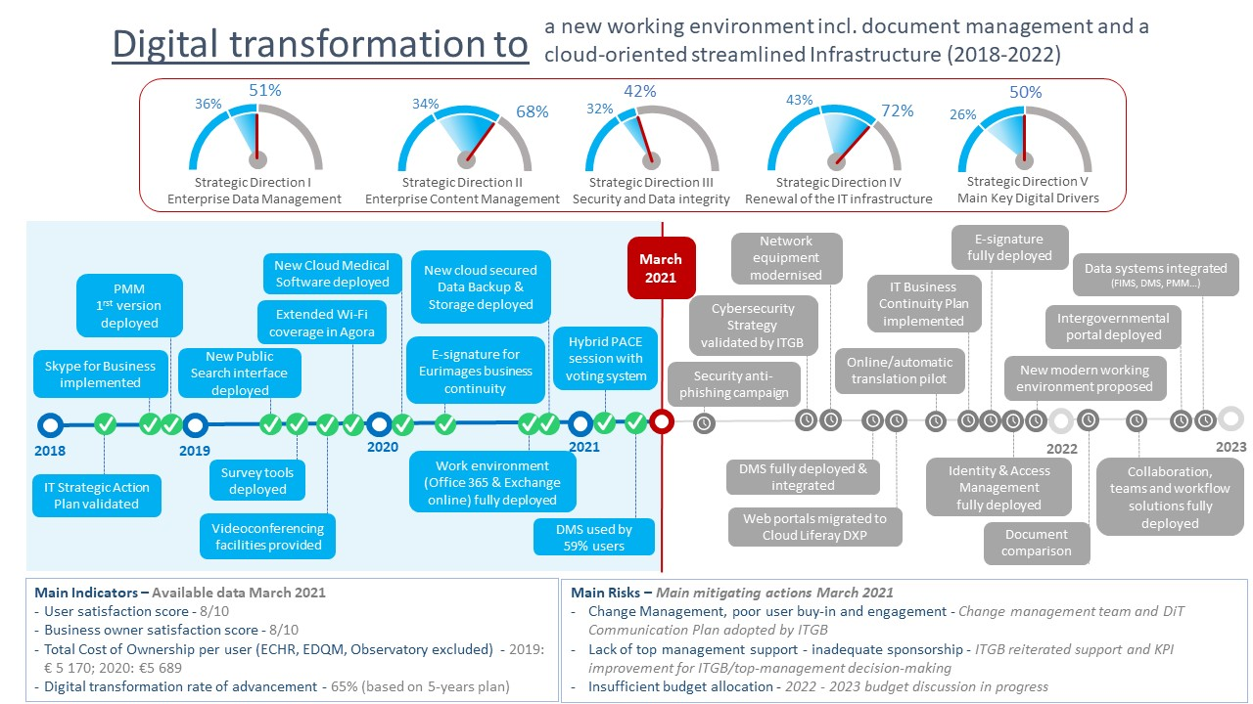

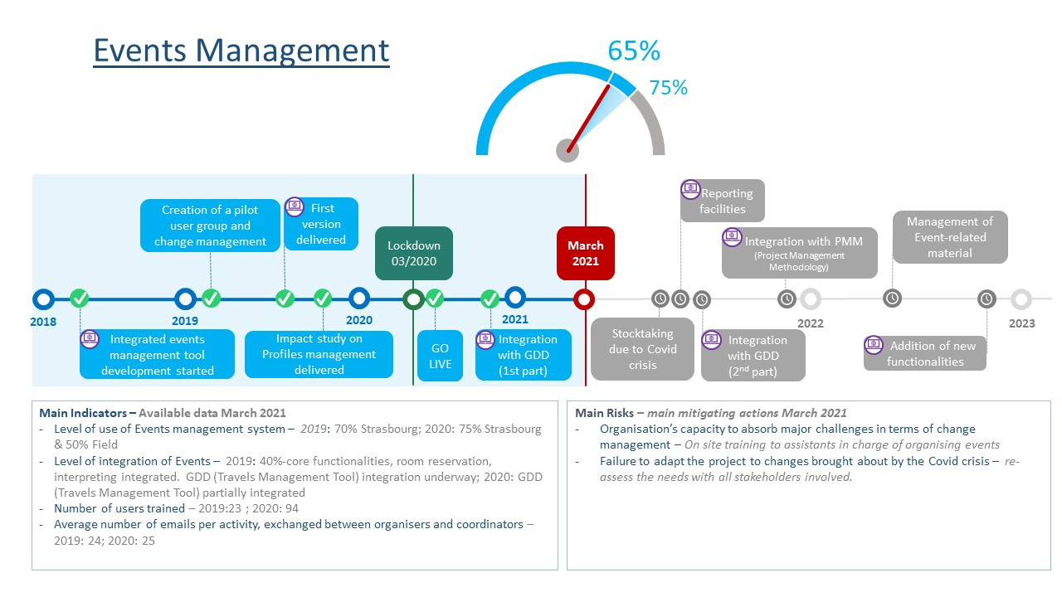

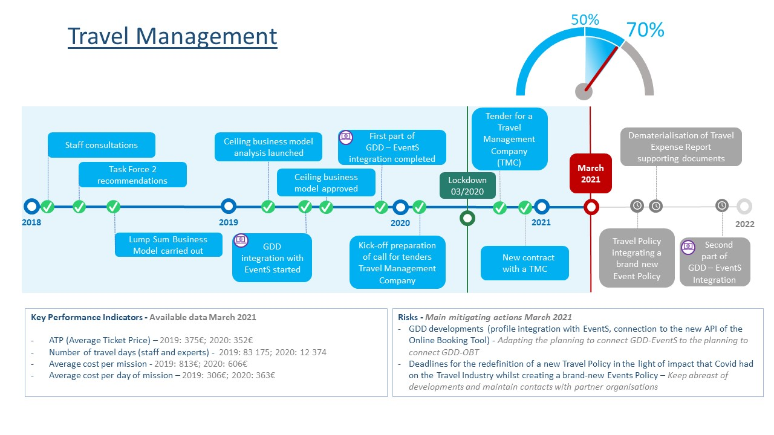

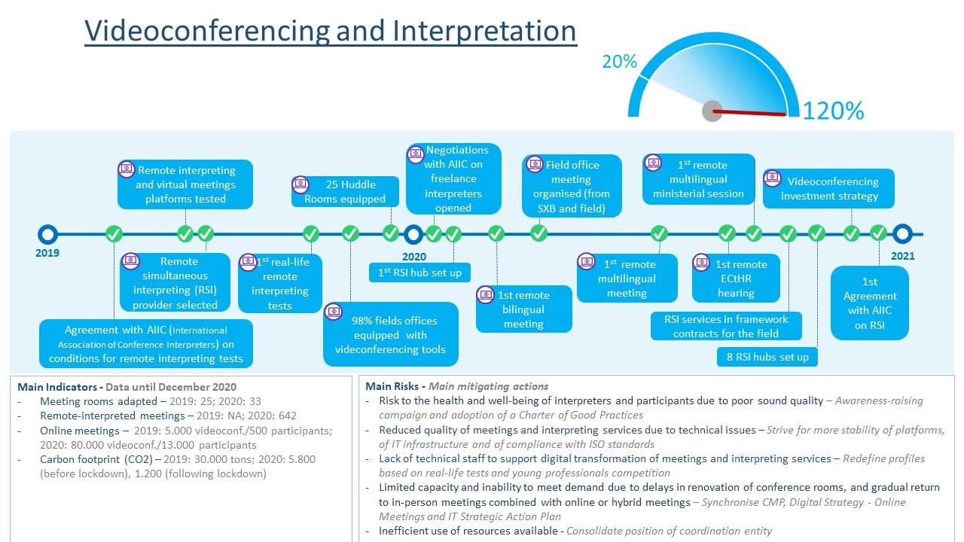

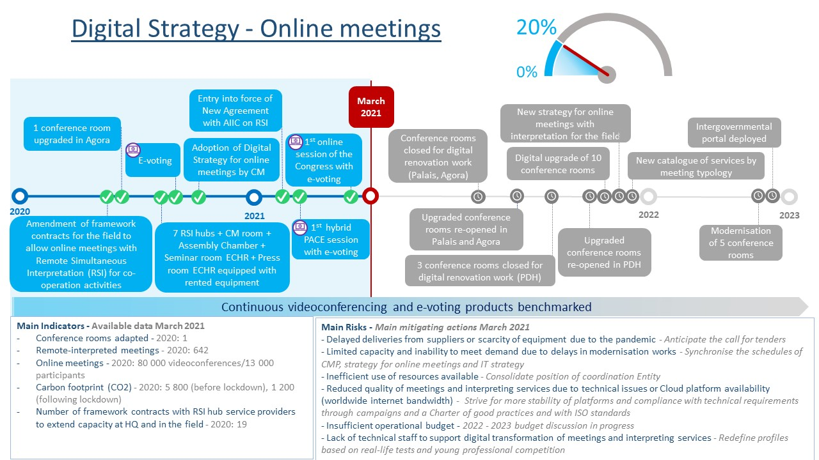

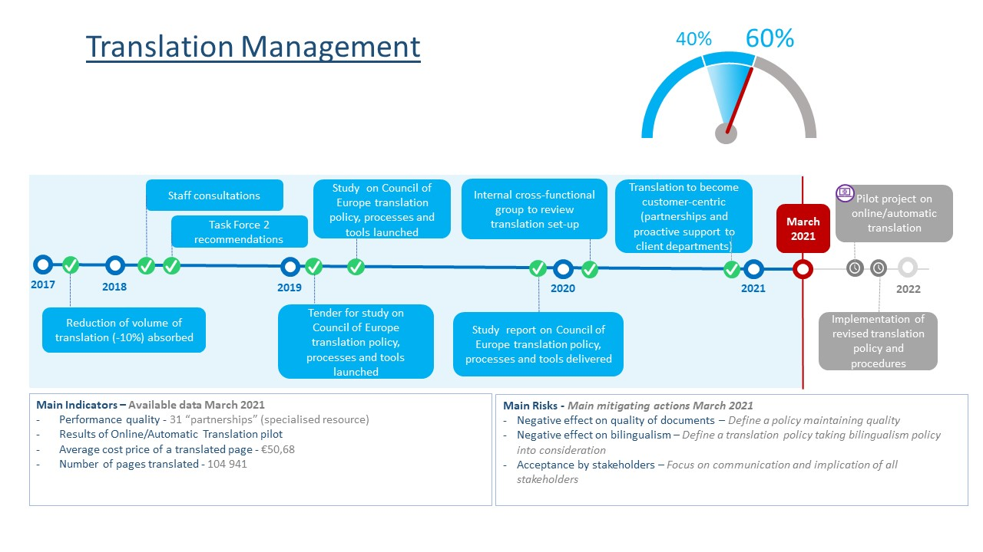

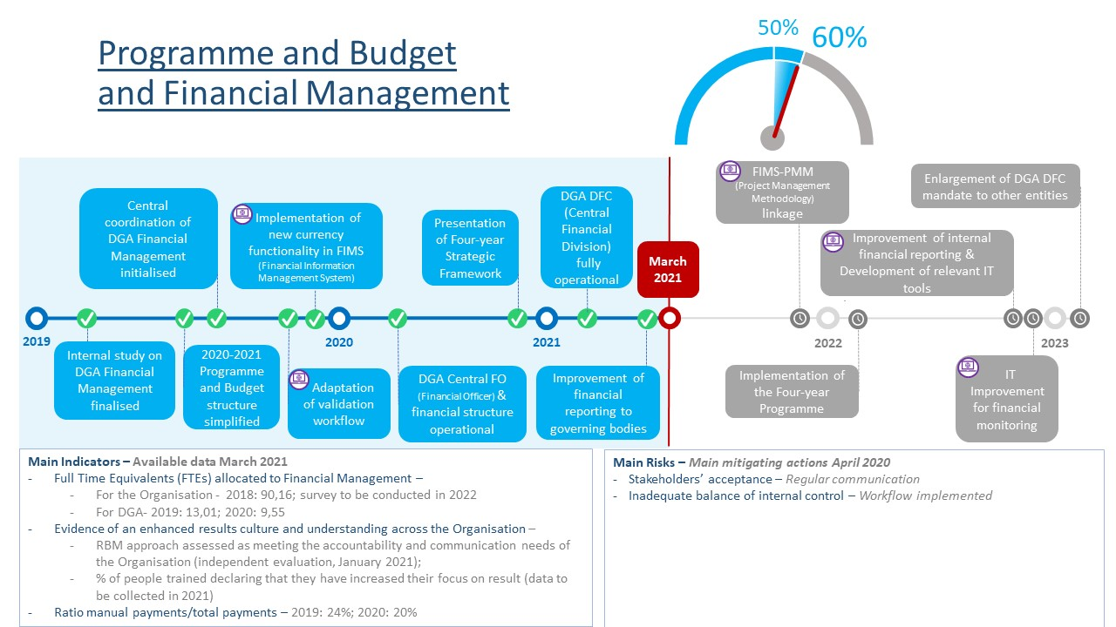

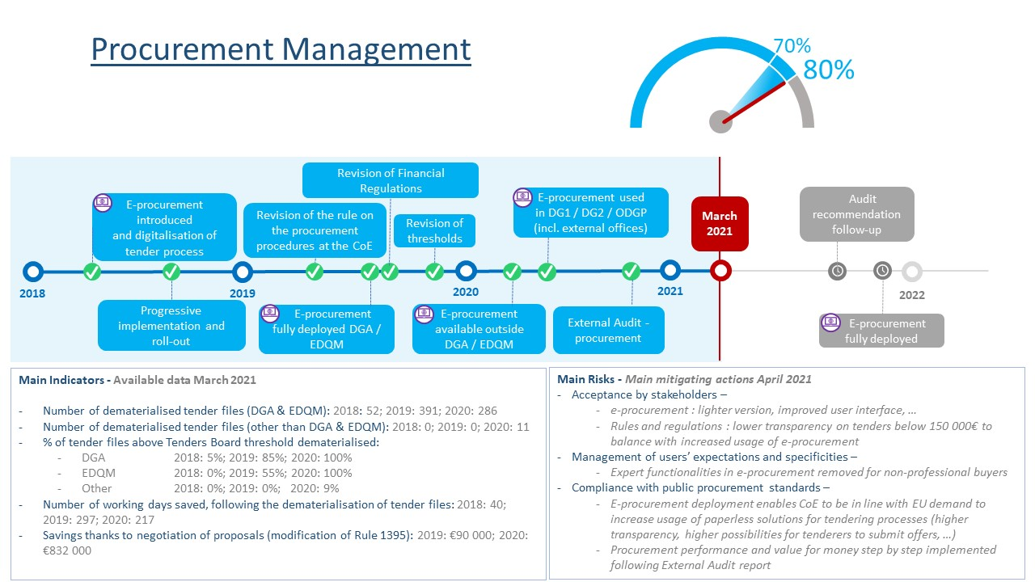

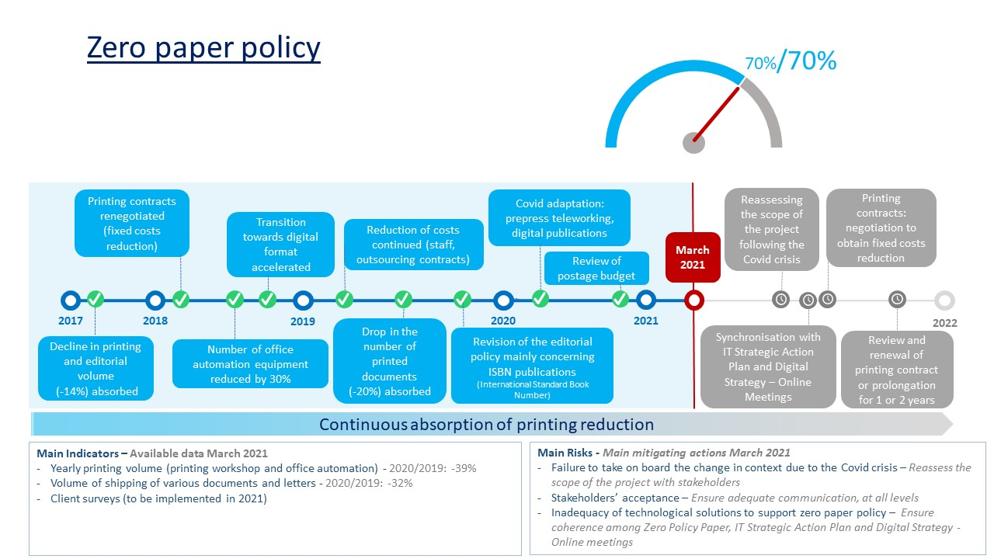

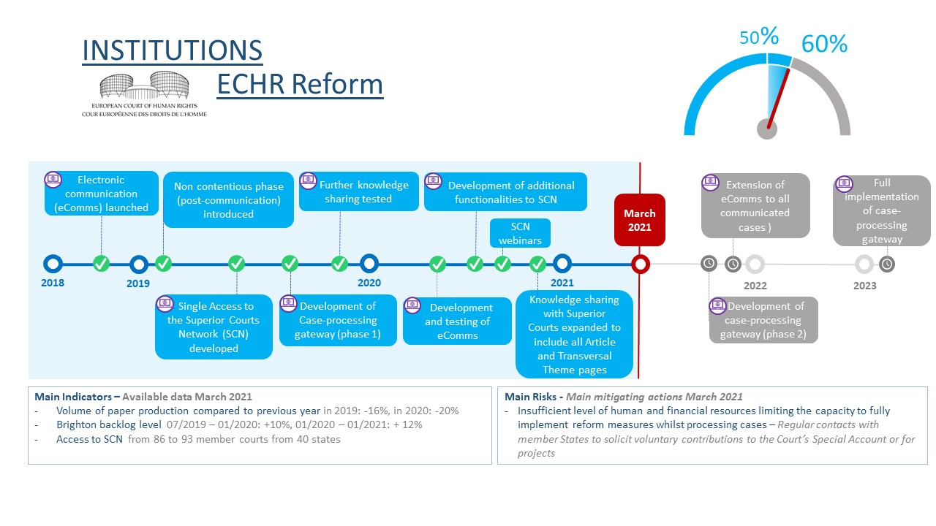

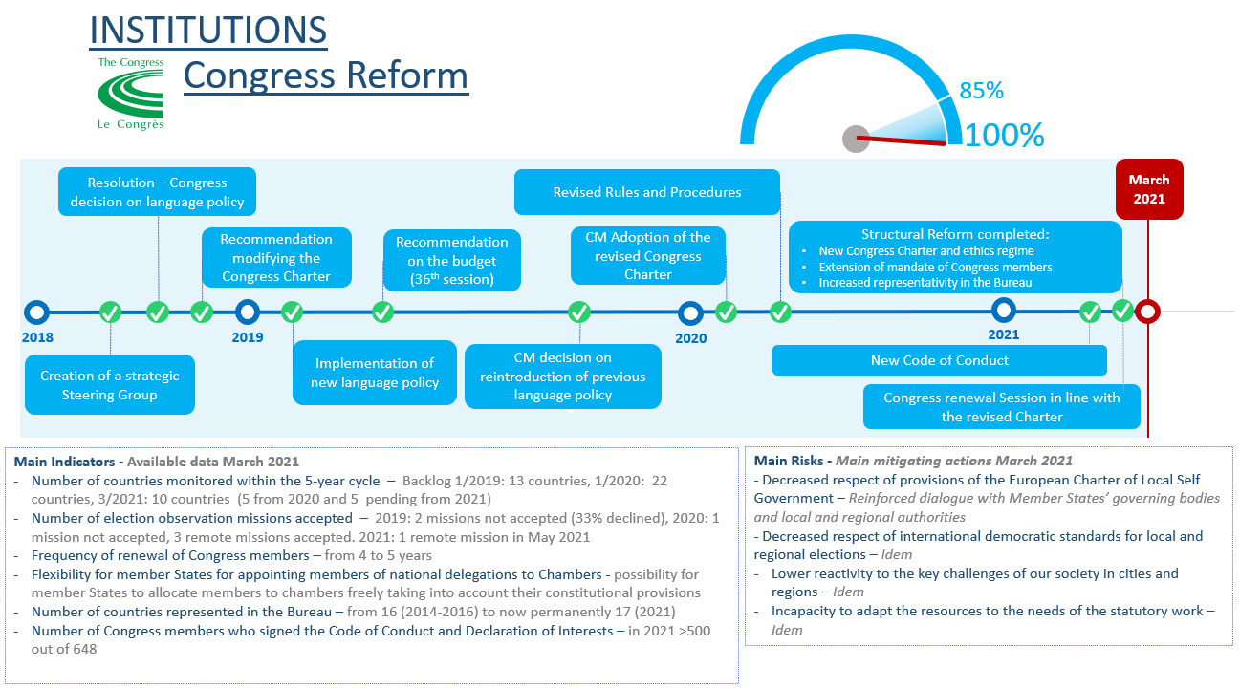

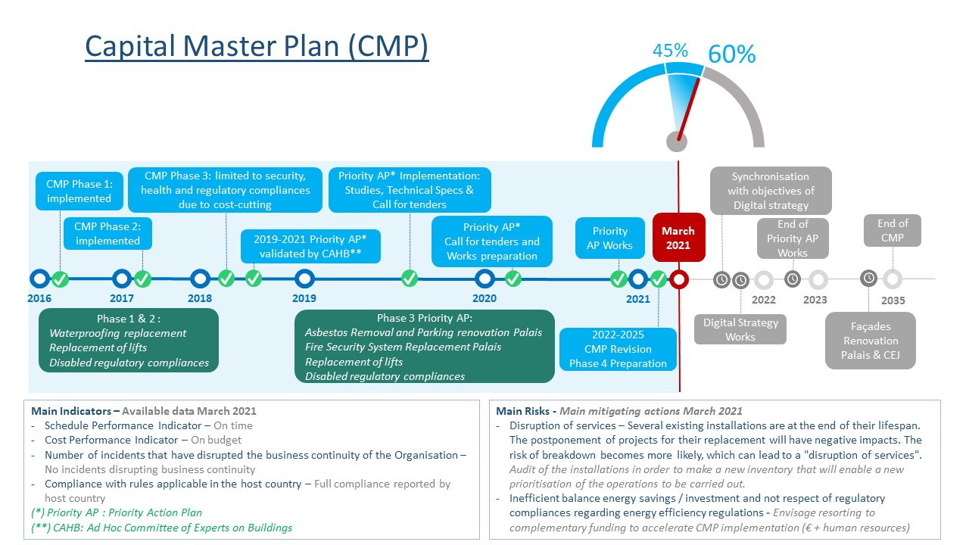

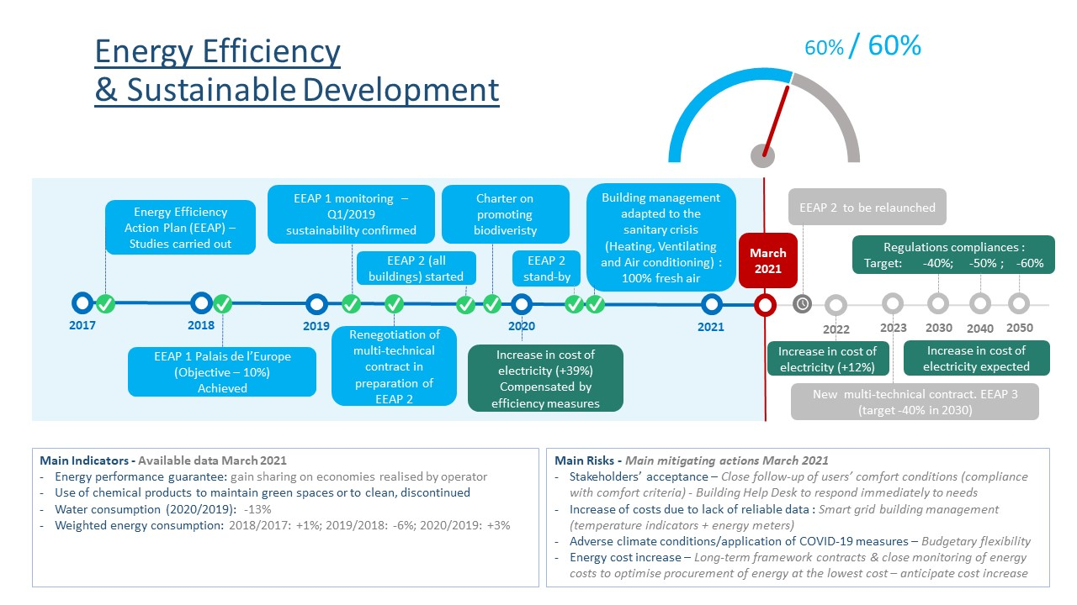

**Appendix 2**

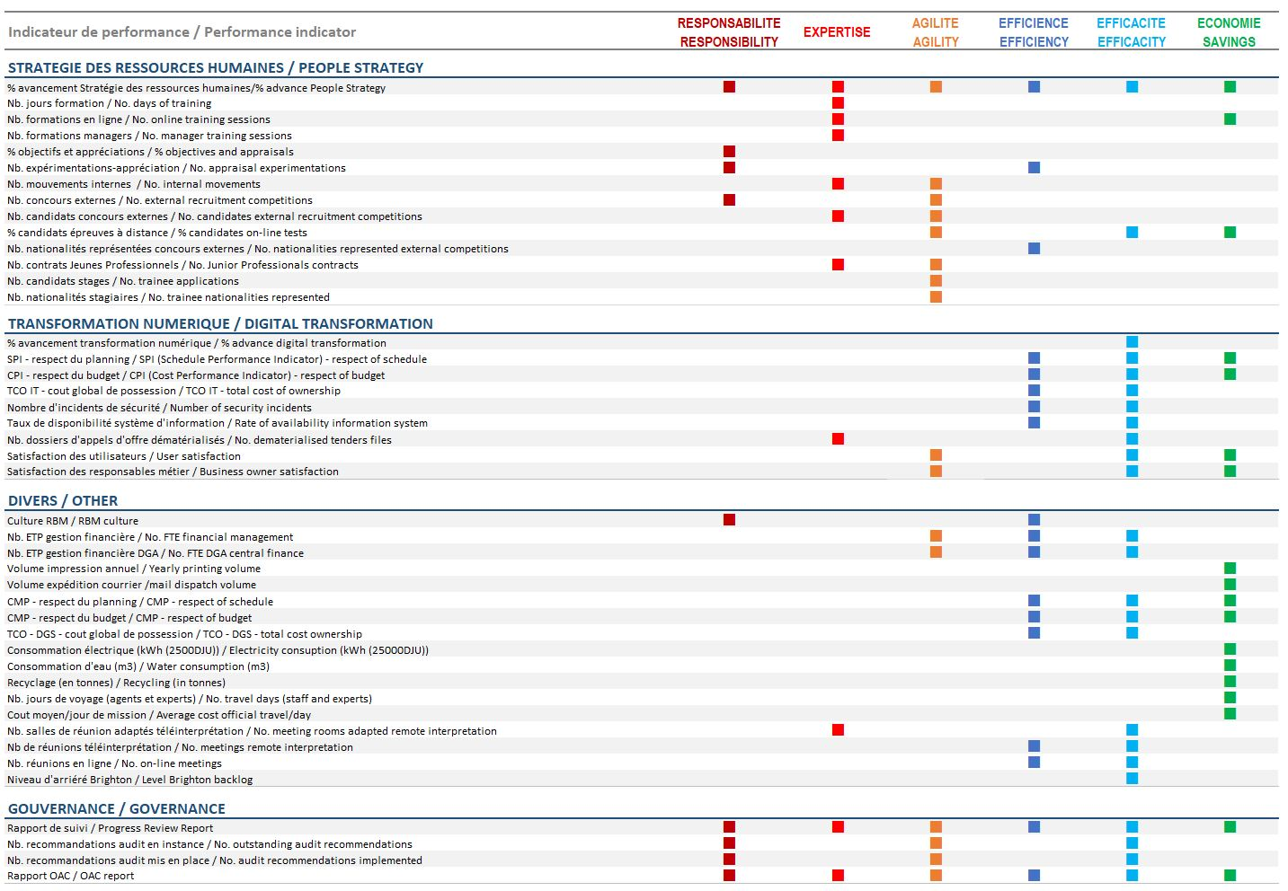

**Appendix 3**

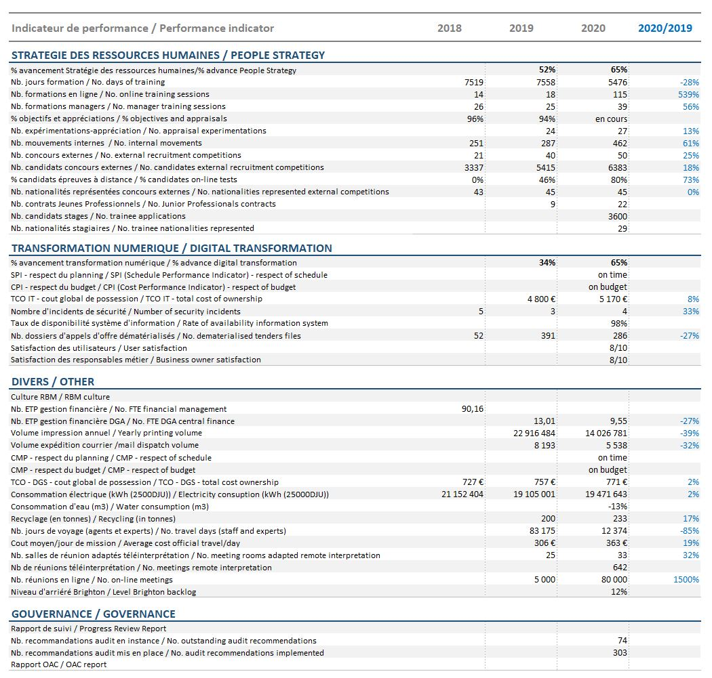

|  |  |
| --- | --- |
| Glossary of acronyms used in the dashboards | |
| AIIC | International Association of Conference Interpreters |
| BC | Budget Committee |
| CAHB | Ad hoc Committee of Experts on Buildings |
| CM | Committee of Ministers |
| CMP | Capital Master Plan |
| CPI | Cost Performance Indicator |
| DGA | Directorate General of Administration |
| DFC | Central Financial Division |
| DMS | Document Management System |
| eComms | Electronic communication |
| EDQM | European Directorate for the Quality of Medicines & HealthCare |
| EEAP | Energy Efficiency Action Plan |
| EventS | Events Management Tool |
| FIMS | Financial Information Management System |
| FO | Financial officer |
| FTE | Full-time equivalent |
| GDD | Travels management tool |
| ISBN | International Standard Book Number |
| ITGB | IT Governance Board |
| KPI | Key Performance Indicator |
| OAC | Oversight Advisory Committee |
| OBT | Online Booking Tool |
| PAEE | Energy Efficiency Action Plan |
| PMM | Project Management Methodology |
| RBM | Results Based Management |
| SCN | Superior Courts Network |
| TCO | Total Cost of Ownership |
| SPI | Schedule Performance Indicator |

1. This document has been classified restricted at the date of issue; it will be declassified in accordance with Resolution [Res(2001)6](https://search.coe.int/cm/Pages/result_details.aspx?Reference=Res(2001)6" \o "on access to Council of Europe documents) on access to Council of Europe documents.
2. Cf. [CM(2021)35](https://search.coe.int/cm/Pages/result_details.aspx?Reference=CM(2021)35" \o "Council of Europe People Strategy 2019-2023 – Reform of the Regulatory Framework for Staff Management) and item 4 [GR-PBA(2021)CB3](https://search.coe.int/cm/Pages/result_details.aspx?Reference=GR-PBA(2021)CB3" \o "Synopsis - Meeting of 16 March 2021).
3. The main Enterprise Data Management (EDM) systems of the CoE - FIMS (the financial management system), PeopleSoft (the human resources and payroll management system) and the related line-of-business applications - contain much of the operational data that allows the CoE to effectively manage budgets, activities and resources.
4. Enterprise Content Management (ECM) aims at moving towards an increasingly paperless Council of Europe. The objective is to provide users with systems that enhance productivity and enable better communication of the Organisation’s content, within an appropriate governance and data protection framework.
5. Cf. [CM(2018)156](https://search.coe.int/cm/Pages/result_details.aspx?Reference=CM(2018)156" \o "Ad Hoc Committee of Experts on Buildings (CAHB) - Meeting report (Strasbourg, 16-17 October 2018) [1332 meeting]).
6. Cf. [CM(2020)87](https://search.coe.int/cm/Pages/result_details.aspx?Reference=CM(2020)87" \o "Programme and Budget 2020-2021 – financing of the 2019 salary adjustment).