|  |  |  |  |
| --- | --- | --- | --- |
| **MINISTERS’ DEPUTIES** | CM Documents | **CM(2020)140** | 28 October 2020[1] |

|  |
| --- |
| **1391st meeting, 8 December 2020**  11 Programme, Budget and Administration    **11.2 Co-ordinating Committee on Remuneration (CCR) –**  d. Review of the system of the daily subsistence allowance –  268th report  **Item to be considered by the GR-PBA at its meeting on 24 November 2020** |

**REVIEW OF THE SYSTEM OF THE DAILY SUBSISTENCE ALLOWANCE**

268th report

1. **Introduction**
2. The rules governing the Daily Subsistence Allowance (DSA) were set out in the CCR 228th Report (CCR/R(2014)3[2]) and replaced those set out in the 189th Report (CCR/R(2008)5[3]). These rules entered into force at 1 January 2015 for a period of six years, i.e. until 31 December 2020. They were complemented with an addendum (CCR/R(2014)3/ADD1[4]) in order to set out some methodological details.
3. As a result, the 2020 Programme of Work of the Co-ordination system foresees a review of the method for the daily subsistence allowance starting in February and a final CCR Report in September 2020 for a method to govern the DSA as from January 2021.
4. **Main features of the current method**
5. The first noticeable feature is about the calculation of the initial level of the rates of the DSA, which were defined by reference to the average of the relevant rates in force at 1 March 2014 in the National Civil Services (NCS) of the reference countries. In case when none of the eight NCS had a daily subsistence rate for a given country, the United Nations DSA rates for the month of June would be used. That was a change compared to the previous system, where the values resulted from a comparison of the United Nations system, data from the private consultant Mercer and from the online hotel reservation portal HRS.
6. The initial levels entered into force on 1 January 2015 and were adjusted every three years, in contrast to the yearly update under the previous framework. As a result, there was an update in DSA rates effective on 1 January 2018.
7. A “compromise” was found on the system of reimbursement for accommodation costs where the reimbursement is either made on the basis of real costs within a ceiling of 60% of the rate or on a flat‑rate basis “*if the cost is deemed to be less expensive than a real-costs reimbursement system*”. In both cases, reimbursements are made upon submission of invoices.
8. **DSA values**
   1. As a result of using a different source for calculating the DSA values, some differences appeared in 2015 and again in 2018 in comparison with those in force in 2014. The CRSG nevertheless concluded that the Organisations could cope with these differences and managed them through exceptional reimbursements. In several cases, difficulties have been experienced to find accommodation that fulfil certain conditions within the ceilings; e.g. travel in high season to destinations, when pre-booked by organisers or relating to security when officials travel to high security risk areas, among other reasons.
9. **Conclusions**
   1. **CRSG position**

The CRSG notes that the current system is providing an effective tool for the Co-ordinated Organisations to manage the cost of staff travelling on duty. The difficulties resulting from a three-yearly periodical adjustment solely based on the reference to national civil services are managed through exceptional reimbursements, as foreseen in the 228th Report.

* 1. **CRP position**

First of all, the CRP continues to strongly regret, as it did when the current method was put in place, that the “other international organisations” comparator and an independent comparator representing hotel/restaurant services, of the HRS/Mercer/HoReCa type, are no longer used in the method used to set daily subsistence allowances (DSAs).

The reference to national civil services only does not reflect the reality of international Organisations’ officials travelling for work, nor does it meet the specific requirements of international organisations.

The CRP also regrets that the CCR has opted to maintain a three-yearly periodical adjustment of the DSA. The CRP would have preferred a return to an annual adjustment, and still fails to understand the arguments used to justify a three-year approach. The frequency for the adjustment in particular, and the CRSG’s proposal in general:

* heavily penalise officials going on mission to high-inflation countries for which the DSA is paid in the local currency;
* do not allow account to be taken of sudden changes in the security situation in countries where officials are sent on mission that could result in drastic changes in accommodation costs far exceeding the cost-of-living increase;
* go against current practices in most reference countries where the amounts of DSAs are revised on an annual basis.
* do not allow an appropriate solution to be found to the problems encountered in some cities where the amount of the DSA is too low given the real cost of hotel rooms (in particular Paris and Brussels).

Nevertheless, and solely for the sake of consensus, the CRP has decided not to delay the adoption of this report.

1. **Recommendation**

The Co-ordinated Committee on Remuneration recommends that Governing bodies approve from 1 January 2021 the attached Rules applying to the DSA for staff members of the Co-ordinated Organisations while travelling on duty. These Rules shall replace the procedure set out in the 228th Report and its Addendum and shall remain in force until 31 December 2026.

David Sydney Maddicott

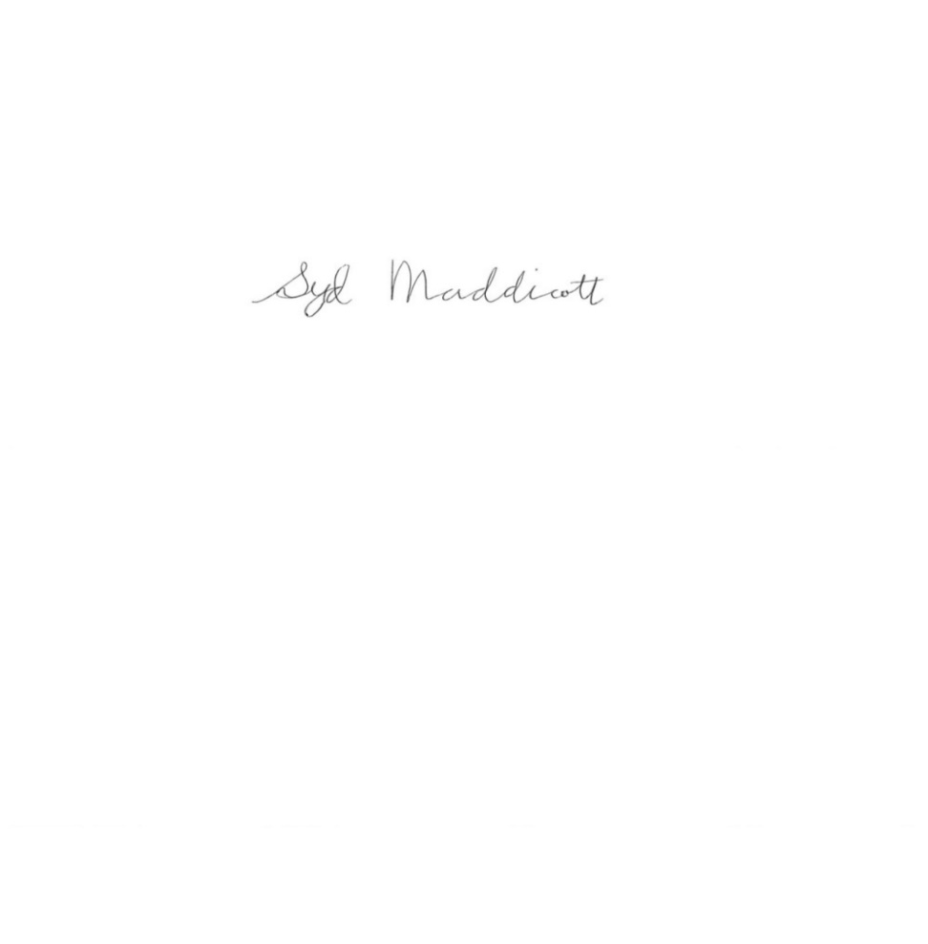

Chairman

ANNEX

**RULES ON ALLOWANCES FOR STAFF**

**OF THE CO-ORDINATED ORGANISATIONS TRAVELLING ON DUTY**

**Daily rates of subsistence allowance**

**Article 1. Description**

1.1 The daily rate of subsistence allowance (DSA) is an amount to reimburse the cost of official or commercial accommodation[5], meals and incidental expenses incurred by staff members of the   
Co-ordinated Organisations (CO) while travelling on duty. In addition, other expenses actually and necessarily incurred in the interest of the Organisation concerned shall be reimbursed within the provisions of the Staff Rules of each Organisation.

1.2 Official or commercial accommodation costs shall be reimbursed on the basis of real costs within a ceiling defined in paragraph 3.2 below. However, subject to approval by the appropriate Committees[6], Organisations may decide to reimburse these costs on a flat-rate basis if the cost is deemed to be less expensive than a real-costs reimbursement system. In both cases, reimbursements shall be made upon submission of invoices.

1.3 Meals and incidental expenses shall be reimbursed on a flat-rate basis, within the ceiling defined in paragraph 3.2.

1.4 Notwithstanding paragraph 1.1 above, Organisations may decide to allocate specific proportions of the total allowance to cover the cost of official or commercial accommodation, meals and incidental expenses under the conditions set out in the Appendix 1.

**Article 2. Initial levels of the rates**

2.1 For all countries, the initial level of the rates of the DSA shall be defined by reference to the average of the relevant rates in force at 1 April 2020 in the national civil services (NCS) of the eight reference countries defined in the salary adjustment method in force.

2.2 When none of the eight NCS has a daily subsistence rate for a given country, the United Nations DSA rates for the month of June shall be used.

**Article 3. Adjustment of the rates**

Adjustment

3.1 The levels calculated as described in paragraphs 2.1 and 2.2 above shall be retained as the initial rates at 1 January 2021. The rates shall be adjusted every three years by reference to the average of the rates in force on 1 April of the previous year in the eight reference countries.

3.2 A 60% weight (including breakfast and taxes) shall be assigned for official or commercial accommodation and 40% for restaurants/cafeterias and incidental expenses.

Application of adjusted amounts

3.3 The Chairperson of the CCR shall, after consulting the CCR under a silence procedure of twenty‑one working days, send to the Governing bodies of the Co-ordinated Organisations a CCR recommendation for the adjustment at 1 January of the rates of the DSA.

**Article 4. Rates and locations**

4.1 There shall be one rate per country and the rates of the allowance shall refer to one reference city per country, generally the capital city[7]. However, France, the United Kingdom and the United States, shall be considered as exceptions to this rule in view of the significant number of missions taking place in cities other than the capital. Consequently, for these countries, more than one rate of the allowance shall be established[8].

**Article 5. Currency**

5.1 The rates of the allowance shall be expressed either in local currency or in euros.

5.2 For those countries where the rate of the allowance is not expressed in the local currency, the exchange rate used shall be the exchange rate at 1 April.

**Article 6. Reimbursement of exceptional expenditure**

6.1 If under certain circumstances the expenditure for official or commercial accommodation (bed, breakfast when included in the rate and taxes) exceeds 60% of the DSA, the administrations shall have the discretion to reimburse the excess amount partially or totally on presentation of invoices and sufficient proof that the additional expenditure was unavoidable. This reimbursement shall normally not exceed 30% of the amount of the DSA.

**Article 7. Review of the levels of the rates and of the procedure**

7.1 An assessment of the levels of the rates shall be carried out by the CCR three years after the date of entry into force of the new Rules and, if necessary, changes shall be introduced to the levels of the rates for the 1 January 2024 adjustment.

**Article 8. Date of entry into force and duration of validity of the Rules**

8.1 These Rules shall replace those set out in the 228th Report and its addendum, and shall come into force at 1 January 2021 for a period of six years, i.e. until 31 December 2026.

**Appendix 1**

**RULES FOR ALL DUTY TRAVEL**

1. Staff members travelling on duty shall be entitled to one day's subsistence allowance for each complete 24-hour period of duty. They shall not be entitled (except as provided for in Article 6 relating to Reimbursement of exceptional expenditure) to more than the full daily allowance for each complete 24-hour period of duty.

2. No subsistence allowance shall be payable for periods of less than four hours.

3. Where the period of duty is four hours or more, but less than eight hours, the staff member shall be entitled to one quarter of the daily allowance. The staff member shall likewise be entitled to one quarter of the daily allowance in respect of any period of four hours or more, but less than eight hours in excess of any complete period of 24 hours.

4. Where the period of duty is eight hours or more without official or commercial accommodation, the staff member shall be entitled to one half of the daily allowance. The staff member shall likewise be entitled to one half of the daily allowance in respect of any period of eight hours or more, but less than 24 hours in excess of any complete period of 24 hours.

5. Where the period of duty is eight hours or more, but less than 24 hours, with official or commercial accommodation, the staff member shall be paid the full daily allowance.

6. Notwithstanding the rules above, each Organisation may introduce special rules for duty travel performed in the vicinity of the staff member's normal place of work or habitual place of residence.

7. Where meals and/or accommodation are provided to the staff member, the daily subsistence allowance shall be abated according to the internal rules of the Organisation.

8. The cost of official or commercial accommodation shall only be reimbursed upon submission of an invoice, whatever the system of reimbursement (real costs or lump sum) retained by the Organisation.

**Appendix 2**

**RULES FOR THE CALCULATION OF THE DSA**

1. **NATIONAL CIVIL SERVICE DATA**

**1.1 Reference date**

In compliance with Article 2 of the 268th Report, the initial DSA rates must be based on the DSA rates in force in 2020 in the eight reference countries (Belgium, France, Germany, Italy, Luxembourg, the Netherlands, Spain and the United Kingdom). The NCS data to be used for the calculation of the DSA make reference to the date of 1 April.

**1.2 Data sources**

The data sources per reference country specifically used for the calculation of the initial levels of the DSA rates are the following:

|  |  |
| --- | --- |
| Belgium | *Arrêté du Régent du 29 avril 1948 : Indemnités de séjour allouées aux représentants et fonctionnaires qui dépendent du Service public fédéral des Affaires étrangères, Commerce extérieur et Coopération au Développement. Arrêté ministériel du 2 juillet 2018.* |
|  |  |
| France | *Décret n° 2006-781 du 3 juillet 2006 fixant les conditions et les modalités de règlement des frais occasionnés par les déplacements temporaires des personnels civils de l'État - publié le 12 juillet 2018.* |
|  |  |
| Germany | *Allgemeine Verwaltungsvorschrift über die Neufestsetzung der Auslandstage- und Auslandsübernachtungsgelder vom 14.10.2019 (ARVVwV).* |
|  |  |
| Italy | *Decreto 23 marzo 2011* *Misure e limiti concernenti il rimborso delle spese di vitto e alloggio per il personale inviato in missione all'estero (11A07480).* |
|  |  |
| Luxembourg | *Règlement du Gouvernement en Conseil du 19 décembre 2018 fixant les indemnités prévues aux articles 16, alinéa 1er, 18 et 20, paragraphe 1er, du règlement grand-ducal du 14 juin 2015 sur les frais de route et de séjour ainsi que sur les indemnités de déménagement des fonctionnaires et employés de l’État.* |
|  |  |
| Netherlands | *Bijlage 7: Tarieflijst verblijfkosten buitenlandse dienstreizen – Appendix from the Central Government Collective Labor Agreement extracted on 1 April 2020 from the official website www.caorijk.nl.* |
|  |  |
| Spain | *Real Decreto 462/2002 del 24 de mayo sobre indemnizaciones por razón de servicio.* |
|  |  |
| United Kingdom | *NCS Global Expenditure Guide published by the Foreign and Commonwealth Office.* |

1. **CALCULATION OF THE DSA**
2. **Calculation of the DSA rates per reference country**

|  |  |
| --- | --- |
| Belgium | Overall DSA rate per country is calculated by adding the accommodation expenses (ceiling), which are the same for the two existing categories of staff, plus the daily lump sum granted to staff classified at Category 1 (i.e. staff from the central administration and non-expatriated staff at Foreign Services). |
|  |  |
| France | All-inclusive DSA rate per country as published in the Decree. |
|  |  |
| Germany | Overall DSA rate per country is calculated by adding the accommodation expenses (ceiling) to the daily lump sum granted to staff on mission. |
|  |  |
| Italy | Considering that hotel ceilings for staff on mission in Italy are calculated on the basis of hotel stars with a reimbursement of 4-star hotels for senior civil servants (Category 1 staff) and 3‑star hotels for other officials (Category 2 staff), the overall DSA per country is calculated by using United Nations (UN) hotel rates published by the International Civil Service Commission (ICSC) on 1 April of the year of the calculations, as best proxy of accommodation costs, plus the corresponding 2-meals lump sum with reference to the appropriate reference city per country as the average from the two existing categories of staff, to be derived from the seven geographic worldwide zones comprised in the Italian DSA system. |
|  |  |
| Luxembourg | Overall DSA rate per country is calculated by adding the lump sums for meals and incidental expenses (*indemnité de jour*) to the amount (ceiling) for overnight accommodation expenses (*indemnité de nuit*). |
|  |  |
| Netherlands | Overall DSA rate per country is calculated by adding the allowance for accommodation costs to the lump sum for meals and incidentals (other costs) foreseen for 24-hour missions. |
|  |  |
| Spain | Overall DSA rate per country is calculated by adding the average of the lump sum for accommodation expenses granted to group 1 and group 2 staff to the average of the daily lump sum granted to group 1 and group 2 staff. |
|  |  |
| United Kingdom | Overall DSA rate for the CO Member countries is calculated by adding the average of the price ranges on accommodation costs to be computed by National Authorities (based on the information presented in the Global Expenditure Guide, complemented by additional information provided by different United Kingdom delegations abroad) to the sum of recommended costs for the three main meals to be derived from the Global Expenditure Guide. |

1. **Calculation of the overall DSA rates**

The initial level of the rates of the DSA for all countries is calculated as the arithmetic average of the relevant NCS rates of the reference countries.

In following years, the rates are adjusted every three years by reference to the average of the rates in force on 1 April of the previous year in the eight reference countries.

1. **OTHER ELEMENTS IN THE CALCULATION OF THE DSA**

**3.1 Exchange rates**

It is a single official and published data set of exchange rates which needs to be retained to the needs of operational efficiency and the objectives of the system adopted by the CCR.

The European Commission data set InforEuro published for the month of April, which indicates the market rates for the penultimate day of March quoted by the European Central Bank (ECB), is used when needed for the conversion of NCS rates into the overall DSA rates in Euros or in hard currency.

DSA rates in hard currency correspond to those set out for Australia, Canada, Denmark, Japan, South Korea, Liechtenstein, New Zealand, Norway, Sweden, Switzerland, the United Kingdom and the United States.

**3.2 DSA rates for “other” locations in France, the United Kingdom and the United States**

NCS data from some reference countries have several rates for France, the United Kingdom and the United States, at times not making reference to the same cities.

NCS rates to be used to calculate the CO DSA for “other” mission locations in these three countries must reflect in the best way possible the locations of interest to the CO when sending staff on mission other than to their respective capital cities.

In line with that principle, which was also followed in previous methods relating to the calculation of the DSA, DSA data from NCS for Strasbourg in France as the reference city for “other locations” of interest to the CO are used when available. Likewise, when available, DSA data from NCS sources for Reading are used as the reference city for “other locations” of interest to the CO in the United Kingdom.

When there is no DSA data from NCS sources specific to the above-mentioned locations for France and the United Kingdom, the arithmetic average of all cities for which there is a rate is used instead.

The same principle is followed as well for the United States. However, because there is not a specific common location to be targeted as a CO reference city for that purpose other than Washington D.C. and New York City where most CO missions take place, the DSA rate “others” in the United States is calculated as the arithmetic average of the rates from NCS sources for all major cities specifically identified, as well as the generic category of “other” cities available in the respective national systems.

1. This document has been classified restricted until examination by the Committee of Ministers.
2. Cf. [CM(2014)105](https://search.coe.int/cm/Pages/result_details.aspx?Reference=CM(2014)105" \o "Co-ordinating Committee on Remuneration (CCR) ‒ b. Review of the system of the daily subsistence allowance – 228th Report [1213 meeting]) and [CM/Del/Dec(2014)1213/11.1b](https://search.coe.int/cm/Pages/result_details.aspx?Reference=CM/Del/Dec(2014)1213/11.1b" \o "Co-ordinating Committee on Remuneration (CCR) - b. Review of the system of the daily subsistence allowance – 228th report and 232nd report).
3. cf. [CM(2008)149](https://search.coe.int/cm/Pages/result_details.aspx?Reference=CM(2008)149" \o "Co-ordinating Committee on Remuneration (CCR) – System of daily subsistence allowance - 189th Report [1042 meeting]) and [CM/Del/Dec(2009)1045/11.4a](https://search.coe.int/cm/Pages/result_details.aspx?Reference=CM/Del/Dec(2009)1045/11.4a" \o "Co-ordinating Committee on Remuneration (CCR) - a. System of daily subsistence allowance – 189th report).
4. Cf. [CM(2015)56](https://search.coe.int/cm/Pages/result_details.aspx?Reference=CM(2015)56" \o "Addendum to the 228th Report of the Co-ordinating Committee on Remuneration (CCR) on the system of the daily subsistence allowance - Explanatory note [1227 meeting]) and [CM/Del/Dec(2015)1227/11.3](https://search.coe.int/cm/Pages/result_details.aspx?Reference=CM/Del/Dec(2015)1227/11.3" \o "Addendum to the 228th report of the Co-ordinating Committee on Remuneration (CCR) on the system of the daily subsistence allowance – Explanatory Note).
5. Official or commercial accommodation includes in particular accommodation provided by the Organisation or by governmental institutions for which the related fees must be paid by the staff members.
6. Management committees composed of Member States.
7. Except for the Netherlands (The Hague) and Switzerland (Geneva)
8. France (Paris and other cities), United Kingdom (London and other cities), United States (New York City, Washington D.C., and other cities)