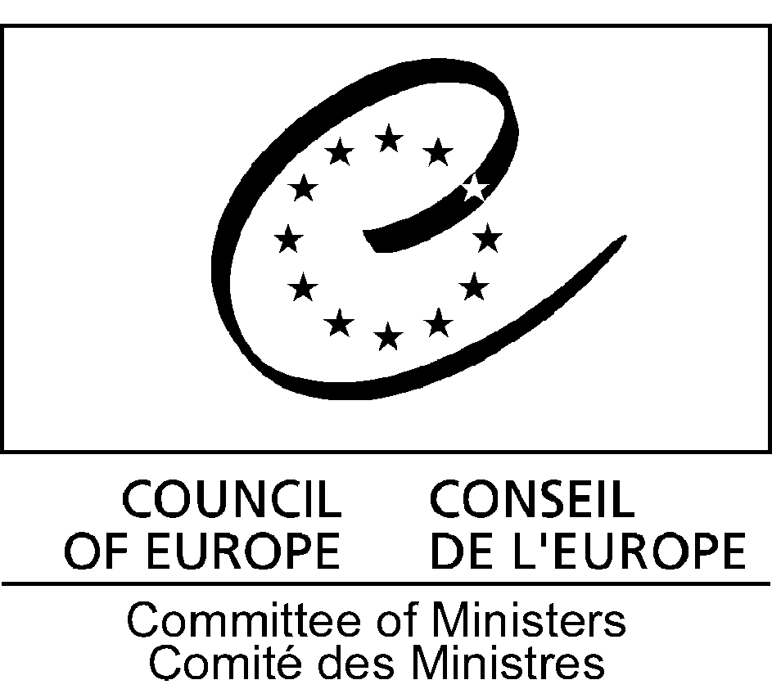

Recommendation Rec(2006)14
of the Committee of Ministers to member states
on citizenship and participation of young people in public life

(Adopted by the Committee of Ministers on 25 October 2006
at the 978th meeting of the Ministers’ Deputies)

The Committee of Ministers, in accordance with Article 15.b of the Statute of the Council of Europe,

Having regard to Resolution Res(2003)7 of the Committee of Ministers to member states on youth policy at the Council of Europe;

Having regard to the Declaration and Action Plan adopted by the Third Summit of Heads of State and Government;

Having regard to the revised European Charter on the participation of young people in local and regional life, adopted within Recommendation 128 (2003) of the Congress of Local and Regional Authorities of the Council of Europe, as well as Recommendation Rec(2004)128 of the Committee of Ministers to member states on the participation of young people in local and regional life;

Having regard to Recommendation Rec(2006)1 of the Committee of Ministers to member states on the role of national youth councils in youth policy development;

Having regard to Resolution 1353 (2003) of the Parliamentary Assembly on the future of democracy: strengthening democratic institutions;

Having regard to Recommendation No. R (97) 3 of the Committee of Ministers to member states on youth participation and the future of civil society;

Bearing in mind the achievements of the Council of Europe’s youth sector since 1972 regarding the promotion of youth participation;

Bearing in mind the outcomes and results of the European Year of Citizenship through Education, organised by the Council of Europe in 2005;

Considering that education for participation and providing opportunities for experiencing participation is a prerequisite for the necessary ongoing improvement of democracy, and that participation is a lifelong learning process, which takes place at all levels and at all ages, including within the family and school;

Considering that participation is fundamental to social organisation and cohesion, and does not allow for any restriction according to gender, ethnicity, religion, choice of lifestyle or social status, and concerns all young people;

Considering the preamble to the revised European Charter on the participation of young people in local and regional life which stipulates in particular that participation is about “having the right, the means, the space and the opportunity, and where necessary, the support to participate in and influence decisions and engage in actions and activities so as to contribute to building a better society”;

Considering that supporting young people’s participation is not restricted to asking their opinions but must include empowering them to be actively involved in a creative and productive manner; that youth participation is not limited to areas and issues which only concern youth;

Considering that there is a need, in particular, to encourage and support the participation of young people who do not belong to youth organisations;

Considering that effective youth participation is best achieved through practice and by participation mechanisms which allow young people to develop their own working methods,

1. Recommends that the governments of member states:

a. consider helping young people to be active citizens as a priority in public youth policies, and, in that respect, provide them with learning opportunities, including in their native language as appropriate, and experience that will increase their participation in public life;

b. encourage the exchange and use of good practice concerning youth participation, at local, regional and national levels, taking into consideration notably the expertise of the Council of Europe in this respect, as well as its educational and training tools;

c. further acknowledge the important role of non-formal learning, and, in this context, of youth associations in education for democratic citizenship and participation;

d. encourage the establishment of independent youth councils at local, regional and national levels;

e. promote the development of partnerships between public authorities and youth councils and organisations, taking into consideration the long practice of the Council of Europe’s youth sector regarding co-management between youth organisations and governments;

f. support the establishment of pupil and student councils within educational establishments, with the possibility of participating in their governance, and in this context, stimulate dialogue between actors in non-formal and formal education, with a view to promoting the use of innovative methods for citizenship education;

g. develop a favourable environment for effective youth participation, by:

i. working towards the improvement of living conditions of the many young people in Europe facing precariousness, as a prerequisite for their participation in society and in democratic structures and processes;

ii. paying special attention to enabling disadvantaged and vulnerable young people, as well as minority youth, to participate at local, regional and national levels;

iii. stimulating the development of youth research with a view, in particular, to enabling better understanding of young people and youth cultures, to identifying obstacles to youth participation and reviewing the issues of current concern and adapting forms of participation;

iv. providing young people with information on the basis of the following principles: equal opportunities and free access, proximity, flexibility and user-friendliness, high standards of ethical behaviour;

v. securing adequate funding for youth participation, while ensuring transparency through clear allocation criteria;

vi. encouraging political parties to open up dialogue with young people and build on their creativity;

h. stimulate the effective implementation, by local and regional authorities, of the revised European Charter on the participation of young people in local and regional life of the Council of Europe,

2. Asks the Secretary General of the Council of Europe to address this recommendation to governments of States Parties to the European Cultural Convention that are not members of the Council of Europe.

